I don’t like your services

Screeen shot below

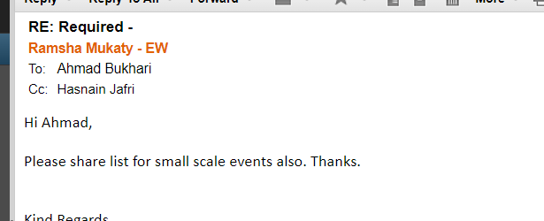

Bye