

CSE370 : Database Systems
Project Report
Project Title : FurFusion

Group No : 08, CSE370 Lab Section : 19, Fall 2025
ID | Name | Contribution
21301600 | Mubasshira Mahajabin | EER Diagram, HTML & Styles, Add , Update And View Pets,  User Authentication & Role-Based Access Control, Adopter Management, Adoption Records & Tracking
22201793 | Shajeeah Juwairiya | Login, Register, Logout, EER Diagram, Schema Diagram, Search & Filter Pets, Health & Vaccination Tracker, Breeding & Pregnancy Tracking, Genetic Feasibility Checker

Table of Contents

Section  No | Content | Page No
1 | Introduction | 3
2 | Project Features | 4
3 | ER/EER Diagram | 5
4 | Schema Diagram | 6
5 | Normalization | 6
6 | Frontend Development | 7-12
7 | Backend Development | 13-20
8 | Source Code Repository | 21
9 | Conclusion | 21

Introduction

FurFusion – Intelligent Pet Adoption & Breeding Management System is a web-based application developed to simplify and digitize pet adoption and breeding management for animal shelters and adopters. The system replaces manual record-keeping with a centralized database that efficiently manages pet information, adopter details, health records, breeding activities, and adoption tracking.
Developed using PHP and MySQL, FurFusion implements role-based access control for administrators and adopters. Administrators can manage pets, health records, breeding plans, and approve adoption requests, while adopters can search for pets, request adoptions, check genetic feasibility of breed combinations, and maintain personal profiles. The system also includes intelligent features such as a genetic feasibility checker and advanced search functionality to support informed adoption and breeding decisions.
Overall, FurFusion applies core database design, normalization, and backend development concepts, ensuring data integrity, efficient workflow management, and a scalable solution for real-world pet adoption systems.

Project Features

ID,  Name | Features
21301600 ,  Mubasshira Mahajabin | Ft 1 | Pet Management (Add / Update / View Pets)
21301600 ,  Mubasshira Mahajabin | Ft 2 | Adopter Management
21301600 ,  Mubasshira Mahajabin | Ft 3 | Role-Based Access Control
21301600 ,  Mubasshira Mahajabin | Ft 4 | Adoption Records & Tracking
22201793 ,  Shajeeah Juwairiya | Ft 1 | Search & Filter Pets
22201793 ,  Shajeeah Juwairiya | Ft 2 | Health & Vaccination Tracker
22201793 ,  Shajeeah Juwairiya | Ft 3 | Breeding & Pregnancy Tracking
22201793 ,  Shajeeah Juwairiya | Ft 4 | Genetic Feasibility Checker

ER/EER Diagram

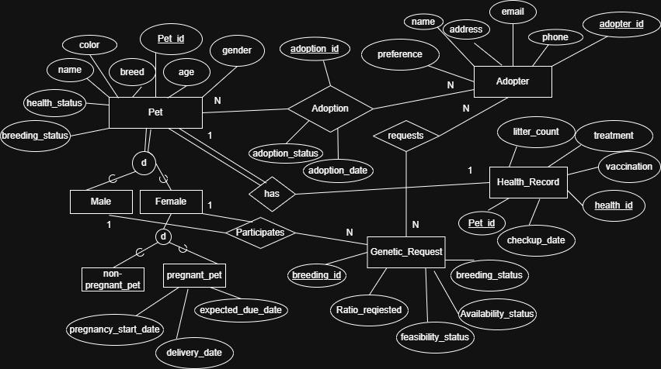

Schema Diagram

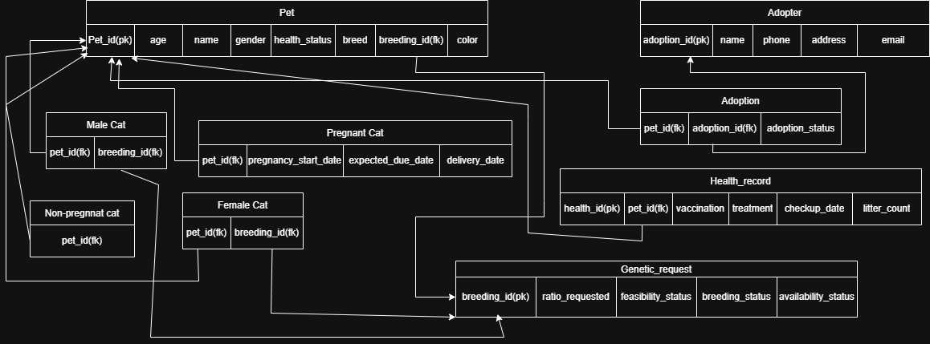

Normalization

- Explain if your converted Schema is in 1NF or not. If not, decompose it to 1NF.
Ans. The schema satisfies 1NF because all attributes are atomic.

- Explain if your converted Schema is in 2NF or not. If not, decompose it to 2NF. Can there be any partial functional dependencies in your relational schema?
Ans. The schema satisfies 2NF because there are no partial dependencies.

- Explain if your converted Schema is in 3NF or not. If not, decompose it to 3NF. Can there be any transitive dependencies in your relational schema?
Ans. The schema satisfies 3NF because there are no transitive dependencies.

Therefore, the schema is fully normalized up to Third Normal Form (3NF).
Frontend Development

Contribution of ID :21301600 , Name : Mubasshira Mahajabin

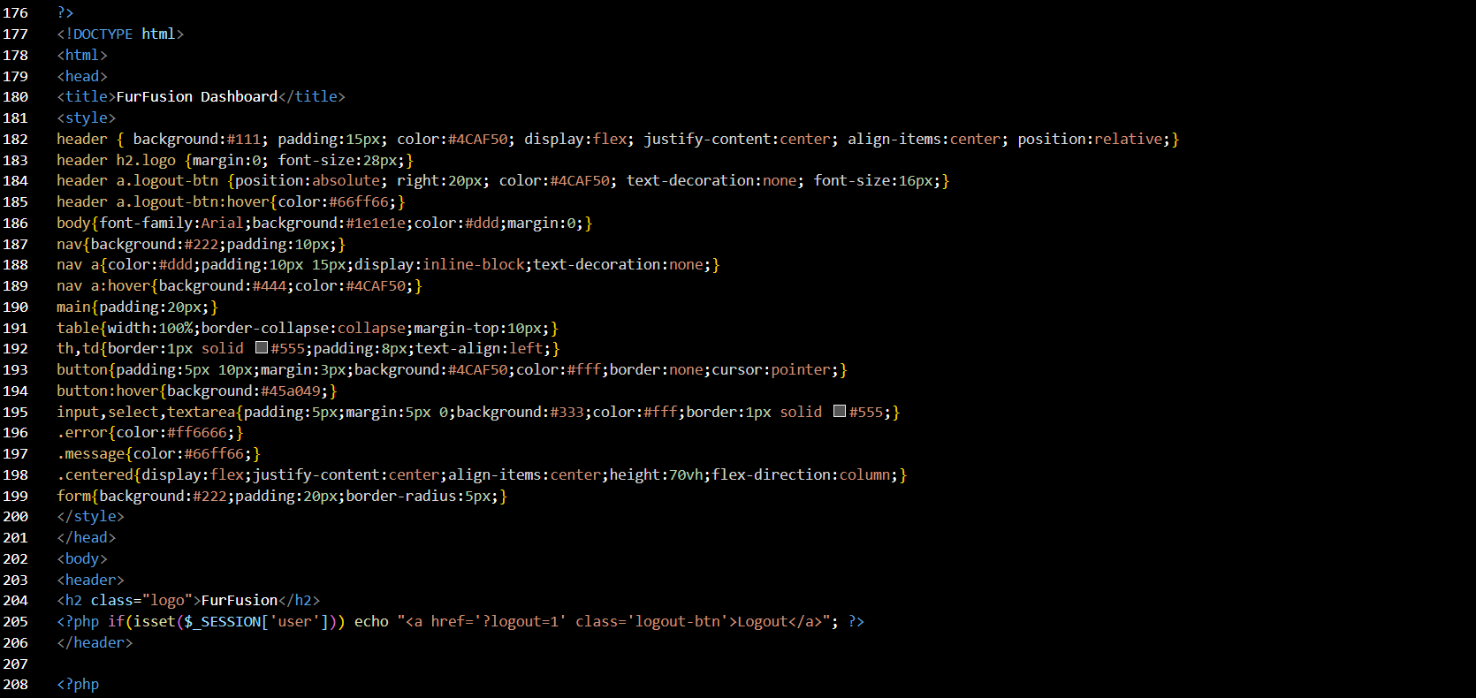
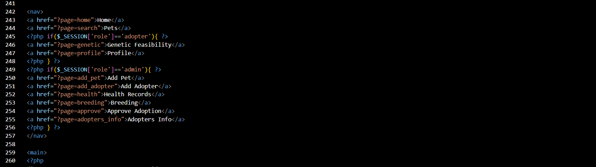

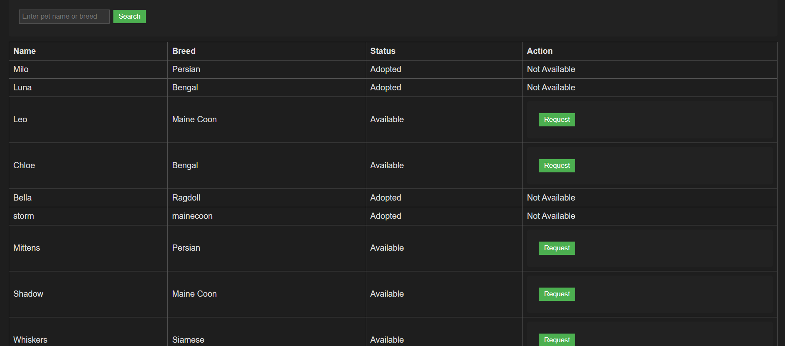
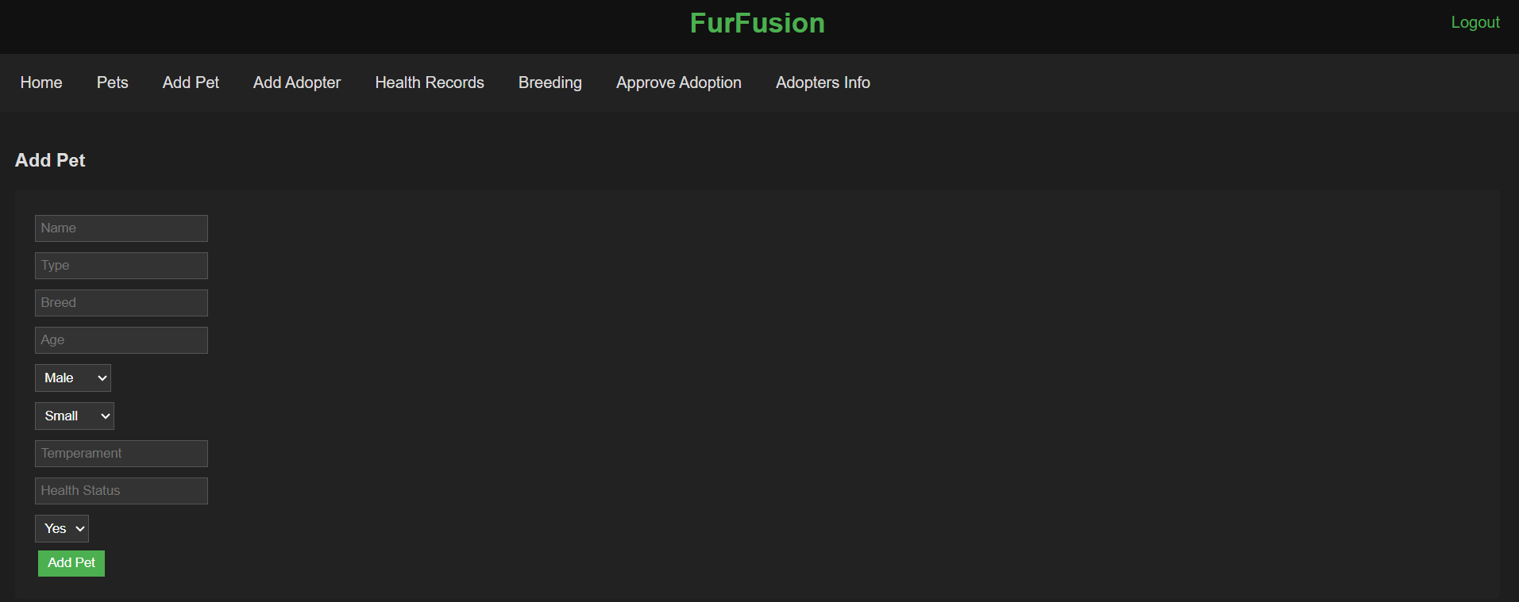
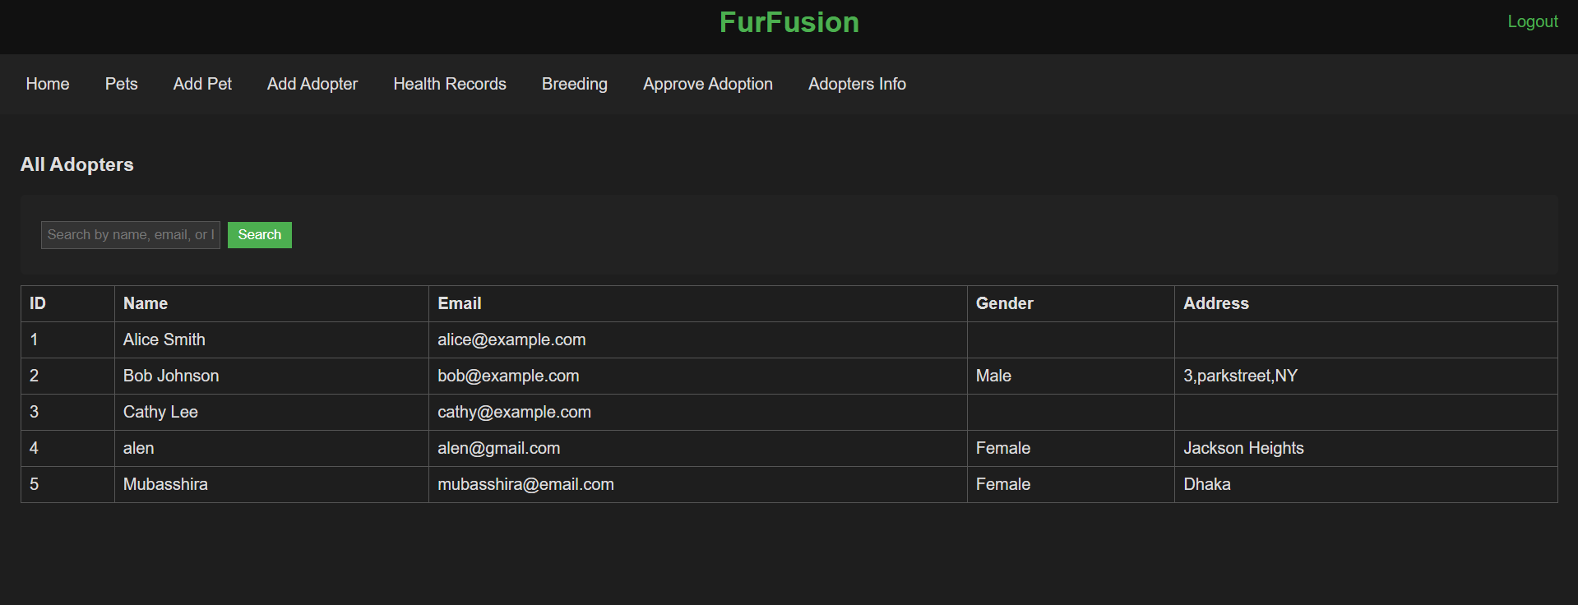
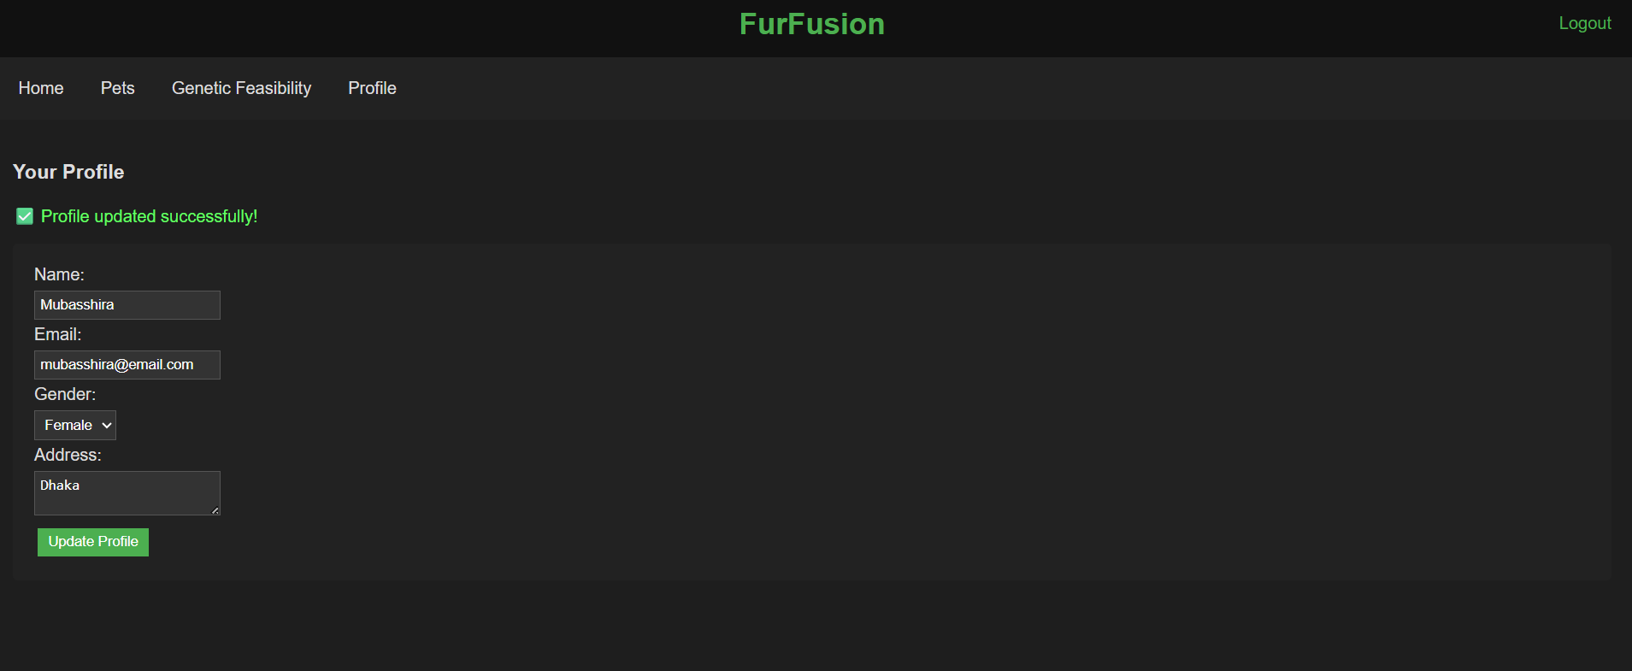
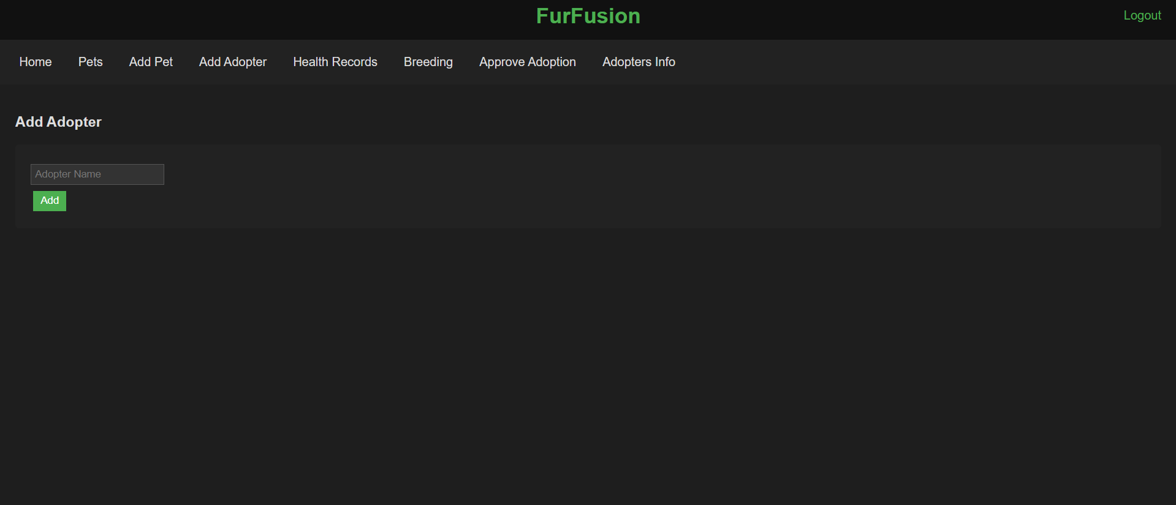

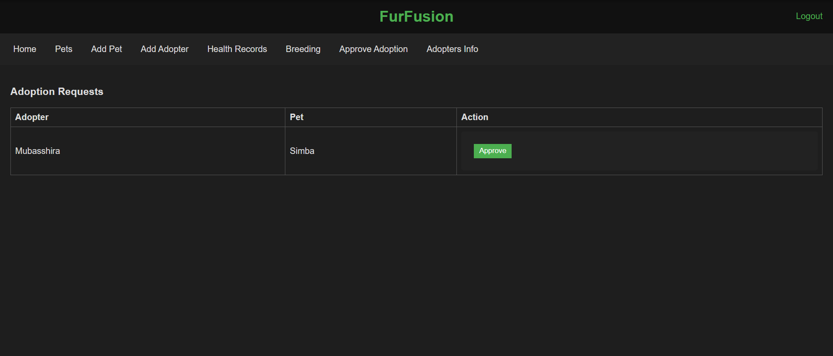

Contribution of ID : 22201793 , Name : Shajeeah Juwairiya

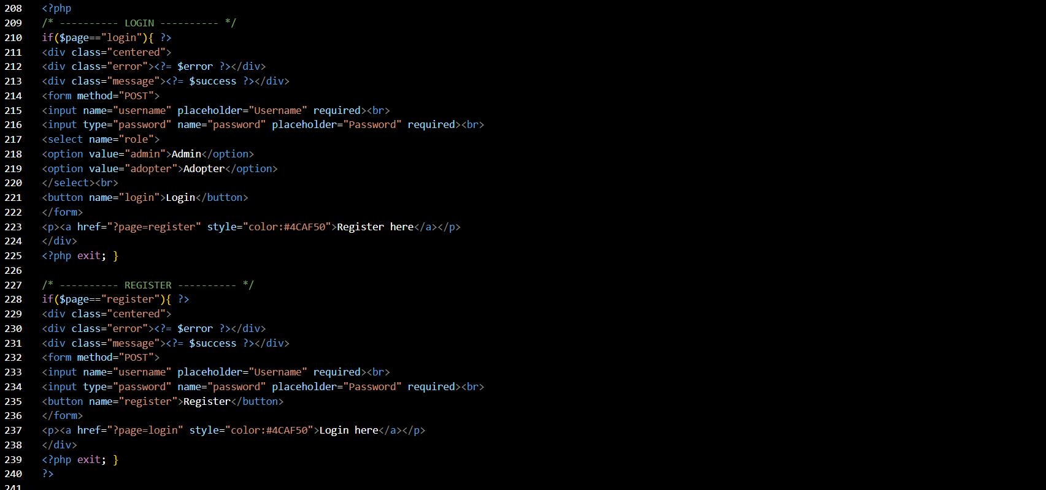




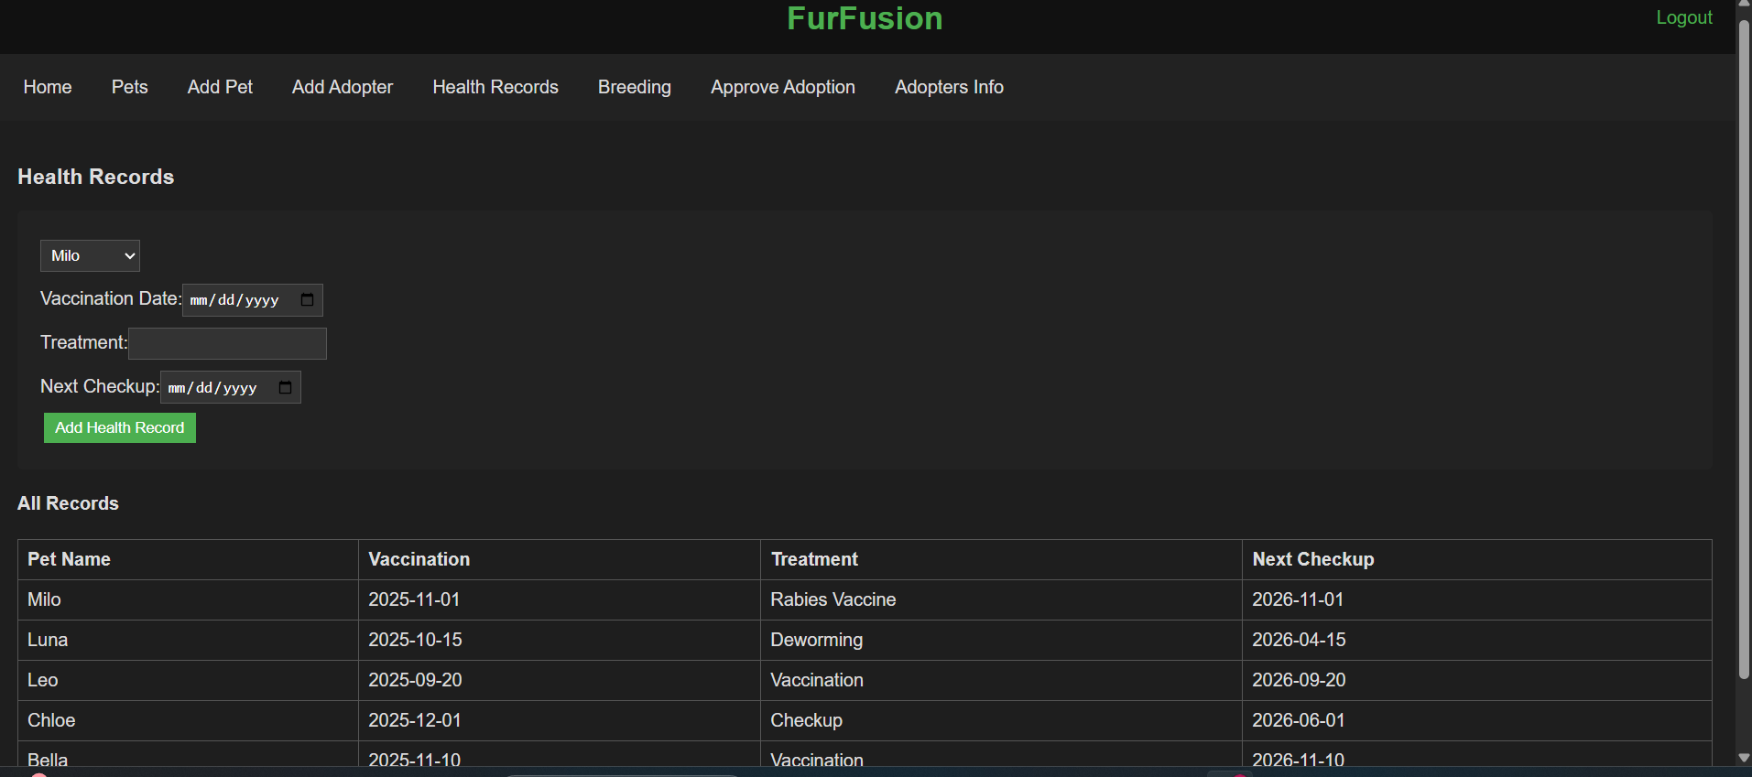
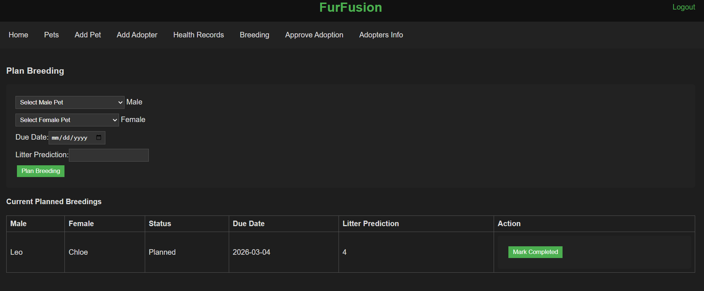
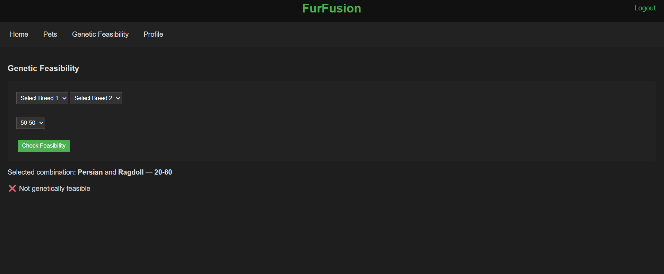

Backend Development

Contribution of ID :21301600 , Name : Mubasshira Mahajabin

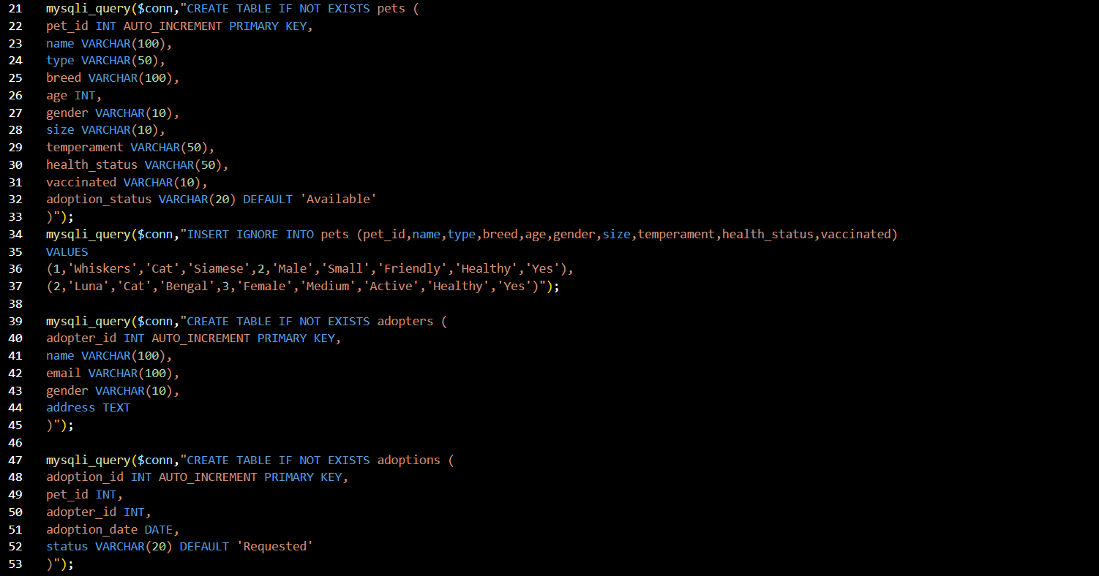
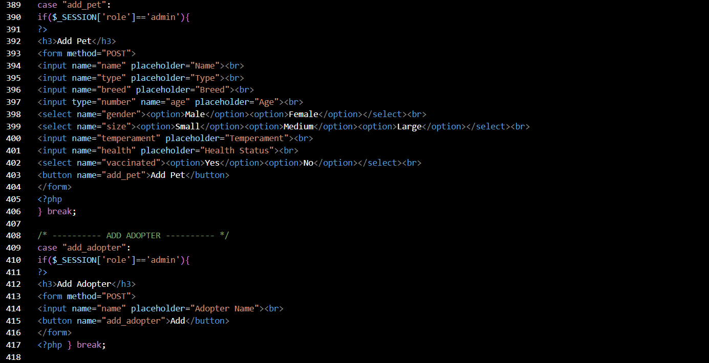
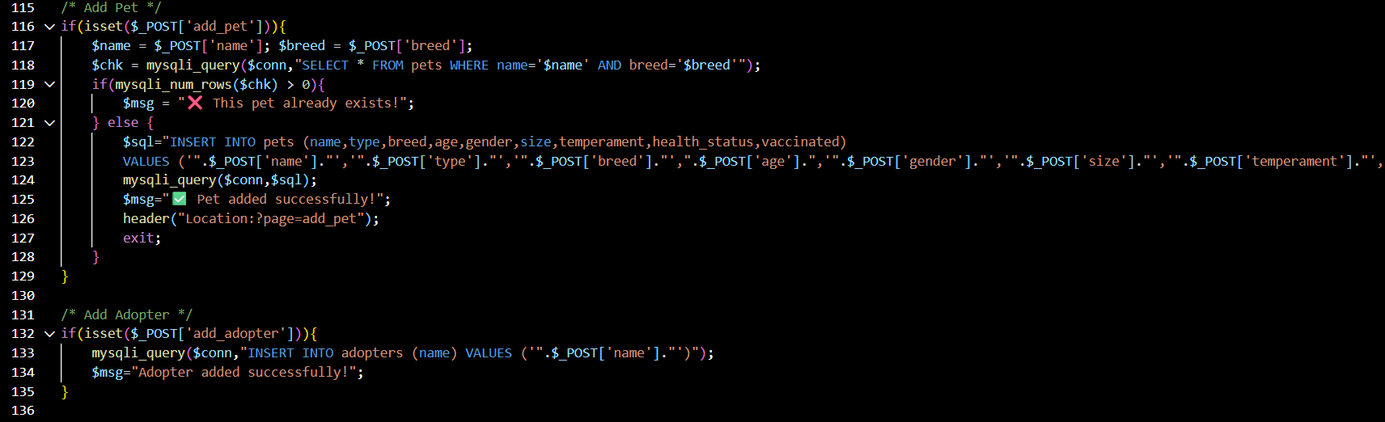
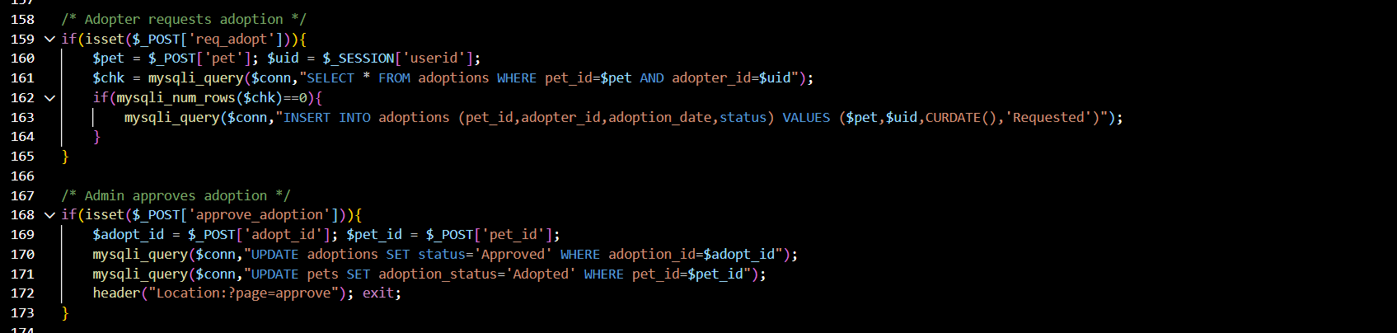
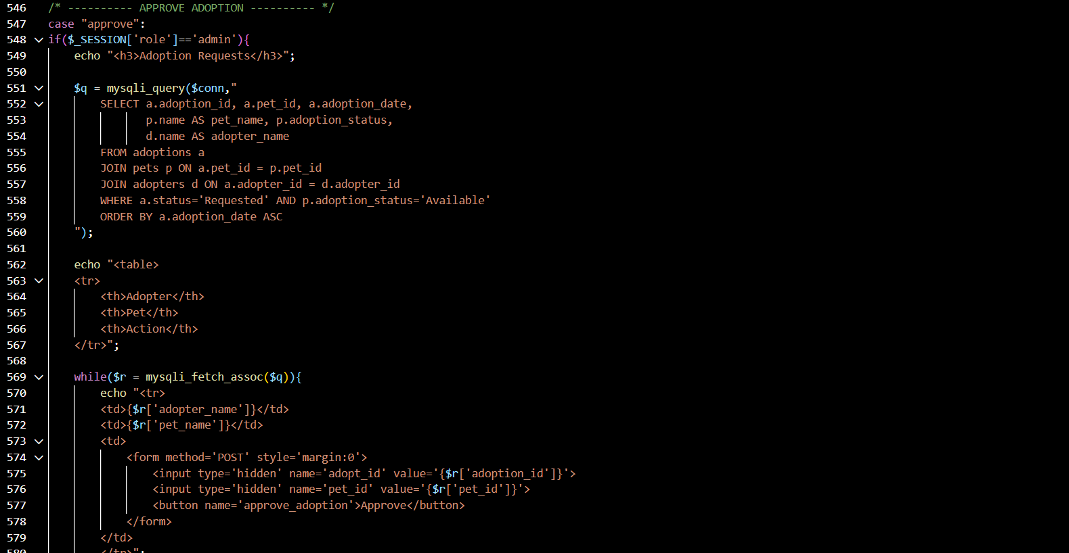
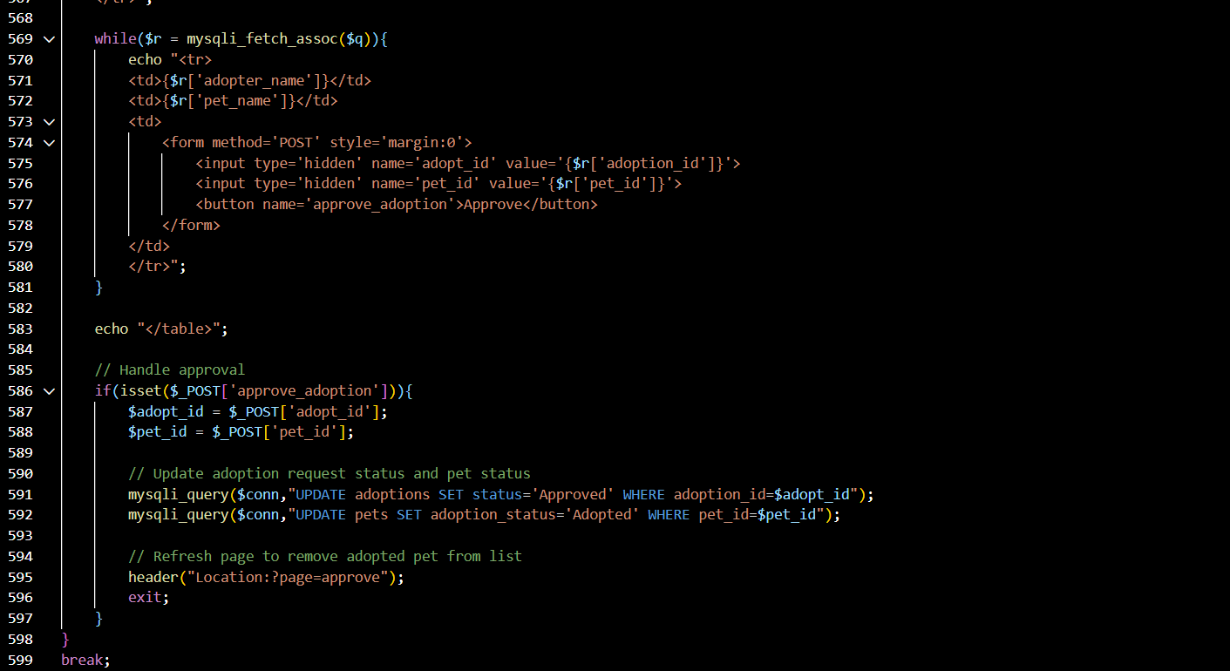
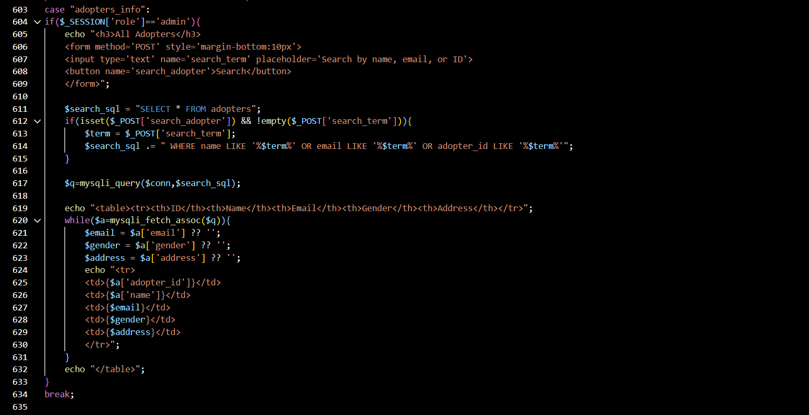
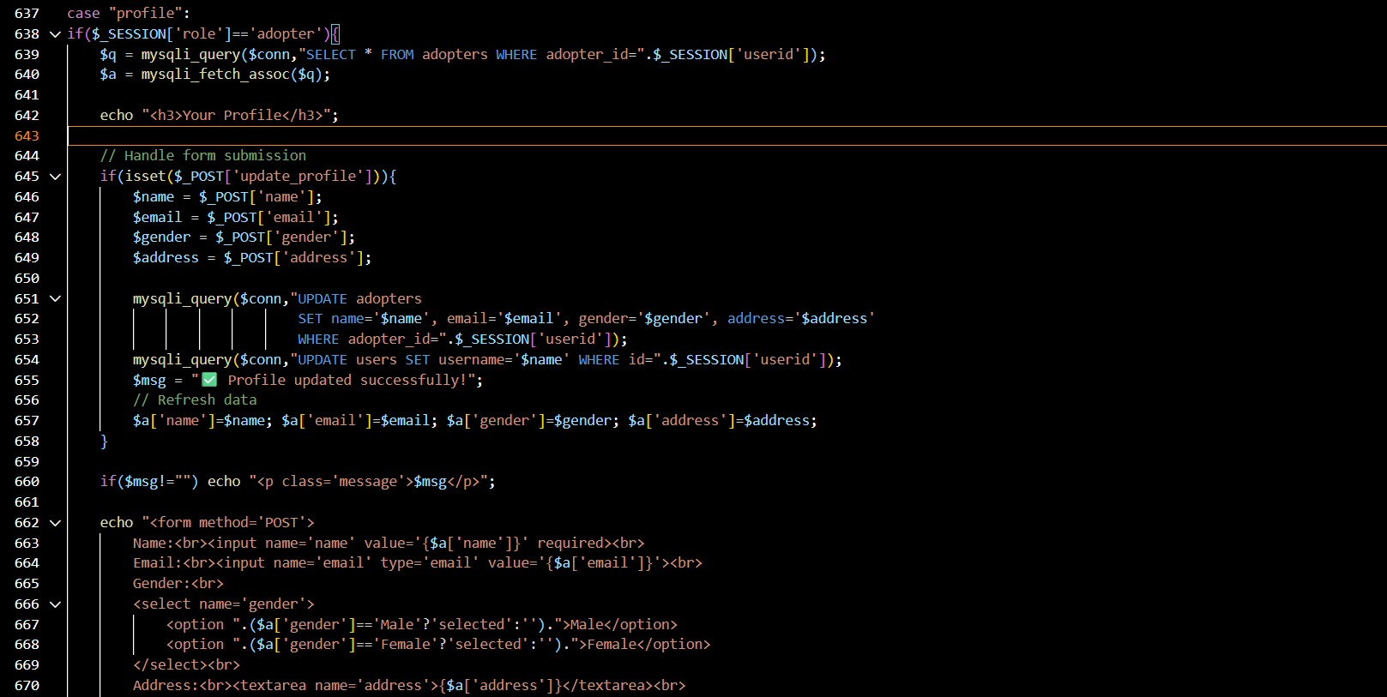
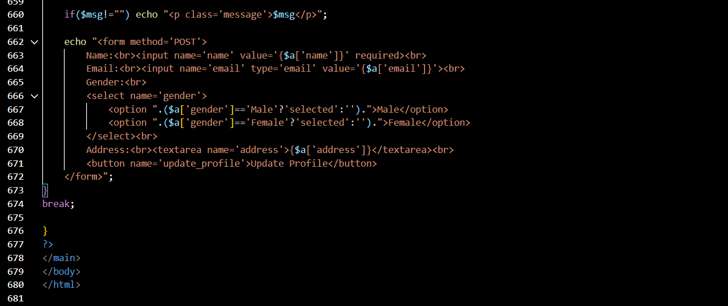

Contribution of ID : 22201793 , Name : Shajeeah Juwairiya

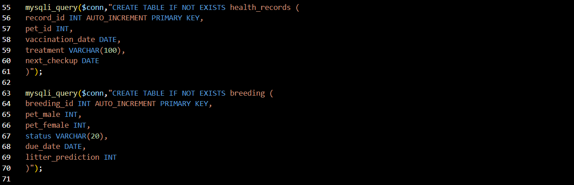
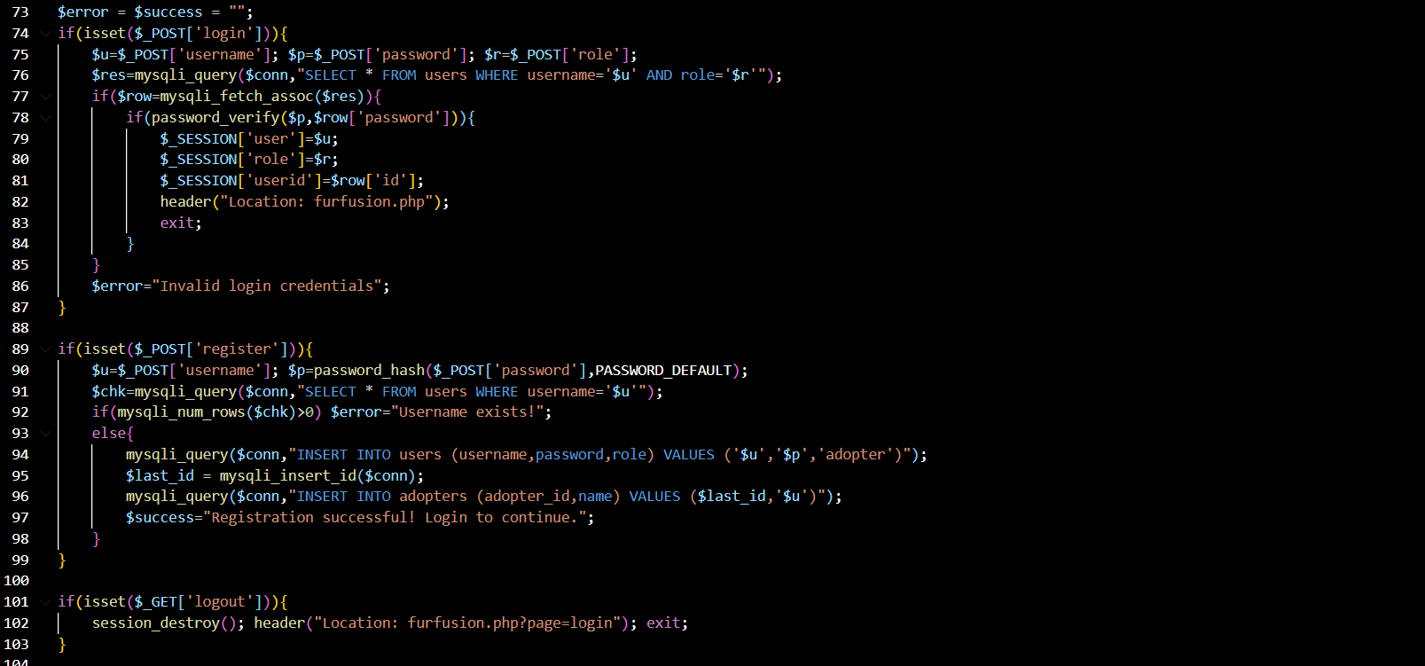
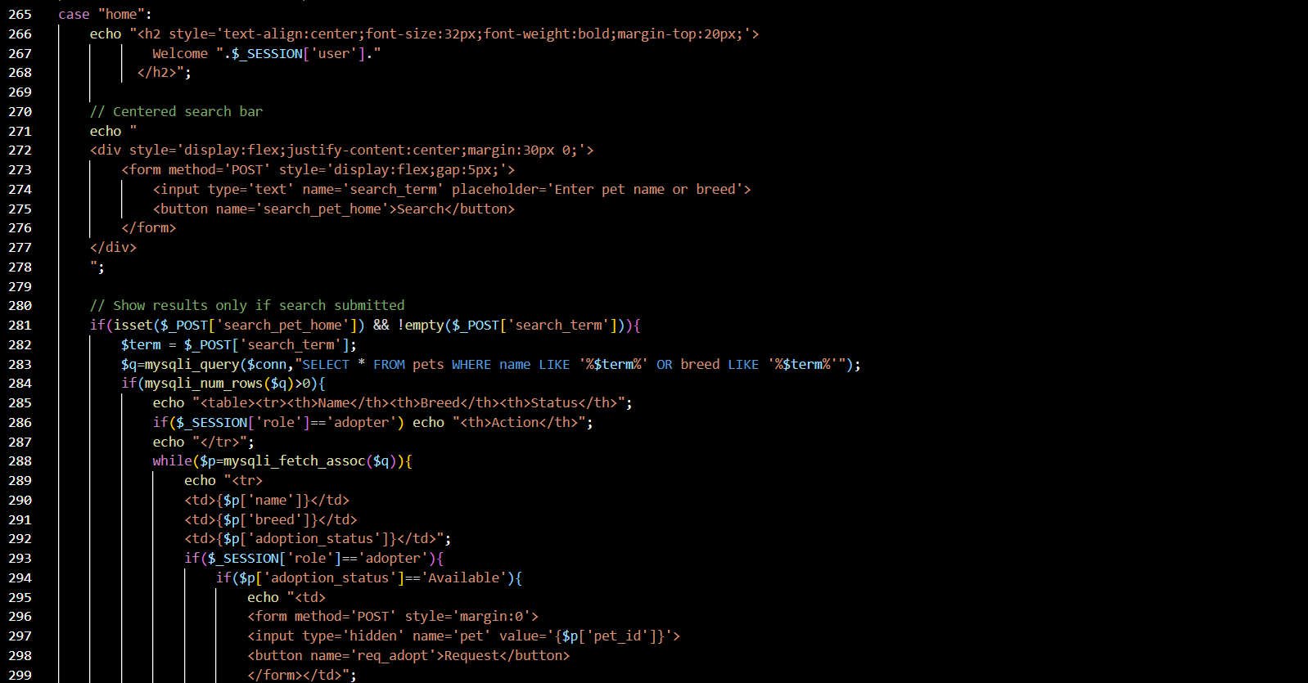
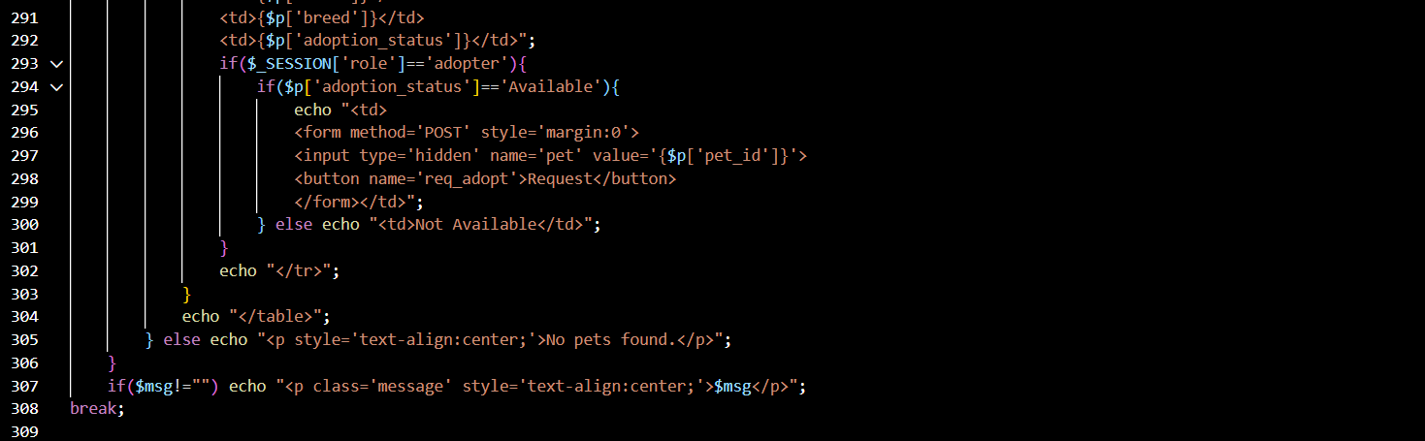
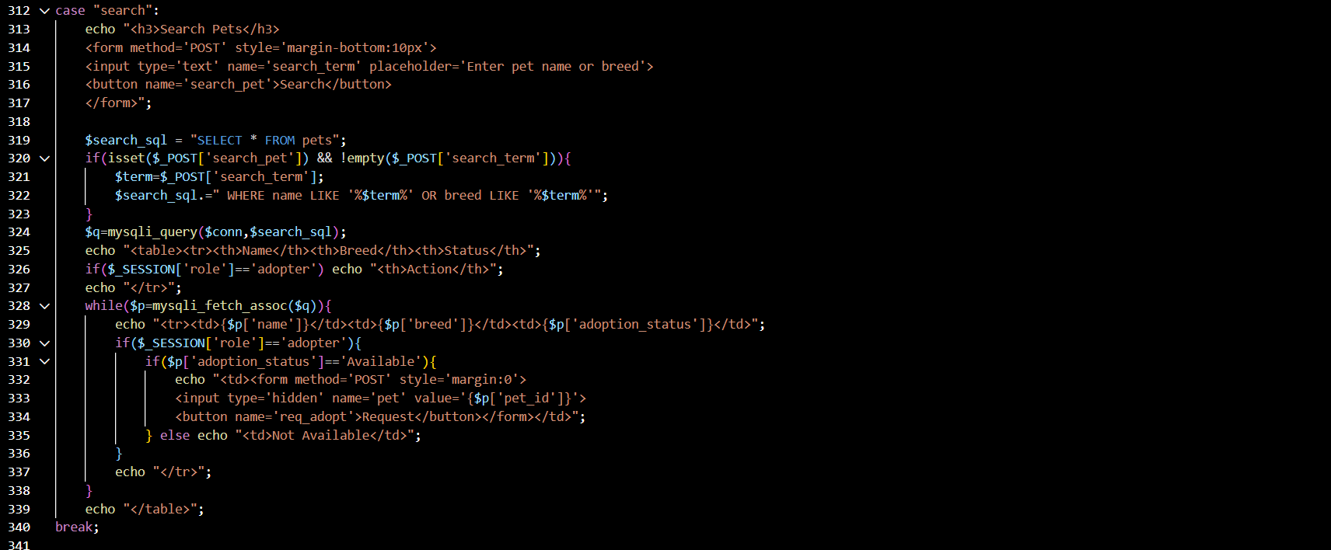
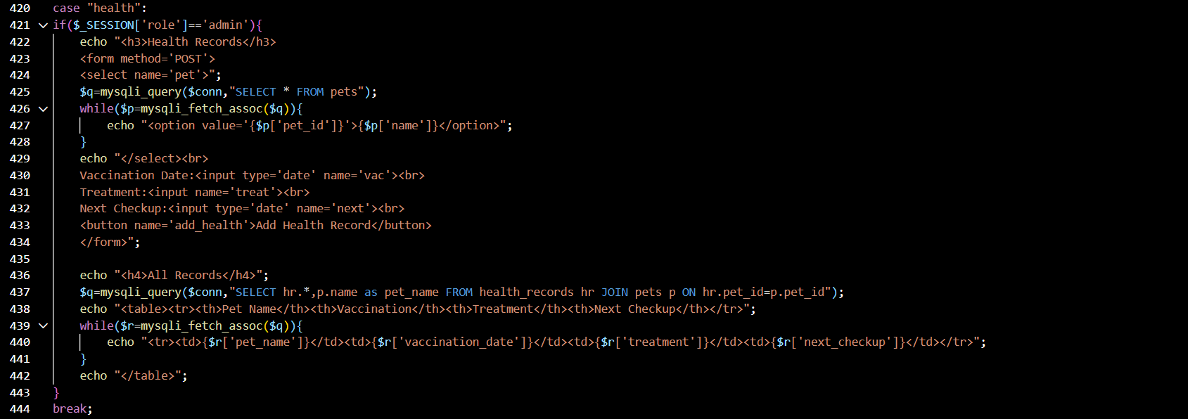
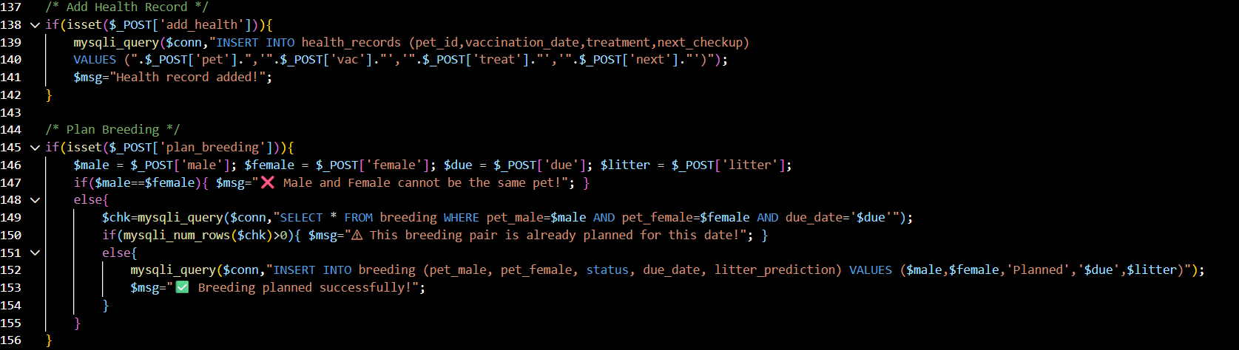
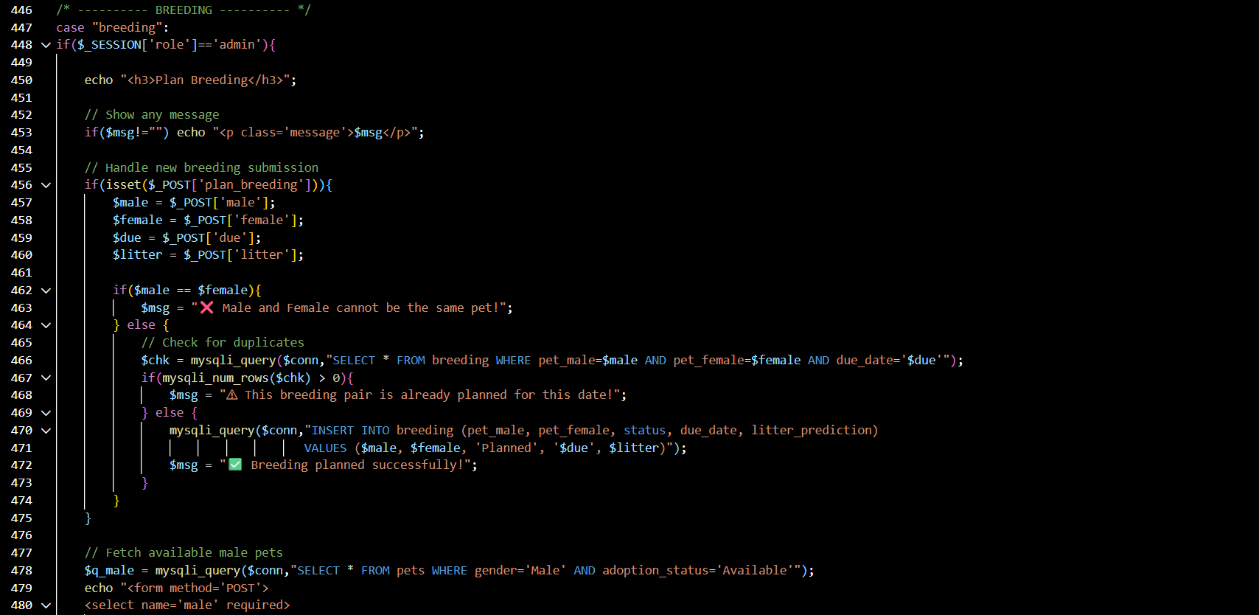
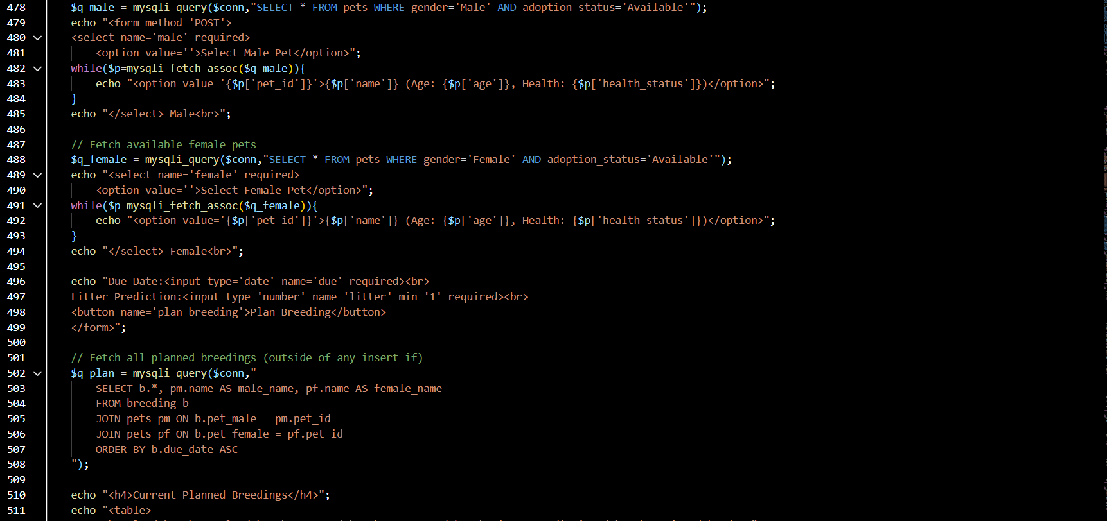
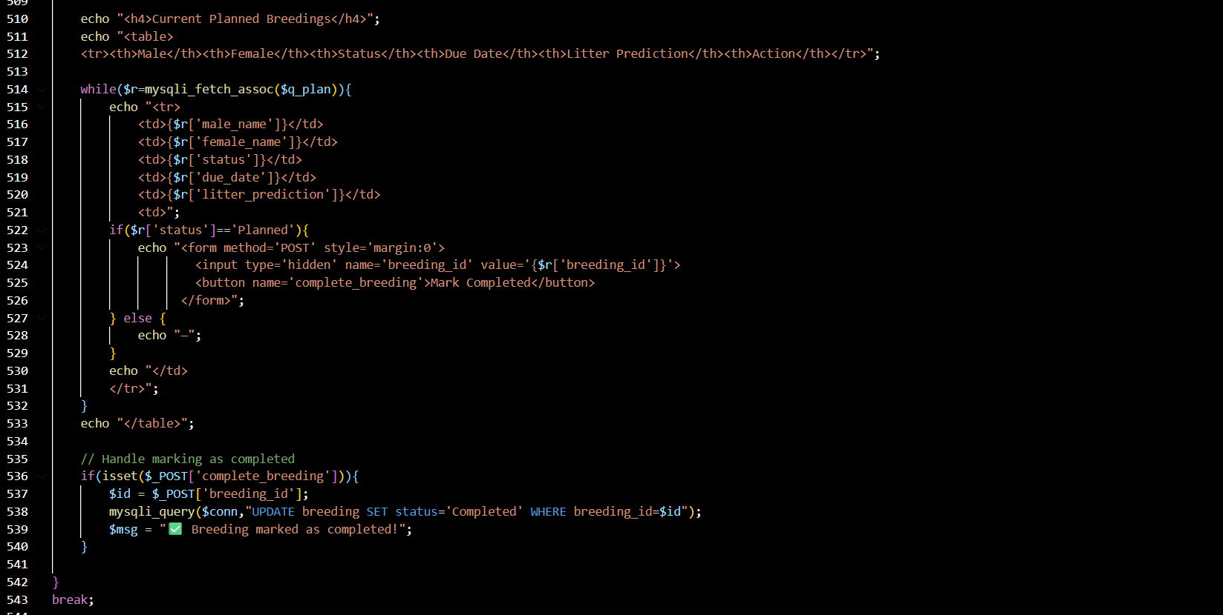

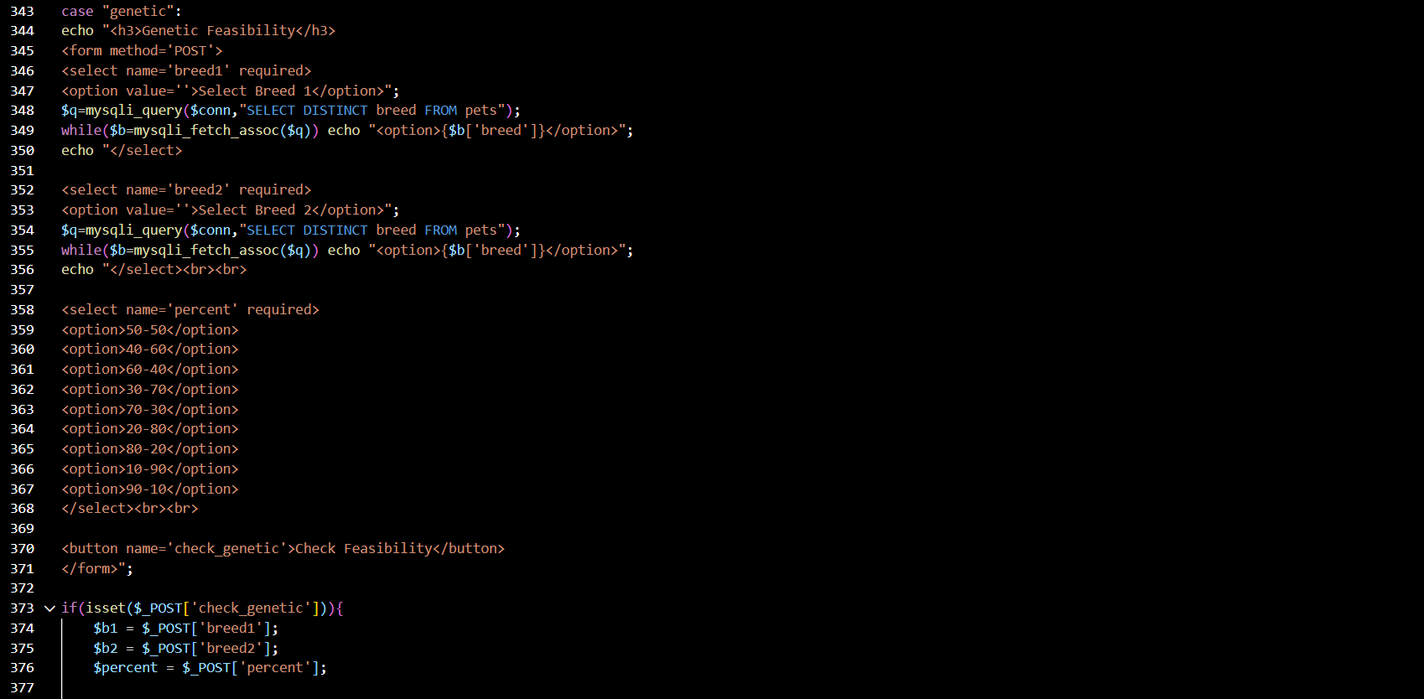
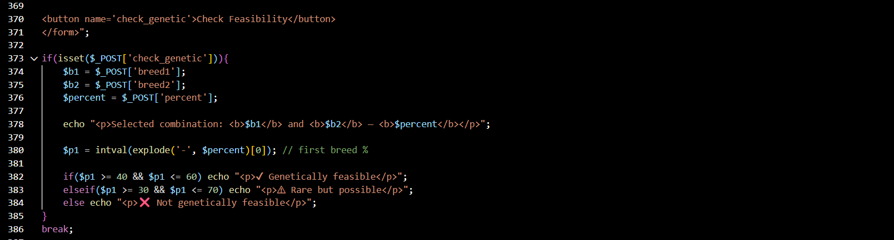

Source Code Repository

Project : FurFusion

Conclusion

To conclude, FurFusion – Intelligent Pet Adoption & Breeding Management System provides a centralized and efficient platform for managing pet adoption, health records, breeding activities, and adopter information. By integrating intelligent search, adoption tracking, health monitoring, and genetic feasibility checking, the system enhances responsible pet adoption and breeding practices.
Overall, FurFusion offers a practical and user-friendly solution that supports effective and ethical pet management.

