Lab 3 ai

L=[]

num=0

inp=1

while(inp!=0):

st=input("Enter your string: ")

pos= int (input("Enter position: "))

L.insert(pos,st)

inp= int (input("Do you want to continue: 0 for break and 1 to continue"))

print(L)

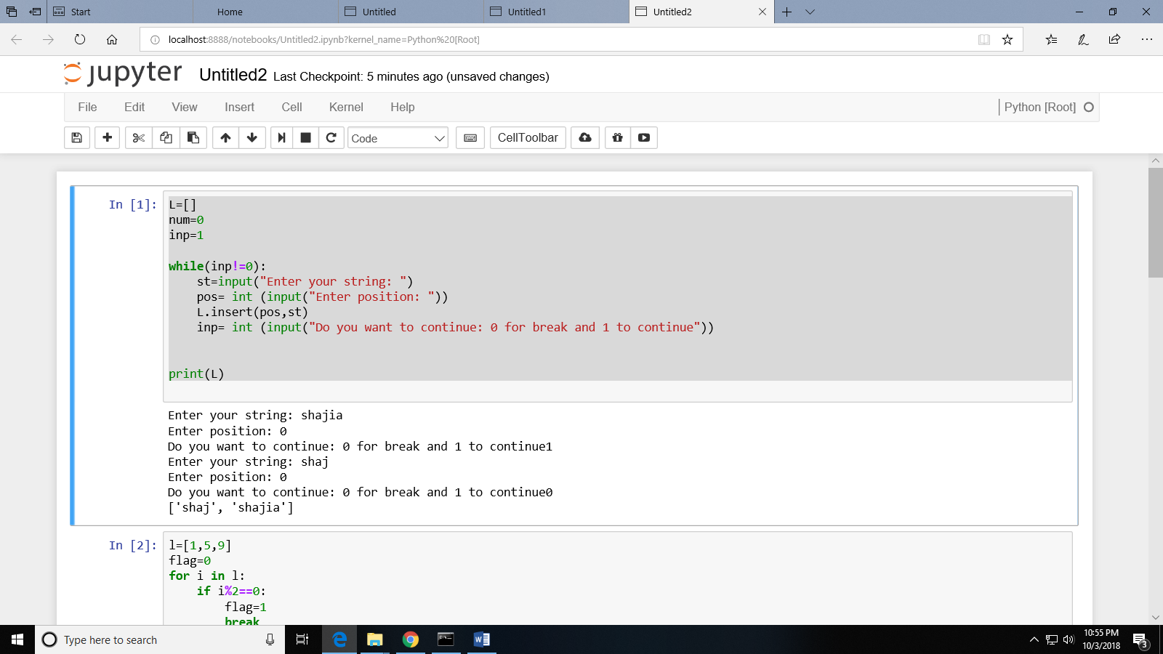

2:

l=[1,5,9]

flag=0

for i in l:

if i%2==0:

flag=1

break

if (flag==1):

print("even")

else:

print("odd")

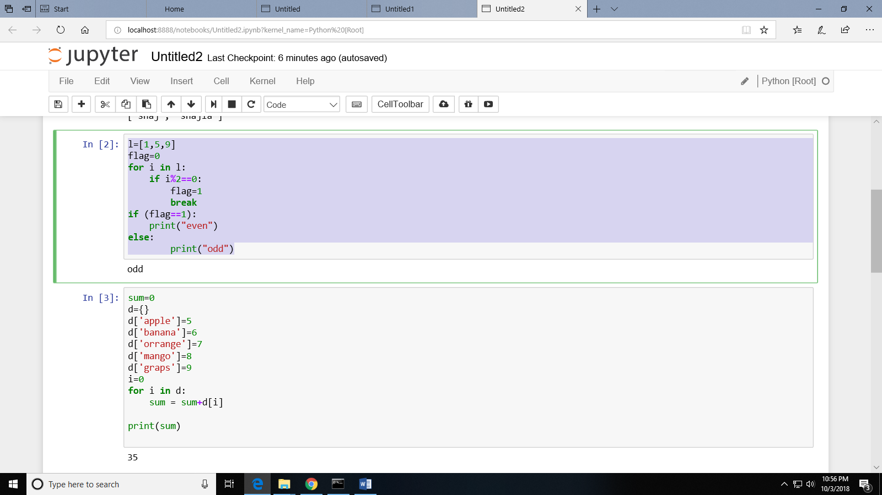

3:

sum=0

d={}

d['apple']=5

d['banana']=6

d['orrange']=7

d['mango']=8

d['graps']=9

i=0

for i in d:

sum = sum+d[i]

print(sum)

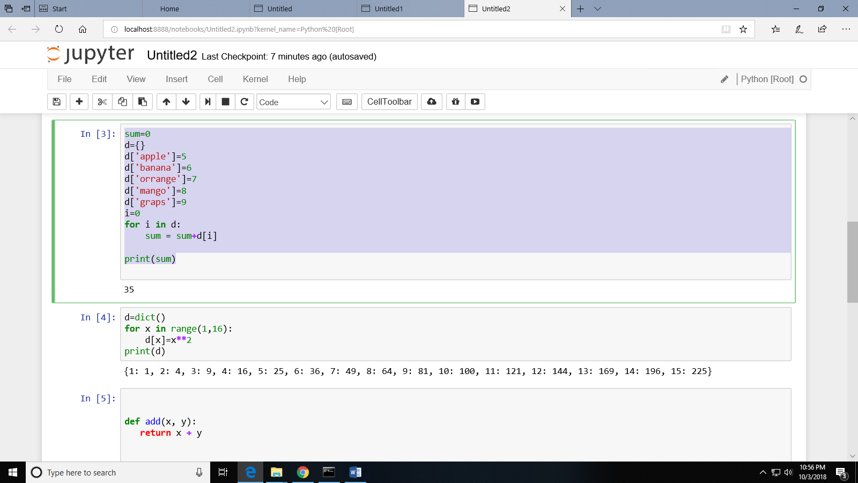

4:

d=dict()

for x in range(1,16):

d[x]=x\*\*2

print(d)

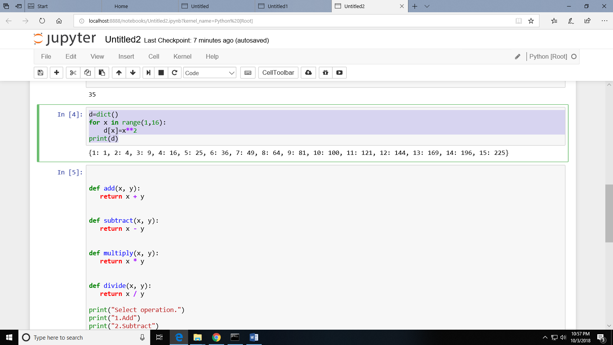

5:

def add(x, y):

return x + y

def subtract(x, y):

return x - y

def multiply(x, y):

return x \* y

def divide(x, y):

return x / y

print("Select operation.")

print("1.Add")

print("2.Subtract")

print("3.Multiply")

print("4.Divide")

choice = input("Enter choice(1/2/3/4):")

num1 = int(input("Enter first number: "))

num2 = int(input("Enter second number: "))

if choice == '1':

print(num1,"+",num2,"=", add(num1,num2))

elif choice == '2':

print(num1,"-",num2,"=", subtract(num1,num2))

elif choice == '3':

print(num1,"\*",num2,"=", multiply(num1,num2))

elif choice == '4':

print(num1,"/",num2,"=", divide(num1,num2))

else:

print("Invalid input")

