***Homework 1***

Shajiah Amin

X500: amin0081

February, 10th, 2015

**B. (15 Points) Chapter 1**

1. *(5 Points) ​List three advantages of using DBMS compared to using File System to store your data.* 
   1. Concurrent access: multiple users are allowed to use the same tables at the same time.
   2. Efficient Data access: through indexing and query optimization techniques.
   3. Data integrity and security: The DBMS enforces the integrity constraints and access control
2. *(10 Points) ​What are the six steps in designing DBMS?*
   1. Requirement Analysis: discussion about the requirements. Understand the requirements to see how different entities relate to each other and what operations will be performed frequently.
   2. Conceptual database design: Develop a high level description of the data by making an ER model to get the semantics of the data.
   3. Logical database design: Convert the ER model into data.
   4. Scheme refinement: identify potential problems in the schema design.
   5. Physical database design: study the expected workload of the system and improve the performance by building indexes and clustering tables.
   6. Application and security design: Decide what parts of the database is accessible and who is able to access those parts.

**C. (80 Points) Chapter 2**

1. *​(20 points, 5 points each) Imagine you are designing a Database for an Auction House. The Database will contain information about its Customers (identified uniquely by customer id/custid) and the Products they bought (identified uniquely by product id/pid). For simplicity, each transaction will be time-stamped each day (identified by date id/did). For each situation below, draw an ER diagram that describes it.*
2. *We want to keep track only the last time each customer buy a specific product. For example, Customer A bought Product B twice in one day. We will only keep track the last transaction.*

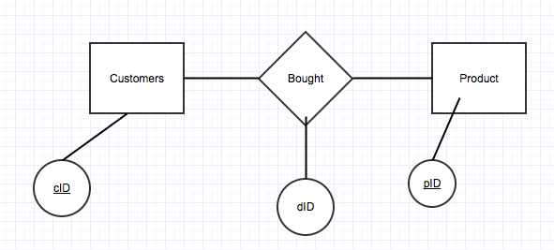

1. *We want to keep the history of all transactions information made by each customer. For example, Customer A bought Product B twice in one day. We will keep track both transactions.*

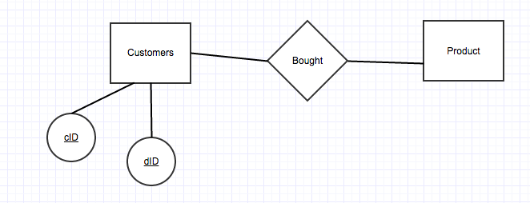

1. *Every customer must buy at least one product and we want to keep track all transactions.*

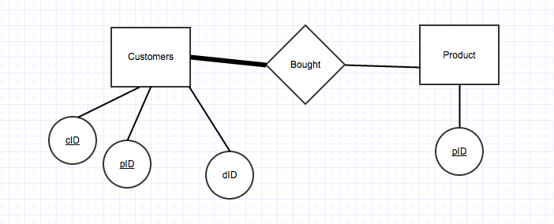

1. *Every customer must buy exactly one product every day and each product can only be bought by at most one customer. We want to keep track all transactions.*

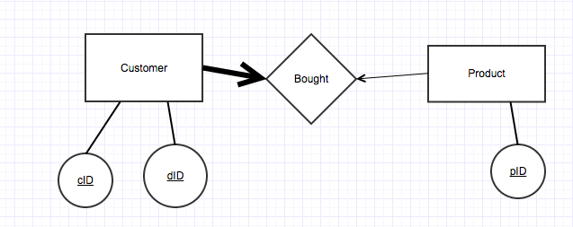

1. *(20 Points) ​You and a group of friends have a new idea for a start-up company: an Internet meta-bookstore. This site will query the site of many bookstores on the Web and give you a consolidated listing of books and prices. You are in charge of creating the database design for the meta-bookstore. Your model should capture the following information. Books have a name, one or more authors, exactly one publisher, and are identified by their ISBN. A publisher may publish several books; the same holds for authors. In addition, books are organized into categories, which form a hierarchy (e.g., “Business & Investing” > “Marketing & Sales” > “Advertising” or “Business & Investing” > “Marketing & Sales” > “Marketing”). A category cannot have more than one parent category. Each book may belong to several categories. You may assume authors, publishers, and categories are identified by their names. Draw an ER Diagram that captures the information above. If there are any constraints your ER Diagram cannot capture, state them explicitly.*

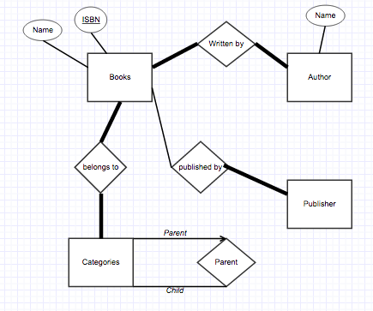

1. *(20 points) The university is having trouble in keeping track its professor and their grad students! It needs to know the basic information about their Professors (identified by SSN, with salary and phone as attributes), Departments (identified with dno, with name and budget as attributes), and Grad Students (with name and year as attributes). Each department has a professor as its chair. Each grad students must be identified uniquely by their name when their advisor (who is a professor, assume that each grad student only has one advisor) is known. Draw an ER Diagram that captures the information above.*

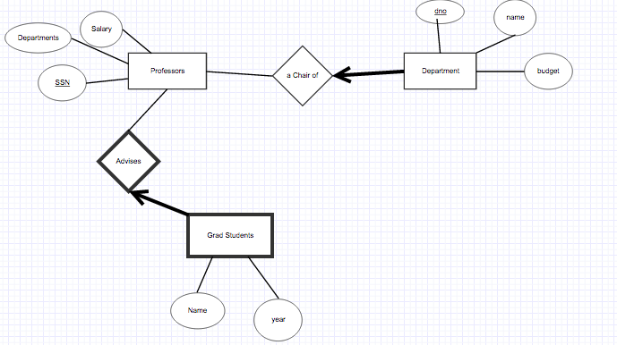

1. *(20 points) There are two types of employees (identified by SSN and has a union member number as its attribute). The first type of employee is a technician (it has specific attributes of name, salary, address and phone number) and the other type of employee is traffic controller (it has a specific attribute of exam date). - Each technician is an expert on at least one specific Model (identified by model number, and has capacity and weight as its attribute). An example of a Model is Boeing 787. - A Plane (identified by registration number) is exactly of a model. For example, Delta DL112 is a Boeing 777 model. - Each plane must be tested regularly with a certain test (identified by FAA Number, and has name and score in its attributes). We want to keep track the last test result of each plane with a specific test (the date of the test, how many hours to do it, and the score of the test).*

