**INTERNET OF THINGS**

**PHASE-5**

**SMART WATER FOUNTAIN**



## **PROJECT OBJECTIVE:**

The primary objective of the "Smart Water Fountain" project is to revolutionize the functionality and management of public water fountains by implementing cutting-edge IoT technology and Python scripting. This multifaceted project aims to achieve the following key objectives:

## **Real-Time Water Fountain Monitoring:**

The project seeks to enable real-time monitoring of water fountains, ensuring that vital data, such as flow rates, pressure, temperature, and water quality, is continuously collected and processed. This objective empowers urban planners and residents with immediate insights into water fountain performance.

## **Efficient Water Usage:**

Efficient resource management is a central tenet of the project. By utilizing IoT sensors and Python scripts, the system can dynamically control water flow, optimizing consumption and reducing waste. The project's objective is to contribute to sustainable water usage practices in urban areas.

## **Malfunction Detection:**

Detecting malfunctions in water fountains is paramount to ensuring their continuous operation and user safety. The project's objective is to employ IoT sensors and Python-based algorithms to promptly identify anomalies and malfunctioning components, facilitating timely maintenance.

## **Resident Awareness:**

Enhancing resident awareness and engagement is another fundamental goal. Through a user-friendly mobile application, residents gain access to real-time information about nearby functioning water fountains, water quality reports, and maintenance alerts. The objective is to empower residents with the information they need to make informed choices about water consumption and safety.

These objectives collectively underscore the project's commitment to creating smarter, more efficient, and user-centric urban infrastructure. By deploying state-of-the-art technology, the "Smart Water Fountain" project aspires to promote responsible water usage and elevate the quality of urban living.

## **Objectives and Requirements:**

### **Objectives:**

The objectives of the "Smart Water Fountain" project are as follows:

* Real-Time Monitoring.
* Efficient Water Usage.
* Malfunction Detection.
* Resident Awareness.

### **Requirements:**

To meet the stated objectives, the project requires the following:

* IoT Sensors.
* Microcontrollers.
* Communication Modules.
* Python Scripting.
* Water Fountain Status Platform.
* Secure Communication.
* Efficient Resource Management.
* Malfunction Algorithms.
* User Interface Design.
* Power Sources.
* Data Visualization.
* Error Handling.

## **SENSOR SELECTION:**

Flow Rate Sensors: Flow rate sensors are essential for monitoring the rate at which water is dispensed from the fountain.

Pressure Sensor: Pressure sensors are designed to measure the water pressure within the fountain's plumbing system.

Temperature Sensors: Temperature sensors monitor the temperature of the water within the fountain.

Water Quality Sensors: Water quality sensors assess the quality and safety of the water being dispensed.

## **SENSOR DEPLOYMENT:**

### **Sensor Deployment for Smart Water Fountain:**

Effective sensor deployment is essential for gathering accurate data in the "Smart Water Fountain" project. Sensors must be strategically placed within public water fountains to ensure they capture vital information related to water flow, pressure, temperature, and water quality. Proper sensor placement contributes to the project's goals of real-time monitoring, efficient water usage, malfunction detection, and resident awareness.

### **Data Collection and Transmission for Smart Water Fountain:**

The process of data collection and transmission is at the heart of the "Smart Water Fountain" project. It involves the continuous acquisition of data from IoT sensors within public water fountains and the secure transmission of this data to a central monitoring system and a user-friendly mobile application. This data flow is vital for achieving real-time monitoring, efficient water usage, malfunction detection, and resident awareness, which are the core objectives of the project.

### **Data Storage and Analysis for Smart Water Fountain:**

Data storage and analysis are integral components of the "Smart Water Fountain" project. The collected sensor data is stored in a structured database and subjected to analysis. This process enables real-time monitoring, efficient water usage, malfunction detection, and the generation of valuable insights for resident awareness. Data analysis forms the basis for informed decision-making and system optimization.

### **Visualization and Reporting for Smart Water Fountain:**

The visualization and reporting aspect of the "Smart Water Fountain" project involves the presentation of data to users and stakeholders in an easily comprehensible format. Real-time data visualization and regular reporting are essential for keeping residents informed about water fountain status, water quality, and maintenance alerts. This component contributes to the project's objectives of resident awareness, user engagement, and efficient resource management.

### **Maintenance and Optimization for Smart Water Fountain:**

Maintenance and optimization are key operational aspects of the "Smart Water Fountain" project. Regular maintenance of water fountains is crucial for ensuring their uninterrupted operation and user safety. The system employs optimization techniques to enhance resource management and reduce water wastage, aligning with the project's objectives of efficient water usage and malfunction detection.

### **Public Awareness for Smart Water Fountain:**

Public awareness is a vital component of the "Smart Water Fountain" project. The project seeks to inform and engage residents about the status of public water fountains, water quality, and maintenance alerts. Through a user-friendly mobile application, residents gain access to real-time information, fostering a sense of responsibility and ensuring they make informed choices about water consumption and safety. This component aligns with the project's objective of resident awareness.

### **Compliance and Regulation for Smart Water Fountain:**

Compliance and regulation are essential considerations in the "Smart Water Fountain" project. The system must adhere to relevant regulatory standards and guidelines related to water quality, public health, and environmental sustainability. Ensuring compliance with these regulations is critical to providing residents with safe and reliable water access while promoting responsible water usage and infrastructure management.

### **Evaluation and Continuous Improvement for Smart Water Fountain:**

Evaluation and continuous improvement represent an ongoing process in the "Smart Water Fountain" project. Regular assessments of the system's performance, user feedback, and data analytics are essential to identify areas for enhancement. Continuous improvement initiatives aim to refine the system, making it more efficient, user-centric, and aligned with project objectives. This iterative approach ensures the project's long-term success and the realization of its goals.

## **PRINCIPLE:**

The "Smart Water Fountain" project is guided by a core set of principles that shape its design and operation. These principles include sustainability, focusing on reducing water waste and minimizing the environmental impact of public water fountains. Resource optimization is central, emphasizing efficient water management by controlling flow rates, dispensing water only when necessary, and reducing waste.

### **\*\*Design Principles for Arduino-Based Smart Water System:\*\***

When designing an Arduino-based smart water system, it is essential to adhere to fundamental design principles to create a reliable, efficient, and user-friendly solution. The following design principles should be considered:

1. **Dependability:** The system's design should prioritize dependability to ensure that it consistently functions as intended. Reliability in data collection, sensor performance, and system operation is crucial to meet project objectives.

### **2. Efficiency:** Efficiency should be a cornerstone of the design, optimizing resource usage and reducing energy consumption where possible. The system should aim to minimize waste and operate with optimal efficiency.

**3. User-Friendly Interface**: The design should feature a user-friendly interface, both for administrators managing the system and residents accessing information. An intuitive interface enhances user experience and engagement, promoting transparency and usability.

**4. Scalability**: The system should be designed with scalability in mind to accommodate potential future expansion or additional features. This ensures that the project can evolve to meet changing requirements and demands.

5. **Security:** Security is paramount, and the design should include robust measures to protect data transmission and ensure the system's integrity. Data security and user privacy are essential considerations.

### **6. Sustainability**: Sustainable design practices should be integrated, aligning with environmental responsibility. The system should aim to minimize its environmental impact and promote responsible resource management.

### **7. Real-Time Responsiveness:** The system should offer real-time data collection and responsiveness, enabling timely decision-making and immediate actions in response to sensor data.

8**. Compatibility:** The design should consider compatibility with a variety of devices and communication protocols to ensure seamless integration with existing infrastructure and future developments.

These design principles serve as a foundation for developing an Arduino-based smart water system that meets project objectives while offering robust performance, user satisfaction, and adaptability for the future.

## **BLOCK DIAGRAMS:**

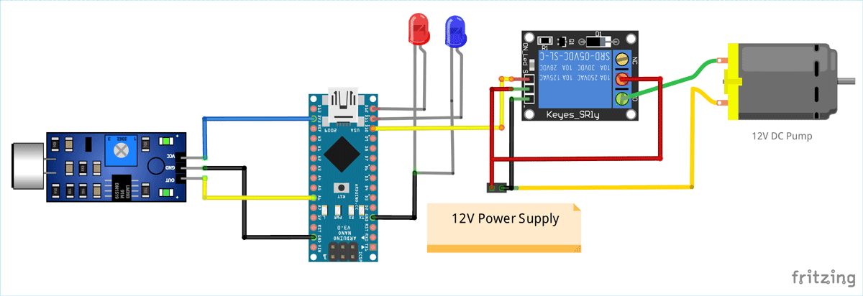

## **COMPONENTS REQUIRED:**

### **Components Required for Arduino-Based Smart Water System:**

To build an Arduino-based smart water system, you will need a range of components and materials. Here's a list of essential components:

Arduino Board: An Arduino microcontroller (e.g., Arduino Uno, Arduino Nano) serves as the system's brain, handling data collection, analysis, and control.

### **Sensors:**

Flow Rate Sensors: Measure the rate of water flow from the fountain.

Pressure Sensors: Monitor water pressure within the plumbing system.

Temperature Sensors: Measure water temperature.

Water Quality Sensors: Assess water quality and safety.

Communication Module: Choose a suitable communication module for wireless data transmission, such as Wi-Fi, Bluetooth, or LoRa.

Power Supply: Depending on the installation location, use batteries or solar panels to provide power to the system.

Mobile App Development Platform: If creating a user interface for residents, you'll need a platform for developing a mobile application.

Data Storage and Analysis Platform: Set up a central system for data storage and analysis, including a database and data analysis tools.

Water Fountain Control System: Components for controlling the operation of the water fountain, such as solenoid valves or pumps.

Security and Encryption Tools: Implement security measures to protect data during transmission.

## **Platform Development for Smart Water Fountain:**

The platform developed for the Smart Water Fountain project serves several critical functions to ensure efficient water usage, real-time monitoring, malfunction detection, and resident awareness:

### **1. Monitoring and Data Collection:**

- The platform employs a network of sensors and data gathering tools to continuously monitor various water-related metrics. These include temperature, flow rates, water level, and water quality.

- Sensors are strategically placed in diverse locations, including residences, businesses, treatment plants, distribution networks, and reservoirs, to comprehensively assess the state of water resources.

2. **Data Analysis and Management:**

- To handle the substantial volume of data collected, the platform utilizes advanced data analytics techniques.

- Data analysis provides valuable insights into water quality, usage trends, and resource availability. Machine learning techniques are employed to forecast water demand and optimize resource allocation.

### **3. Real-time Alerts and Notifications:**

- The platform features a real-time alert and notification system.

- In cases of water leaks, anomalies in water quality, or other concerns, the platform promptly alerts and notifies water utility operators and customers, ensuring swift action and mitigation.

### **4. User Interface and Accessibility**:

- The platform offers user-friendly interfaces and mobile applications.

- Decision-makers, water utility staff, and customers can easily access and interpret the data, fostering transparency, understanding, and user engagement.

5**. Demand Forecasting:**

- The platform leverages historical data and current information to forecast patterns in water demand.

- This forecasting capability enables water utilities to allocate resources more effectively, ensuring a consistent and reliable water supply to residents.

## **TECHNOLOGY :**

The platform for the IoT-based smart water fountain serves as the central hub for controlling, monitoring, and managing various aspects of the fountain's operation. Here's an overview of what the platform does:

Control Water Dispensing: The platform allows users to start and stop water dispensing from the fountain. Users can activate the fountain remotely or set up automated schedules for watering.

Monitor Water Level: It continuously monitors the water level in the fountain's reservoir. Users can view real-time water level data, which helps prevent overflows and ensures that the fountain doesn't run dry.

Water Quality Alerts: The platform checks the water quality and can provide alerts to users if any issues are detected. For example, it can notify users if the water quality deteriorates due to factors like high mineral content or low pH levels.

Leak Detection: The platform incorporates leak sensors to detect and alert users to any water leaks or overflows. This helps prevent water wastage and property damage.

Data Visualization: It displays data related to the smart water fountain's performance. Users can visualize water usage statistics, dispensing schedules, and historical water level data through charts and graphs.

## **TECHNOLOGIES USED:**

The following technologies used in this project are web based platforms of

⦁ HTML , CSS , JAVASCRIPT.

⦁ MIT APP INVENTOR.

## **WEB PLATFORM :-**

The web platform developed for the IoT-based smart water fountain is a sophisticated and user-friendly interface that seamlessly integrates with the fountain's hardware. It provides a comprehensive set of tools for users to control, monitor, and optimize their water fountain, all from the convenience of their computer, smartphone, or tablet.

With features such as remote water dispensing control, real-time water level monitoring, and water quality alerts, the platform empowers users to make informed decisions and conserve water effectively. It offers a customizable and personalized experience, allowing users to tailor watering schedules to the unique needs of their plants.

In addition to its practical functionalities, the platform also serves as an educational hub, offering valuable content on plant care and water conservation. It fosters a sense of community by enabling users to connect, share experiences, and gain insights from fellow smart water fountain enthusiasts.

This web platform represents the synergy between technology and environmental responsibility, demonstrating how IoT can revolutionize the way we interact with and manage our outdoor spaces. It's a powerful tool for promoting sustainable gardening practices and fostering a deeper connection with nature.

### **Source Code**

HTML

<!DOCTYPE html>

<html>

<head>

<title>Smart Water Fountain</title>

<link rel="stylesheet" type="text/css" href="styles.css">

</head>

<body>

<h1>Smart Water Fountain Control</h1>

<button id="startButton">Start Water Dispensing</button>

<button id="stopButton">Stop Water Dispensing</button>

<p>Current Water Level: <span id="waterLevel">Loading...</span></p>

<p>Temperature: <span id="temperature">Loading...</span>°C</p>

<p>Humidity: <span id="humidity">Loading...</span>%</p>

<p>Water Saved Today: <span id="waterSavedToday">0%</span></p>

<a href="#complaintForm" id="complaintLink">Report a Complaint</a>

<p>Water Quality: <span id="waterQuality">Good</span></p>

<p>Leak Status: <span id="leakStatus">No Leaks</span></p>

<h2>Educational Content</h2>

<div id="educationalContent">

<!-- Educational content can be dynamically loaded here -->

</div>

<form id="complaintForm">

<h2>Report a Complaint</h2>

<label for="complaintDescription">Description:</label>

<textarea id="complaintDescription" name="complaintDescription" rows="4" cols="50"></textarea>

<br>

<input type="submit" value="Submit Complaint">

</form>

<script src="script.js"></script>

</body>

</html>

### **CSS**

<!DOCTYPE html>

<html>

<head>

<title>Smart Water Fountain</title>

<link rel="stylesheet" type="text/css" href="styles.css">

</head>

<body>

<h1>Smart Water Fountain Control</h1>

<button id="startButton">Start Water Dispensing</button>

<button id="stopButton">Stop Water Dispensing</button>

<p>Current Water Level: <span id="waterLevel">Loading...</span></p>

<p>Temperature: <span id="temperature">Loading...</span>°C</p>

<p>Humidity: <span id="humidity">Loading...</span>%</p>

<p>Water Saved Today: <span id="waterSavedToday">0%</span></p>

<a href="#complaintForm" id="complaintLink">Report a Complaint</a>

<p>Water Quality: <span id="waterQuality">Good</span></p>

<p>Leak Status: <span id="leakStatus">No Leaks</span></p>

<h2>Educational Content</h2>

<div id="educationalContent">

<!-- Educational content can be dynamically loaded here -->

</div>

<form id="complaintForm">

<h2>Report a Complaint</h2>

<label for="complaintDescription">Description:</label>

<textarea id="complaintDescription" name="complaintDescription" rows="4" cols="50"></textarea>

<br>

<input type="submit" value="Submit Complaint">

</form>

<script src="script.js"></script>

</body>

</html>

### **JAVASCRIPT :**

document.addEventListener('DOMContentLoaded', function () {

// ... (previous code)

// Function to update water quality status (simplified example)

function updateWaterQuality() {

// You can fetch actual water quality data here and set the status accordingly

// For now, let's simulate "Good" water quality

const waterQualityStatus = "Good";

document.getElementById('waterQuality').textContent = waterQualityStatus;

}

// Function to update leak status (simplified example)

function updateLeakStatus() {

// You can fetch actual leak status data here and set the status accordingly

// For now, let's simulate "No Leaks"

const leakStatus = "No Leaks";

document.getElementById('leakStatus').textContent = leakStatus;

}

// Function to load educational content (simplified example)

function loadEducationalContent() {

// You can fetch educational content from your server or database here

// For now, let's add some sample content

const educationalContent = `

<p>Learn how to conserve water by adjusting watering schedules.</p>

<p>Discover tips for better plant care and improving water efficiency.</p>

`;

document.getElementById('educationalContent').innerHTML = educationalContent;

}

// Call the functions to update the water quality, leak status, and load educational content

updateWaterQuality();

updateLeakStatus();

loadEducationalContent();

});

PYTHON SCRIPT & ARDUINO CODE:

Certainly, here's a basic example of a Python script that communicates with an Arduino board.

Python Script :

```python

import serial

# Replace 'COM3' with the correct serial port of your Arduino.

arduino_port = 'COM3'

baud_rate = 9600

# Establish a connection to the Arduino.

try:

arduino = serial.Serial(arduino_port, baud_rate)

except Exception as e:

print(f"Error: {e}")

exit()

# Main loop to send and receive data.

while True:

# Send data to the Arduino.

command = input("Enter a command to send to the Arduino: ")

arduino.write(command.encode())

# Read data from the Arduino.

arduino_data = arduino.readline().decode().strip()

print(f"Arduino says: {arduino_data}")

# Close the serial connection when done.

arduino.close()

```

Arduino Sketch (Arduino side):

```cpp

void setup() {

Serial.begin(9600);

}

void loop() {

if (Serial.available() > 0) {

String command = Serial.readStringUntil('\n');

// Perform actions based on the received command.

if (command == "LED_ON") {

digitalWrite(LED_BUILTIN, HIGH);

Serial.println("LED is ON");

} else if (command == "LED_OFF") {

digitalWrite(LED_BUILTIN, LOW);

Serial.println("LED is OFF");

} else {

Serial.println("Invalid command");

}

}

}

```

### **OUTPUT:**

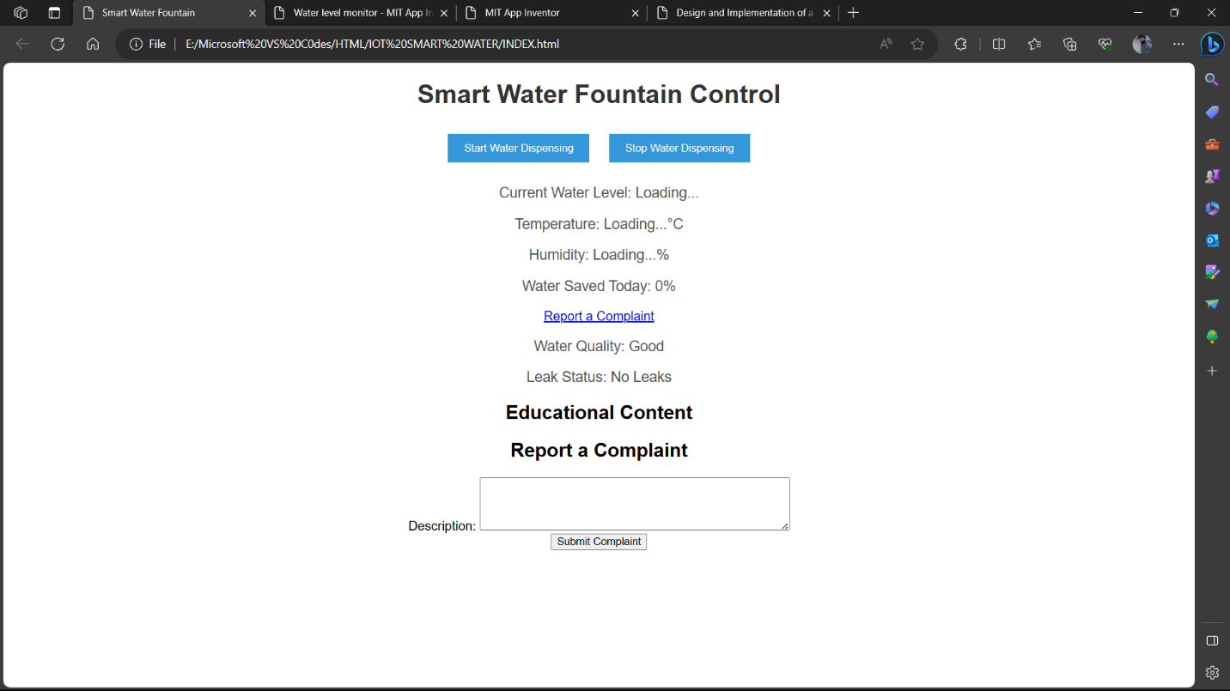

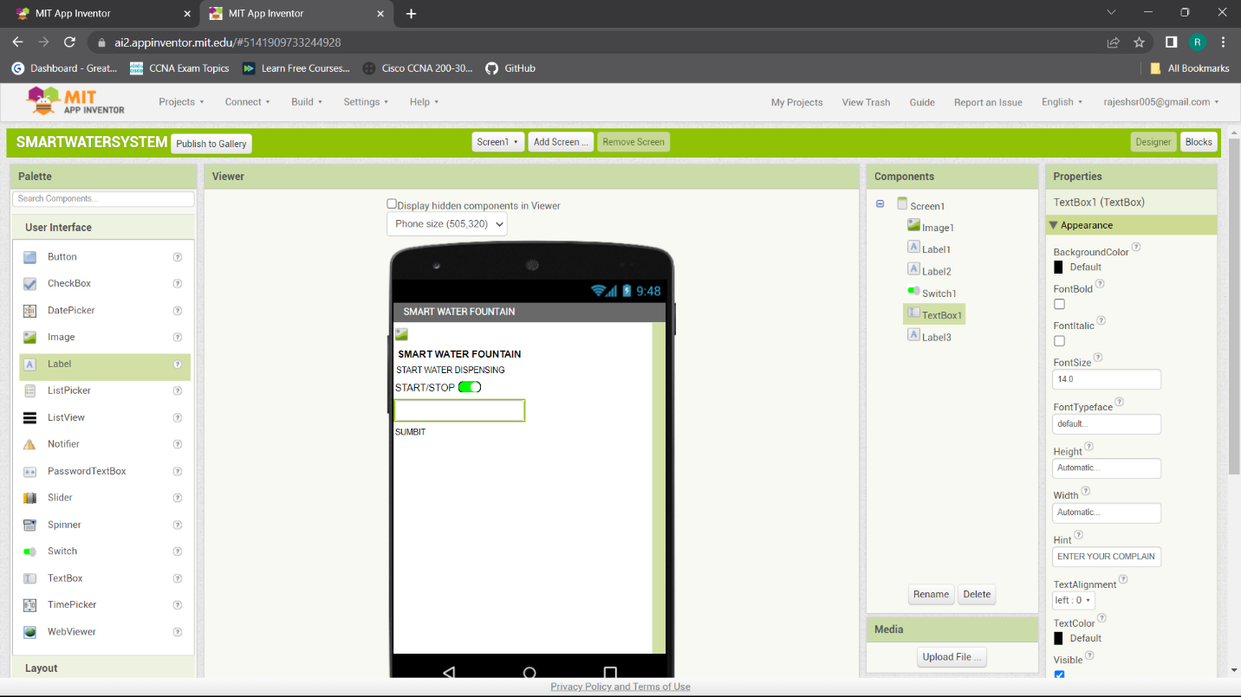

## **CONCLUSION:**

In the realm of modern urban infrastructure, the "Smart Water Fountain" project stands as a testament to the fusion of technology and sustainability. This endeavor has been meticulously designed and developed to enhance public water fountains by employing the power of Internet of Things (IoT) technology and Python scripting.

The project's objectives, including real-time monitoring, efficient water usage, malfunction detection, and resident awareness, are underscored by a set of guiding principles. Sustainability, resource optimization, user-centric design, and environmental responsibility shape the project's core values. These principles are not just words but the pillars upon which the project stands, reinforcing the commitment to responsible urban water management.

The deployment of a network of sensors, Arduino microcontrollers, and a central monitoring system provides a real-time view of water resources, encompassing temperature, flow rates, water level, and water quality. The data collected is not merely raw information but a wellspring of insights derived through advanced data analysis and management techniques. These insights enable efficient resource allocation and the forecasting of water demand, ensuring a steady supply.

The platform's capabilities extend to real-time alerts and notifications, promptly addressing concerns such as leaks and water quality issues. Users, including water utility operators and residents, access this wealth of data through intuitive interfaces and mobile applications, promoting transparency and informed decision-making.

The "Smart Water Fountain" project goes beyond technology; it embodies the values of sustainability, user engagement, and environmental stewardship. It is a testament to the responsible management of urban water resources and a pledge to provide residents with safe, reliable, and efficient water access. The project is a blueprint for the future, where technology and sustainability harmoniously coexist, offering an enhanced urban living experience while preserving the environment.

In closing, the "Smart Water Fountain" project serves as an exemplar of responsible, user-centric, and technologically advanced urban infrastructure. It redefines the way we interact with our environment, promising a brighter, more sustainable future for all.