Question 1 (AA1, AA2): *14 marks*  
a. Select 2 game engines *(1 mark)* and list 4 reasons *(1.5 marks each)*  
why one particular game engine was selected (giving advantages of  
the game engine) and why the other was not selected.  
*7 marks*

Unity vs Unreal:

1. Unity is easier to use for beginners

2. unity caters better for 2D games

3. unity is better for people who wish to be more involved with coding and not design

4. unity provides the user with a larger asset store (more sounds, more animations etc to implement in games)

<https://www.pluralsight.com/blog/film-games/unreal-engine-4-vs-unity-game-engine-best>

b. Select 2 programming languages *(1 mark)* used in game  
development and choose one to support the game engine chosen  
and list 4 of its features *(1.5 marks each)*  
*7 marks*

Csharp(C#) supports Unity game engine, Python for game development.

Csharp features:

1. Makes use of visual studio IDE

2. provides developers with the ability to create console apps, windows apps along with web apps

3. csharp is capable of producing efficient programs(programs able to reach their full potential)

4.csharp is also quite easy to learn, even for beginners

<https://www.tutorialspoint.com/csharp/csharp_overview.htm>

Question 2 (SE1 ): *10 marks*  
Prepare detailed design documents for the game:  
*a.* One Game design document (State Diagram) should contain an  
overview of the whole game, from the Start Menu till the end showing  
correctly the interactions between the scenes  
*5 marks*

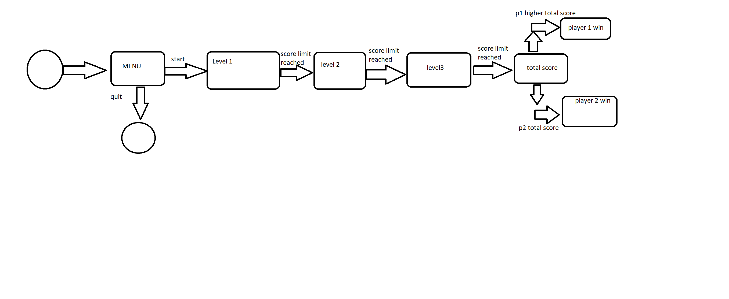b. The second design document should contain a detailed State  
Diagram of either Level 2 or Level 3 of the game showing correctly all  
events and interactions happening in the scene  
*5 marks*

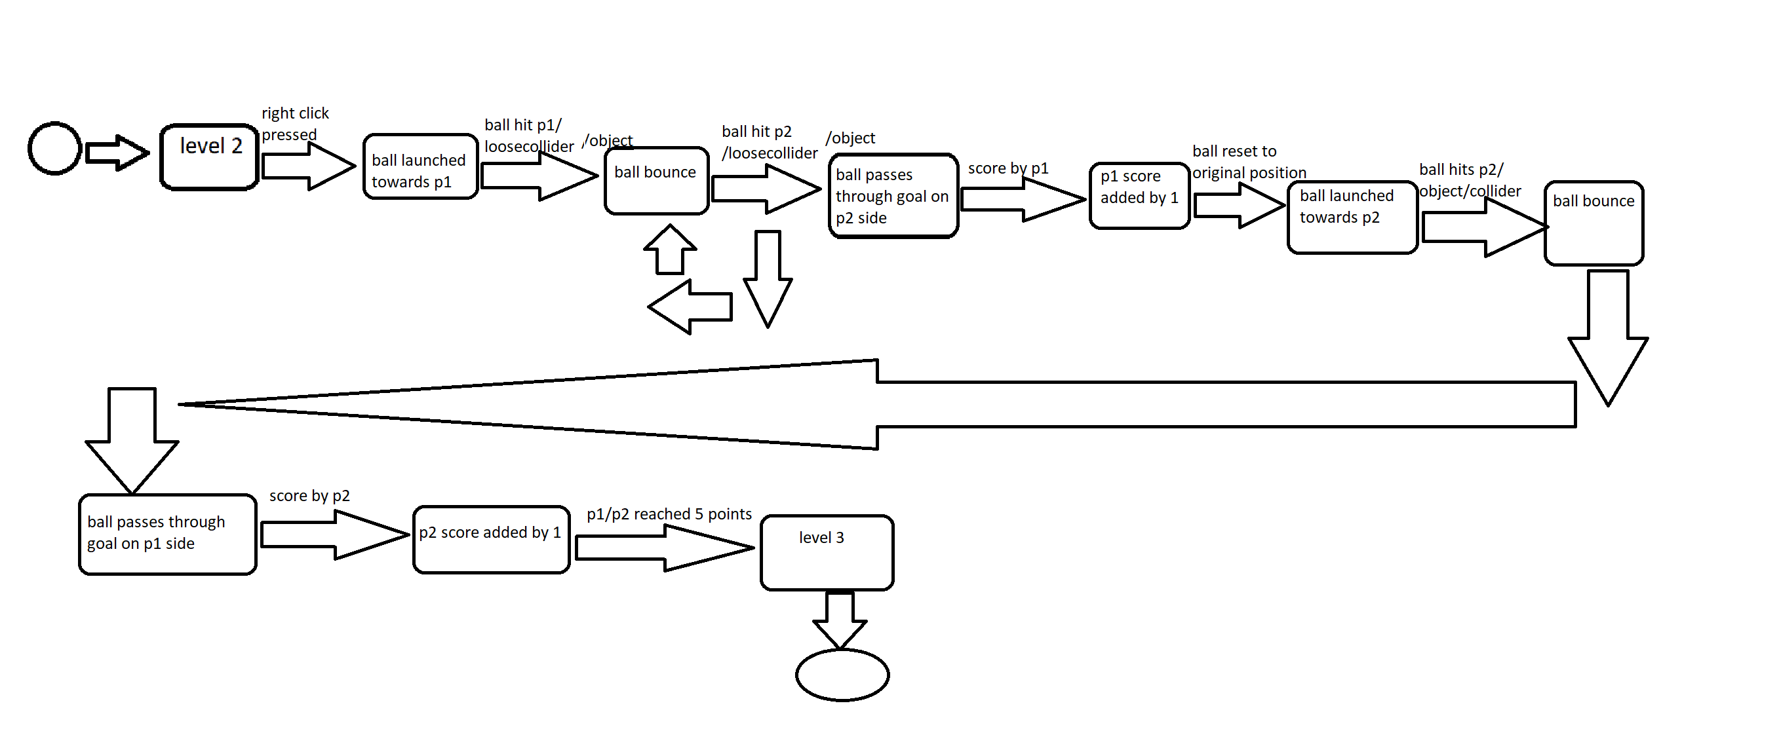

Question 3 (KU 4) *5 marks*  
In not less than 100 words, explain why compression is needed when using  
media assets such as images, videos and audio. Provide examples.

Compression is required for such files in order to shrink their stock sizes which is actually quite large, making them impractical to store on your device. since videos, images and audio are stored in an uncompressed format (dvd for video, RAW for images and WAV for audio files stored on Windows OS) which causes them to take up more space than expected. So in order to use up less space and keep the files at the same level of quality this is where file compression comes into play, there are different types of compression for files, namely lossless ,lossy and more.

example: you have a collection of images that can be compressed into a .ZIP file, ZIP files are the most common type of compressed files on the internet mainly when it comes to downloading multiple files from one source.

References:

|  |  |
| --- | --- |
| **Website title:** | Www1.curriculum.edu.au |
| **URL:** | http://www1.curriculum.edu.au/digitalvideo/compression.htm |

|  |  |
| --- | --- |
| **Article title:** | C# Overview |
| **Website title:** | www.tutorialspoint.com |
| **URL:** | https://www.tutorialspoint.com/csharp/csharp_overview.htm |

|  |  |
| --- | --- |
| **Article title:** | Unreal Engine 4 vs. Unity: Which Game Engine Is Best for You? |
| **Website title:** | Pluralsight.com |
| **URL:** | https://www.pluralsight.com/blog/film-games/unreal-engine-4-vs-unity-game-engine-best |

|  |  |
| --- | --- |
| **Video title:** | Unity Tutorial #1 PONG (2 / 9) [Moving the Bats] |
| **Website title:** | YouTube |
| **URL:** | https://www.youtube.com/watch?v=W_GxMS1qnMI&list=PLr5pWzIcuyNZEiKeC1zTg_jkjSwNX7o3J&index=1 |