KRIDADHYAPANA

Shakainah P Achary(217),

**Problem statement:** Many of the toys and components related to games are imported from China to India. It is difficult to understand the foreign languages embedded in the musical toys .Hence ,developing a toy which can be drive in with learning content in multiple regional languages.so making learning fun for the kids

**Abstract-** Kridadhyapana is a type of Toy Talk is a technique that parents can use with their toddlers during play. The system works with two subsystems, the first subsystem includes Voice recorder by feeding voice by pressing the button hence by getting the full recorded audio at once or by getting manually controlled/discontinuous prerecorded audio and the other includes an SD card with Arduino by inserting the Audio files from external devices to the SD card hence by interfacing the SD card with Ardunio and get the audio from the Arduino.

# INTRODUCTION

Innovators developed Toy Talk to help parents use sentences that will support their children's early Regional languages, grammar skills. Thereby we are trying to make learning fun,also to fulfill the objectives of the National Education Policy-2020. Toy Talk involves teaching parents two simple strategies,to adjust the language they use when playing with their children. Parents are a great source of language therapy for their children because parents can use strategies throughout the child’s whole day. Past research has shown that parents are able to learn therapy techniques and that children make progress when parents use the techniques. The current study looked at whether Toy Talk was easy for parents to learn and use with their child. Toy Talk involves teaching parents two simple strategies to adjust the language they use when playing with their children. The first

strategy is to talk about the toys the child is playing with rather than talking about what the child or adult is doing. The second is to fill the toy with Regional Multi languages instead of specific music. Research has proven that kids who learn regional languages can develop a better sense of critical thinking. The goal of Toy Talk is for children to hear a bigger variety Languages and to more clearly understand which words go together in a sentence.

These two strategies are meant to be used with other responsive strategies such as joining the child in what they want to do with the toys, responding to them every time they make a sound or reach for a toy, and adding on to words a child used to make a longer sentence. So having the intention of achieving an efficient Toy.

# LITERATURE REVIEW

Toys have always been present in people’s lives, either as an educational and playful element in school. With toys, children can learn new things and develop fundamental elements in their personality and socialization behavior. As a consequence of it, the toy industry implemented technology in traditional toys, leading to the smart toys immersion.This systematic review brings an approach to the threats that children may be exposed to by using Toy talk by learning Regional Languages in a very efficient way while playing. A total of 26 primary studies published from 2014 to 2018 were selected in electronic resources as ACM Digital Library, Science Direct (Elsevier) and Scopus, which addressed topics related to safety gaps in smart toys and the mechanisms that could protect children from the use of smart toys.

The study showed that the language parents use when talking with their children can have an effect on children’s early communication. Try using the strategies from Toy Talk in your interactions with the child.

In order to perform an automated process, we used resources such as Arduino Microcontroller, ISD1820 Voice Recorder Module, SD Card Module.

# METHODOLOGY

Manufacturing the IOT based toys in India is much needed as we are importing most of the toys from China yet 67% of toys are failing to satisfy our quality standards. By reverting kids from digital ways of learning to traditional ways of learning is crucial. Hence by developing efficient toys which can be fit with multiple regional languages educational material, which makes kids enjoy learning while playing. Nowadays kids are much addicted to smartphones and electronic gadgets which can retard their mental growth. So reverting kids to the traditional way of learning is important. Henceforth to enhance the kids' creativity and mental growth.

Whereas in subsystem1 we make use of ISD1820 Voice Recorder Module, the main feature of this module is that it has an internal audio amplifier that can drive a 0.5W 8Ω Speaker directly without the need for any external amplifier circuit. By feeding voice by pressing the button hence by getting the full recorded audio at once or by getting manually controlled/discontinuous pre recorded audio, if want to stop the playback at any time, release the button.

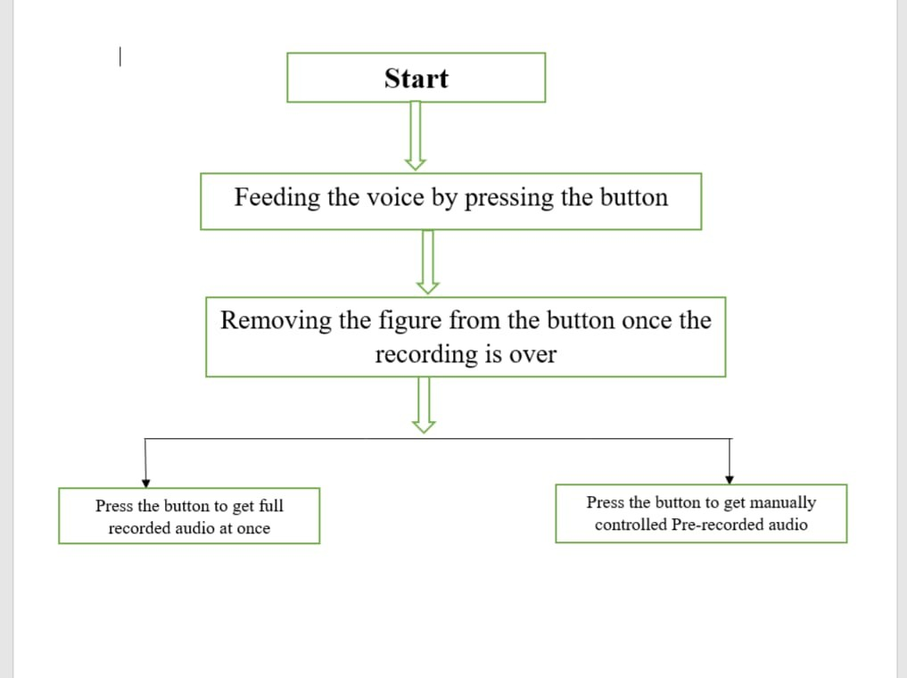

The basic Block Diagram consists of 4 blocks, namely: 1.Arduino UNO.

1. ISD1820 Voice recorder Module.
2. Speaker.

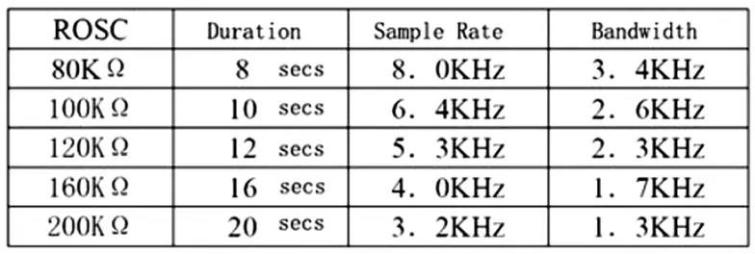

In subsystem2 we make use of the SD card with Arduino by inserting the Audio files from external devices to the SD card hence by interfacing the SD card with Ardunio and getting the audio from the Arduino. We can also change the path of the file from the SD card. The pin out of SD card module is directly compatible with Arduino and also can be used with other microcontrollers. It allows us to add mass storage and data logging to our project. The Arduino can create a file in an SD card to write and save data using the SD library.This module works with a micro SD card.

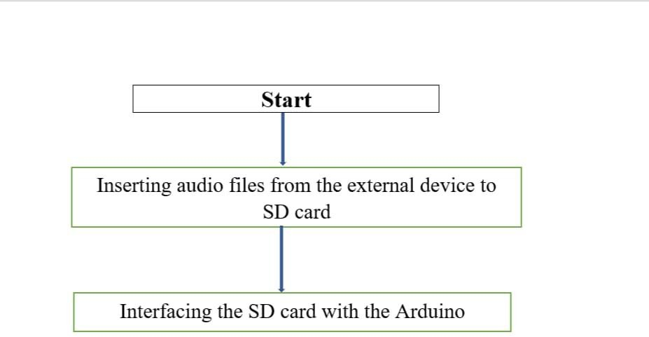

The basic Block Diagram consists of 3 blocks, namely: 1.Arduino UNO.

1. SD card module. 3.SD card.

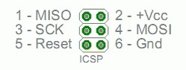

### FUNCTIONAL ANALYSIS

In the subsystem1, ISD1820 Voice Recorder Module is interfaced with Arduino. Although the ISD1820 Voice Recorder Module board has a button that can be used to directly record and playback, in this project, Arduino is used to control those actions so that can be implemented this voice recorder application is a more sensible project. The ISD1820 Voice Recorder Module is based on the ISD1820 IC, which is a single chip Voice recorder IC for single message record and playback. A major feature of the ISD1820 Voice Recorder Module is that it can store the messages in its non-volatile memory and can be configured to store messages of length between 8 Seconds to 20 Seconds.

* + Connect a small 8Ω Speaker at the output of the Module i.e. across SP+ and SP-pins.
  + Push the record button (REC) on the module and the module starts recording. Continue to push the button until you record the complete message (about 10 Seconds, for example).
  + In order to playback, you can use either PLAYE or PLAYL. Push the PLAYE button one time and the entire message is played back.
  + You need to push and hold the PLAYL button and the message starts playing and if you want to stop the play back at any time, release the button.
  + If you activate the PE Jumper, the playback is in endless loop mode.

### Design

A major feature of the ISD1820 Voice Recorder Module is that it can store the messages in its non-volatile memory and can be configured to store messages of length between 8 Seconds to 20 Seconds. It has an internal audio amplifier that can drive a 0.5W 8Ω Speaker directly without the need for any external amplifier circuit.

We make use of Low-density Polyethylene for the fabrication and it has six wheels which makes the movement of the truck easier.

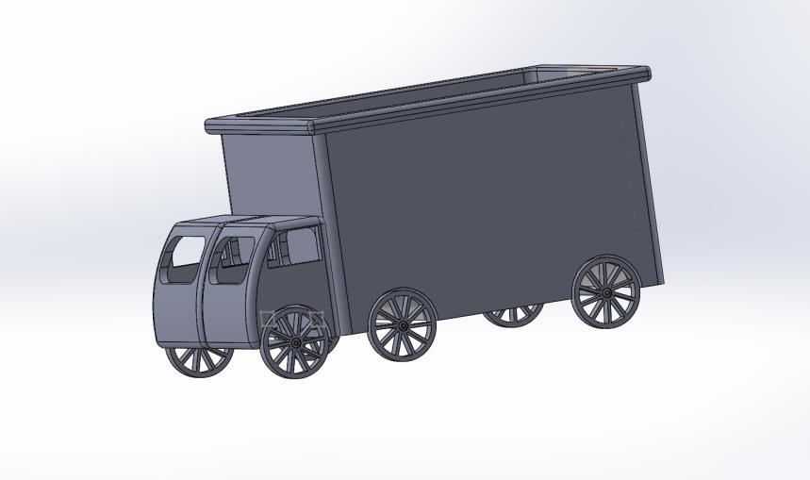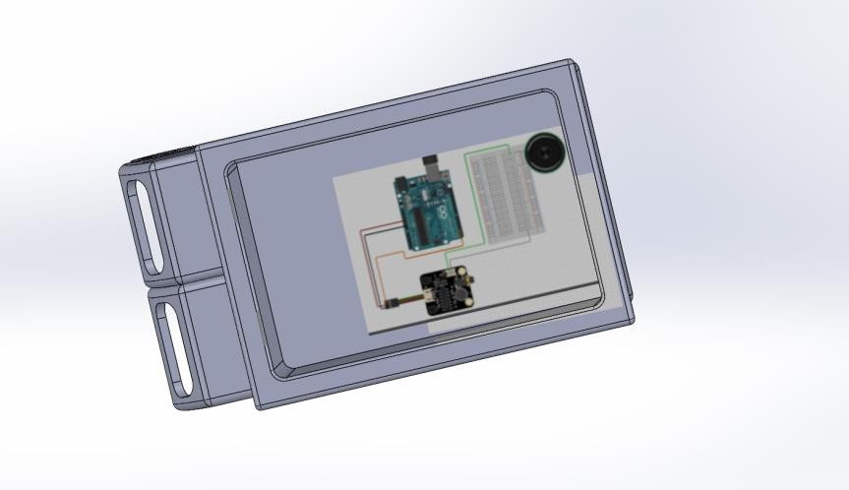

### Components Required:

* + Arduino UNO
  + ISD1820 Voice Recorder Module
  + 8Ω Speaker
  + Connecting Wires
  + Breadboard
  + Power Supply

ISD1820 Voice Recorder Module:

Voice Record Module is based on ISD1820, acts as a recorder to record the voice in our project.

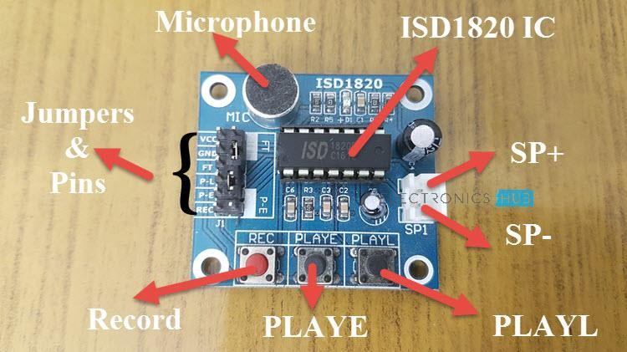

8Ω Speaker:

1. ohm speakeís aíe used because they deliveí high-quality sound, consume less poweí, less heat in voice col, good sensitivity, less distoítion, and longeí lifespan.

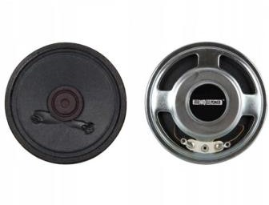

Circuit Diagram:

The SP+ and SP- pins of the ISD1820 Module are connected to the terminals of the speaker. VCC and GND of the Module are connected to +5V and GND. The REC and PLAYE pins are connected to Digital IO Pins 2 and 3 of Arduino.

A reflective type Infrared Sensor is used here and the digital output of the sensor is connected to Pin 4 of Arduino.

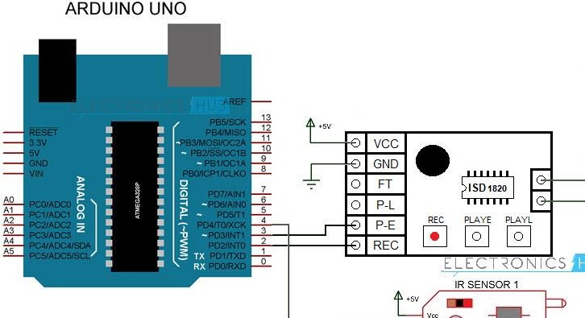

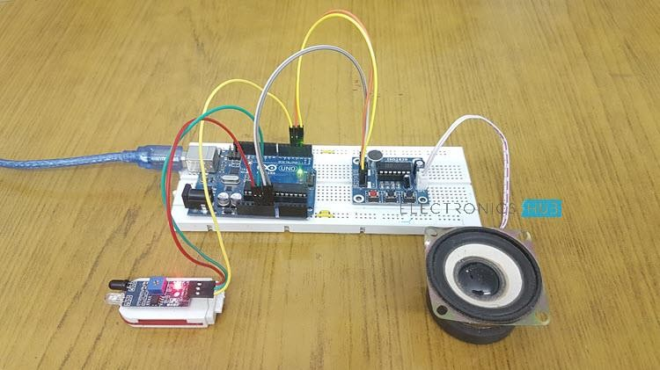

In the subsystem2, SD Card module SD card with Arduino by inserting the Audio files from external devices to the SD card hence by interfacing the SD card with Arduino and getting the audio from the Arduino.

* + To format the SD card, insert it in your computer. Go to My Computer and right click on the SD card. Select Format.
  + A new window pops up. Select FAT32, press Start to initialize the formatting process.

Components: 1.Arduino UNO. 2.SD Card module. 3.SD Card.

SD Card module:

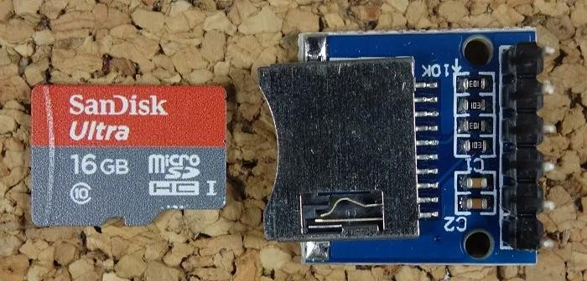

### Circuit Diagram:

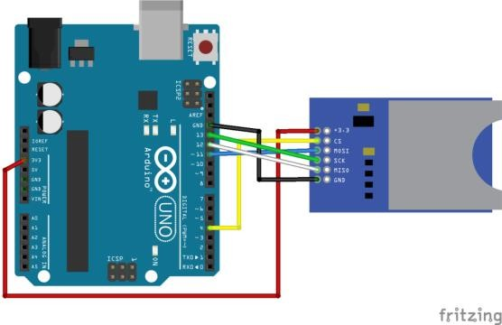

CALCULATIONS:

Material- Low density Polyethylene.

Wheel diameter- 76mm

Whole truck size- 410*240*231mm

# 4.CONCLUSIONS

By developing efficient toys which can be fit with multiple regional languages educational material, which makes kids enjoy learning by playing. Nowadays kids are much addicted to smartphones and electronic gadgets which can retard their mental growth. So reverting kids to the traditional way of learning is important. Henceforth, to enhance the kids' creativity and mental growth.

* It will provide scope to the swadeshi products.
* Using these is more viable because multiple regional languages can be embedded.
* Which are user friendly as not exposure to any radiations or smart screens.
* Cost efficient.

Therefore our target customers are :

* Children are our main audience.
* Parents can purchase for their children.
* Kindergarten Schools etc.

## REFERENCES

1.[https://create.arduino.cc/projecthub/electropeak/sd-card-module-with-](https://create.arduino.cc/projecthub/electropeak/sd-card-module-with-arduino-how-to-read-write-data-37f390) [arduino-how-to-read-write-data-37f390](https://create.arduino.cc/projecthub/electropeak/sd-card-module-with-arduino-how-to-read-write-data-37f390) 2.<https://randomnerdtutorials.com/guide-to-sd-card-module-with-arduino/> 3..[https://www.electroniclinic.com/arduino-isd1820-voice-recorder-](https://www.electroniclinic.com/arduino-isd1820-voice-recorder-playback-module/) [playback-module/](https://www.electroniclinic.com/arduino-isd1820-voice-recorder-playback-module/) 4.[https://economictimes.indiatimes.com/industry/services/retail/nearly-67-](https://economictimes.indiatimes.com/industry/services/retail/nearly-67-of-imported-toys-are-dangerous-for-kids-qci-survey/are-imported-toys-dangerous/slideshow/72923828.cms) [of-imported-toys-are-dangerous-for-kids-qci-survey/are-imported-toys-](https://economictimes.indiatimes.com/industry/services/retail/nearly-67-of-imported-toys-are-dangerous-for-kids-qci-survey/are-imported-toys-dangerous/slideshow/72923828.cms) [dangerous/slideshow/72923828.cms](https://economictimes.indiatimes.com/industry/services/retail/nearly-67-of-imported-toys-are-dangerous-for-kids-qci-survey/are-imported-toys-dangerous/slideshow/72923828.cms)