**Abstract**

Efficient memory management is a cornerstone of modern operating systems, and page replacement algorithms play a vital role in optimizing system performance. This project, titled **Smart Memory Management and Algorithm Customization Simulator**, is a comprehensive C++-based tool designed to simulate, analyze, and compare various page replacement strategies used in operating systems.

The simulator supports widely-used algorithms such as FIFO, LRU, Optimal, Second Chance, LFU, MFU, and Aging, along with two customizable algorithms that allow user-defined eviction policies. Users can input page references manually or generate them randomly, enabling flexible experimentation. A built-in memory access pattern detector provides intelligent recommendations by analyzing access behavior (e.g., sequential, locality-based, or random).

In addition to simulating page replacement, the tool generates detailed performance reports, textual hit ratio graphs, and comparative analysis with the Optimal algorithm, thereby serving both educational and experimental purposes. By visualizing algorithm behavior and outcomes, this simulator helps learners and researchers gain deeper insights into the working and efficiency of memory management strategies.

**Introduction**

Memory management is a fundamental function of any operating system, responsible for efficiently allocating memory to processes and ensuring optimal system performance. Among the core aspects of memory management is the use of **page replacement algorithms**, which decide which memory pages to swap out when new pages are needed and the memory is full. With growing application demands and limited physical memory, the effectiveness of these algorithms directly influences system responsiveness and throughput.

This project presents the **Smart Memory Management and Algorithm Customization Simulator**, a C++-based console application that allows users to simulate and compare a variety of page replacement strategies. The simulator implements several classical algorithms such as FIFO, LRU, Optimal, Second Chance, LFU, MFU, and Aging, along with two custom algorithms that provide rule-based flexibility.

The tool supports both manual and randomized page reference input and includes an intelligent memory access pattern detector to guide algorithm selection. Through visual trace outputs, summary statistics, and report generation, users gain practical exposure to how each algorithm behaves under different workloads. By combining theoretical principles with real-time simulation and analysis, this simulator serves as an educational tool and a testing platform for algorithmic behavior in memory management.

**Objectives**

The primary objective of the **Smart Memory Management and Algorithm Customization Simulator** is to provide a practical, interactive platform for understanding and evaluating different page replacement algorithms used in operating systems. This project aims to bridge the gap between theoretical knowledge and hands-on learning by simulating real-time memory management scenarios.

**Specific objectives include:**

* **To implement and simulate** standard page replacement algorithms such as FIFO, LRU, Optimal, Second Chance, LFU, MFU, and Aging.
* **To allow customization** by enabling users to define and test their own page replacement rules through custom algorithms.
* **To visualize algorithm behavior** through real-time trace outputs showing frame states, hits, and faults step-by-step.
* **To analyze performance** by generating reports that include hit/fault counts, hit and miss rates, and text-based hit ratio graphs.
* **To detect access patterns** (e.g., sequential, locality-based, random) and recommend suitable algorithms accordingly.
* **To support flexible input options**, including manual and auto-generated random page reference strings.
* **To assist students and researchers** in evaluating and comparing algorithm effectiveness under varying workloads and access behaviors.

By fulfilling these objectives, the simulator not only supports academic understanding but also enables performance-driven exploration in the field of memory management.

**System Design**

The **Smart Memory Management and Algorithm Customization Simulator** is designed as a modular, console-based application developed in C++. It provides an interactive interface for simulating multiple page replacement algorithms, detecting memory access patterns, and generating performance reports.

**1 System Architecture Overview**

The system consists of the following core components:

* **User Interface Layer:**  
  A simple console-based interface that allows the user to:
  + Select input method (manual or random)
  + Enter number of page references and memory frames
  + Choose among various algorithms or run all
  + Customize custom algorithms with rule-based options
* **Simulation Engine:**  
  Contains individual implementations of:
  + Classical page replacement algorithms: FIFO, LRU, Optimal, Second Chance, LFU, MFU, Aging
  + Custom algorithms based on user-defined eviction policies  
    Each function maintains frame tracking, hit/fault counting, and optionally outputs trace logs.
* **Pattern Detection Module:**  
  Analyzes the input page reference string to determine access characteristics (e.g., sequential, locality-based, random) and suggests appropriate algorithms.
* **Report Generator:**  
  Outputs simulation results in:
  + Human-readable .txt format with summary statistics
  + Tabular .csv format for structured data analysis
  + Text-based hit ratio graph for visual comparison
  + Optimal comparison logic to identify the closest-performing algorithm

This layered, functional design enables extensibility, efficient debugging, and a clear flow from input to output.

**Algorithms Implemented**

This simulator incorporates a diverse collection of page replacement algorithms, each with unique strategies and decision-making mechanisms. These algorithms represent both classical and advanced approaches used in operating systems for efficient memory management. The system allows detailed comparison of their behavior, performance, and suitability under different memory access patterns.

**1 First-In First-Out (FIFO)**

**Strategy:** The oldest page in memory (loaded first) is the first to be removed when a new page needs to be loaded.

**Working:**

* Maintains a queue to track insertion order.
* Pages are removed from the front of the queue.

**Pros:**

* Simple and easy to implement.

**Cons:**

* Suffers from **Belady’s Anomaly** (increasing frame count can increase page faults).
* Ignores recent usage patterns.

**2 Least Recently Used (LRU)**

**Strategy:** Evicts the page that hasn't been used for the longest time.

**Working:**

* Uses a list to maintain the usage history.
* On each access, moves the page to the front of the list.

**Pros:**

* Performs well in workloads with **temporal locality**.
* Reduces unnecessary replacements.

**Cons:**

* Requires more complex tracking of access order.
* Higher overhead compared to FIFO.

**3 Optimal Algorithm**

**Strategy:** Replaces the page that will not be used for the longest time in the future.

**Working:**

* Requires future knowledge of the reference string.
* Scans forward to find the farthest-used page.

**Pros:**

* Produces the **least possible number of page faults**.
* Serves as a benchmark for comparison.

**Cons:**

* Impractical for real-time systems due to the need for future knowledge.

**4 Second Chance Algorithm**

**Strategy:** A modified FIFO that gives recently used pages a "second chance" before eviction.

**Working:**

* Each page is associated with a reference bit.
* On a page fault, the oldest page is checked:
  + If its bit is 0, it's replaced.
  + If its bit is 1, it’s cleared and moved to the back of the queue.

**Pros:**

* Improves upon FIFO by considering recent usage.
* Simple and low overhead.

**Cons:**

* Doesn’t fully capture usage frequency or recency beyond one bit.

**5 Least Frequently Used (LFU)**

**Strategy:** Evicts the page with the fewest accesses.

**Working:**

* Tracks the frequency of each page’s usage.
* Removes the page with the lowest count on a fault.

**Pros:**

* Effective in workloads with **frequent reuse** of specific pages.

**Cons:**

* May retain old but frequently-used pages unnecessarily.
* Not suitable when access patterns shift rapidly.

**6 Most Frequently Used (MFU)**

**Strategy:** Opposite of LFU – evicts the **most frequently used** page.

**Working:**

* Based on the idea that pages with high usage have completed their role.
* Removes the page with the highest frequency count.

**Pros:**

* May work well in **burst access patterns**.

**Cons:**

* Counterintuitive and often performs worse than LFU.
* May evict still-relevant pages.

**7 Aging Algorithm**

**Strategy:** Approximates LRU using aging counters that decay over time.

**Working:**

* Each page has an 8-bit counter.
* On every access, the MSB is set.
* On each time step, all counters are right-shifted.
* Pages with the smallest counter values are considered least recently used.

**Pros:**

* Hardware-friendly LRU approximation.
* Balances recency and performance.

**Cons:**

* Less precise than true LRU.
* Still requires periodic updates to counters.

**8 Custom Algorithms**

The simulator supports user-defined replacement rules, enabling experimentation with new ideas.

**(a) Custom Rule 1 – Fewest Accesses in Window**

**Strategy:** Evicts the page that was accessed least often in the most recent N page references (sliding window).

**Working:**

* Counts how many times each page in memory appeared in the last N accesses.
* The page with the lowest count is replaced.

**Pros:**

* Adapts to **localized recent behavior**.
* Highly dynamic and responsive to current patterns.

**Cons:**

* Requires maintaining a window and recalculating counts frequently.

**(b) Custom Rule 2 – Even-Priority**

**Strategy:** Retains even-numbered pages longer; evicts odd-numbered pages first.

**Working:**

* On a fault, scans memory for odd-numbered pages to evict first.
* If all pages are even, uses FIFO fallback.

**Pros:**

* Demonstrates how priority rules affect performance.
* May be useful in **domain-specific memory models**.

**Cons:**

* Artificial and may not align with real-world patterns.
* Depends heavily on input characteristics.

This rich algorithm set empowers users to test and understand the strengths, weaknesses, and trade-offs of different replacement strategies under a wide variety of memory access behaviors.

**Custom Algorithm Module**

To promote experimentation and extend beyond classical page replacement strategies, the simulator includes a **Custom Algorithm Module**. This module allows users to define and test replacement rules dynamically, offering flexibility in how memory pages are managed.

**Purpose and Motivation**

Traditional algorithms such as FIFO or LRU follow fixed logic. However, in real-world systems, memory access patterns may vary significantly depending on workload type, application behavior, or system priorities. The custom module addresses this by enabling **adaptive logic**, where replacement behavior can be tailored based on user-defined criteria.

**User Interaction**

Upon selecting the custom algorithm option, the simulator prompts the user to choose one of two available custom rules:

**1 Rule 1: Evict Page with Fewest Accesses in Recent Window**

**Description:**  
Tracks how frequently each page in memory was accessed during the last N page references (a sliding time window). The page with the lowest frequency in this window is evicted.

**User Input:**

* Choose rule 1
* Enter window size N (e.g., 4)

**Advantages:**

* Responsive to **short-term locality**
* Helps adapt to **bursty** or recently shifting access patterns

**Use Case:**

* Suitable for workloads where recent behavior is more important than long-term frequency

**2 Rule 2: Even-Numbered Page Priority**

**Description:**  
Implements a biased replacement strategy that prioritizes even-numbered pages over odd ones. On a page fault, the system searches for and evicts an odd-numbered page first. If all pages are even, it falls back to FIFO.

**Advantages:**

* Demonstrates **priority-based memory management**
* Allows exploration of how domain-specific rules affect performance

**Use Case:**

* Useful in educational settings to explore “what-if” scenarios
* Can simulate scenarios where certain page ranges (even IDs) are deemed more critical

**Performance Reporting**

Both rules are fully integrated into the simulator’s reporting system. After simulation:

* Page hits, faults, and hit/miss ratios are calculated
* Behavior is logged to console and exported to .txt and .csv files
* Included in the comparative analysis in “Run All” mode
* Displayed on the textual hit ratio graph

**Extensibility**

The custom module is designed with extensibility in mind. Additional custom strategies can be integrated by:

* Defining a new rule identifier
* Adding logic to the custom() function
* Hooking it into the menu and user prompt system

This flexibility makes the simulator a useful sandbox for algorithm development, research, or education.

**Memory Access Pattern Detector**

Modern memory management systems can significantly benefit from understanding the **access pattern** of the workload. To emulate this adaptability, the simulator includes a **Memory Access Pattern Detector**, a feature that analyzes the page reference string and classifies its behavior before algorithm selection. This helps in choosing an optimal page replacement strategy for better performance.

**1 Purpose**

The pattern detector serves two main purposes:

* **Analyze** the nature of the page reference sequence (e.g., repetitive, sequential, or random)
* **Recommend** the most suitable page replacement algorithm based on detected behavior

**2 Detection Mechanism**

After the reference string is input (manually or randomly), the detector evaluates the sequence using the following criteria:

* **Sequential Access**
  + Pages appear in a strictly increasing or cyclic order
  + Suggests FIFO or Optimal as strong candidates
* **Locality-Based Access**
  + Frequent repetition of a small subset of pages (temporal or spatial locality)
  + Suggests LRU or Aging for better performance
* **Random Access**
  + No clear pattern; high variability and spread
  + Suggests LFU or Second Chance as fallback strategies

The detection is based on frequency distribution, run-length checks, and sliding window similarity.

**3 Role in 'Run All' Mode**

When the user selects “Run All” mode:

* The pattern detector still runs first
* Its recommendation is highlighted alongside the overall comparison
* This allows users to verify if the best-performing algorithm matched the recommended one

**Woking Flow Diagram:**

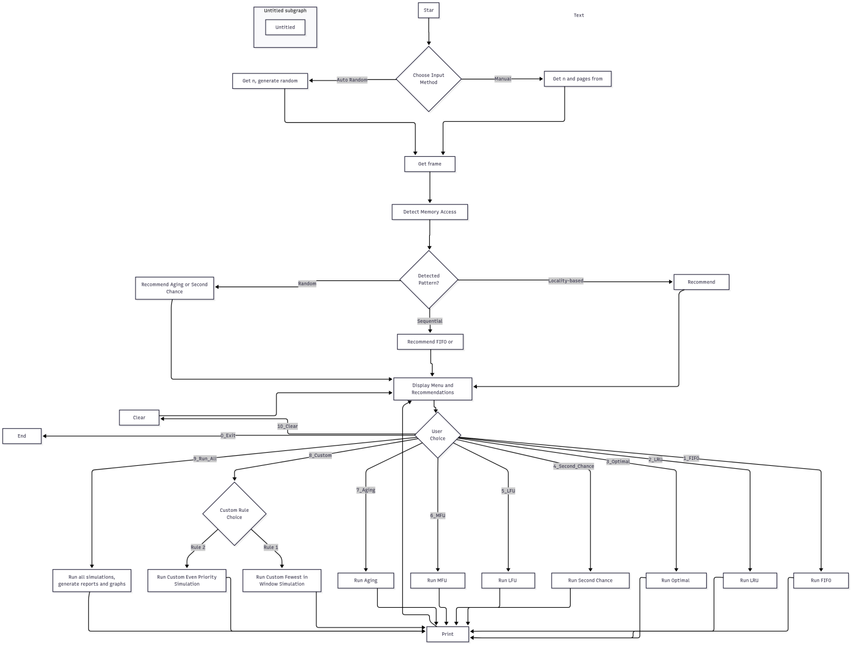

**Output Of The Project:**

This output shows the initial screen of the "Smart Memory Manager Simulator" program. The user is given two options for input: "Manual Input" or "Auto Random Generation". The user has chosen "Manual Input" by typing "1".

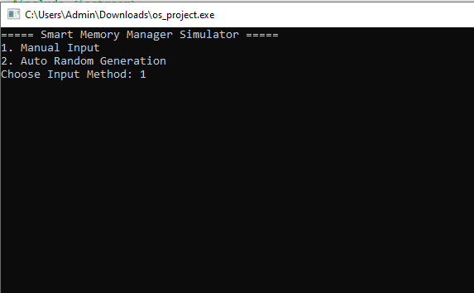

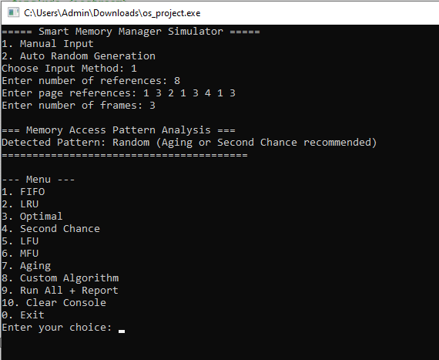

This console continues from the first, showing the user has selected "Manual Input". The user is prompted to enter the number of references, which they set to 8, and the page references, which are "13213413". They also enter the number of frames as 3. The simulator then analyzes the memory access pattern, detecting a "Random" pattern and recommending "Aging or Second Chance" algorithms. A menu of page replacement algorithms is then displayed, including FIFO, LRU, Optimal, Second Chance, LFU, MFU, Aging, and Custom Algorithm. The user is prompted to enter a choice.

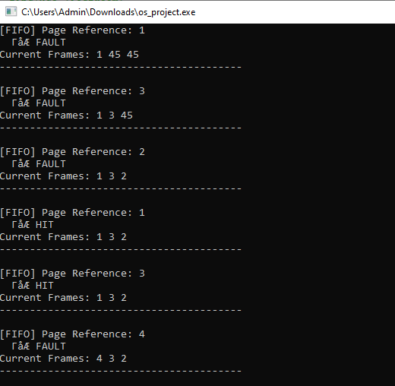

This console shows the step-by-step execution of the FIFO (First-In, First-Out) algorithm. For a page reference of 1, a fault occurs, and the frames become "1 45 45". A fault also occurs for page reference 3, and the frames become "1 3 45". For page reference 2, a fault occurs, and the frames become "1 3 2". When page reference 1 is accessed again, a "HIT" is recorded, and the frames remain "1 3 2". Similarly, for page reference 3, a "HIT" is recorded. A fault occurs for page reference 4, and the frames change to "4 3 2".

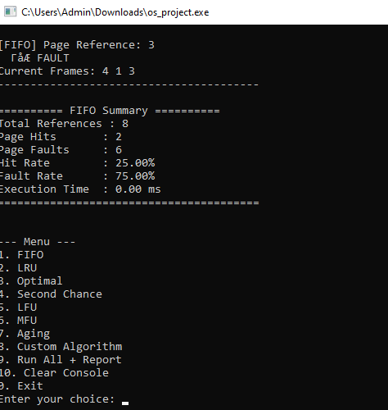

This console is the 2nd part of previous console which shows the continuation of the FIFO simulation. A page reference of 3 results in a "FAULT," and the frames become "413". The "FIFO Summary" is then displayed, showing that out of 8 total references, there were 2 page hits and 6 page faults. This results in a hit rate of 25.00% and a fault rate of 75.00%. The execution time is listed as 0.00 ms. The menu of algorithms is then displayed again.

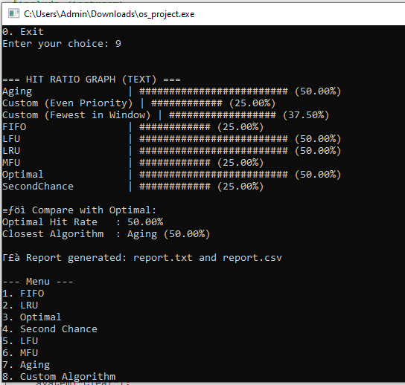

This console displays the results after the user chose to "Run All + Report" by entering "9". A "HIT RATIO GRAPH (TEXT)" is shown, comparing the performance of different algorithms. The graph shows the hit rates for various algorithms, including Aging (50.00%), Custom (Even Priority) (25.00%), Custom (Fewest in Window) (37.50%), FIFO (25.00%), LFU (50.00%), LRU (50.00%), MFU (25.00%), and Optimal (50.00%). The report also notes that the Optimal hit rate is 50.00% and the "Closest Algorithm" is Aging, with a 50.00% hit rate as well. Finally, it states that a report has been generated in report.txt and report.csv.

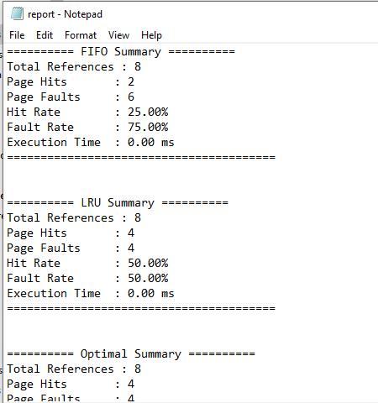

This page shows the content of the report.txt file. The file contains summaries for different page replacement algorithms. The FIFO summary shows 8 total references, 2 page hits, 6 page faults, a 25.00% hit rate, and a 75.00% fault rate. The LRU summary shows 8 total references, 4 page hits, 4 page faults, a 50.00% hit rate, and a 50.00% fault rate. The Optimal summary shows 8 total references, 4 page hits, and 4 page faults. There have also the remain summary for other optimal algorithm i.e. LFU , MFU .Aging and so on.

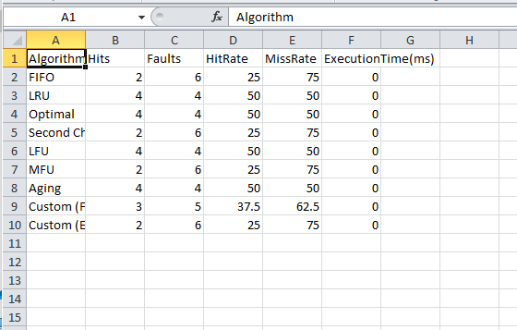

This image displays a table, likely from the report.csv file, comparing the performance of different algorithms. The table lists several algorithms, including FIFO, LRU, Optimal, Second Chance, LFU, MFU, Aging, and two custom algorithms. It provides columns for Hits, Faults, Hit Rate, and Execution Time (ms) for each algorithm.

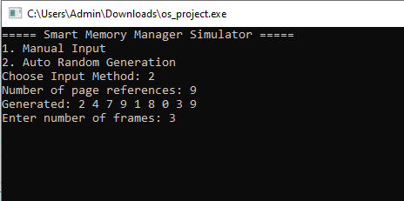

This console shows the "Smart Memory Manager Simulator" again, but this time the user has selected "Auto Random Generation" by choosing option "2". The program automatically generates 9 page references: "2 4 7 9 1 8 0 3 9". The user then enters "3" for the number of frames.

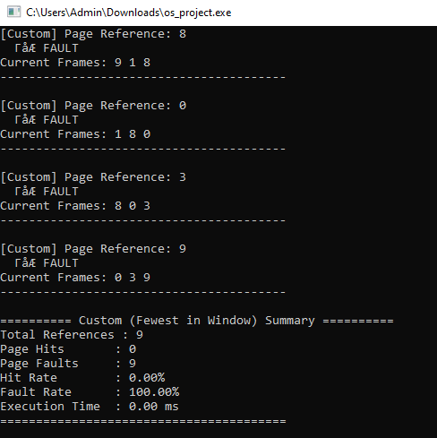

This page shows the step-by-step execution and summary for a custom algorithm called "Custom (Fewest in Window)". For a page reference of 8, a fault occurs and the frames become "918". For a page reference of 0, a fault occurs and the frames become "180". For page reference 3, a fault occurs and the frames become "803". For page reference 9, a fault occurs and the frames become "039". The summary for this algorithm shows 9 total references, 0 page hits, 9 page faults, a 0.00% hit rate, and a 100.00% fault rate.

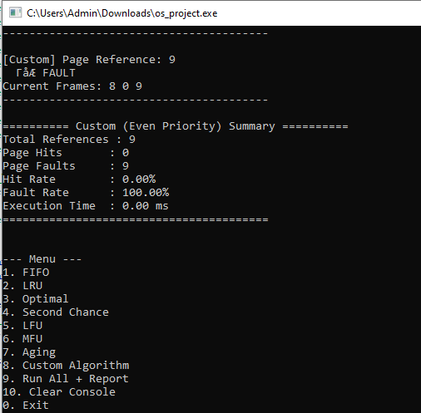

This image displays the step-by-step execution and summary for another custom algorithm called "Custom (Even Priority)". A page reference of 9 results in a fault, and the current frames are "809". The summary for this algorithm shows 9 total references, 0 page hits, 9 page faults, a 0.00% hit rate, and a 100.00% fault rate. The menu of algorithms is shown again at the bottom.

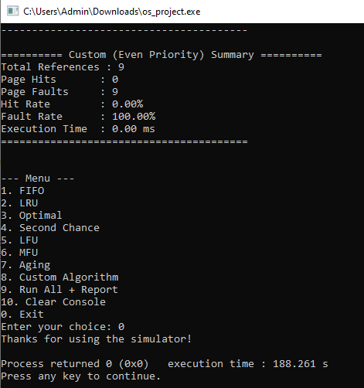

This final image shows the end of the program's execution. The "Custom (Even Priority) Summary" is shown with 9 total references, 0 page hits, 9 page faults, a 0.00% hit rate, and a 100.00% fault rate. The user has chosen to exit the program. A message "Thanks for using the simulation!" is displayed, followed by the program's execution time.

**Limitations and Future Enhancements**

While the **Smart Memory Management and Algorithm Customization Simulator** provides a robust and feature-rich platform for simulating page replacement strategies, like any project, it has certain limitations that can be addressed in future versions to improve its usability, scalability, and educational value.

**1 Current Limitations**

**1. Console-Based Interface Only**

* The simulator operates entirely in a **text-based console environment**, which limits user interaction and accessibility.
* Complex inputs and large outputs can become harder to interpret without a graphical view.

**2. Limited Input Sources**

* Inputs are currently taken manually or generated randomly within the session.
* No support for importing page reference strings from external files like .txt or .csv.

**3. Custom Algorithms Require Manual Coding**

* Although the simulator allows for two customizable algorithms, these are **pre-coded with specific rules**.
* Users without C++ experience may struggle to modify or define new custom behaviors.

**4. No GUI or Visualization Tools**

* There's no graphical memory frame simulation or timeline view of hits/misses.
* The textual hit ratio graph, while informative, lacks interactivity or exportability as an image/chart.

**5. Pattern Detector is Basic**

* Current pattern detection uses simple frequency and locality checks.
* It may not accurately detect hybrid or complex real-world memory access behaviors.

**Future Enhancements**

**1. Graphical User Interface (GUI)**

* Implement a **cross-platform GUI** using frameworks like Qt, Tkinter, or Electron.
* Allow drag-and-drop input files, graphical frame states, and color-coded hit/miss tracking.

**2. Support for File-Based Inputs and Batch Processing**

* Enable users to load reference strings from files and run batch tests across multiple configurations.
* Useful for automated testing and large-scale simulations.

**3. Custom Algorithm Builder (No Code)**

* Introduce a **rule-based visual editor** where users can define eviction policies without coding.
* Could include dropdowns for eviction rules, frame conditions, and tie-breaking policies.

**4. Enhanced Pattern Detection (AI/ML-Based)**

* Use machine learning or statistical modeling to recognize complex or real-world patterns (e.g., working set model, hybrid access).

**5. Interactive Charts and Reports**

* Replace text-based graphs with interactive plots (e.g., using matplotlib or Plotly in GUI/web version).
* Allow export as images, PDFs, or interactive HTML reports.

**6. Memory and Time Profiling**

* Add tools to **measure algorithm complexity** in terms of memory and time usage under different workloads.

**7. Multithreaded Simulation**

* Enable parallel simulation of algorithms to reduce total runtime in “Run All” mode, especially with large input sizes.

By addressing these limitations, future versions of the simulator can evolve into a **comprehensive educational suite** and **research-grade platform**, supporting deeper insights into memory management systems.

**Conclusion**

The **Smart Memory Management and Algorithm Customization Simulator** is a powerful, educational, and extendable tool that brings theoretical concepts of memory management into practical, observable form. Designed with versatility and clarity in mind, it allows users to simulate and compare a wide range of page replacement algorithms, from classical techniques like **FIFO**, **LRU**, and **Optimal**, to advanced approaches such as **LFU**, **MFU**, **Second Chance**, **Aging**, and **custom user-defined rules**.

Through its support for **manual and random inputs**, **real-time hit/miss tracking**, **access pattern detection**, and **comparative graph-based output**, the simulator offers a hands-on environment for learning, teaching, and experimenting with memory management strategies. Its “Run All” mode enables meaningful benchmarking across algorithms under identical conditions, while its reporting features provide exportable results for academic analysis or documentation.

While the simulator currently operates in a console-based interface and has some scope limitations, it establishes a strong foundation for future enhancements—such as GUI integration, AI-driven pattern recognition, and no-code customization tools.

Overall, the simulator not only reinforces fundamental operating system concepts but also promotes algorithmic thinking, system-level analysis, and creative exploration—making it a valuable asset for students, educators, and researchers in the field of computer science.