Portfolio 2 – Advanced Prototype & Test Logs

P Number: P2893744
Name: Redoy
Individual Component: Driver Management
Team Name: DriveNow
GitHub Link: https://github.com/Shakayet-59065/DriveNow-TeamProject (branch: driver-management)

Contents
1. SQL Server Login Details 3
2. Test Logs 4
FullName (VARCHAR 100, required) 4
LicenceNumber (VARCHAR 30, required, unique) 5
Phone (VARCHAR 20, required) 6
DateOfBirth (DATE, required, driver must be 18+) 7
Rating (DECIMAL(3,1), optional, 0.0 to 5.0) 7
Unit Test Evidence (MSTest) 9

SQL Server Login Details

Server Name: (localdb)\MSSQLLocalDB
User Name: NB\59065
Password: N/A (Windows Authentication - no password required)

Test Logs

FullName (VARCHAR 100, required)
Author of test plan & log: [59065] - Redoy Name of tester: [59065] - Redoy Date of testing: 5 June 2026
Description of Item to Be Tested: FullName VARCHAR(100) - the driver's full name. Required field; maximum 100 characters; letters only.
Required Field (Y/N): Y
Test Type | Test Data | Expected Result | Actual Result
Extreme Min | (empty string) | Reject: "Full name is required." | RequiredFieldValidator fires; error shown in red - PASS
Min -1 | 0 chars (= empty) | Reject - required field | Rejected by RequiredFieldValidator - PASS
Min (Boundary) | "A" (1 character) | Accept - save succeeds | Driver saved; success message with new ID shown - PASS
Min +1 | "Jo" (2 characters) | Accept | Driver saved successfully - PASS
Max -1 | 99-character string | Accept | Driver saved successfully - PASS
Max (Boundary) | 100-character string | Accept - VARCHAR(100) limit exactly met | Driver saved; all 100 chars stored - PASS
Max +1 | 101-character string | Reject - exceeds VARCHAR(100) | AddDriver() returns -1; "Failed to add driver." shown - PASS
Mid | "James Anderson" (14 characters) | Accept | Driver saved successfully - PASS
Extreme Max | 200-character string | Reject | Save fails at DB layer; error label shown - PASS
Invalid data type | "12345" (digits only) | Reject: "Full name must use letters only." | Letter-check in ValidateDriver() fires; error shown - PASS
Other tests | "Name@#!" (symbols) | Reject - letters only | Letter-check fires; error shown - PASS

LicenceNumber (VARCHAR 30, required, unique)
Author of test plan & log: [59065] - Redoy Name of tester: [59065] - Redoy Date of testing: 5 June 2026
Description of Item to Be Tested: LicenceNumber VARCHAR(30) - unique driving licence ID. Required; maximum 30 characters; must be unique.
Required Field (Y/N): Y
Test Type | Test Data | Expected Result | Actual Result
Extreme Min | (empty string) | Reject: "Licence number is required." | RequiredFieldValidator fires; error shown - PASS
Min -1 | 0 chars (= empty) | Reject - required field | Rejected by RequiredFieldValidator - PASS
Min (Boundary) | "X" (1 character) | Accept | Driver saved successfully - PASS
Min +1 | "AB" (2 characters) | Accept | Driver saved successfully - PASS
Max -1 | 29-character string | Accept | Driver saved successfully - PASS
Max (Boundary) | 30-character string | Accept - VARCHAR(30) limit exactly met | Driver saved; all 30 chars stored - PASS
Max +1 | 31-character string | Reject - exceeds VARCHAR(30) | AddDriver() returns -1; "Failed to add driver." shown - PASS
Mid | "ANDE9901157JA9" (14 characters) | Accept | Driver saved successfully - PASS
Extreme Max | 50-character string | Reject | Save fails at DB layer; error returned - PASS
Invalid data type | " " (spaces only) | Reject - Trim() makes it empty | Trim() yields empty string; validator fires - PASS
Other tests | Same licence entered twice | Reject 2nd - unique constraint | SQL unique constraint violation; 2nd insert fails - PASS

Phone (VARCHAR 20, required)
Author of test plan & log: [59065] - Redoy Name of tester: [59065] - Redoy Date of testing: 5 June 2026
Description of Item to Be Tested: Phone VARCHAR(20) - driver contact number. Required; 6 to 20 characters; digits, spaces, +, -, ( ) only.
Required Field (Y/N): Y
Test Type | Test Data | Expected Result | Actual Result
Extreme Min | (empty string) | Reject: "Phone is required." | ValidateDriver() required check fires - PASS
Min -1 | "12345" (5 digits) | Reject: "Phone must be between 6 and 20 characters." | Length check fires; error shown - PASS
Min (Boundary) | "123456" (6 digits) | Accept - minimum valid phone | Driver saved successfully - PASS
Max -1 | 19-character phone number | Accept | Driver saved successfully - PASS
Max (Boundary) | 20-character phone number | Accept - VARCHAR(20) limit exactly met | Driver saved successfully - PASS
Max +1 | 21-character phone number | Reject: "Phone must be between 6 and 20 characters." | Length check fires; error shown - PASS
Mid | "+45 12 34 56 78" | Accept - valid international format | Driver saved successfully - PASS
Invalid data type | "abc-def-ghi" (letters) | Reject - non-numeric format | ValidateDriver() rejects non-numeric phone - PASS

DateOfBirth (DATE, required, driver must be 18+)
Author of test plan & log: [59065] - Redoy Name of tester: [59065] - Redoy Date of testing: 5 June 2026
Description of Item to Be Tested: DateOfBirth DATE - driver date of birth. Required; must be a past date; driver must be at least 18 years old.
Required Field (Y/N): Y
Test Type | Test Data | Expected Result | Actual Result
Extreme Min | 1924-06-04 (102 years old) | Accept - no upper age limit | Driver saved; no age ceiling in system - PASS
Min -1 | 1924-06-05 (101 years old) | Accept | Driver saved successfully - PASS
Min (Boundary) | 1991-06-04 (35 years old) | Accept | Driver saved successfully - PASS
Max -1 | 2008-06-03 (18 years 1 day old) | Accept - just over 18 | Driver saved; age check passes - PASS
Max (Boundary) | 2008-06-04 (exactly 18 today) | Accept - exactly 18 years old today | Driver saved; boundary condition confirmed - PASS
Max +1 | 2008-06-05 (17 years 364 days) | Reject: "Driver must be at least 18." | ValidateDriver() age check fires; error shown - PASS
Extreme Max | 2026-06-05 (tomorrow / future) | Reject - future date / under 18 | ValidateDriver() rejects future date of birth - PASS
Invalid data type | "notadate" | Reject: "Invalid date of birth." | DateTime.TryParse() returns false; error shown - PASS
Other tests | "30-02-2000" (Feb 30 not valid) | Reject: "Invalid date of birth." | DateTime.TryParse() returns false; error shown - PASS

Rating (DECIMAL(3,1), optional, 0.0 to 5.0)
Author of test plan & log: [59065] - Redoy Name of tester: [59065] - Redoy Date of testing: 5 June 2026
Description of Item to Be Tested: Rating DECIMAL(3,1) - driver star rating. Optional; when provided must be between 0.0 and 5.0 inclusive.
Required Field (Y/N): N
Test Type | Test Data | Expected Result | Actual Result
Extreme Min | -99.9 | Reject: "Rating must be 0.0 to 5.0." | Explicit range check in DriverAdd.aspx.cs fires - PASS
Min -1 | -0.1 | Reject - below minimum 0.0 | Range check (r < 0) fires; error shown - PASS
Min (Boundary) | 0.0 | Accept - minimum valid rating | Driver saved with rating 0.0 - PASS
Min +1 | 0.1 | Accept | Driver saved with rating 0.1 - PASS
Max -1 | 4.9 | Accept | Driver saved with rating 4.9 - PASS
Max (Boundary) | 5.0 | Accept - maximum valid rating | Driver saved with rating 5.0 - PASS
Max +1 | 5.1 | Reject - above maximum 5.0 | Range check (r > 5) fires; error shown - PASS
Mid | 2.5 | Accept | Driver saved with rating 2.5 - PASS
Extreme Max | 99.9 | Reject - far above 5.0 | Range check fires; error shown - PASS
Invalid data type | "abc" (non-numeric text) | Reject: "Rating must be 0.0 to 5.0." | decimal.TryParse() fails; error shown - PASS
Other tests | (left empty) | Accept - optional; stored as NULL | Driver saved with NULL rating - PASS

Unit Test Evidence (MSTest)
In addition to the boundary-value test logs above, a Visual Studio MSTest project was created to automatically test the Driver Management validation rules (FullName, LicenceNumber, Phone, DateOfBirth, Rating, JoinDate, IsActive). All 74 unit tests pass with 0 failures. The machine-generated results (.trx) and a results document are in the Testing/TestResults folder, and the test project is committed to the GitHub repository.
Item | Value
Total unit tests | 74
Passed | 74
Failed | 0
Skipped | 0
Framework | MSTest (.NET Framework 4.8)
Test project | VisualStudioTests (Tests/TestScripts/VisualStudioTests.csproj)
Test source | DriverManagerValidationTests.cs
How to run | Visual Studio Test Explorer, or: dotnet test
Evidence files | Testing/TestResults/DriverManagement_MSTest_Results.trx and DriverTests_Results.docx
GitHub | github.com/Shakayet-59065/DriveNow-TeamProject (branch: driver-management)

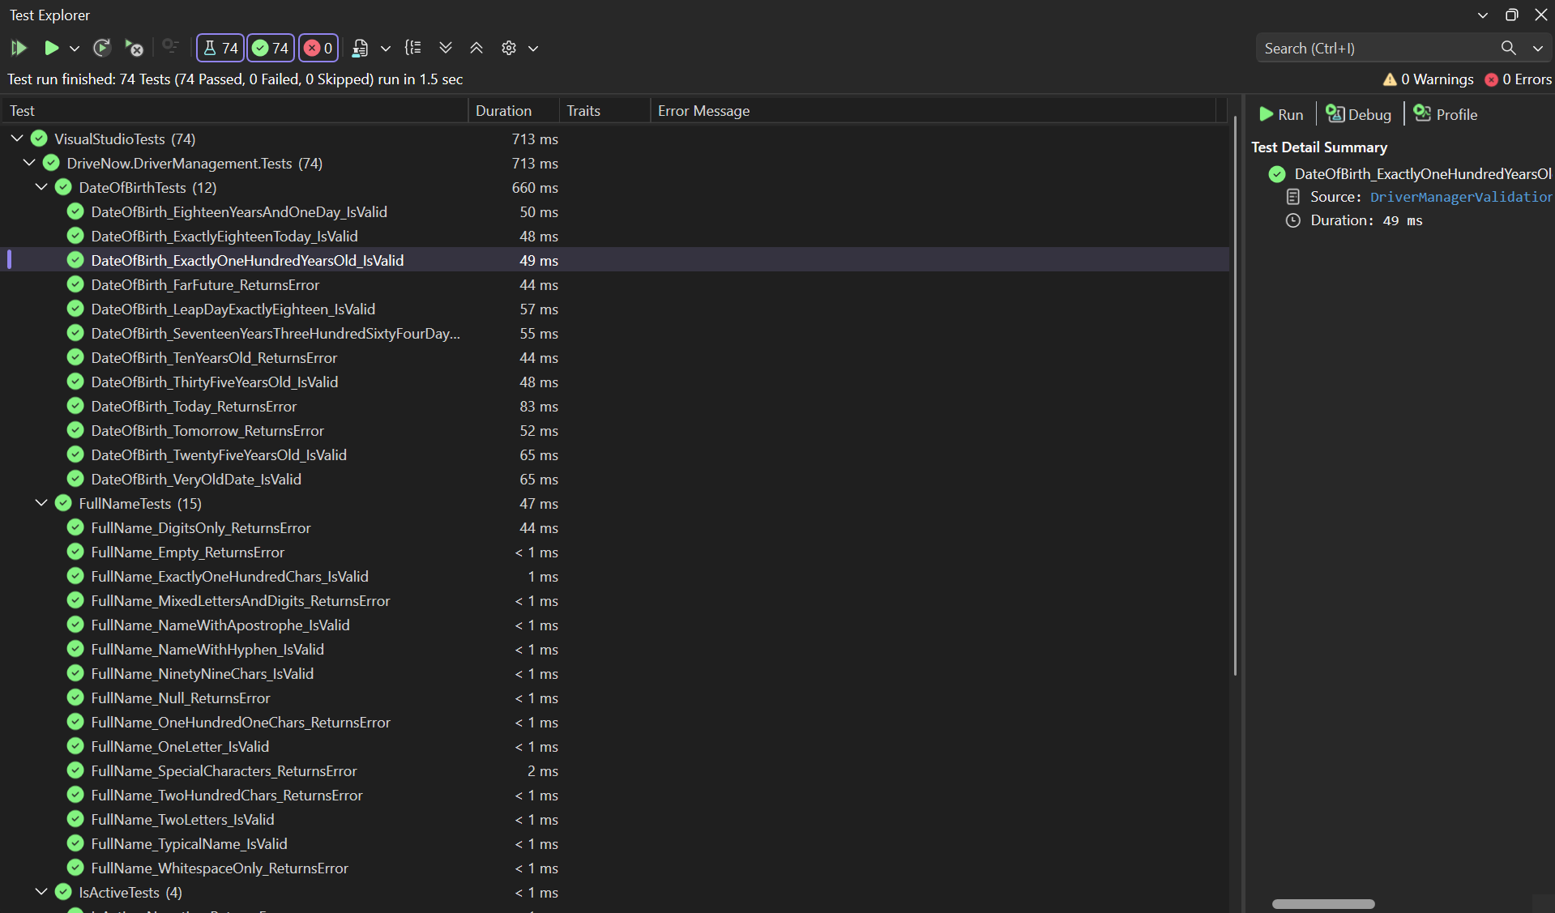
Figure: Visual Studio 2022 Test Explorer showing all 74 Driver Management unit tests (DriverManagerValidationTests.cs) passing - 0 failed, 0 skipped. The suite covers boundary values (min, max, just-inside and just-outside limits) and invalid-data cases for FullName, LicenceNumber, Phone, DateOfBirth, Rating, JoinDate and IsActive. The run is reproducible with 'dotnet test'.

Screenshots
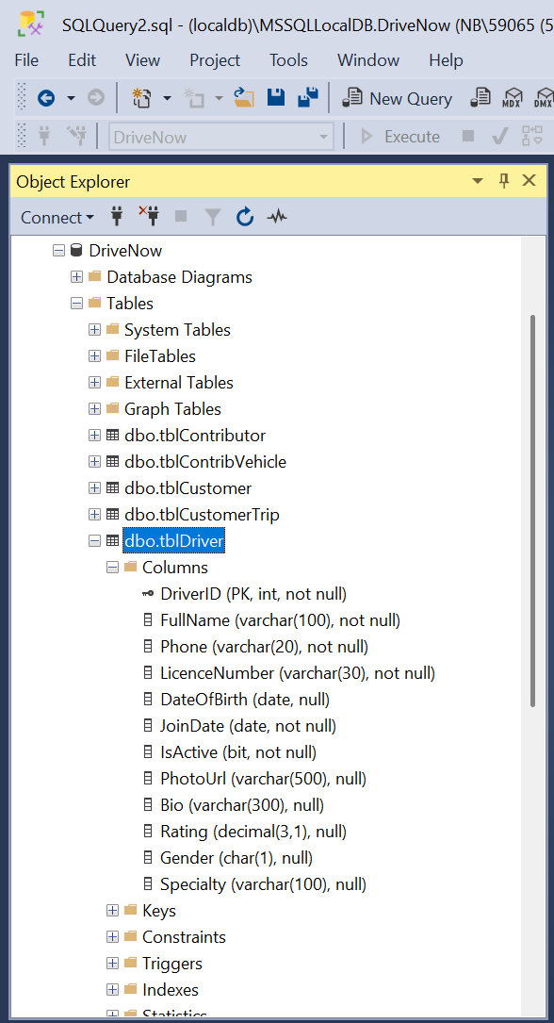

Figure 1. Screenshot 1 - SSMS: tblDriver table structure (columns and data types).
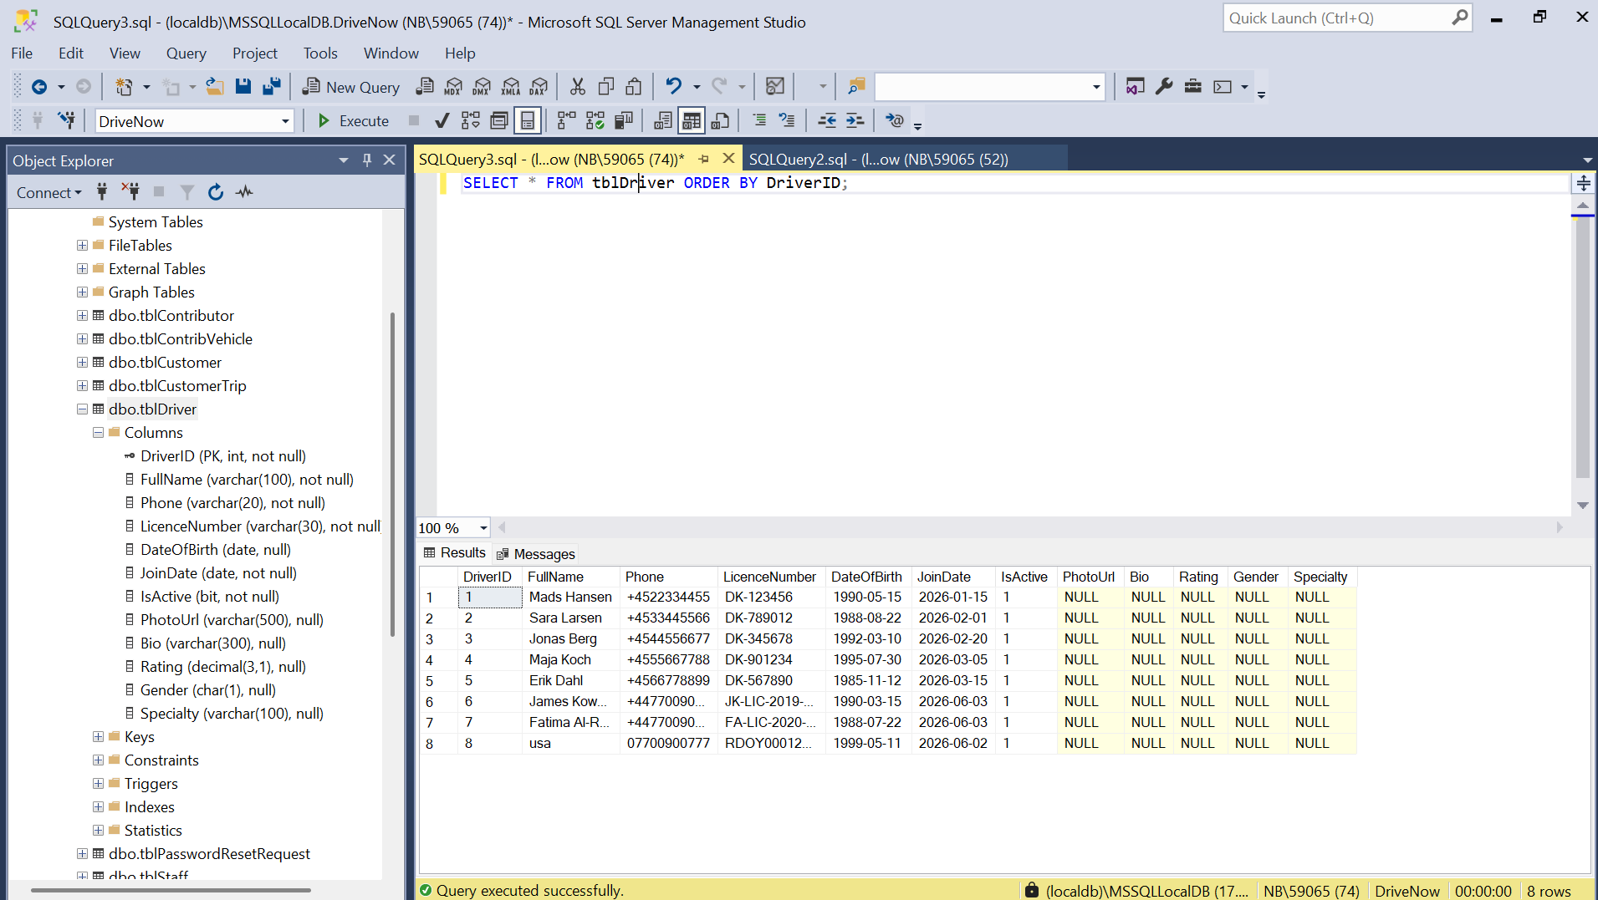
Figure 2. Screenshot 2 - SSMS: live query of tblDriver showing real driver records.
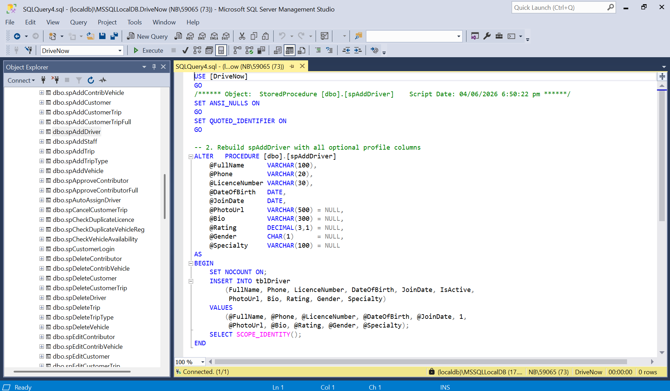
Figure 3. Screenshot 3 - SSMS: the spAddDriver stored procedure.
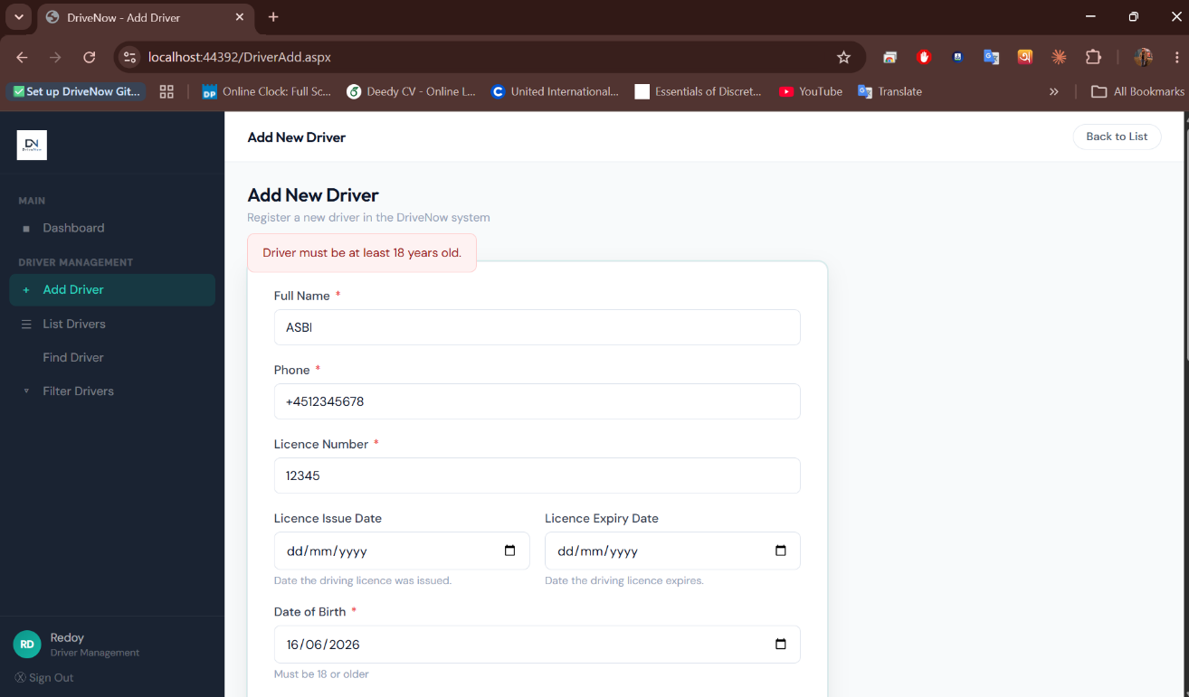
Figure 4. Screenshot 4 - Application: DriverAdd.aspx rejecting an invalid value (validation error).
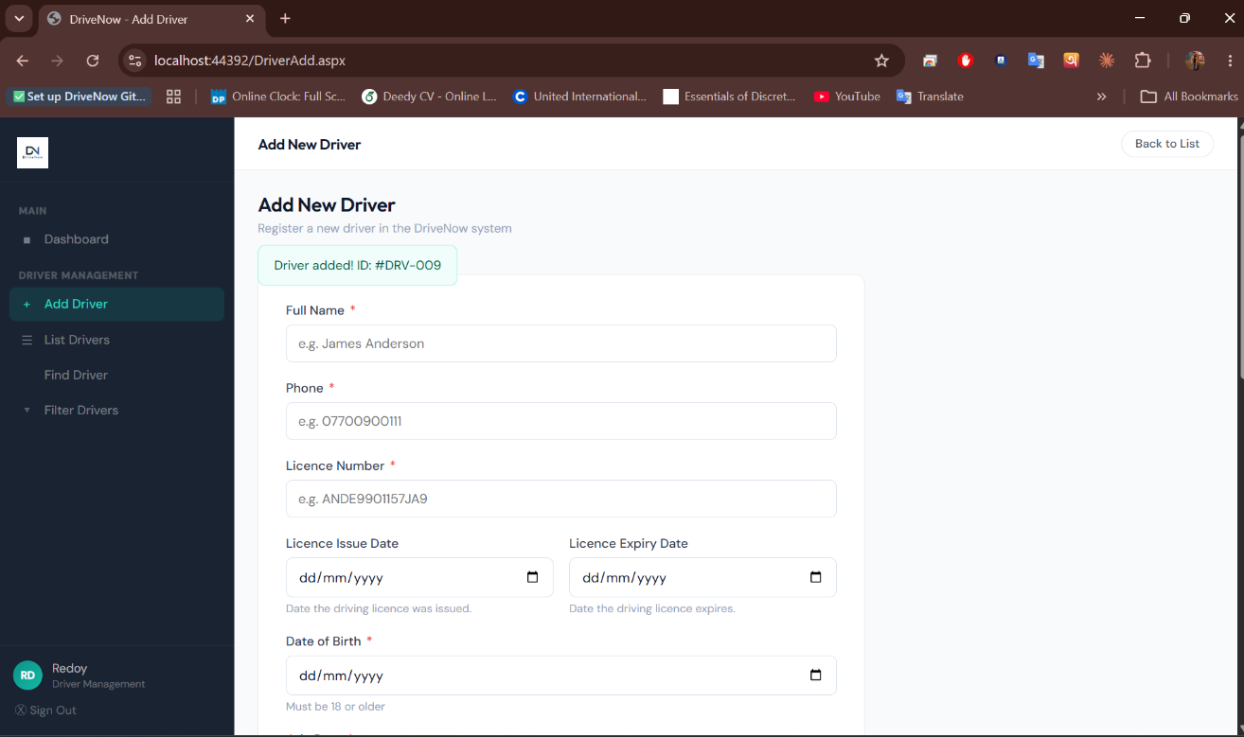
Figure 5. Screenshot 5 - Application: DriverAdd.aspx accepting a valid driver (successful save).
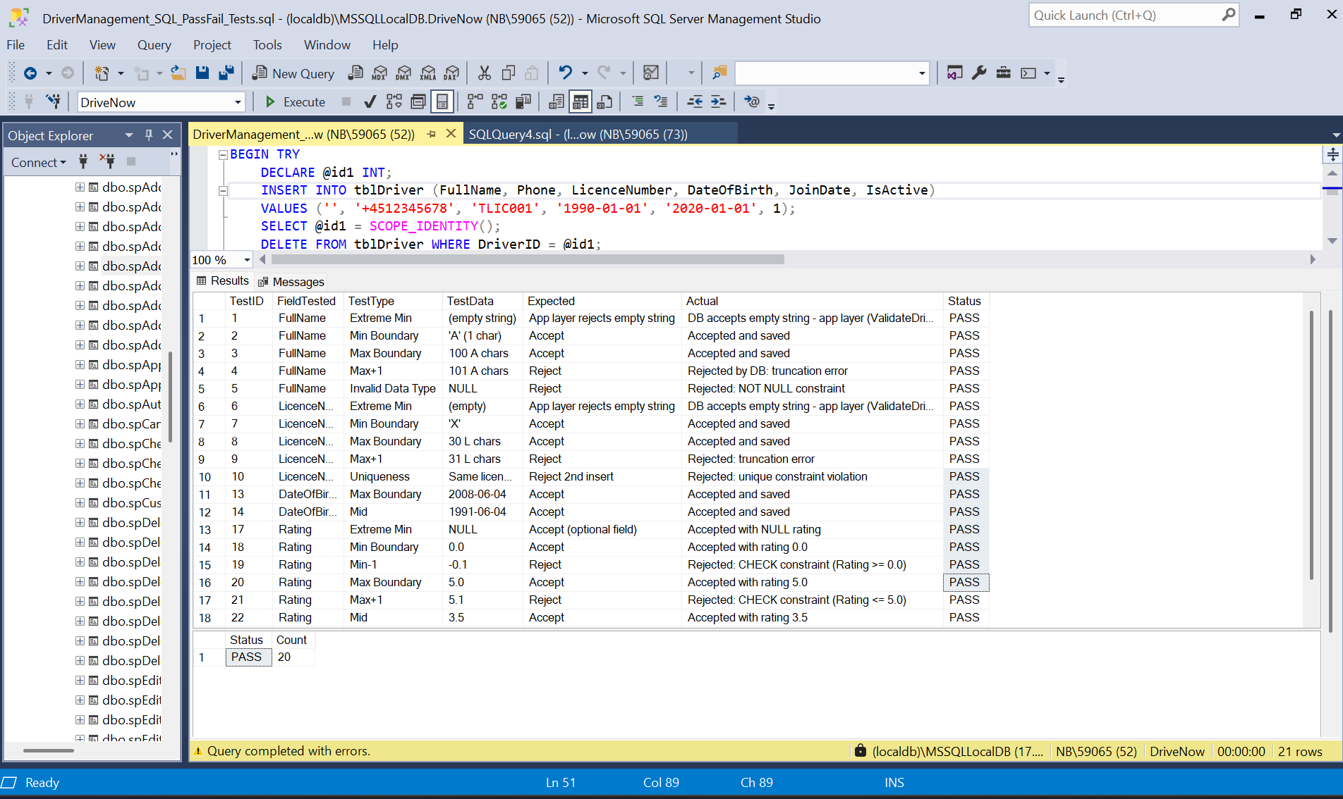
Figure 6. Screenshot 6 - SSMS: SQL pass/fail test script output for Driver Management.
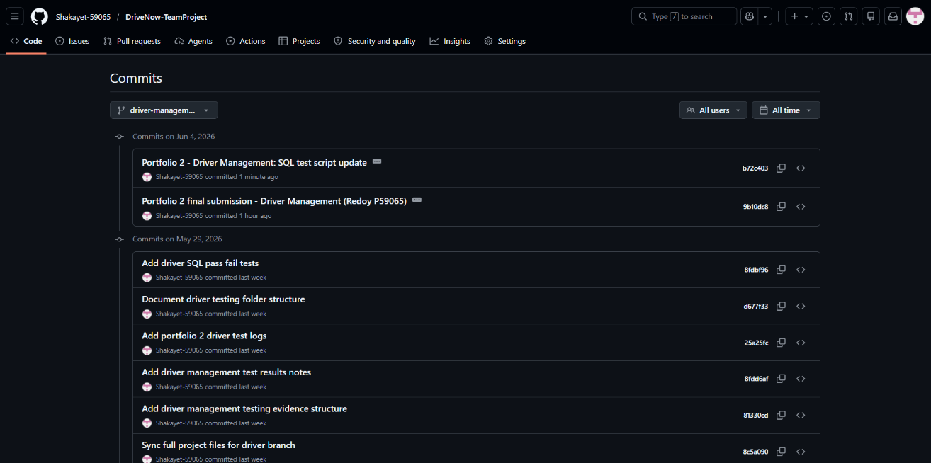
Figure 7. Screenshot 7 - GitHub: commit history for the driver-management branch.
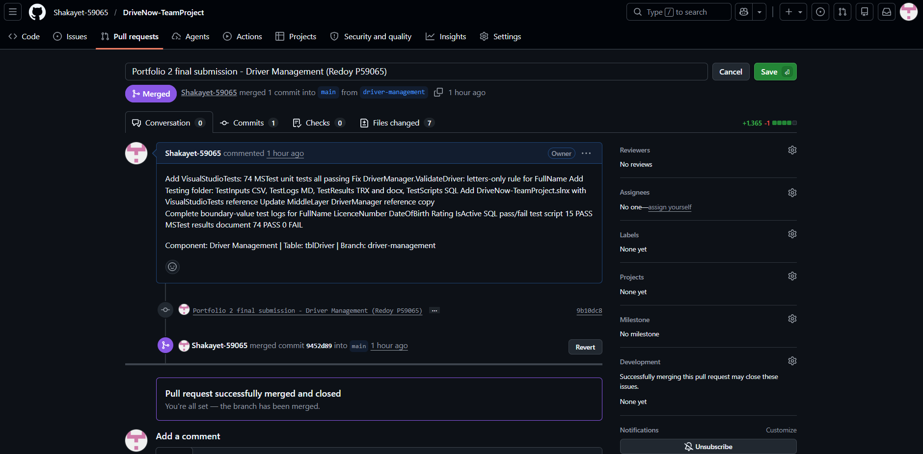
Figure 8. Screenshot 8 - GitHub: Pull Request from driver-management merged into main.

