Introduction
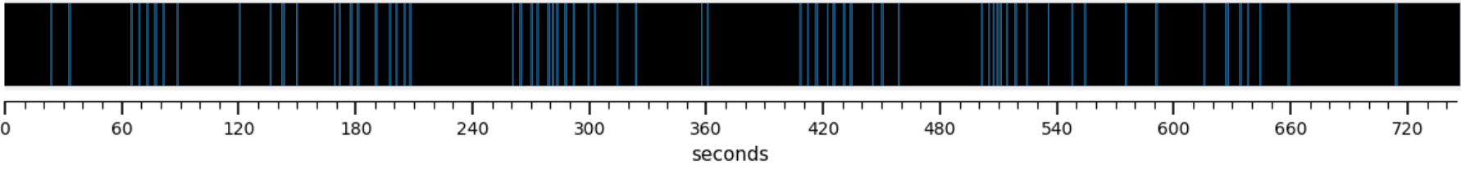
Figure 1. ISFS concept: example N2 trace with spindle clustering. A representative N2 sleep segment of roughly 12.5 minutes. Each vertical bar marks the timing of one detected spindle. The spindles are not evenly spaced; they gather into clusters separated by quieter gaps, and this grouping recurs on an infra-slow timescale of tens of seconds. This rhythmic clustering of spindles is the infra-slow fluctuation of sigma power (ISFS) examined in this study.

Methods
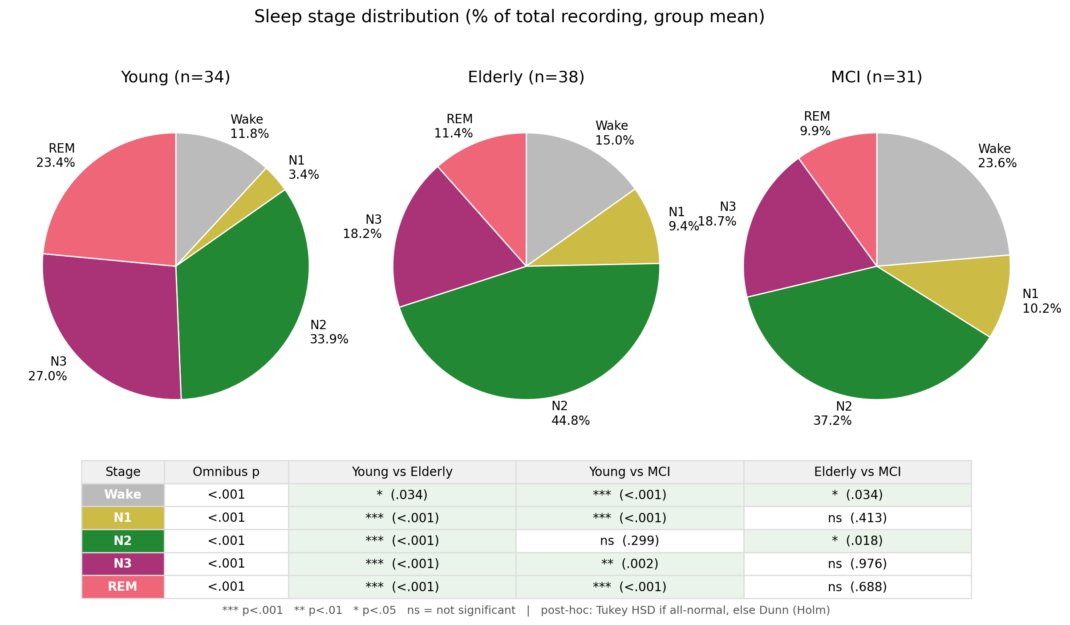
Figure 2. Sleep architecture pies. Proportion of each sleep stage per group. Deep (N3) and REM sleep were reduced in elderly and MCI relative to young adults, whereas N2 sleep, the stage in which ISFS occurs, remained the largest stage in all three groups.
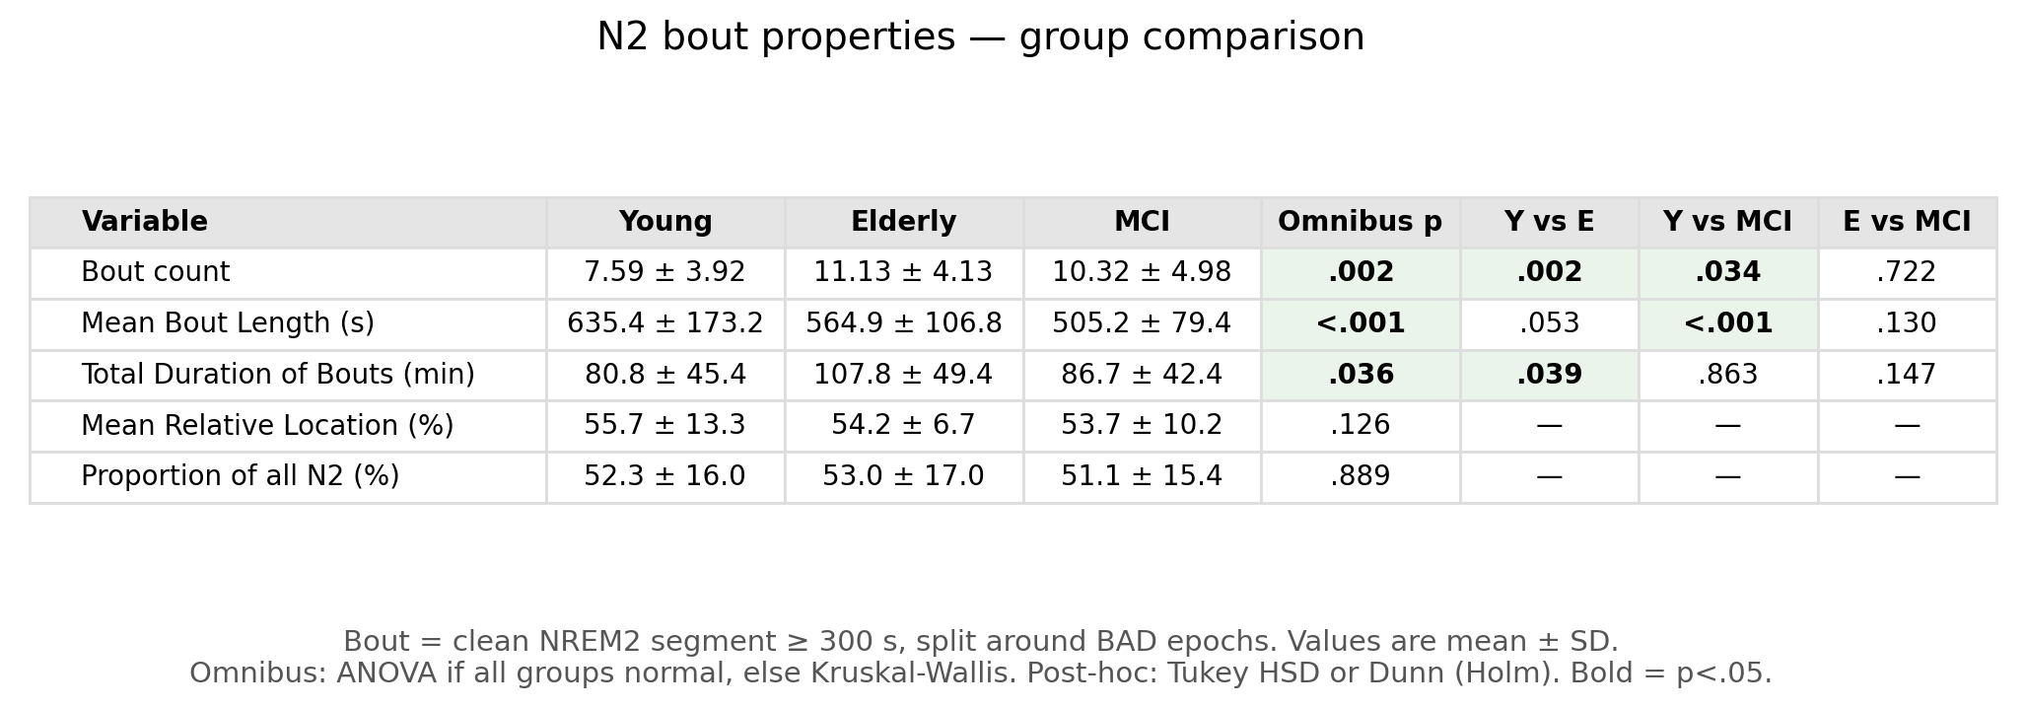
Figure 3. N2 bout properties comparison. N2 bout properties by group. Elderly and MCI had more frequent but shorter stable N2 bouts than young adults, whereas the total proportion of N2 sampled was similar across groups.

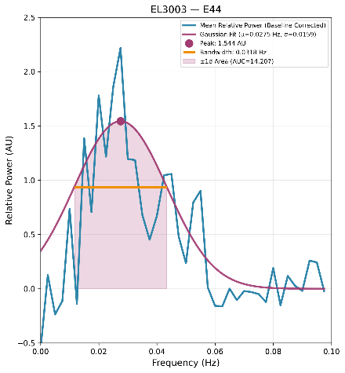
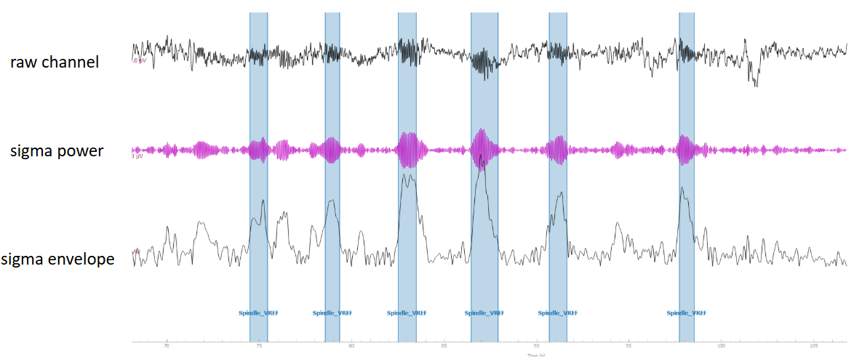

Figure 4. Feature extraction: signal chain + example Gaussian fit. Feature extraction for a single channel. The left panel show a roughly 40-second excerpt: the raw EEG, the same signal band-pass filtered to the sigma band (13–16 Hz), and the sigma amplitude envelope. The fast Fourier transform (FFT) of the envelope, computed over the full N2 bout, is fitted with a Gaussian (right panel). The fit yields three metrics: peak frequency (the dominant rate of the rhythm), bandwidth (the spread of the peak), and area under the curve (AUC, the overall strength of the fluctuation).

Results
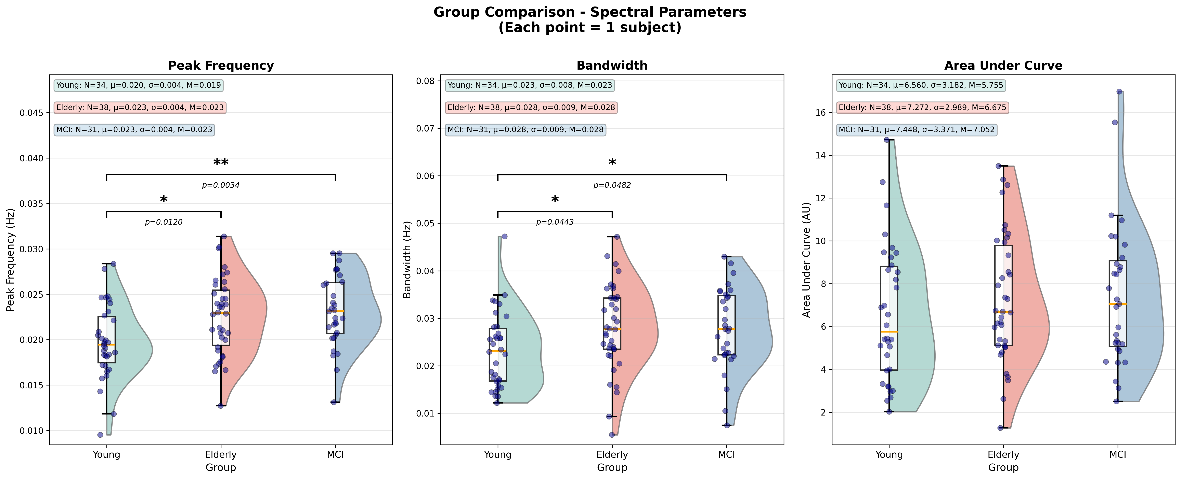
Figure 5. Whole-scalp ISFS parameter comparison. Whole-scalp ISFS parameters across groups. Each dot is one subject's mean across successfully fitted electrodes (young n = 34, elderly n = 38, MCI n = 31); the box shows the median and interquartile range, and the half-violin shows the kernel density. Peak frequency and bandwidth were higher in both older groups than in young adults (peak frequency: young < elderly = MCI, p = 0.002; bandwidth: young < elderly = MCI, p = 0.025), whereas overall strength (AUC) did not differ between groups. Elderly and MCI did not differ on any parameter.

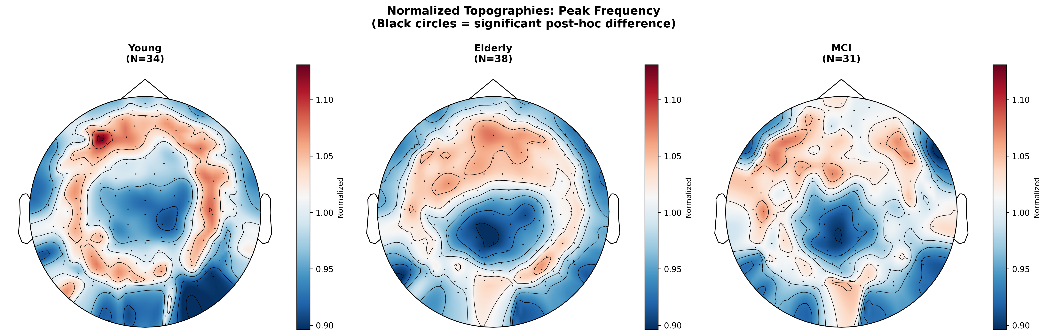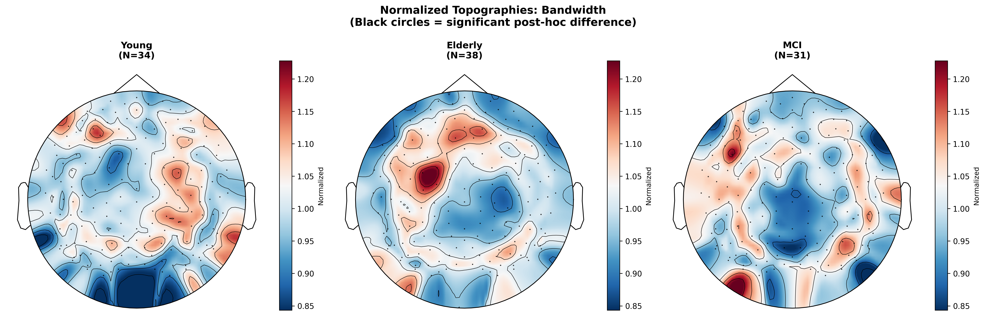
Figure 6. Peak-frequency & bandwidth normalized topographies. Peak frequency and bandwidth across the scalp, per-subject normalized. Peak frequency shows a frontal emphasis in young adults that flattens with age. Bandwidth shows no consistent spatial pattern across groups. Although both parameters differed when averaged across the whole scalp, neither produced a significant spatial cluster.

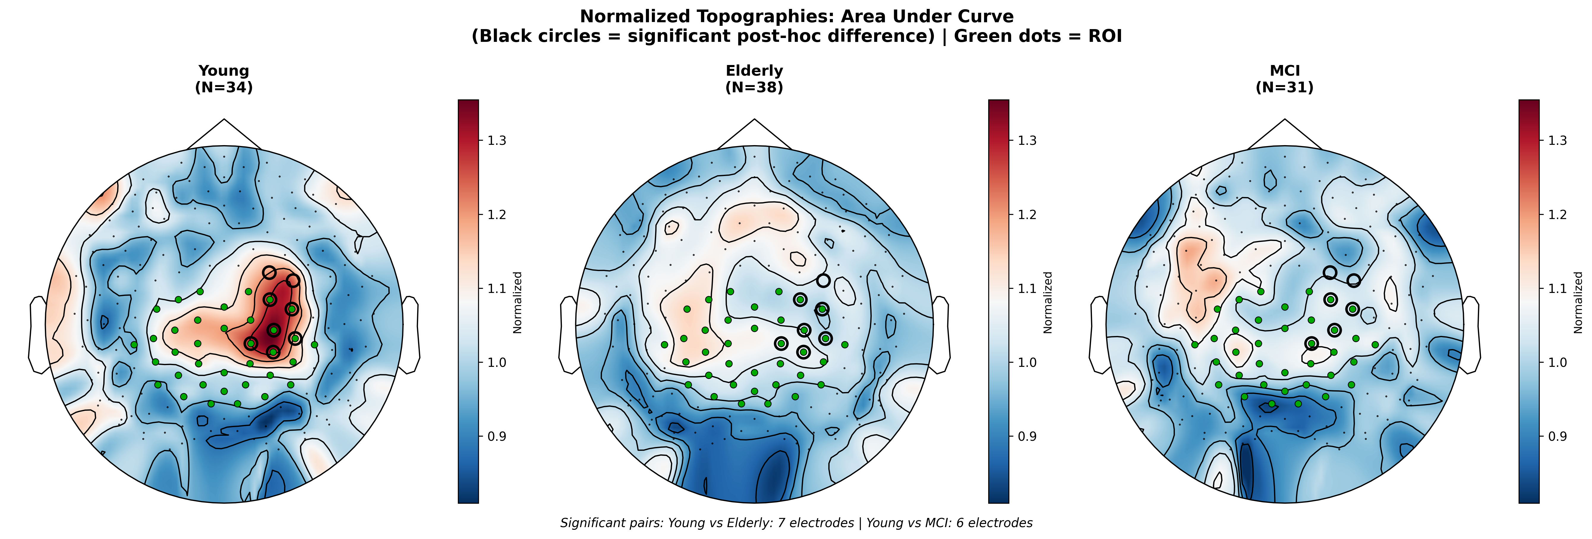
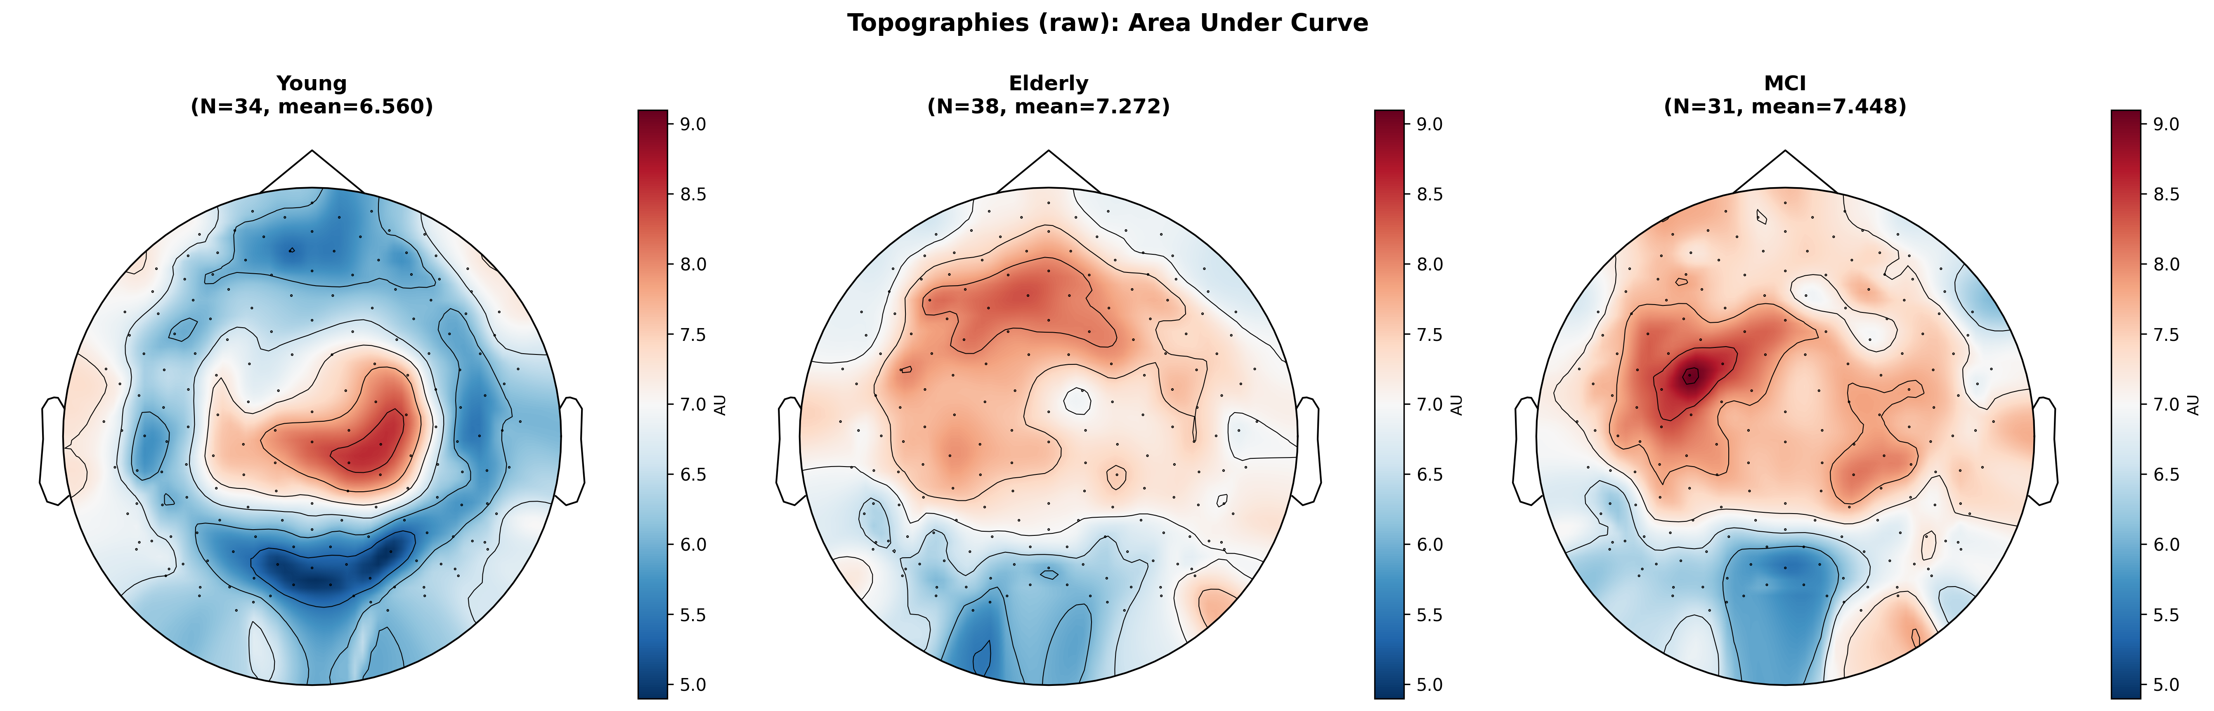
Figure 7. AUC topographies + cluster-permutation result. ISFS strength (AUC) across the scalp. Per-group maps are shown as raw values and as per-subject normalized values, next to the cluster-based permutation result. The region of interest (ROI), a set of central-parietal electrodes defined a priori from the young-adult AUC hotspot of Dimitriades et al. (2024), is marked as green dots on the normalized maps. Young adults show higher AUC over these central-parietal electrodes, and the hotspot flattens and spreads in aging and MCI. A cluster-based permutation test identified a single significant central-parietal cluster (p = 0.014, 9 electrodes), driven by lower AUC in elderly and MCI than in young adults. Elderly and MCI did not differ.

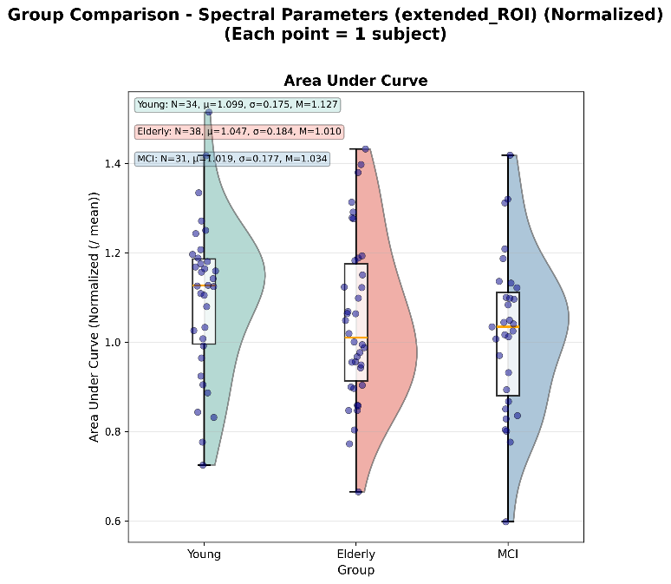

Figure 8. ROI AUC comparison. ISFS strength within the pre-defined central-parietal ROI, per-subject normalized. The ROI is the set of central-parietal electrodes defined a priori from the young-adult AUC hotspot of Dimitriades et al. (2024). Each dot is one subject's mean across the successfully fitted ROI electrodes. The group means followed the expected order (young 1.10, elderly 1.05, MCI 1.02), but the three-group comparison was not significant (one-way ANOVA, p = 0.194).

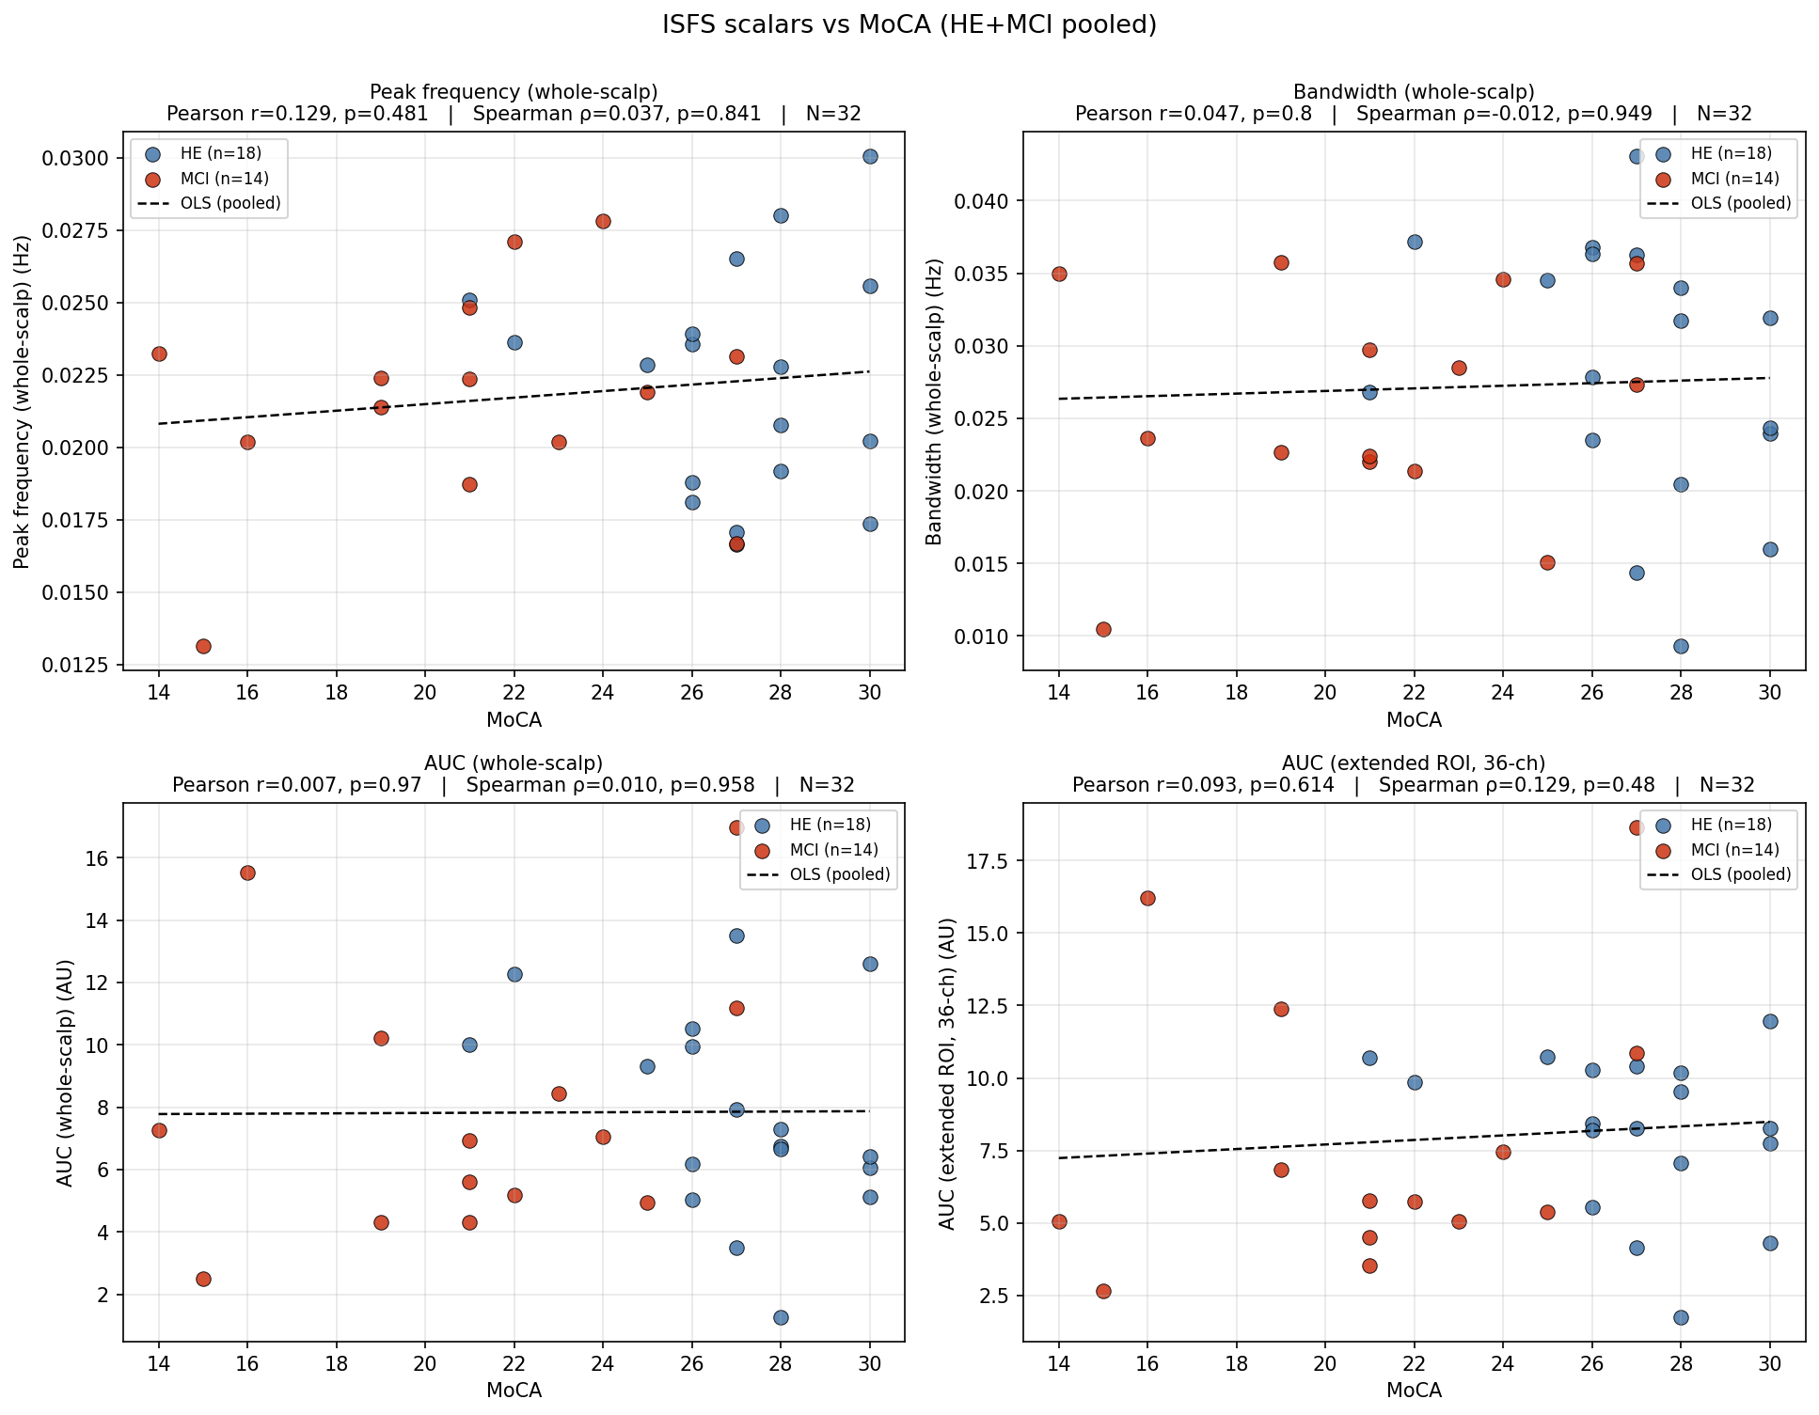
Figure 9. ISFS metrics × MoCA correlation grid. ISFS scalars against the Montreal Cognitive Assessment (MoCA) in the pooled elderly and MCI sample (n = 32). Each panel plots one scalar (peak frequency, bandwidth, whole-scalp AUC, or ROI AUC) against MoCA score. No scalar correlated with MoCA (all |r| ≤ 0.13, all p ≥ 0.48; Pearson and Spearman).

