Beyond Arousal: The Locus Coeruleus–Norepinephrine System as a Multimodal Orchestrator of Sleep Physiology

Yuval Nir^{1,2,3,4,5,*}, Noa Matosevich^{1,2,*}, Noam Zelinger^{1,2}, Rotem Falach^{1,2}, Uddi Kimchy^{1,2}, Noa Regev^{1,2}

¹ Department of Neuroscience and Brain Disorders, Gray Faculty of Medical and Health Sciences, Tel Aviv University, Israel, Tel Aviv, Israel.
² Sagol School of Neuroscience, Tel Aviv University, Tel Aviv, Israel.
³ Department of Biomedical Engineering, Faculty of Engineering, Tel Aviv University, Tel Aviv, Israel.
⁴ Sagol Brain Institute, Tel Aviv Sourasky Medical Center, Tel Aviv, Israel.
⁵ The Sieratzki-Sagol Center for Sleep Medicine, Tel Aviv Sourasky Medical Center, Tel Aviv, Israel.
* These authors contributed equally

Abstract

Sleep and the locus coeruleus–norepinephrine (LC–NE) system are linked by a reciprocal relationship with broad implications for arousal, sensory processing, memory, brain recovery, stress, and neurodegeneration. Recent advances, including genetically encoded NE sensors, high-resolution imaging, and pupillometry during sleep, are transforming the study of LC–NE dynamics across species and vigilance states. In this Review, we synthesize evidence that reduced and dynamic LC–NE activities are defining features of sleep, creating neuromodulatory conditions that support its core features and functions including disconnection from the environment and restorative brain processes. Dynamic LC–NE fluctuations during sleep, particularly infraslow oscillations in NREM sleep, shape state transitions and sleep stability, memory consolidation, and cerebrospinal fluid dynamics. In turn, sleep helps recover LC-NE signaling. Across conditions ranging from anxiety and trauma to Alzheimer’s and Parkinson’s disease, abnormal and excessive LC–NE signaling intruding into sleep may represent a common mechanism linking disrupted sleep with stress-related disorders and neurodegeneration through a vicious cycle. Together, the LC–NE system emerges as a central regulator of sleep physiology, a powerful model for general understanding of how neuromodulation and sleep interact, and a promising target for treating sleep-related brain disorders.

SECTION A: Sleep, LC-NE activity, and their reciprocal relation
The intersection between sleep and the locus coeruleus-norepinephrine (LC-NE) system is drawing increasing attention, owing to the broad relevance of this neuromodulatory system across multiple neuroscience domains such as arousal, plasticity, stress and emotional coordination, autonomic regulation, neurodegeneration, glymphatic brain clearance, and interactions with other neuromodulatory systems. In addition, the LC represents a prototypical “model system” to experimentally study general interactions between sleep and neuromodulatory systems (especially wake-promoting monoaminergic systems) due to its unique structure, a well-defined genetic profile, and an expanding toolkit of experimental methods. Indeed, recent interest is bolstered by technical innovations, such as NE-specific optical sensors (e.g. GRAB_{NE}) ¹, non-invasive neuromelanin magnetic resonance imaging (MRI)² and pupillometry³, enabling increasingly sophisticated measurements of LC-NE dynamics across species to drive new discoveries. Thus, the LC-NE system and its relation to sleep represent a timely domain of interest with relevance to multiple neuroscience fields and neuromodulatory systems.

By shifting the perspective from the LC as a mere 'wake-promoting' center to a multimodal orchestrator of sleep physiology, this review aims to provide a new framework for understanding sleep not merely as a passive state, but as a dynamic process shaped by the rise, fall, and precise timing of neuromodulatory activity. Emerging evidence positions the LC-NE system as a central orchestrator of sleep architecture, plasticity, and emotional regulation, with its disruption potentially driving pathology and neuropsychiatric disease. Understanding how LC–NE dynamics interact with other brain systems across time and space may redefine sleep as a window into brain health, and as a powerful target for next-generation interventions.

We begin with an introduction to sleep and the LC-NE system and discuss their intersections. We then move on to discuss how such interactions relate to sensory processing in sleep, to functional aspects such as brain recovery and memory consolidation, and to dysfunctions and pathologies in stress and neurodegeneration. Finally, we provide an outlook for outstanding open questions and experimental tools with potential to drive the field forward.

Sleep and vigilance states

Sleep is essential for supporting multiple functions ranging from brain health, through metabolism and immunity, to memory and emotional wellbeing. It supports brain restoration at several levels including neuronal cellular and subcellular resolutions (e.g. DNA repair, macromolecule synthesis, firing rate normalization), synaptic homeostasis, and systems-wide processes such as thermoregulation or potential glymphatic clearance. Sleep is defined as a reversible state of quiescence (reduced physical activity) accompanied by reduced responsiveness to external sensory stimuli (higher ‘arousal threshold’) that is homeostatically regulated⁴. Its tight homeostatic regulation, orchestrated by interactions between circadian and homeostatic processes⁵, attests to its essential roles in supporting health and survival. Slow-wave activity (SWA, 0.5–4 Hz) is an established marker of homeostatic sleep pressure that decreases over hours of sleep, and is increased following sleep deprivation or restriction⁴.
In mammals, vigilance states of sleep and wakefulness are typically divided into three states (Fig. 1): (in red) wakefulness, marked by low-amplitude, high-frequency brain activity, high muscle tone, large pupil size (beyond effects of ambient light), and autonomic arousal (increased heart and respiration rates); (in blue) non-rapid eye movement (NREM) sleep, characterized by high-amplitude, low-frequency activity, lower muscle tone, reduced pupil size, and low autonomic arousal; and (in purple) rapid eye movement (REM) sleep accompanied by muscle atonia, wake-like brain activity, and constricted pupil co-occurring with high and less regular autonomic arousal. Broadly speaking, NREM is typically associated with the restorative aspects of sleep, and REM sleep is associated with the highest probability of vivid dreaming in humans⁶. There is substantial variability across species in the proportion of time spent in each vigilance state, and in the successive cyclic occurrence of NREM and REM sleep episodes (‘ultradian cycle’ occurring every 10–15 minutes in mice versus every 90–120 minutes in humans⁷).

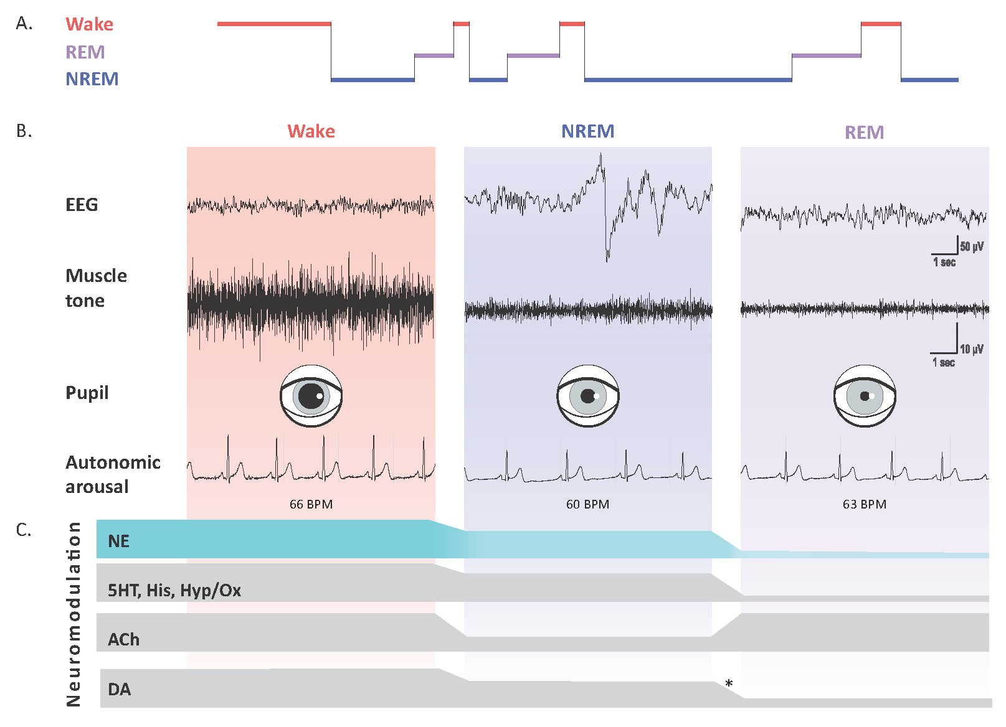
Figure 1. Vigilance states and their characteristic features and neuromodulation profiles

(A) Hypnogram (time-course of vigilance states across time) representing sleep architecture. (B) Representative features of wakefulness (left column, red), NREM sleep (middle column, blue) and REM sleep (right column, purple) including (top to bottom): EEG, muscle tone (EMG), pupil size, and heart rate representing autonomic arousal. (C) Neuromodulator levels exhibit distinct profiles across vigilance states. Asterisk marks complexity in DA signaling beyond global tonic levels, including bursts around NREM->REM transitions and regional variability.
Each vigilance state is characterized by distinct electrophysiological oscillations in brain activity. During alert wakefulness, neurons are tonically depolarized and theta (4-8Hz), beta (15-30Hz), and gamma (>30Hz) oscillations prevail. In NREM sleep, slow waves (<4Hz) represent alternations between silent OFF states (corresponding to neuronal hyperpolarization) and active ON periods (periods of neuronal depolarization rich with synaptic transmission and action potential firing) that occur synchronously among neuronal populations regionally or globally⁸. This bistable activity gives rise to high-amplitude low-frequency slow waves in the EEG. Sleep spindles, another hallmark electrophysiological signature of NREM sleep, reflect ~1s-long oscillatory events in the sigma (10–16 Hz) range, each with a characteristic waxing and waning amplitude, occurring few times per minute⁹. Sleep spindles involve thalamocortical loops¹⁰ and occur during both N2 (light NREM sleep, when spindles are most dominant and easily identified in field potentials or EEG) and also in N3 (deeper NREM sleep rich with SWA). Additional electrophysiological sleep oscillations such as hippocampal sharp wave ripples are reviewed extensively elsewhere¹¹. Finally, in REM sleep, electrical forebrain activity is similar to wakefulness with predominantly theta and gamma activity in the hippocampus and cortical networks, respectively.
LC-NE neuromodulation
During sleep, the neurotransmitter and neuromodulatory milieu change profoundly, and the shift in biochemical environment represents a fundamental aspect of sleep that orchestrates its signature oscillations and functions. Neuromodulation regulates brain activity via small populations of neurons that release modulatory chemicals such as monoamines, acetylcholine, and neuropeptides in ways that go beyond millisecond-precise synaptic transmission. Following the discovery of the ascending reticular activating system¹², several specific neuromodulatory systems were identified that promote (and are maximally active in) wakefulness^{13,14}. Levels of norepinephrine (NE), serotonin (5HT), histamine, and hypocretin/orexin (H/O) are high during wake and suppressed during NREM and REM sleep^{15–19}. By contrast, acetylcholine (ACh) levels are high during both wakefulness and REM sleep and decrease during NREM sleep²⁰. Tonic dopamine (DA) levels are high during wakefulness, lower in NREM sleep, whereas REM sleep is associated with more complex profiles including overall low tonic activity co-occurring with bursts (e.g. around REM onset) and regional variability²¹ (Fig. 1C). Furthermore, neuromodulatory activities causally drive awakenings. Optogenetic activation of H/O neurons in the lateral hypothalamus²², NE neurons in the locus coeruleus²³, and 5HT or DA neurons in the dorsal raphe nuclei^{19,24} promote sleep-to-wake transitions. Beyond neuromodulators, additional thalamic populations promote rapid awakening from NREM sleep, but not awakenings from REM sleep ^{25,26}.
Among the central wake-promoting neuromodulators, NE is a catecholamine that also has additional functions as a stress hormone and as a transmitter in the sympathetic nervous system. In the brain, it is secreted by seven noradrenergic cell groups (A1-7). The main cell group projecting to the forebrain is the LC (A6) located in the pons by the fourth ventricle, originally discovered due to its fluorescence in the presence of formaldehyde²⁷. LC neurons receive highly diverse afferent inputs from cortical, subcortical, and brainstem regions, including the prefrontal cortex, amygdala, hypothalamus, thalamus, and sensory nuclei. They project widely to most regions of the brain and spinal cord, primarily in an ipsilateral manner²⁸ , and are the sole source of NE to the forebrain²⁹. A major ascending projection travels in the medial forebrain bundle up to the anterior commissure, and then innervates the diencephalon and telencephalon, with the thalamus being a central target receiving dense projections. The fact that all forebrain NE is secreted from a compact and relatively homogenous region has made it appealing for experimental interrogation (e.g. compared with ACh or DA released from multiple locations, or highly heterogeneous regions such as the hypothalamus). NE receptors are distributed throughout the brain and can elicit either excitatory postsynaptic potentials (via α1 receptors), inhibitory presynaptic potentials (via α2 receptors)^{30–32} or functionally mixed effects (via β receptors) that are typically excitatory or modulatory (Fig. 2B & BOX 1).
Box 1 – NE receptors
Many drugs and causal experimental interrogations of LC-NE activities rely on pharmacological interventions (e.g. reuptake inhibitors, monoamine oxidase inhibitors) and on modulating of NE receptors via agonists and antagonists. Different receptor types, their affinity for NE, and their activation by different NE levels influence the results of such pharmacological interventions and their interpretation. Adrenergic receptors can be categorized into four α1 subtypes (α1A, α1B, α1D, α1L), four α2 subtypes (α2A\D, α2B, α2C³³ ), and three β subtypes (β1, β2, β3). The α2 receptors, which have a high affinity for NE, become activated at moderate NE levels, whereas α1 have intermediate affinity, and β receptors have lower affinities for NE and are activated only at higher concentrations³⁴. The α1 receptors are primarily postsynaptic and excitatory, expressed throughout the brain and body, including arterial and venous tissues, the heart, and other internal organs. In contrast, α2 receptors primarily function as presynaptic inhibitory autoreceptors. The α2A\D subtypes are predominantly expressed in the brain^{35–38} , making their selective pharmacological modulation particularly relevant to brain-specific interventions. The β receptors can be either pre- or post-synaptic and facilitate various physiological responses, including the regulation of blood pressure. While the β3 subtype is absent from the brain, the β1 and β2 subtypes are present in both the brain and peripheral tissues³⁶ .
NE is synthesized within the nerve axon from tyrosine. First, tyrosine is converted to DA by the enzyme tyrosine hydroxylase (TH). Dopamine is subsequently transported into vesicles, where it is converted to NE by dopamine β-hydroxylase (DBH). Importantly, in addition to NE, LC axons co-release several other neurotransmitters including DA, galanin, neuropeptide Y (NPY) and corticotropin-releasing hormone (CRH) (see ³⁹ for recent review).
Traditionally, LC-NE neuromodulation has been viewed as homogeneous for several reasons. Individual LC neurons, even when integrating information from diverse brain regions, are highly interconnected^{40,41}, their activity can be synchronized electrically via gap junctions⁴² , and NE is secreted from varicosities along distributed unmyelinated axons rather than at compartmentalized synapses. However, LC efferents display projection-specific structural heterogeneity⁴³ and LC ensembles may often show only sparse synchronization⁴⁴. Indeed, it is now realized that circuit-based modularity within the LC is substantial and associated with functional, developmental, genetic, molecular, and anatomical diversity (reviewed in ⁴⁵). Accordingly, LC cells can be classified into subpopulations based on their inputs, receptor expression, molecular composition, and relation to different functional roles^{41,46,47}. For example, LC neurons projecting to prefrontal versus motor cortex differ in their molecular profiles, excitability, and their activity across vigilance states⁴⁸. Afferent inputs also exhibit partially distinct channels, targeting LC subpopulations either directly or via peri-LC GABAergic neurons, to support context-dependent neuromodulation^{49,50}.
The LC-NE system regulates a wide range of functions related to arousal, including sleep-wake transitions, forebrain EEG ‘activation’ (desynchronization) and neuronal depolarization⁵¹, autonomic regulation, as well as muscle tone and motor output. Such modulation is brought about by multiple ‘circles of influence’ ranging from direct effects of LC neurons on target neurons (e.g. in thalamus, cortex, and cerebellum), through reciprocal connections with other sleep- and wake-promoting nodes (e.g. hypothalamus, basal forebrain, brainstem), to modulation of non-neuronal targets (e.g. glia, blood vessels), brain-body interactions (e.g. via the vagus nerve), and peripheral organs (Fig. 2).
LC neurons modulate vigilance and state transitions through two distinct discharge patterns: tonic and phasic firing³¹. Tonic LC discharge is characterized by slow, stochastic firing (0.1–5.0 Hz) and determines the overall level of maintaining wakefulness and vigilance⁵². Extracellular NE levels are linearly related to tonic LC discharge rates observed across vigilance states⁵³, suggesting that these small changes in firing rates affect NE efflux. In contrast, phasic mode features a brief 10-20Hz synchronous burst of discharge across many LC units that is often followed by a 200-500ms period of firing suppression^{54,55}. Phasic responses produce higher NE release and are typically driven by salient environmental stimuli or internally generated through top-down mechanisms^{15,56}. The NE “hotspot” framework⁵⁷ proposes that phasic LC firing creates transient glutamate–NE microdomains at active synapses. These hotspots generate NE levels sufficient to recruit lower-affinity β- and α1-receptors on neurons and astrocytes, selectively enhancing excitability and prioritized neural processing beyond tonic LC activity.
Beyond arousal and sleep, LC-NE is key for several additional domains, including attention, stress, sensory processing, plasticity, learning and memory, nociception, task switching, decision-making, and orienting responses toward behaviorally meaningful and salient stimuli^{50,58,59}. Some functions are regulated in a circuit-specific manner. For instance, spinally projecting versus ascending LC neurons exert opposite analgesic or pro-nociceptive effects, respectively⁶⁰. Similarly, LC → amygdala projections promote aversive learning whereas LC → prefrontal pathways drive extinction learning⁶¹.
Recent methodological advancements have significantly propelled the study of LC-NE activities. Traditionally, microdialysis and pharmacology were used to monitor and modulate LC-NE activity, respectively, with limited temporal resolution and specificity. Specificity has greatly improved with cre-expressing mouse lines (e.g. DBH and TH) and promoter-mediated transgene expression (e.g. PRS promoter) that now enable precise viral targeting of LC-NE neurons⁶² for cell type-specific monitoring (e.g. with calcium indicators) and interventions (e.g. optogenetic or chemogenetic control). Additionally, NE indicators such as GRAB_{NE} and nLightG^{63,64} monitor extracellular NE dynamics in target regions in a region-specific, temporally-precise manner with low interference from co-released biochemicals.
In human research, neuromelanin MRI and high-field (e.g. 7T) imaging have enhanced localization of the LC for structural and functional studies (see^{65,66} for reviews), overcoming some difficulties inherent to such imaging (a small region adjacent to the fourth ventricle in the pulsating brainstem). Furthermore, pupil monitoring has matured into a robust proxy for LC activity across human and animal research. Pupil dynamics represent a complex mixture of non-arousal-related processes (e.g. changes in ambient light) and arousal-related factors reflecting a wide range of neuromodulators beyond the LC-NE system. Nevertheless, pupillometry provides a valuable non-invasive tool for approximating LC-NE activity (and also for validating other LC-NE monitoring and intervention tools)^{46,67–69,3,70–72}.
Collectively, these advancements have led to substantial progress in monitoring and manipulating LC-NE activity in freely behaving and sleeping conditions across species, enabling several important recent discoveries discussed below.

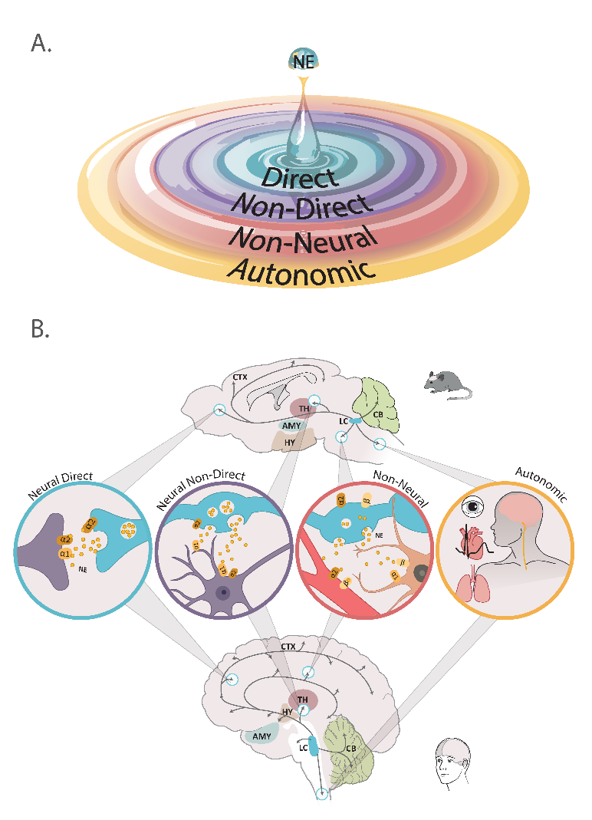
Figure 2. The locus coeruleus norepinephrine (LC-NE) system
(A) LC-NE system exerts its influence on sleep-related processes via several “circles of influence”. These include (from center to periphery) direct effects of NE on target neurons, effects on intermediate nodes (e.g. thalamus) that then affect target neurons, non-neuronal targets, and effects on autonomic system and peripheral targets. (B) Schematic illustration of main LC projections as viewed in mid-sagittal brain section in rodents (top) and humans (bottom). Inset circles (left to right) show zoon-in on (i) cyan: neural direct effects: LC-NE axon terminal affects the target neuron through release from varicosities, and NE release into synapse harboring different NE receptors. (ii) purple: neural non-direct effects of LC neurons on intermediate nodes (e.g. thalamus, other brainstem regions) then influence target neurons (iii) red: modulation of non-neuronal targets (e.g. glia, blood vessels), and (iv) orange: autonomic effects on peripheral organs that ultimately feedback to the brain to affect sleep and arousal.

Relation between sleep and LC-NE activity
LC firing rates are highest during wakefulness, decrease significantly during NREM sleep, and become nearly silent during REM sleep¹⁵ (Fig. 3A). While this pattern is shared by several monoaminergic neurons, a key feature of LC neurons is that enhanced firing is already observed immediately upon waking compared to other neuromodulators, highlighting the central role of LC-NE activity in mediating awakening from sleep.
In NREM sleep, LC firing occurs specifically around transitions from OFF to ON periods of slow wave activity³, and is reduced during spindles¹⁵. Furthermore, an important recent discovery is that during NREM sleep, LC activity and NE levels across multiple brain regions (e.g. thalamus, basal forebrain, brainstem) exhibit an infra-slow oscillation (ISO: ~0.02 Hz or ~50-second cycles). During such ISOs, NE peaks are associated with more micro-arousals, while decreased NE levels are associated with spindle occurrence (NE release in thalamus reduces spindles), and with increased propensity to transition into REM sleep^{73–75}(Fig. 3B). ISOs in arousal during NREM sleep emerge as an important organizing element beyond LC-NE activity, with associated fluctuations in heart rate and pupil size across mice and humans, synchronized modulations in other modulatory systems such as 5-HT and ACh⁷⁶, and analogous evolutionary conserved rhythms across reptiles and mammals⁷⁷.
Beyond correlative observations, causal interventions further define the role of LC-NE activity in vigilance states and their transitions. Optogenetic LC activation induces immediate awakening from natural sleep^{23,68,78}; pharmacogenetic LC activation accelerates emergence from anesthesia⁷⁹ and desynchronizes cortical EEG activity⁸⁰. Conversely, inhibition of NE signaling (for example via α2 agonists such as Clonidine, Xylazine, or Dexmedetomidine) promotes sedation⁸¹, while LC inhibition increases synchrony in cortical population activity⁸² and blocks the wake-promoting effects of orexin neurons⁸³.

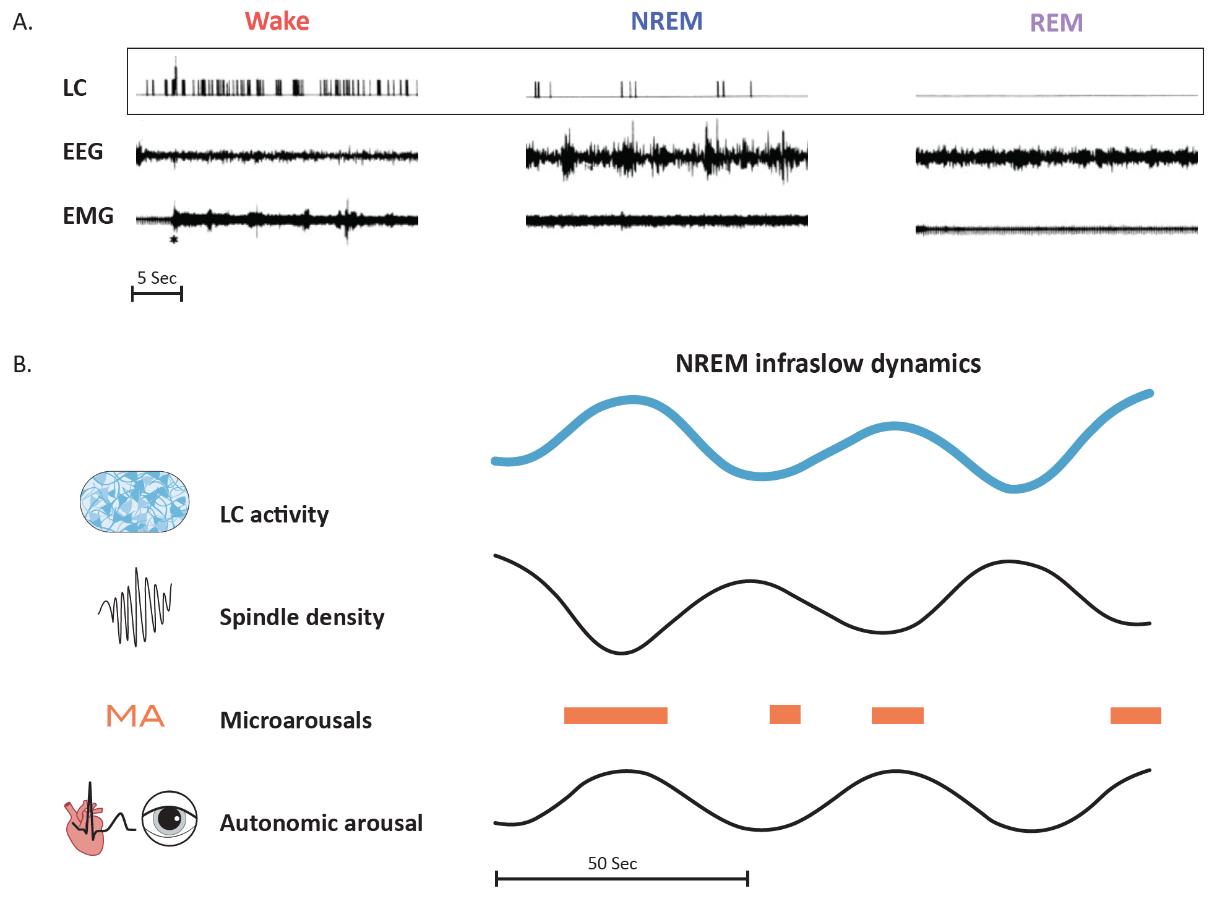
Figure 3 LC-NE neuronal discharges across wakefulness and sleep and NREM infraslow dynamics

(A) Rat LC single neuron activity (upper row), along with EEG (middle row), and EMG (bottom row) during wake, NREM sleep, and REM sleep. Asterisk marks awakening from sleep associated with enhanced LC firing. Adapted from¹⁵. (B) Schematic illustration of NREM sleep infraslow oscillation (ISO) dynamics. Rows (top to bottom) denote oscillatory dynamics of LC activity around ~0.02Hz, anti-correlated sleep spindle activity and concomitant fluctuations in autonomic arousal (e.g. heart rate and pupil diameter).

Beyond direct influence on neurons, the relation of LC-NE activity and sleep also involves interactions with glia, the immune system, and vasculature (Fig. 2B). Glia (astrocytes and microglia specifically) serve as sleep-regulating effectors via intracellular Ca²⁺ signaling mechanisms that depend on NE levels. Tonic LC activity likely sets baseline astroglial excitability and brain-state-dependent responsiveness, whereas phasic LC bursts evoke large synchronized astrocytic calcium transients through α1-adrenergic signaling⁸⁴. An emerging theme is that NE may act as a state-dependent switch for astrocytes, keeping them in a “wake-like” configuration when tonic levels are high, and releasing this constraint during sleep, when tonic NE reductions drive changes in astrocyte volume and calcium signaling that expand extracellular space and enable metabolite clearance⁸⁵ (see also ‘LC-NE and brain restoration in sleep’ below). Indeed, astrocytes dynamically change their activity across the sleep–wake cycle^{86–89} and are linked to sleep homeostasis^{87,90–92}. Astroglial calcium activity levels ramp with sleep need, and their homeostatic response to sleep deprivation is modulated by NE⁹³. Similarly to extracellular NE levels, astrocytic calcium activity is highest in wake and lowest in REM sleep⁸⁷, and astrocytes become less synchronized during sleep when NE levels are lower. Moreover, astrocytic Ca²⁺ signals upon awakening are triggered by NE⁸⁶. NE is also involved in how sleep and sleep loss modulate microglial immune activity across the sleep-wake cycle^{94–96}. The role of microglia in sleep regulation, and how NE may dynamically modulate this regulation, require further investigation^{97–99}.
The relation between sleep and LC-NE activity also affects hemodynamics. NE is a potent vasoconstrictor¹⁰⁰ (particularly of big blood vessels) that raises blood pressure, heart rate, and cardiac contraction force through α1 and β receptor actions and modulates blood-brain barrier (BBB) permeability^{101,102}. Thus, NE fluctuations across sleep and wakefulness represent a potent modulator of vascular dynamics either directly, or through their interplay with astrocytes that generate ultra-slow arteriole oscillations¹⁰³. Sleep-related changes of blood flow dynamics reveal state-specific arteriole vasomotion, coupled to reciprocal changes in the perivascular spaces. Notably, during NREM sleep, slow high-amplitude oscillations of blood vessel diameter co-occur with increased cerebrospinal fluid (CSF) peak velocities⁸⁶. The robust effects of NE on hemodynamics must also be considered when interpreting any BOLD fMRI studies of sleep and wakefulness, as the relation of the BOLD signal to local neuronal activity is bound to be altered. Indeed, a recent study combining fMRI, EEG, and pupillometry identified pupil-locked modulations of cerebrovascular fluctuations compatible with NE-driven vasoconstriction, where attentional lapses were linked to pupil constriction likely reflecting low NE¹⁰⁴. These results, combining measures of neuronal activity and vasculature, further illustrate how the relation between LC-NE activity and sleep spans multiple ‘circles of influence’ (Fig. 2B).
Finally, in addition to sleep, the LC-NE system also exhibits a bidirectional multi-level relation with the circadian system. Gene expression regulating NE synthesis in the LC follows circadian rhythms¹⁰⁵ and disrupting the LC gene expression decreases wakefulness during the dark phase, but not the light phase of rodents ¹⁰⁶. Circadian signals affect the LC primarily via indirect pathways from the main circadian clock centered in the suprachiasmatic nucleus (SCN) through the dorsomedial hypothalamus to the LC¹⁰⁷. Additional relays through hypothalamic and orexinergic systems shape time-of-day differences in LC firing and arousal¹⁰⁸. The extent to which LC feedback to the circadian system influences clock function and circadian physiology is less clear (see Future Directions).

SECTION B: Functional implications and consequences
LC-NE modulation affects many processes related to sleep, ranging from disconnecting from the environment, through offline memory consolidation, to restorative brain processes. As such, its activity (or lack thereof) is key for supporting the functional benefits of sleep; conversely, conditions when LC-NE activity is abnormal are associated with sleep disruptions and associated clinical pathologies.

Low LC-NE promotes deep sleep, disconnected from sensory stimuli

Multiple lines of evidence support the notion that LC-NE activity mediates full-fledged responses to sensory stimuli, including their perception and ability to drive behavioral responses, whereas reduced LC-NE activity in sleep supports reduced responsiveness (higher arousal threshold). In other words, “deep” (unarousable) sleep is tightly associated with low LC-NE activity, whereas light fragmented sleep is tightly associated with high LC-NE activity.
In wakefulness, LC activity regulates sensory processing according to behavioral demands³¹ and exhibits burst responses to sensory stimuli across multiple modalities— particularly for novel, salient, or surprising events^{31,109}. Furthermore, LC-NE activity modulates the signal-to-noise ratio (SNR) within sensory circuits¹¹⁰ via a dual mechanism: NE reduces GABAergic suppression of postsynaptic targets (thereby increasing responses to excitatory inputs) and simultaneously enhances presynaptic GABA release (amplifying surround inhibition). Together, these actions focus and amplify cortical responses to relevant stimuli^{57,111}. Along this line, pharmacological boosting or suppression of NE signaling in humans modulates the perception of liminal sensory stimuli and associated brain responses¹¹².
During sleep, the reliable processing of sensory information is replaced by "sensory disconnection", a state in which the probability of a stimulus eliciting a behavioral response is significantly reduced¹¹³. Despite its ubiquity, the neural pathways underlying this disconnection remain poorly understood^{73,114–116}. Whether a stimulus will awaken a subject depends both on stimulus properties such as its intensity¹¹⁵ and its behavioral relevance¹¹⁷, as well as on the internal state. For example, arousal threshold depends on sleep stage (NREM vs. REM sleep), slow wave activity, and sleep spindles^{115,118}.
Recent evidence identifies LC-NE activity as a major determinant of awakening by sensory stimuli such as sound-evoked awakening (SEA), beyond its involvement in spontaneous awakenings (Fig. 4). In rats, weak optogenetic LC activation during sleep increases the probability of SEA whereas optogenetic LC silencing has the opposite effect⁶⁸. Interestingly, LC-NE mediation of SEA is facilitated by a selective LC projection pathway to the brainstem pontine reticular nucleus (PRN)⁷⁸ , indicating that modular LC-NE activity plays a role even in the domain of arousal and awakening.
Importantly, sensory-evoked awakenings are not only related to stimuli from the external environment but also involve interoceptive information regarding respiration (e.g. low O₂ and high CO₂ prevalent in obstructive sleep apnea), pain and cold signals, as well as urination drive^{13,119}. In a way, what we call ‘spontaneous awakenings’ may often (or even entirely) be driven by sensory signals from within the body that sleepers do not consciously monitor and experimenters do not consider. Many such signals are processed by brainstem nodes such as the parabrachial nucleus (PB), nucleus of the solitary tract (NTS), and the periaqueductal gray matter (PAG), which have strong connections with the LC. For example, PAG neurons change their excitability due to LC activity to promote awakening just before bladder pressure reaches the threshold for voiding¹²⁰
Another important link between LC-NE activity and disconnection relates to sleep spindles, associated with increased arousal thresholds in sleep^{121,122}. Indeed, LC-NE activity causally suppresses spindles⁷³, and LC infraslow oscillations during NREM sleep are anticorrelated with spindle power⁷³. Thus, heightened LC-NE activity and low spindle occurrence represent windows of relative sensitivity to awakening by stimuli, whereas lower LC-NE activity and high spindle occurrence define moments of higher disconnection from the environment^{114,73,123}. Altogether, LC-NE is a key factor mediating awakenings and its low activity throughout most of sleep is key for maintaining sensory disconnection.
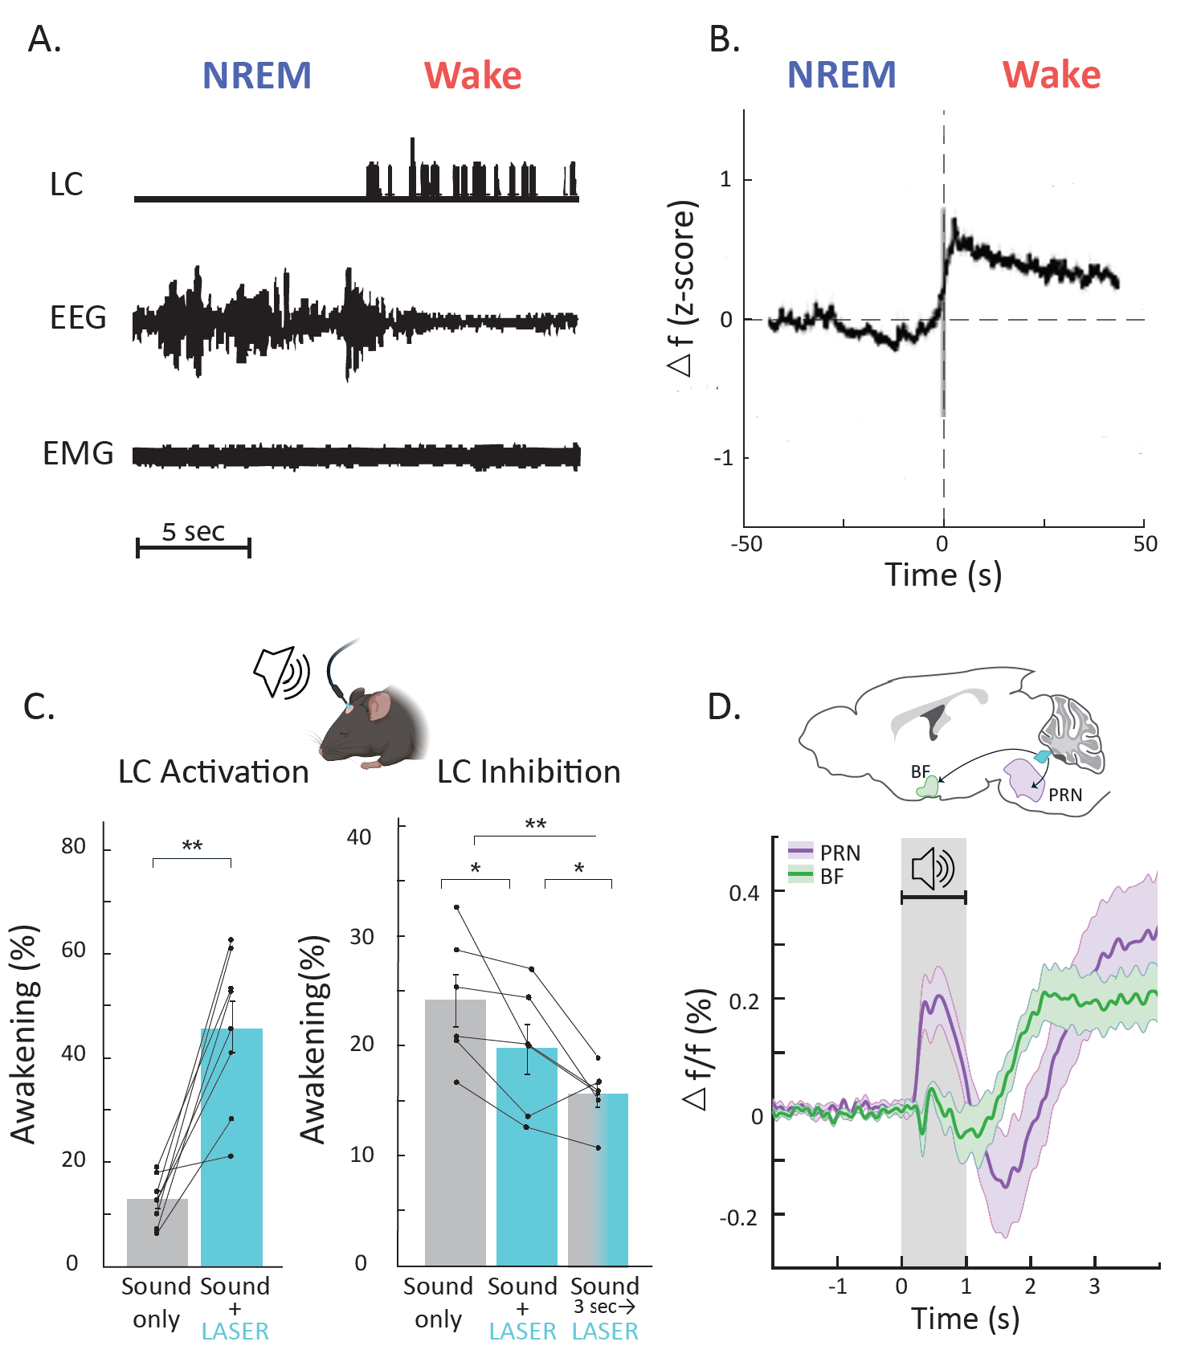
Figure 4 LC-NE activity around spontaneous and stimulus-evoked awakenings

(A) Rat LC neuronal discharges around spontaneous NREM-to-wake transition reveal firing prior to EEG activation and awakening (adapted from ¹⁵). (B) Mouse LC calcium activity recorded with GCaMP fiber photometry reveals similar increased activity beginning in the few seconds prior to spontaneous awakening (adapted from ¹²⁴). (C) Optogenetic enhancement (left) or suppression (right) of LC activity in rats (‘laser’ conditions, x-axis) increases or decreases the probability for sound-evoked awakening in rats compared with sensory stimulation alone (‘sound’ conditions, x-axis; adapted from ⁶⁸). (D) NE dynamics in pontine reticular nucleus (PRN, purple) or basal forebrain (green) reveal projection-specific early surge of brainstem NE associated with sound-evoked awakening (adapted from ⁷⁸).
LC-NE, brain restoration, and sleep homeostasis
LC-NE dynamics are associated with sleep-dependent restoration of brain resources. In wakefulness, LC activity drives neuronal gene expression related to synaptic plasticity and immediate early genes including Arc, BDNF, c-fos, and nerve growth factor inducible-A (NGFI-A)¹²⁵ whereas reduced LC-NE activity in sleep may be necessary for the unique profile of gene expression that promotes processes such as cellular and lipid transport, macromolecule biosynthesis, proteostasis, and DNA and mitochondrial repair. Indeed, low LC-NE activity increases the expression of the sleep-related gene encoding the translation elongation factor 2 (eEF2) that controls the rate of protein synthesis¹²⁶, yet direct evidence for modulation of other restorative-related genes is still lacking.
Over the past 15 years, restorative processes in sleep have received renewed attention with interest in the glymphatic system and the emerging relation between LC-NE dynamics and CSF flow. Already at the time of its original discovery¹²⁷, it was observed that Xylazine anesthesia (suppressing NE signaling as an α2 agonist) is associated with enhanced CSF flow even more than during natural sleep. A recent study further claims that ISOs in LC-NE activities during NREM sleep drive pulsatile CSF flow that removes toxic metabolic waste byproducts¹²⁸, yet some controversy persists regarding the relation between sleep and glymphatic clearance^{127–131}. The relation between NE and CSF dynamics is also supported by recent research in awake humans, linking pupil constriction, CSF flow changes, and attentional lapses after sleep deprivation¹⁰⁴. Beyond CSF and glymphatic clearance, an important emerging theme is that LC-NE dynamics (low during sleep, oscillating during NREM sleep, minimal during REM sleep) are tightly linked with its restorative functions. In fact, it could be that these LC-NE dynamics represent a core feature of sleep that could be both necessary and sufficient to bring about many or most of its restorative benefits.
Finally, the homeostasis of sleep pressure and LC-NE transmission may be linked reciprocally. Sleep homeostasis refers to the process by which sleep features such as its amount, timing, and intensity are regulated by previous wakefulness⁵. A progressive accumulation of sleep need in wakefulness leads to a proportional increase in SWA during NREM sleep, and several mechanisms are suggested to be involved including adenosine signaling and proteome/transcriptome changes. Interestingly, this homeostatic response is blunted after NE depletion, indicating that LC-NE is causally related to sleep need buildup. Moreover, recent studies find that activation of LC, but not other arousal-promoting neurons, increases sleep propensity ¹³². Thus, functional fatigue of LC neurons contributes to sleep pressure, an effect that depends on α2A receptor-mediated auto-suppression of NE release. Sleep, in turn, serves an essential role in restoring LC-NE transmission, which in mice occurs on a timescale of minutes and depends on mammalian target of rapamycin (mTOR) signaling¹³³. Together, these findings show that LC-NE activity in wakefulness builds up sleep pressure, and that low LC-NE during sleep counteracts fatigue of LC (and possibly other neuromodulatory) neurons, restoring their ability to sustain wakefulness once again.

LC-NE and sleep-dependent memory benefits
Another fundamental function of sleep is memory consolidation. Dynamic LC activity is strongly associated with learning and memory, including its encoding, consolidation, and retrieval^{134–136} and thereby modulates the ways by which sleep benefits memory. Specifically, LC activity drives both NE and DA pre-synaptic release, enhances plasticity and memory (particularly during memory acquisition and in relation to novelty), and modulates hippocampus excitability^{137–140} (reviewed in¹⁴¹). Additionally, in fear learning LC-NE amplifies amygdala plasticity during salient or threatening events, strengthening cue-outcome associations, while simultaneously modulating medial prefrontal cortex (mPFC) control over emotional responses by inhibiting amygdala output during extinction⁶¹.
The role of LC-NE during offline memory consolidation, and specifically during sleep, is attracting attention but evidence is yet to be established. Reduced or silent LC-NE activity in sleep, its dynamic ISOs in NREM sleep, and specific moments of heightened activity on a quiet background, may all serve roles for offline memory consolidation.
In general, both NREM and REM sleep contribute to offline memory consolidation across diverse types of learning and memory systems¹⁴². Most evidence suggests that reduced or silent LC-NE activity provides optimal conditions for offline memory consolidation¹³⁹. Low LC-NE and other neuromodulatory activity, combined with synchronous ON and OFF firing patterns, favor global synaptic downscaling associated with sleep benefits for plasticity¹⁴³. In mice, descending phases of extracellular NE oscillations drive spindles, associated with plasticity¹⁴⁴ and offline memory consolidation⁷⁵. Along this line, LC suppression that induces spindles also improves memory, while elevating LC-NE activity pharmacologically impairs memory⁷⁵, possibly by fragmenting sleep¹⁴⁵. In the context of hippocampal-dependent consolidation and replay, moments of pupil constriction during natural mouse sleep, indexing low LC-NE activity, represent privileged moments for memory consolidation, and causal disruption of sharp wave ripples during such moments impaired consolidation of recent memories¹⁴⁶. Finally, during REM sleep, quiescence of LC-NE neurons may enable emotional memories to be woven into existing memory networks while weakening the accompanying arousal signals in limbic regions ¹⁴⁷. Emotional memories likely benefit from REM sleep when reduced NE signaling could facilitate the resolution of emotional distress.
At the same time, other studies point to moments of heightened LC-NE activity in NREM sleep as pro-plastic windows associated with elevated cAMP levels, greater hippocampal-cortical connectivity, and ripples¹⁴⁸. Similarly, rare yet precisely timed LC-NE activity on a quiet background may nevertheless play important roles in sleep-dependent memory consolidation¹⁴⁹. The temporal locking of LC firing to sleep oscillations such as slow waves, implicated in memory consolidation provides support, albeit indirectly, for the notion that LC firing relates to memory consolidation. Indeed, a transient increase in LC activity is observed in rats during slow wave sleep in the hours after learning¹⁵⁰, and the presence of adrenergic antagonists may interfere with learning^{139,151}.
Finally, LC-NE may also modulate sleep-dependent memory consolidation via its effects during memory acquisition in wakefulness, as it has been suggested to ‘tag’ specific circuits and synapses for subsequent consolidation during sleep¹⁵² and promote memory linking¹⁵³. Future work is needed to elucidate in more detail the ways by which LC-NE activities support sleep-dependent memory consolidation.

SECTION C: LC-NE and disrupted sleep
Altered LC-NE activity spans a continuum from normal variability to clinical pathology. Across a range of conditions, LC-NE dysregulation co-occurs with disturbances in sleep, underscoring a tight bidirectional coupling between these systems. A recurring theme is that when diverse processes converge on LC-NE hyperactivity during sleep, it promotes sleep fragmentation and impairs the restorative functions essential for recovery (Fig. 5). A growing discourse highlights a three-way link between the LC-NE system, sleep, and behavioral phenotypes such as stress or cognitive impairment that may amplify pathology via a vicious cycle. While bilateral relations between LC and conditions such as stress and neurodegeneration are well established, the mediating role of disrupted sleep in such processes is under appreciated. Importantly, LC’s bidirectional relationship with pathology during sleep highlights its potential as both a biomarker and a therapeutic target.
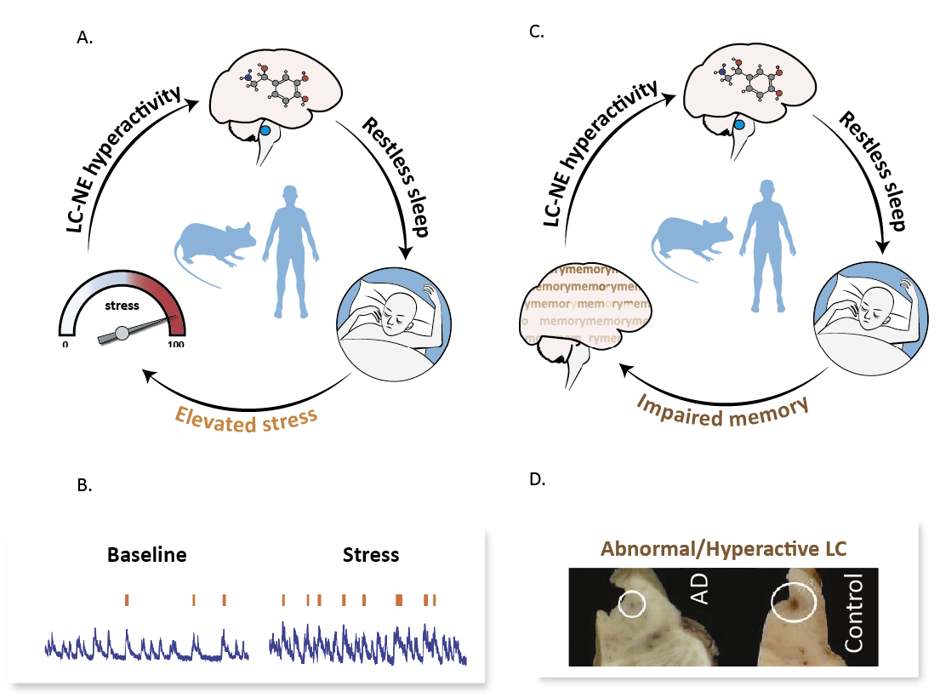

Figure 5 Maladaptive progressive dysregulation of LC-NE and sleep in stress and neurodegeneration

(A,C) Schematic illustration of progressive dysregulation associated with LC-NE hyperactivity (e.g. due to stress, or compensation due to cellular degeneration in early Alzheimer’s) that can promote sleep disturbances. Disrupted sleep, in turn, amplifies impaired functionality (e.g. in emotional regulation, or accelerating cognitive decline and neurodegeneration) that, in some cases, can further drive LC hyperactivity thereby promoting a ‘viscous cycle’. (B) Mouse LC calcium activity during NREM sleep (blue traces) during baseline conditions (left) and after 2h of stress due to restraint (right). Orange ticks mark micro-arousals that are more evident after stress and are linked with abnormal LC-NE dynamics (adapted from⁷⁴). (D) Histopathologic changes in LC during AD (left circle) showing the absence of the darkly pigmented neuromelanin evident in a section from healthy control individual (right circle), adapted from¹⁵⁴

LC-NE and sleep in stress and anxiety
The relationship between LC-NE and stress is well-established^{155,156}. The LC is exquisitely sensitive to stressors, and NE secretion in the sympathetic system shifts the brain and body into an aroused ‘fight-or-flight’ response. The NE surge that occurs during acute stress is beneficial to the following adaptive sleep rebound that typically follows¹⁵⁷. In parallel, the link between stress and sleep disruption is equally robust^{158,159}. Continuous stress leads to disrupted sleep and frequent arousals (sleep fragmentation). Importantly, this relationship is bidirectional: while stress disrupts sleep, the lack of restorative sleep following acute stress impairs emotional regulation and hinders the normalization of the Hypothalamic–Pituitary–Adrenal (HPA) axis¹⁶⁰, thereby amplifying progressive dysregulation (Fig. 5A,B).
An increasingly explored hypothesis posits that LC-NE hyperactivity during sleep is a primary mediator of stress-induced sleep disturbances¹⁶¹. Accordingly, stress may cause LC activity to “leak” into sleep and prevent the brain from reaching deep restorative depths by prolonging bouts of high LC activity, destabilizing NREM infraslow oscillations, driving sleep fragmentation, and delaying REM sleep onset¹⁶². Indeed, stress-induced LC activity during NREM sleep drives micro-arousals and suppresses sleep spindles⁷⁴. Causal opto- and chemogenetic interventions reveal that LC activation mimics stress-induced sleep deficits, whereas inhibiting specific LC->hypothalamic preoptic pathways restores sleep quality and normalizes REM latency⁷⁴. Still, these experiments employ acute short-term adaptations, which are important to distinguish from chronic pathological manifestations. Acute stress involves both emotional reactivity and behavioral hyperarousal mechanisms designed to ensure survival. However, when these responses fail to terminate or are triggered by trauma, they may evolve into chronic conditions such as Post-Traumatic Stress Disorder (PTSD) and Generalized Anxiety Disorder (GAD). The involvement of LC-NE hyperactivity during sleep in such chronic conditions awaits additional mechanistic longer-term animal experiments.
In humans, converging evidence indicates that physiological LC–NE activity is central to emotional homeostasis. Across subclinical and clinical populations, dysregulation of LC–NE signaling and sleep can progress from a transient state to a pathogenic driver, with the bidirectional interaction between stress and LC–NE hyperactivity increasingly intruding into sleep. For example, in healthy individuals sleep deprivation leads to elevated pupil reactivity in response to negative emotional stimuli, suggesting LC sensitization¹⁶³. Without adequate sleep, the LC may lose its top-down regulation and amplify affective vulnerability¹⁶³. Longitudinal monitoring of combat soldiers indicates that elevated heart rate during sleep, reflecting autonomic hyperarousal, is a robust predictor of future PTSD severity, suggesting that dampening nocturnal adrenergic tone may be required for normalizing trauma¹⁶⁴. Indeed, patients with anxiety and PTSD exhibit elevated LC responses to unpredictable threats¹⁶⁵, and shorter sleep in these patients is associated with insufficient nocturnal decline in NE metabolites¹⁶⁶. The brain origin of such excess NE is supported by CSF studies associating NE hyperactivity with symptom severity¹⁶⁷. Interventional studies further indicate that blocking postsynaptic NE signaling with Prazosin (α1-antagonist) reduces trauma-related nightmares and sleep disturbance in PTSD patients¹⁶⁸. Collectively, these findings support the notion that excessive LC-NE activity during sleep is a significant and modifiable contributor to these stress-related pathologies and sleep disruptions. Despite these findings, causal interrogation of the LC-sleep-stress triad awaits further studies that test this hypothesis more directly and specifically (see Future Directions).
LC-NE and sleep in neurodegeneration
In healthy aging, postmortem histology shows minimal structural damage to the LC^{169,170} and NE concentration across brain regions remains relatively stable¹⁷¹. By contrast, LC structure and activity are substantially affected in neurodegenerative diseases such as Alzheimer’s disease (AD) and Parkinson’s disease (PD), where early pathology in the LC emerges as a key factor in disease progression¹⁷².
In AD, LC is the primary site for the accumulation of hyperphosphorylated tau (p-tau) and neurofibrillary tangles (NFTs). Such accumulation occurs as early as the fourth decade of life, decades before clinical symptoms manifest¹⁷³. LC degeneration in AD follows a two-phase process¹⁷⁴: initially, p-tau burden causes axonal and dendritic loss and functional impairment without significant cell death¹⁷⁰. By the time mild cognitive impairment (MCI, early AD stage) is diagnosed, LC volume declines by ~30%^{170,175,176}, eventually reaching 60–80% neuronal loss in advanced disease stages¹⁷⁷. This structural decay correlates with reduced NE across the cingulate, hypothalamus, and striatum^{178,179}. LC neuromelanin-MRI can quantify LC structural decay and has proven to be a powerful predictive tool for identifying MCI patients who will eventually convert to AD¹⁸⁰.
Despite LC cell loss, biochemical evidence suggests a compensatory hyperactivity of remaining LC neurons in early AD, where patients exhibit increased CSF NE and metabolites concentrations alongside decreased α2 adrenergic receptor expression, suggesting reduced auto-inhibition of neuronal activity^{181,182}. In advanced AD, this hyperactivity is believed to be exhausted. This is functionally mirrored by pupillometry: healthy aging is characterized by tonic hyperactivity that blunts phasic pupil responses to non-targets yet preserves pupil response to target stimui¹⁸³, hinting for early hyperactivity. Meanwhile, advanced AD eventually leads to global LC-NE failure, where structural integrity is so compromised that pupil dilations become smaller and slower even for salient targets¹⁸⁴. How LC-NE hyperactivity abruptly transforms into LC-NE failure remains poorly understood and awaits further investigation.
In line with this evidence, it is hypothesized that compensatory LC-NE activation is among the drivers for the sleep fragmentation and insomnia prevalent in ~50% of AD patients, representing one of the earliest detectable symptoms that often appears before or around MCI diagnosis^{185–188}. A growing discourse highlights a trilateral link between the LC-NE system, sleep, and AD, suggesting a vicious cycle as may also occur in stress (Fig. 5C,D): LC-mediated sleep disruption may accelerate the neurodegenerative processes that characterize the disease^{154,189}.
Despite growing interest, few human studies have moved beyond subjective questionnaires to probe this connection with objective sleep measurements, and those that do so are still limited by specific design gaps. On one hand, research utilizing actigraphy in healthy older adults found that lower LC density correlates with fragmented wake-sleep patterns and higher day-to-day variability, specifically in those with high plasma p-tau¹⁹⁰. While these results link LC integrity to circadian and sleep stability, actigraphy lacks the sleep-stage granularity provided by full polysomnography (PSG). On the other hand, studies employing fMRI and PSG in older adults have linked higher LC activity (via an oddball task) to lower REM theta power and poor subjective sleep quality^{191,192}. However, these designs did not account for AD biomarkers, and the relation between LC activity and objective sleep metrics (e.g. SWA, sleep efficiency, or other) remains unclear. These gaps highlight the need for a unified approach: one that pairs objective PSG with AD biomarkers and LC-activity surrogates (e.g., neuromelanin-MRI or pupillometry). Without such designs, it remains difficult to pinpoint whether and which sleep-metric alterations are specifically driven by LC dysfunction in the context of AD pathology. Rodent models of AD, while allowing precise monitoring and causal interventions, are limited in that they do not necessarily reflect the LC pathology observed in patients (due to species-related differences in amyloid-β, tau, and NFT accumulation, reviewed in ¹⁹³) and LC lesions do not mimic the gradual progression of the disease (BOX 2).
In Parkinson’s disease, LC is also among the first regions to exhibit α-synuclein pathology even prior to dopaminergic substantia nigra^{194,195}, in a manner reminiscent of the early LC pathology in AD. Post mortem research indicates LC degeneration is as broad, and even more extensive, than in the substantia nigra pars compacta (SNc)^{196,197}, and is accompanied by massive cell loss in the adjacent sub-coeruleus area¹⁹⁸. These structural findings may provide a mechanistic basis for REM sleep behavior disorder (RBD): a parasomnia characterized by the loss of muscle atonia during REM sleep, leading patients to act out their dreams¹⁹⁹. Given that the sub-coeruleus is specifically responsible for mediating REM sleep muscle atonia, early degradation in and around the LC may explain why RBD often emerges as a prodromal marker decades before motor onset. Supporting this link, imaging studies have found that PD patients with RBD exhibit lower LC signal intensity compared to those without the disorder, and lower LC signals correlate with more severe atonia loss²⁰⁰. Furthermore, LC signal intensity is similarly reduced in both isolated RBD and diagnosed PD, suggesting that LC-complex degeneration may be a primary driver of this sleep pathology²⁰¹. Beyond structural degeneration, evidence for compensatory LC hyperactivity in human PD (as in AD) remains less robust¹⁷⁴.
Box 2 – LC lesions and sleep
Despite the established role of LC-NE in arousal and sleep regulation, experimental lesions typically only result in transient or negligible sleep disturbances. Extensive bilateral LC lesions via 6-OHDA do not produce significant changes to total time spent in vigilance states, and immediate effects like drowsiness or elevated EEG synchrony typically dissipate within days^{202–204}. Long-term effects are inconsistent, ranging from no alterations to sleep architecture and EEG²⁰⁵ to increases in REM sleep²⁰⁶. Similarly, DSP-4 lesions often cause only short-lived REM suppression before returning to baseline within days^{207,208} . Subsequent weeks show either circadian-dependent sleep fragmentation²⁰⁹ or no significant changes to sleep architecture^{210,211}. In human patients, lesions in the upper (rostral) pontine tegmentum that include the LC and additional regions can cause coma^{212,213} but isolated focal LC lesions are rare, precluding a direct comparison to animal studies.
The lack of a robust sleep phenotype upon experimental LC lesions likely reflects the redundancy and overlap in arousal-promoting neuromodulation, as well as compensatory mechanisms such as increased firing rates in surviving neurons²¹⁴ and rapid axonal sprouting²¹⁵ , which effectively stabilize sleep despite substantial noradrenergic damage.
Some methodological considerations should also be acknowledged. Early research employed imprecise lesioning via heat or electric shock, whereas modern toxins offer greater specificity. 6-OHDA, a toxin that specifically lesions catecholamines when injected locally, causes rapid cell death and NE depletion that mimics late-stage AD, yet surviving LC neurons may become hyperactive in compensation. DSP-4 crosses the BBB and targets LC terminals, modeling early AD projection loss; however, its effects are often transient due to axonal sprouting. Thus, future studies investigating the relation between LC damage and sleep, particularly in the context of AD neurodegeneration, should incorporate additional methods to better replicate the gradual sustained LC degeneration observed in patients.

SECTION D: Future directions
Outstanding open questions
- How specific are the relations between LC-NE and sleep, and how do they relate to other modulatory systems? In other words, is the LC-NE system simply a useful ‘model system’ for aminergic signaling and neuromodulation at large (a system where new discoveries were observed first) or, alternatively, will analogous studies focusing on other neuromodulators such as serotonin, histamine, or hypocretin/orexin reveal fundamentally different patterns? Recent works employing multi-site monitoring of neuromodulatory activities suggest that ISOs in NREM sleep are also prevalent in other modulatory systems and are largely coordinated^{76,216}. In addition, we need to better understand the functional interactions between the LC-NE system and other wake/sleep neuromodulatory circuits. Is there a hierarchy or key control nodes, or do these systems operate during sleep and state-transitions as weakly coupled oscillators? Mapping this organization may benefit from a coordinated effort across several labs sharing resources and unifying protocols, as was performed for decision making in the international brain laboratory²¹⁷.
- How do spatiotemporal complexity and modularity shape the relation between LC-NE and sleep? Given increasing evidence showcasing complexity with respect to LC cell types, input/output projections, modulator co-release, interactions with target site states and cortical cell types, and multiple temporal regimes (tonic vs. phasic, infraslow) we will need to conceptualize, design experiments, and interpret data about LC-NE and sleep with this complexity in mind. For example, most knowledge so far (for example about NE levels across vigilance states and state transitions) is from few target regions (e.g. thalamus, specific cortical regions, typically monitored separately) that may or may not generalize to other areas. Indeed, around sound-evoked awakenings, markedly different NE dynamics occur in basal forebrain and in pontine regions⁷⁸.
- How do circadian rhythms affect the relation between LC-NE and sleep? Given the known interactions between circadian and homeostatic processes in sleep regulation, and emerging links between circadian rhythms and LC–NE activity, a better understanding of circadian–LC–NE relationships is needed to address several unresolved fundamental questions. First, does LC rhythmicity reflect intrinsic clock mechanisms, or is it largely imposed by upstream circuits? Evidence for a robust cell-autonomous clock in LC neurons remains inconclusive. Second, the extent, functional significance, and specificity of LC→SCN feedback are unclear: does LC–NE signaling modulate clock gene expression and behavioral entrainment, and if so, how? Third, does LC–NE activity differentially regulate microarousals, micro-naps, and state transitions depending on circadian phase, and how are these effects mediated by the SCN and other mechanisms? More broadly, disentangling circadian and sleep-state dynamics that interact across timescales requires dedicated experimental designs and precise measurements. Addressing these questions will require combined circuit-specific manipulations, continuous multimodal recordings, and cross-species approaches to resolve how arousal systems and circadian timing are integrated in the brain, a question that is also critical for understanding functional consequences and informing future therapeutics across domains ranging from stress through glymphatic clearance to neurodegeneration.
- How do abnormalities in LC structure and activity map to specific sleep disruptions? Beyond the coarse level of current understanding linking LC dysfunctions to sleep disruptions, we need to seek a more precise mapping between specific LC patterns (altered excitability, cell loss, changes in tonic baseline or burst activities, damage to specific projections) and specific sleep disturbances (micro-arousals, changes in REM sleep duration, onset, and tonic vs. phasic aspects, disrupted NREM ISOs). Investigating such subtleties could benefit from activity-dependent monitoring and manipulation of specific LC-NE neurons (e.g. with TRAP²¹⁸ and even with finer temporal resolution in a light-gated manner using FLARE²¹⁹). From an applied perspective, such nuanced understanding may also promote future personalized treatments that employ increasingly specific interventions applied during sleep in anxiety, PTSD, and neurodegeneration.
- What is the source of LC vulnerability and what drives variability in its individual susceptibility? There are many different explanations for the vulnerability of LC cells (for example in neurodegeneration). Such explanations include high metabolic demand due to their pacemaker-like activity²²⁰ , oxidative stress from catecholamine metabolism producing toxic metabolites²²¹, accumulation of neuromelanin that binds metals and promotes oxidative reactions²²², as well as extremely widespread and energy-demanding broad axonal projections²²³. However, systematic comparisons via selective causal interventions are lacking. Future studies should therefore seek to control and selectively manipulate these factors. In addition, what differentiates individuals in whom LC activity halts its pathological decline, or even returns to a normal firing pattern, from those in whom its dysregulation continues to progress? Such understanding could advance interventions that restore a dysregulated LC-NE system to its normal state.
- What is the precise role of excessive LC-NE activity during sleep in stress-related pathologies? Despite ongoing research, interrogation of the LC-sleep-stress triad awaits studies that put this hypothesis to direct, causal, and selective tests. In humans, studies combining high-resolution fMRI and concurrent pupillometry with sleep polysomnography are needed. Moreover, we need to move beyond correlational data to determine if silencing LC activity specifically during the post-stress "window" can prevent the development of chronic sleep and stress pathologies. Animal studies that often do provide causal evidence typically focus only on responses to acute stress (which are often adaptive) and fail to capture the complex longitudinal progression of pathology associated with recurrent or chronic stress and post-trauma. Finally, understanding the relation between excessive LC-NE activity and sleep may also bear relevance to additional domains such as Attention-Deficit/Hyperactivity Disorder (ADHD) and its treatments.
- How does LC–NE activity modulate sleep-dependent benefits for memory? Despite growing interest, key mechanistic questions remain unresolved. Does the near-silence of LC–NE activity during sleep simply permit consolidation processes, or do precisely timed noradrenergic fluctuations actively gate them? Are specific phases of NREM oscillations—such as slow waves, spindles, or hippocampal ripples—preferential windows for LC influence on plasticity? To what extent do projection-specific LC ensembles shape consolidation in distinct circuits, such as hippocampal–cortical or amygdala networks? Finally, does LC activity during wakefulness and memory encoding ‘tag’ circuits for selective consolidation during sleep, and how might this process interact with neuromodulatory dynamics during subsequent sleep stages? Resolving these questions will require causal manipulation and monitoring of LC–NE activity with high temporal and circuit specificity across natural sleep.
Next-generation experimental tools
In animal models, methods should go beyond monitoring LC neuronal activity and extracellular NE dynamics to develop and fine-tune methods that investigate additional aspects of LC-NE signaling, such as receptor-specific activation, co-release beyond NE, and reuptake (NET) in specific target regions and cell types. In particular, optical monitoring and manipulation of specific alpha/beta receptor activities with high temporal resolution during sleep and state-transitions is bound to drive novel discoveries given the receptor-specific modulation of sleep activities²²⁴. New and improved animal models are also needed, for example in the context of gradual neurodegeneration and prodromal LC dysfunctions, and for separating maladaptive responses vs. short-term adaptive responses to stress and sleep.
Finally, animal research could provide essential ground truth and a bridge for developing next-generation tools for non-invasive monitoring and manipulation of LC structure and LC-NE activities that could subsequently be applied also in humans. Such tools could include some molecular tagging that is specific for LC-NE for imaging-based measurements of LC neuronal activity and NE dynamics (e.g. with MRI/fMRI, and ultimately in ambulatory home settings).
In terms of non-invasive monitoring, pupillometry during sleep is emerging as a powerful indirect readout of LC-NE dynamics across species including rodents¹⁴⁶ and in human sleep^{225,226}. A recent study also shows that pupillometry is possible through closed eyes²²⁷. Closed eye pupillometry is being further developed for application in natural sleep; when mature, it is bound to open multiple research and clinical applications.

With respect to non-invasive interventions in humans, novel methods for drug administration such as intranasal spray or buccal Dexmedetomidine²²⁸ also hold promise for LC-NE and sleep research (particularly stress and insomnia) as they enable user-friendly (oral self-administrated rather than intravenous) delivery of the highly selective α₂-adrenoceptor agonist with less undesirable effects on sympathetic tone.
Beyond pharmacology, new tools are needed for selective modulation of human LC activity with high temporal resolution. Existing methods for non-invasive modulation of deep brain activity (e.g. temporal interference, low intensity focused ultrasound) could be fine-tuned in conjunction with elements leveraging intrinsic properties of LC neurons (such as neuromelanin or catecholamine synthesis) to achieve selectivity for LC²²⁹.
Transcutaneous vagal nerve stimulation (‘tVNS’, which employs stimulation on the outer ear by the auricular branch of the vagus nerve) has received attention as a possible manner to modulate LC-NE activity non-invasively, given the known ability of invasive vagal stimulation to drive LC-NE activity. While short tVNS pulses induce pupil dilation and EEG alpha attenuation²³⁰ (effects compatible with LC-NE activation), this method has yet to mature into a robust mainstay tool given considerable variability between individuals and stimulation protocols.
Collectively, these advances now place the field in a position to directly test how LC–NE dynamics shape the physiology and functions of sleep. The emerging picture is that the LC–NE system is not merely a wake-promoting circuit, but a central organizing axis through which sleep is structured, stabilized, interrupted, and functionally shaped. Rather than serving only as a permissive background signal for arousal, LC–NE dynamics appear to structure key features of sleep, from sensory gating and state transitions to restoration, plasticity, and emotional recalibration.
This review points to a broader organizing principle: sleep is not merely the absence of neuromodulation, but an active regime shaped by orchestrated cycles of neuromodulatory silence, infraslow oscillations, and transient reactivation across the brain. We propose that the LC–NE system sits at the center of nested circles of influence—coupling neuronal, glial, vascular, and immune dynamics—and that its breakdown gives rise to self-reinforcing vicious cycles, in which LC–NE hyperactivity across pathologies (e.g., stress, neurodegeneration, insomnia) invades sleep, fragments its architecture, and further amplifies hyperarousal. Future progress will require resolving the spatiotemporal logic of LC activity across scales and mapping how its dysregulation drives distinct clinical sleep phenotypes. Meeting this challenge will not only refine our understanding of the LC and sleep, but may also establish a broader framework for how neuromodulatory systems govern brain state, resilience, and disease, thereby accelerating biomarker discovery and targeted intervention.

Acknowledgements
We thank Inna Slutsky and Hagai Bergman for insightful comments on earlier drafts, and Sharon Amlani for assistance with figures. Research in the Nir lab is supported by grants from the Israel Science Foundation (ISF 1557/22) and the European Research Council (ERC-2019-COG 864353).

References

1. Simpson, E. H. et al. Lights, fiber, action! A primer on in vivo fiber photometry. Neuron 112, 718–739 (2024).
2. Sasaki, M. et al. Neuromelanin magnetic resonance imaging of locus ceruleus and substantia nigra in Parkinson’s disease. NeuroReport 17, 1215 (2006).
3. Joshi, S., Li, Y., Kalwani, R. & Gold, J. I. Relationships between pupil diameter and neuronal activity in the locus coeruleus, colliculi, and cingulate cortex. Neuron 89, 221–234 (2016).
4. Cirelli, C. & Tononi, G. Is sleep essential? PLoS Biol 6, 1605–1611 (2008).
5. Borbély, A. A. A two process model of sleep regulation. Hum. Neurobiol. 1, 195–204 (1982).
6. Nir, Y. & Tononi, G. Dreaming and the brain: from phenomenology to neurophysiology. Trends Cogn Sci 14, 88–100 (2010).
7. Peever, J. & Fuller, P. M. The Biology of REM Sleep. Curr. Biol. 27, R1237–R1248 (2017).
8. Nir, Y. Regional Slow Waves and Spindles in Human Sleep. Neuron 70, 153–169 (2011).
9. Loomis, A. L., Harvey, E. N. & Hobart, G. Potential rhythms of the cerebral cortex during sleep. Science 81, 597–598 (1935).
10. Gennaro, L. & Ferrara, M. Sleep spindles: An overview. Sleep Med Rev 7, 423–440 (2003).
11. Adamantidis, A. R., Gutierrez Herrera, C. & Gent, T. C. Oscillating circuitries in the sleeping brain. Nat. Rev. Neurosci. 20, 746–762 (2019).
12. Moruzzi, G. & Magoun, H. W. Brain stem reticular formation and activation of the EEG. Electroencephalogr. Clin. Neurophysiol. 1, 455–473 (1949).
13. Scammell, T. E., Arrigoni, E. & Lipton, J. O. Neural Circuitry of Wakefulness and Sleep. Neuron 93, 747–765 (2017).
14. Nir, Y. & Lecea, L. de. Sleep and vigilance states: Embracing spatiotemporal dynamics. Neuron 111, 1998–2011 (2023).
15. Aston-Jones, G. & Bloom, F. E. Activity of norepinephrine-containing locus coeruleus neurons in behaving rats anticipates fluctuations in the sleep-waking cycle. J. Neurosci. 1, 876–886 (1981).
16. Portas, C. M. On-line detection of extracellular levels of serotonin in dorsal raphe nucleus and frontal cortex over the sleep/wake cycle in the freely moving rat. Neuroscience 83, 807–814 (1998).
17. Mileykovskiy, B. Y., Kiyashchenko, L. I. & Siegel, J. M. Behavioral Correlates of Activity in Identified Hypocretin/Orexin Neurons. Neuron 46, 787–798 (2005).
18. Takahashi, K., Lin, J.-S. & Sakai, K. Neuronal Activity of Histaminergic Tuberomammillary Neurons During Wake–Sleep States in the Mouse. J. Neurosci. 26, 10292–10298 (2006).
19. Kato, T. et al. Oscillatory Population-Level Activity of Dorsal Raphe Serotonergic Neurons Is Inscribed in Sleep Structure. J. Neurosci. 42, 7244–7255 (2022).
20. Jasper, H. H. & Tessier, J. Acetylcholine liberation from cerebral cortex during paradoxical (REM) sleep. Science 172, 601–602 (1971).
21. Eban-Rothschild, A., Rothschild, G., Giardino, W. J., Jones, J. R. & de Lecea, L. VTA dopaminergic neurons regulate ethologically relevant sleep–wake behaviors. Nat. Neurosci. 19, 1356–1366 (2016).
22. Adamantidis, A. R., Zhang, F., Aravanis, A. M., Deisseroth, K. & de Lecea, L. Neural substrates of awakening probed with optogenetic control of hypocretin neurons. Nature 450, 420–424 (2007).
23. Carter, M. E. Tuning arousal with optogenetic modulation of locus coeruleus neurons. Nat Neurosci 13, 1526–1533 (2010).
24. Cho, J. R. et al. Dorsal Raphe Dopamine Neurons Modulate Arousal and Promote Wakefulness by Salient Stimuli. Neuron 94, 1205-1219.e8 (2017).
25. Herrera, C. G. Hypothalamic feedforward inhibition of thalamocortical network controls arousal and consciousness. Nat Neurosci 19, 290–298 (2016).
26. Honjoh, S. Regulation of cortical activity and arousal by the matrix cells of the ventromedial thalamic nucleus. Nat Commun 9, (2018).
27. Falck, B., HILLARP, N.-Å., THIEME, G. & TORP, A. Fluorescence of catechol amines and related compounds condensed with formaldehyde. J. Histochem. Cytochem. 10, 348–354 (1962).
28. Kebschull, J. M. High-Throughput Mapping of Single-Neuron Projections by Sequencing of Barcoded RNA. Neuron 91, 975–987 (2016).
29. Swanson, L. W. & Hartman, B. K. The central adrenergic system. An immunofluorescence study of the location of cell bodies and their efferent connections in the rat utilizing dopamine‐B‐hydroxylase as a marker. J Comp Neurol 163, 467–505 (1975).
30. Aston-Jones, G. & Cohen, J. D. An integrative theory of locus coeruleus-norepinephrine function: Adaptive gain and optimal performance. Annu Rev Neurosci 28, 403–450 (2005).
31. Berridge, C. W. & Waterhouse, B. D. The locus coeruleus-noradrenergic system: modulation of behavioral state and state-dependent cognitive processes. Brain Res. Rev. 42, 33–84 (2003).
32. Sara, S. J. The locus coeruleus and noradrenergic modulation of cognition. Nat Rev Neurosci 10, 211–223 (2009).
33. Starke, K. Presynaptic autoreceptors in the third decade: focus on α2-adrenoceptors. J. Neurochem. 78, 685–693 (2001).
34. Ramos, B. P. & Arnsten, A. F. T. Adrenergic pharmacology and cognition: focus on the prefrontal cortex. Pharmacol Ther 113, 523–536 (2007).
35. Scheinin, M. Distribution of a2-adrenergic receptor subtype gene expression in rat brain.
36. Molinoff, P. B. α- and β-Adrenergic Receptor Subtypes. Drugs 28, 1–15 (1984).
37. Delaney, A. J., Crane, J. W. & Sah, P. Noradrenaline Modulates Transmission at a Central Synapse by a Presynaptic Mechanism. Neuron 56, 880–892 (2007).
38. Rinne, A., Birk, A. & Bünemann, M. Voltage regulates adrenergic receptor function. Proc. Natl. Acad. Sci. U. S. A. 110, 1536–1541 (2013).
39. Becker, L. J. et al. Neuropeptides as transmitters and regulators of the locus coeruleus noradrenergic system. Pharmacol. Rev. 77, 100081 (2025).
40. McKinney, A. et al. Cellular composition and circuit organization of the locus coeruleus of adult mice. eLife 12, e80100 (2023).
41. Schwarz, L. A. Viral-genetic tracing of the input-output organization of a central noradrenaline circuit. Nature 524, 88–92 (2015).
42. Alvarez, V. A., Chow, C. C., Bockstaele, E. J. & Williams, J. T. Frequency-dependent synchrony in locus ceruleus: Role of electrotonic coupling. Proc Natl Acad Sci U A 99, 4032–4036 (2002).
43. Loughlin, S. E., Foote, S. L. & Bloom, F. E. Efferent projections of nucleus locus coeruleus: topographic organization of cells of origin demonstrated by three-dimensional reconstruction. Neuroscience 18, 291–306 (1986).
44. Totah, N. K. The Locus Coeruleus Is a Complex and Differentiated Neuromodulatory System. Neuron 99, 1055-1068 6 (2018).
45. Chandler, D. J. et al. Redefining Noradrenergic Neuromodulation of Behavior: Impacts of a Modular Locus Coeruleus Architecture. J. Neurosci. 39, 8239–8249 (2019).
46. Breton-Provencher, V., Drummond, G. T. & Sur, M. Locus Coeruleus Norepinephrine in Learned Behavior: Anatomical Modularity and Spatiotemporal Integration in Targets. Front Neural Circuits 15, (2021).
47. Luskin, A. T. Heterogeneous pericoerulear neurons tune arousal and exploratory behaviours. Nature 643, 437–447 (2025).
48. Chandler, D. J., Gao, W.-J. & Waterhouse, B. D. Heterogeneous organization of the locus coeruleus projections to prefrontal and motor cortices. Proc. Natl. Acad. Sci. 111, 6816–6821 (2014).
49. Luskin, A. T. et al. Heterogeneous pericoerulear neurons tune arousal and exploratory behaviours. Nature 643, 437–447 (2025).
50. Poe, G. R. et al. Locus coeruleus: a new look at the blue spot. Nat. Rev. Neurosci. 21, 644–659 (2020).
51. McCormick, D. A. Cholinergic and noradrenergic modulation of thalamocortical processing. Trends Neurosci. 12, 215–221 (1989).
52. Aston-Jones, G. Afferent regulation of locus coeruleus neurons: anatomy, physiology and pharmacology. in Progress in Brain Research vol. 88 47–75 (Elsevier, 1991).
53. Berridge, C. W. & Abercrombie, E. D. Relationship between locus coeruleus discharge rates and rates of norepinephrine release within neocortex as assessed by in vivo microdialysis. Neuroscience 93, 1263–1270 (1999).
54. Florin-Lechner, S. M., Druhan, J. P., Aston-Jones, G. & Valentino, R. J. Enhanced norepinephrine release in prefrontal cortex with burst stimulation of the locus coeruleus. Brain Res 742, 89–97 (1996).
55. Devilbiss, D. M. & Waterhouse, B. D. Phasic and Tonic Patterns of Locus Coeruleus Output Differentially Modulate Sensory Network Function in the Awake Rat. J. Neurophysiol. 105, 69–87 (2011).
56. Bouret, S. & Sara, S. J. Reward expectation, orientation of attention and locus coeruleus-medial frontal cortex interplay during learning. Eur J Neurosci 20, 791–802 (2004).
57. Mather, M., Clewett, D., Sakaki, M. & Harley, C. W. Norepinephrine ignites local hot spots of neuronal excitation: How arousal amplifies selectivity in perception and memory. Behav. Brain Sci. 39, e200 (2016).
58. Waterhouse, B. D. & Navarra, R. L. The locus coeruleus-norepinephrine system and sensory signal processing: A historical review and current perspectives. Brain Res. 1709, 1–15 (2019).
59. Sara, S. J. & Bouret, S. Orienting and Reorienting: The Locus Coeruleus Mediates Cognition through Arousal. Neuron 76, 130–141 (2012).
60. Hirschberg, S., Li, Y., Randall, A., Kremer, E. J. & Pickering, A. E. Functional dichotomy in spinal- vs prefrontal-projecting locus coeruleus modules splits descending noradrenergic analgesia from ascending aversion and anxiety in rats. eLife 6, e29808 (2017).
61. Uematsu, A. et al. Modular organization of the brainstem noradrenaline system coordinates opposing learning states. Nat. Neurosci. 20, 1602–1611 (2017).
62. Wissing, C., Maheu, M., Wiegert, S. & Dieter, A. Targeting Noradrenergic Neurons of the Locus Coeruleus: A Comparison of Model Systems and Strategies. bioRxiv 2022.01.22.477348-2022.01.22.477348 (2022) doi:10.1101/2022.01.22.477348.
63. Feng, J. Monitoring norepinephrine release in vivo using next-generation GRABNE sensors. Neuron https://doi.org/10.1016/J.NEURON.2024.03.001. (2024) doi:10.1016/J.NEURON.2024.03.001.
64. Kagiampaki, Z. Sensitive multicolor indicators for monitoring norepinephrine in vivo. Nat Methods 209 20, 1426–1436 (2023).
65. Berger, A. et al. Structural and functional characterization of the locus coeruleus in young and late middle-aged individuals. Front. Neuroimaging 2, (2023).
66. Trujillo, P., Aumann, M. A. & Claassen, D. O. Neuromelanin-sensitive MRI as a promising biomarker of catecholamine function. Brain 147, 337–351 (2023).
67. Varazzani, C., San-Galli, A., Gilardeau, S. & Bouret, S. Noradrenaline and Dopamine Neurons in the Reward/Effort Trade-Off: A Direct Electrophysiological Comparison in Behaving Monkeys. J. Neurosci. 35, 7866–7877 (2015).
68. Hayat, H. Locus coeruleus norepinephrine activity mediates sensory-evoked awakenings from sleep. Sci Adv 6, (2020).
69. Wietek, J. A bistable inhibitory optoGPCR for multiplexed optogenetic control of neural circuits. Nat Methods 1–13 (2024) doi:10.1038/s41592-024-02285-8.
70. Reimer, J. et al. Pupil fluctuations track rapid changes in adrenergic and cholinergic activity in cortex. Nat. Commun. 7, 13289 (2016).
71. de Gee, J. W. et al. Dynamic modulation of decision biases by brainstem arousal systems. eLife 6, e23232 (2017).
72. Murphy, P. R., O’Connell, R. G., O’Sullivan, M., Robertson, I. H. & Balsters, J. H. Pupil diameter covaries with BOLD activity in human locus coeruleus. Hum. Brain Mapp. 35, 4140–4154 (2014).
73. Osorio-Forero, A. et al. Noradrenergic circuit control of non-REM sleep substates. Curr. Biol. 31, 5009-5023.e7 (2021).
74. Antila, H. et al. A noradrenergic-hypothalamic neural substrate for stress-induced sleep disturbances. Proc. Natl. Acad. Sci. 119, e2123528119 (2022).
75. Kjaerby, C. Memory-enhancing properties of sleep depend on the oscillatory amplitude of norepinephrine. Nat Neurosci 1–12 (2022) doi:10.1038/s41593-022-01102-9.
76. Teng, S., Maldonado Rodriguez, A. N., Wang, R., Chen, X. & Peng, Y. Synchrony of neuromodulatory systems during NREM sleep. Proc. Natl. Acad. Sci. 122, e2514202122 (2025).
77. Bergel, A. et al. Sleep-dependent infraslow rhythms are evolutionarily conserved across reptiles and mammals. Nat. Neurosci. 29, 543–550 (2026).
78. Matosevich, N. An early surge of norepinephrine along brainstem pathways drives sensory-evoked awakening. Sci Adv 11, eadw6375, (2025).
79. Vazey, E. M. & Aston-Jones, G. Designer receptor manipulations reveal a role of the locus coeruleus noradrenergic system in isoflurane general anesthesia. Proc. Natl. Acad. Sci. U. S. A. 111, 3859–3864 (2014).
80. Berridge, C. W. & Foote, S. L. Effects of locus coeruleus activation on electroencephalographic activity in neocortex and hippocampus. J Neurosci 11, 3135–3145 (1991).
81. Zhang, Z. Neuronal ensembles sufficient for recovery sleep and the sedative actions of α 2 adrenergic agonists. Nat Neurosci 18, 553–561 (2015).
82. Berridge, C. W., Page, M. E., Valentino, R. J. & Foote, S. L. Effects of locus coeruleus inactivation on electroencephalographic activity in neocortex and hippocampus. Neuroscience 55, 381–393 (1993).
83. Carter, M. E. Mechanism for Hypocretin-mediated sleep-to-wake transitions. Proc Natl Acad Sci U A 109, (2012).
84. Drummond, G. T. et al. Cortical norepinephrine-astrocyte signaling critically mediates learned behavior. 2024.10.24.620009 Preprint at https://doi.org/10.1101/2024.10.24.620009 (2024).
85. O’Donnell, J., Ding, F. & Nedergaard, M. Distinct functional states of astrocytes during sleep and wakefulness: Is norepinephrine the master regulator? Curr. Sleep Med. Rep. 1, 1–8 (2015).
86. Bojarskaite, L. Astrocytic Ca2+ signaling is reduced during sleep and is involved in the regulation of slow wave sleep. Nat Commun 11, 3240 (2020).
87. Ingiosi, A. M. et al. A Role for Astroglial Calcium in Mammalian Sleep and Sleep Regulation. Curr. Biol. 30, 4373-4383.e7 (2020).
88. Tsunematsu, T., Sakata, S., Sanagi, T., Tanaka, K. F. & Matsui, K. Region-Specific and State-Dependent Astrocyte Ca2+ Dynamics during the Sleep-Wake Cycle in Mice. J Neurosci 41, 5440–5452 (2021).
89. Vaidyanathan, T. V., Collard, M., Yokoyama, S., Reitman, M. E. & Poskanzer, K. E. Cortical astrocytes independently regulate sleep depth and duration via separate GPCR pathways. eLife 10, 63329 (2021).
90. Blum, I. D. Astroglial Calcium Signaling Encodes Sleep Need in Drosophila. Curr Biol CB 31, 150-162 7 (2021).
91. Ingiosi, A. M. & Frank, M. G. Goodnight, astrocyte: waking up to astroglial mechanisms in sleep. FEBS J 290, 2553–2564 (2023).
92. Gu, X. et al. Imaging microglia surveillance during sleep-wake cycles in freely behaving mice. eLife 12, RP86749 (2023).
93. Cirelli, C., Huber, R., Gopalakrishnan, A., Southard, T. L. & Tononi, G. Locus ceruleus control of slow-wave homeostasis. J. Neurosci. 25, 4503–4511 (2005).
94. Deurveilher, S., Golovin, T., Hall, S. & Semba, K. Microglia dynamics in sleep/wake states and in response to sleep loss. Neurochem Int 143, 104944 (2021).
95. Gentry, N. W. Microglia are involved in the protection of memories formed during sleep deprivation. Neurobiol Sleep Circadian Rhythms 12, 100073, (2022).
96. Hristovska, I. Sleep decreases neuronal activity control of microglial dynamics in mice. Nat Commun 13, 6273 (2022).
97. Corsi, G. Microglia modulate hippocampal synaptic transmission and sleep duration along the light/dark cycle. Glia 70, 89–105 (2022).
98. Liu, H. Microglia modulate stable wakefulness via the thalamic reticular nucleus in mice. Nat Commun 12, 4646 (2021).
99. Ma, C. Microglia regulate sleep through calcium-dependent modulation of norepinephrine transmission. Nat Neurosci 27, 249–258 (2024).
100. Avakian, O. V. & Gillespie, J. S. Uptake of noradrenaline by adrenergic nerves, smooth muscle and connective tissue in isolated perfused arteries and its correlation with the vasoconstrictor response. Br J Pharmacol Chemother 32, 168–184 (1968).
101. Berridge, C. W., Schmeichel, B. E. & España, R. A. Noradrenergic modulation of wakefulness/arousal. Sleep Med Rev 16, 187–197 (2012).
102. Peppiatt, C. M., Howarth, C., Mobbs, P. & Attwell, D. Bidirectional control of CNS capillary diameter by pericytes. Nature 443, 700–704 (2006).
103. Haidey, J. N. Astrocytes regulate ultra-slow arteriole oscillations via stretch-mediated TRPV4-COX-1 feedback. Cell Rep 36, (2021).
104. Yang, Z. Attentional failures after sleep deprivation are locked to joint neurovascular, pupil and cerebrospinal fluid flow dynamics. Nat Neurosci 28, 2526–2536 (2025).
105. Caputo, R. et al. Circadian functioning of Locus Cœruleus of the nocturnal rat and diurnal rodent Arvicanthis. Neurosci. Lett. 799, 137091 (2023).
106. Yamaguchi, H., Hopf, F. W., Li, S.-B. & de Lecea, L. In vivo cell type-specific CRISPR knockdown of dopamine beta hydroxylase reduces locus coeruleus evoked wakefulness. Nat. Commun. 9, 5211 (2018).
107. Aston-Jones, G., Chen, S., Zhu, Y. & Oshinsky, M. L. A neural circuit for circadian regulation of arousal. Nat. Neurosci. 4, 732–738 (2001).
108. Gompf, H. S. & Aston-Jones, G. Role of orexin input in the diurnal rhythm of locus coeruleus impulse activity. Brain Res. 1224, 43–52 (2008).
109. Foote, S. L., Bloom, F. E. & Aston Jones, G. Nucleus locus ceruleus: New evidence of anatomical and physiological specificity. Physiol Rev 63, 844–914 (1983).
110. McBurney-Lin, J., Lu, J., Zuo, Y. & Yang, H. Locus coeruleus-norepinephrine modulation of sensory processing and perception: A focused review. Neurosci. Biobehav. Rev. 105, 190–199 (2019).
111. Salgado, H. Pre- and postsynaptic effects of norepinephrine on γ-aminobutyric acid-mediated synaptic transmission in layer 2/3 of the rat auditory cortex. Synapse 66, 20–28 (2012).
112. Gelbard-Sagiv, H., Magidov, E., Sharon, H., Hendler, T. & Nir, Y. Noradrenaline Modulates Visual Perception and Late Visually Evoked Activity. Curr. Biol. 28, 2239-2249.e6 (2018).
113. Nir, Y., Peever, J. & Fraigne, J. Sensory-Motor Processing during Sleep. in Fundamentals of Sleep and Circadian Science (ed. Cirelli, C.) (Oxford University Press, Oxford, 2025).
114. Lecci, S. et al. Coordinated infraslow neural and cardiac oscillations mark fragility and offline periods in mammalian sleep. Sci. Adv. 3, e1602026 (2017).
115. Neckelmann, D. & Ursin, R. Sleep stages and EEG power spectrum in relation to acoustical stimulus arousal threshold in the rat. Sleep 16, 467–477 (1993).
116. Titos, I. A gut-secreted peptide suppresses arousability from sleep. Cell 186, 1382-1397 21 (2023).
117. French, A. S., Geissmann, Q., Beckwith, E. J. & Gilestro, G. F. Sensory processing during sleep in Drosophila melanogaster. Nature 598, 479–482 (2021).
118. Sleep Spindles: Mechanisms and Functions. https://journals.physiology.org/doi/epdf/10.1152/physrev.00042.2018 doi:10.1152/physrev.00042.2018.
119. Foo, H. & Mason, P. Brainstem modulation of pain during sleep and waking. Sleep Med. Rev. 7, 145–154 (2003).
120. Stone, E., Coote, J. H., Allard, J. & Lovick, T. A. GABAergic control of micturition within the periaqueductal grey matter of the male rat. J. Physiol. 589, 2065–2078 (2011).
121. Yamadori, A. Role of the spindles in the onset of sleep. Kobe J Med Sci 17, 97–111 (1971).
122. Wimmer, R. D. Sustaining sleep spindles through enhanced SK2-channel activity consolidates sleep and elevates arousal threshold. J Neurosci 32, 13917–13928 (2012).
123. Cardis, R. Cortico-autonomic local arousals and heightened somatosensory arousability during nrems of mice in neuropathic pain. eLife 10, (2021).
124. Antila, H. et al. A noradrenergic-hypothalamic neural substrate for stress-induced sleep disturbances. Proc. Natl. Acad. Sci. 119, e2123528119 (2022).
125. Cirelli, C., Pompeiano, M. & Tononi, G. Neuronal Gene Expression in the Waking State: A Role for the Locus Coeruleus. Science 274, 1211–1215 (1996).
126. Cirelli, C. & Tononi, G. Locus Ceruleus Control of State-Dependent Gene Expression. J. Neurosci. 24, 5410–5419 (2004).
127. Xie, L. et al. Sleep Drives Metabolite Clearance from the Adult Brain. Science 342, 373–377 (2013).
128. Hauglund, N. L. Norepinephrine-driven slow vasomotion drives glymphatic clearance in sleep. Cell 188, 606-622 17 (2025).
129. Jiang-Xie, L.-F. et al. Neuronal dynamics direct cerebrospinal fluid perfusion and brain clearance. Nature 627, 157–164 (2024).
130. Shokri-Kojori, E. et al. β-Amyloid accumulation in the human brain after one night of sleep deprivation. Proc. Natl. Acad. Sci. 115, 4483–4488 (2018).
131. Miao, A. Brain clearance is reduced during sleep and anesthesia. Nat Neurosci 27, 1046–1050 (2024).
132. Silverman, D. et al. Activation of locus coeruleus noradrenergic neurons rapidly drives homeostatic sleep pressure. Sci. Adv. 11, eadq0651 (2025).
133. Sima, J. et al. Restoration of locus coeruleus noradrenergic transmission during sleep. bioRxiv 2024.07.03.601820 (2024) doi:10.1101/2024.07.03.601820.
134. O’Callaghan, C. Noradrenaline drives learning across scales of time and neurobiological organisation. Trends Cogn. Sci. 30, 264–278 (2026).
135. Breton-Provencher, V., Drummond, G. T., Feng, J., Li, Y. & Sur, M. Spatiotemporal dynamics of noradrenaline during learned behavior. Nature 606, 732–738 (2022).
136. Murchison, C. F. et al. A Distinct Role for Norepinephrine in Memory Retrieval. Cell 117, 131–143 (2004).
137. Glennon, E. Locus Coeruleus Activation Accelerates Perceptual Learning. Brain Res 1709, 39–49 (2019).
138. Takeuchi, T. Locus coeruleus and dopaminergic consolidation of everyday memory. Nature 537, 357–362 (2016).
139. Tronel, S., Feenstra, M. G. P. & Sara, S. J. Noradrenergic Action in Prefrontal Cortex in the Late Stage of Memory Consolidation. Learn Mem 11, 453–458 (2004).
140. Wagatsuma, A. Locus coeruleus input to hippocampal CA3 drives single-trial learning of a novel context. Proc Natl Acad Sci U A 115, 310–316 (2018).
141. Osorio-Forero, A., Cherrad, N., Banterle, L., Fernandez, L. M. J. & Lüthi, A. When the Locus Coeruleus Speaks Up in Sleep: Recent Insights, Emerging Perspectives. Int. J. Mol. Sci. 23, 5028 (2022).
142. Brodt, S., Inostroza, M., Niethard, N. & Born, J. Sleep—A brain-state serving systems memory consolidation. Neuron 111, 1050–1075 (2023).
143. Tononi, G. & Cirelli, C. Sleep and the Price of Plasticity: From Synaptic and Cellular Homeostasis to Memory Consolidation and Integration. Neuron 81, 12–34 (2014).
144. Seibt, J. Cortical dendritic activity correlates with spindle-rich oscillations during sleep in rodents. Nat Commun 8, 684 (2017).
145. Lüthi, A., Franken, P., Fulda, S., Siclari, F. & Someren, E. J. W. Do all norepinephrine surges disrupt sleep? Nat Neurosci 26, 955–956 (2023).
146. Chang, H. Sleep micro-structure organizes memory replay. Nature 637, 1161–1169 (2025).
147. van der Helm, E. & Walker, M. P. Overnight Therapy? The Role of Sleep in Emotional Brain Processing. Psychol. Bull. 135, 731–748 (2009).
148. Deng, Z., Fei, X., Zhang, S. & Xu, M. A time window for memory consolidation during NREM sleep revealed by cAMP oscillation. Neuron 113, 1983-1997.e7 (2025).
149. Sara, S. J. Locus Coeruleus in time with the making of memories. Curr Opin Neurobiol 35, 87–94 (2015).
150. Eschenko, O. & Sara, S. J. L.-D. Transient Increase of Activity in Noradrenergic Neurons of Locus Coeruleus during Slow Wave Sleep in the Rat: Brain Stem–Cortex Interplay for Memory Consolidation? Cereb. Cortex 18, 2596–2603 (2008).
151. Sara, S. J., Roullet, P. & Przybyslawski, J. Consolidation of Memory for Odor–Reward Association: β-Adrenergic Receptor Involvement in the Late Phase. Learn Mem 6, 88–96 (1999).
152. Fan, X. Noradrenergic signaling mediates cortical early tagging and storage of remote memory. Nat Commun 13, 7623 (2022).
153. Chowdhury, A. A Locus Coeruleus- dorsal CA1 dopaminergic circuit modulates memory linking. Neuron 110, 3374-3388 8 (2022).
154. Matchett, B. J., Grinberg, L. T., Theofilas, P. & Murray, M. E. The mechanistic link between selective vulnerability of the locus coeruleus and neurodegeneration in Alzheimer’s disease. Acta Neuropathol. (Berl.) 141, 631–650 (2021).
155. Ross, J. A. & Bockstaele, E. J. The Locus Coeruleus- Norepinephrine System in Stress and Arousal: Unraveling Historical, Current, and Future Perspectives. Front Psychiatry 11, (2021).
156. Reyes, B. A. S. The Locus Coeruleus: Anatomy, Physiology, and Stress-Related Neuropsychiatric Disorders. Eur J Neurosci 61, e70111, (2025).
157. Gonzalez, C., M., M., Debilly, G., Valatx, J.-L. & Jouvet, M. Sleep increase after immobilization stress: role of the noradrenergic locus coeruleus system in the rat. Neurosci Lett 202, 5–8 (1995).
158. Kalmbach, D. A., Anderson, J. R. & Drake, C. L. The impact of stress on sleep: Pathogenic sleep reactivity as a vulnerability to insomnia and circadian disorders. J Sleep Res 27, 12710 (2018).
159. Kim, E.-J. & Dimsdale, J. E. The Effect of Psychosocial Stress on Sleep: A Review of Polysomnographic Evidence. Behav Sleep Med 5, 256–278 (2007).
160. Buckley, T. M. & Schatzberg, A. F. On the Interactions of the Hypothalamic-Pituitary-Adrenal (HPA) Axis and Sleep: Normal HPA Axis Activity and Circadian Rhythm, Exemplary Sleep Disorders. J. Clin. Endocrinol. Metab. 90, 3106–3114 (2005).
161. Cano, G., Mochizuki, T. & Saper, C. B. Neural Circuitry of Stress-Induced Insomnia in Rats. J. Neurosci. 28, 10167–10184 (2008).
162. Osorio-Forero, A. Infraslow noradrenergic locus coeruleus activity fluctuations are gatekeepers of the NREM–REM sleep cycle. Nat Neurosci 28, 84–96 (2025).
163. Franzen, P. L., Buysse, D. J., Dahl, R. E., Thompson, W. & Siegle, G. J. Sleep deprivation alters pupillary reactivity to emotional stimuli in healthy young adults. Biol Psychol 80, 300–305 (2009).
164. Simon, L., Levi, S., Shapira, S. & Admon, R. Stress-induced increase in heart-rate during sleep as an indicator of PTSD risk among combat soldiers. SLEEP 48, zsae183 (2025).
165. Boukezzi, S. C. Role of the Locus Coeruleus in Response to Threat in Anxiety Disorders and Posttraumatic Stress Disorder: An Ultra-High-Field 7T Functional Magnetic Resonance Imaging Study. Biol Psychiatry Glob Open Sci 5, 100596 (2025).
166. Mellman, T. A., Kumar, A., Kulick-Bell, R., Kumar, M. & Nolan, B. Nocturnal/daytime urine noradrenergic measures and sleep in combat-related PTSD. Biol Psychiatry 38, 174–179 (1995).
167. Geracioti, T. D. CSF Norepinephrine Concentrations in Posttraumatic Stress Disorder. Am J Psychiatry 158, 1227–1230 (2001).
168. Raskind, M. A. A Trial of Prazosin for Combat Trauma PTSD With Nightmares in Active-Duty Soldiers Returned From Iraq and Afghanistan. Am J Psychiatry https://doi.org/10.1176/appi.ajp.2013.12081133. (2013) doi:10.1176/appi.ajp.2013.12081133.
169. Kubis, N. et al. Preservation of midbrain catecholaminergic neurons in very old human subjects. Brain 123, 366–373 (2000).
170. Theofilas, P. Locus coeruleus volume and cell population changes during Alzheimer’s disease progression: A stereological study in human postmortem brains with potential implication for early-stage biomarker discovery. Alzheimers Dement 13, 236–246 (2017).
171. Ishida, Y., Shirokawa, T., Komatsu, Y. & Isobe, K. Changes in cortical noradrenergic axon terminals of locus coeruleus neurons in aged F344 rats. Neurosci. Lett. 307, 197–199 (2001).
172. Arnsten, A. F. T., Datta, D., Del Tredici, K. & Braak, H. Hypothesis: Tau pathology is an initiating factor in sporadic Alzheimer’s disease. Alzheimers Dement 17, 115–124 (2021).
173. Braak, H., Thal, D. R., Ghebremedhin, E. & Del Tredici, K. Stages of the pathologic process in alzheimer disease: Age categories from 1 to 100 years. J Neuropathol Exp Neurol 70, (2011).
174. Weinshenker, D. Long Road to Ruin: Noradrenergic Dysfunction in Neurodegenerative Disease. Trends Neurosci 41, 211–223 (2018).
175. Arendt, T., Brückner, M. K., Morawski, M., Jäger, C. & Gertz, H.-J. Early neurone loss in Alzheimer’s disease: cortical or subcortical? Acta Neuropathol Commun 3, 10 (2015).
176. Kelly, S. C. Locus coeruleus cellular and molecular pathology during the progression of Alzheimer’s disease. Acta Neuropathol Commun 5, 8, (2017).
177. Beardmore, R., Hou, R., Darekar, A., Holmes, C. & Boche, D. The Locus Coeruleus in Aging and Alzheimer’s Disease: A Postmortem and Brain Imaging Review. J Alzheimers Dis 83, 5–22 (2021).
178. Aral, H., Kosaka, K. & Iizuka, R. Changes of Biogenic Amines and Their Metabolites in Postmortem Brains from Patients with Alzheimer-Type Dementia. J Neurochem 43, 388–393 (1984).
179. Storga, D., Vrecko, K., Birkmayer, J. G. D. & Reibnegger, G. Monoaminergic neurotransmitters, their precursors and metabolites in brains of Alzheimer patients. Neurosci Lett 203, 29–32 (1996).
180. Galgani, A. Magnetic resonance imaging Locus Coeruleus abnormality in amnestic Mild Cognitive Impairment is associated with future progression to dementia. Eur J Neurol 00, 1–15 (2022).
181. Hoogendijk, W. J. G. et al. Increased activity of surviving locus ceruleus neurons in Alzheimer’s disease. Ann. Neurol. 45, 82–91 (1999).
182. Szot, P. Neurobiology of Disease Compensatory Changes in the Noradrenergic Nervous System in the Locus Ceruleus and Hippocampus of Postmortem Subjects with Alzheimer’s Disease and Dementia with Lewy Bodies. (2006) doi:10.1523/JNEUROSCI.4265-05.2006.
183. Kim, A. J., Morales, S., Senior, J. & Mather, M. Electroencephalography, pupillometry, and behavioral evidence for locus coeruleus-noradrenaline system related tonic hyperactivity in older adults. Neurobiol. Aging 159, 15–32 (2026).
184. David, M. C. B. et al. Pupil-linked arousal, cortical activity, and cognition in Alzheimer’s disease. Brain Commun. 7, fcaf236 (2025).
185. Mander, B. A., Winer, J. R., Jagust, W. J. & Walker, M. P. Sleep: A Novel Mechanistic Pathway, Biomarker, and Treatment Target in the Pathology of Alzheimer’s Disease? Trends Neurosci. 39, 552–566 (2016).
186. Peter-Derex, L., Yammine, P., Bastuji, H. & Croisile, B. Sleep and Alzheimer’s disease. Sleep Med. Rev. 19, 29–38 (2015).
187. Zhou, G. et al. High prevalence of sleep disorders and behavioral and psychological symptoms of dementia in late-onset Alzheimer disease: A study in Eastern China. Medicine (Baltimore) 98, e18405 (2019).
188. Slutsky, I. Linking activity dyshomeostasis and sleep disturbances in Alzheimer disease. Nat. Rev. Neurosci. 25, 272–284 (2024).
189. Van Egroo, M., Koshmanova, E., Vandewalle, G. & Jacobs, H. I. L. Importance of the locus coeruleus-norepinephrine system in sleep-wake regulation: Implications for aging and Alzheimer’s disease. Sleep Med. Rev. 62, (2022).
190. Van Egroo, M. Relationships between locus coeruleus microstructural integrity, sleep, and 24-h rest-activity rhythm in the context of plasma markers of Alzheimer’s disease: a 7T MRI study of asymptomatic older individuals. Alzheimers Dement. 20, e085381 (2024).
191. Koshmanova, E. et al. Locus coeruleus activity while awake is associated with REM sleep quality in older individuals. JCI Insight 8, (2023).
192. Mortazavi, N. et al. REM sleep quality is associated with balanced tonic activity of the locus coeruleus during wakefulness. J. Biomed. Sci. 32, 35 (2025).
193. Chalermpalanupap, T., Weinshenker, D. & Rorabaugh, J. M. Down but Not Out: The Consequences of Pretangle Tau in the Locus Coeruleus. Neural Plast. 2017, (2017).
194. Betts, M. J. et al. Locus coeruleus imaging as a biomarker for noradrenergic dysfunction in neurodegenerative diseases. Brain 142, 2558–2571 (2019).
195. Braak, H. et al. Staging of brain pathology related to sporadic Parkinson’s disease. Neurobiol. Aging 24, 197–211 (2003).
196. Zarow, C., Lyness, S. A., Mortimer, J. A. & Chui, H. C. Neuronal Loss Is Greater in the Locus Coeruleus Than Nucleus Basalis and Substantia Nigra in Alzheimer and Parkinson Diseases. Arch. Neurol. 60, 337–341 (2003).
197. Huynh, B., Fu, Y., Kirik, D., Shine, J. M. & Halliday, G. M. Comparison of Locus Coeruleus Pathology with Nigral and Forebrain Pathology in Parkinson’s Disease. Mov. Disord. 36, 2085–2093 (2021).
198. German, D. C. et al. Disease-specific patterns of locus coeruleus cell loss. Ann. Neurol. 32, 667–676 (1992).
199. Stefani, A. & Högl, B. Sleep in Parkinson’s disease. Neuropsychopharmacology 45, 121–128 (2020).
200. García-Lorenzo, D. et al. The coeruleus/subcoeruleus complex in rapid eye movement sleep behaviour disorders in Parkinson’s disease. Brain 136, 2120–2129 (2013).
201. Pasquini, J. et al. Substantia nigra and locus coeruleus microstructural abnormalities in isolated rapid eye movement sleep behaviour disorder and Parkinson’s disease. Brain Commun. 7, fcaf023 (2025).
202. Corrodi, H., Fuxe, K., Hökfelt, T., Lidbrink, P. & Ungerstedt, U. Effect of ergot drugs on central catecholamine neurons: Evidence for a stimulation of central dopamine neurons. J. Pharm. Pharmacol. 25, 409–412 (1973).
203. Lidbrink, P. The effect of lesions of ascending noradrenaline pathways on sleep and waking in the rat. Brain Res. 74, 19–40 (1974).
204. Lanfumey, L. & Adrien, J. Regulation of sleep after neonatal locus coeruleus lesion: Functional evidence of β-adrenergic supersensitivity. Eur. J. Pharmacol. 79, 257–264 (1982).
205. Cirelli, C., Pompeiano, M., D’Ascanio, P., Arrighi, P. & Pompeiano, O. C-fos expression in the rat brain after unilateral labyrinthectomy and its relation to the uncompensated and compensated stages. Neuroscience 70, 515–546 (1996).
206. Hartmann, E., Chung, R., Draskoczy, P. R. & Schildkraut, J. J. Effects of 6-Hydroxydopamine on Sleep in the Rat. Nature 233, 425–427 (1971).
207. del C. González, M. M., Debilly, G. & Valatx, J.-L. Noradrenaline neurotoxin DSP-4 effects on sleep and brain temperature in the rat. Neurosci. Lett. 248, 93–96 (1998).
208. Monti, J. M., D’Angelo, L., Jantos, H., Barbeito, L. & Abó, V. Effect of DSP-4, a Noradrenergic Neurotoxin, on Sleep and Wakefulness and Sensitivity to Drugs Acting on Adrenergic Receptors in the Rat. Sleep 11, 370–377 (1988).
209. González, M. M. C. & Aston-Jones, G. Circadian Regulation of Arousal: Role of the Noradrenergic Locus Coeruleus System and Light Exposure. Sleep 29, 1327–1336 (2006).
210. Cirelli, C. et al. Reduced sleep in Drosophila Shaker mutants. Nature 434, 1087–1092 (2005).
211. Markussen, N. B. et al. Locus coeruleus ablation in mice: protocol optimization, stereology and behavioral impact. Front. Cell. Neurosci. 17, 1138624 (2023).
212. Parvizi, J. Neuroanatomical correlates of brainstem coma. Brain 126, 1524–1536 (2003).
213. Parvizi, J. Neuroanatomical correlates of brainstem coma. Brain 126, 1524–1536 (2003).
214. Chiodo, L. A., Acheson, A. L., Zigmond, M. J. & Stricker, E. M. Subtotal destruction of central noradrenergic projections increases the firing rate of locus coeruleus cells. Brain Res. 264, 123–126 (1983).
215. Cooke, P. & Linden, D. J. Functional Regrowth of Norepinephrine Axons in the Adult Mouse Brain Following Injury. eNeuro 12, ENEURO.0418-24.2024 (2025).
216. Kjaerby, C. et al. Coordinated infraslow cortical oscillations of neuromodulators during NREM sleep. iScience 29, (2026).
217. Findling, C. et al. Brain-wide representations of prior information in mouse decision-making. Nature 645, 192–200 (2025).
218. Guenthner, C. J., Miyamichi, K., Yang, H. H., Heller, H. C. & Luo, L. Permanent Genetic Access to Transiently Active Neurons via TRAP: Targeted Recombination in Active Populations. Neuron 78, 773–784 (2013).
219. Wang, W. et al. A light- and calcium-gated transcription factor for imaging and manipulating activated neurons. Nat. Biotechnol. 35, 864–871 (2017).
220. Alreja, M. & Aghajanian, G. K. Pacemaker activity of locus coeruleus neurons: whole-cell recordings in brain slices show dependence on cAMP and protein kinase A. Brain Res. 556, 339–343 (1991).
221. Burke, W. J. et al. Neurotoxicity of MAO Metabolites of Catecholamine Neurotransmitters: Role in Neurodegenerative Diseases. NeuroToxicology 25, 101–115 (2004).
222. Zucca, F. A. et al. The Neuromelanin of Human Substantia Nigra: Physiological and Pathogenic Aspects. Pigment Cell Res. 17, 610–617 (2004).
223. Schwarz, L. A. & Luo, L. Organization of the Locus Coeruleus-Norepinephrine System. Curr. Biol. 25, R1051–R1056 (2015).
224. Durán, E., Novitskaya, Y. & Eschenko, O. Receptor-specific noradrenergic modulation of oscillatory dynamics during non-rapid eye movement sleep in adult male rats. Neuropharmacology 282, 110721 (2026).
225. Carro-Domínguez, M. et al. Pupil size reveals arousal level fluctuations in human sleep. Nat. Commun. 16, 2070 (2025).
226. Yuzgec, O. et al. iSleep: Continuous, binocular pupil tracking in sleep and reduced consciousness for physiological monitoring, predictions and interventions. 2025.06.13.659058 Preprint at https://doi.org/10.1101/2025.06.13.659058 (2025).
227. Ben Barak-Dror, O. et al. Touchless short-wave infrared imaging for dynamic rapid pupillometry and gaze estimation in closed eyes. Commun. Med. 4, 157 (2024).
228. Schnider, L. K. et al. Effects of Subanesthetic Oromucosal Dexmedetomidine on Sleep in Humans: A Randomized, Controlled Pharmacokinetics-Pharmacodynamics Study. Anesthesiology 142, 476–487 (2025).
229. Murphy, K. R. et al. Optimized ultrasound neuromodulation for non-invasive control of behavior and physiology. Neuron 112, 3252-3266.e5 (2024).
230. Sharon, O., Fahoum, F. & Nir, Y. Transcutaneous Vagus Nerve Stimulation in Humans Induces Pupil Dilation and Attenuates Alpha Oscillations. J. Neurosci. 41, 320–330 (2021).

