**EEG and Eye-Tracker real-time BCI – 1st Milestone**

Shaked Aglamaz and Maya Adar

Computational Clinical Psychology Shahar Lab

**First Milestone – System Calibration**

Our first challenge was to collect and label the time series data from Eye-Tracker and EEG. We conducted small experiments in order to understand the data structure of the recorded data. Later, when we were able to analyze the data, we conducted an experiment to calibrate the system.

**How did we do that?**

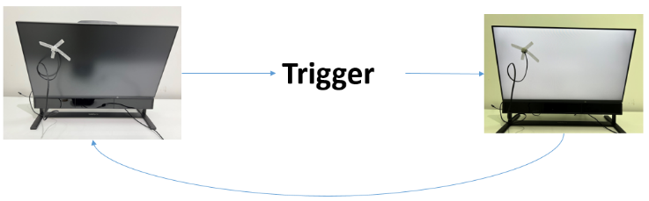We created an experiment to find the latency between one computer sending triggers and another computer recording the input.

First we taped a photo diode on the computer screen. We wrote a python function that sends a trigger through one EEG channel, and then turns the screen white for 200 ms many times.

Then we recorded the data from the EEG on the second computer and measured the latency between the time the trigger was sent and the time the photo diode recorded a significant change in brightness.

We conducted this experiment twice: when recording one channel in EEG, and when recording multiple channels in EEG, in order to check if there is a difference when the system is loaded.

**Results**

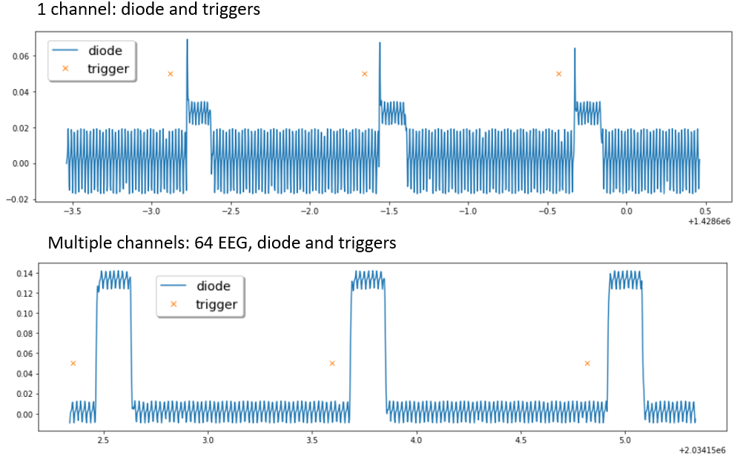

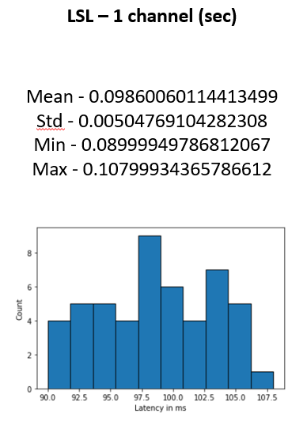 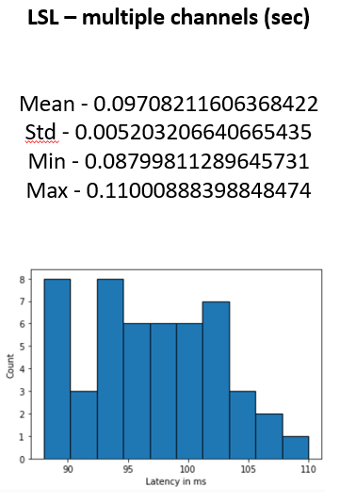

As we can see the average latency is 100 ms in both conditions. It should be considered when later conducting real time experiments.