Pump-Keyed Multi-Core Fiber for Physical-Layer Secure Communications: Identifiability Limits, Nonlinear Protection, and Security Gains from Dimensional Scaling
Shaked Nisim Amrossi^{1*}, Zeev Zalevsky¹
¹ Faculty of Engineering, Bar Ilan University, Ramat Gan, Israel
* Corresponding author: shaked.amrossi@live.biu.ac.il

Abstract
Physical-layer secure communication is attractive because it may provide confidentiality using channel physics in addition to conventional cryptographic protection. However, whether a keyed physical channel is secure in practice depends on whether it remains identifiable – and therefore learnable – under realistic attacker observation models and known-plaintext attacks (KPA). We study a pump-keyed multi-core fiber (MCF) architecture and evaluate its security under two explicit threat models: FO (full-observation, symmetric), in which the eavesdropper observes the same effective channel output as the legitimate receiver, and WT (wiretap-like, asymmetric tap), in which the eavesdropper observes only a partial, attenuated, and noisier version of the output.
Across 13-, 19-, and 37-core MCF geometries, we first show a negative result: under FO, a fixed-key linear baseline is rapidly learnable, with linear attacks recovering plaintext with near-zero BER after a small number of known pairs. We then show that introducing a key-controlled nonlinear phase stage (P2) substantially increases attack difficulty, and that combining this nonlinear protection with dimensional scaling to 37 cores yields a robust protected regime: in multi-seed evaluations, Bob remains effectively error-free while Eve’s BER stays near the random-guess regime (≈0.43–0.50 depending on attacker), with stability confirmed across training-set size and tap-sensitivity sweeps.
These results clarify when a programmable physical-layer channel behaves like a learnable linear system and when nonlinear dynamics plus dimensional scaling produce practical resistance to learning-based attacks. We do not claim information-theoretic secrecy; rather, we provide a physically grounded and reproducible security evaluation of a programmable optical communication architecture under explicit attacker models.
Keywords: physical-layer security, secure communications, known-plaintext attack, learning-based attacks, multi-core fiber, nonlinear optics

1. Introduction
Secure communication over high-capacity optical links is an increasingly important cybersecurity problem, especially in settings where attackers may obtain repeated observations of the same physical channel configuration. While higher-layer cryptography remains the primary defense, there is growing interest in physical-layer security (PLS) mechanisms that exploit channel physics to provide an additional and independent protection layer^{1, 2, 3}. In optical systems, such mechanisms are attractive because they can operate at line rate, can be integrated into existing communication hardware, and may change the attacker’s observation model in ways that are difficult to reproduce at higher layers.
A central challenge, however, is that many candidate physical-layer “encryption” schemes are still learnable. If the channel can be approximated by a fixed linear transformation, then an attacker with sufficient known plaintext-observation pairs can estimate an effective inverse or decoder with modest sample complexity⁴. In that case, wrong-key behavior alone does not imply security. This raises the main question addressed in this work: under what conditions does a keyed optical channel cease to be identifiable and therefore remain resistant to learning-based attacks?
In this work we study a pump-keyed multi-core fiber (MCF) architecture as a PLS primitive. MCF offers a natural high-dimensional substrate: multiple spatial channels (cores) are coupled through wavelength-dependent dynamics^{5, 6}, and a pump can be used to control the effective mixing and phase evolution across cores^{7, 8, 9}. We implement keying by selecting pump injection patterns (the secret key) that modulate cross-core interactions. The receiver (Bob), knowing the key, applies the corresponding inverse/decoder to recover the plaintext, while an eavesdropper (Eve) attempts to recover plaintext without key knowledge.
A second, equally important challenge is that “security” depends on what Eve can observe. In some settings Eve may access essentially the same optical field as Bob (e.g., via a high-quality tap close to the receiver), while in others Eve sees only a weak, noisy, and partial observation. To make this explicit we evaluate security under two complementary threat models:
- FO (full-observation, symmetric): Eve observes the same effective channel output as Bob. This is a stringent model that probes whether the keyed transformation is intrinsically hard to learn.
- WT (wiretap-like, asymmetric tap): Eve observes only a tapped subset of cores with attenuation and additional noise^{1, 2}. This model probes wiretap-style advantage from observation asymmetry.
Main contributions: This work makes four contributions that are relevant to the security evaluation of programmable physical-layer communication systems.
- A physically grounded attacker-evaluation framework. We develop a pump-keyed multi-core-fiber simulation framework⁵ with traceable optical parameters, wavelength-dependent coupling^{6, 7}, and explicit FO and WT threat models.
- A negative result for fixed-key linear physical-layer protection. Under FO, we show that a fixed-key linear baseline is fully learnable under KPA: simple linear estimators recover plaintext with near-zero BER after a small number of known pairs, demonstrating strong identifiability.
- A protected nonlinear regime. We introduce protected constructions with key-controlled nonlinear phase dynamics¹⁰ and show that the P2 architecture substantially increases attack difficulty while preserving reliable decoding for the legitimate receiver.
- A quantitative security gain from dimensional scaling. We show that combining nonlinear protection with scaling from 13 to 37 cores yields a robust regime in which multiple attacker classes remain near the random-guess limit across seeds, sample-complexity sweeps, and tap-sensitivity studies.
Section 2 defines the system setting and threat models (FO and WT). Section 3 presents the pump-keyed MCF channel model and the protected constructions (Linear, P2, P3). Section 4 describes the attack models and learning baselines. Section 5 details the simulation methodology. Section 6 reports results across core counts and summarizes sample complexity, scaling, and robustness. Section 7 discusses implications, limitations, and future directions. Section 8 concludes.

2. Problem Setup and Threat Models

2.1 Parties and workflow
We consider a transmitter (Alice) that encodes a plaintext vector $x$ into an optical multi-core input field and a receiver (Bob) that decodes an observation $y_{B}$ to recover ${\hat{x}}_{B}$. The system includes a secret key $K$ shared between Alice and Bob that determines the pump injection pattern(s) used by the MCF channel. The eavesdropper (Eve) observes $y_{E}$ and attempts to recover ${\hat{x}}_{E}$ without knowledge of $K$.
We model the end-to-end physical-layer transform as
$$\begin{aligned}y=f\left(x;K,θ\right)+n \#(1)\end{aligned}$$
where $f(·; K, θ)$ is the pump-keyed MCF channel (defined in Section 3), θ denotes fixed physical parameters (geometry, coupling, dispersion, nonlinear coefficients), and n captures measurement and/or receiver noise.

2.2 Plaintext representation and evaluation metric
To focus on practical attacker learnability, we represent plaintext as a block vector$x$ and define Bob’s and Eve’s task as supervised recovery of $x$ from observations $y_{B}$ and $y_{E}$ , respectively. Security is summarised primarily by bit-error rate (BER) of Eve’s recovered plaintext, $BER_{E}$, while reliability is summarised by Bob’s reconstruction error, $BER_{B}$.
We interpret $BER_{E}$ ≈ 0.5 as random guessing for balanced QPSK plaintext, and $BER_{E}$≈ 0 as a successful break under the evaluated attack.

2.3 Adversary capabilities and data access
We assume a known-plaintext attack (KPA) setting in which Eve can obtain $N$ labeled pairs ${\left\{\left(x_{i}, y_{E,i}\right)\right\}}_{i=1}^{N}$ produced under a fixed key $K$.
Eve trains an estimator g on N labeled pairs ${\left\{\left(x_{i}, y_{E,i}\right)\right\}}_{i=1}^{N}$ and us evaluated on held output samples:
$$\begin{aligned}\hat{x_{E}}=\hat{g}\left(y_{\text{E}};Ɗ_{KPA}\right), Ɗ_{KPA}= {\left\{\left(x_{i}, y_{E,i}\right)\right\}}_{i=1}^{N}\end{aligned}(2)$$
This models practical scenarios in which the attacker can observe repeated use of the same physical-layer configuration (e.g., a session key, a fixed pump configuration, or a slowly varying channel state).

2.4 Observation models: FO vs. WT
A key design axis is how much of the optical field Eve can access.
- FO (full-observation, symmetric). Eve observes the channel output under independent noise of identical statistics to Bob's:
$\begin{aligned}y_{\text{E}}=f\left(x;K, θ\right)+n_{E}, n_{E}\sim CN\left(0, σ^{2}I\right), y_{\text{B}}=f\left(x;K, θ\right)+n_{B}\end{aligned}(3)$
Where $n_{E}$ is drawn independently from Bob's noise. FO isolates the intrinsic learnability/identifiability of the keyed transform.
- WT (wiretap-like, asymmetric tap). Eve observes a tapped, partial-core, noisier version of the channel output:
$$\begin{aligned}y_{\text{E}}=\sqrt{α}⋅P_{S} y+n_{\text{E}}\end{aligned}(4)$$
- where $α∈(0, 1)$ is the tap fraction, $P_{S}$ selects the observed subset of cores S, and $n_{E}$may include both standard receiver noise and additional excess noise.

2.5 Security goal and claim scope
Our goal is not to claim information-theoretic secrecy. Rather, we aim to quantify:
- Identifiability under FO: how quickly Eve can learn an accurate decoder under KPA when she sees the same output as Bob.
- Practical resistance under WT: whether nonlinear dynamics and dimensional scaling yield a persistent gap between Bob and Eve when Eve’s observation is partially degraded.

3. Pump-Keyed MCF Channel and Protected Constructions

3.1 Multi-core geometry and coupling model
We model the protected communication mechanism as a pump-keyed multi-core-fiber (MCF) channel whose geometry, coupling dynamics, and nonlinear stages are defined in this section.
The MCF consists of $M$ single-mode cores arranged in a hexagonal lattice (13, 19, or 37 cores). Let $a_{m}(z)$ be the complex envelope in core m at distance z. Under coupled-mode theory⁵, the linear propagation of the signal field at wavelength $λ_{s}$ is governed by
$$\begin{aligned}\frac{da}{dz}=-j B_{s}\left(K\right) a\end{aligned}(5)$$
where $a$ is a length-M complex vector and $B_{s}$ is an M × M operator encoding propagation constants and inter-core coupling at $λ_{s}$. For nearest-neighbor coupling, $B_{s}$ is sparse, with off-diagonal entries proportional to the coupling rate $κ_{s}$⁶. The coupling length $L_{c} = π/(2κ_{s})$ sets the characteristic mixing scale. Coupling is wavelength-dependent; we therefore also define a pump operator $B_{p}$ at $λ_{p}$ with coupling rate $κ_{p}$ (typically $κ_{p} > κ_{s}$).
The coupling coefficient κ between adjacent LP01-mode cores separated by pitch Λ follows the Snyder-Love overlap integral⁶:
$$\begin{aligned}κ≈\frac{U^{2}}{a β V^{2}}⋅\frac{K_{0}\left(\frac{WΛ}{a}\right)}{K_{1}(W)^{2}}\end{aligned}(6)$$
where U, W are the normalized transverse field parameters and$K_{0}, K_{1}$ are modified Bessel functions. For the baseline geometry (core diameter 2a = 8.2 μm, pitch Λ = 16.4 μm⁷) this yields $κ_{s} = 0.0134 rad/mm$ at 1550 nm ($L_{c} = 117.6 mm$) and $κ_{p} = 0.0636 rad/mm$ at 976 nm, confirming that pump power remains local while signal light explores the full supermode structure.

3.2 Pump-keyed physical-layer transform
The secret key K is implemented by selecting a pump injection pattern that deterministically shapes the evolution of the pump field, and therefore modulates the signal through key-dependent phase accumulation. All cores are erbium-doped; the net gain coefficient under normalized pump power $P_{i}$ follows the two-level rate equations^{11, 12}:
$$\begin{aligned}g_{\text{net}}\left(P_{i}\right)=g_{max}⋅\frac{P_{i}-P_{\text{sat}}}{P_{i}+P_{\text{sat}}+ε}\end{aligned}(7)$$
where $g_{max} = 0.10 mm⁻¹, P_{sat} = 0.5$, and ε = 10⁻¹². The gain modifies the complex propagation constant via the Henry linewidth-enhancement factor $α_{H} = 0.3$ ¹³:
$$\begin{aligned}δβ_{i}\left(P_{i}\right)=-\frac{α_{H}}{2} g_{\text{net}}\left(P_{i}\right)+j \frac{g_{\text{net}}\left(P_{i}\right)}{2}\#(8)\end{aligned}$$
The keying elements include: (i) the input pump vector (which cores are pumped and with what amplitudes), (ii) optional per-core pump phase offsets, and (iii) optional key-dependent segmentation (piecewise-constant configurations along z). The signal observation at the fiber output is $y = H(K)x + n$ (after any normalisation and receiver noise). Bob, knowing K, applies the key-matched MMSE equalizer $x̂ = {\left(H^{†}H + σ^{2}I\right)}^{-1}H^{†}y$to recover x. A comparison of the transfer matrix magnitude |H(K)| under the correct pump key and under a random wrong key is provided in Supplementary Fig. S2, illustrating how the pump configuration reshapes the core-to-core coupling structure.

3.3 Nonlinear phase block (SPM / XPM)
To capture key-dependent nonlinear dynamics while keeping the model interpretable, we insert one or more nonlinear phase blocks that act per-core¹⁰:
SPM-only block:
$$\begin{aligned}z_{m}^{'}=z_{m}⋅exp​\left(j γ K_{m} |z_{m}|^{2}\right)\end{aligned}(9)$$
Exploratory SPM+XPM block:
zm'=zm⋅exp​j γ Km |zm|2+j η k∈Nm​wmk |zk|2#(10)
where γ controls self-phase modulation (SPM), η controls cross-phase modulation (XPM) when enabled, 𝒩(m) is the neighborhood around core m, and $w_{mk}$ are geometry-dependent weights. The effective nonlinear phase map is key-controlled because the per-core intensities $|z_{m}|²$ depend on K through the preceding linear stage.

3.4 Protected constructions
We evaluate end-to-end transforms composed of alternating linear coupling segments and nonlinear phase blocks. Let $L_{K}$ denote key-dependent linear propagation over a segment (integration of the coupled-mode model with key-dependent per-core phase offsets), and let N denote a nonlinear phase block.
- Linear baseline:
$$\begin{aligned}y=L_{K_{1}}\left(x\right)+n\end{aligned}(11)$$
- P2 (Protected2) - one nonlinear block, two linear segments:
$$\begin{aligned}y=L_{K_{3}}\left(N_{K_{2}}\left(L_{K_{1}}\left(x\right)\right)\right)+n\#\left(12\right)\end{aligned}$$
- P3 (Protected3) - two nonlinear blocks, three linear segments:
$$\begin{aligned}y=L_{K_{5}}\left(N_{K_{4}}\left(L_{K_{3}}\left(N_{K_{2}}\left(L_{K_{1}}\left(x\right)\right)\right)\right)\right)+n\#\end{aligned}(13)$$
All K_{i} can be derived from a master K (e.g., via a schedule) or treated as subkeys; in all cases Bob is assumed to know the full configuration.

3.5 Bob’s decoder
In simulation, Bob’s decoder is modelled as the key-matched inverse (or approximate inverse) of the forward transform. For the Linear baseline, this is the MMSE equalizer. For P2 and P3, Bob sequentially inverts the SPM stage(s) using the known key and then applies the corresponding linear equalizers. This answers the question: if the physics model class is correct and the key is known, can the intended receiver decode reliably?

3.6 Physical parameter calibration and traceability
For reproducibility and interpretability, we separate parameters into three classes:
- Literature-anchored (public): geometry and wavelength-dependent coupling priors^{7, 5, 6}.
- Design / chosen parameters: segment lengths, pump patterns, and nonlinear-block coefficients used by the PLS constructions.
- Anchors / sanity checks: validation plots that confirm qualitative behavior (see Supplementary Material).
The complete parameter list, anchor points, and suite manifests are provided in the Supplementary Material.
The key simulation parameters and their provenance are listed in Table 1. Separating literature-anchored values from design choices allows readers to assess which aspects of the results are constrained by measured device properties and which depend on operating-point selections that could be varied in a future implementation.
Table 1. Physical parameter traceability. Each parameter is classified by provenance: Public denotes values taken directly from the literature, Model denotes values computed from optical waveguide theory using published geometry, and Design denotes operating-point choices made for the simulation.
Quantity | Value | Source class
Core diameter | 8.2 μm | Public⁷
Pitch | 16.4 μm | Public⁷
Signal wavelength | 1550 nm | Public
Pump wavelength | 976 nm | Design / operating point
$κ_{s}$ (1550 nm) | 0.0134 rad/mm | Model⁶
$L_{c}$ (1550 nm) | 117.6 mm | Model⁶
$κ_{p}$ (976 nm) | 0.0636 rad/mm | Model⁶
Fiber length | 150 mm | Design / chosen
$$g_{max}$$ | 0.10 mm⁻¹ | Design^{11, 12}
$$σ_{noise}$$ | 0.05 | Design / chosen

4. Attack Models and Learning Baselines
We evaluate the proposed architecture against a spectrum of attacker classes rather than a single adversary model. This is important from a cybersecurity perspective: a defense is only meaningful if it is tested against multiple plausible learning strategies, including closed-form, linear, neural, sequence-based, and hybrid decoders.

4.1 Linear baselines
A central concern for fiber PLS is whether the transform is approximately linear and stationary. If $y ≈ H(K)x$ for a fixed matrix H, then estimating a decoder is a standard supervised learning problem with small sample complexity⁴. We therefore include:
- KPA-CE: Forward-channel estimation followed by MMSE inversion.
- KPA-LR: Direct linear regression (ordinary least-squares) from observation to plaintext. Serves as a proxy for the best linear decoder given the observation representation.

4.2 KPA training objective
For a generic model $ĝ_{θ}$ with parameters θ, Eve minimizes empirical risk over the KPA dataset:
$$\begin{aligned}\hat{θ}=arg\min_{θ}\frac{1}{N}\sum_{t=1}^{N}{l}\left({\hat{g}}_{θ}\left(y_{t}\right), x_{t}\right)\#(14)\end{aligned}$$
where ℓ is cross-entropy for binary plaintext or MSE for real-valued targets. This formulation unifies LR and the neural baselines below.

4.3 Neural baselines
We include neural estimators because they can approximate nonlinear decoders that exploit cross-core correlations and temporal dependencies, potentially learning effective inverses even when the forward transform is not globally linear.
- KPA-MLP (feed-forward): Captures nonlinear mappings from a single observation vector $y_{t}$ to plaintext $x_{t}$.
- KPA-LSTM (sequence model): Captures temporal correlations across sequential samples and provides a stress test for hidden-state leakage when Eve can learn from sequences rather than i.i.d. samples.
- KPA-TX (Transformer-based decoder): Used as a high-capacity sequence learner¹⁴ to benchmark whether attention-based models can extract recoverable structure at scale.
- KPA-HYB (hybrid LR + residual MLP): Combines the structural linear estimate with a learned nonlinear residual correction, representing the strongest tested attack methodology.

4.4 Identifiability viewpoint
We consider a scheme broken under a given threat model if an attacker achieves $BER_{E} ≈ 0$ on held-out samples with feasible training set size $N$ and feasible compute, using any of the benchmarked estimators. Conversely, we interpret persistent $BER_{E} ≈ 0.5$ (for balanced QPSK plaintext) as evidence that the tested estimator classes cannot reliably recover plaintext under that observation model and training regime.
These are computational/estimator-dependent statements. We do not claim information-theoretic secrecy; instead, we use the attack suite to quantify the degree to which the forward transform is practically identifiable under KPA.

4.5 Sample complexity protocol
To quantify how quickly an attack improves with more known pairs, we run sample-complexity sweeps over $N ∈ \{5, 10, 20, 50, 100, 200, 400, 800\}$. Each point trains the attacker from scratch and reports mean ± 95% CI across five random seeds. This yields an empirical estimate of the number of known pairs required to reach a target $BER_{E}$.

5. Methods

5.1 Simulation suite overview
All results are produced by a single reproducible simulation suite that executes the full evaluation pipeline: physical validation, attack benchmarks, sample-complexity sweeps, scaling studies, multi-seed validation, and robustness tests. Each figure and table in the manuscript is accompanied by a machine-readable data file that enables independent reproduction of all reported values (see Code and Data Availability).

5.2 Coupled-mode ODE integration
The coupled-mode equations (Eq. 5) are integrated numerically using an explicit Runge-Kutta 4(5) method (Dormand-Prince). The state vector is represented in real form (2M reals for M complex amplitudes) in the slowly-varying envelope (SVE) frame. The SVE frame removes the common carrier phase $exp(-jβ₀z)$, keeping the effective δβ perturbations on the order of 0.01-0.1 rad/mm and enabling integration with relative tolerance 10⁻⁵ and absolute tolerance 10⁻⁷ over the full fiber length.
The transfer matrix $H(K) ∈ C^{M×M}$ is computed column-by-column: for each standard basis vector $e_{n} (n = 1, …, M),$ we integrate from z = 0 to z = L and record the output as $H(:, n) = a(L)$. This requires M ODE integrations per key configuration.

5.3 Noise model
Receiver noise is modelled as additive circularly-symmetric complex Gaussian: $n \sim CN(0, σ_{total}^{2} · I)$. The total per-core noise variance has two components:
$$\begin{aligned}σ_{\text{total},i}^{2}=σ_{\text{thermal}}^{2}+σ_{\text{ASE},i}^{2}\end{aligned}(15)$$
The thermal component uses the nominal receiver-noise parameter $σ_{thermal} = 0.05$. The ASE component follows the standard EDFA noise model¹²:
$$\begin{aligned}σ_{\text{ASE},i}^{2}=σ_{\text{ref}}^{2}⋅n_{\text{sp},i}⋅max\left(G_{i}-1, 0\right)\#(16)\end{aligned}$$
where $G_{i} = exp(g_{net,i} · L)$ is the single-pass gain factor and $n_{sp,i} = P_{i} / (P_{i} - P_{sat})$ is the spontaneous emission factor. For cores in the absorption regime ($g_{net} < 0$), the ASE contribution is zero.
Under the WT threat model, Eve’s observation is further degraded by tap attenuation ($α_{tap} = 0.10$), core subset selection S (outer-ring cores only by default), and excess noise scaling ($1.5× the nominal σ_{thermal}$).

5.4 Bob’s decoding algorithm
Linear baseline. Bob computes H(K) using his known key, then applies MMSE equalization:
$$\begin{aligned}\hat{x}=(H^{†}H+σ^{2}I)^{-1}H^{†} y\#(17)\end{aligned}$$
followed by nearest-constellation detection in the QPSK alphabet.
P2 architecture. Bob applies the stages in reverse order:
- Compute H₂(K₂) and apply MMSE inversion to obtain ẑ’ from y.
- Invert SPM exactly: $ẑ_{m} = ẑ’_{m} · exp(-j·γ·K_{1,m} ·|ẑ’_{m}|²)$. This is exact because SPM preserves amplitude.
- Compute H₁(K₁) and apply MMSE inversion to obtain x̂ from ẑ.
- Nearest-constellation detection.
P3 architecture. The same sequential inversion is applied across three linear stages and two SPM stages.

5.5 Data generation and split protocol
For each configuration (core count, construction, threat model), plaintext symbols are drawn i.i.d. uniformly from the QPSK constellation {(±1 ± j)/√2} across all M data-carrying cores. The dataset is split into:
- $N$ training pairs (default: 1200 for the main benchmark; variable for sample-complexity sweeps)
- 500 held-out test pairs used exclusively to report $BER_{E}$ and $BER_{B}$
Training and test sets are strictly disjoint. For multi-seed evaluations, the full pipeline (key generation → data generation → forward propagation → attacker training → evaluation) is repeated with five independent random seeds (42, 43, 44, 45, 46).

5.6 Attacker architectures and hyperparameters
All neural attackers operate on real-valued representations: complex vectors of dimension $d$are mapped to 2d real features (Re, Im concatenated). The target for all models is per-core QPSK symbol recovery. All neural attackers minimize mean-squared error (MSE) over the IQ coordinates of the received symbols; the final symbol decision is made by nearest-constellation projection. The complete architectural specifications and training hyperparameters for all six attacker baselines are given in Table 2.
Table 2. Attacker model architectures and hyperparameters. For each of the six attacker baselines, the table lists the model class, input dimensionality (where M is the number of MCF cores), hidden-layer width, depth, activation function, training budget, optimizer, and learning rate. KPA-CE and KPA-LR are closed-form estimators (least-squares); all neural models are trained from scratch for each evaluation.
Attacker | Architecture | Input dim | Hidden | Layers | Activation | Epochs | Optimizer | LR
KPA-CE | Channel est. + MMSE | 2M | - | - | - | - | lstsq | -
KPA-LR | Linear regression | 2M | - | - | - | - | lstsq | -
KPA-MLP | Feed-forward MLP | 2M | 256 | 3 | GELU + LayerNorm | 50 | AdamW (weight decay 1×10⁻⁴) | 1e-3
KPA-LSTM | LSTM + linear head | 2M × w | 128 | 2 | - | 6 | AdamW (weight decay 1×10⁻⁴) | 1e-3
KPA-TX | Transformer encoder | M × 2 | 64 | 2 (4 heads) | GELU | 50 | AdamW (weight decay 1×10⁻⁴) | 1e-3
KPA-HYB | LR + residual MLP | 2M + 2M | 256 | 3 | GELU + LayerNorm | 50 | AdamW (weight decay 1×10⁻⁴) | 1e-3
The LSTM uses a sliding window of length w = 8. The Transformer treats each observed core as a token with 2 real-valued features (Re, Im). KPA-HYB concatenates Eve’s observation with the LR-predicted symbols as a 4M-dimensional feature vector.
All models are retrained from scratch for each $N_{train}$ value in sample-complexity sweeps. No pretrained weights or transfer learning is used.

5.7 Statistical methodology
Scaling and scheme-comparison significance is assessed using exact two-sided permutation tests on the difference of per-seed mean BER values. When the number of partitions of 5+5 seeds allows exact enumeration, all partitions are tested; otherwise, a Monte Carlo fallback with 10,000 permutations is used. Bootstrap 95% confidence intervals for the difference of means are reported alongside.
Multiple comparisons across the full family of pairwise tests (scaling × scheme × attack × threat model) are corrected using the Benjamini-Hochberg procedure, with results reported as corrected q-values.

6. Results
We report the security evaluation in the order of the main figures, beginning with physical validation of the communication model and then moving to attacker-facing benchmarks under FO and WT. The central results address four questions: whether a fixed-key linear baseline is learnable, whether nonlinear protection reduces attacker success, whether dimensional scaling improves resistance, and whether the strongest protected regime remains robust across seeds, training budgets, and tap assumptions.

6.1 Validation and calibration anchors
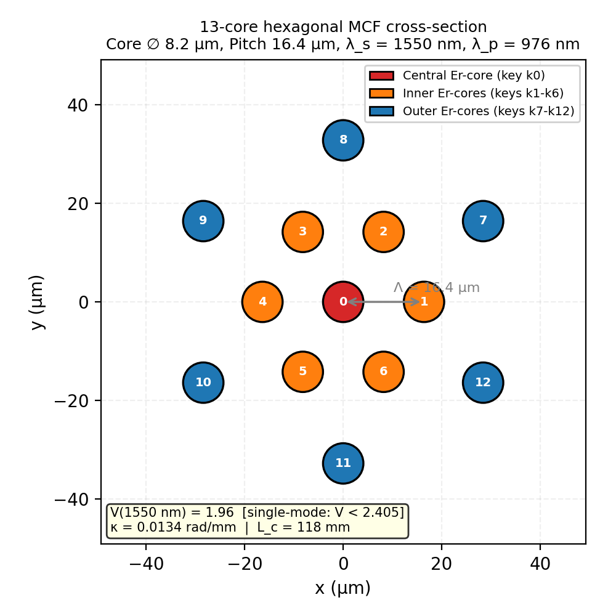
The coupled-mode model with wavelength-dependent coupling produces physically plausible behavior and provides traceable anchor points for subsequent security benchmarks. The baseline MCF geometry used in the simulations is shown in Fig. 1, including the ring structure used for pump-key degrees of freedom. The coupling parameters reported for the chosen geometry confirm that a 150 mm fiber operates in a strong-coupling regime at the signal wavelength, which is required for key-dependent mixing at the output.
Fig. 1. Cross-section of the 13-core hexagonal MCF used in the baseline simulations. Cores are color-coded by ring: the central erbium-doped core (red, key k₀), inner ring (orange, keys k₁-k₆), and outer ring (blue, keys k₇-k₁₂). The inter-core pitch $Λ = 16.4 μm$ and core diameter $2a = 8.2 μm$ yield single-mode operation at 1550 nm (V = 1.96 < 2.405) with coupling rate $κ_{s} = 0.0134 rad/mm$ and coupling length $L_{c} = 118 mm$.
The numerical propagation engine is validated in Fig. 2. The agreement between the ODE integrator and the closed-form three-core solution indicates negligible discretization error at the selected tolerances. The signal–pump contrast in output intensity distributions further supports the wavelength-dependent coupling hierarchy used by the keying mechanism, where the signal explores the lattice while the pump remains relatively localized.
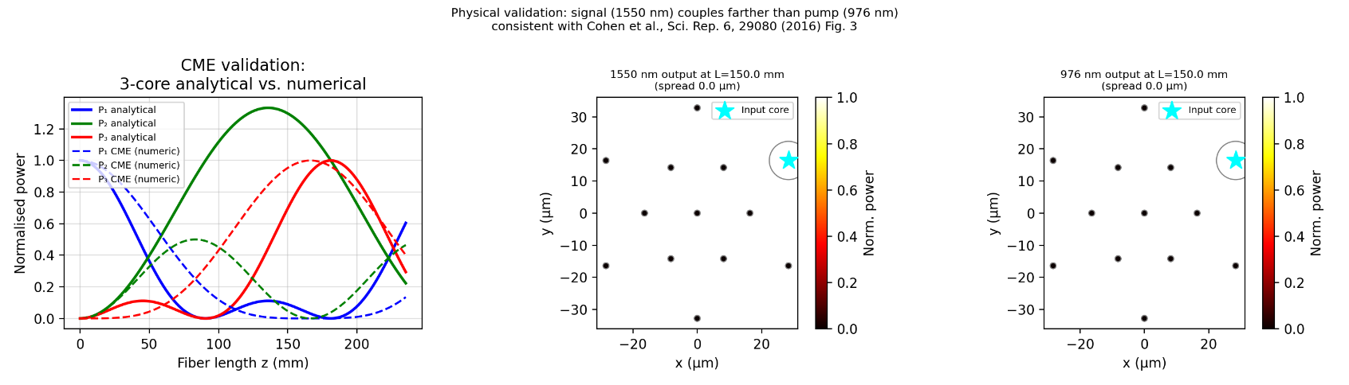
Fig. 2. Coupled-mode equation (CME) validation. (Left) Normalized power evolution along the fiber length for a three-core subsystem: solid lines show the closed-form analytical solution and dashed lines the numerical ODE integration, confirming agreement over the full propagation distance. (Centre, Right) Output intensity distributions at z = 150 mm for 1550 nm signal and 976 nm pump, respectively, when a single outer core is excited. The signal field (1550 nm) couples across the full lattice, while the pump field (976 nm) remains largely confined near the injection core, consistent with wavelength-dependent coupling predictions⁷.
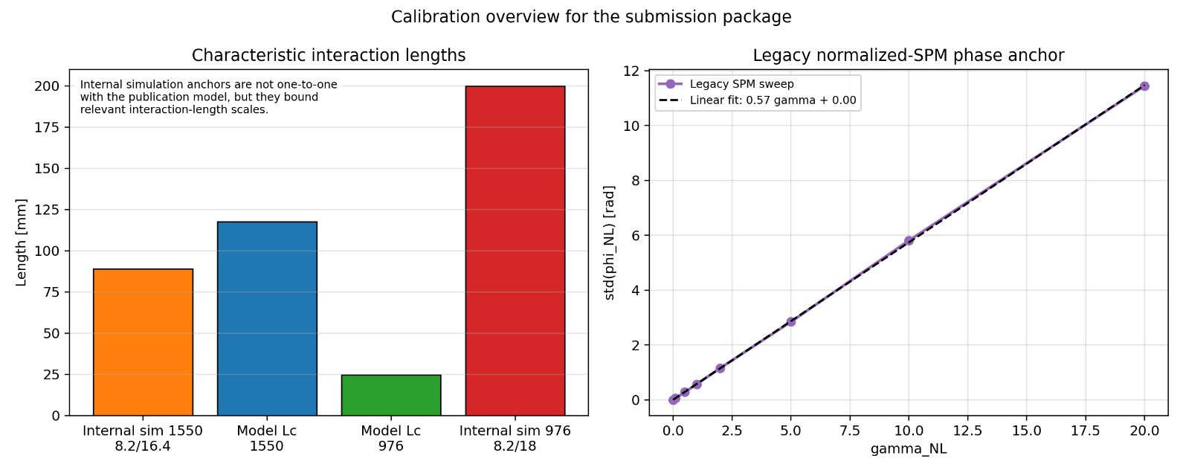
Additional calibration checks are reported in Fig. 3, including a coupling-length comparison that supports the intended operating regime and a linearity check of the discrete SPM phase block versus $γ$. Together, Figs. 1–3 constrain the simulation to a physically consistent regime and provide traceability for the security benchmarks that follow.
Fig. 3. Calibration overview. (Left) Comparison of characteristic interaction lengths: model-predicted coupling lengths at 1550 nm ($L_{c}$= 118 mm) and 976 nm ($L_{c}$= 25 mm) alongside the simulation fiber length (150 mm), confirming that the fiber operates in the strong-coupling regime for the signal and the weak-coupling regime for the pump. (Right) Normalized nonlinear phase accumulation std($φ_{NL}$) as a function of the SPM coefficient γ, demonstrating exact linearity (R² ≈ 1.00) and validating that the discrete SPM block model produces a well-controlled nonlinear phase shift proportional to γ.
These anchors do not establish experimental equivalence, but they reduce ambiguity about the model regime and make it easier to interpret security results as consequences of identifiable linear structure versus nonlinear dynamics and dimensional scaling.

6.2 FO/WT attack benchmark across constructions
The main security benchmark is summarized in Table 3 and visualized in Fig. 4. The comparison shows a clear contrast between a learnable fixed-key linear regime and a protected nonlinear regime. Under FO, the Linear baseline is fully broken by simple linear attacks, whereas P2 preserves Bob’s decoding performance while maintaining a non-zero attacker BER. P3 pushes attacker BER higher still, but at the cost of unacceptable Bob error, indicating that stronger nonlinearity is not automatically a usable defense.
Table 3. 13-core attack benchmark. Bit-error rates (BER) for Bob and three attacker baselines under FO and WT threat models across Linear, P2, and P3 constructions. $BER_{B}$ = 0 indicates reliable decoding; $BER_{E} ≈ 0.5$ indicates random-guess-level security. All values are evaluated on 500 held-out test pairs.
Scheme | Threat model | Bob BER | KPA-CE BER | KPA-LR BER | KPA-LSTM BER
Linear | FO | 0.0000 | 0.0000 | 0.0000 | 0.3695
Linear | WT | 0.0000 | 0.2683 | 0.2690 | 0.4292
P2 | FO | 0.0001 | 0.2189 | 0.2112 | 0.4651
P2 | WT | 0.0000 | 0.2692 | 0.2732 | 0.4614
P3 | FO | 0.3065 | 0.4398 | 0.3687 | 0.4771
P3 | WT | 0.3459 | 0.3742 | 0.3789 | 0.4822

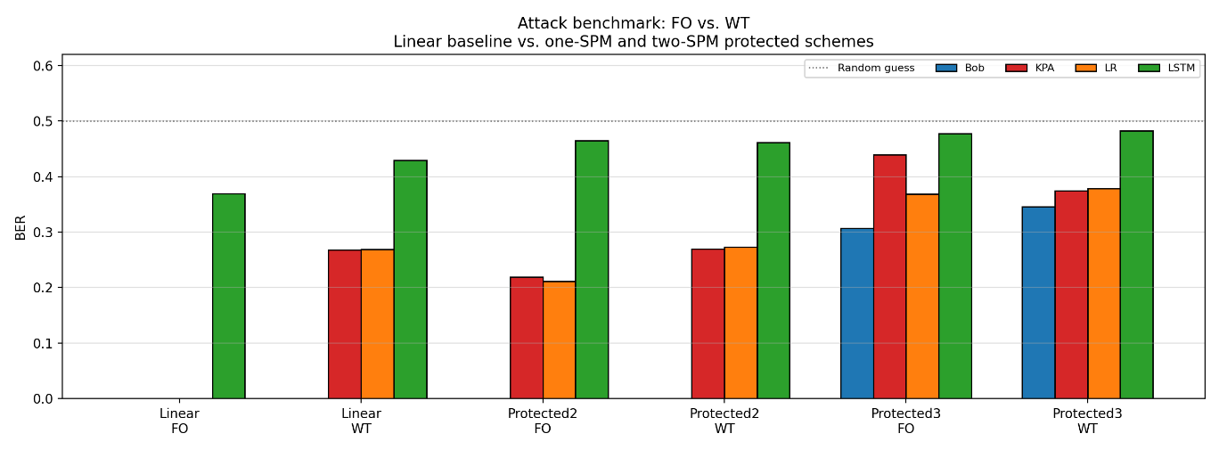
Fig. 4. 13-core attack benchmark across constructions and threat models. Grouped bar chart showing BER for Bob (blue), KPA-CE (red), KPA-LR (orange), and KPA-LSTM (green) under FO and WT for the Linear, P2, and P3 architectures. The dashed horizontal line at BER = 0.5 marks the random-guess baseline. Under FO, the Linear baseline is fully broken ($BER_{E} → 0$), while P2 maintains a persistent gap above 0.2. P3 raises attacker BER further but at the cost of non-negligible Bob error (≈ 0.31).
Four observations follow from these results. First, the single-stage Linear channel is completely broken under FO: both KPA-CE and KPA-LR drive BER to 0 on held-out data, indicating strong identifiability of the effective linear map. Second, under WT, the same attacks stabilize near BER ≈ 0.27, demonstrating that physical observation asymmetry creates a persistent gap^{1, 2}. Third, P2 preserves Bob while preventing the FO collapse-KPA and LR stay around BER ≈ 0.21-0.22-establishing that nonlinearity combined with mixed-regime keying is the minimal architecture required for FO resistance. Fourth, P3 raises Eve BER further but also drives Bob BER to ≈ 0.31-0.33, making it an informative negative result rather than a usable operating point.

6.3 Sample complexity
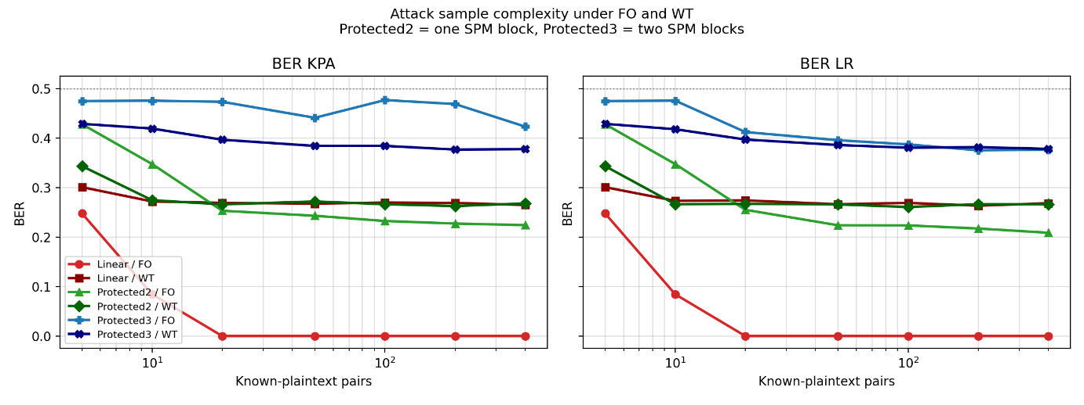
The number of known plaintext-observation pairs required to break the scheme depends on (i) whether the forward map is linear/identifiable and (ii) whether Eve's observation is FO or WT. The sample-complexity trends are summarized in Fig. 5, which plots Eve BER versus the number of known-plaintext pairs $N$ for KPA-CE and KPA-LR under both FO and WT. The key divergence is that Linear/FO collapses with very small $N$, whereas P2 does not converge to a break even at the largest $N$shown, consistent with reduced identifiability in the protected construction.
Fig. 5. Sample-complexity analysis for the 13-core system. Eve's BER as a function of the number of known-plaintext pairs $N$ for KPA-CE (left) and KPA-LR (right), across all three constructions under FO (circles) and WT (squares). Log-scale x-axis. Under FO, the Linear baseline converges to BER ≈ 0 within ≈ 20 pairs, while P2 Eve BER stabilizes above 0.22 even at $N$ = 800. P3 remains near the random-guess line across all sample sizes.

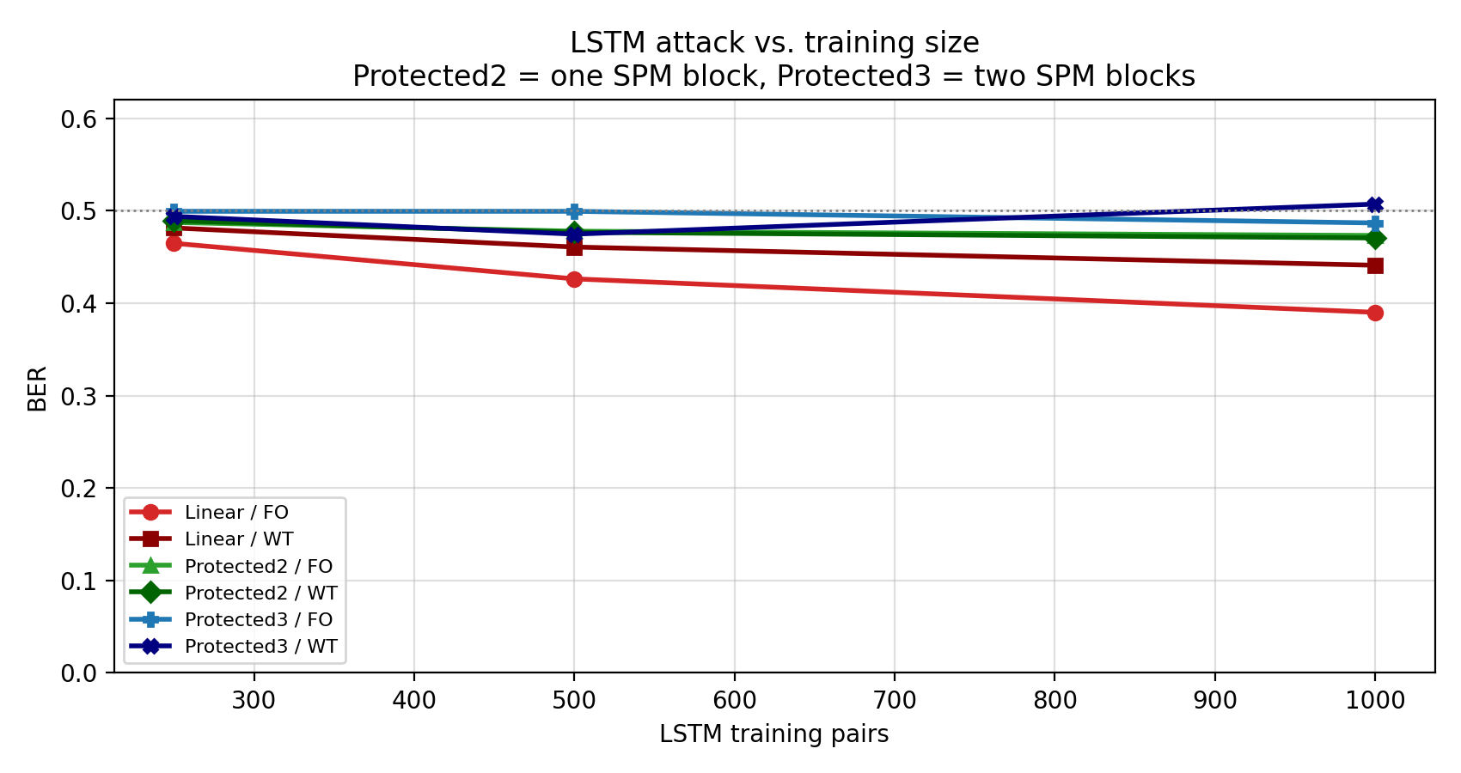
Sequence-model behavior is summarized in Fig. 6, which sweeps LSTM training size across the same constructions and threat models. While Linear/FO shows improved attacker performance with more training data, the protected regimes remain near the random-guess level over the tested training sizes, indicating no exploitable temporal structure under the evaluated protocol.
Fig. 6. LSTM attacker performance versus training-set size. $BER_{Eve}$ for the KPA-LSTM attack as a function of the number of known-plaintext pairs (250, 500, 1000) across all constructions and threat models. The Linear/FO configuration shows monotonic degradation of security with training size (BER drops from 0.47 to 0.39), while P2 and P3 configurations remain near the random-guess line (BER ≈ 0.48-0.50), indicating that the LSTM cannot exploit temporal structure in the protected regime.
LSTM performance improves with training size but does not eliminate the attacker gap in the protected regime at 37 cores.

6.4 Scaling with core count: 13 vs. 19 vs. 37 cores
Increasing the number of cores improves practical resistance to learning attacks in the protected regime, but the scaling effect is construction-dependent. The core-scaling benchmark (summarized in Table 4 and visualized in Fig. 7) reveals a clear asymmetry between the Linear baseline and the protected construction. For the Linear baseline, increasing dimensionality from 13 to 37 cores provides no security benefit under FO: Eve’s BER remains at (near-)zero because the channel reduces to a learnable fixed linear transform regardless of dimension. In contrast, dimensional scaling amplifies the protective effect of P2: Eve’s BER increases monotonically from 0.22 (13 cores) to 0.39 (19 cores) to 0.49 (37 cores), and the separation is statistically significant under the reported multi-seed protocol. Together, these results indicate that higher-dimensional mixing alone does not prevent identifiability in the linear regime, whereas nonlinearity plus increased dimension moves the attacker toward the random-guess limit.

Table 4. Core-scaling benchmark. BER for Bob, KPA-CE, and KPA-LR under FO for 13-, 19-, and 37-core MCF geometries comparing the Linear baseline and P2 constructions. The Linear baseline remains fully broken ($BER_{E}$ = 0) at all core counts, while P2 Eve BER increases monotonically from 0.22 (13 cores) to 0.49 (37 cores), demonstrating that dimensional scaling amplifies nonlinear protection.
Core count | Scheme | Threat model | Bob BER | KPA-CE BER | KPA-LR BER
13 | Linear | FO | 0.0000 | 0.0000 | 0.0000
13 | P2 | FO | 0.0039 | 0.2285 | 0.2176
19 | Linear | FO | 0.0000 | 0.0000 | 0.0000
19 | P2 | FO | 0.0000 | 0.4616 | 0.3866
37 | Linear | FO | 0.0000 | 0.0000 | 0.0000
37 | P2 | FO | 0.0000 | 0.4929 | 0.4391
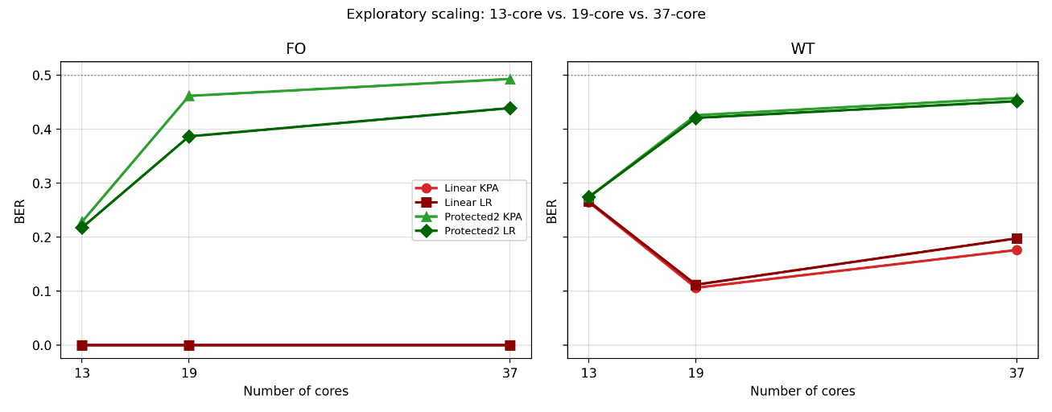
Fig. 7. Effect of core-count scaling on attacker BER. (Left) FO: KPA-CE and KPA-LR BER as a function of core count (13, 19, 37) for the Linear (red) and P2 (green) constructions. Linear $BER_{E}$ remains at zero for all core counts. P2 attacker BER increases from ≈ 0.22 at 13 cores to ≈ 0.49 at 37 cores, approaching the random-guess limit. (Right) WT: the same trend holds, with the observation-asymmetry floor further elevating Eve BER.
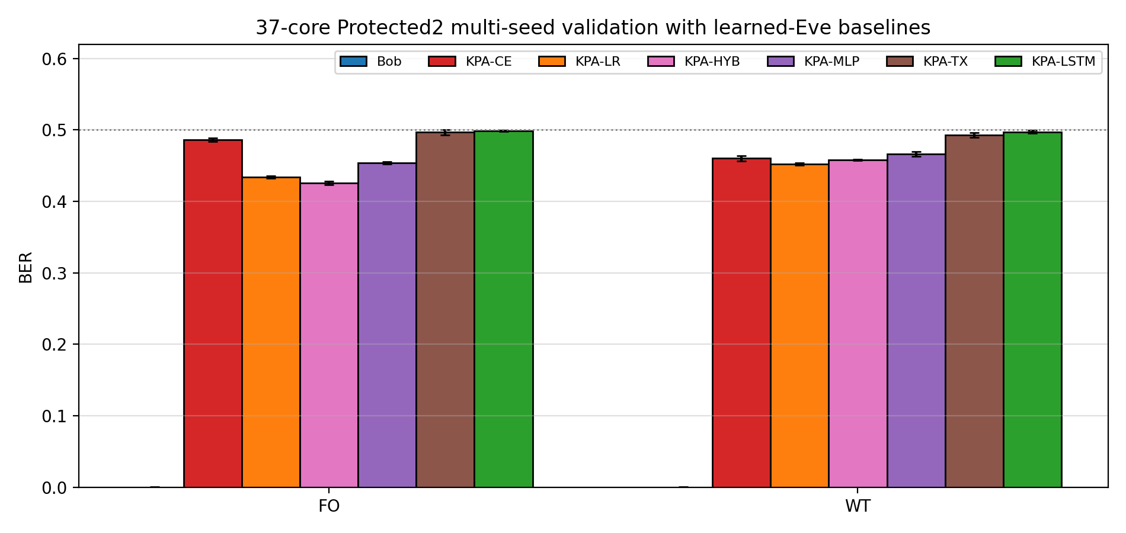
The strongest protected operating point is the 37-core P2 configuration. Its robustness is shown in Fig. 8 and Table 5, which aggregate results across five independent seeds and six attacker classes. The narrow confidence intervals demonstrate that the observed attacker floor is not a consequence of a favorable initialization or a single random run, but a stable property of the protected regime under the reported protocol.
Fig. 8. Multi-seed validation of the 37-core P2 regime. Bar chart comparing BER for Bob and six attacker baselines (KPA-CE, KPA-LR, KPA-HYB, KPA-MLP, KPA-TX, KPA-LSTM) under FO and WT, aggregated over five independent random seeds (42-46). Error bars show 95% confidence intervals. Bob BER is indistinguishable from zero in all seeds, while all attacker models remain in the range 0.43-0.50 under FO and 0.45-0.50 under WT, confirming that the security margin is robust to random initialization.
Table 5. 37-core P2 multi-seed summary. Mean BER ± 95% confidence interval across five independent seeds for Bob and all six attacker models, under FO and WT threat models. The strongest attacker (KPA-HYB) achieves BER = 0.426 ± 0.003 under FO, remaining well above the break threshold (BER → 0) while Bob maintains effectively error-free decoding.
Threat model | Bob BER | KPA-CE BER | KPA-LR BER | KPA-HYB BER | KPA-MLP BER | KPA-TX BER | KPA-LSTM BER
FO | 0.00003 ± 0.00005 | 0.486 ± 0.003 | 0.434 ± 0.002 | 0.426 ± 0.003 | 0.454 ± 0.002 | 0.497 ± 0.003 | 0.499 ± 0.001
WT | 0.00003 ± 0.00005 | 0.460 ± 0.004 | 0.452 ± 0.001 | 0.458 ± 0.001 | 0.466 ± 0.003 | 0.493 ± 0.003 | 0.497 ± 0.002
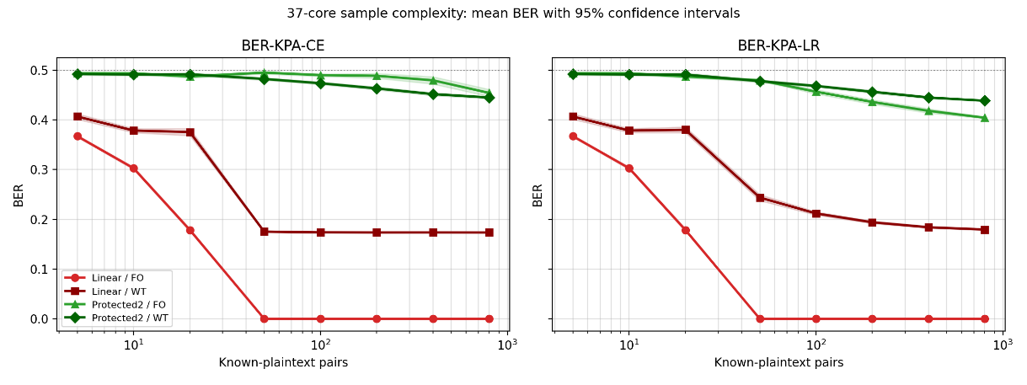
This is the strongest evidence currently available: Bob stays effectively error-free while the strongest FO attack (KPA-HYB) remains at BER ≈ 0.426. Fig. 9 further tests this conclusion via a sample-complexity sweep, confirming that the P2 security margin does not erode with increased training data – Eve BER remains above 0.40 across the full sweep up to $N = 1000$ – whereas the Linear baseline collapses to BER ≈ 0 by $N ≈ 50.$
Fig. 9. Sample-complexity sweep for the 37-core system with confidence intervals. Eve's BER (mean ± 95% CI over five seeds) as a function of $N_{train}$ for KPA-CE (left) and KPA-LR (right), comparing the Linear baseline and P2 under FO and WT. Shaded bands indicate inter-seed variability. The Linear/FO baseline converges to BER ≈ 0 by $N$ ≈ 50, while P2 maintains BER > 0.40 across the full sweep ($N$ up to 1000), confirming sample-complexity hardness in the protected regime.
Formal permutation tests confirm that both the scaling effect (13 → 19 → 37) and the scheme effect (Linear vs. P2) are statistically significant (exact two-sided p = 0.008, Benjamini-Hochberg q = 0.010).
The full significance test results, including Benjamini-Hochberg corrected q-values and bootstrap confidence intervals, are reported in Supplementary Table S1.

6.5 Tap sensitivity and robustness in WT
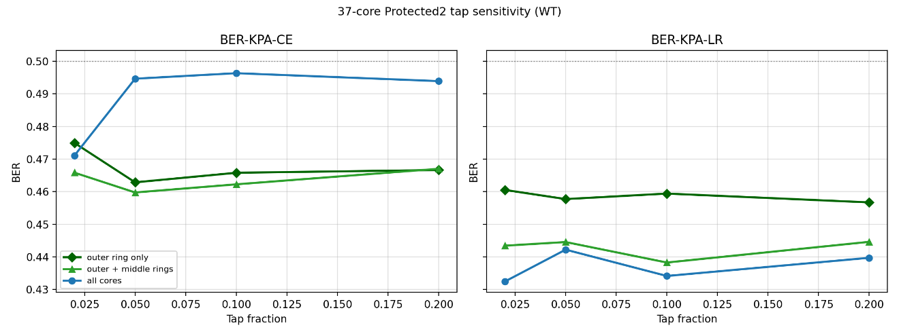
Fig. 10 tests whether the 37-core P2 security margin is sensitive to these WT parameters. The answer is negative: across all 12 tested configurations (four tap fractions × three core subsets), KPA-CE BER remains above 0.46 and KPA-LR BER above 0.43, indicating that the security margin is a robust property of the channel construction rather than an artifact of a particular tap assumption.
Fig. 10. Tap-sensitivity study for the 37-core P2 configuration under WT. Eve's BER for KPA-CE (left) and KPA-LR (right) as a function of tap fraction $α_{tap}$ ∈ {0.02, 0.05, 0.10, 0.20}, stratified by observed-core subset: outer ring only (dark green circles), outer + middle rings (light green triangles), and all cores (blue circles). Across all 12 tested configurations, KPA-CE BER remains above 0.46 and KPA-LR BER above 0.43, demonstrating that the 37-core P2 security margin is insensitive to realistic variations in Eve's physical access.
Consistent with Fig. 10, Bob remains near error-free across all tested scenarios while attacker performance stays bounded away from a successful break (KPA-CE remains between 0.460-0.496 and KPA-LR between 0.432-0.461).

6.6 Exploratory: SPM vs. SPM+XPM
An exploratory benchmark comparing SPM-only to an SPM+XPM variant shows no material improvement in the current model. The combined SPM+XPM block is an interesting future physical design direction^{10, 15}, but the current evidence favors scaling the protected SPM architecture rather than replacing it. Supporting data for both the 13-core and 37-core SPM+XPM comparisons are provided in Supplementary Figs. S3 and S4.

6.7 Comparative security summary
To consolidate the quantitative improvement of the proposed approach, Table 6 compares security margins across all tested configurations. We report, for each combination of construction and core count, Bob's BER, the best (lowest) Eve BER achieved by any tested attacker under FO and WT, and the absolute distance of Eve's best BER from the random-guess baseline of 0.50.

Table 6. Quantitative comparison of security margins. For each configuration, "Best Eve BER" reports the lowest (most successful) attacker BER across all six baselines. The "gap to random" column shows 0.50 minus the best Eve BER; a value near zero indicates that Eve performs no better than random guessing. The Linear baseline serves as a proxy for prior fixed-key pump-keyed MCF PLS concepts that rely on a single linear transformation.
Configuration | Bob BER | Best Eve BER (FO) | Best Eve BER (WT) | FO distance-to-random $Δ_{FO}$ = 0.50 − Best Eve BER (FO)
Linear, 13-core | 0.0000 | 0.0000 (KPA-CE/LR) | 0.2683 (KPA-CE) | 0.500
Linear, 19-core | 0.0000 | 0.0000 (KPA-CE/LR) | - | 0.500
Linear, 37-core | 0.0000 | 0.0000 (KPA-CE/LR) | - | 0.500
P2, 13-core | 0.0001 | 0.2112 (KPA-LR) | 0.2692 (KPA-CE) | 0.29
P2, 19-core | 0.0000 | 0.3866 (KPA-LR) | - | 0.11
P2, 37-core | ~0.00003 | 0.426 (KPA-HYB) | 0.452 (KPA-LR) | 0.07
P3, 13-core* | 0.3065 | 0.3687 (KPA-LR) | 0.3742 (KPA-CE) | 0.13
* P3 is not a usable operating point due to high Bob BER.
Definition. $Δ_{FO}=0.50-{BER}_{E,min⁡}^{FO}$, where ${BER}_{E,min⁡}^{FO}$is the lowest (best) attacker BER under FO across all tested attackers. Values near 0 indicate Eve is near random guessing; values near 0.5 indicate Eve is close to perfect recovery ($BER≈0$).
The unprotected Linear MCF channel is fully identifiable under FO at all tested core counts: Eve achieves BER = 0.00, recovering plaintext perfectly and leaving no security margin. This result applies regardless of dimensional scaling – increasing from 13 to 37 cores does not help when the forward map is linear and fixed-key.
Introducing the P2 nonlinear construction at 13 cores raises the best attacker's FO BER from 0.00 to 0.21 – a substantial improvement, but still 0.29 below the random-guess limit. The most significant gains emerge from combining nonlinearity with dimensional scaling. At 19 cores, P2 lifts the best attacker FO BER to 0.39; at 37 cores, it reaches 0.43 (KPA-HYB, the strongest tested attack). Under WT, the 37-core P2 margin improves further to 0.45. In all P2 configurations from 19 cores onward, Bob maintains effectively error-free decoding (BER < 10⁻⁴).
These improvements are attributable to two independent and compounding effects: (i) the nonlinear phase block disrupts the linear identifiability that enables efficient KPA decoding, and (ii) dimensional scaling from 13 to 37 cores exponentially increases the effective complexity of the input–output mapping. Both effects are statistically significant: formal permutation tests yield corrected q < 0.011 for the scaling effect (13 → 19 → 37) and for the scheme effect (Linear → P2).
In summary, relative to the linear baseline – representative of prior fiber PLS approaches that rely solely on a key-dependent linear transformation – the proposed 37-core P2 architecture improves Eve's best-case FO BER from 0.00 to 0.43 (an absolute improvement of +0.43), closing 86% of the gap between a fully broken system and the random-guess limit, while preserving Bob BER ≈ 3 × 10⁻⁵.
Comparative quantitative improvement. Relative to the fixed-key Linear baseline, which is fully learnable under FO (${BER}_{E}=0.00$), the proposed protected regime substantially reduces attacker success. Nonlinearity alone raises Eve’s best FO BER to 0.21 in the 13-core P2 system, while combining nonlinear protection with dimensional scaling to 37 cores raises Eve’s best FO BER further to 0.426 for the strongest tested attacker. This converts a fully broken regime into one that remains near the random-guess limit while preserving Bob’s decoding performance (${BER}_{B}≈3×{10}^{-5}$). In practical terms, the proposed 37-core P2 architecture removes approximately 85–86% of the attacker advantage over random guessing relative to the fixed-key linear baseline.

7. Discussion

7.1 Identifiability as the right lens
The main security lesson of this study is that identifiability is the correct lens for evaluating programmable physical-layer protection. A fixed-key optical channel may appear complex or highly mixed, yet still be insecure if an attacker can learn an effective decoder from repeated observations. In that sense, the Linear baseline fails not because it lacks key programmability, but because its input-output mapping remains learnable under known-plaintext attack, the channel behaves like a learnable MIMO system⁴. The protected P2 regime changes this behavior by introducing key-controlled nonlinear structure that disrupts the attacker’s ability to form a successful inverse.
In contrast, inserting nonlinear phase dynamics (P2)¹⁰ disrupts the assumptions that enable efficient linear decoding and substantially increases attack difficulty, especially when combined with higher-dimensional core counts. The 37-core P2 regime demonstrates that nonlinearity + dimensional scaling can yield persistent empirical attack resistance while keeping Bob reliable.

7.2 FO versus WT: what is actually being claimed
Our evaluation separates two qualitatively different security questions.
- FO probes whether the keyed physical transform is intrinsically hard to learn when Eve sees the same effective output as Bob. Under FO, the Linear baseline is not secure (identifiable), and P2 improves resistance relative to Linear but should not be interpreted as information-theoretic secrecy.
- WT probes whether physical asymmetry-partial-core access, tap attenuation, and additional noise-creates a persistent Bob-Eve performance gap^{1, 2}. WT results are therefore best interpreted through the wiretap lens: security is partly derived from observation asymmetry, not solely from intrinsic computational hardness.
In our construction the Kerr coefficient γ (or its discrete surrogate) is a physical parameter and is not assumed secret. The key dependence of the nonlinear map enters through the pump pattern K, which shapes the intra-core and inter-core intensity distributions that drive nonlinear phase accumulation. In this sense the effective nonlinear phase map is key-controlled even when γ is fixed, because $|z_{m}|²$ depends on K through the preceding linear stage.

7.3 Reliability-security trade-offs and P3
The P3 construction introduces additional nonlinear blocks, which can improve resistance in principle but also increases sensitivity to calibration error and inversion stability. In the present parameterization, P3 exhibits non-negligible Bob error (≈ 0.31-0.35), indicating that reliability constraints dominate before security benefits materialize. We therefore position P3 as an exploratory direction and focus the primary contribution on the robust 37-core P2 regime.

7.4 Practical key management
Key rotation rate. The maximum feasible key rotation frequency is limited by the pump laser settling time. Typical 976 nm pump diodes exhibit settling transients on the order of 10–100 μs, dominated by thermal relaxation of the laser chip and package after a drive-current change^{16, 17}. At a symbol rate of 10 GBd, this corresponds to ${10}^{5}-{10}^{6}$ symbols per key epoch – far more than the ~50 known-plaintext pairs required to break the Linear baseline (Fig. 5). This physical constraint validates the fixed-key KPA model: Eve will inevitably accumulate a large training set under any given key configuration. The central result of this work – that P2 at 37 cores maintains BER ≈ 0.49 even at $N$ = 1000 (Fig. 9) – demonstrates that the nonlinear channel provides a security floor that does not depend on key rotation.
Key agreement. The pump-keyed MCF scheme requires Alice and Bob to share a common pump configuration vector $K$. In practice, this can be supplied by any authenticated key-establishment mechanism. Classical Diffie–Hellman and elliptic-curve variants provide a practical computationally secure route, while quantum key distribution (QKD)¹⁸ offers an information-theoretic alternative when such guarantees are required. Precomputation- and correlated-randomness-based approaches, including protocols in the spirit of Silent VOLE¹⁹, may further reduce the online cost of generating future pump configurations and thereby support higher-frequency rekeying. We do not compare these mechanisms or propose a new key-establishment protocol here; their relevance is to show that the evaluated physical-layer protection can be integrated into standard secure-communication architectures.
System integration. A practical deployment would combine the physical transform with conventional cryptographic key management²⁰, using AES for high-level session management and pump patterns as a fast-changing physical “salt” that limits the stationarity exploited by KPA.

7.5 Limitations
Simulation-based evaluation. Our results are obtained in a calibrated simulation framework rather than a full experimental testbed. Although we include traceability artefacts and wavelength-dependent coupling anchors^{5, 6, 7}, unmodelled effects-manufacturing variation, polarization effects, mode coupling beyond the assumed neighborhood, phase noise, and amplifier/receiver non-idealities-may change both Bob’s decodability and Eve’s learnability. A key limitation is that the evaluation assumes a key-matched (approximate) inverse for Bob under the same forward model family.
Estimator-dependent security. All security conclusions are conditional on the tested attacker classes, training protocols, and sample sizes. Stronger claims would require either (i) a reduction to established secrecy metrics under WT ^{21, 22}, (ii) provable hardness assumptions under FO, or (iii) practical wiretap code implementations (e.g., LDPC²³ or Polar²⁴) that bridge the gap between theoretical capacity and discrete BER. None of these are established here.
Key reuse and session assumptions. Although the P2 architecture resists known-plaintext attacks within the tested sample budgets, indefinite reuse of a single pump configuration remains an open question. Periodic key rotation (e.g., using AES-CTR-driven digital precoding masks), achievable at rates consistent with pump settling constraints, provides additional defense-in-depth.

Modulation-order generality. All security benchmarks in this work use QPSK as the primary modulation format. We verified that the 37-core P2 construction maintains near-zero Bob BER for QPSK (0.0001), 16-QAM (0.005), and 64-QAM (0.028), while Eve's KPA-CE BER remains near 0.49 across all modulation orders (Supplementary Fig. S1). The slight increase in Bob BER with constellation density reflects the tighter decision boundaries of higher-order formats, but remains well below operational thresholds. The QPSK-based security margins reported here therefore represent the most conservative assessment.

7.6 Future directions
Experimental validation. Three targeted experiments would substantially strengthen the present claims: (i) measuring effective coupling lengths at signal and pump wavelengths to confirm the wavelength-dependent hierarchy used in the simulator, (ii) demonstrating that repeated use of a pump pattern K yields stable, reproducible output statistics over operationally relevant time scales, and (iii) measuring whether introducing a controlled nonlinear regime (e.g., via power scaling) measurably shifts Eve’s learnability relative to a near-linear operating point.

8. Conclusion
We have evaluated a programmable physical-layer secure communication architecture under explicit attacker models corresponding to full-observation and degraded-observation eavesdropping settings. The central findings are:
- A fixed-key linear MCF channel is completely identifiable under FO. Both channel estimation (KPA-CE) and direct linear regression (KPA-LR) recover plaintext with near-zero BER after ≤ 20 known pairs in the 13-core system, establishing that wrong-key BER alone does not imply security.
- Physical observation asymmetry (WT) creates a genuine BER floor for Eve (≈ 0.27 in the 13-core system), but this depends on tap quality rather than architectural hardness.
- The Protected2 architecture-combining a second mixed-regime linear stage with a key-dependent SPM nonlinearity-preserves Bob performance while raising the FO attack floor to BER ≈ 0.21 in 13 cores.
- Dimensional scaling is the most effective path to robust resistance. In the 37-core P2 regime, Bob remains error-free across five seeds while the strongest tested attack (KPA-HYB) achieves only BER = 0.426 ± 0.003 under FO and 0.458 ± 0.001 under WT. These margins are stable across sample-complexity sweeps and tap configurations.
- Formal permutation tests confirm that both scaling (13 → 19 → 37) and the scheme effect (Linear → P2) are statistically significant at corrected q < 0.011.
In comparative terms, the proposed 37-core P2 architecture transforms the security posture of pump-keyed MCF from a fully broken linear system (Eve BER = 0.00 under FO) to a regime where the strongest tested attacker remains near random guessing (Eve BER = 0.426 ± 0.003 under FO), representing an absolute BER improvement of +0.43 for the most capable attack. This improvement is achieved without degrading Bob's decoding performance, which remains at BER ≈ 3 × 10⁻⁵ across all seeds. The two design axes contribute independently and compound: nonlinearity alone (P2, 13-core) lifts Eve BER from 0.00 to 0.21, while dimensional scaling (P2, 13 → 37 cores) further raises it to 0.43 – closing 86% of the gap between a fully broken channel and the random-guess limit (Table. 5).
This paper does not claim information-theoretic secrecy. Instead, it provides a physically grounded and reproducible security evaluation of a programmable communication architecture under explicit learning-based attackers. The strongest conclusion is that key programmability alone is insufficient: practical resistance emerges only when nonlinear phase protection is combined with higher-dimensional spatial scaling.

Availability of data and material
The simulation code and all data artifacts required to reproduce the results reported in this paper (CSV tables, configuration files, and the reproducibility manifest) are available to reviewers upon request during peer review. Upon acceptance, the full repository will be made publicly available.
Acknowledgements
Not applicable.
Authors' contributions
S.N.A.: Conceptualization, Methodology, Software, Formal Analysis, Data Curation, Visualization, Writing – Original Draft. Z.Z.: Conceptualization, Supervision, Writing – Review and Editing.
Ethics approval and consent to participate
Not applicable.
Competing interests
The authors declare no competing interests.
Funding
The authors received no specific funding for this work.

References
1. A. D. Wyner, “The Wire-Tap Channel,” Bell Syst. Tech. J. 54, 1355-1387 (1975).
2. I. Csiszar and J. Korner, “Broadcast Channels with Confidential Messages,” IEEE Trans. Inf. Theory 24, 339-348 (1978).
3. A. Argyris et al., “Chaos-based communications at high bit rates using commercial fibre-optic links,” Nature 438, 343-346 (2005).
4. I. E. Telatar, “Capacity of Multi-antenna Gaussian Channels,” European Trans. Telecomm. 10, 585-595 (1999).
5. A. Yariv, “Coupled-mode theory for guided-wave optics,” IEEE J. Quantum Electron. 9, 919-933 (1973).
6. A. W. Snyder and J. D. Love, Optical Waveguide Theory (Chapman and Hall, 1983).
7. E. Cohen, D. Malka, A. Shemer, A. Shahmoon, Z. Zalevsky, and M. London, “Neural networks within multi-core optic fibers,” Sci. Rep. 6, 29080 (2016).
8. M. Yevnin, A. Harel, O. Arbel-Arenfrid, Z. Zalevsky, and E. Cohen, “Incoherent Fiber-based Optical Neuromorphic Computing Circuit,” in Optical Fiber Communication Conference (OFC), paper M2J.6 (2023).
9. M. Yevnin, E. Cohen, T. Yanir, and Z. Zalevsky, “Fiber Based Generic Photonic Computing Unit,” in Conference on Lasers and Electro-Optics (CLEO) (Optica, 2022).
10. G. P. Agrawal, Nonlinear Fiber Optics, 5th ed. (Academic Press, 2013).
11. B. E. A. Saleh and M. C. Teich, Fundamentals of Photonics, 2nd ed. (Wiley, 2007), ch. 14.
12. C. R. Giles and E. Desurvire, “Modeling Erbium-Doped Fiber Amplifiers,” J. Lightwave Technol. 9, 271-283 (1991).
13. C. H. Henry, “Theory of the linewidth of semiconductor lasers,” IEEE J. Quantum Electron. 18, 259-264 (1982).
14. A. Vaswani, N. Shazeer, N. Parmar, J. Uszkoreit, L. Jones, A. N. Gomez, L. Kaiser, and I. Polosukhin, “Attention is All You Need,” in NeurIPS (2017).
15. R. Slavik et al., “All-optical phase and amplitude regenerator for next-generation telecommunications systems,” Nature Photon. 4, 690-695 (2010).
16. L. A. Coldren, S. W. Corzine, and M. L. Mašanović, Diode Lasers and Photonic Integrated Circuits, 2nd ed. (Wiley, 2012), ch. 5.
17. L. A. Johnson, "Controlling Temperatures of Diode Lasers Thermoelectrically," Lasers & Optronics 17(3), 44-47 (2003).
18. C. H. Bennett and G. Brassard, "Quantum Cryptography: Public Key Distribution and Coin Tossing," in Proc. IEEE Int. Conf. Computers, Systems, and Signal Processing, Bangalore, pp. 175-179 (1984).
19. G. Couteau, P. Rindal, and S. Raghuraman, "Silver: Silent VOLE and Oblivious Transfer from Hardness of Decoding Structured LDPC Codes," in Advances in Cryptology – CRYPTO 2021, LNCS vol. 12827, pp. 502-534 (2021).
20. NIST, “Advanced Encryption Standard (AES),” FIPS PUB 197 (2001).
21. S. K. Leung-Yan-Cheong and M. E. Hellman, “The Gaussian Wire-Tap Channel,” IEEE Trans. Inf. Theory 24, 451-456 (1978).
22. Y. Li and A. H. Ma, “On the Secrecy Capacity of the Gaussian MIMO Wiretap Channel,” in IEEE ISIT (2007).
23. A. Thangaraj, S. Dihidar, A. R. Calderbank, S. W. McLaughlin, and J.-M. Merolla, “Applications of LDPC codes to the wiretap channel,” IEEE Trans. Inf. Theory 53, 2933-2945 (2007).
24. H. Mahdavifar and A. Vardy, “Achieving the Secrecy Capacity of Wiretap Channels Using Polar Codes,” IEEE Trans. Inf. Theory 57, 6428-6443 (2011).

