Supplementary Information
S1. Multi-Modulation Validation (QPSK, 16-QAM, 64-QAM)
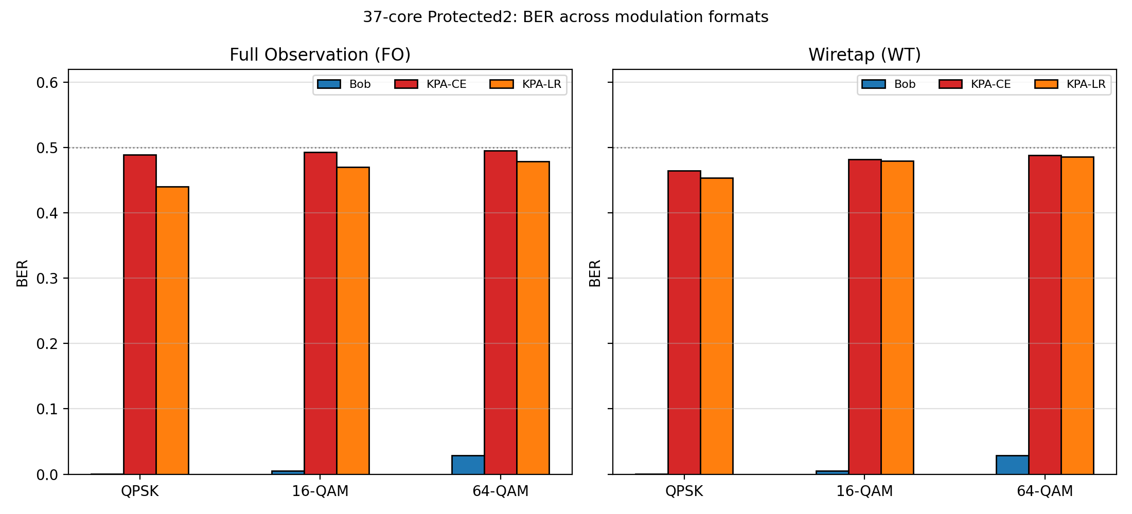
All security benchmarks in the main text use QPSK as the primary modulation format. To verify that the security conclusions extend to higher-order modulations used in practice, we simulated QPSK, 16-QAM, and 64-QAM transmission through the 37-core pump-keyed MCF channel under the P2 (Protected2) construction, evaluated under both FO and WT threat models.
Fig. S1. BER for Bob (correct key, MMSE equalizer) and Eve (KPA-CE and KPA-LR attackers) across QPSK, 16-QAM, and 64-QAM modulation formats for the 37-core P2 construction, under both full observation (FO) and wiretap (WT) threat models. (Left) FO: Bob BER increases from 0.0001 (QPSK) to 0.005 (16-QAM) to 0.028 (64-QAM), reflecting the tighter Voronoi cells of denser constellations, but remains well below the operational threshold in all cases. Eve KPA-CE BER stays near 0.49 across all modulation orders, and KPA-LR increases from 0.44 (QPSK) to 0.48 (64-QAM). (Right) WT: the same pattern holds with slightly elevated Eve BER due to observation asymmetry. These results confirm that the QPSK-based security margins in the main text are the most conservative assessment, and that the P2 architecture provides equivalent protection for practical higher-order modulation formats.

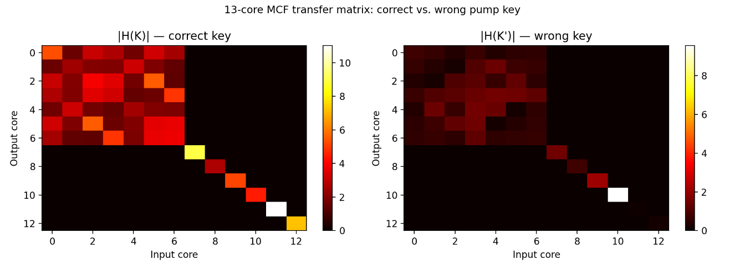
S2. Transfer Matrix Visualization
Fig. S2. Magnitude of the 13-core pump-keyed transfer matrix under two key configurations. (Left) |H(K)| with the correct pump key: coupling is concentrated in the inner-ring block (cores 0–6), with weaker coupling to outer-ring cores (7–12), reflecting the hexagonal geometry and ring-dependent coupling rates. (Right) |H(K′)| with a random wrong key: the power distribution shifts visibly, with different cores receiving greater coupling. The structural difference between the two matrices underlies the key-dependent scrambling exploited by the encryption scheme - Bob, knowing K, can invert H(K), while Eve, using K′ ≠ K, applies the wrong inverse.
S3. 13-Core SPM vs. SPM+XPM Exploratory Benchmark
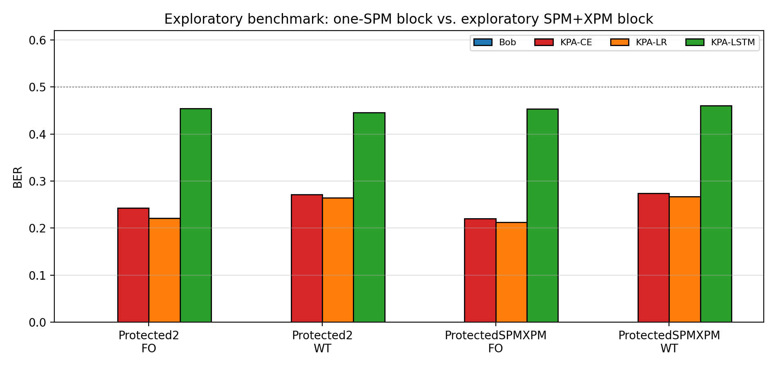
Section 5.6 of the article reports that an exploratory SPM+XPM nonlinear block does not improve security over the SPM-only block in the current model. The supporting data is presented here.
Fig. S3. 13-core attack benchmark comparing the SPM block (Protected2) with an exploratory SPM+XPM block (ProtectedSPMXPM) under FO and WT, for Bob, KPA-CE, KPA-LR, and KPA-LSTM. The SPM+XPM variant shows no material improvement in attacker BER relative to SPM-only at the tested operating point (γ = 2.0, η = 0.5). The result indicates that the dominant security effect in the current regime is the key-dependent intensity-to-phase coupling, not the additional inter-core nonlinear interaction. Source: `benchmark_xpm_exploratory` in the simulation suite.]
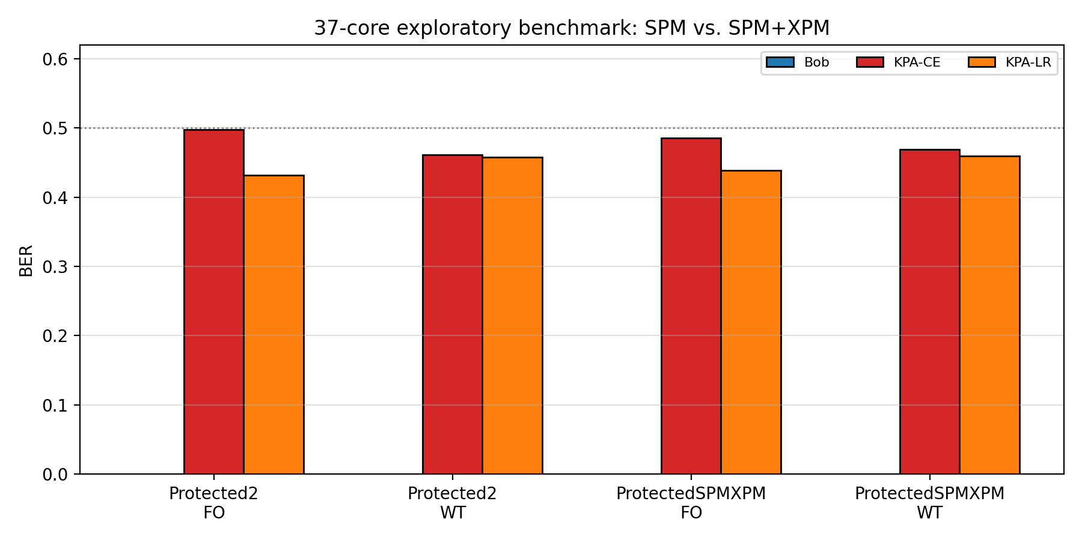
S4. 37-Core SPM vs. SPM+XPM Benchmark
Fig. S4. 37-core benchmark comparing Protected2 (SPM-only) with ProtectedSPMXPM (SPM+XPM) under FO and WT, for Bob, KPA-CE, and KPA-LR. At 37 cores, the SPM+XPM variant again shows no improvement over SPM-only, reinforcing the conclusion that dimensional scaling of the SPM architecture is the more effective path to robust resistance than adding cross-phase modulation at the current operating point. Source: `benchmark_spm_xpm_combo_37core` in the simulation suite.
S5. Scaling Significance Tests
BER_Bob | BER_KPA_CE | BER_KPA_LR | core_count | geometry | Threat model | scheme | seed
0 | 0 | 0 | 13 | 13-core | FO | Linear | 42
0 | 0.264712 | 0.26625 | 13 | 13-core | WT | Linear | 42
0.003942 | 0.228462 | 0.217596 | 13 | 13-core | FO | Protected2 | 42
0 | 0.274327 | 0.274327 | 13 | 13-core | WT | Protected2 | 42
0 | 0 | 0 | 19 | 19-core | FO | Linear | 42
0 | 0.106184 | 0.111974 | 19 | 19-core | WT | Linear | 42
0 | 0.461579 | 0.386579 | 19 | 19-core | FO | Protected2 | 42
0 | 0.425789 | 0.420789 | 19 | 19-core | WT | Protected2 | 42
0 | 0 | 0 | 37 | 37-core | FO | Linear | 42
0 | 0.176284 | 0.197838 | 37 | 37-core | WT | Linear | 42
0 | 0.492905 | 0.439054 | 37 | 37-core | FO | Protected2 | 42
0 | 0.457872 | 0.451723 | 37 | 37-core | WT | Protected2 | 42
0 | 0 | 0 | 13 | 13-core | FO | Linear | 43
0 | 0.265577 | 0.271635 | 13 | 13-core | WT | Linear | 43
0 | 0.220288 | 0.204038 | 13 | 13-core | FO | Protected2 | 43
0.000481 | 0.266635 | 0.265962 | 13 | 13-core | WT | Protected2 | 43
0 | 0 | 0 | 19 | 19-core | FO | Linear | 43
0 | 0.107039 | 0.11625 | 19 | 19-core | WT | Linear | 43
0 | 0.458092 | 0.394868 | 19 | 19-core | FO | Protected2 | 43
0 | 0.443026 | 0.427368 | 19 | 19-core | WT | Protected2 | 43
0 | 0 | 0 | 37 | 37-core | FO | Linear | 43
0 | 0.174088 | 0.193514 | 37 | 37-core | WT | Linear | 43
0 | 0.490203 | 0.435169 | 37 | 37-core | FO | Protected2 | 43
0 | 0.462061 | 0.450642 | 37 | 37-core | WT | Protected2 | 43
0 | 0 | 0 | 13 | 13-core | FO | Linear | 44
0 | 0.271538 | 0.264231 | 13 | 13-core | WT | Linear | 44
0.000192 | 0.217019 | 0.197692 | 13 | 13-core | FO | Protected2 | 44
0 | 0.267981 | 0.271154 | 13 | 13-core | WT | Protected2 | 44
0 | 0 | 0 | 19 | 19-core | FO | Linear | 44
0 | 0.096974 | 0.108158 | 19 | 19-core | WT | Linear | 44
0.000132 | 0.46625 | 0.411645 | 19 | 19-core | FO | Protected2 | 44
0.000724 | 0.450987 | 0.429408 | 19 | 19-core | WT | Protected2 | 44
0 | 0 | 0 | 37 | 37-core | FO | Linear | 44
0 | 0.177331 | 0.198615 | 37 | 37-core | WT | Linear | 44
0 | 0.483074 | 0.448581 | 37 | 37-core | FO | Protected2 | 44
0 | 0.463209 | 0.454764 | 37 | 37-core | WT | Protected2 | 44
0 | 0 | 0 | 13 | 13-core | FO | Linear | 45
0 | 0.272019 | 0.269808 | 13 | 13-core | WT | Linear | 45
0 | 0.22 | 0.213365 | 13 | 13-core | FO | Protected2 | 45
0.000769 | 0.263846 | 0.272212 | 13 | 13-core | WT | Protected2 | 45
0 | 0 | 0 | 19 | 19-core | FO | Linear | 45
0 | 0.104145 | 0.111382 | 19 | 19-core | WT | Linear | 45
0.000132 | 0.474934 | 0.410395 | 19 | 19-core | FO | Protected2 | 45
0 | 0.434408 | 0.4225 | 19 | 19-core | WT | Protected2 | 45
0 | 0 | 0 | 37 | 37-core | FO | Linear | 45
0 | 0.172703 | 0.192905 | 37 | 37-core | WT | Linear | 45
0 | 0.491216 | 0.43277 | 37 | 37-core | FO | Protected2 | 45
0 | 0.468547 | 0.464358 | 37 | 37-core | WT | Protected2 | 45
0 | 0 | 0 | 13 | 13-core | FO | Linear | 46
0 | 0.268462 | 0.270096 | 13 | 13-core | WT | Linear | 46
0 | 0.215962 | 0.210288 | 13 | 13-core | FO | Protected2 | 46
0.001058 | 0.276442 | 0.268462 | 13 | 13-core | WT | Protected2 | 46
0 | 0 | 0 | 19 | 19-core | FO | Linear | 46
0 | 0.106382 | 0.112105 | 19 | 19-core | WT | Linear | 46
0 | 0.44125 | 0.393289 | 19 | 19-core | FO | Protected2 | 46
0 | 0.424671 | 0.415921 | 19 | 19-core | WT | Protected2 | 46
0 | 0 | 0 | 37 | 37-core | FO | Linear | 46
0 | 0.176014 | 0.196047 | 37 | 37-core | WT | Linear | 46
0 | 0.482466 | 0.437804 | 37 | 37-core | FO | Protected2 | 46
0 | 0.463142 | 0.454561 | 37 | 37-core | WT | Protected2 | 46
Table S1. Full permutation-test results for scaling (13 → 19 → 37 cores) and scheme (Linear → P2) comparisons. Each row reports the comparison pair, the raw two-sided permutation-test p-value, the Benjamini-Hochberg corrected q-value, and the bootstrap 95% confidence interval for the difference of mean BER values. All pairwise comparisons achieve q < 0.011, confirming that both the scaling effect and the scheme effect are statistically significant.
Method:
- Exact two-sided permutation test on the difference of per-seed mean BER values (all partitions enumerated when feasible)
- Monte Carlo fallback with 10,000 permutations otherwise
- Bootstrap 95% confidence interval for the difference of means (10,000 resamples)
- Benjamini-Hochberg correction across the full comparison family
S6. Attacker Definitions
Attacker | Class | Description
KPA-CE | Closed-form | Forward-channel estimation from known pairs, followed by MMSE inversion
KPA-LR | Closed-form | Direct linear regression from observation to plaintext (least-squares)
KPA-HYB | Neural | Linear-regression front end plus learned residual MLP (256 hidden, 3 layers, GELU)
KPA-MLP | Neural | Feed-forward MLP operating on current-sample observations (256 hidden, 3 layers, GELU + LayerNorm)
KPA-TX | Neural | Transformer encoder treating each observed core as a token (2 heads, 2 layers, dim 64)
KPA-LSTM | Neural | LSTM sequence model with sliding window (128 hidden, 2 layers, window = 8)
S7. Seeds and Reproducibility
All multi-seed evaluations (37-core P2 validation, scaling significance, sample-complexity sweeps) use five seeds: 42, 43, 44, 45, 46. The focused publication suite is executed via the `main()` entry point. All outputs are written to the `mcf_pls_figs3/` directory alongside a reproducibility manifest that maps every figure and table to its source data file.
S8. Output File Inventory
Core configuration:
- publication_suite_config.csv - simulation parameters and saved key
- physical_parameter_traceability.csv - parameter-by-parameter provenance map
- validation_anchor_points.csv - public, internal-simulation, and measurement anchors
Main benchmark data:
- FO_WT_attack_benchmark.csv
- FO_WT_kpa_lr_sample_complexity.csv
- FO_WT_lstm_training_size.csv
- core_scaling_13_19_37_attack_benchmark.csv
- protected2_37core_multiseed.csv / protected2_37core_multiseed_summary.csv
- protected2_37core_sample_complexity.csv / protected2_37core_sample_complexity_summary.csv
- protected2_37core_tap_sensitivity.csv
- spm_xpm_combo_37core_benchmark.csv
- scaling_multiseed_benchmark.csv / scaling_multiseed_summary.csv
- scaling_significance_tests.csv
S9. Calibration and Validation Traceability
The simulation package includes explicit provenance artefacts:
- physical_parameter_traceability.csv: classifies each parameter as Public (from published literature), Model (computed from optical waveguide theory), or Design (operating-point choice)
- validation_anchor_points.csv: compact list of anchors with their provenance type
- fig_validation_calibration_overview.png: visual summary of interaction-length anchors and the normalized-SPM phase anchor
These artefacts do not convert the study into an experimental paper. They make the simulation claims auditable by stating which quantities are publicly anchored, which are internally anchored from related simulation campaigns, and which remain operating-point assumptions.
S10. Scope of Physical Validation
Validated at the simulator level:
- Geometry and wavelength-dependent coupling trend (Fig. 2 in main text)
- Pump-controlled transfer-matrix reshaping (Fig. S2)
- Consistent noise handling with ASE and thermal components
- Explicit traceability of all geometry, wavelength, and nonlinear operating-point parameters
Not yet experimentally calibrated:
- Exact pump-to-transfer sensitivity curve for the specific device
- Exact nonlinear phase coefficient in the physical fiber
- Exact passive-tap interception model
- Hardware drift, calibration error, and pump-settling transient effects
This distinction is important. The paper is strongest as a simulation manuscript with physics-consistency support, not as an experimentally calibrated device paper.

