Comparative Genomic Analysis Report: Human, Chimpanzee, and Dog
Authors: Yamit Moreno & Shaked Tadesse
Course: Algorithms and Data Structures on Strings (62013)
1. Dataset Description
The study was conducted on coding DNA sequences (CDS) from three mammalian species. The data is represented using a 4-letter alphabet $\{A, C, G, T\},$ with the addition of the character $N$ representing undetermined or unreadable bases.
- Human: ~5.5 million bases.
- Chimpanzee: ~3.2 million bases.
- Dog: ~1.6 million bases.
2. Algorithms and Data Structures
To handle millions of characters efficiently, we utilized advanced string-processing structures instead of naive search methods:
- Suffix Array & LCP Array: We indexed the entire genome into a sorted structure of all possible suffixes. The Longest Common Prefix (LCP) array was then used to identify repetitions of length $L$ in linear time $O(n)$ after the initial construction.
- LRS Identification: By finding the maximum value in the LCP array, we identified the Longest Repeating Substring—the largest identical block of genetic information that appears at least twice.
- Shared Motif Discovery: Using a Generalized Suffix Array (merging sequences of different species), we identified the intersection of motifs across species.
Complexity Analysis:
- Time Complexity: $O\left(n\log{n}\right)$ for Suffix Array construction (using prefix doubling) and $O(n)$for LCP construction and scanning.
- Memory Complexity: $O(n),$ which is significantly more space-efficient than a Suffix Tree, allowing us to process 5.5 million characters on standard hardware.
3. Results: Repeating Substrings and Motifs
A. Longest Repeating Substring (LRS) Comparison
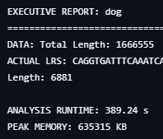
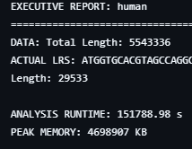
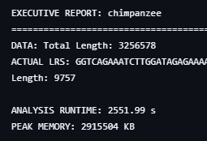
Species | LRS Length (Bases) | Biological Interpretation
Human | 29,533 | Indicates massive Segmental Duplications. These provide "raw material" for the evolution of complex brain-related genes.
Chimpanzee | 9,757 | Substantial length but 3x shorter than Human. Primarily associated with muscle function and visual systems.
Dog | 6,881 | Large relative to its genome size, but indicates a less "modular" evolutionary strategy compared to primates.

B. Frequency Distribution by Length (L)

Length (L) | Max Frequency (Human) | Max Frequency (Chimpanzee) | Max Frequency (Dog)
L=30 | 117 (Dense Control) | 105 (Similar Control) | 44 (Simple Control)
L=70 | 116 (Protein Modules) | 11 (High Uniqueness) | 6 (High Uniqueness)
L=120 | 114 (Complex Patterns) | 10 (Sharp Drop) | 4 (Minimal)

Human:
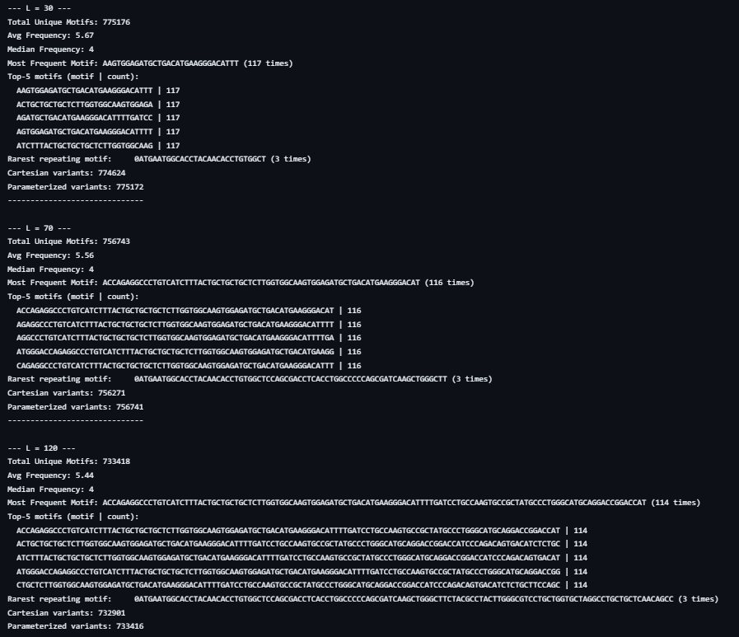
Dog:
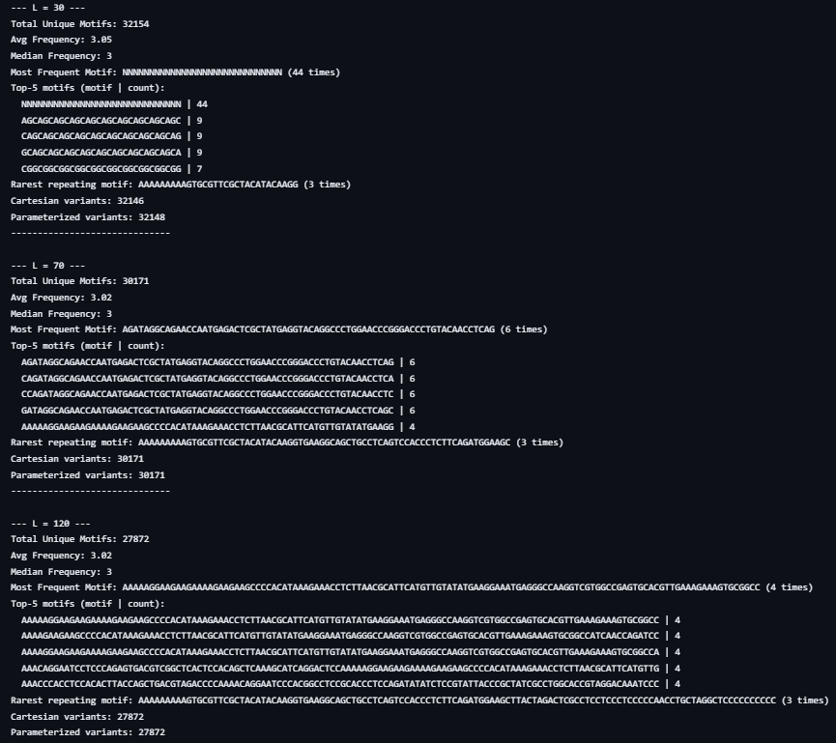
Chimpanzee:

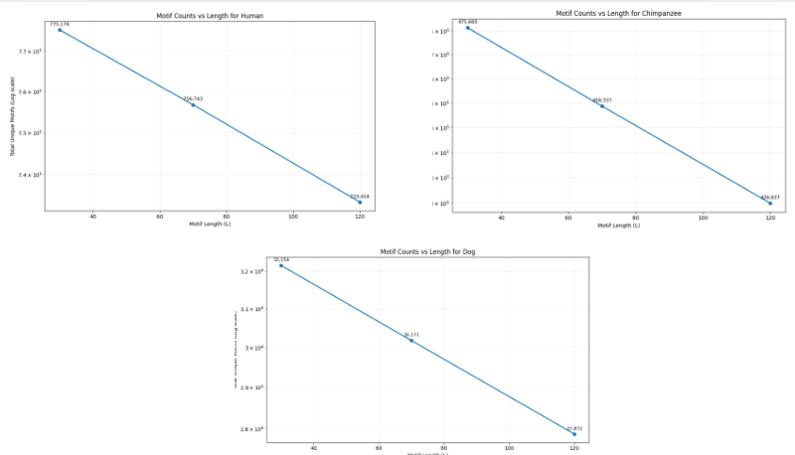
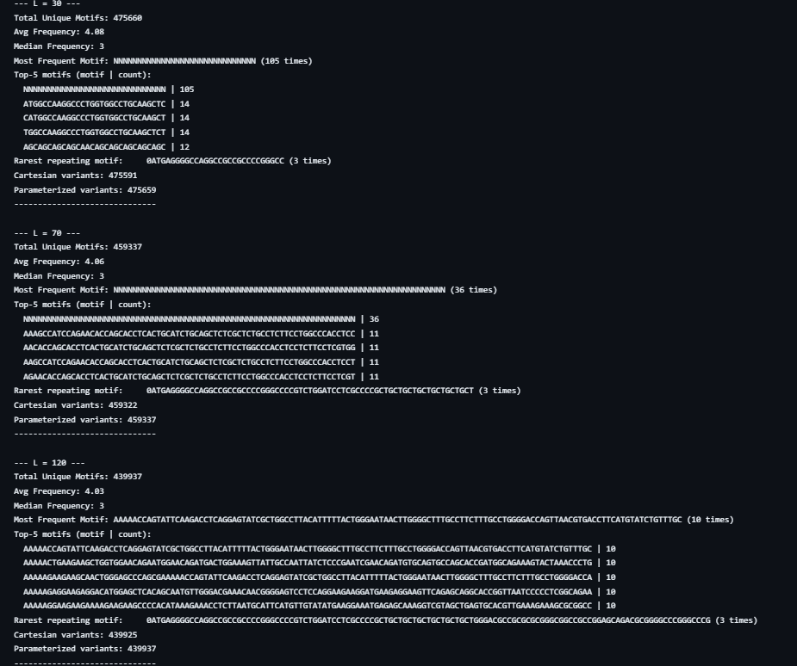
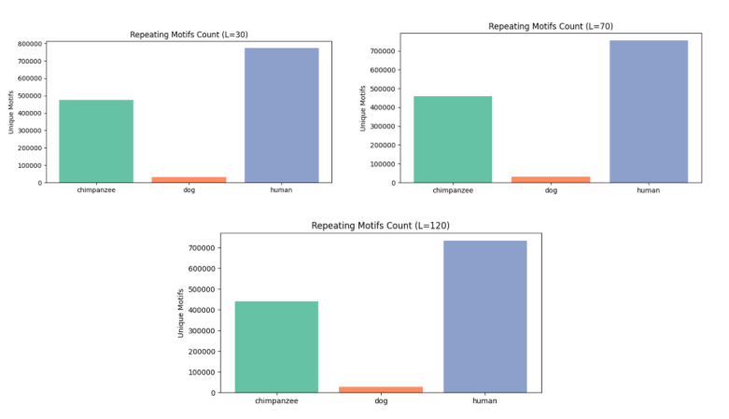
4. Cross-Species Comparison (Shared Motifs)
This analysis identifies the "Shared Language" between species.
Pairwise Shared Motifs Table
Length (L) | Chimp vs. Human | Human vs. Dog | Shared by ALL (Core)
L=30 | 333,742 | 1,664 | 759
L=70 | 265,054 | 151 | 62
L=120 | 202,243 | 25 | 0

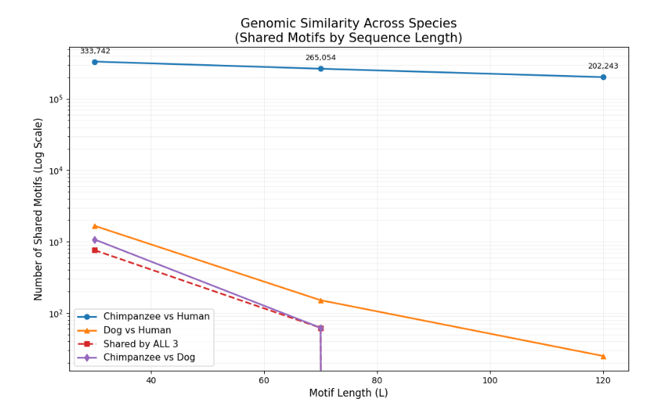
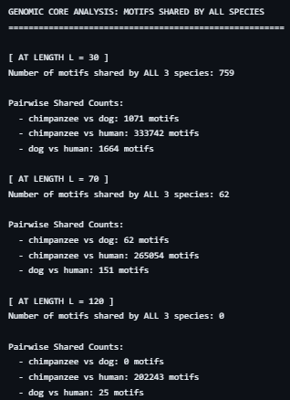

5. Interpretations and Conclusions
- The Primate Connection: The data provides mathematical proof of the close relationship between Humans and Chimpanzees. Even at a complex length of L=120, they share over 200,000 identical sequences, indicating nearly identical protein "toolkits."
- The "Human Advantage" in Replication: A key discovery is the stability of human repetitions. While Chimpanzees and Dogs show a sharp decline in frequency as length increases (L=30 to 120), the Human genome maintains high frequency (114 repetitions). This suggests a specialized mechanism for mass-producing complex functional units, a hallmark of human biological complexity.
- The Evolutionary Core: The 759 motifs shared by all three species at L=30 represent the "Operating System" of mammals—essential sequences for basic cellular life (respiration, DNA replication) that have been conserved for millions of years.
- Technical Insights (The 'N' Factor): The high frequency of 'N' sequences in the Chimpanzee report (36 repeats) highlights gaps in current sequencing technology, usually found in highly repetitive structural areas like Centromeres.

6. Results and Discussion

6.1 Dataset and Evaluation Setup
We analyzed coding DNA sequences (CDS) from three mammals:
- Human (~5.5M bases)
- Chimpanzee (~3.2M bases)
- Dog (~1.6M bases)
Sequences use the DNA alphabet {A, C, G, T}. Because sequence lengths differ substantially across species, results were interpreted comparatively rather than relying only on raw counts.
We searched for repeated motifs at three representative scales:
- L = 30: short patterns, often associated with regulatory “keywords”
- L = 70: intermediate patterns, often treated as modular/domain-like units
- L = 120: longer and more complex patterns

6.2 Longest Repeating Substring (LRS): Large-Scale Duplication Signal
A major outcome is the large difference in the Longest Repeating Substring (LRS) across species:
- Human: extremely long repeated block (~29,533 bases), likely indicating segmental duplication—a large-scale “copy-paste” event of genomic DNA.
- Dog: LRS is also long (~6,881 bases), suggesting large repeated blocks exist, though substantially shorter than in Human.

6.3 Motif Frequency by Length: Humans Remain Highly Repetitive
As motif length increases, exact repetition generally becomes rarer; however, humans show a strong exception:
- Human: repetition is very high at L=30 and L=70 (>115 repeats), indicating extensive reuse of short and intermediate patterns. Even at L=120, a long motif repeats ~114 times.
- Chimpanzee: repetition drops sharply at longer lengths; at L=120, frequency is much lower (~10 repeats).
- Dog: long repeats are rare; in the 70–120 range, repetition is markedly lower than in humans.

6.4 Data Quality Signal: ‘N’ in the Chimpanzee Sequence
Outputs for Chimpanzee include occurrences of 'N' (unknown base). This reflects unresolved or ambiguous sequence positions (often in repetitive or difficult-to-assemble regions) and may affect motif counting and interpretation.

6.5 Spatial Patterns of Repeats: Clustering, Long Gaps, and Periodicity
Three qualitative positional patterns were observed:
- Clustering: many repeat occurrences concentrated in nearby regions, potentially indicating localized functional or structural regions.
- Large Genomic Gaps: the same repeat appearing in distant locations, consistent with large-scale duplication-like behavior.
- Periodic Repeats: repeats appearing at roughly regular intervals, characteristic of tandem arrays.

6.6 Cross-Species Similarity: Strong Human–Chimp Overlap and Small Shared Core
- Human–Chimp: 333,742 shared motifs at L=30, 202,243 shared motifs at L=120, consistent with high conservation between these primates.
- Three-Species Core: 759 motifs shared by all three species at L=30, decreasing to 62 at L=70, and 0 at L=120, showing that only shorter essential patterns remain broadly conserved as motif length increases.

7. Conclusions
- Humans exhibit exceptionally strong repetition at long motif lengths (70–120), including a length-120 motif repeating ~114 times, suggesting extensive reuse of long, complex sequence blocks.
- Chimpanzee shows a sharp decrease at L=120 and contains frequent 'N' symbols, requiring caution in interpretation.
- Dog shows minimal long-motif repetition (70–120), though the presence of a substantial LRS indicates some large repeated blocks.
- Human–chimp similarity dominates across lengths; the three-species shared core persists mainly at short motif lengths (L=30).
- Repeat positions are non-random: clusters, long gaps, and periodicity support localized, large-scale, and tandem-array structural interpretations.

Final Summary
The algorithmic analysis confirms that human uniqueness is not just about the "letters" of DNA, but the efficiency of organization. Humans utilize high-frequency, long-pattern repetitions to build more sophisticated regulatory and structural networks than their closest relatives.

