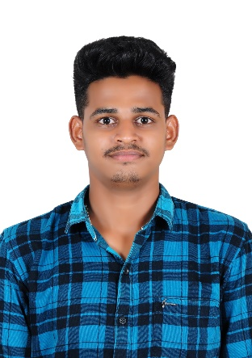

SHAIK MANSOOR ALI

Email : [mansooralisk891@gmail.com](mailto:mansooralisk891@gmail.com)

Contact: +917416726406

# Career Objective:

To associate myself with an organization where there is an opportunity to expose and update my knowledge and strive hard for organization and personal growth.

**Basic Academic Credentials:**

|  |  |  |  |
| --- | --- | --- | --- |
| **Qualification** | **Board/University** | **Year** | **Percentage** |
| B.Tech  (Computer Science  Engineering) | PBR Visvodaya Institute of Technology & Science, Kavali. | 2021-Present | 87.40% |
| Intermediate | Narayana Junior College, Kavali. | 2019-2021 | 82.5% |
| SSC | Ratnam English Medium High School, Kavali. | 2019 | 90% |

# PROFESSIONAL PROFICIENCY:

* Participated in designing **website for SPREE2K23** that was conducted by PBR Visvodaya Institute of Technology & Science in the year 2023.
* Participated in a 6days workshop on **“AMAZON WEB SERVICES”** that was conducted by Visvodaya Institute of Technology & Science in the year 2023.
* Participated and won prize in debugging in a college fest

**Operating System**: WINDOWS 10, LINUX

**Application Package**: Microsoft Office

**Technical Skills**: Java, C and Basics of Python languages

## Achievements:

* Python and Java basic certificates from Hacker Rank.
* **Cyber Security and Applied Ethical Hacking** course completion certificate from **Infosys**.
* **Cyber Security and Analyst job simulation** completion certificate from **TCS**
* **Mobile App Development Advanced Applications** course completion certificate from **Infosys**.
* **Full Stack Java** course completion certificate from **WIPRO.**

**Personality Traits:**

* Hard working
* Leadership Skills
* Creativity
* Organizing Skills

**Languages Known:**

Telugu, Hindi and English.

**Interests:**

Looking out my father’s business, Watching Movies, Listening Music, Interacting with people.

**Declaration:**

I do hereby declare that the above information is true to the best of my knowledge.

**Place:**

**Date:**

**(SHAIK MANSOOR ALI)**