

Project Title: Maidmate

Name: Abdul Samad

Sap ID: 48865

Name: Shakeel Ahmad

Sap Id: 48237

SEMESTER: 6th

Instructor: MR. Adnan Ahmad

Table of Contents

ABSTRACT 3

INTRODUCTION 3

Problem Statement 3

Proposed Solution 4

Target Demographics 4

The application addresses the needs of diverse user groups including busy professionals, families with special care requirements, and domestic workers seeking stable employment opportunities. 4

Personas 4



**Persona 1: Rubina Nadeem** 4

**Persona 2: Muhammad Sami** 4

**Persona 3: Mazhar Hussain** 5

**Anti-Persona 1: Muhammad Asim Adeel** 5

User Research Methods 5

Mental Models in MaidMate 9

Key User Needs/Goals 10

**Family Members' Needs** 10

**Caregivers' Needs** 10

Task Analysis 10

**Family Member Tasks** 10

**Caregiver Tasks** 10

Core Features of the Prototype 10

Design Rationale 11

HCI Principles 12

User Interface (UI) Description 13

Interaction Design Description 14

Usability Considerations 15

Evaluation Goals 15

Evaluation Methods 16

Participants (in evaluation) 20

**Evaluation Procedure (briefly)** 20

Key Evaluation Findings 21

Future Work 21

Conclusion 22

## ABSTRACT

Maidmate is a mobile application designed to safely connect families in Pakistan with verified domestic workers through a user-friendly interface that prioritizes trust, safety, and convenience. This project addresses the significant challenges faced by families in hiring reliable domestic help while providing employment opportunities for service providers in a structured, accountable ecosystem.

## INTRODUCTION

The domestic service industry in Pakistan operates largely through informal networks, creating challenges around trust, safety, and quality assurance. Families struggle to find reliable domestic workers while service providers lack structured platforms to showcase their skills and build professional reputations. **Maidmate** addresses these challenges by creating a comprehensive digital platform that bridges the gap between families seeking domestic assistance and qualified service providers.

This project applies human-computer interaction principles to design a mobile application that prioritizes user safety, trust verification, and seamless service delivery within the Pakistani cultural context.

## Problem Statement

Families in Pakistan face significant challenges when hiring domestic workers due to

* Lack of trust in unverified individuals
* No centralized platform for finding trusted workers
* No quality assurance system through ratings and reviews
* Particular difficulties for working parents, homes with elderly members, and overseas Pakistanis managing care remotely
* Risk of theft or property damage
* No emergency support system
* No rating system to build reputation

## Proposed Solution

Maidmate provides a comprehensive platform that addresses these challenges through

* Verified worker profiles with background checks
* Simplified booking and payment systems
* Performance ratings and reviews
* Safety features including emergency alerts and live tracking
* Real-time service monitoring for accountability
* Safety features including emergency alerts
* Live tracking and verified profiles

## Target Demographics

The application addresses the needs of diverse user groups including busy professionals, families with special care requirements, and domestic workers seeking stable employment opportunities.

## Personas



**Persona 1: Rubina Nadeem**

* **Age:** 48
* **Occupation:** School Principal
* **Family Status:** Married
* **Tech Proficiency:** Moderate to high
* **Goals:** Find reliable car wash and household help while managing a demanding career
* **Pain Points:** Trust issues with previous helpers, difficulty verifying backgrounds, concerned about household precious things
* **Motivations:** Peace of mind, work-life balance, children's wellbeing

**Persona 2: Muhammad Sami**

* **Age:** 31
* **Occupation:** Taxi Driver
* **Family Status:** Married with 2 child
* **Tech Proficiency:** Basic smartphone skills, uses WhatsApp and basic apps
* **Goals:** Keep his home clean for his family while working long hours.
* **Pain Points:** No time to clean house, wife works too, unreliable maids who don't show up
* **Motivations:** Healthy environment for his child, trustworthy cleaning service, affordable weekly cleaning

**Persona 3: Mazhar Hussain**

* **Age:** 53
* **Occupation:** Retired Government Employee
* **Family Status:** Married with adult children
* **Tech Proficiency:** Basic smartphone skills
* **Goals:** Maintain his large family home, find reliable help for weekly deep cleaning
* **Pain Points:** Physical limitations for heavy cleaning, difficulty trusting strangers in his home, fixed pension budget
* **Motivations:** Keep home well-maintained, find respectful and trustworthy cleaning staff, stay within budget

**Anti-Persona 1: Muhammad Asim Adeel**

* **Age:** 22
* **Occupation:** Student
* **Family Status:** Un-married
* **Tech Proficiency:** Intermediate social skills
* **Goals:** Care for elderly mother, secure home and precious belongings, find trustworthy help for household tasks
* **Pain Points:** Home feels lonely, worried about mother's safety, concerned about security of valuable items, young age makes it hard to find reliable household help
* **Motivations**: Protect mother and home, ensure family safety, maintain household, find mature and trustworthy service providers

## User Research Methods

* Use Google form

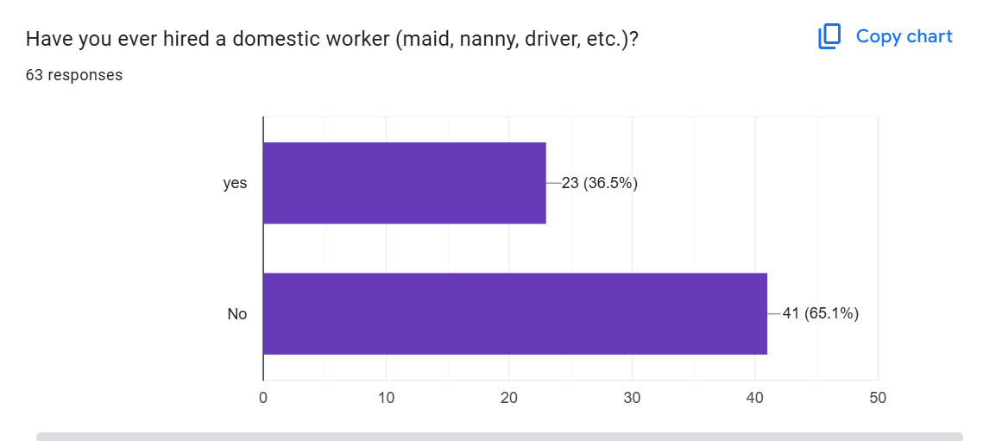

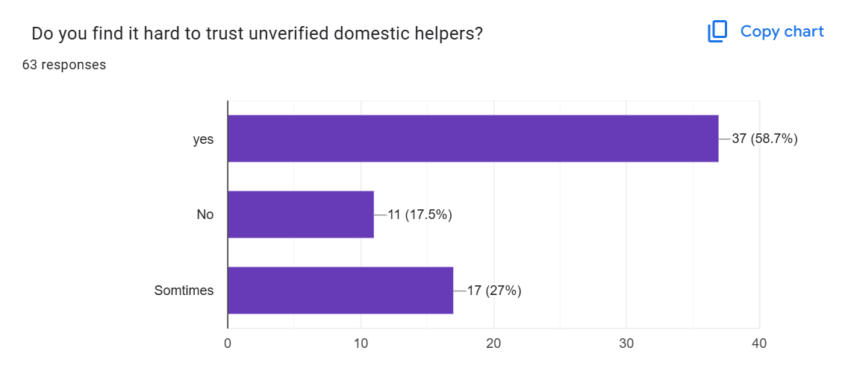

* 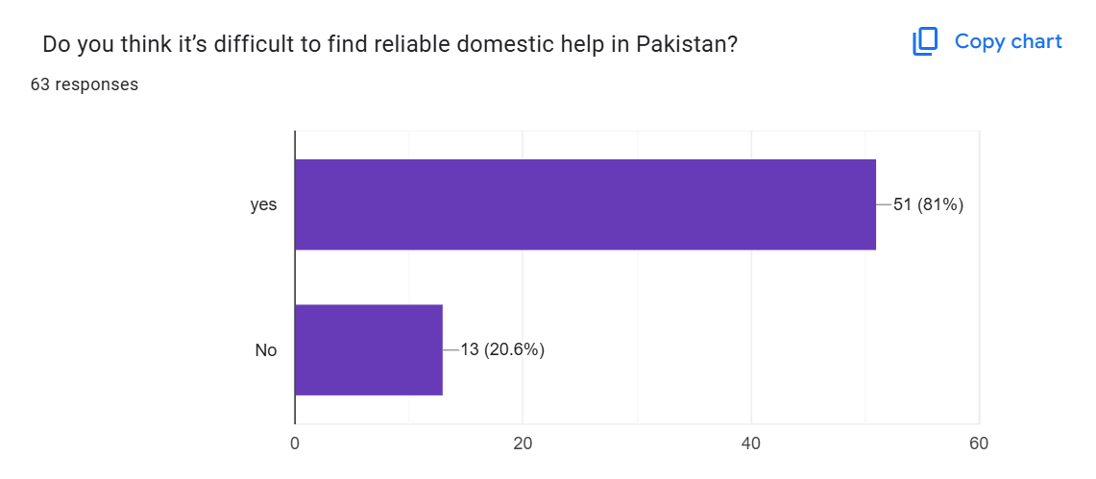
* 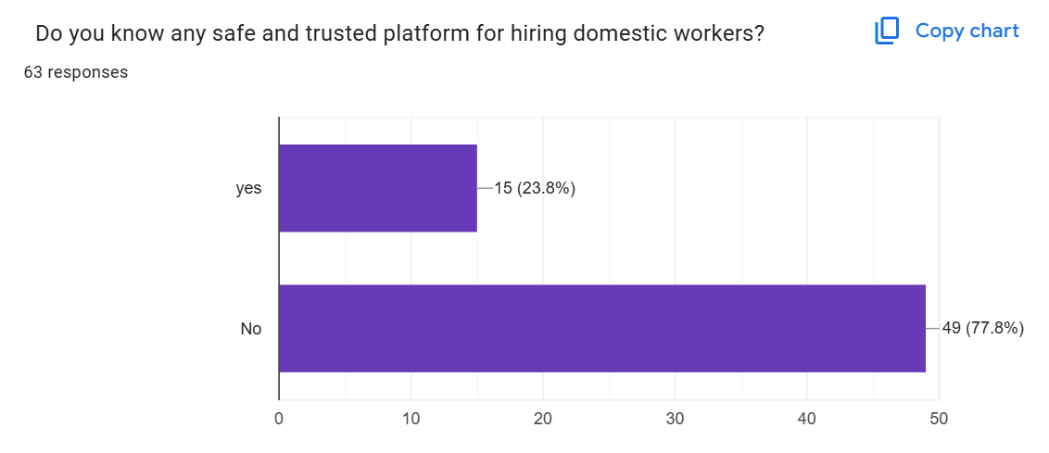
* 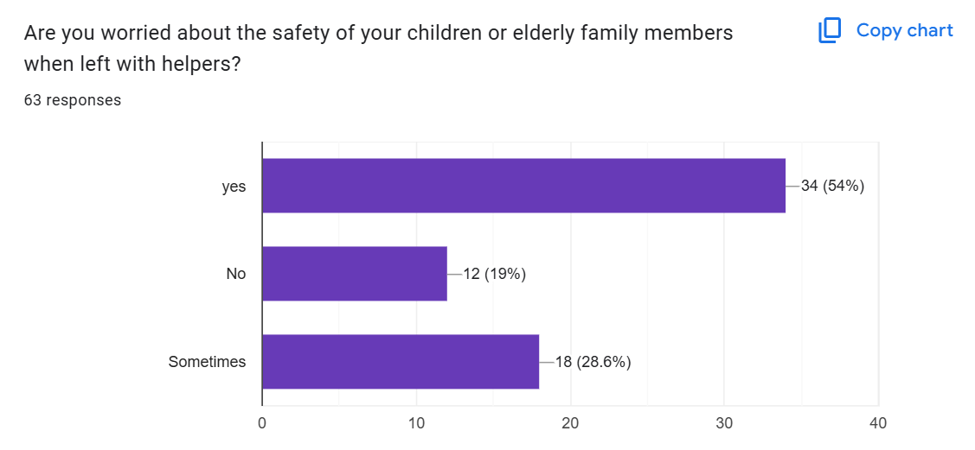
* 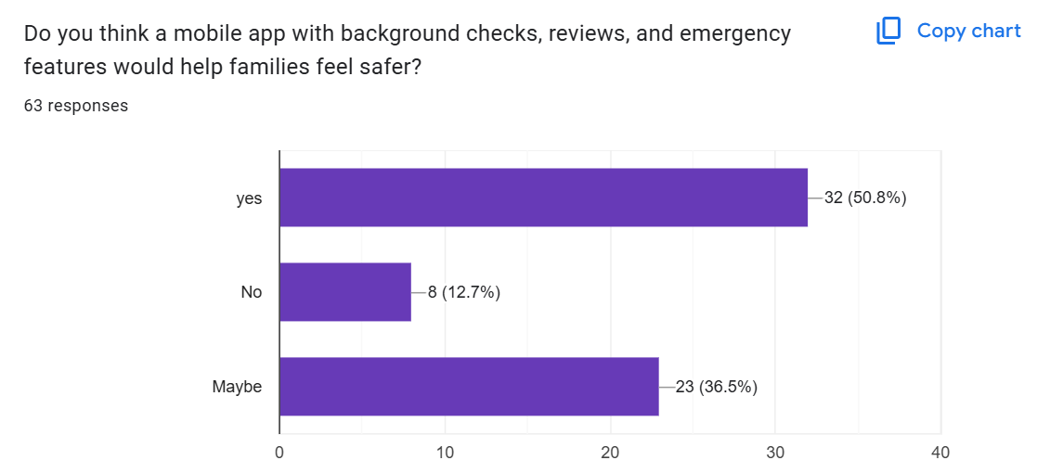
* 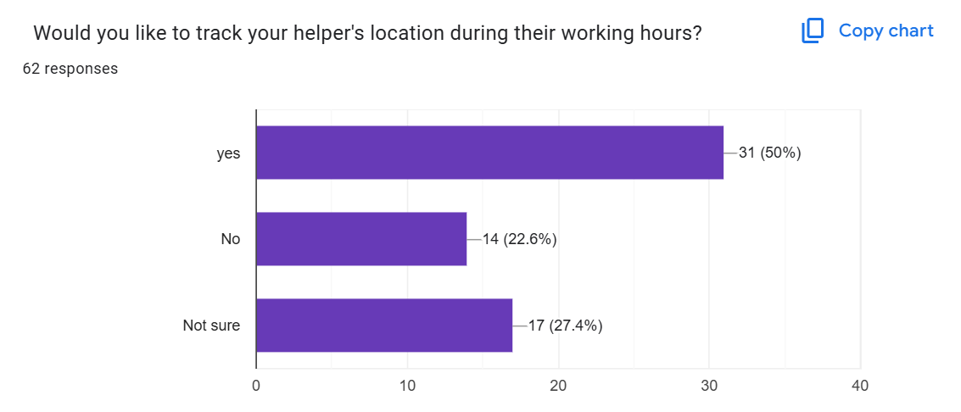
* 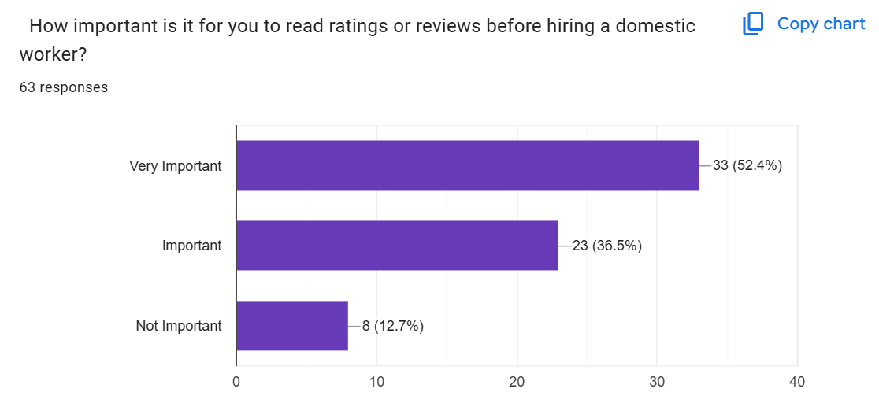
* 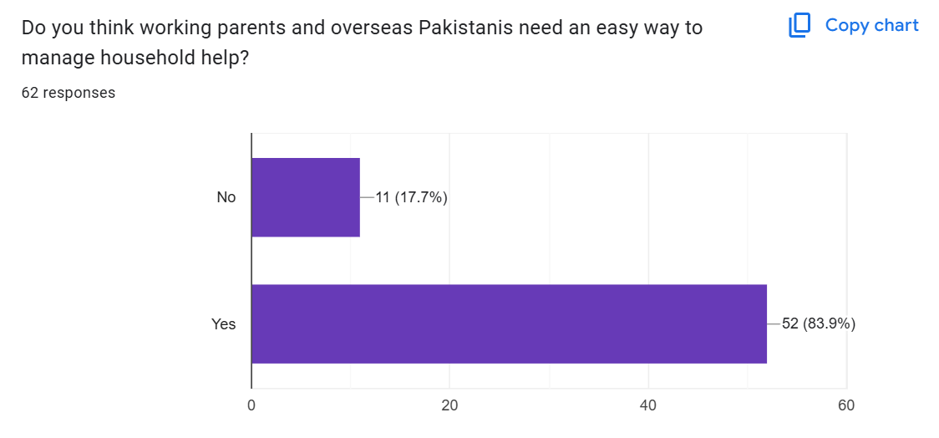
* 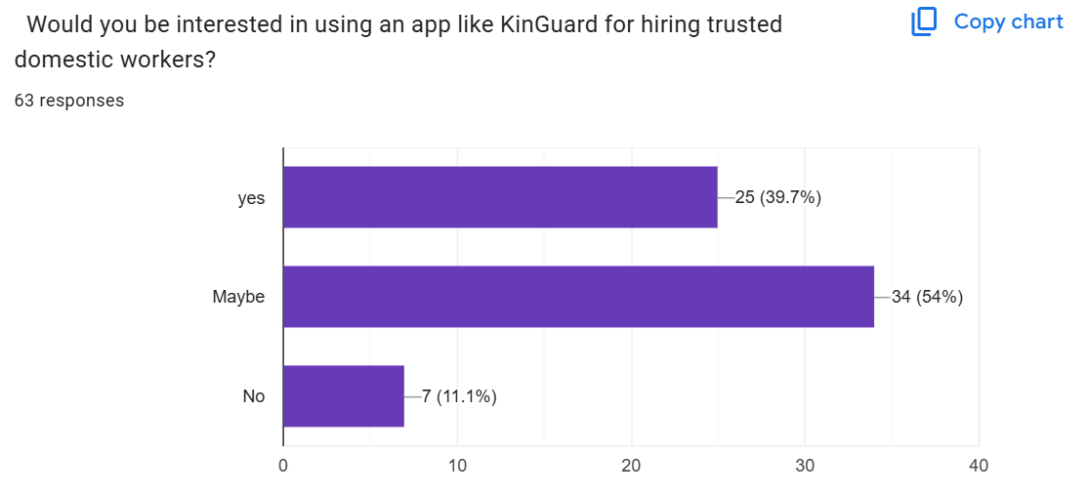
* 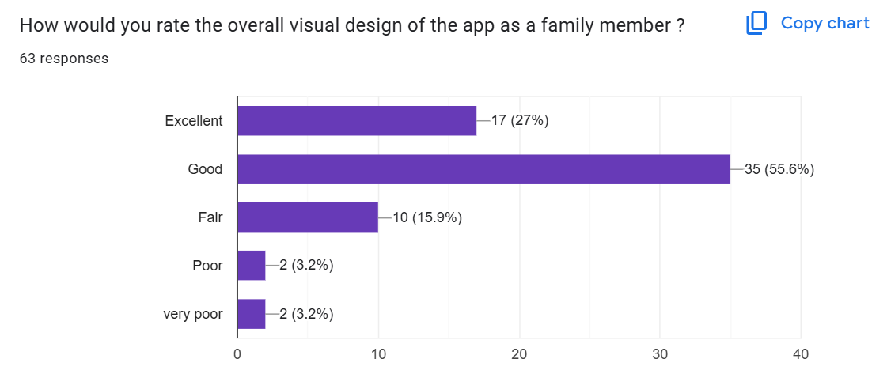
* 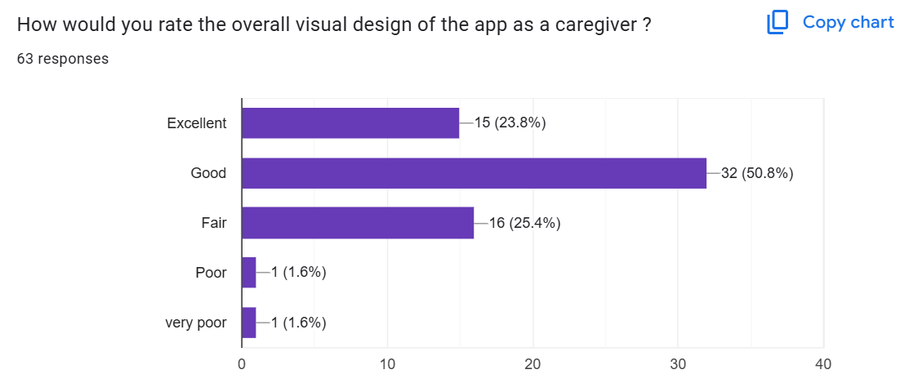
* Competitive analysis of existing platforms

|  |  |  |  |
| --- | --- | --- | --- |
| ****Feature**** | ****Karsaaz App**** | ****Local Caregiver App**** | ****MaidMate (Our App)**** |
| **Target Audience** | Skilled labor seekers (electricians, plumbers, etc.) | Families needing medical or childcare support | Households hiring domestic job seekers (maids, cleaners, babysitters) |
| **Gig Posting** | ❌ | ❌ | ✅ |
| **User Roles** | Clients, Professionals | Families, Caregivers | Clients (employers), Helpers (job seekers) |
| **Search & Filter** | ✅ | ✅ | ✅ |
| **Booking Management** | ❌ | ✅ | ✅ |
| **Payment** | ✅ | ❌ | ✅ |
| **Security** | Basic verification | ✅ | ✅ |
| **Ratings & Reviews** | ✅ | ✅ | ✅ |
| **Emergency Support** | ❌ | ❌ | ✅ |
| **Mobile Platform** | ✅ | ✅ | ✅ |
| **Map Search** | ✅ | ✅ | ✅ |
| **Domestic Role Focus** | ❌ | ✅ | ✅ |
| **Background Verification** | ❌ | ✅ | ✅ |
| **Service Categories** | ✅ | ✅ | ✅ |

## Mental Models in MaidMate

* **Two-Sided Platform** – Users see the app as having two roles: families hiring help and caregivers offering services (like Uber: rider vs. driver).
* **Trust by Verification** – Users trust verified badges and checks, like they do in banking apps or verified social media profiles.
* **Booking Like Appointments** – The service booking feels like scheduling a doctor or salon appointment with time slots and confirmations.
* **Safety by Transparency** – Features like live tracking, emergency buttons, and worker info make users feel safer, just like in ride-sharing apps.
* **Ratings = Quality** – Users rely on reviews and ratings to judge service quality, similar to shopping or food delivery apps.
* **Mobile-First Access** – Users expect full control via smartphone, without needing a computer—just like most modern apps.

## Key User Needs/Goals

**Family Members' Needs**

1. Trust verification for workers entering their homes
2. Easy search and booking of qualified domestic help
3. Emergency features for safety concerns
4. Rating system to ensure quality service

**Caregivers' Needs**

1. Platform to showcase skills and find employment
2. Fair payment system and job security
3. Ability to manage bookings efficiently
4. Building a verifiable reputation through reviews
5. Clear communication with potential employers

## Task Analysis

**Family Member Tasks**

1. **Search for help:** Browse available workers, filter by service type, view profiles
2. **Book service:** Select service, choose date/time, confirm booking
3. **Monitor service:** Track worker arrival, check progress, use emergency features if needed
4. **Complete interaction:** Pay for service, rate experience, leave review

**Caregiver Tasks**

1. **Profile setup:** Create account, complete verification, showcase skills
2. **Service listing:** Post available services with details and pricing
3. **Booking management:** Accept/decline requests, manage schedule
4. **Service delivery:** Check in on arrival, perform duties, check out
5. **Payment collection:** Confirm completion, receive payment

## Core Features of the Prototype

1. **Dual User Interfaces**

* Separate flows for Family Members and Caregivers
* Role-specific dashboards and functionality

1. **Verification System**

* Background checks for caregivers
* Identity confirmation

1. **Search & Discovery**

* Category-based service browsing
* Advanced filtering options
* Map-based search

1. **Booking System**

* Real-time availability calendar
* Request and confirmation flow
* Booking management tools

1. **Safety Features**

* Live tracking during service
* Emergency alert system
* In-app has FAQs for user

1. **Rating & Review System**

* Post-service evaluation
* Profile reputation scoring
* Quality assurance metrics

1. **Payment Integration**

* Secure in-app payments
* Transaction history
* Payment protection

## Design Rationale

1. **Role-Based Architecture**

* Separated user experiences based on distinct needs of families and caregivers
* Streamlined workflows specific to each user type's goals

1. **Trust-Centered Design**

* Verification badges prominently displayed
* Transparency in worker backgrounds
* Review visibility prioritized in UI

1. **Mobile-First Approach**

* Optimized for smartphone users in Pakistan
* Support for lower bandwidth environments
* Minimal data entry requirements

1. **Familiar UI Patterns**

* Bottom navigation bar for easy access
* Card-based UI for better scanning
* Tab-based organization for content management

1. **Safety Integration**

* Emergency features easily accessible throughout the app
* One-tap alerts and help requests
* Real-time location sharing during service

## HCI Principles

1. **Visibility of System Status**

* Clear booking status indicators
* Real-time tracking of workers
* Notification system for updates

1. **Match Between System and Real World**

* Familiar domestic service categories
* Natural language throughout interface
* Cultural considerations in design elements

1. **User Control and Freedom**

* Easy booking cancellation and modification
* Simple navigation with back buttons
* Update profile emergency setting

1. **Consistency and Standards**

* Uniform color scheme and typography
* Consistent button styling and positioning
* Standardized form elements

1. **Error Prevention**

* Confirmation dialogs for critical actions
* Form validation during input
* Clear warning messages

1. **Recognition Rather Than Recall**

* Service categories with icons
* Visual cues for navigation
* Recently viewed services section

1. **Flexibility and Efficiency**

* Quick actions for common tasks
* Search shortcuts and filters
* Saved preferences and favorites

1. **Aesthetic and Minimalist Design**

* Clean, uncluttered interface
* Important information highlighted
* Progressive disclosure of complex features

1. **Help Users Recognize and Recover from Errors**

* Clear error messages with solutions
* Guided correction paths
* Support contact options

1. **Help and Documentation**

* Quick cleaning tips and guides
* Select based on ratings and reviews
* FAQ section

## User Interface (UI) Description

The Maidmate interface uses a modern, clean design with a blue and white color scheme that conveys trust and professionalism

1. **Onboarding Screens**

* Simple registration flow with role selection
* Minimalist form design with progress indicators
* Clear explanation of verification requirements

1. **Home Screen**

* Role-specific dashboard showing key information
* Quick access to frequently used features
* Status updates and notifications area

1. **Service Browsing**

* Card-based service listings with key details
* Image, price, and rating prominently displayed
* Filter and sort controls for refined searching

1. **Profile Screens**

* Verification badges clearly visible
* Review section with summarized metrics

1. **Booking Management**

* Tab-based organization (Upcoming, Completed, Cancelled)
* Timeline visualization of scheduled services
* Action buttons for managing bookings

1. **Safety Features**

* Prominent emergency button
* Real-time map tracking interface
* Simple alert confirmation dialogs

1. **Navigation System**

* Persistent bottom navigation bar
* Clear iconography with labels
* Hierarchical structure with breadcrumbs

## Interaction Design Description

1. **User Registration and Onboarding**

* Progressive disclosure approach with step-by-step forms
* OTP verification via mobile number
* Guided profile completion with progress indicators

1. **Service Discovery**

* Horizontal scrolling categories for quick access
* Vertical scrolling for service listings
* Pull-to-refresh for updated content
* Tap interactions for service details

1. **Booking Process**

* Multi-step booking flow with clear progress indicators
* Date/time selection using native pickers
* One-tap booking confirmation
* Animated transitions between booking steps

1. **In-Service Interactions**

* Real-time status updates with push notifications
* Simple check-in/check-out process
* One-touch emergency assistance

1. **Post-Service Workflow**

* Optional detailed review input
* Payment confirmation with receipt

## Usability Considerations

1. **Accessibility**

* Support for screen readers
* Adequate contrast ratios for text
* Appropriately sized touch targets (minimum 48dp)

1. **Language and Literacy**

* Dictation support
* Simple language avoiding technical jargon
* Icon-based navigation to support low literacy users

1. **Connectivity Challenges**

* Offline mode for viewing scheduled bookings
* Low-bandwidth optimized images
* Minimal data requirements for core functions
* Graceful error handling for connection issues

1. **Security and Privacy**
   * Clear permissions explanations
   * Selective information sharing controls
   * Secure storage of personal data
   * Privacy-focused default settings
2. **Cultural Sensitivities**
   * Allow users to set their comfort preferences for service providers
   * Family-appropriate imagery and language
   * Respect for traditional household structures
   * Recognition of cultural norms around home assistance

## Evaluation Goals

1. Assess the effectiveness of the dual-role interface design
2. Measure the perceived trustworthiness of the verification system
3. Evaluate the efficiency of the booking process
4. Determine the usability of safety features
5. Assess the overall user satisfaction with the platform

## Evaluation Methods

1. **Usability Testing**
   * Task completion testing with representative users
   * Think-aloud protocol during key tasks
   * Time-on-task measurements
   * Error rate tracking
2. **Heuristic Evaluation**
   * Expert review against Nielsen's heuristics
   * Identification of usability issues
   * Severity rating of discovered problems
3. **System Usability Scale (SUS)**
   * Standardized questionnaire for overall usability
   * Benchmark comparison with similar apps
   * Identification of improvement areas
4. **Prototype Testing**
   * Interactive Figma prototype evaluation
   * User flow validation

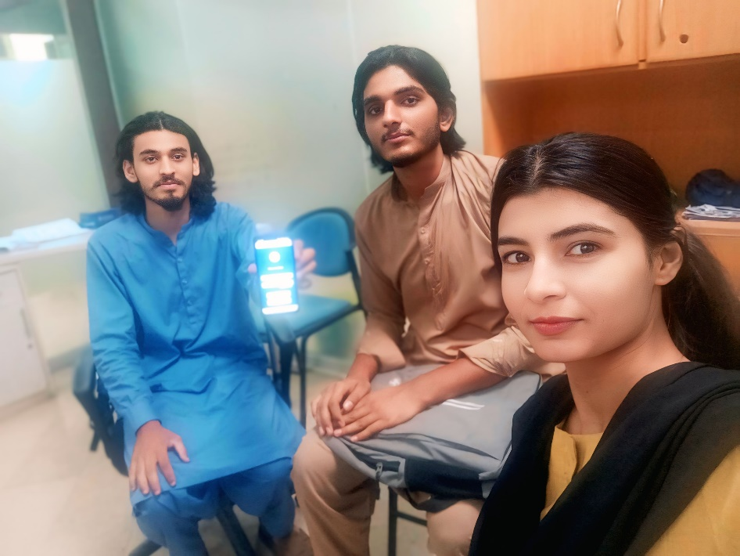

Usability test with MS. Madeeha Kanwal

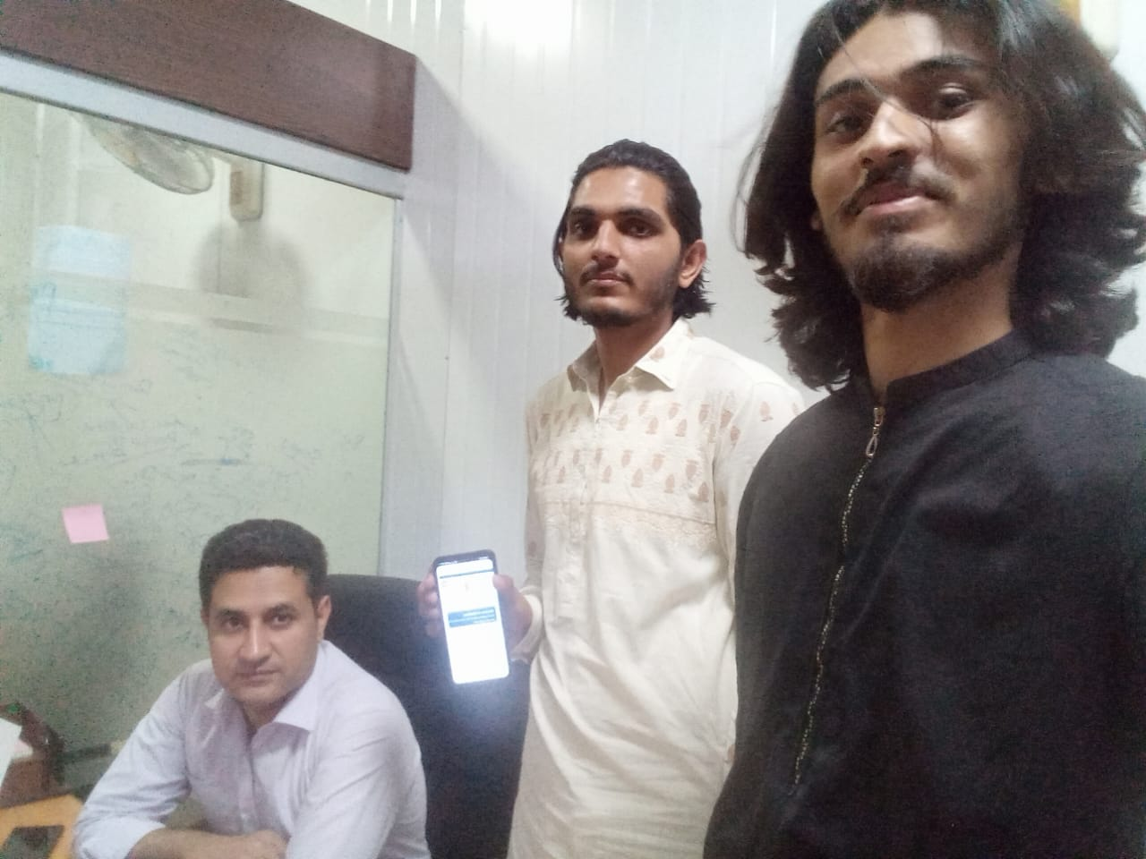

Usability test with Dr. Adnan Ahmad

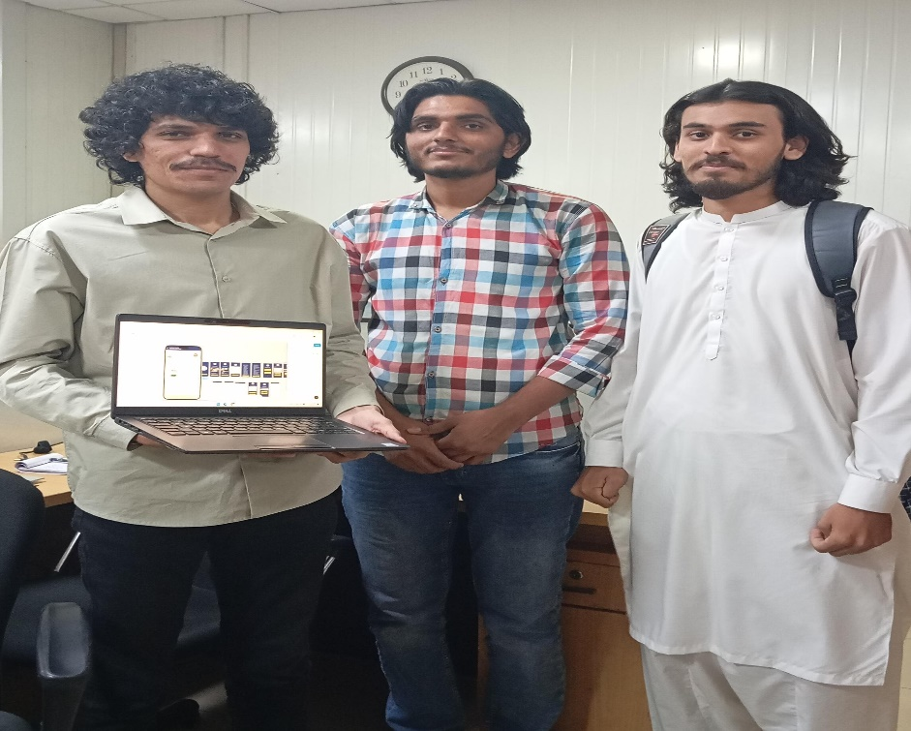

Usability test with Mr. Muneeb Majid



Usability test with Mr. Amir

## Participants (in evaluation)

1. **Family Member Group** 
   * 2 working professionals with childcare needs
   * 3 families with elderly members
   * Age range: 30-55 years
   * Equal gender representation
   * Various tech proficiency levels
2. **Caregiver Group**

* 1 professional domestic workers
* 4 occasional service providers
* 2 new entrants to domestic work
* Age range: 25-50 years
* Range of smartphone experience levels

**Evaluation Procedure (briefly)**

1. **Pre-test**

* Background questionnaire
* Brief introduction to project goals
* Informed consent collection

1. **Task-Based Testing**

* Specific scenarios based on user role
* Minimal guidance during task completion
* Observation and note-taking
* Screen and audio recording (with permission)

1. **Post-Task Interviews**

* Semi-structured questions about experience
* Difficulty ratings for each task
* Suggestions for improvement
* Overall impressions

1. **Quantitative Measures**

* Task success rates
* Time-on-task metrics
* Error frequency
* SUS questionnaire completion

1. **Analysis**

* Data compilation and pattern identification
* Priority ranking of usability issues
* Recommendations development

## Key Evaluation Findings

1. **Verification Process**

* Most family members felt more confident with verification badges
* Many caregivers found document uploading unclear and difficult
* Families generally liked knowing verification status but wanted it clearer

1. **Booking Flow**

* Users could complete bookings in reasonable time
* Most first-time users successfully finished their bookings
* Some users got confused when picking dates and times

1. **Navigation System**

* Bottom menu was easy to understand and use
* Users appreciated having different dashboards for their roles
* Some mixed up History and Bookings sections

1. **Safety Features**

* Emergency button was easy to find for nearly everyone
* Families really valued the tracking feature
* Some worried about phone battery draining with location tracking

1. **Overall Experience**

* Most users said they would use the app again
* App scored well above average for usability
* Features most valued: verification, tracking, and ratings

## Future Work

1. **Feature Expansions**

* Video and voice recording verification option for enhanced trust
* AI-powered matching of families with compatible caregivers
* Subscription model for regular service needs
* Extended service categories (gardening, tutoring, shifting house etc.)

1. **Technical Enhancements**

* Offline functionality improvements
* Advanced notification preferences
* Integration with smart home systems for access management

1. **Business Development**

* Corporate packages for employee benefits
* Housing society partnerships
* Insurance options for additional security
* Training and certification programs for caregivers

1. **User Experience Research**

* Longitudinal studies on trust development
* Ethnographic research in different Pakistani regions
* Impact assessment on domestic worker employment quality
* Cross-cultural adaptation study for international expansion

## Conclusion

**MaidMate** is a trusted app that connects Pakistani families with verified caregivers. It uses user-friendly HCI design to solve hiring problems. Key features include two user roles (family & caregiver), strong verification, and safety tools. User feedback shows the app is easy to use and helpful. It improves job quality, family safety, and accountability. Future updates will add more features while keeping trust and safety the top priority.