Hybrid Decision Engine for Real-Time Intelligent Surveillance & IoV-Based threat Detection

Name:
Shakeel Ur Rehman (2022-CS-426)
Ahmad Arshad (2022-CS-408)
Muzamil Raza (2022-CS-405)
Department of Computer Science
University of Engineering and Technology, Lahore

Table of Content
Gun Detection System Error! Bookmark not defined.
1. Introduction 3
2. Background & Motivation 3
3. Project Overview 3
4. Objectives 3
5. System Architecture 4
6. Technology Stack 4
7. Functional Components 4
8. Agent-Based Decision System 5
9. Threat Level Classification 5
10. Evidence Management 5
11. Performance Metrics 6
12. Project Output 7
13. Conclusion 8

Introduction

The Integrated Gun Detection System is an advanced AI-powered surveillance solution designed to enhance public and private security infrastructures.
This documentation provides a comprehensive, industry-standard explanation of the system’s design, architecture, implementation, and deployment.
The system leverages real-time computer vision, intelligent agent-based decision-making, and automated response mechanisms to detect firearms and related threats accurately.

Background & Motivation

With the increasing need for intelligent security systems, traditional CCTV monitoring has become insufficient due to human limitations.
This project addresses these challenges by integrating deep learning-based weapon detection with autonomous decision-making agents,
ensuring rapid response, reduced false alarms, and reliable evidence generation.

Project Overview

The Integrated Gun Detection System is a real-time surveillance framework that combines YOLO-based object detection with a hybrid multi-agent intelligence engine.
It processes live video streams, detects weapons, classifies threat levels, stores digital evidence, and triggers alerts or IoV-based responses.

Objectives

The primary objectives of this project are:
•Detect and track humans in real time
• Recognize human activities using pose estimation
• Detect weapons such as guns and knives
• Assess threat levels using a hybrid decision engine
• Provide real-time visualization and alerts
• Automated evidence recording and storage
• Fast and intelligent response generation
• Scalable, modular, and maintainable architecture

System Architecture

The system follows a modular layered architecture that ensures scalability, flexibility, and fault tolerance.
• Computer Vision Layer: Uses YOLO v8 for real-time weapon detection.
• Agent-Based Intelligence Layer: Coordinates intelligent agents using a structured workflow.
• Decision & Threat Assessment Layer: Determines threat severity.
• Evidence Management Layer: Stores images, videos, and metadata.
• Notification & Response Layer: Sends alerts and triggers UAV coordination.

Technology Stack

• Programming Language: Python 3.8+
• Deep Learning Framework: YOLO v8
• Agent Framework: LangGraph
• User Interface: OpenCV-based GUI

Core Features

- Human Detection and Tracking (YOLOv8 + DeepSORT)
- Activity Recognition (Pose-based classification)
- Weapon Detection (ONNX-based gun and knife detection)
- Hybrid Decision Engine
- Real-time Visualization

Decision-Making Module
The decision engine combines rule-based logic, finite state machines, Bayesian confidence fusion, and multi-criteria decision making to evaluate threats and trigger appropriate responses.

Agent-Based Decision Engine

The system consists of six intelligent agents:
• Perception Agent – Interprets detection results
• Threat Assessment Agent – Evaluates severity
• Decision Agent – Selects response strategy
• Evidence Agent – Handles data recording
• Notification Agent – Sends alerts
• Memory Agent – Learns from past events
These agents interact through a structured workflow ensuring reliability and adaptability.

Threat Level Classification

Threat levels are divided into five categories:
NONE – No threat detected
LOW – Suspicious activity
MEDIUM – Potential armed presence
HIGH – Confirmed weapon detected
CRITICAL – Active or violent threat
Each level activates predefined automated responses.

Evidence Management

Every detected threat generates verifiable evidence including:
• Video clips
• Still images
• Detection timestamps
• Threat classification
• Agent decisions

Performance Metrics

• Detection Speed: 25–35 FPS
• Threat Assessment Time: <50 ms
• Total Response Time: <200 ms
• Detection Accuracy: >78%

Project Output

This section is reserved for system output visuals.
• Detection screenshot
• Bounding box result
• Threat level overlays
• Evidence storage snapshot
• Alert notification sample
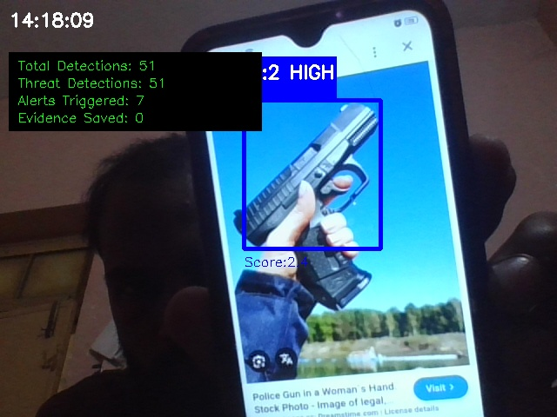

Conclusion

The Integrated Gun Detection System is a production-ready intelligent surveillance solution that combines advanced AI,
multi-agent decision-making, and automated response mechanisms. It is suitable for smart cities, campuses, and critical infrastructure protection.

