***Documentation***

**Integration between Asana and Airtable**

* **At first, create Airtable account.**
* **After creating Airtable account, create base and name it as Integration.**
* **In base, create one table and name it as Asana Tasks.**
* **In that Asana Tasks table, create 5 fields:**

**Task Id**

**Name**

**Assignee**

**Due Date**

**Description**

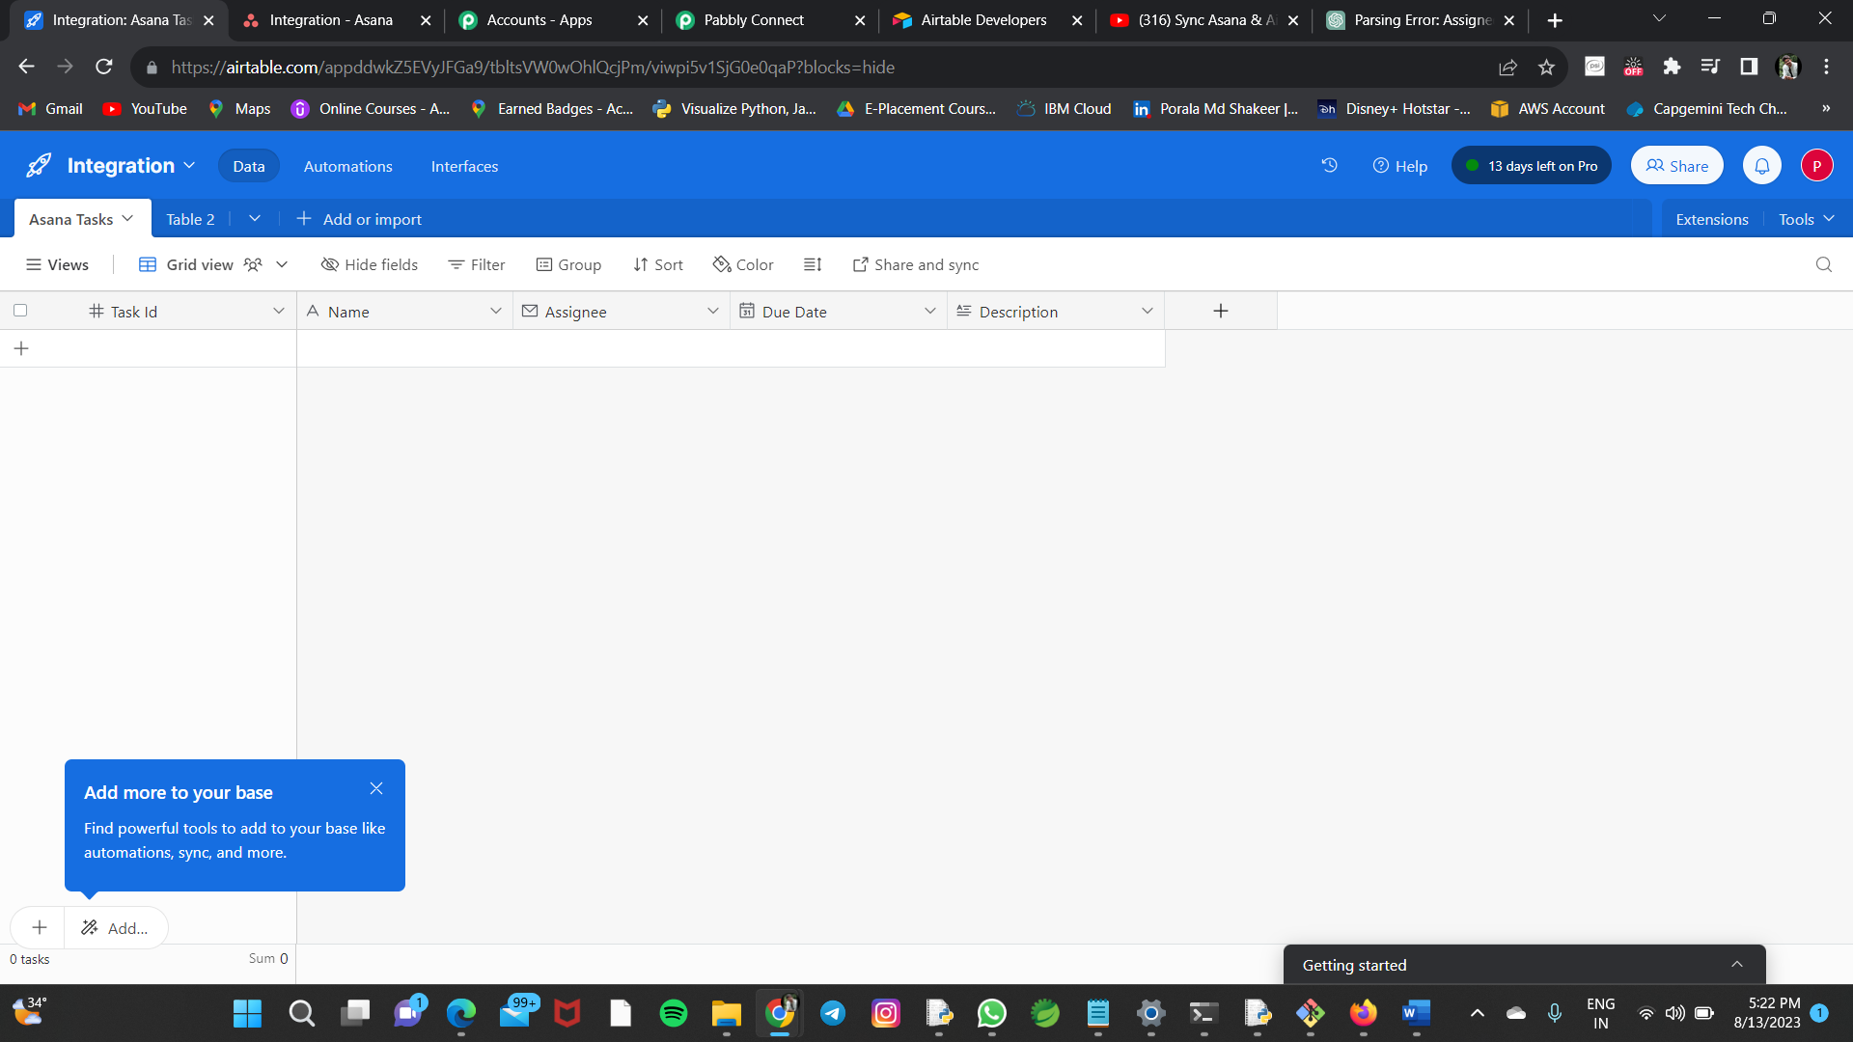

* **Now create Asana account, there create Project named Integration.**
* **Inside that project, create the same fields we have created in Airtable account i.e.,**

**Task Id**

**Name**

**Assignee**

**Due Date**

**Description**

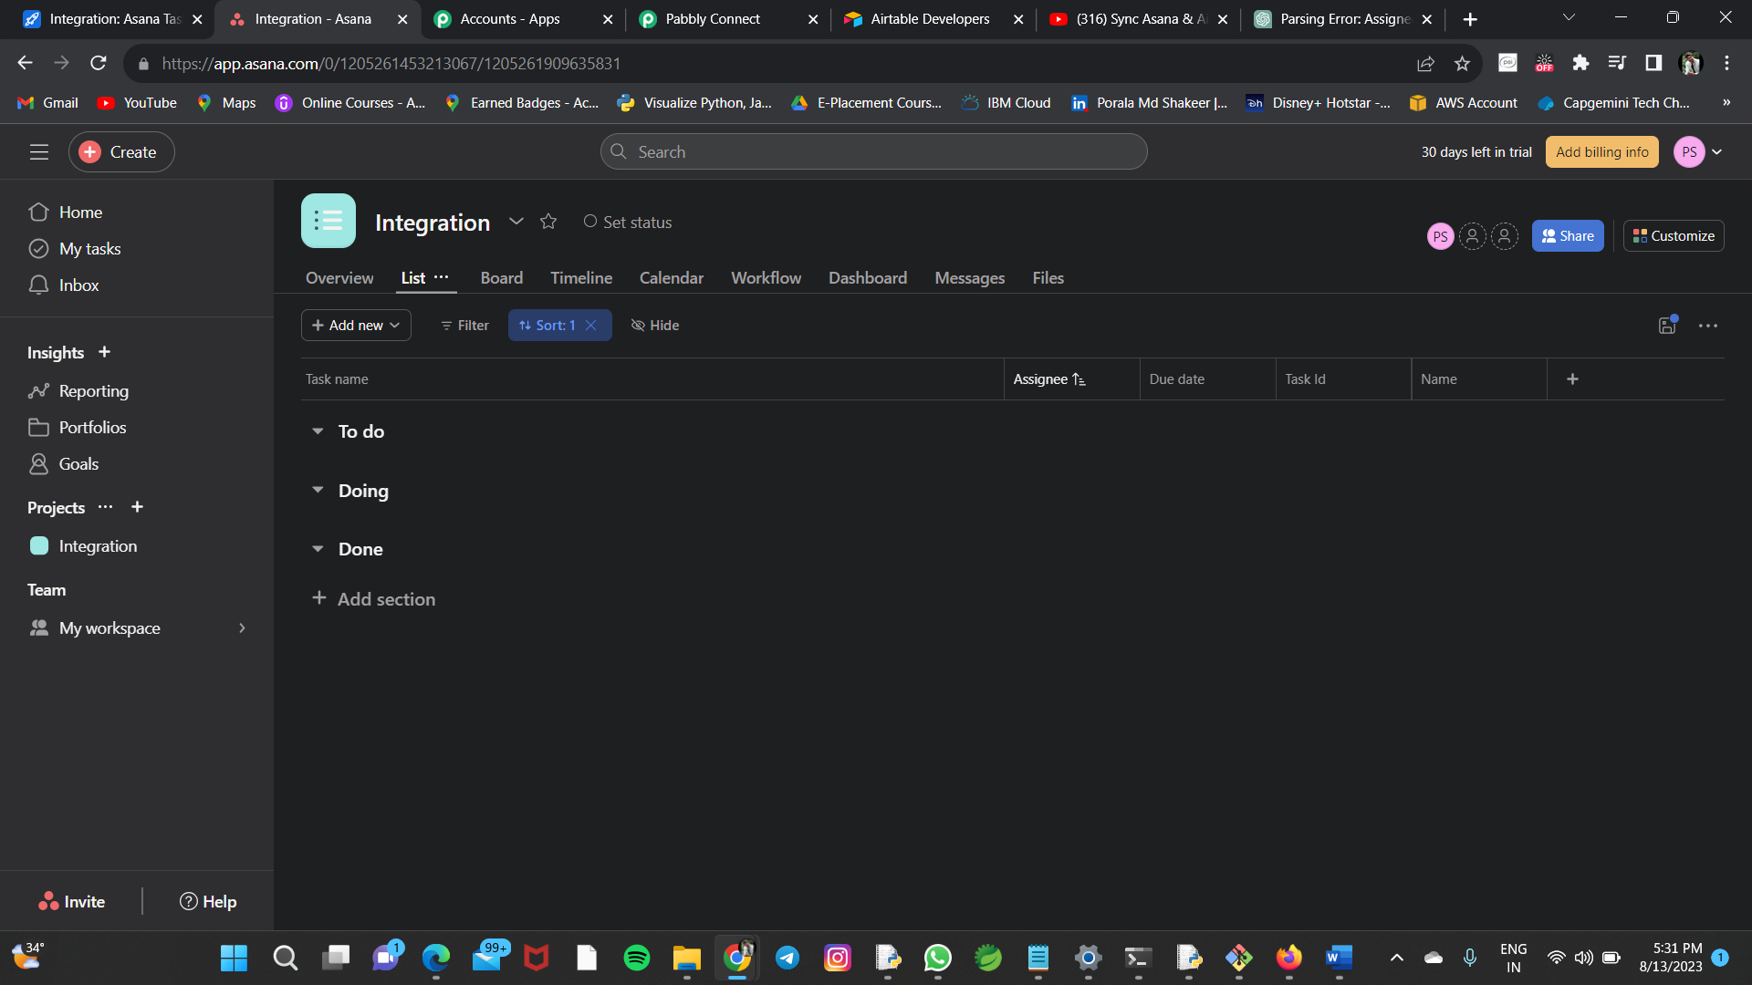

* **Now we will make use of Pabbly account to make integration between Asana account and Airtable account.**
* **Pabbly account acts as a Webhook so that whenever a new task is added in Asana, it will automatically update that task in Airtable as a record.**
* **At first, we have to create our own Workflow to do this whole process in Pabbly account. Say, we will name it as Asana Workflow.**

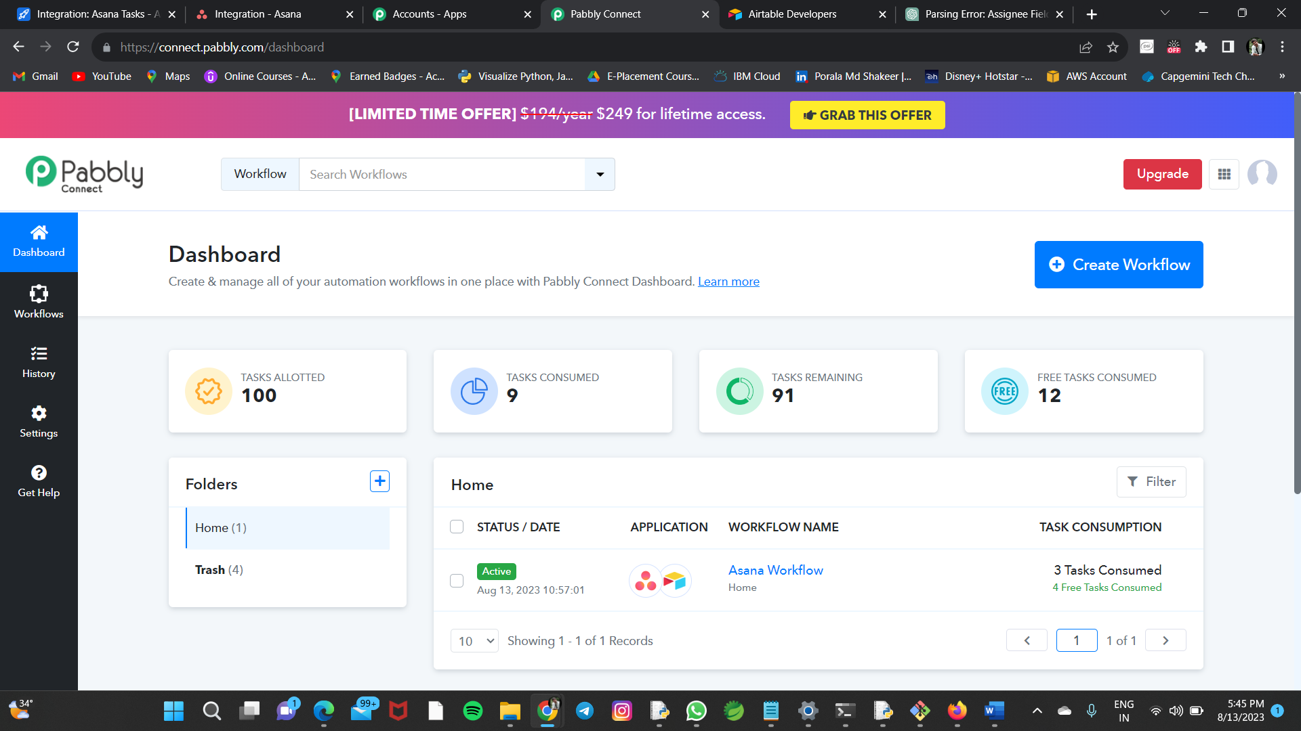

* **Get inside that workflow we created.**
* **Now at trigger label, select Asana app.**
* **Choose trigger event as New Task in Project.**
* **Now click on connect, create a connection and select that one, to make connection.**
* **Choose our existing project i.e., Integration and click on Save and Send Test Request**

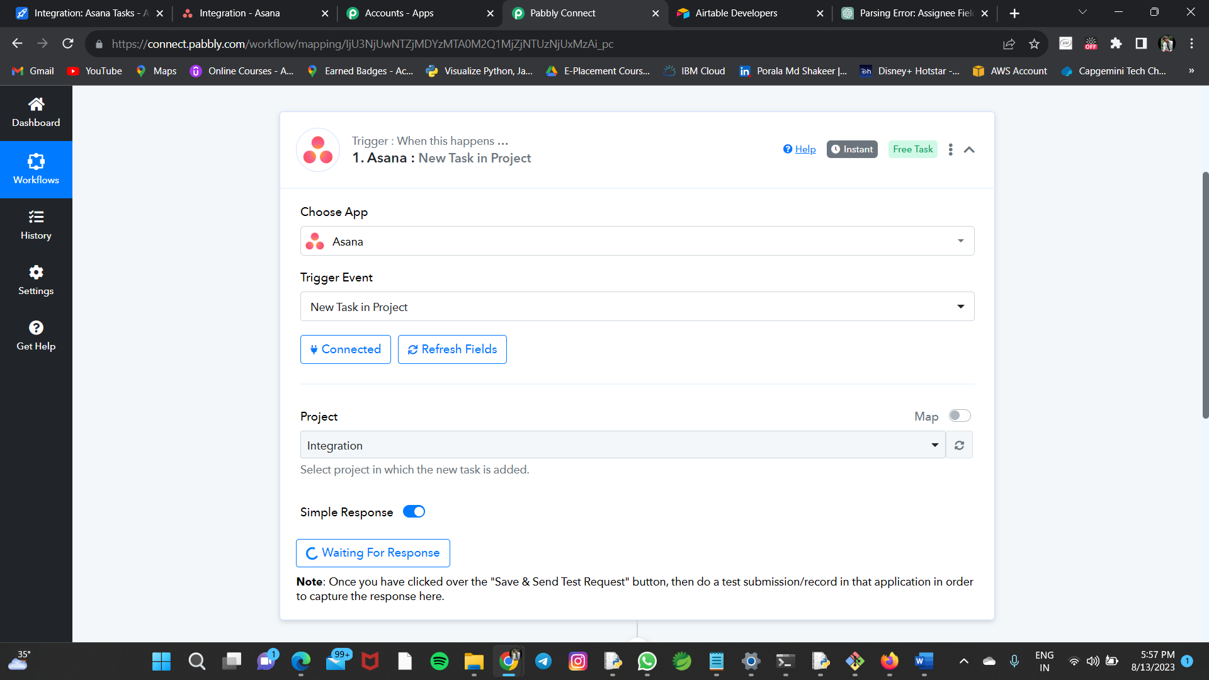

* **And then, you will get Waiting For Response option.**
* **Now to get the desired response from that request, go to Asana account and add task by creating one.**
* **It will go as response in that Pabbly account and we will get the desired response.**

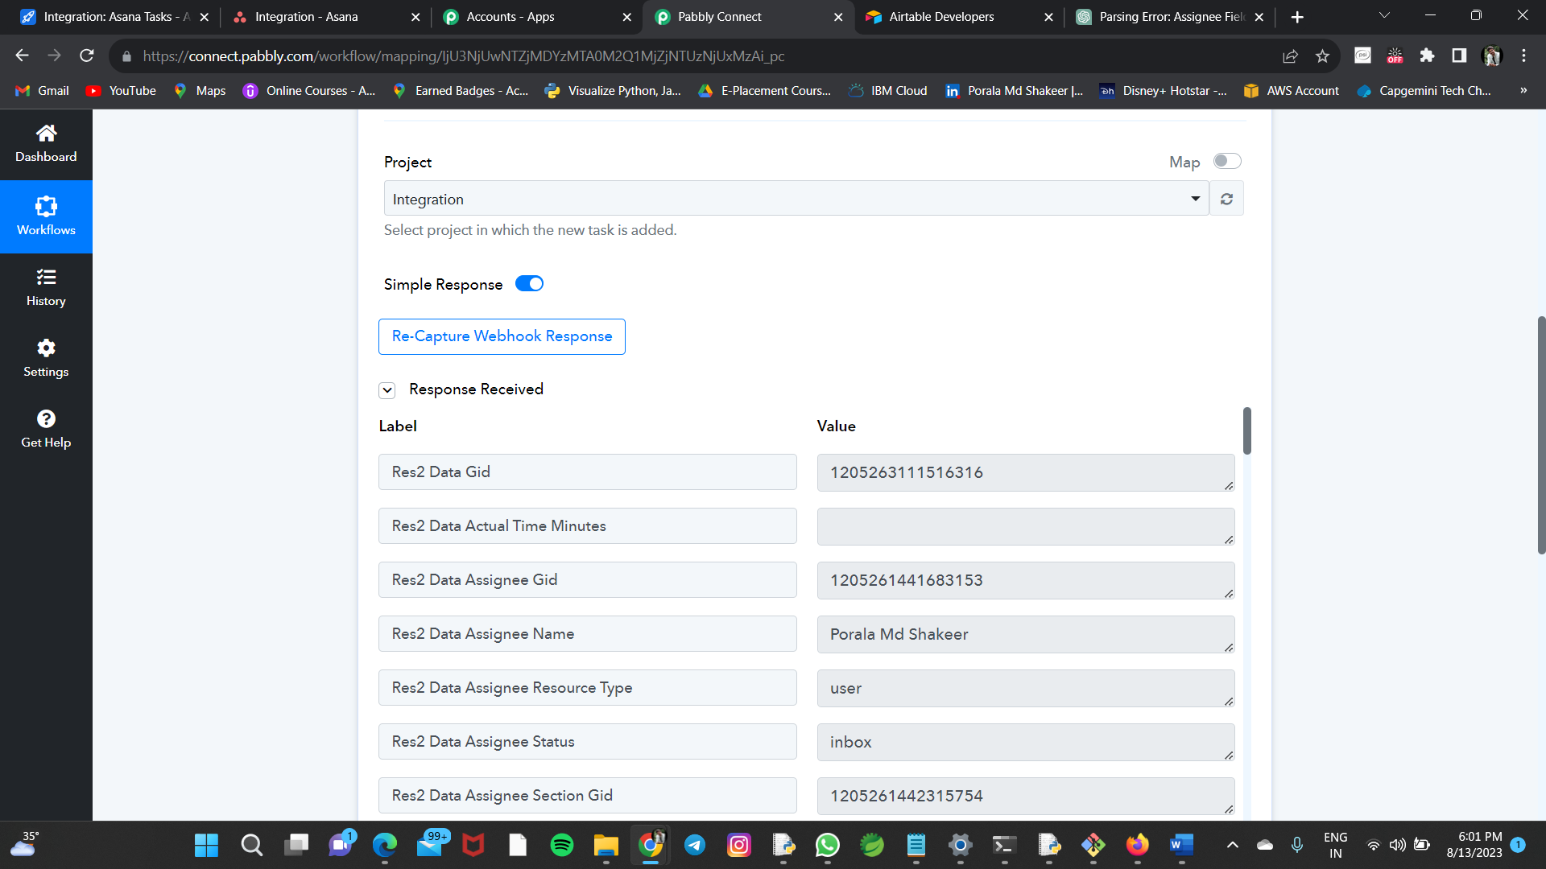

* **Now go to Action label and choose Airtable app.**
* **Choose Create a Record in Action Event.**
* **Click on Connect and provide the token, in which we have to create it in Airtable account, and click on save for making connection.**

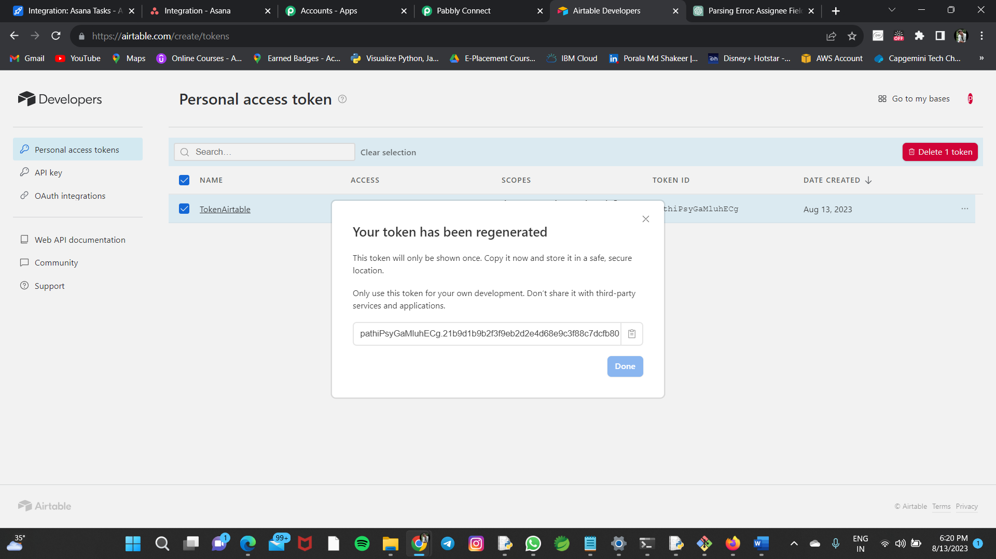

* **Now choose Base Id, Table Id accordingly by checking in Airtable account.**
* **Now choose all the fields i.e., Task Id, Name, Assignee, Due Date and Description accordingly by the task we created in Asana account.**
* **Select those options carefully.**

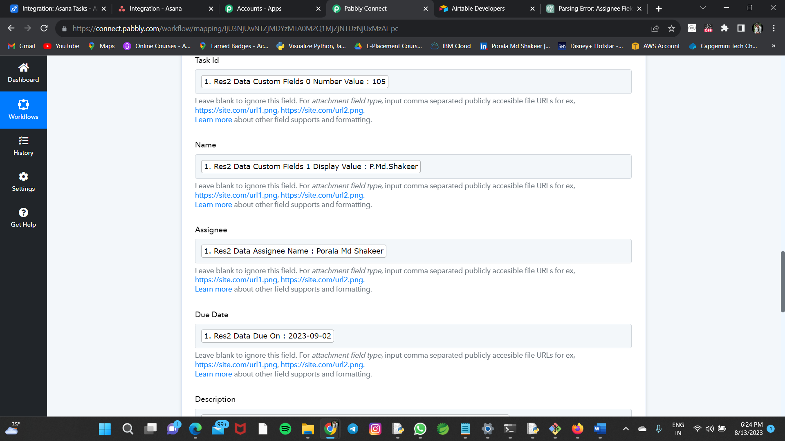

* **Now click on Save and Send Test Request, we will get the desired response there itself.**

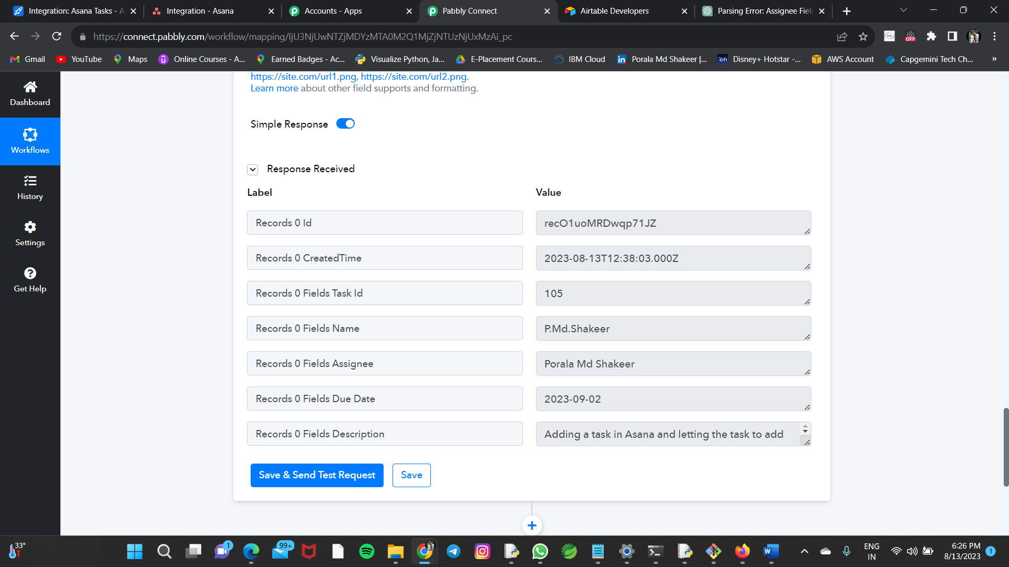

* **Now go and verify in Airtable account, whether the Asana Tasks table is got updates or not.**

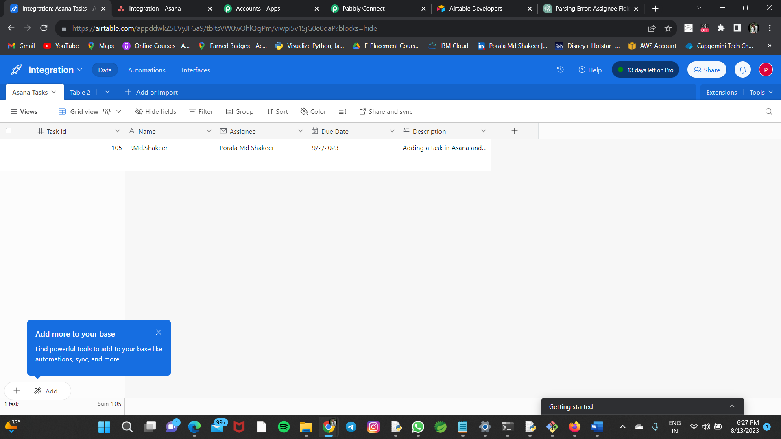

* **Finally, the task we added in Asana account got automatically updated in Airtable account through the webhook called Pabbly account.**

**Thank you**