**Lab Report-03**

*Course Title: Algorithm-I Laboratory*

*Course code: CSE-210*

*2nd Year 1st Semester Examination 2021*

**Date of Submission**: 06-09-2022



**Submitted to-**

***Mohammad Ashraful Islam***

*Department of Computer Science and Engineering*

*Jahangirnagar University*

*Savar, Dhaka-1342*

|  |  |  |  |
| --- | --- | --- | --- |
| **Sl** | Class Roll | Exam Roll | Name |
| 01 | 376 | 202188 | Md. Shakhawat Hosen |

Lab Report**: Optimal offline Caching**

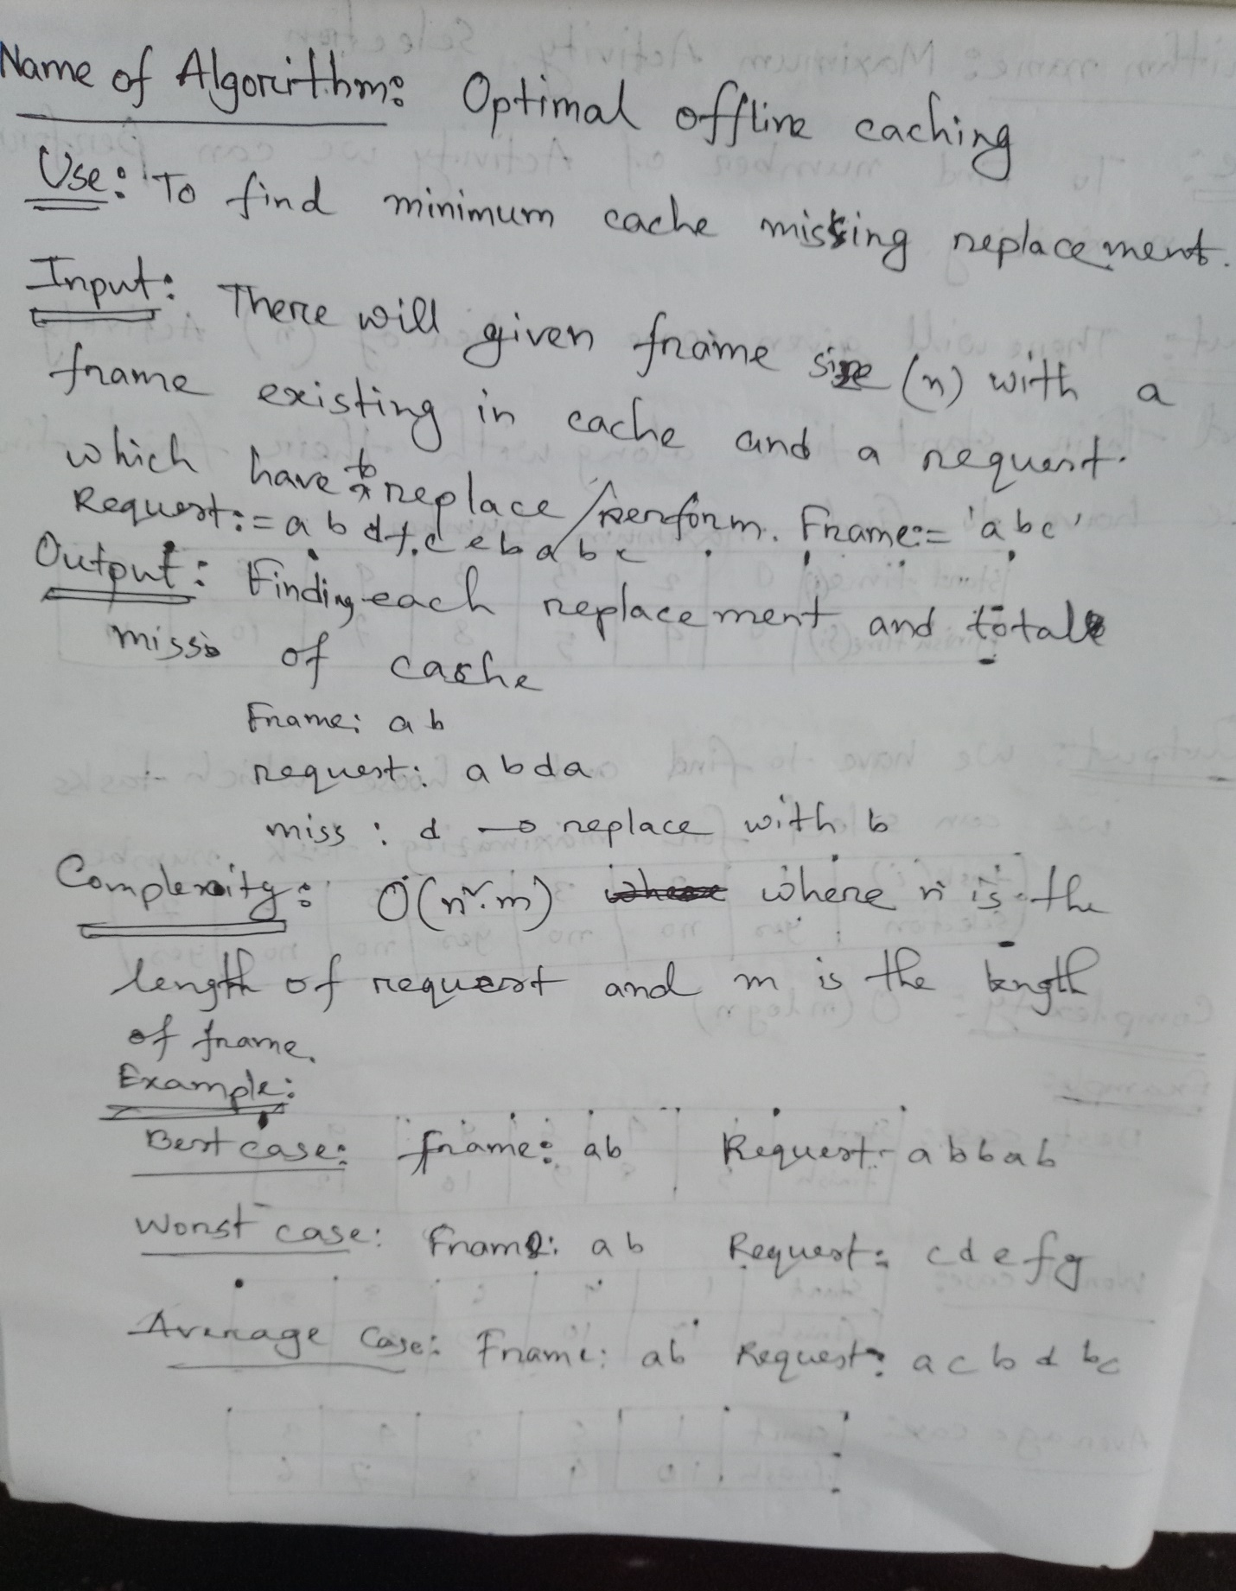

**Source code:**

|  |  |
| --- | --- |
| #include<bits/stdc++.h>  using namespace std;  string Frames;  string Requests;  int main()  {  // freopen("input_OptimalCaching.txt","r",stdin);  int FrameSize;  scanf("%d",&FrameSize);  cout<<"Frame: ";  cin>>Frames;  cout<<"Request: ";  cin>>Requests;  int cnt=0;  int fr_size=Frames.size();  int rq_size=Requests.size();  cout<<"\nRequest \thit/miss \t replaced by \tpresent cache\n";  for(int i=0;i<rq_size;i++){  cout<<Requests[i]<<" \t";  bool hit=false;  for(int j=0;j<fr_size;j++){  if(Requests[i]==Frames[j]){  hit=true;  break;  }  }  if(hit){  cout<<"\thit \t\t none \t\t";  } | else{  cout<<"\tmiss \t\t ";  }  int repl_ind,mx_dist=0;  for(int j=0;j<fr_size;j++){  int dis=INT_MAX;  for(int k=i+1;k<rq_size;k++){  if(Frames[j]==Requests[k]){  dis=k-i;  break;  }  }  if(mx_dist<dis){  mx_dist=dis;  repl_ind=j;  }  }  if(!hit){  cnt++;  cout<<Frames[repl_ind]<<"\t\t";  }  Frames[repl_ind]=Requests[i];  for(int j=0;j<fr_size;j++)cout<<Frames[j];  cout<<"\n";  }  cout<<"Minimum miss: "<<cnt<<"\n";  return 0;  } |

**Output:**

