**Lab Report-04**

*Course Title: Algorithm-I Laboratory*

*Course code: CSE-210*

*2nd Year 1st Semester Examination 2021*

**Date of Submission**: 06-09-2022



**Submitted to-**

***Mohammad Ashraful Islam***

*Department of Computer Science and Engineering*

*Jahangirnagar University*

*Savar, Dhaka-1342*

|  |  |  |  |
| --- | --- | --- | --- |
| **Sl** | Class Roll | Exam Roll | Name |
| 01 | 376 | 202188 | Md. Shakhawat Hosen |

Lab Report**: Fractional Knapsack**

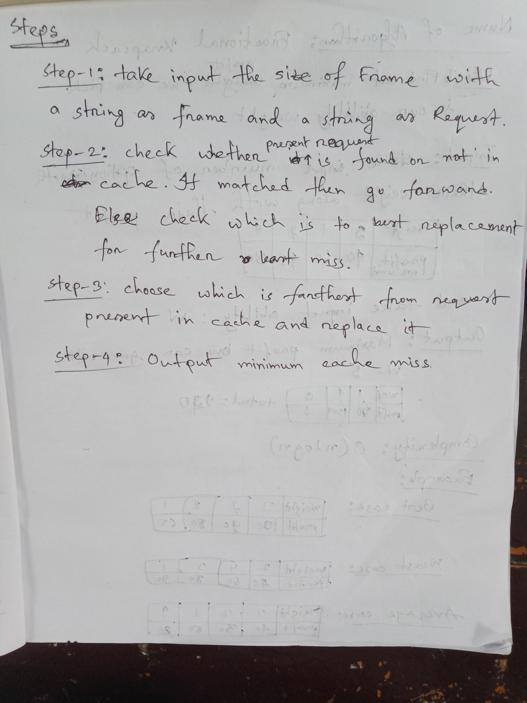

**Source code:**

|  |  |
| --- | --- |
| #include<bits/stdc++.h>  using namespace std;  struct Event{  int weight;  int profit;  Event(){}  Event(int _dur, int _dead){  weight = _dur;  profit =_dead;  }  void print()  {  printf("weight = %d, profit=%d\n",weight,profit);  }  };  Event E[100];  bool com(Event a, Event b)  {  if(a.profit>b.profit)  return true;  return false;  }  int main(){  // freopen("input.txt","r",stdin);  int N;  scanf("%d",&N);  for(int i=0;i<N;i++)  { scanf("%d%d",&E[i].weight,&E[i].profit);  } | int W,picked=0;  long long total_profit=0;  printf("Ability: ");  scanf("%d", &W);  sort(E,E+N,com);  for(int i=0;i<N;i++)  {  cout<<"\n";  E[i].print();  if(W>0){  if(W-picked>E[i].weight){  picked+=E[i].weight;  total_profit+=(E[i].weight)*(E[i].profit);  cout<<E[i].weight<<"picked\t profit gathered: "<<total_profit;  }  else {  total_profit+=(W-picked)*(E[i].profit);  picked+=W-picked;  cout<<W-picked<<"picked\t profit: "<<total_profit;  }  }  }  cout<<"\nMaximum profit: "<<total_profit<<"\n";  return 0;  } |

**Output:**

