Bangladesh University of Engineering and Technology

Department of Electrical and Electronic Engineering

EEE 416 (January 2022) **C1**

Microprocessor and Embedded Systems Laboratory

**Final Project Report**

SMART EVM with IOT and FINGERPRINT

# Evaluation Form:

|  |  |  |  |
| --- | --- | --- | --- |
| STEP | DESCRIPTION | MAX | SCORE |
| 1 | Report (Format, Reference) | 10 |  |
| 2 | Design Method and Complete Design (Hardware Implementation) | 15 |  |
| 3 | Video Demonstration | 10 |  |
| 4 | Novelty of Design | 15 |  |
| 5 | Project Management and Cost Analysis | 10 |  |
| 6 | Considerations to Public Health and Safety, Environment and Cultural and Societal Needs | 10 |  |
| 7 | Assessment of Societal, Health, Safety, Legal and Cultural issues relevant to the solution | 10 |  |
| 8 | Evaluation of the sustainability and impact of designed solution in societal and environmental contexts | 10 |  |
| 9 | Individual Contribution (Viva) | 20 |  |
| 10 | Team work and Diversity | 10 |  |
|  | TOTAL | 120 |  |

**Signature of Evaluator: ___________________________________________________**

# Academic Honesty Statement:

**IMPORTANT! Please carefully read and sign the Academic Honesty Statement, below. Type the student ID and Write your name in your own handwriting. *You will not receive credit for this project experiment unless this statement is signed in the presence of your lab instructor.***

*“In signing this statement, We hereby certify that the work on this project is our own and that we have not copied the work of any other students (past or present), and cited all relevant sources while completing this project. We understand that if we fail to honor this agreement, We will each receive a score of ZERO for this project and be subject to failure of this course.”*

|  |  |  |
| --- | --- | --- |
| **Full Name:**  **Student ID: 1706136** | **Full Name:**  **Student ID: 1706137** |  |
| **Full Name:**  **Student ID: 1706138** | **Full Name:**  **Student ID: 1706145** | **Full Name:**  **Student ID:** |
| **Full Name:**  **Student ID: 1706150** | **Full Name:**  **Student ID: 1706153** |  |

Table of Contents

Evaluation Form: 1

Academic Honesty Statement: 1

1 Abstract 2

2 Introduction 2

3 Design 2

3.1 Design Method 2

3.2 Circuit Diagram 2

3.3 Full Source Code of Firmware 2

4 Implementation 2

4.1 Description 2

4.2 Results 3

4.3 Github Link 3

4.4 YouTube Link 3

5 Design Analysis and Evaluation 3

5.1 Novelty 3

5.2 Project Management and Cost Analysis 3

5.2.1 Bill of Materials 3

5.2.2 Calculation of Per Unit Cost of Prototype 3

5.2.3 Calculation of Per Unit Cost of Mass-Produced Unit 3

5.2.4 Timeline of Project Implementation 3

5.3 Practical Considerations of the Design to Address Public Health and Safety, Environment, Cultural, and Societal Needs 3

5.3.1 Considerations to public health and safety 3

5.3.2 Considerations to environment 3

5.3.3 Considerations to cultural and societal needs 3

5.4 Assessment of the Impact of the Project on Societal, Health, Safety, Legal and Cultural Issues 3

5.4.1 Assessment of Societal Issues 3

5.4.2 Assessment of Health and Safety Issues 3

5.4.3 Assessment of Legal Issues 3

5.4.4 Assessment of Cultural Issues 3

5.5 Evaluation of the Sustainability the and Impact of the Designed Solution in the Societal and Environmental Contexts 3

5.5.1 Evaluation of Sustainability 3

5.5.2 Evaluation of Impact of Design in Societal Context 3

5.5.3 Evaluation of Impact of Design in Environmental Context 4

6 Reflection on Individual and Team work 4

6.1 Individual Contribution of Each Member 4

6.2 Mode of TeamWork 4

6.3 Diversity Statement of Team 4

6.4 Log Book of Project Impelementation 4

7 References 4

# Abstract

|  |
| --- |
| In this EEE 416 project we implemneted a IOT based electric voting machine that takes a voter’s fingerprint, confirms identity ad |

# Introduction

Write here….

# Design

## Design Method

## Circuit Diagram

## Full Source Code of Firmware

|  |  |
| --- | --- |
| Use small font size, Consolas Size 7, double column  Test |  |

Table: Source Code for the main program

# Implementation

## Description

This is the description for the design

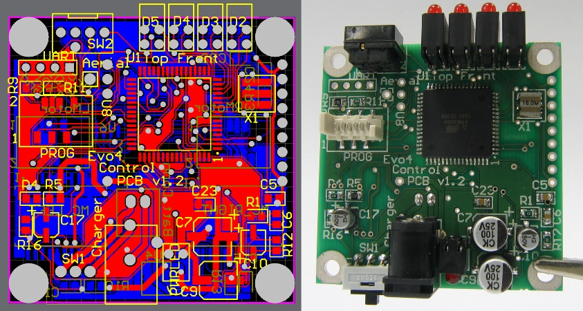

Figure 2: (Left) PCB Layout and (Right) Implementation of Design

## Results

## Github Link

## YouTube Link

# Design Analysis and Evaluation

## Novelty

## Dual power backup.

## Real time update of vote & Update to website after a time interval.

## Dual purpose (Voting + Enrolling).

## Detect suspicious activities because of Real Time.

## Cheap Microcontroller.

## No Arduino used.

## Voter’s privacy is maintained.

## Project Management and Cost Analysis

### Bill of Materials

|  |  |  |  |  |
| --- | --- | --- | --- | --- |
| **Product** | **Model** | **Quantity** | **Unit Price(Tk)** | **Total(Tk)** |
| Fingerprint sensor | R307 | 1 | 1300 | 1300 |
| WiFi Module | ESP 8266 | 1 | 200 | 200 |
| Push Button |  | 5 | 8 | 40 |
| Wire |  | 2 | 40 | 80 |
| Omron Tact Switch | SWT- 111212 | 10 | 5 | 50 |
| 40*1 Female Headers | 1FPH25B401 | 3 | 12 | 36 |
| XT60 Connector’s Pair | CON- 10260 | 1 | 70 | 70 |
| Multi Colors Cap for Tactile Push Switch | CAP-12121 | 10 | 2 | 20 |
| Jia Long Xing 1200 mAh 11.1 V 3S 45C Li-Po Battery |  | 1 | 1100 | 1100 |
| 2x16 LCD Display |  | 1 | 250 | 250 |
| I2C LCD adapter |  | 1 | 90 | 90 |
| L7805 IC |  | 1 | 10 | 10 |
| 5V 2A AC to DC Adapter Power Supply Charger |  | 1 | 240 | 240 |
| PVC Plastic |  | 1 | 200 | 200 |
| PCB (5.5 Gis) 8’x 6’ + Processing Charge |  | 1 |  | 680 |
| **Total** |  |  |  | **4366** |

### Calculation of Per Unit Cost of Prototype

Per Unit Cost of prototype is 4366 Tk.

### Calculation of Per Unit Cost of Mass-Produced Unit

If mass raw elements are purchased, the cost of IC, and other equipment are reduced. By rough calculation and approximation, per unit cost of mass- produced unit is 2500 Tk.

### Timeline of Project Implementation

|  |  |
| --- | --- |
| Week | Timeline |
| 7th | **Component Purchased** |
| 8th | **Implementation of Fingerprint Sensor** |
| 9th | **Schematic Design and Implementation of Circuit** |
| 10th | **IoT Design and Implementation** |
| 11th | **Coding in Arduino ide** |
| 12th | **PCB design** |
| 13th | **Soldering and Hardware Implementation in PCB** |
| 14th | **Report writing and making Video Demonstration** |

## Practical Considerations of the Design to Address Public Health and Safety, Environment, Cultural, and Societal Needs

### Considerations to public health and safety

We didn’t used any kind of devices that is harmful to public health and safety. The used electronic devices work in low voltage. So, if any malfunction happens, there is no possibility to get shocked of personnel. Also, proper privacy is maintained of voting data and remains hidden. So, people can see only result of election in server.

### Considerations to environment

There is no hazardous equipment used in our project that are harmful to environment. Where this smart EVM machine save the cost of simply printing and distributing the millions of ballots required to make an election happen in the ballot paper system. Rejecting the ballot paper system will help to improve our environment and reduce deforestation. We used DC battery source which reduces electricity cost.

### Considerations to cultural and societal needs

The EVM system leads to strengthening of democratic institution and better representation of marginalized and vulnerable segments of society. Reducing electoral fraud, it has to make elected officials more accountable.

## Assessment of the Impact of the Project on Societal, Health, Safety, Legal and Cultural Issues

### Assessment of Societal Issues

It reduces the public gathering. People get known of this new device and aware of the digital electronic product.

### Assessment of Health and Safety Issues

Public health and safety are most prior thing to use this device. we didn’t use any kind of hazardous material for this project. It can increase voter turnouts, integrity, and security and thus defends democracy.

### Assessment of Legal Issues

The device is legal by the code of govt. rules. Also, a person can only vote one time and if any fraud comes to vote again, it detects the fraud. There is no chance of delaying the vote count, or changing the result under the cover of delayed announcement.

### Assessment of Cultural Issue

The EVM framework leads to fortifying of equitable institution and way better representation of marginalized and powerless portions of society. Lessening discretionary extortion, it needs to make chosen authorities more responsible.

### Evaluation of the Sustainability the and Impact of the Designed Solution in the Societal and Environmental Contexts

### Evaluation of Sustainability

In our project, It is reusable and cost effective and ensure a faster and more accurate collation of votes. It reduces the total number of votes; since voters know when their choice is recorded. They are not allowed to choose more than one candidate.

### Evaluation of Impact of Design in Societal Context

### The EVM framework leads to fortifying of law-based institution and superior representation of marginalized and powerless fragments of society. Diminishing appointive extortion, it needs to make chosen authorities more responsible.

### Evaluation of Impact of Design in Environmental Context

There's no perilous hardware utilized in our venture that are hurtful to environment. Where this keen EVM machine spare the fetched of basically printing and dispersing the millions of ballots required to form a decision happen within the vote paper framework. Dismissing the vote paper framework will offer assistant to move forward our environment and decrease deforestation. We utilized DC battery source which diminishes power taken a toll.

# Reflection on Individual and Team work

## Individual Contribution of Each Member

## We have distributed the task such as fingerprint sensor, PCB design, Enclosure box making, Nodemcu working, hardware implementation and IoT based website design to individual member of team. Then we have conjoined all task together.

## Mode of TeamWork

## We have worked together in hall to conjoin the segments of project.

## Diversity Statement of Team

## Our team members are from power major, communication major background. So, all of our member are qualified in different skill which helped to stand this project.

## Log Book of Project Implementation

|  |  |
| --- | --- |
| Week | Timeline |
| 7th | **Component Purchased** |
| 8th | **Implementation of Fingerprint Sensor** |
| 9th | **Schematic Design and Implementation of Circuit** |
| 10th | **IoT Design and Implementation** |
| 11th | **Coding in Arduino IDE** |
| 12th | **PCB design** |
| 13th | **Soldering and Hardware Implementation in PCB** |
| 14th | **Report writing and making Video Demonstration** |

# References

# <https://circuitdigest.com/microcontroller-projects/electronic-voting-machine-using-arduino>

# <https://www.electroniclinic.com/google-spreadsheet-or-google-sheets-with-esp8266-nodemcu-for-data-logging/>

# <https://github.com/adafruit/Adafruit-Fingerprint-Sensor-Library>

# <https://www.make-it.ca/nodemcu-details-specifications/>