PSME Macroeconomics 2024  
Vaagn Shakhkian

**Introduction**   
As part of this work, the RBC model will be constructed, which explains the cycles of gross output, household consumption, private sector investment, interest rates, and the unemployment rate through the response of optimizing agents to random shocks in the general equilibrium. The DSGE-RBC model for Austria is a closed economy model, the model analyzes variables such as gross domestic product, personal consumption, gross fixed capital formation, physical capital, numerical labor force, real interest rate, real wages. The developed model is abstracted from the effects of foreign trade and capital flows. When calibrating the model, empirical features of the dynamics of inflation and unemployment in Austria were taken into account in accordance with the Phillips curve.

Households maximize the utility function by choosing the optimal level of consumption based on the dynamics of capital and wage levels. Firms maximize their profits by choosing the optimal level of capital investment and hiring for technology shocks. Technological shocks can be modeled as a random process that can be described as a stochastic equation. Austria's markets for goods, labor, and capital are in a state of general equilibrium, with flexible prices and wages.

Dynamic stochastic general equilibrium (DSGE) models are considered in modern macroeconomic theory for forecasting crises. Fritz Breuss and Jorge A. Fornero "An Estimated DSGE Model of Austria, the Euro Area, and the U.S.: Some Welfare Implications of EMU" (Breussa and Fornero, 2009) apply the Bayesian estimate DSGE model to analyze the economies of Austria, the Eurozone, and the United States. In the scientific article, Austria was considered as a small open economy, and the welfare costs before and after the creation of the European Monetary Union (EMU) were examined. The DSGE model is used to analyze the impact of monetary policy and various shocks on welfare costs. In the scientific work, numerical simulations were carried out to understand the distribution of nominal and real shocks, calculations of nominal prices are given. In the scientific article, data such as GDP, private consumption, and investment are used to form the model, which have been transformed per employee, logarithmized and detrended using the Hodrick-Prescott filter. Nominal interest rates, price inflation and wages are analyzed. The DSGE model created in the scientific article is used to assess the impact of nominal and real shocks on the economy. Shocks include policy changes, external economic factors, and internal economic processes. The DSGE model makes it possible to determine how shocks propagate in the economy, affect production, consumption, and other macroeconomic indicators.

The Breuss scientific paper presents an analysis of the predictive power of DSGE models during the Great Recession in Austria in 2009 (Breuss, 2018). The study uses eight different DSGE models, including open and closed economy analyses, for one and several countries, and assesses how these models can predict the turning point of the Austrian business cycle and the subsequent deep recession. The analysis found that those models that incorporated the characteristics underlying the global financial crisis, such as financial frictions and interbank credit flows, were quite successful in predicting the turning point of the Austrian economy and the subsequent recession. The open economy models and the two-country models were the most effective in predicting recessions.

Based on the conceptual approaches considered in theoretical sources and empirical experience in constructing DSGE models for the analysis of the Austrian economy, the DSGE-RBC model will be developed within the framework of this work.

The hypothesis of the model is that major macroeconomic indicators such as gross output, household consumption, investment, interest rates, and the unemployment rate are subject to cyclical fluctuations that are affected by random technological shocks. Economic agents react optimally to technological shocks in conditions of general equilibrium in the market of goods, labor and capital. The model is calibrated and estimated based on Austrian macroeconomic data using Bayesian methods provided on the official website of the World Bank (World Bank, 2024). The results of the simulation show the impact of shocks on economic cycles and allow for scenario analysis to predict key macroeconomic data in Austria.

The following parameters were applied to build the model:

1. $Ct$- Household consumption over time; $t$
2. $It$- investments (gross fixed capital formation) in the period $t$;
3. $wt$- real wages in the period ;

4) - employment (number of employees) in the period;

5) the real interest rate in the period;

6) - physical capital in the period ;

7) - rate of depreciation (retirement) of capital for the period;

8) - physical capital in the next period (); $t+1$

Households maximize the intertemporal utility function with a constant elasticity of substitution between consumption at different time periods:

$U = E*∑βt* u(Ct)$ (1)

- subjective discounting factor;

- Austrian household consumption in period t.

The output of firms Y in Austria is determined by the Cobb-Douglas production function with technological shock, which can be represented by the following formula:

$Yt = At*Ktα* Nt1-α$ (2)

- technological shock in period t;

–capital; $Kt$

$Nt$–labour;

- Capital elasticity of the issue.

For the DSGE-RBC model, the following household budget constraints have been imposed:

$Ct + It = wtNt + rtKt$ (3)

$Kt+1 = (1-δ)Kt + It$ (4)

Equation (3) shows that household expenditure on consumption and investment () in the current period is limited by their income from wages () and their capital income in the form of interest (). Equation (4) describes the evolution of capital over time: capital in the next period is equal to capital in the current period minus depreciation plus new investment. $Ct + ItwtNtrtKt$

Model hypothesis. The dynamics of the main macroeconomic indicators in Austria is determined by the impact of random technological shocks, as well as by the optimizing behavior of economic agents - households and firms.

The following data were selected for the analysis and construction of the DSGE model.

1. GDP of Austria for 1972-2021 The use of GDP growth (annual %)-Y) is acceptable and correct for the analysis of the dynamic DSGE-RBC model. Moreover, the use of annual growth rates is preferable from an econometric point of view, since it allows you to work with a stationary time series;
2. The indicator "Household Final Consumption Expenditure and NPISHs (% of GDP)" from the World Bank data for Austria can be used as a replacement for the variable "Household Consumption (C)" in the DSGE-RBC model, the chosen indicator reflects the share of household and non-profit expenditure on final consumption of goods and services as a percentage of GDP in Austria for each year, respectively, it is well suited as an approximation for modeling the dynamics of household consumption in Austria;
3. In the DSGE model, it is necessary to use an investment indicator normalized relative to the size of the economy (GDP). Therefore, it is better to take the indicator "Gross fixed capital formation (% of GDP)" of Austria, since this indicator reflects investment in fixed capital as a share of nominal GDP of Austria for each year - I;
4. The indicator "Unemployment, total (% of total labor force) (modeled ILO estimate)" from the World Bank data for Austria is suitable for use as a variable of the N - unemployment rate in the DSGE-RBC model, the chosen indicator reflects the unemployment rate as a percentage of the total labor force of Austria according to the estimates of the ILO (International Labor Organization). Thus, it directly corresponds to the required variable -N;
5. "Interest Rates: Immediate Rates: Central Bank Rates: Total for Austria" is used as the central bank interest rate (r) in the DSGE-RBC model for Austria and reflects the key policy rate set by the Central Bank of Austria on an annual basis since 1960. The selected time series from 1970 to 2022 corresponds to the required indicator of the interest rate of the Central Bank to characterize the cost of borrowing in the Austrian economy in the model developed by DSGE-RBC;
6. Compensation of employees (current LCU) This indicator reflects the total amount of compensation to employees in the national currency of Austria for each year, the compensation includes both wages and social security contributions (w);
7. Gross fixed capital formation (% of GDP) is an indicator that reflects the annual investment of Austrian residents in tangible assets - buildings, machinery, equipment, the change in this indicator from year to year can be interpreted as an increase in physical capital in the DSGE-RBC model.

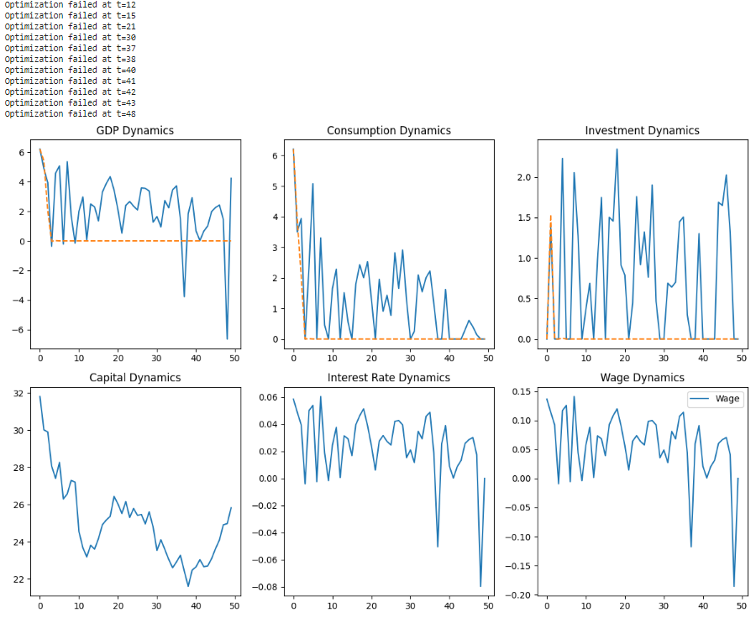

Based on the results of the ADF test, the variables 'Y' and 'r' can be considered steady-state, since the null hypothesis of the presence of unit roots was rejected at all levels of significance, but the other variables of the model ('C', 'I', 'N', 'w', 'K') are not stationary at the 5% significance level, since the null hypothesis of the presence of single roots was not rejected at this level of significance. Thus, stationary series are generally more predictable and lend themselves to more standard time series analysis methods, while nonstationary series may require additional steps to analyze and model them, such as differentiation or the use of more complex models.

In the context of the RBC model, fluctuations in GDP can be interpreted as the economy's response to technological shocks that affect firms' production functions. Changes in consumption can be driven by changes in household incomes, expectations of future economic growth, and interest rates. The investment chart shows sharper fluctuations, which may indicate a more volatile nature of investment decisions. Investments depend on expected returns on capital and can respond to changes in technology and interest rates. Changes in capital inventories reflect investment activity and depreciation, capital changes over time, which may be due to investment decisions by firms and changes in production technology in Austria. The hypothesis of the model is partially confirmed, since the observed fluctuations in macroeconomic indicators can be explained by both the impact of technological shocks and the optimizing behavior of economic agents. For a more detailed conclusion, a more in-depth econometric analysis is needed, including an assessment of the structural parameters of the model on a more extensive group of indicators.

**References**

1. Fritz Breuss & Jorge A. Fornero, 2009. "An Estimated DSGE Model of Austria, the Euro Area and the U.S.: Some Welfare Implications of EMU," FIW Working Paper series 034, FIW.
2. Breuss, F. Would DSGE Models Have Predicted the Great Recession in Austria?. J Bus Cycle Res 14, 105–126 (2018). <https://doi.org/10.1007/s41549-018-0025-1>
3. GDP growth (annual %) – Austria. World Bank national accounts data, and OECD National Accounts data files. <https://data.worldbank.org/indicator/NY.GDP.MKTP.KD.ZG?locations=AT>
4. Gross fixed capital formation (current US$) – Austria <https://data.worldbank.org/indicator/NE.GDI.FTOT.CD?locations=AT>
5. Gross fixed capital formation (% of GDP) – Austria <https://data.worldbank.org/indicator/NE.GDI.FTOT.ZS?locations=AT>
6. Interest Rates: Immediate Rates (< 24 Hours): Central Bank Rates: Total for Austria (IRSTCB01ATA156N) <https://fred.stlouisfed.org/series/IRSTCB01ATA156N>
7. Compensation of employees (current LCU) <https://data.worldbank.org/indicator/GC.XPN.COMP.CN>
8. Gross fixed capital formation (% of GDP) – Austria <https://data.worldbank.org/indicator/NE.GDI.FTOT.ZS?locations=AT>

Application

|  |  |  |  |  |  |  |  |
| --- | --- | --- | --- | --- | --- | --- | --- |
| Year | Y | C | I | N | r | w | K |
| 1972 | 6,21 | 54,74 | 31,82 | 31,82 | 5,5 | 3071153972 | 31,82 |
| 1973 | 4,89 | 54,24 | 30,02 | 30,02 | 5,5 | 2722324368 | 30,02 |
| 1974 | 3,94 | 54,00 | 29,91 | 29,91 | 6,5 | 3092955822 | 29,91 |
| 1975 | -0,36 | 56,70 | 28,07 | 28,07 | 6 | 3717942196 | 28,07 |
| 1976 | 4,58 | 57,18 | 27,41 | 27,41 | 4 | 4249907342 | 27,41 |
| 1977 | 5,08 | 58,06 | 28,27 | 28,27 | 5,5 | 4546412506 | 28,27 |
| 1978 | -0,21 | 56,17 | 26,30 | 26,30 | 4,5 | 5018785928 | 26,30 |
| 1979 | 5,36 | 55,81 | 26,58 | 26,58 | 3,75 | 5377789728 | 26,58 |
| 1980 | 1,73 | 56,50 | 27,30 | 27,30 | 6,75 | 5736793529 | 27,30 |
| 1981 | -0,14 | 57,51 | 27,21 | 27,21 | 6,75 | 6294920896 | 27,21 |
| 1982 | 2,01 | 57,69 | 24,54 | 24,54 | 4,81 | 6745492467 | 24,54 |
| 1983 | 2,97 | 58,92 | 23,68 | 23,68 | 3,75 | 7158274166 | 23,68 |
| 1984 | 0,05 | 57,82 | 23,18 | 23,18 | 4,5 | 7536172903 | 23,18 |
| 1985 | 2,50 | 57,73 | 23,81 | 23,81 | 4 | 8009999782 | 23,81 |
| 1986 | 2,30 | 56,92 | 23,60 | 23,60 | 4 | 8531790731 | 23,60 |
| 1987 | 1,36 | 56,81 | 24,17 | 24,17 | 3,05 | 8829749351 | 24,17 |
| 1988 | 3,30 | 56,30 | 24,92 | 24,92 | 4 | 8937305146 | 24,92 |
| 1989 | 3,89 | 55,98 | 25,17 | 25,17 | 6,5 | 9370435238 | 25,17 |
| 1990 | 4,35 | 55,92 | 25,37 | 25,37 | 6,5 | 4967914944 | 25,37 |
| 1991 | 3,44 | 55,42 | 26,44 | 26,44 | 7,69 | 5416306331 | 26,44 |
| 1992 | 2,09 | 56,11 | 26,03 | 26,03 | 8 | 5754235009 | 26,03 |
| 1993 | 0,53 | 56,04 | 25,52 | 25,52 | 5,25 | 6117599180 | 25,52 |
| 1994 | 2,40 | 55,70 | 26,16 | 26,16 | 4,5 | 6370500643 | 26,16 |
| 1995 | 2,67 | 54,94 | 25,30 | 25,30 | 3,23 | 9556280000 | 25,30 |
| 1996 | 2,35 | 55,51 | 25,79 | 25,79 | 2,5 | 9723310000 | 25,79 |
| 1997 | 2,09 | 54,76 | 25,42 | 25,42 | 2,5 | 9742130000 | 25,42 |
| 1998 | 3,58 | 54,30 | 25,47 | 25,47 | 2,5 | 9986790000 | 25,47 |
| 1999 | 3,56 | 53,63 | 24,96 | 24,96 | 2,5 | 10472520000 | 24,96 |
| 2000 | 3,38 | 53,87 | 25,61 | 25,61 | 4,25 | 10625400000 | 25,61 |
| 2001 | 1,27 | 54,11 | 24,80 | 24,80 | 2,75 | 10710340000 | 24,80 |
| 2002 | 1,65 | 53,54 | 23,53 | 23,53 | 2,38 | 10770610000 | 23,53 |
| 2003 | 0,94 | 54,08 | 24,11 | 24,11 | 1,47 | 11100580000 | 24,11 |
| 2004 | 2,74 | 53,86 | 23,59 | 23,59 | 1,47 | 11581820000 | 23,59 |
| 2005 | 2,24 | 53,81 | 23,05 | 23,05 | 1,47 | 12816110000 | 23,05 |
| 2006 | 3,45 | 53,22 | 22,60 | 22,60 | 2,67 | 13407650000 | 22,60 |
| 2007 | 3,73 | 52,02 | 22,92 | 22,92 | 3,19 | 13734510000 | 22,92 |
| 2008 | 1,46 | 51,83 | 23,28 | 23,28 | 2,1 | 14358670000 | 23,28 |
| 2009 | -3,76 | 53,48 | 22,41 | 22,41 | 0,38 | 14896380000 | 22,41 |
| 2010 | 1,84 | 53,50 | 21,60 | 21,60 | 0,38 | 15100920000 | 21,60 |
| 2011 | 2,92 | 53,38 | 22,47 | 22,47 | 0,59 | 15216520000 | 22,47 |
| 2012 | 0,68 | 53,46 | 22,65 | 22,65 | 0,38 | 15688540000 | 22,65 |
| 2013 | 0,03 | 53,66 | 23,04 | 23,04 | -0,12 | 15801000000 | 23,04 |
| 2014 | 0,66 | 53,40 | 22,66 | 22,66 | -0,12 | 16141330000 | 22,66 |
| 2015 | 1,01 | 52,68 | 22,70 | 22,70 | -0,12 | 16743830000 | 22,70 |
| 2016 | 1,99 | 52,26 | 23,10 | 23,10 | -0,62 | 17247640000 | 23,10 |
| 2017 | 2,26 | 52,51 | 23,63 | 23,63 | -0,62 | 17758640000 | 23,63 |
| 2018 | 2,43 | 51,93 | 24,10 | 24,10 | -0,62 | 18301530000 | 24,10 |
| 2019 | 1,45 | 51,56 | 24,91 | 24,91 | -0,62 | 18847790000 | 24,91 |
| 2020 | -6,63 | 49,77 | 24,98 | 24,98 | -0,62 | 19289490000 | 24,98 |
| 2021 | 4,24 | 49,79 | 25,83 | 25,83 | -0,62 | 19899610000 | 25,83 |