Федеральное государственное бюджетное образовательное учреждение высшего образования «Национальный исследовательский университет «МЭИ»

Институт информационных и вычислительных технологий

Кафедра Управления и интеллектуальных технологий

**Отчёт по лабораторной работе № 2**

**По курсу «Разработка ПО систем управления»**

# «Система контроля версий Git»

Выполнил студент группы А-01-19

Шахов А. И.

Проверили

Мохов А. С

Козлюк Д. А

Москва 2020

**Вход в терминал и создание структуры каталогов**

Открываем Git Bash. Создаем каталоги Алисы и Боба, а также папку проекта Алисы

Acer@LAPTOP-O0TP07M6 MINGW64 ~/Desktop/lab02

$ ls

Acer@LAPTOP-O0TP07M6 MINGW64 ~/Desktop/lab02

$ mkdir alice

Acer@LAPTOP-O0TP07M6 MINGW64 ~/Desktop/lab02

$ mkdir bob

Acer@LAPTOP-O0TP07M6 MINGW64 ~/Desktop/lab02

$ cd alice

Acer@LAPTOP-O0TP07M6 MINGW64 ~/Desktop/lab02/alice

$ mkdir project

Acer@LAPTOP-O0TP07M6 MINGW64 ~/Desktop/lab02/alice

$ cd project

Acer@LAPTOP-O0TP07M6 MINGW64 ~/Desktop/lab02/alice/project

$ cd ..

Acer@LAPTOP-O0TP07M6 MINGW64 ~/Desktop/lab02/alice

$ cd project

## **Инициализация репозитария и настройка Git**

## Указываем имя пользователя и почту

Acer@LAPTOP-O0TP07M6 MINGW64 ~/Desktop/lab02/alice/project

$ git init

Initialized empty Git repository in C:/Users/Acer/Desktop/lab02 (1)/alice/project/.git/

Acer@LAPTOP-O0TP07M6 MINGW64 ~/Desktop/lab02/alice/project (master)

$ git config user.name 'ShakhovAI'

Acer@LAPTOP-O0TP07M6 MINGW64 ~/Desktop/lab02/alice/project (master)

$ git config user.email 'shakhov-arthur@mail.ru'

## **Создание коммитов**

## Создаем и собираем проект

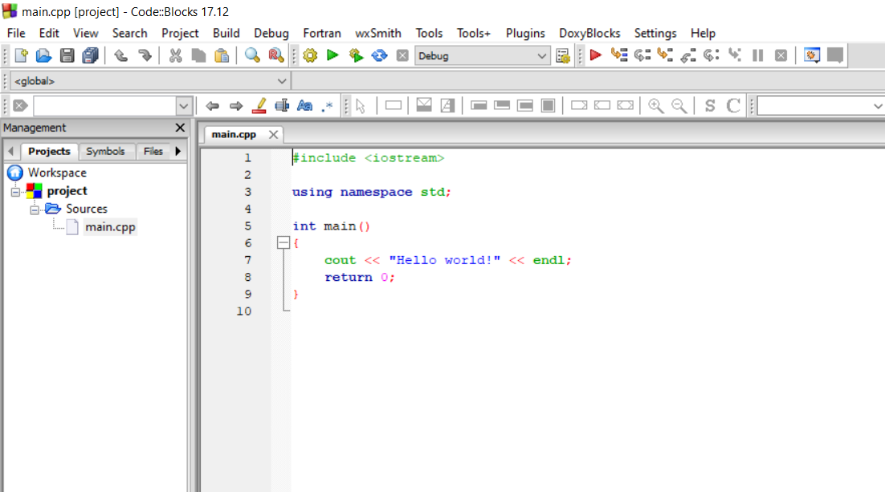

**Занесение файлов под контроль версий**

Acer@LAPTOP-O0TP07M6 MINGW64 ~/Desktop/lab02/alice/project (master)

$ git status

On branch master

No commits yet

Untracked files:

(use "git add <file>..." to include in what will be committed)

bin/

main.cpp

obj/

project.cbp

project.layout

nothing added to commit but untracked files present (use "git add" to track)

Acer@LAPTOP-O0TP07M6 MINGW64 ~/Desktop/lab02/alice/project (master)

$ git add main.cpp

Acer@LAPTOP-O0TP07M6 MINGW64 ~/Desktop/lab02/alice/project (master)

$ git status

On branch master

No commits yet

Changes to be committed:

(use "git rm --cached <file>..." to unstage)

new file: main.cpp

Untracked files:

(use "git add <file>..." to include in what will be committed)

bin/

obj/

project.cbp

project.layout

Acer@LAPTOP-O0TP07M6 MINGW64 ~/Desktop/lab02/alice/project (master)

$ git commit -m 'code: заготовка программы'

[master (root-commit) 55ff1bc] code: ╨╖╨░╨│╨╛╤В╨╛╨▓╨║╨░ ╨┐╤А╨╛╨│╤А╨░╨╝╨╝╤Л

1 file changed, 9 insertions(+)

create mode 100644 main.cpp

Консоль сообщает что коммитов нет и показывает неотслеживаемые файлы и призывает добавить коммиты командой “git add”

Добавляем коммит с файлом main.cpp

Acer@LAPTOP-O0TP07M6 MINGW64 ~/Desktop/lab02/alice/project (master)

$ git add project.cbp

warning: LF will be replaced by CRLF in project.cbp.

The file will have its original line endings in your working directory

Acer@LAPTOP-O0TP07M6 MINGW64 ~/Desktop/lab02/alice/project (master)

$ git commit -m 'build: добавлен файл проекта'

[master c06dd18] build: ╨┤╨╛╨▒╨░╨▓╨╗╨╡╨╜ ╤Д╨░╨╣╨╗ ╨┐╤А╨╛╨╡╨║╤В╨░

1 file changed, 42 insertions(+)

create mode 100644 project.cbp

Добавляем коммит с файлом project.cbp

***Создание коммитов с* изменениями**

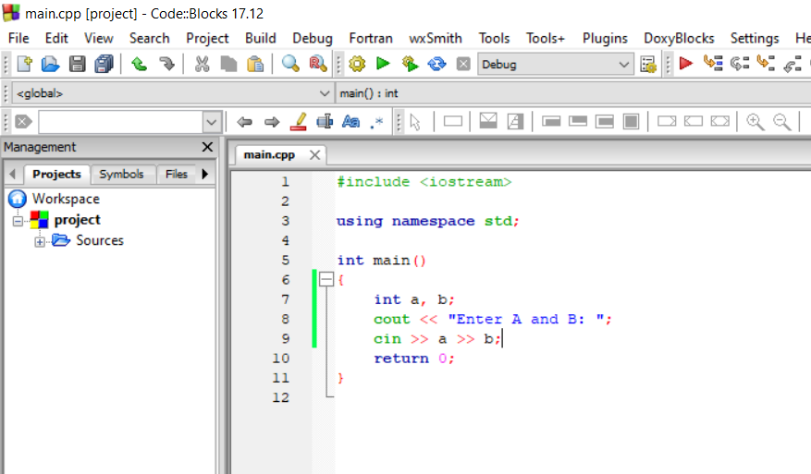

Добавляем ввод двух чисел и смотрим состояние репозитория

Видим , что main.cpp был изменен, делаем коммит

Acer@LAPTOP-O0TP07M6 MINGW64 ~/Desktop/lab02/alice/project (master)

$ git status

On branch master

Changes not staged for commit:

(use "git add <file>..." to update what will be committed)

(use "git restore <file>..." to discard changes in working directory)

modified: main.cpp

Untracked files:

(use "git add <file>..." to include in what will be committed)

bin/

obj/

project.layout

no changes added to commit (use "git add" and/or "git commit -a")

Acer@LAPTOP-O0TP07M6 MINGW64 ~/Desktop/lab02/alice/project (master)

$ git add main.cpp

Acer@LAPTOP-O0TP07M6 MINGW64 ~/Desktop/lab02/alice/project (master)

$ git status

On branch master

Changes to be committed:

(use "git restore --staged <file>..." to unstage)

modified: main.cpp

Untracked files:

(use "git add <file>..." to include in what will be committed)

bin/

obj/

project.layout

Acer@LAPTOP-O0TP07M6 MINGW64 ~/Desktop/lab02/alice/project (master)

$ git commit -m 'code: добавлен ввод A и B'

[master 69fbd8a] code: ╨┤╨╛╨▒╨░╨▓╨╗╨╡╨╜ ╨▓╨▓╨╛╨┤ A ╨╕ B

1 file changed, 3 insertions(+), 1 deletion(-)

Добавляем вывод суммы и разности чисел, делаем коммит

Acer@LAPTOP-O0TP07M6 MINGW64 ~/Desktop/lab02/alice/project (master)

$ git add -u

Acer@LAPTOP-O0TP07M6 MINGW64 ~/Desktop/lab02/alice/project (master)

$ git commit -m 'code: добавлен вывод суммы и разности A и B'

[master c00ffca] code: ╨┤╨╛╨▒╨░╨▓╨╗╨╡╨╜ ╨▓╤Л╨▓╨╛╨┤ ╤Б╤Г╨╝╨╝╤Л ╨╕ ╤А╨░╨╖╨╜╨╛╤Б╤В╨╕ A ╨╕ B

1 file changed, 2 insertions(+)

**Игнорирование файлов**

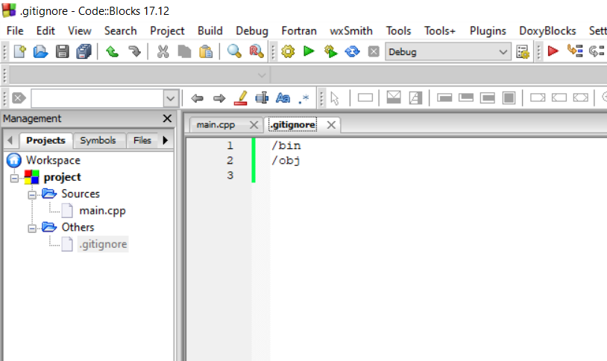

Добавим .gitignore, видим что /bin и /obj не отображается, делаем коммит

Acer@LAPTOP-O0TP07M6 MINGW64 ~/Desktop/lab02/alice/project (master)

$ git status

On branch master

Untracked files:

(use "git add <file>..." to include in what will be committed)

.gitignore

project.depend

project.layout

nothing added to commit but untracked files present (use "git add" to track)

Acer@LAPTOP-O0TP07M6 MINGW64 ~/Desktop/lab02/alice/project (master)

$ git add .gitignore

Acer@LAPTOP-O0TP07M6 MINGW64 ~/Desktop/lab02/alice/project (master)

$ git status

On branch master

Changes to be committed:

(use "git restore --staged <file>..." to unstage)

new file: .gitignore

Untracked files:

(use "git add <file>..." to include in what will be committed)

project.depend

project.layout

Acer@LAPTOP-O0TP07M6 MINGW64 ~/Desktop/lab02/alice/project (master)

$ git commit -m 'build: добавлено игнорирование bin и obj'

[master 2ade3c4] build: ╨┤╨╛╨▒╨░╨▓╨╗╨╡╨╜╨╛ ╨╕╨│╨╜╨╛╤А╨╕╤А╨╛╨▓╨░╨╜╨╕╨╡ bin ╨╕ obj

1 file changed, 2 insertions(+)

create mode 100644 .gitignore

**Просмотр истории**

Acer@LAPTOP-O0TP07M6 MINGW64 ~/Desktop/lab02/alice/project (master)

$ git log

commit 2ade3c4377757bd0c4ab70c448c5075d56e5ca1f (HEAD -> master)

Author: ShakhovAI <shakhov-arthur@mail.ru>

Date: Tue Oct 6 13:42:07 2020 +0300

build: добавлено игнорирование bin и obj

commit c00ffca9ecdb264db65357b70b464915b6bcc591

Author: ShakhovAI <shakhov-arthur@mail.ru>

Date: Tue Oct 6 13:34:39 2020 +0300

code: добавлен вывод суммы и разности A и B

commit 69fbd8ab5acbef932e42c31006fa621e52e6c36d

Author: ShakhovAI <shakhov-arthur@mail.ru>

Date: Tue Oct 6 13:28:09 2020 +0300

code: добавлен ввод A и B

commit c06dd18cf480ed3de0286081268dcb20b4546400

Author: ShakhovAI <shakhov-arthur@mail.ru>

Date: Tue Oct 6 13:23:28 2020 +0300

build: добавлен файл проекта

Acer@LAPTOP-O0TP07M6 MINGW64 ~/Desktop/lab02/alice/project (master)

$ git log --oneline --decorate

2ade3c4 (HEAD -> master) build: добавлено игнорирование bin и obj

c00ffca code: добавлен вывод суммы и разности A и B

69fbd8a code: добавлен ввод A и B

c06dd18 build: добавлен файл проекта

55ff1bc code: заготовка программы

Acer@LAPTOP-O0TP07M6 MINGW64 ~/Desktop/lab02/alice/project (master)

$ git log --oneline --decorate --all --graph

* 2ade3c4 (HEAD -> master) build: добавлено игнорирование bin и obj

* c00ffca code: добавлен вывод суммы и разности A и B

* 69fbd8a code: добавлен ввод A и B

* c06dd18 build: добавлен файл проекта

* 55ff1bc code: заготовка программы

Acer@LAPTOP-O0TP07M6 MINGW64 ~/Desktop/lab02/alice/project (master)

$ git log --stat

commit 2ade3c4377757bd0c4ab70c448c5075d56e5ca1f (HEAD -> master)

Author: ShakhovAI <shakhov-arthur@mail.ru>

Date: Tue Oct 6 13:42:07 2020 +0300

build: добавлено игнорирование bin и obj

.gitignore | 2 ++

1 file changed, 2 insertions(+)

commit c00ffca9ecdb264db65357b70b464915b6bcc591

Author: ShakhovAI <shakhov-arthur@mail.ru>

Date: Tue Oct 6 13:34:39 2020 +0300

code: добавлен вывод суммы и разности A и B

main.cpp | 2 ++

1 file changed, 2 insertions(+)

commit 69fbd8ab5acbef932e42c31006fa621e52e6c36d

Author: ShakhovAI <shakhov-arthur@mail.ru>

Date: Tue Oct 6 13:28:09 2020 +0300

code: добавлен ввод A и B

Просмотр изменений в рабочей копии

Acer@LAPTOP-O0TP07M6 MINGW64 ~/Desktop/lab02/alice/project (master)

$ git diff

warning: LF will be replaced by CRLF in project.cbp.

The file will have its original line endings in your working directory

**diff --git a/main.cpp b/main.cpp**

**index f9db054..4770a21 100644**

**--- a/main.cpp**

**+++ b/main.cpp**

@@ -9,5 +9,6 @@ int main()

cin >> a >> b;

cout << "A + B = " << a + b << '\n';

cout << "A - B = " << a - b << '\n';

+ cout << "A * B = " << a * b << '\n';

return 0;

}

**diff --git a/project.cbp b/project.cbp**

**index ad8f6e9..4f15edc 100644**

**--- a/project.cbp**

**+++ b/project.cbp**

@@ -32,6 +32,9 @@

<Add option="-Wall" />

<Add option="-fexceptions" />

</Compiler>

+ <Unit filename=".gitignore">

+ <Option target="&lt;{~None~}&gt;" />

## **Откат изменений**

## Создадим коммит и откатим его

Acer@LAPTOP-O0TP07M6 MINGW64 ~/Desktop/lab02/alice/project (master)

$ git status

On branch master

Changes not staged for commit:

(use "git add <file>..." to update what will be committed)

(use "git restore <file>..." to discard changes in working directory)

modified: main.cpp

Untracked files:

(use "git add <file>..." to include in what will be committed)

project.depend

project.layout

no changes added to commit (use "git add" and/or "git commit -a")

Acer@LAPTOP-O0TP07M6 MINGW64 ~/Desktop/lab02/alice/project (master)

$ git add -u

Acer@LAPTOP-O0TP07M6 MINGW64 ~/Desktop/lab02/alice/project (master)

$ git commit 'code: добавили надпись // you may type whatever you want'

error: pathspec 'code: ╨┤╨╛╨▒╨░╨▓╨╕╨╗╨╕ ╨╜╨░╨┤╨┐╨╕╤Б╤М // you may type whatever you want' did not match any file(s) known to git

Acer@LAPTOP-O0TP07M6 MINGW64 ~/Desktop/lab02/alice/project (master)

$ git status

On branch master

Changes to be committed:

(use "git restore --staged <file>..." to unstage)

modified: main.cpp

Untracked files:

(use "git add <file>..." to include in what will be committed)

project.depend

project.layout

Acer@LAPTOP-O0TP07M6 MINGW64 ~/Desktop/lab02/alice/project (master)

$ git commit -m 'code: добавили надпись // you may type whatever you want'

[master d0ac0e6] code: ╨┤╨╛╨▒╨░╨▓╨╕╨╗╨╕ ╨╜╨░╨┤╨┐╨╕╤Б╤М // you may type whatever you want

1 file changed, 1 insertion(+), 1 deletion(-)

Acer@LAPTOP-O0TP07M6 MINGW64 ~/Desktop/lab02/alice/project (master)

$ git reset --hard HEAD~1

HEAD is now at 44ac2eb code: ╨▓╤Л╨▓╨╛╨┤ ╨┐╤А╨╛╨╕╨╖╨▓╨╡╨┤╨╡╨╜╨╕╨╡ A ╨╕ B

В итоге мы вернулись к предыдущему коммиту без надписи // you may type whatever you want

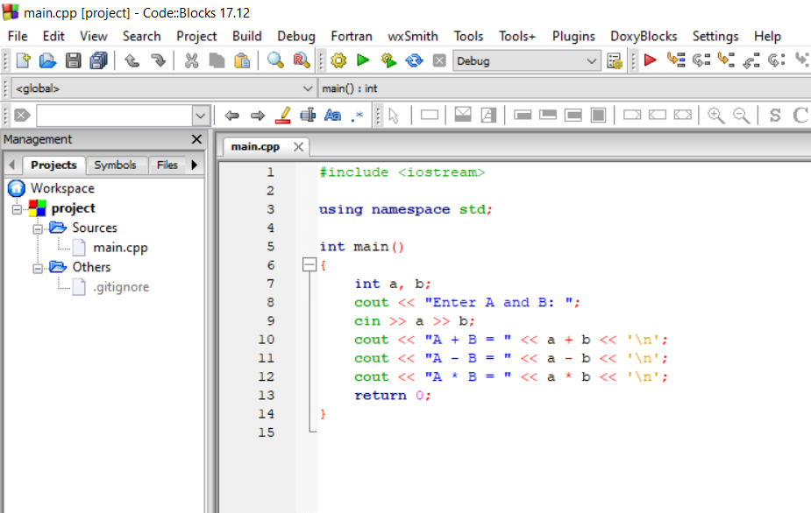

## **Обмен кодом через удаленное хранилище**

Загрузка проекта на GitHub

Acer@LAPTOP-O0TP07M6 MINGW64 ~/Desktop/lab02/alice/project (main)

$ $ git remote add origin https://github.com/shakhov-arthur/cs-lab02.gitgit

bash: $: command not found

Acer@LAPTOP-O0TP07M6 MINGW64 ~/Desktop/lab02/alice/project (main)

$ git branch -M main

Acer@LAPTOP-O0TP07M6 MINGW64 ~/Desktop/lab02/alice/project (main)

$ git push -u origin main

Enumerating objects: 6, done.

Counting objects: 100% (6/6), done.

Delta compression using up to 4 threads

Compressing objects: 100% (5/5), done.

Writing objects: 100% (6/6), 1.03 KiB | 352.00 KiB/s, done.

Total 6 (delta 0), reused 0 (delta 0), pack-reused 0

To https://github.com/ShakhovAI/cs-lab02.git

* [new branch] main -> main

Branch 'main' set up to track remote branch 'main' from 'origin'.

Загрузка с GitHub

Acer@LAPTOP-O0TP07M6 MINGW64 ~/Desktop/lab02/bob

$ git clone https://github.com/ShakhovAI/test.git

Cloning into 'test'...

remote: Enumerating objects: 6, done.

remote: Counting objects: 100% (6/6), done.

remote: Compressing objects: 100% (5/5), done.

remote: Total 6 (delta 0), reused 6 (delta 0), pack-reused 0

Unpacking objects: 100% (6/6), 1.01 KiB | 3.00 KiB/s, done.

## **Совместная работа над проектом без конфликтов правок**

Добавим произведение на машине БОБА и создадим коммит

Acer@LAPTOP-O0TP07M6 MINGW64 ~/Desktop/lab02/bob/test (main)

$ git add -u

Acer@LAPTOP-O0TP07M6 MINGW64 ~/Desktop/lab02/bob/test (main)

$ git commit -m 'code: вывод произведения A и B'

[main 93a2ef4] code: ╨▓╤Л╨▓╨╛╨┤ ╨┐╤А╨╛╨╕╨╖╨▓╨╡╨┤╨╡╨╜╨╕╤П A ╨╕ B

1 file changed, 8 insertions(+), 1 deletion(-)

Загрузим на GitHub

Acer@LAPTOP-O0TP07M6 MINGW64 ~/Desktop/lab02/bob/test (main)

$ git push

Enumerating objects: 5, done.

Counting objects: 100% (5/5), done.

Delta compression using up to 4 threads

Compressing objects: 100% (3/3), done.

Writing objects: 100% (3/3), 447 bytes | 447.00 KiB/s, done.

Total 3 (delta 1), reused 0 (delta 0), pack-reused 0

remote: Resolving deltas: 100% (1/1), completed with 1 local object.

To https://github.com/ShakhovAI/cs-lab02.git

9cb2be9..93a2ef4 main -> main

Загрузка изменений у Алисы

Acer@LAPTOP-O0TP07M6 MINGW64 ~/Desktop/lab02/bob/test (main)

$ cd ..

Acer@LAPTOP-O0TP07M6 MINGW64 ~/Desktop/lab02/bob (master)

$ cd ..

Acer@LAPTOP-O0TP07M6 MINGW64 ~/Desktop/lab02

$ cd alice/

Acer@LAPTOP-O0TP07M6 MINGW64 ~/Desktop/lab02/alice

$ cd project/

Acer@LAPTOP-O0TP07M6 MINGW64 ~/Desktop/lab02/alice/project (main)

$ git fetch

remote: Enumerating objects: 5, done.

remote: Counting objects: 100% (5/5), done.

remote: Compressing objects: 100% (2/2), done.

remote: Total 3 (delta 1), reused 3 (delta 1), pack-reused 0

Unpacking objects: 100% (3/3), 427 bytes | 1024 bytes/s, done.

From https://github.com/ShakhovAI/test

9cb2be9..93a2ef4 main -> origin/main

Продвигаем ветку master

Acer@LAPTOP-O0TP07M6 MINGW64 ~/Desktop/lab021/alice/project (main)

$ git log --oneline --decorate --all --graph

* 93a2ef4 (origin/main) code: вывод произведения A и B

Acer@LAPTOP-O0TP07M6 MINGW64 ~/Desktop/lab021/alice/project (main)

$ git pull --ff-only

error: Your local changes to the following files would be overwritten by merge:

main.cpp

Please commit your changes or stash them before you merge.

Aborting

Updating 9cb2be9..93a2ef4

Добавляем деление у Алисы и загружаем у Боба

Acer@LAPTOP-O0TP07M6 MINGW64 ~/Desktop/lab021/alice/project (main)

$ git status

On branch main

Your branch is behind 'origin/main' by 1 commit, and can be fast-forwarded.

(use "git pull" to update your local branch)

Changes to be committed:

(use "git restore --staged <file>..." to unstage)

modified: main.cpp

modified: project.layout

Acer@LAPTOP-O0TP07M6 MINGW64 ~/Desktop/lab021/alice/project (main)

$ git commit -m 'code: добавлено деление числа A нa B'

[main be351ec] code: ╨┤╨╛╨▒╨░╨▓╨╗╨╡╨╜╨╛ ╨┤╨╡╨╗╨╡╨╜╨╕╨╡ ╤З╨╕╤Б╨╗╨░ A ╨╜a B

2 files changed, 9 insertions(+), 2 deletions(-)

Acer@LAPTOP-O0TP07M6 MINGW64 ~/Desktop/lab021/alice/project (main)

$ git push

To https://github.com/ShakhovAI/cs-lab02.git