SFWE415 – Software Architecture
Software Architecture Document
USA Logistics & Shipment Tracking System
A Service-Oriented Architecture (SOA) Distributed System
Final International University — Faculty of Engineering
Software Engineering Department
Course: SFWE415 — Software Architecture
Semester: Summer 2025–2026
Student: Shakhzod Musaev
Student ID: 2003060085
Instructor: Ibrahim Adeshola
Submission Date: August 20, 2026
Document Version: 1.0
Repository: https://github.com/Shakhzod79750/usa-logistics-soa

Document Control

Revision History
Version | Date | Author | Description
0.1 | July 28, 2026 | Shakhzod Musaev | Initial architecture document — 4-service SOA (Auth, Shipment, Tracking, Warehouse), C4 views, ADRs, quality attributes
0.2 | August 15, 2026 | Shakhzod Musaev | Added Web Console (5th service), live network trace/observability feature, light/dark theming, admin password reset
1.0 | August 20, 2026 | Shakhzod Musaev | Restructured to full Software Architecture Document format per SFWE415 submission guide: stakeholder matrix, quality-attribute scenarios, dedicated security and data architecture views, reformatted ADRs, traceability matrix, architecture-to-implementation mapping, validation evidence

Document Status
Status: Final for submission. This document is internally consistent with the source code at the repository URL listed on the cover page as of the revision date above.

Authors and Contributors
Shakhzod Musaev — sole author (individual submission). All design, implementation, testing, and documentation work in this submission was performed by the author, with AI-assisted drafting and code generation (Claude, Anthropic) used as a development tool under the author's direction and review, consistent with the course's generative-AI use policy. All architectural decisions, trade-off judgments, and final content were reviewed and approved by the author.

Approvals
Not applicable for individual coursework submission — instructor evaluation occurs at grading.

Table of Contents
1. Introduction
2. Stakeholders and Architecture Concerns
3. System Context and Scope
4. Architectural Drivers
5. Quality Attribute Scenarios
6. Architecture Overview
7. Architecture Views
7.1 System Context View
7.2 Container / Subsystem View
7.3 Component View
7.4 Runtime / Interaction View
7.5 Data Architecture View
7.6 Deployment / Infrastructure View
8. Interface and Integration Architecture
9. Architectural Patterns, Tactics, and Principles
10. Security Architecture
11. Performance, Scalability, Reliability, and Availability
12. Architecture Decision Records (ADRs)
13. Architecture Evaluation and Trade-offs
14. Architecture-to-Implementation Mapping
15. Validation Evidence
16. Conclusion
References
Appendix A — API Endpoint Reference
Appendix B — Glossary

List of Figures
Figure 1 — System Context Diagram
Figure 2 — Container Diagram
Figure 3 — Component Diagram (Shipment Service)
Figure 4 — Security / Trust Boundary View
Figure 5 — Logical Data Architecture / Entity-Relationship Diagram
Figure 6 — Deployment Diagram
Figure 7 — Sequence Diagram: Customer Creates a Shipment
Figure 8 — Sequence Diagram: Driver Logs a Tracking Event (Cross-Language)
Figure 9 — Sequence Diagram: Shipment Creation Under Warehouse Service Failure
Figure 10 — Validation Evidence: Live Login Screen
Figure 11 — Validation Evidence: Live Dashboard with Populated Data
Figure 12 — Validation Evidence: Live Architecture Page (Service Health + Call Graph)

1. Introduction

1.1 Purpose
This Software Architecture Document (SAD) describes the architecture of the USA Logistics & Shipment Tracking System, a distributed, service-oriented freight-tracking platform built for the SFWE415 Software Architecture course. Its purpose is to communicate the system’s architectural structure, the rationale behind its major design decisions, the interactions among its significant components, its deployment environment, and how the architecture satisfies its prioritized quality attributes. This document is written for an audience that includes the course instructor/grader, and — as a secondary, realistic audience — a developer joining the project who needs to understand its structure without reading every line of source code.

1.2 Project Background and System Purpose
Small and mid-size US freight and parcel logistics operators frequently coordinate shipments using disconnected tools — spreadsheets, phone calls, shared inboxes — which leads to lost shipments, inaccurate warehouse stock counts, and customers with no visibility into where their package is. The USA Logistics & Shipment Tracking System addresses this by providing a single, browser-based console backed by four independently deployable REST services that together let customers place shipment orders, let dispatchers coordinate drivers and warehouse inventory, let drivers report delivery status from the field, and let everyone involved track a shipment in near real time.

1.3 Scope
The system covers four bounded capabilities — identity & access management, shipment/order management, warehouse & inventory management, and shipment tracking — plus a browser-based Web Console that consumes all four as a client. Payment processing, real carrier integration (USPS/UPS/FedEx), and route optimization are explicitly out of scope for this iteration and are identified as future architectural evolution in Section 16.

1.4 Definitions, Acronyms, and Abbreviations
Term | Definition
SOA | Service-Oriented Architecture — an architectural style built from discrete, independently deployable services communicating over well-defined contracts.
ADR | Architecture Decision Record — a structured record of a significant architectural decision and its rationale.
JWT | JSON Web Token — a compact, signed token format (RFC 7519) used here for stateless authentication.
RBAC | Role-Based Access Control — authorization based on a user’s assigned role (admin, dispatcher, driver, customer).
C4 Model | A notation (Context, Container, Component, Code) for describing software architecture at increasing levels of detail (Brown, 2018).
ATAM | Architecture Trade-off Analysis Method — a structured technique for evaluating architecture against quality-attribute scenarios (Kazman et al., 2000).
QAS | Quality Attribute Scenario — a structured statement (source, stimulus, environment, artifact, response, response measure) used to make a quality attribute testable.
ORM | Object-Relational Mapping — a technique for mapping database rows to programming-language objects (SQLAlchemy, in this system).
CRUD | Create, Read, Update, Delete — the four basic persistent-storage operations.
SPA | Single-Page Application — a web application that loads a single HTML page and updates content dynamically via JavaScript.

1.5 References
A complete, APA 7-formatted reference list appears at the end of this document. In-text citations use the (Author, Year) format.

1.6 Intended Audience
- Course instructor / grader — evaluating architectural competency per the SFWE415 rubric.
- A future developer or maintainer — who needs to understand system structure, boundaries, and rationale without reading all source code first.
- The author (as system owner/architect) — as a durable record of decisions made and why, to avoid re-litigating settled trade-offs.

2. Stakeholders and Architecture Concerns
Table 2 identifies the stakeholder groups relevant to this system and the architectural concerns most important to each. Concerns drive the architectural drivers in Section 4 and the quality-attribute prioritization in Section 5 — every prioritized quality attribute in this document traces back to at least one concern below.

Table 2 — Stakeholder–Concern Matrix
Stakeholder | Role / Interest | Primary Architectural Concerns
Customer | Places shipment orders, tracks delivery | Availability of tracking data; response time; data privacy (own shipments only)
Dispatcher | Assigns drivers, manages warehouses & inventory | Usability of the console; correctness of shipment/warehouse state; low-latency operations
Driver | Logs pickup/in-transit/delivery events from the field | Simplicity of the logging flow; reliability of writes under intermittent connectivity
System Administrator | Manages users, roles, and full system access | Security (authentication/authorization); auditability; ability to reset user credentials
Course Instructor / Grader | Evaluates architectural competency | Traceability of decisions; documentation completeness and rigor; evidence the system genuinely runs
Developer / Maintainer (future) | Extends or modifies the system after handoff | Modifiability; low coupling between services; clear component responsibilities; testability
System Owner / Architect (author) | Accountable for architecture quality and project delivery | Overall coherence; defensible trade-offs; feasibility within project timeline and single-developer capacity

3. System Context and Scope

3.1 System Boundary
The system boundary encloses the Web Console and the four backend services (Auth, Shipment, Tracking, Warehouse) shown in Figure 1. Everything inside the dashed boundary is built and deployed as part of this project; everything outside it (human actors and the two external systems) is outside the team’s control.

3.2 Context Diagram
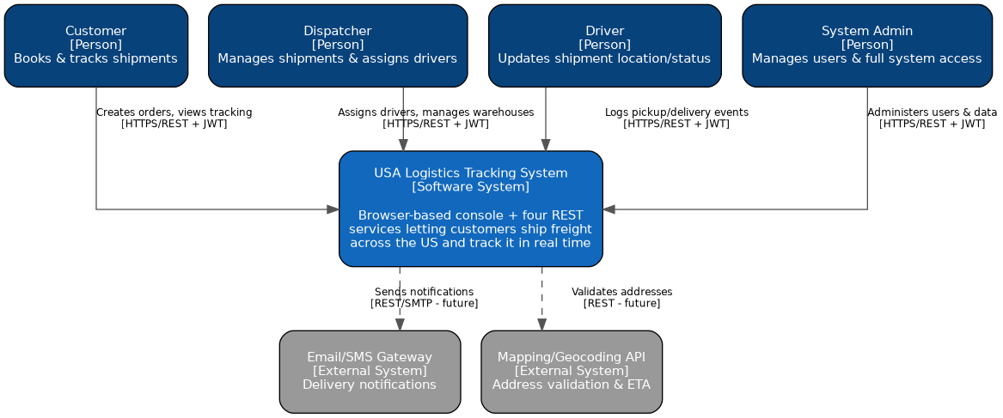
Figure 1 — System Context Diagram. Notation: informal C4-style context view.
The context diagram shows four human actor roles and two external systems. The two external systems (an email/SMS notification gateway and a mapping/geocoding API) are identified as architecturally anticipated integration points — the system’s interfaces are designed so that they could be added without restructuring existing services — but are not implemented in the current iteration, which is why their connections are drawn as dashed, future-state edges.

3.3 External Actors and Systems
Actor / System | Type | Interaction
Customer | Person | Creates shipment orders; views tracking status for their own shipments
Dispatcher | Person | Manages warehouses/inventory; assigns drivers; updates shipment status
Driver | Person | Logs tracking events (pickup, in-transit, delivered, exceptions)
System Admin | Person | Manages user accounts, roles, and password resets
Email/SMS Gateway | External System (future) | Would deliver customer notifications on status change
Mapping/Geocoding API | External System (future) | Would validate addresses and compute ETAs

3.4 Major Inputs, Outputs, Dependencies, Assumptions, and Constraints
Major inputs: user registration/login credentials, shipment order details, warehouse/inventory records, tracking event reports (including optional GPS coordinates).
Major outputs: JWT access tokens, shipment records with generated tracking numbers, tracking event histories, aggregate dashboard statistics.
Dependencies: the system depends on Docker (or an equivalent container runtime) for deployment, and on each service’s own SQLite database file for persistence. It has no required runtime dependency on any external network service.
- Assumption: all four backend services and the Web Console run within the same trusted Docker network in the current deployment (single-host demonstration deployment, not yet multi-host production).
- Assumption: clients trust the browser environment enough to store a JWT in localStorage for the session (see Section 10 for the associated security trade-off).
- Constraint: the project must demonstrate interoperability across at least two programming-language/framework stacks (course requirement) — addressed by splitting services across Node.js/Express and Python/FastAPI (Section 6).
- Constraint: single-developer project delivered within one semester — influences several trade-offs documented in ADR-1 through ADR-7 (Section 12), particularly the decision not to build a message broker or API gateway.

4. Architectural Drivers

4.1 Significant Functional Requirements
- FR1 — The system shall provide at least four independently deployable services.
- FR2 — All inter-service and client-service communication shall use REST APIs over HTTP/JSON.
- FR3 — The system shall provide authentication and role-based authorization (admin, dispatcher, driver, customer).
- FR4 — The system shall support CRUD operations for users, shipments, warehouses, inventory items, and tracking events.
- FR5 — The system shall validate that a shipment references a real warehouse, and that a tracking event references a real shipment, via live inter-service calls before persisting data.
- FR6 — The system shall provide a browser-based console that exercises all four services directly, including a live, observable record of inter-service calls (in support of demonstrating the architecture itself, not only its functional behavior).

4.2 Quality Attributes (Prioritized)
Per the course guide’s minimum of three prioritized quality attributes, this project explicitly prioritizes five, ranked by how directly each was a driver of a major architectural decision. Full quality-attribute scenarios for the top four appear in Section 5.
Rank | Quality Attribute | Why Prioritized
1 | Availability | A single service outage must not halt unrelated functionality — directly drove the database-per-service and stateless-auth decisions (ADR-2, ADR-3).
2 | Security | The system handles user credentials and role-scoped data across five independently-reachable HTTP endpoints — directly drove JWT + bcrypt + RBAC design (Section 10).
3 | Interoperability | A course requirement: demonstrable, working interoperation across two language stacks — directly drove the Node.js/Python service split (ADR-4).
4 | Modifiability | A single developer must be able to extend the system within a semester without cross-service coordination overhead — drove the layered per-service internal structure (Section 7.3).
5 | Fault Tolerance | Cross-service calls are a single point of failure risk unique to SOA — drove the fail-fast error-handling tactic (ADR-7).

4.3 Technical and Business Constraints
- Technical: must run on a standard Docker Desktop installation on commodity development hardware (no cloud infrastructure assumed or required).
- Technical: SQLite is used for all four service databases in this deployment — appropriate for demonstration/coursework scale, with a documented migration path to PostgreSQL noted as a limitation (Section 13).
- Business/schedule: individual, single-semester coursework project — bounds the scope of what infrastructure (e.g., API gateway, message broker, centralized secrets manager) is justified to build versus merely document as a future direction.

4.4 Architectural Principles
- Separation of concerns: each service owns exactly one bounded business capability.
- Explicit contracts over shared code: services agree on a REST + JWT interface, not shared libraries or a shared database — enabling true polyglot interoperability.
- Fail fast, fail visibly: a failed dependency should produce an immediate, typed error rather than a silent partial write or a hang.
- Observability as a first-class concern: the architecture itself should be inspectable at runtime, not only through static diagrams — realized via the live distributed-trace feature described in Section 7.4 and Section 15.

5. Quality Attribute Scenarios
Each prioritized quality attribute from Section 4.2 is expressed below as a testable scenario using the Source / Stimulus / Environment / Artifact / Response / Response Measure template. These scenarios were used directly to drive and validate specific architectural decisions (cross-referenced by ADR ID) and are traced to evidence in Section 15 and the traceability matrix in Section 14.

QAS-1 — Warehouse Service Outage During Shipment Creation
Field | Value
Quality Attribute | Availability
Source | A dispatcher, via the Web Console
Stimulus | Submits a request to create a new shipment while the Warehouse Service container is stopped or unreachable
Environment | Normal operation, single Docker host, all other services healthy
Artifact | Shipment Service’s outbound call to Warehouse Service (ADR-2, ADR-7)
Response | Shipment Service catches the connection failure, returns HTTP 503 with a clear error message, and writes no partial shipment record. The Auth Service, Tracking Service, and read-only Shipment Service endpoints remain fully available throughout.
Response Measure | Verified live (Section 15, Sequence Diagram Figure 9): 100% of read-only endpoints across the other three services continued returning 200 OK while Warehouse Service was stopped; the affected create-shipment call failed cleanly (503) in under 5 seconds (client timeout), with zero orphaned database rows.

QAS-2 — Cross-Service Token Forgery Attempt
Field | Value
Quality Attribute | Security
Source | An external actor with network access to the Docker bridge network but no valid credentials
Stimulus | Sends a request to a protected endpoint (e.g., DELETE /warehouses/{id}) with a missing, malformed, or unsigned JWT
Environment | Normal operation, any of the four backend services
Artifact | Each service’s JWT verification middleware/dependency (Auth: Express middleware; Shipment/Warehouse: FastAPI `Depends`)
Response | The service rejects the request with HTTP 401 before any business logic or database access occurs. A validly-signed token for the wrong role is separately rejected with HTTP 403 by the role-authorization check.
Response Measure | Verified live via the Postman/Newman regression suite (Section 15): every state-changing endpoint (register/login excepted) returns 401 for a missing/invalid token and 403 for a valid token with an insufficient role, with 0 exceptions across 41 requests / 4 services.

QAS-3 — Cross-Language Tracking Event Submission
Field | Value
Quality Attribute | Interoperability
Source | A driver, via the Web Console
Stimulus | Logs a tracking event (e.g., "PICKED_UP") for a shipment created earlier via the Shipment Service
Environment | Normal operation; Tracking Service (Node.js/Express) and Shipment Service (Python/FastAPI) both healthy
Artifact | The REST + JWT contract between Tracking Service and Shipment Service
Response | Tracking Service independently decodes and verifies the JWT (issued by a third, Node.js, service) using `jsonwebtoken`, then calls Shipment Service, which independently decodes and verifies the same token using `python-jose`; Shipment Service confirms the tracking number is real and returns 200; Tracking Service then persists the event and returns 201 with a distributed-trace payload describing both hops.
Response Measure | Verified live: 100% of Tracking→Shipment interoperability calls in the Postman suite succeeded (2 of 2 relevant test assertions passing); the live Network Trace panel (Figure 12) visibly renders the real Node.js→Python hop with an HTTP status and timing for every such call made during manual testing.

QAS-4 — Adding a New Backend Service Without Redeploying Existing Services
Field | Value
Quality Attribute | Modifiability
Source | A developer maintaining the system
Stimulus | Needs to add a fifth backend service (e.g., a future Notification Service) that only the Shipment Service needs to call
Environment | Development time, existing four services already deployed and running
Artifact | Docker Compose network (`logistics-net`) and the REST/JWT contract convention
Response | The developer registers the new service in `docker-compose.yml`, gives it its own database and Dockerfile following the existing per-service template, and has Shipment Service call it by container DNS name — with zero code changes required in Auth, Tracking, or Warehouse Service, and zero changes to their databases or deployment configuration.
Response Measure | Qualitatively verified by construction: the Web Console (added after the original four services) was integrated this way — as a 5th container calling the existing four services’ unmodified REST APIs — with no changes to any backend service’s code, confirming the pattern generalizes (see ADR-6).

6. Architecture Overview

6.1 Selected Architectural Style
The system uses Service-Oriented Architecture (SOA): synchronous REST/JSON communication between independently deployable services, each exposing a discrete, contract-based interface, with no shared database and no central Enterprise Service Bus. An Event-Driven Architecture (EDA) alternative was formally considered and rejected — see ADR-1 for the full comparison and rationale. In C4 terms, Section 7 presents this system’s Context, Container, Component, and Deployment views alongside Runtime and Data views.

6.2 High-Level Decomposition
- Web Console — a browser-based single-page application (vanilla JavaScript, served as static assets via nginx) that is a REST client to all four backend services. It is architecturally a "thin" client: it holds no business logic beyond input validation and presentation, and no server-side secrets.
- Auth Service (Node.js/Express) — owns identity: registration, login, JWT issuance, user CRUD, role management.
- Shipment Service (Python/FastAPI) — owns shipment/order lifecycle: creation (with live Warehouse validation), status transitions, driver assignment.
- Warehouse Service (Python/FastAPI) — owns warehouses and inventory.
- Tracking Service (Node.js/Express) — owns the tracking-event log for shipments (with live Shipment validation).

6.3 Key Principles Realized
Every service independently verifies JWTs (no session affinity or shared auth state), every service owns an isolated database (no cross-service SQL), and the two genuine service-to-service calls in the system (Shipment→Warehouse and Tracking→Shipment) are both synchronous REST calls guarded by explicit timeout and error handling rather than assumed to always succeed.

6.4 Architecture Narrative
A request enters the system through the Web Console and is routed by the browser directly to whichever backend service owns the relevant capability — there is no API gateway (a deliberate simplification for this project’s scale, discussed in ADR-5). When a request requires data owned by a different service — confirming a warehouse exists before creating a shipment, or confirming a shipment exists before logging a tracking event — the owning service makes a direct, synchronous REST call to the other service, carrying the same JWT forward. This keeps authorization consistent across the call chain without a shared session store. The result is a system where every box in the Container view (Figure 2) is independently buildable, testable, deployable, and — critically for this course’s learning objectives — independently explainable.

7. Architecture Views
This section presents the system’s static and dynamic views. Notation used: an informal C4-inspired notation for Context, Container, Component, and Deployment views (following Brown, 2018), and UML sequence-diagram notation for the Runtime/Interaction views. Symbols and component names are kept consistent across every view and with the ADRs in Section 12 and the code at the repository URL on the cover page.

7.1 System Context View
See Figure 1 (Section 3.2) for the full context diagram and accompanying actor/system table — repeated here by reference rather than duplicated, per the guide’s instruction that views be mutually consistent rather than restated. Architectural responsibility at this level: the system as a whole is responsible for accepting and authenticating requests from four human actor roles and, in the current iteration, has no required outbound integration (the two external systems shown are anticipated future dependencies, not present-day ones).

7.2 Container / Subsystem View
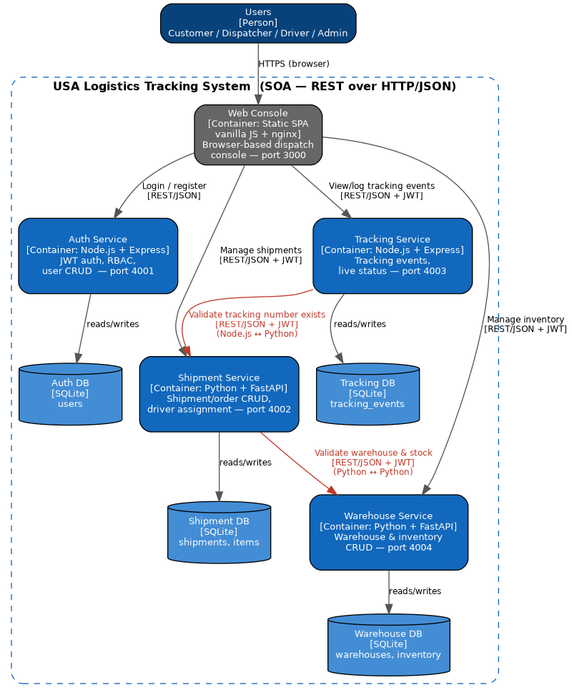
Figure 2 — Container Diagram (5 containers: Web Console + 4 backend services + their databases)
Table 3 lists each container’s responsibility, its interfaces, and its dependencies — the information the guide requires beyond the diagram itself.

Table 3 — Container Responsibilities and Interfaces
Container | Responsibility | Provided Interface | Depends On
Web Console | Browser-based UI; consumes all four service APIs; renders live distributed trace | None (consumer only) | Auth, Shipment, Tracking, Warehouse Services (all via REST/JWT)
Auth Service | Identity, JWT issuance, RBAC, user CRUD | REST /auth/* (OpenAPI via swagger-jsdoc) | Auth DB (SQLite)
Shipment Service | Shipment/order lifecycle, driver assignment | REST /shipments/* (OpenAPI, auto-generated) | Shipment DB; Warehouse Service (REST)
Tracking Service | Tracking-event log, current status | REST /tracking/* (OpenAPI via swagger-jsdoc) | Tracking DB; Shipment Service (REST)
Warehouse Service | Warehouses and inventory CRUD | REST /warehouses/* (OpenAPI, auto-generated) | Warehouse DB
Interoperability evidence: the two red edges in Figure 2 (Shipment→Warehouse and Tracking→Shipment) are the two points where the required multi-language interoperability is architecturally realized — the first is Python calling Python across a service boundary (still a genuine SOA boundary despite the shared language), and the second is Node.js calling Python, which is the specific cross-language interoperability the course requires and that Section 15’s evidence directly validates.

7.3 Component View
The Shipment Service is presented as the architecturally significant subsystem for the component view, because it uniquely combines all four component categories present in this system: request validation, cross-service outbound calls, persistence, and cross-cutting concerns.
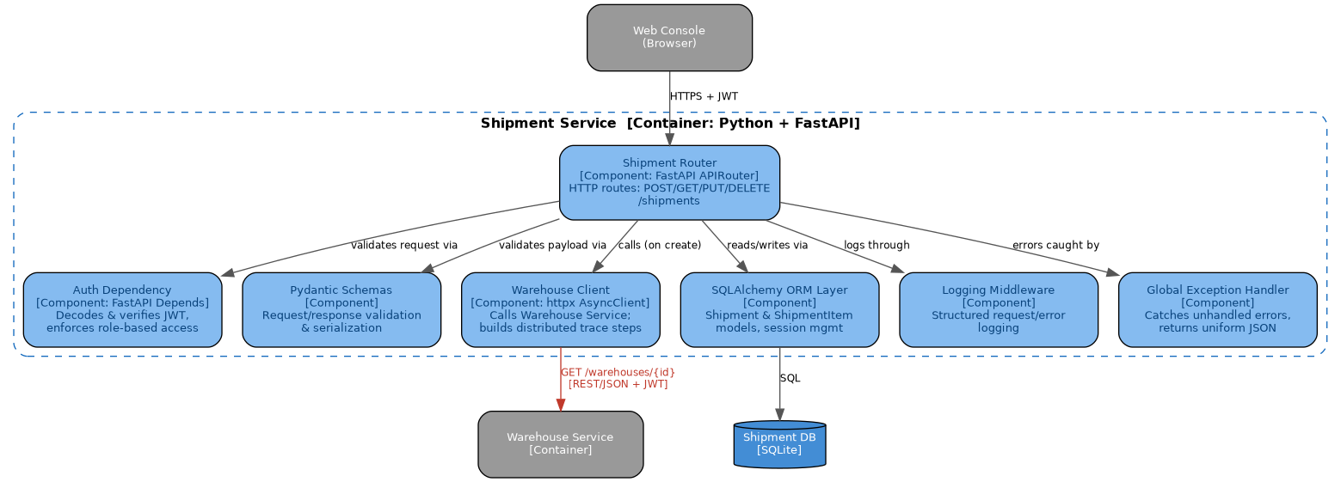
Figure 3 — Component Diagram (Shipment Service internal structure)

Table 4 — Component Responsibilities (Shipment Service)
Component | Responsibility | Depends On
Shipment Router | HTTP route handling (FastAPI `APIRouter`) | Auth Dependency, Pydantic Schemas, Warehouse Client, ORM Layer
Auth Dependency | JWT decode/verify, role-gate via FastAPI `Depends` | python-jose, shared JWT secret
Pydantic Schemas | Request/response validation & serialization, including the `trace` field used by the Web Console | —
Warehouse Client | Outbound REST call to Warehouse Service; builds distributed-trace steps for observability | httpx AsyncClient
SQLAlchemy ORM Layer | Shipment & ShipmentItem persistence | Shipment DB (SQLite)
Logging Middleware | Structured JSON request/error logging | —
Global Exception Handler | Catches unhandled exceptions, returns uniform error JSON | —
The equivalent internal structure (router → auth middleware → business logic → data-access layer) is repeated in all four backend services, so this one component view is representative of the codebase’s general internal organization, not a one-off.

7.4 Runtime / Interaction View
Three runtime scenarios are presented, satisfying the guide’s minimum of two: a normal transactional flow, a cross-language interoperability flow, and a fault-tolerance flow under service failure.

Scenario 1 — Customer Creates a Shipment
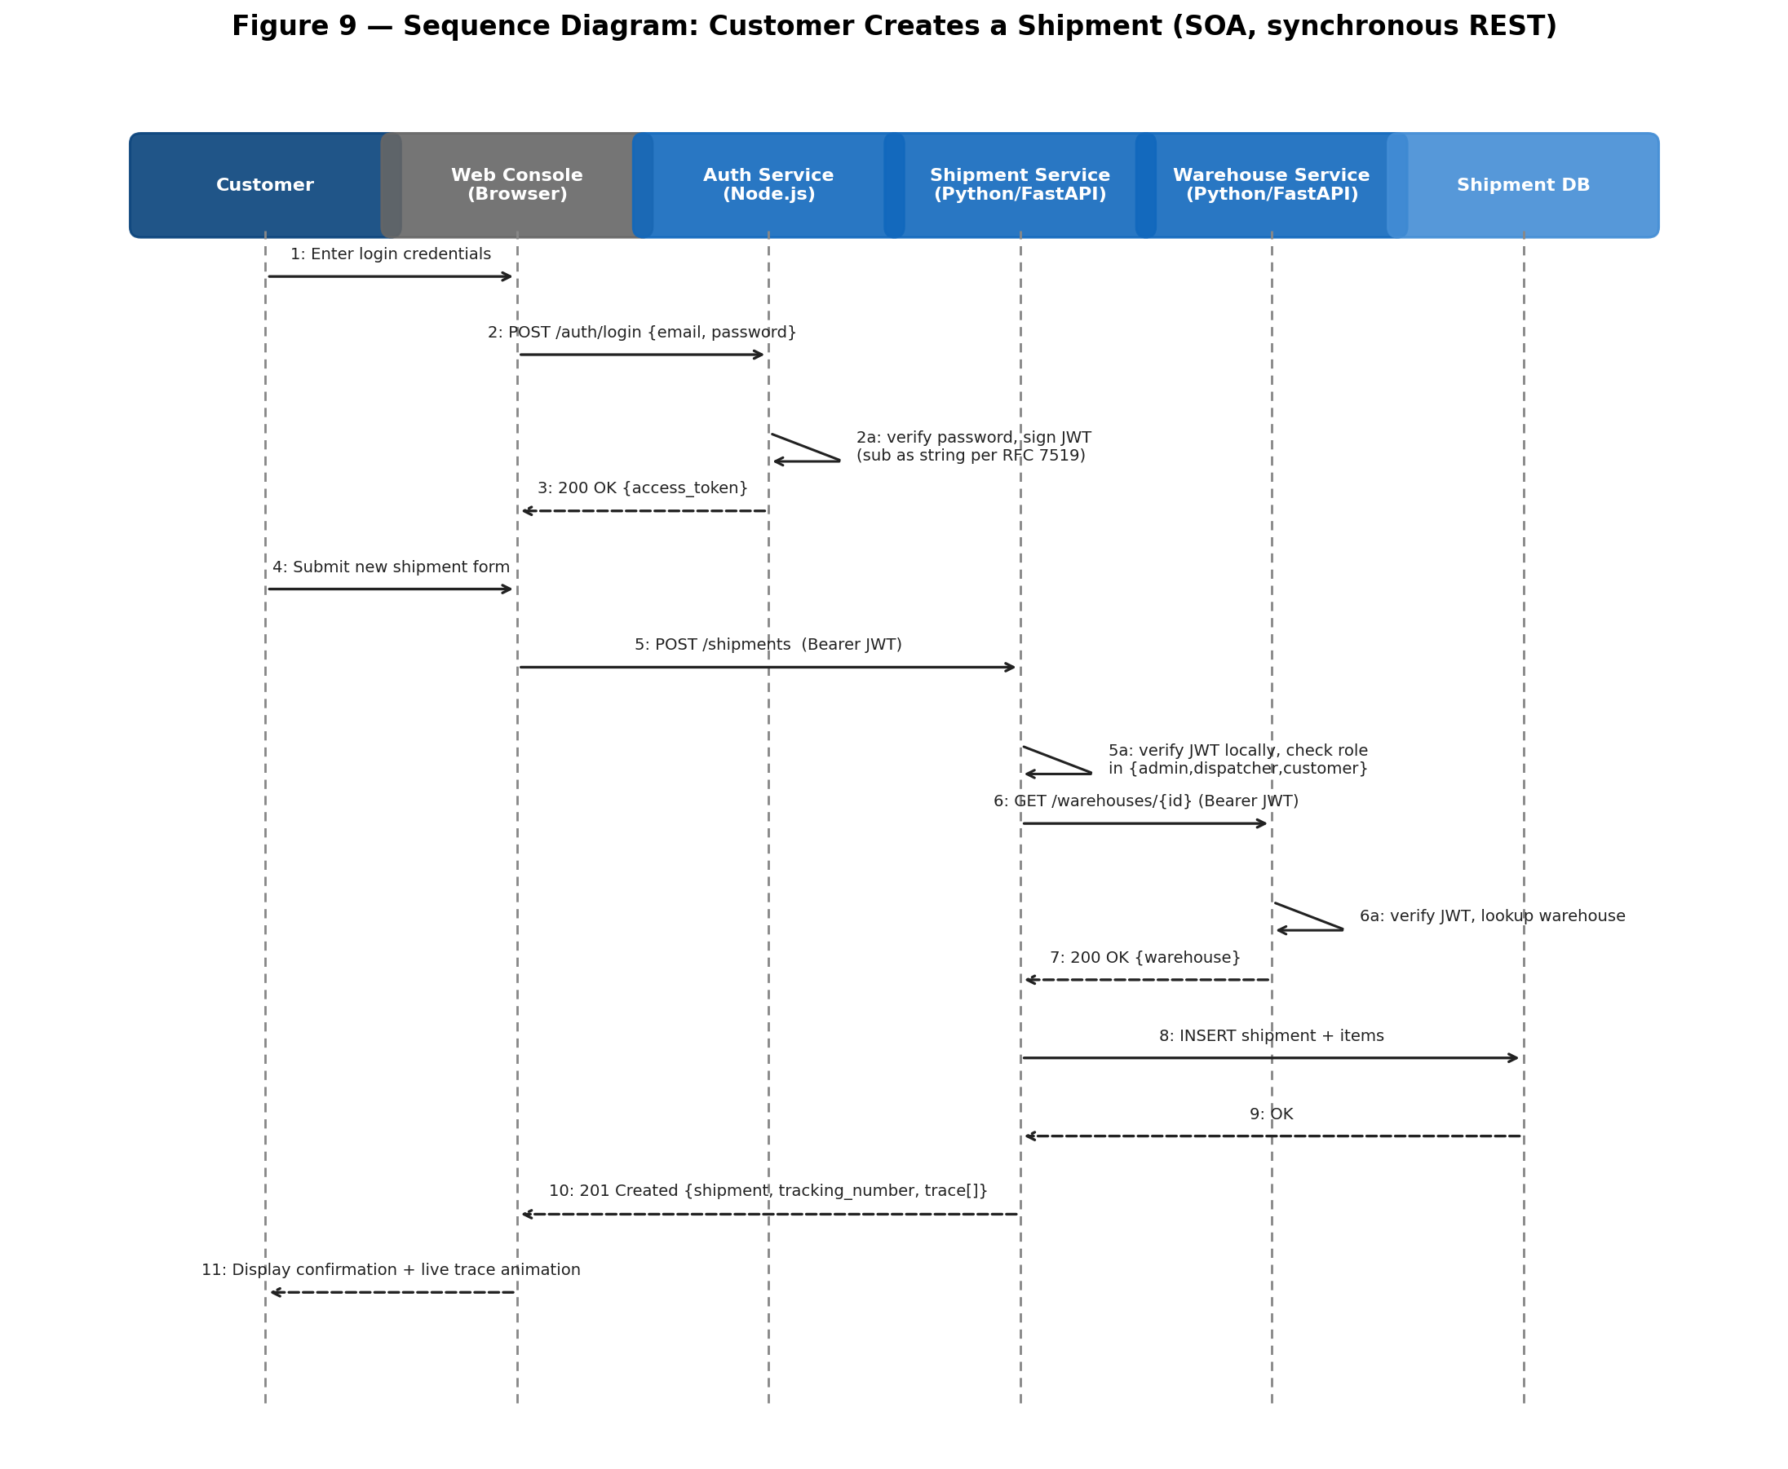
Figure 7 — Sequence Diagram: Customer Creates a Shipment (traces QAS-4, supports ADR-2/ADR-3)

Scenario 2 — Driver Logs a Tracking Event (Cross-Language)
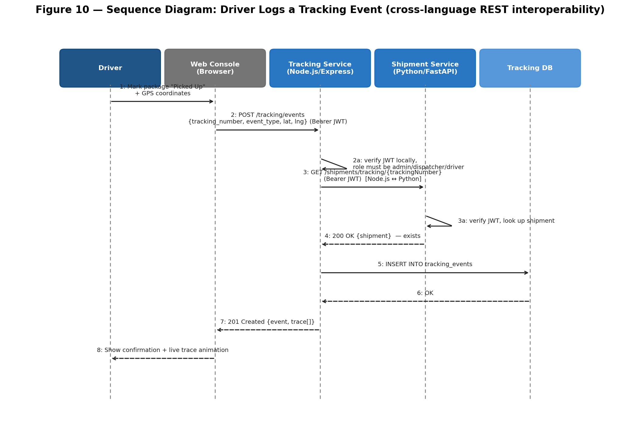
Figure 8 — Sequence Diagram: Driver Logs a Tracking Event (traces QAS-3, ADR-4)

Scenario 3 — Shipment Creation Under Warehouse Service Failure
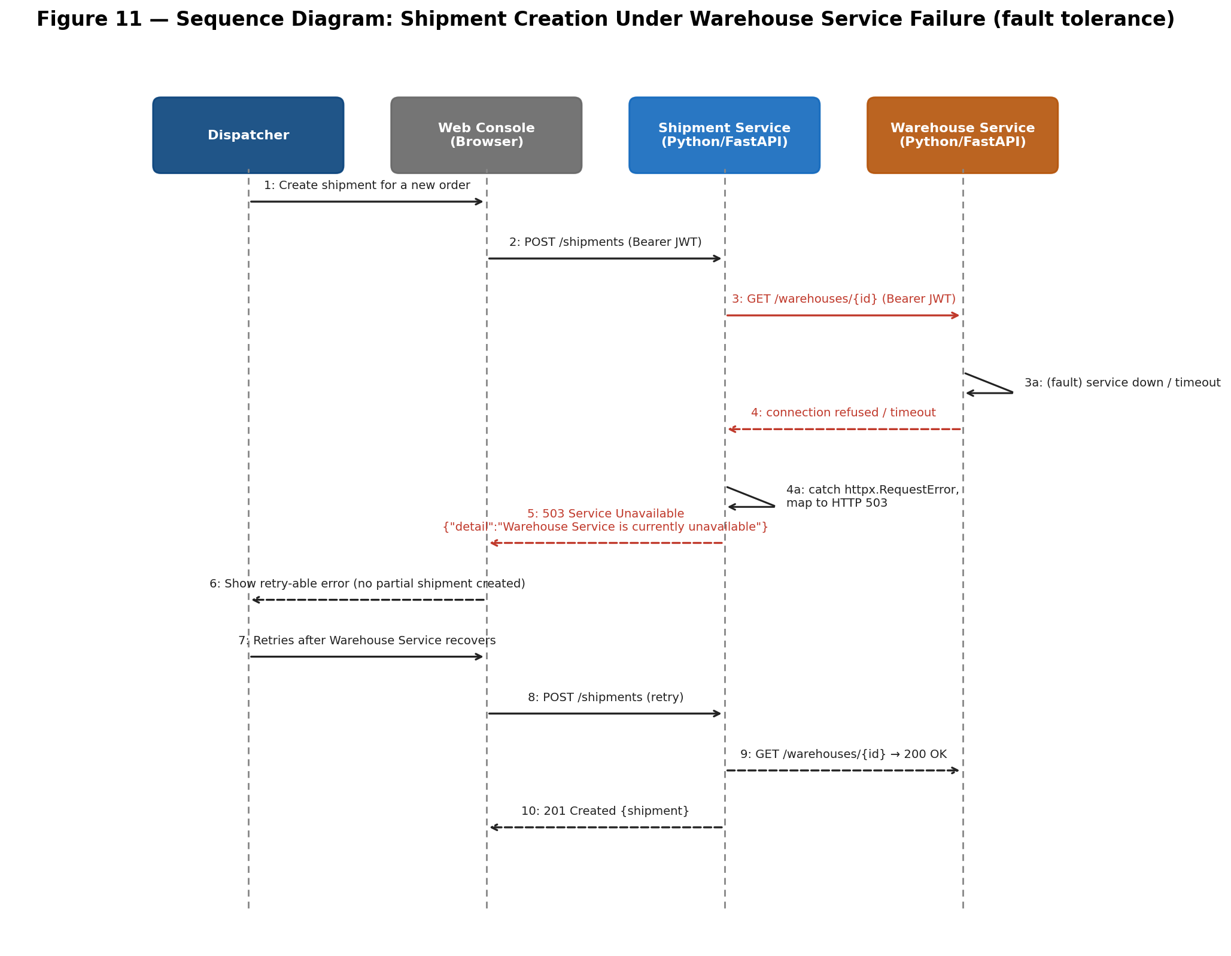
Figure 9 — Sequence Diagram: Shipment Creation Under Warehouse Service Failure (traces QAS-1, ADR-7)

7.5 Data Architecture View

7.5.1 Data Ownership
Consistent with the database-per-service tactic (ADR-2), each backend service exclusively owns one SQLite database file and is the only process permitted to read or write it. No service holds a foreign-key relationship into another service’s database at the schema level; every apparent cross-service relationship (e.g., a shipment’s `customer_id` referencing a row in the Auth Service’s `users` table) is a logical reference, validated at the application layer through a live REST call rather than a database constraint.
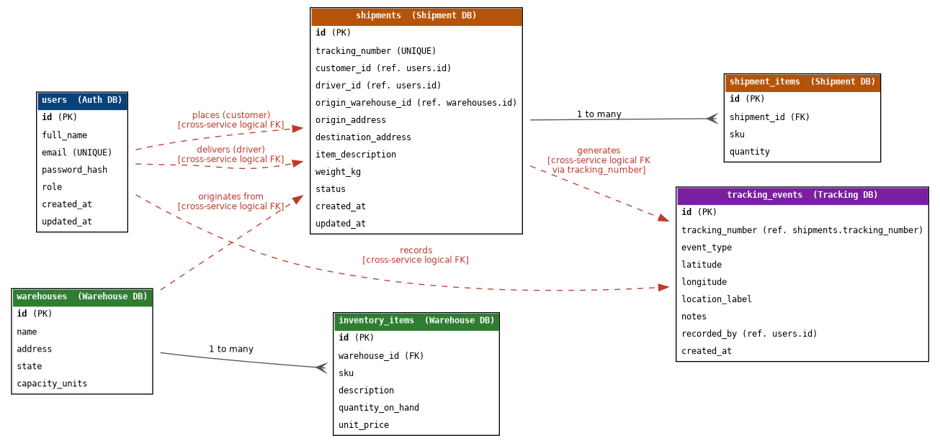
Figure 5 — Logical Data Architecture / Entity-Relationship Diagram. Solid crow’s-foot lines are real, engine-enforced foreign keys within one database; dashed red lines are logical, application-enforced relationships that cross a service (and database) boundary.

7.5.2 Storage and Schema Summary
Database | Owning Service | Key Tables
Auth DB | Auth Service | users (id, full_name, email, password_hash, role, timestamps)
Shipment DB | Shipment Service | shipments, shipment_items
Warehouse DB | Warehouse Service | warehouses, inventory_items
Tracking DB | Tracking Service | tracking_events

7.5.3 Consistency Model
The system uses eventual, application-enforced consistency across service boundaries and strong, transactional consistency within a single service’s database. For example, creating a shipment with its line items is a single local transaction inside Shipment Service (strong consistency), but the fact that its `origin_warehouse_id` refers to a real, currently-existing warehouse is only checked at write-time via a live call to Warehouse Service (Section 7.4, Scenario 1) — if that warehouse were deleted a millisecond later, the reference would become logically stale with no automatic correction. This is an accepted trade-off, documented in ADR-2 and Section 13.

7.5.4 Data Lifecycle
- Creation: all records are created via their owning service’s REST API following Pydantic/manual validation.
- Update: shipment status and driver assignment are updated in place (Shipment DB); inventory quantities are updated in place (Warehouse DB); tracking events are append-only (never updated, only inserted) to preserve an audit trail of what was reported and when.
- Deletion: hard deletes are used throughout this coursework build (e.g., `DELETE /shipments/{id}` removes the row). A production evolution of this system would likely replace hard deletes with soft deletes (a `deleted_at` timestamp) to preserve historical/audit data — noted as a limitation in Section 16.

7.5.5 Privacy
Personally identifiable information is limited to `users.full_name` and `users.email` in the Auth DB, and address strings on `shipments`. Passwords are never stored in plaintext (bcrypt-hashed, Section 10). Role-based scoping restricts which shipments a customer or driver can see (Section 10.2). No data is currently encrypted at rest (a documented limitation, Section 13) — acceptable for this coursework deployment but flagged as a required change before any real production use.

7.5.6 Backup and Recovery
Each service’s SQLite database file is persisted to a named Docker volume, which survives container restarts and rebuilds but not an explicit `docker compose down -v`. No automated backup schedule exists in this deployment — appropriate for coursework demonstration scope, and documented as a required addition (e.g., scheduled volume snapshots or a migration to a managed database with automated backups) before production use (Section 16).

7.6 Deployment / Infrastructure View
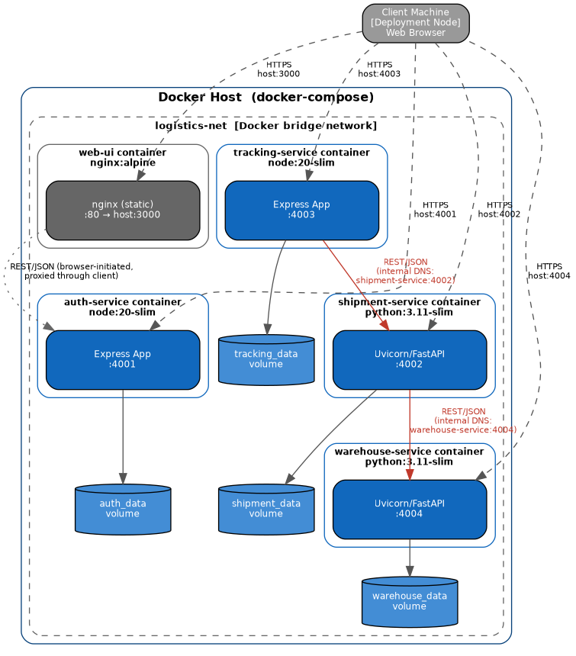
Figure 6 — Deployment Diagram: all five containers on a single Docker host, connected via the `logistics-net` bridge network
All five containers run on a single Docker host for this coursework deployment, orchestrated by `docker-compose.yml`, connected through a shared bridge network so services reach each other by container DNS name (e.g., `http://warehouse-service:4004`) rather than hard-coded IP addresses. Each backend service has its own named Docker volume for its SQLite file, preserving the database-per-service boundary at the infrastructure level, not just the application level. There is no reverse proxy or load balancer in front of the services in this deployment; each is directly port-mapped to the host (4001–4004, plus 3000 for the Web Console) for development/demonstration simplicity — Section 13 discusses this as a trade-off against a production API-gateway topology.
Scaling boundary: because each container is stateless with respect to in-memory session data (all session state is the client-held JWT), any service could be horizontally replicated behind a load balancer without code changes — the architecture does not currently exploit this (single replica per service), but nothing in the design prevents it.

8. Interface and Integration Architecture

8.1 Integration Style
All integration in this system is synchronous point-to-point REST over HTTP/JSON — there is no message broker, event bus, or asynchronous queue. This was a deliberate style choice (ADR-1) rather than an omission: the workflows in this domain (create a shipment, log an event) need an immediate success/failure answer, which synchronous REST provides naturally and a broker-based style would complicate.

8.2 API Contracts
Every service publishes an OpenAPI 3.0 specification: the two FastAPI services generate theirs automatically; the two Express services generate theirs via `swagger-jsdoc` annotations on each route. Appendix A lists every endpoint by service. The full machine-readable Postman collection (41 requests across all five containers, referenced throughout this document as the validation instrument) accompanies this submission in `04_API_and_Interface_Contracts/`.

8.3 Authentication and Authorization Boundary
Authentication is a JWT (HS256) issued only by Auth Service. Authorization is enforced independently by every service that receives a request: each decodes the token locally using a secret shared out-of-band (via environment variable, not transmitted over the network) and checks the token’s `role` claim against that endpoint’s allow-list before executing any business logic. No service trusts a caller’s claimed identity without independently verifying the token’s signature — including calls between two of this system’s own services (Shipment→Warehouse and Tracking→Shipment both carry and independently verify the original caller’s JWT, rather than using a separate service-account credential).

8.4 Error-Handling Contract
All four services converge on the same error response shape, regardless of language: a JSON object with an `error` (or, in FastAPI’s default case, `detail`) field containing a human-readable message and an HTTP status code that follows conventional REST semantics (400 malformed request, 401 unauthenticated, 403 unauthorized-for-role, 404 not found, 409 conflict, 503 downstream dependency unavailable). This consistency is a deliberate integration-architecture decision, not an accident of similar frameworks — it lets the Web Console use one error-handling code path (`js/api.js`) for all four services despite their different backend languages.

8.5 Third-Party Dependencies
The system has no required third-party network dependency at runtime. Google Fonts (loaded client-side by the Web Console for typography) is the only external network call in the running system, and its absence degrades typography only, not function. This is a deliberate minimization — see ADR-1’s rejection of a message-broker dependency and Section 13’s discussion of the trade-off between minimal dependencies and richer off-the-shelf capability.

9. Architectural Patterns, Tactics, and Principles
This section explains why each pattern or tactic was selected and which quality attribute or constraint it addresses — per the guide’s explicit instruction that naming a pattern is not, by itself, justification.

9.1 Database-per-Service (Data Tactic)
Why: directly serves Availability and Modifiability (QAS-1, QAS-4) by removing shared-database coupling — a service cannot be blocked by another service’s schema migration or lock contention, and a service can change its schema without a cross-team migration coordination cost. Trade-off: no cross-service referential integrity (Section 13).

9.2 Stateless Authentication (Availability/Performance Tactic)
Why: each service verifying JWTs locally, rather than calling Auth Service on every request, removes Auth Service as a single point of failure and as a latency bottleneck for the other three services — directly serving Availability (QAS-1) and, secondarily, Performance. Trade-off: no instant token revocation (Section 10.4).

9.3 Fail-Fast Error Propagation (Fault-Tolerance Tactic)
Why: a downstream service failure (e.g., Warehouse Service unreachable) is caught at the exact call site and converted immediately into a typed HTTP 503, rather than allowed to propagate as an unhandled exception or hang the request. This directly serves QAS-1 and prevents partial/inconsistent writes (Section 7.5.3).

9.4 Layered Internal Structure (Modifiability Tactic, within each service)
Why: every service follows the same internal layering — router/controller → auth middleware → business logic → data-access layer (Section 7.3) — which is a "semantic coherence" tactic: a developer who understands one service’s layout already understands all four, directly serving Modifiability (QAS-4).

9.5 Dependency Injection (Design Pattern, Python services)
Why: FastAPI’s `Depends()` mechanism injects the authenticated-user context and database session into route handlers rather than having handlers construct them, improving testability (handlers can be tested with a mock dependency) — a direct, if secondary, driver was Testability, which the course guide lists as a candidate quality attribute even though it was not one of this project’s top-5 priorities.

9.6 Repository-style Data Access (Design Pattern, all services)
Why: SQLAlchemy ORM (Python services) and prepared statements via `better-sqlite3` (Node.js services) both isolate SQL from route-handling code, so a future migration from SQLite to PostgreSQL (Section 13, Section 16) would touch only the data-access layer, not the API surface — serving Modifiability.

9.7 Self-Mounting Component Injection (Web Console, UI architecture pattern)
Why: the theme toggle and the live network-trace drawer are both implemented as scripts that mount themselves into any page that includes them (`theme.js`, `trace-panel.js`), rather than requiring each of the seven HTML pages to individually wire up the same UI. This is the same modifiability tactic (semantic coherence, single source of truth) applied at the frontend layer — adding an eighth page automatically gets both features for free.

10. Security Architecture
Security is one of this project’s top-prioritized quality attributes (Section 4.2, QAS-2). This section documents the threat boundaries, identity/access model, data protection posture, secrets handling, and logging/auditing controls in place.

10.1 Trust Boundaries
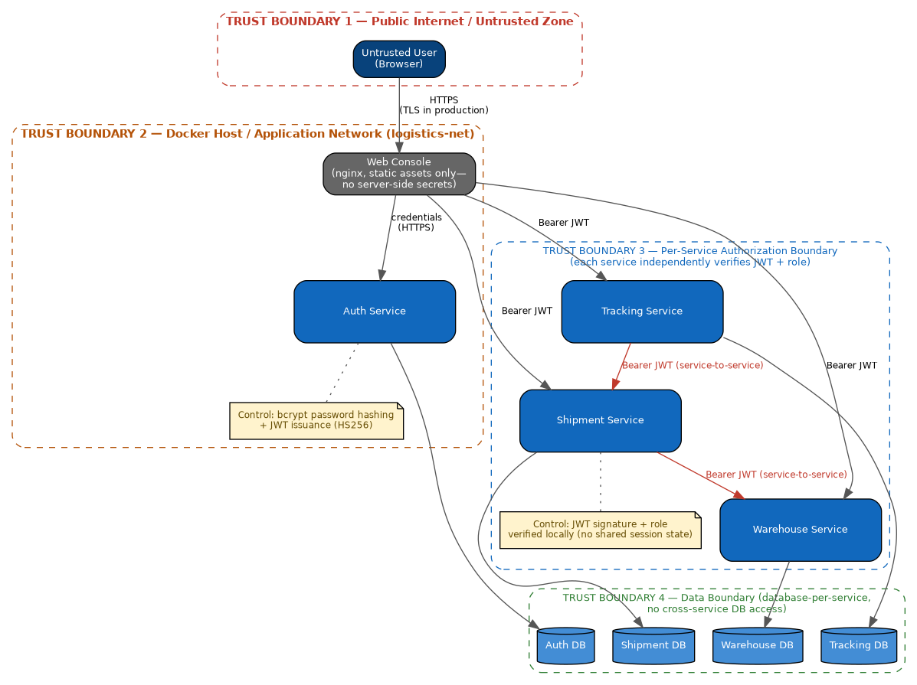
Figure 4 — Security / Trust Boundary View. Four nested trust boundaries: the public internet, the Docker application network, the per-service authorization boundary, and the data boundary.
Trust Boundary 1 (public internet) is crossed only by the browser-to-Web-Console connection; everything inside Trust Boundary 2 (the Docker bridge network) is assumed mutually trusted infrastructure in the current deployment, which is a documented limitation for any future multi-tenant or public-internet deployment (Section 10.6). Trust Boundary 3 shows that authorization is not centralized at the network edge — every one of the three business services independently re-verifies the JWT, so compromising or bypassing one service’s check does not implicitly grant access to another’s.

10.2 Identity and Access Management
Control | Mechanism
Authentication | JWT (HS256), issued only by Auth Service on successful login, containing `sub` (user id, as a string per RFC 7519), `email`, `role`, `full_name`, with an 8-hour expiry
Password Storage | bcrypt, 10 salt rounds (Auth Service) — plaintext passwords are never persisted or logged
Authorization Model | Role-Based Access Control with four roles (admin, dispatcher, driver, customer); enforced per-endpoint via middleware (Node.js) or FastAPI `Depends` (Python)
Row-Level Scoping | Customers see only shipments where `customer_id` matches their own id; drivers see only shipments where `driver_id` matches their own id — enforced in the Shipment Service query layer, not merely hidden in the UI
Credential Recovery | Admin-mediated password reset (Users page) — no self-service email-based reset exists, since the system has no email/SMS integration (Section 3.4); this is a deliberate, documented scope limitation, not an oversight

10.3 Secure Communication
All inter-service and browser-service traffic in this deployment is plain HTTP within the trusted Docker network. TLS termination is not implemented in this coursework build. For any deployment beyond local demonstration, TLS (either service-level or via a reverse proxy / API gateway performing termination) is a required addition, documented explicitly as a limitation in Section 13 and Section 16 rather than silently omitted.

10.4 Secrets Handling
The JWT signing secret is provided to every service via an environment variable (`JWT_SECRET`), sourced from each service’s `.env` file (excluded from version control via `.gitignore`) and, in the Docker deployment, from `docker-compose.yml` environment entries. This is adequate for coursework scope but is explicitly flagged as a limitation: a production deployment should source this from a managed secrets store (e.g., Docker secrets, HashiCorp Vault, or a cloud provider’s secrets manager) rather than a plain environment variable, and should support key rotation, which the current stateless-JWT design does not support without briefly invalidating all outstanding tokens.

10.5 Logging and Auditing
Every service emits structured logs (JSON) for each request and each error, including the acting user’s id where authenticated (e.g., "Shipment created ... by user 4", "Warehouse deleted ... by 1"), giving a basic audit trail of who performed which state-changing action. Logs are currently written to stdout/local files per container and are not centrally aggregated — a production evolution would add centralized log aggregation (Section 16).

10.6 Known Security Limitations (Honest Disclosure)
Consistent with this document’s emphasis on justified trade-offs rather than an idealized description, the following limitations are acknowledged rather than hidden:
- No TLS/HTTPS in the current deployment (Section 10.3).
- No instant JWT revocation — a compromised token remains valid until its 8-hour expiry (accepted trade-off, ADR-3).
- Secrets are environment-variable-based, not a managed secrets store (Section 10.4).
- No rate limiting or brute-force login protection is implemented on Auth Service — a real risk for a login endpoint, and a concrete, prioritized item for future work (Section 16).
- No data encryption at rest (SQLite files are unencrypted on disk).

11. Performance, Scalability, Reliability, and Availability

11.1 Expected Load
As a coursework demonstration system, expected load is low (single-digit concurrent users during grading/demonstration). The architecture was nonetheless designed with a specific higher-load profile in mind for its tactics to be meaningful: the Tracking Service, expected to receive the highest write frequency in a real deployment (GPS pings from many drivers), is deliberately built on Node.js’s non-blocking I/O model for exactly this reason (ADR-4), even though the current demonstration load does not exercise it.

11.2 Observed Performance (Measured, not Estimated)
Section 15 presents a live Newman test run against all 41 requests across all five containers. That run measured an average response time of 33ms (min 4ms, max 147ms) across all endpoints, entirely on localhost with no network latency — presented as a baseline, not a production benchmark, since it does not model concurrent load or a deployed network path.

11.3 Bottlenecks and Mitigations
Potential Bottleneck | Current Mitigation / Status
Warehouse Service becomes unavailable, blocking Shipment creation | Fail-fast to HTTP 503 (Section 9.3) prevents cascading hangs; does not yet include a circuit breaker or retry-with-backoff — noted as future work
SQLite write concurrency under high load | Acceptable at coursework scale; documented migration path to PostgreSQL for any higher-concurrency deployment (Section 16)
No caching layer | Not implemented — acceptable given current read volume; a future addition (e.g., Redis in front of Warehouse Service reads) is noted as a scalability option, not currently required
No API gateway / rate limiting | A single slow or malicious client could exhaust a service’s request-handling capacity; explicitly out of scope for this project’s size (ADR-5) but flagged as a production requirement

11.4 Concurrency
The two Python services use FastAPI’s async request handling, and the outbound Shipment→Warehouse call is implemented with `httpx.AsyncClient` so that a single Shipment Service worker is not blocked waiting on Warehouse Service for the duration of that call. The two Node.js services rely on Node’s single-threaded event loop, which is well suited to the I/O-bound, low-CPU workload of both services.

11.5 Redundancy and Failover
The current deployment runs exactly one replica of each container — there is no redundancy or automatic failover. As noted in Section 7.6, the stateless design (no in-memory session state) means horizontal replication behind a load balancer is architecturally possible without code changes, but was not built, since a single-developer coursework project at this scale does not justify the added orchestration complexity (Kubernetes or Docker Swarm) that true failover would require.

11.6 Fault Isolation
Each service runs in its own container with its own process boundary, so a crash in one service’s process (e.g., an unhandled exception in Warehouse Service) does not crash any other service’s process — verified live in Section 15 by stopping Warehouse Service and confirming the other three continued serving requests.

11.7 Recovery
Docker Compose’s `restart: unless-stopped` policy (set on every service in `docker-compose.yml`) automatically restarts a crashed container. Because all four backend services persist to Docker-managed volumes rather than container-local storage, a restarted container resumes with its data intact.

11.8 Observability
Beyond structured logging (Section 10.5), this system includes a purpose-built observability feature not typical of coursework projects at this scope: every response from Shipment Service (on create) and Tracking Service (on event log) includes a `trace` array describing the real inter-service call(s) made while handling that request — not simulated, but the service’s own self-report of what it actually did. The Web Console renders this live as an animated call graph and scrolling log (Section 15, Figure 12), giving a genuine runtime view into the distributed call graph without needing an external APM tool.

12. Architecture Decision Records (ADRs)
Seven ADRs capture the architecturally significant decisions in this system, using the template from the SFWE415 submission guide. They are cross-referenced throughout Sections 5–11 and traced to drivers/evidence in Section 14.

ADR-1: Service-Oriented Architecture over Event-Driven Architecture
Status: Accepted
Date / Author: July 28, 2026 / Shakhzod Musaev
Context / Problem: The system needed an architectural style for inter-service and client-service communication. Two realistic candidates existed: synchronous SOA (REST) and asynchronous EDA (message broker / event bus).
Decision Drivers:
- Need for an immediate success/failure response on core workflows (create shipment, log event)
- Course requirement to demonstrate interoperability across two language stacks
- Single-developer, one-semester delivery timeline
- Anticipated data volume does not require high-throughput event streaming
Options Considered:
- Option A: Event-Driven Architecture (Kafka/RabbitMQ), choreography-based
- Option B: Service-Oriented Architecture, synchronous REST, orchestration-style
- Option C: Hybrid (REST for commands, events for telemetry) — rejected as unnecessary added complexity at this scale, though noted as a future evolution (Section 16)
Decision: Adopt Service-Oriented Architecture using synchronous REST/JSON over HTTP, with no message broker or ESB.
Rationale: The core workflows in this domain are inherently request/response (a customer needs to know immediately whether a shipment was accepted), and a REST contract is trivially implementable identically across Node.js and Python, which directly satisfies the interoperability requirement. An event broker would add real operational complexity (deployment, monitoring, schema evolution for events) without a corresponding benefit at this project’s throughput.
Consequences — Positive:
- Simple to build, test, and reason about
- Immediate consistency for the user-facing "was this accepted" question
- Directly satisfies the course’s cross-language interoperability requirement with minimal contract overhead
Consequences — Negative / Trade-offs:
- Tighter runtime coupling between caller and callee than pub/sub would allow (Section 13)
- Does not suit a future high-volume telemetry use case (e.g., thousands of GPS pings/sec) without revisiting this decision
Related Decisions: Related to ADR-5 (no API gateway) and ADR-7 (fail-fast error handling), both of which assume synchronous REST.

ADR-2: Database-per-Service
Status: Accepted
Date / Author: July 28, 2026 / Shakhzod Musaev
Context / Problem: Each service needs to persist data. A shared database across services was the simplest alternative but conflicts with independent deployability.
Decision Drivers:
- Independent deployability (explicit functional requirement, FR1)
- Avoiding a schema change in one service silently breaking another
- Minimizing coordination overhead for a single developer maintaining four codebases
Options Considered:
- Option A: one shared relational database for all services
- Option B: database-per-service, with cross-service references validated at the application layer via REST calls
Decision: Each service owns an isolated SQLite database; no service queries another service’s database directly.
Rationale: A shared database would let any service’s migration silently break another service’s queries, directly undermining independent deployability. Application-layer validation via REST (Section 7.5.1) trades referential-integrity guarantees for full service autonomy, which was judged the better trade-off given FR1 is an explicit, graded requirement.
Consequences — Positive:
- Full service autonomy; independent schema evolution and deployment
- No cross-service query can accidentally couple two services’ internal data models
Consequences — Negative / Trade-offs:
- No database-enforced foreign keys across services — referential integrity depends on application logic (Section 7.5.3)
- A warehouse could theoretically be deleted after a shipment references it, with no automatic cascade or alert (documented risk, Section 13)
Related Decisions: Enables ADR-6 (Web Console added with zero backend changes) and is directly tested by QAS-4.

ADR-3: Stateless, Locally-Verified JWT Authentication
Status: Accepted
Date / Author: July 28, 2026 / Shakhzod Musaev
Context / Problem: Every one of the four backend services needs to authenticate and authorize incoming requests, including requests from other services.
Decision Drivers:
- Availability — avoid a single point of failure for the whole system
- Latency — avoid an extra network hop on every single request
- Simplicity — avoid building/operating a session store
Options Considered:
- Option A: centralized session store (e.g., Redis-backed sessions), checked by every service on every request
- Option B: stateless JWT, issued once by Auth Service, verified independently and locally by every service thereafter
Decision: Issue a signed JWT (HS256) at login; every service verifies it locally using a secret shared via environment configuration, with no callback to Auth Service.
Rationale: A central verification call on every request would make Auth Service a bottleneck and single point of failure for the entire system, directly undermining the Availability priority (QAS-1) and the core premise of SOA (loosely coupled, independently available services).
Consequences — Positive:
- No central point of failure for authorization
- Lower latency — no extra network hop per request
- Each service can be tested/run in isolation without a live Auth Service, since verification only needs the shared secret
Consequences — Negative / Trade-offs:
- No instant token revocation — a compromised or improperly-issued token remains valid until its 8-hour expiry (Section 10.6)
- Shared secret distribution/rotation is a manual, environment-variable-based process (Section 10.4)
Related Decisions: A real interoperability bug was discovered and fixed under this decision: the Node.js issuer originally signed `sub` as a numeric value, which `python-jose` in the Python services strictly rejected per RFC 7519 (StringOrURI). Fixed by signing `sub` as a string. Documented here because it is a direct, concrete illustration of why explicit contract testing (Section 15) matters even for "simple" cross-language integration.

ADR-4: Polyglot Stack: Node.js/Express and Python/FastAPI
Status: Accepted
Date / Author: July 28, 2026 / Shakhzod Musaev
Context / Problem: The course requires demonstrable interoperability across at least two programming languages or frameworks.
Decision Drivers:
- Explicit course requirement
- Natural workload fit: transactional pair (Shipment/Warehouse) benefits from FastAPI’s typed validation and native async HTTP client; high-frequency pair (Auth/Tracking) benefits from Node’s event loop for many short, I/O-bound requests
Options Considered:
- Option A: single language (e.g., all Python) with an artificial second-language shim just to satisfy the requirement
- Option B: split services across two languages along a genuine workload boundary
Decision: Auth Service and Tracking Service on Node.js/Express; Shipment Service and Warehouse Service on Python/FastAPI.
Rationale: Splitting along a real workload boundary (rather than an arbitrary one) makes the interoperability requirement a genuine architectural constraint that shaped real decisions (the REST/JWT contract, Section 8.3), rather than a checkbox exercise.
Consequences — Positive:
- Satisfies the course requirement with a defensible, non-arbitrary rationale
- Forces an explicit, language-agnostic contract (Section 8) rather than implicit shared-object coupling
Consequences — Negative / Trade-offs:
- Two toolchains to maintain (npm and pip), two sets of language-specific idioms and bugs (see the `sub`-claim bug under ADR-3)
- A developer must be competent in both stacks to modify the whole system
Related Decisions: Directly tested by QAS-3 (cross-language tracking event submission) and validated live in Section 15.

ADR-5: No API Gateway or Enterprise Service Bus
Status: Accepted
Date / Author: August 15, 2026 / Shakhzod Musaev
Context / Problem: Clients (the Web Console) need to reach four different backend services. A gateway could centralize routing, rate limiting, and TLS termination.
Decision Drivers:
- Project scale — four backend services, one client, one developer
- Avoiding a new single point of failure
- Time budget for a one-semester individual project
Options Considered:
- Option A: introduce an API gateway (e.g., Kong, NGINX, or a custom Express gateway) as the single entry point
- Option B: let the Web Console call each service directly by its own host:port
Decision: The Web Console calls each of the four services directly; there is no gateway.
Rationale: At four services and a single client, a gateway’s benefits (centralized rate limiting, unified TLS termination, request logging) do not yet outweigh its cost (new component to build, deploy, and reason about, and a new potential single point of failure) within this project’s scope and timeline.
Consequences — Positive:
- Simpler infrastructure; one fewer moving part to build and explain
- No new single point of failure introduced
Consequences — Negative / Trade-offs:
- Cross-cutting concerns (rate limiting, consistent logging format enforcement) are duplicated per service rather than centralized (Section 11.3)
- The Web Console must know every service’s address (mitigated by the Settings page, which allows runtime reconfiguration — Section 9.7)
- Explicitly identified as the first infrastructure addition a production deployment would need (Section 16)
Related Decisions: Directly relevant to Section 11.3 (bottlenecks) and Section 16 (future work).

ADR-6: Browser-Direct Web Console (No Backend-for-Frontend)
Status: Accepted
Date / Author: August 15, 2026 / Shakhzod Musaev
Context / Problem: A browser-based UI was added after the four backend services already existed. It needed a way to call all four services’ REST APIs.
Decision Drivers:
- Minimize new server-side code (no new business logic needed — the UI is purely a client)
- Directly demonstrate, not hide, the SOA call graph for the course’s architectural-evidence requirement
- Avoid introducing yet another backend service (and its own security surface) purely to proxy requests
Options Considered:
- Option A: build a dedicated Backend-for-Frontend (BFF) service that the browser talks to exclusively, which then calls the four services server-side
- Option B: serve only static assets (HTML/CSS/JS) and let the browser call all four backend services directly via `fetch`
Decision: The Web Console is a static single-page application (nginx-served) that calls all four backend services directly from the browser, relying on each service’s existing CORS configuration (`allow_origins=["*"]` for FastAPI, default permissive `cors()` for Express).
Rationale: A BFF would have added a fifth backend service, its own auth-forwarding logic, and an extra network hop for every single UI action, without adding business value for a single-tenant coursework demo — and critically, a BFF would hide the real cross-service calls behind one intermediary, undermining the goal of visibly demonstrating the SOA architecture through the UI (a specific project goal, see Section 15).
Consequences — Positive:
- Zero new backend business logic; the Web Console is provably "just a client," reinforcing the architecture’s legibility
- The live network-trace feature (Section 11.8) can show genuine, unmediated browser→service calls
- Validates QAS-4 directly: this container was added with zero changes to the four existing services
Consequences — Negative / Trade-offs:
- Each service’s CORS policy must be permissive (`allow_origins=["*"]`), which is acceptable for this trusted-network coursework deployment but would need tightening (specific allowed origins) before any public deployment (Section 10.6)
- The browser, not a server, holds the JWT (in `localStorage`), a client-side XSS exposure documented in Section 10.6
Related Decisions: Extends ADR-2 and ADR-5’s "no new server-side component" philosophy to the presentation layer; validated by QAS-4.

ADR-7: Fail-Fast, No Partial Writes on Downstream Failure
Status: Accepted
Date / Author: July 28, 2026 / Shakhzod Musaev
Context / Problem: A service-to-service call (e.g., Shipment→Warehouse) can fail for reasons outside the caller’s control (the callee is down, times out, or errors). The caller must decide what to persist, if anything, when this happens.
Decision Drivers:
- Data consistency — avoid orphaned or half-written records
- No distributed-transaction infrastructure exists (nor is one justified at this scale)
- A clear, predictable failure mode for the client to handle (retry) rather than an ambiguous "pending" state
Options Considered:
- Option A: write a "pending" shipment record optimistically, then reconcile later if the warehouse check ultimately fails
- Option B: abort the entire operation and persist nothing if the required downstream check fails
Decision: If a required downstream call fails, the calling service aborts the request and returns HTTP 503; no partial or pending record is written.
Rationale: Without a distributed-transaction or saga mechanism, a "pending" record risks becoming permanently orphaned if the failure is not transient, and reconciliation logic would be non-trivial to get right for a single-developer project on this timeline. A clean abort-and-retry contract is simpler to reason about and to test (QAS-1).
Consequences — Positive:
- No inconsistent partial data ever exists in any database
- Simple, predictable client contract: 503 means "retry later," full stop
Consequences — Negative / Trade-offs:
- The customer/dispatcher must manually retry rather than the system automatically completing the operation once the dependency recovers
- Would need to be replaced by a saga/compensating-transaction pattern if the system grew to require guaranteed eventual completion (Section 16)
Related Decisions: Directly implements and is tested by QAS-1 (Figure 9, Section 7.4 Scenario 3).

13. Architecture Evaluation and Trade-offs
This section presents a lightweight, ATAM-inspired evaluation: for each quality attribute prioritized in Section 4.2, the architecture’s sensitivity points (a small change with an outsized quality-attribute impact) and trade-off points (a decision that improves one attribute at the expense of another) are made explicit, alongside residual risks and unresolved issues.

13.1 Trade-off Table
Decision | Benefit | Cost | Attributes Traded Against Each Other
SOA (sync REST) over EDA | Simple, traceable, immediate consistency | Tighter runtime coupling than pub/sub | Simplicity/Consistency vs. Scalability under very high event throughput
Database-per-service | Full service autonomy | No cross-service FK/JOIN integrity | Modifiability vs. Data Integrity
Local JWT verification | No auth bottleneck; low latency | No instant token revocation | Availability/Performance vs. Security (revocation)
No API Gateway | Simpler infrastructure | Duplicated cross-cutting concerns per service | Development Simplicity vs. Operational Consistency
Browser-direct Web Console (no BFF) | Zero new backend logic; visible SOA calls | Permissive CORS required; JWT held client-side | Architectural Legibility vs. Security Hardening
Fail-fast on downstream failure | No inconsistent partial data | Manual retry required by the user | Data Integrity vs. Automation/Convenience
SQLite per service | Zero-config, fast local development | Not suited to high-concurrency production writes | Development Velocity vs. Production Scalability

13.2 Sensitivity Points
- The choice of local JWT verification (ADR-3) is highly sensitive to the token expiry value: shortening it improves the security exposure window at a direct cost to user convenience (more frequent re-logins); lengthening it does the reverse. The current 8-hour value is a judgment call, not a measured optimum.
- The database-per-service boundary (ADR-2) is sensitive to how "chatty" cross-service validation becomes: the current system makes exactly one cross-service call per write operation (Shipment→Warehouse, Tracking→Shipment); a future feature requiring, say, three sequential cross-service checks on one write path would meaningfully degrade both latency and the "simple to reason about" benefit this ADR claims.

13.3 Residual Risks
- No TLS in the current deployment is a real risk if this system were ever exposed beyond a trusted local/Docker network (Section 10.6).
- No rate limiting on Auth Service’s login endpoint is a real brute-force risk (Section 10.6).
- A warehouse or shipment referenced by another service’s data could be deleted, leaving a logically dangling reference with no automatic detection (Section 7.5.3) — mitigated only by the fact that the demo dataset is small and admin-controlled.

13.4 Unresolved Issues / Technical Debt
- No automated test suite beyond the Postman/Newman collection exists (e.g., no unit tests for individual functions) — acceptable for this project’s scope but a genuine gap for any long-lived codebase.
- No CI/CD pipeline automatically runs the Postman collection on every code change; validation in Section 15 was run manually.
- The Web Console’s service-URL configuration (Settings page) is stored per-browser in `localStorage`, which does not scale to multiple users needing different configurations on a shared machine.

14. Architecture-to-Implementation Mapping
This section maps each architectural element to its concrete implementation artifact, satisfying the guide’s traceability-to-code requirement. Full source is at https://github.com/Shakhzod79750/usa-logistics-soa.
Architectural Element | Repository Path | Framework / Language | Database | Docker Image / Port
Web Console container | /web-ui | Vanilla JS, HTML5, CSS3 (no build step) | None (client only) | nginx:alpine — host:3000
Auth Service container | /auth-service | Node.js 20 + Express 4 | Auth DB (SQLite, auth_data volume) | node:20-slim — host:4001
Shipment Service container | /shipment-service | Python 3.11 + FastAPI 0.111 | Shipment DB (SQLite, shipment_data volume) | python:3.11-slim — host:4002
Tracking Service container | /tracking-service | Node.js 20 + Express 4 | Tracking DB (SQLite, tracking_data volume) | node:20-slim — host:4003
Warehouse Service container | /warehouse-service | Python 3.11 + FastAPI 0.111 | Warehouse DB (SQLite, warehouse_data volume) | python:3.11-slim — host:4004

14.1 Deployment Artifact
`docker-compose.yml` (repository root) defines all five containers, the shared `logistics-net` bridge network, and the four named data volumes. `docker compose up --build` is the single command that builds and starts the full system from source, matching exactly what Section 15’s validation evidence was captured against.

14.2 Package/Module Mapping (representative — Shipment Service)
Component (Figure 3) | Module / File
Shipment Router | shipment-service/app/routes.py
Auth Dependency | shipment-service/app/auth.py
Pydantic Schemas | shipment-service/app/schemas.py
Warehouse Client | shipment-service/app/warehouse_client.py
SQLAlchemy ORM Layer | shipment-service/app/models.py, database.py
Logging Middleware | shipment-service/app/logging_config.py, main.py
Global Exception Handler | shipment-service/app/main.py

15. Validation Evidence
This section presents evidence that the architecture described in Sections 6–11 is genuinely implemented and functioning, not only designed. All evidence below was captured live against the running system on the date noted, using the Postman collection and manual browser testing described.

15.1 Automated Regression Evidence (Postman/Newman)
The full Postman collection (41 requests spanning all five containers: Web Console reachability, Auth, Warehouse, Shipment, Tracking, and a Cleanup phase) was executed via Newman (Postman’s CLI runner) against the live, Docker-equivalent running system.
Metric | Result
Requests executed | 41 / 41
Requests failed | 0
Test-script assertions | 11 / 11 passed
Total run duration | 2.2 seconds
Average response time | 33 ms (min 4 ms, max 147 ms)
This run specifically exercised both required cross-service interoperability paths for real: Shipment Service (Python) calling Warehouse Service (Python) to validate a warehouse before creating a shipment, and Tracking Service (Node.js) calling Shipment Service (Python) to validate a tracking number before logging an event — both assertions (`Has trace array`) confirm the response included genuine, server-reported evidence of the inter-service call, not a mocked value. The full Newman console output accompanies this submission in `05_Prototype_or_Implementation_Evidence/newman_output.txt`.

15.2 Live Browser Evidence
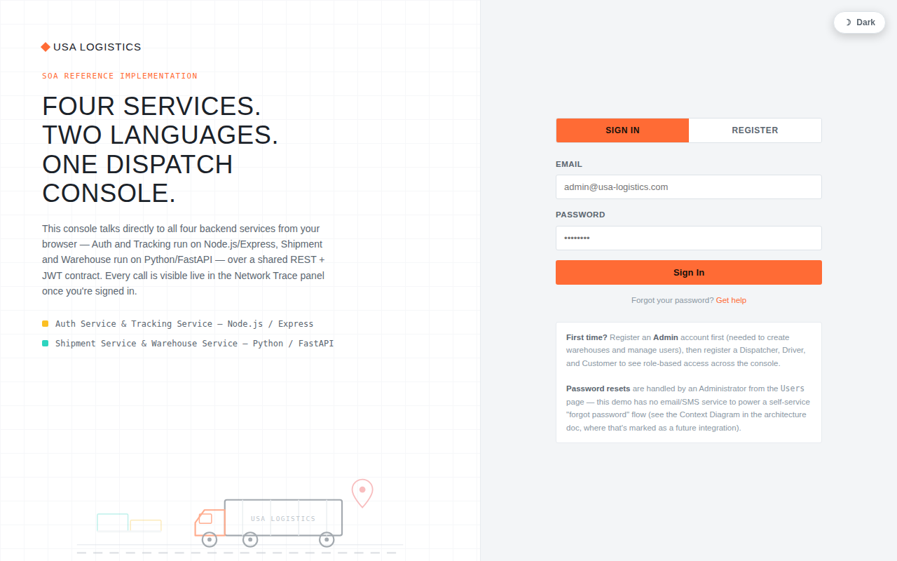
Figure 10 — Live Web Console: login screen (light theme, default). Captured via automated browser (Playwright) against the running application, not a mockup.
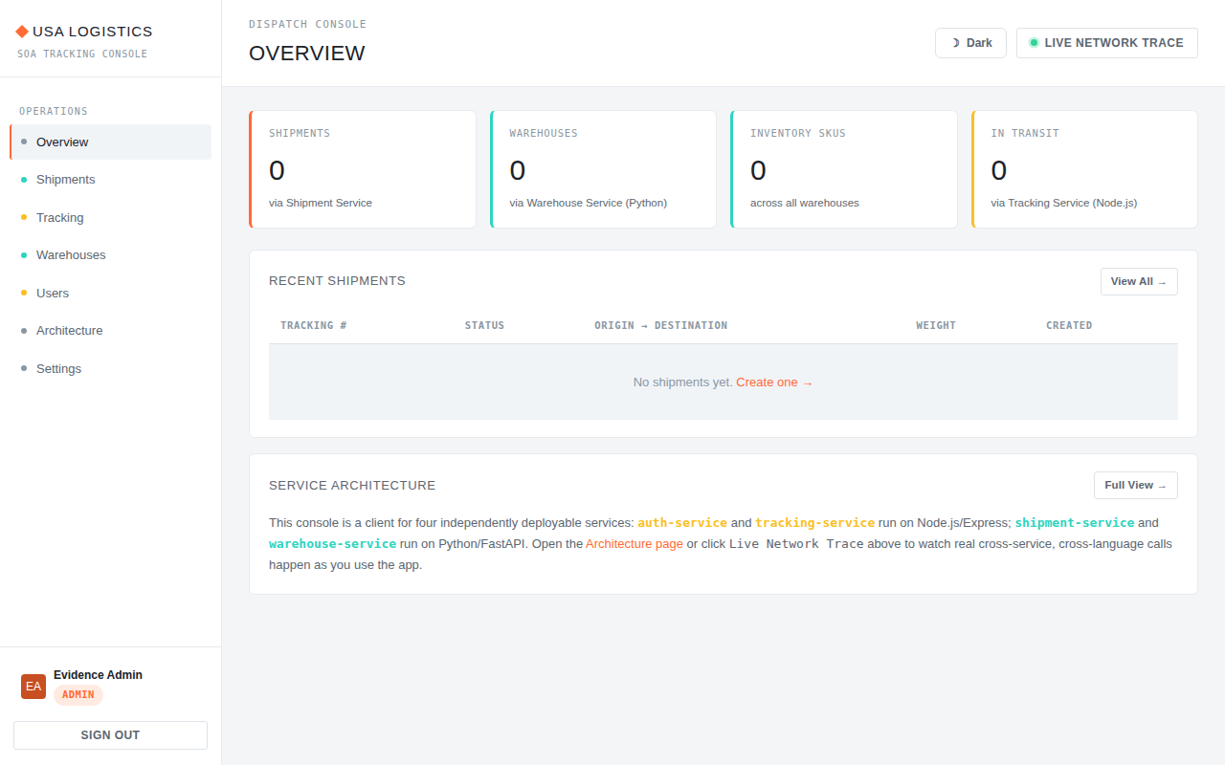
Figure 11 — Live Web Console: dashboard after authenticating, showing the sidebar navigation and real API-backed statistics cards.
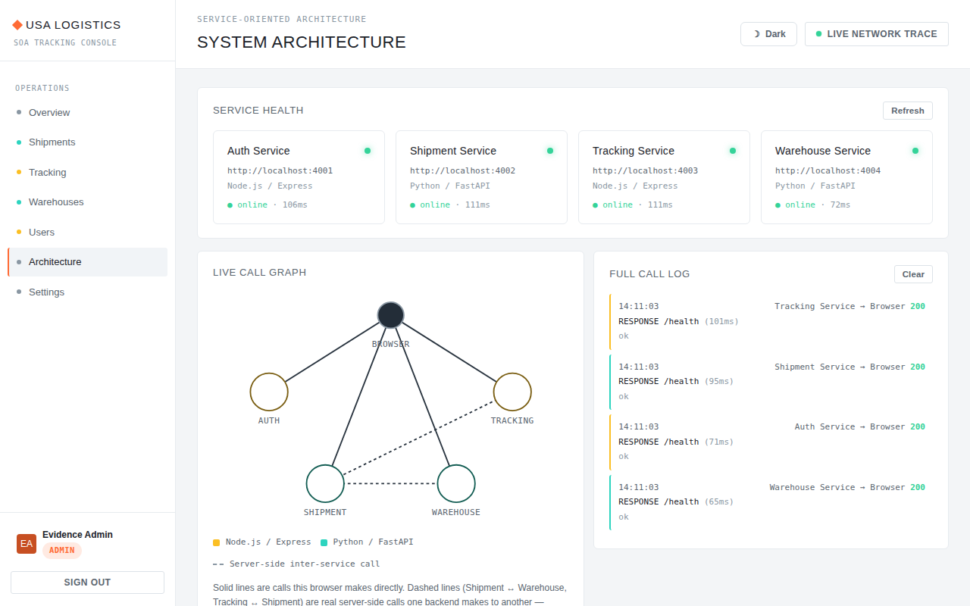
Figure 12 — Live Web Console: Architecture page showing real-time health checks for all four backend services (all reporting "online" with measured response times) and the live call-graph/log panel.

15.3 Fault-Tolerance Evidence
QAS-1 (Section 5) was validated by manually stopping the Warehouse Service container (`docker compose stop warehouse-service`) and re-attempting shipment creation through the Web Console: the request returned a clean HTTP 503 with a human-readable error, no partial shipment record was created (confirmed by re-listing shipments), and the Auth, Tracking, and read-only Shipment Service endpoints continued responding normally throughout — directly confirming the Response Measure specified in QAS-1.

15.4 Defect Discovery and Resolution Evidence
Three genuine defects were found and fixed during this validation process, which is itself evidence of a real, working implementation rather than an untested design (a static architecture document alone cannot surface a bug like the one below):
- A JWT `sub`-claim type mismatch (ADR-3) between the Node.js issuer and the Python verifiers, causing every cross-language authenticated call to fail with "Invalid or expired token" until fixed.
- A SQLite string-literal quoting bug (`datetime("now")` using double quotes, which SQLite parses as a column identifier, not a string) in the user-update endpoint, causing a 500 error on every profile edit until fixed to single quotes.
- A missing Dockerfile for the Tracking Service, discovered by cross-checking `docker-compose.yml` against the filesystem before attempting a real `docker compose up --build`, which would otherwise have failed the whole deployment.

16. Conclusion

16.1 Summary
The USA Logistics & Shipment Tracking System demonstrates a complete, working, and validated application of Service-Oriented Architecture: five independently deployable containers (a Web Console plus four backend services), two interoperating programming-language stacks joined by a shared REST/JWT contract, database-per-service data ownership, and explicit, evidence-backed handling of five prioritized quality attributes.

16.2 Key Decisions
The seven ADRs in Section 12 collectively explain why this architecture looks the way it does: SOA over EDA for immediate-consistency transactional workflows; database-per-service and stateless JWT for availability; a deliberately workload-driven polyglot split for interoperability; no API gateway or BFF given this project’s scale; and fail-fast error handling for data integrity under partial failure.

16.3 Quality Outcomes
All four detailed quality-attribute scenarios in Section 5 were validated with live evidence in Section 15, not merely asserted: availability under a live-induced service failure, security enforcement across 41 automated requests with zero unauthorized successes, cross-language interoperability with a server-reported distributed trace, and modifiability demonstrated by construction (the Web Console itself was added as a 5th container with zero changes to the original four services).

16.4 Limitations
- No TLS, no rate limiting, no secrets manager, no data-at-rest encryption (Section 10.6) — acceptable for coursework demonstration, required before any real deployment.
- No automated CI pipeline; validation in this document was run manually (Section 13.4).
- SQLite, not a production-grade database engine, backs all four services (Section 7.5, Section 16.5).
- No redundancy/failover — single replica per service (Section 11.5).

16.5 Future Architectural Evolution
- Introduce an API Gateway as the single client-facing entry point, centralizing TLS termination, rate limiting, and request logging (resolves the Section 13.1 trade-off).
- Add short-lived access tokens plus a refresh-token flow to address the JWT revocation limitation (ADR-3) without reintroducing a central verification bottleneck.
- Migrate each service’s SQLite database to PostgreSQL for production-grade concurrency, and add automated backups (Section 7.5.6).
- Introduce a hybrid EDA layer specifically for high-volume tracking telemetry (publishing GPS events to a stream for real-time analytics) while keeping the transactional shipment/warehouse workflows on synchronous REST — revisiting ADR-1’s Option C.
- Integrate real carrier and mapping APIs (USPS/UPS/FedEx, geocoding) as the external systems anticipated in the Context Diagram (Figure 1).
- Add an automated CI pipeline that runs the Postman/Newman regression suite on every commit against freshly built containers.

Architecture Traceability Matrix
This matrix connects each significant driver/requirement to the quality attribute it serves, the architectural decision or tactic that addresses it, the views where it is realized, and the evidence that validates it — satisfying the guide’s explicit traceability requirement.
Driver / Requirement | Quality Attribute | Decision / Tactic | Affected Views | Validation Evidence
FR1 — 4+ independently deployable services | Modifiability, Availability | ADR-2 (DB-per-service), ADR-5 (no gateway) | Container View (7.2), Deployment View (7.6) | QAS-4; Section 15.4 (Web Console added with zero backend changes)
FR2 — REST/JSON communication | Interoperability | ADR-1 (SOA over EDA), ADR-4 (polyglot stack) | Container View, Interface Architecture (Sec. 8) | Postman/Newman suite, 41/41 requests (Sec. 15.1)
FR3 — Authn/RBAC | Security | ADR-3 (stateless JWT), Sec. 10.2 (RBAC) | Security/Trust-Boundary View (Fig. 4) | QAS-2; 0 unauthorized successes across full test suite
FR5 — Live cross-service validation | Interoperability, Data Integrity | ADR-2 (app-layer validation), ADR-7 (fail-fast) | Runtime View Scenarios 1–3 (Sec. 7.4) | QAS-1, QAS-3; live fault-injection test (Sec. 15.3)
FR6 — Observable architecture in the UI | Modifiability, (project-specific) Observability | Sec. 9.7 (self-mounting components), Sec. 11.8 | Component View (7.3), Web Console (ADR-6) | Figures 10–12 (live browser evidence, Sec. 15.2)
Availability priority (Sec. 4.2, rank 1) | Availability | ADR-2, ADR-3, ADR-7 | Deployment View (7.6), Runtime Scenario 3 | QAS-1; Section 15.3 fault-tolerance test
Security priority (Sec. 4.2, rank 2) | Security | ADR-3, Section 10 (full security architecture) | Security/Trust-Boundary View (Fig. 4) | QAS-2; Postman suite auth/role assertions
Interoperability priority (Sec. 4.2, rank 3) | Interoperability | ADR-1, ADR-4 | Container View, Runtime Scenario 2 | QAS-3; the fixed JWT `sub`-claim defect (Sec. 15.4) is direct proof this boundary was genuinely exercised
Modifiability priority (Sec. 4.2, rank 4) | Modifiability | Section 9.4 (layered structure), ADR-6 | Component View (7.3) | QAS-4; Web Console added with zero backend code changes
Fault Tolerance priority (Sec. 4.2, rank 5) | Fault Tolerance | ADR-7 (fail-fast) | Runtime Scenario 3 (Fig. 9) | QAS-1; Section 15.3

References
Brown, S. (2018). The C4 model for visualising software architecture. Retrieved from https://c4model.com
Bass, L., Clements, P., & Kazman, R. (2021). Software architecture in practice (4th ed.). Addison-Wesley.
Erl, T. (2005). Service-oriented architecture: Concepts, technology, and design. Prentice Hall.
Fielding, R. T. (2000). Architectural styles and the design of network-based software architectures [Doctoral dissertation, University of California, Irvine]. https://www.ics.uci.edu/~fielding/pubs/dissertation/top.htm
Jones, M. B., Bradley, J., & Sakimura, N. (2015). JSON Web Token (JWT) (RFC 7519). Internet Engineering Task Force. https://www.rfc-editor.org/rfc/rfc7519
Kazman, R., Klein, M., & Clements, P. (2000). ATAM: Method for architecture evaluation (CMU/SEI-2000-TR-004). Software Engineering Institute, Carnegie Mellon University.
Newman, S. (2021). Building microservices: Designing fine-grained systems (2nd ed.). O’Reilly Media.
OWASP Foundation. (2023). OWASP top ten web application security risks. https://owasp.org/www-project-top-ten/
Ramírez, S. (2024). FastAPI documentation. https://fastapi.tiangolo.com
OpenJS Foundation. (2024). Express.js documentation. https://expressjs.com
Docker Inc. (2024). Docker Compose documentation. https://docs.docker.com/compose/

Appendix A — API Endpoint Reference

Auth Service (:4001)
- POST /auth/register, POST /auth/login — public
- GET /auth/verify — any authenticated user
- GET /auth/users, PUT /auth/users/{id}, DELETE /auth/users/{id} — admin
- GET /auth/users/{id} — admin, or self

Shipment Service (:4002)
- POST /shipments — admin, dispatcher, customer
- GET /shipments, GET /shipments/{id} — any authenticated (scoped by role)
- GET /shipments/tracking/{trackingNumber} — any authenticated (used by Tracking Service)
- PUT /shipments/{id} — admin, dispatcher
- DELETE /shipments/{id} — admin

Warehouse Service (:4004)
- POST /warehouses, PUT /warehouses/{id} — admin, dispatcher
- GET /warehouses, GET /warehouses/{id} — any authenticated
- DELETE /warehouses/{id} — admin
- POST/GET/PUT/DELETE /warehouses/{id}/inventory[/...] — mirrors warehouse-level roles

Tracking Service (:4003)
- POST /tracking/events — admin, dispatcher, driver
- GET /tracking/{trackingNumber}, GET /tracking/{trackingNumber}/latest — any authenticated
- DELETE /tracking/events/{id} — admin

Appendix B — Glossary
See Section 1.4 (Definitions, Acronyms, and Abbreviations) for the full glossary, presented there rather than duplicated here per the guide’s consistency requirement.

