

**Department of Electronics and Computer Engineering**

**Project Topic: IoT Based Real-time Sleep Apnea screening system.**

**Group Members: Abdur Rab Dhruba 1712441642**

**Kazi Nabiul Alam 1711217042**

**Shakib Khan 1711661042**

**Supervisor:**

**DR. MOHAMMAD MONIRUJJAMAN KHAN**

**Associate Professor at North South University,**

**PhD, Electrical and Electronic Engineering,**

**Queen Mary  University of London, UK**

**B.Eng., Electrical and Electronic Engineering,**

**Queen Mary, University of London, UK.**

**Submission Date: 27.04.21**

**Background Study & Problem Statement:**

Sleep Apnea is a disorder which is parallely connected to our respiratory system and our brain. It indicates the problem in breathing and respiration obstacles during sleep. There are two kinds of Sleep Apnea: Obstructive Sleep Apnea (OSA) & Central Sleep Apnea (CSA), sometimes they both takes place at a same time, that can be said as Complex Sleep Apnea but it’s too rare to be called as apnea type. Obstructive Sleep Apnea (OSA) is basically upper airway congestion. It occurs due to relaxation of our throat muscle and lack of Oxygen passing through our nasal-throat passage that causes irritation in breathing and sometimes results in serious complications [1]. Central Sleep Apnea is less popular but more alarming than OSA. Our brain is the key maintenance center of our whole body, as every organ and system runs by its directed signal or instruction, and their Central Sleep Apnea comes into a major exposure. Central Sleep Apnea occurs when our brain fails to send the necessary instructions or signals to the system which controls our breathing and respiration. Here, neurons fail to transmit signals to our breathing muscle, which pauses our breath for a good amount of time, maybe near 10 seconds [2].

And in rare cases, they both can take place which is more than an emergency medical treatment issue and alarming also.

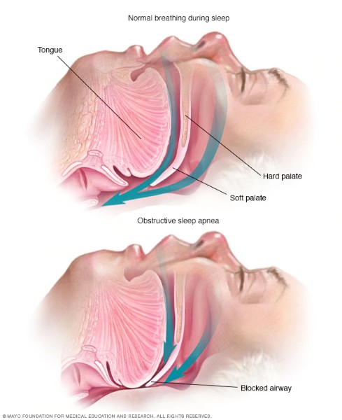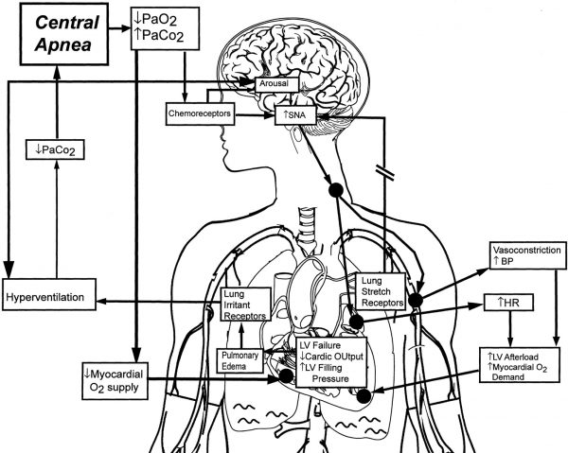

Fig. 1. Central Sleep Apnea [1] Fig. 2. Central Sleep Apnea [3]

Now, we will discuss why we’re that much concerned about sleep apnea issues and what it causes to us. Medical and Clinical researches are going on regarding this issue and some alarming scenarios are keeping us alert. Sleep Apnea is reliable for developing so many physical complexities and diseases such as: strokes, hypertension, cardiac abnormality, depression and so on [4]. According to research, around 3 to 7% of the Male and 2% to 5% of the Female are suffering from sleep apnea that sum up approximately more than 100 million people in the world including adolescents. Interestingly, 80% of Apnea cases remain undiagnosed. Children of around 1 to 4% at age between 2 to 8 suffer from sleep apnea (OSA mostly) and 20% of them snores. It varies in different parameters, like who is affected, who is not [5] [6]. Some complications or risk factors related to this problem identifying process are: excessive weight or obesity, being men (2-3 times higher risk), alcohol consumption, smoking, family history, neck circumference, nasal congestion, medical conditions like high blood pressure, type-2 diabetes, lung or other respiratory diseases etc. Diseases like Parkinson’s, after stroke patients are at risk of suffering from Central sleep Apnea. Sleep Apnea can cause a good amount of health complications and death in the very worst case. Loud snoring, Fatigue, Drowsiness, Weakness in the body, lack of concentration, these are the common symptoms. Heart diseases like: High Blood pressure due to lack of sleep and of oxygen level and it may be a risk of Heart Attack also. Apnea patients are at 3 times higher risk of Stroke. Lung can be affected even more dangerously, SpO2 level reduces and lung disability due to lack of oxygen is a very common but alarming issue of this apnea. 43% of people suffering from mild sleep apnea got ‘Hypertension’. Research says, 15% of traffic accidents happen for this apnea problem and cost around 1k lives in the US. Over 38k people in USA, die every year due to direct and indirect effects of sleep apnea, mostly affected by cardiovascular complexities regarding [7]. So, this is a matter of awareness as it’s not being focused yet or got that much exposure but we’ll try to identify it with ease with our research so that people don’t remain undiagnosed and can have a comfortable life with no life risk.

**Existing system review, our proposed solution & their objectives:**

In our research, we will monitor the parameters of Sleep Apnea on a real time basis. The very basic parameters of health which is related to the sleep apnea includes: AHI (Apnea-Hypopnea Index), Heart Rate (BPM), Blood Oxygen Saturation (SpO2), Body Mass Index (BMI), Sleeping time, REM, Blood Glucose, Age, Blood Cholesterol and many more [8]. In different researches, we saw such parameters are covered on the basis of medical research. In most cases, they come up with a study of medical data of a particular or group of patients and they analyzed the results. Devices are mostly used: Polysismography (PSG), Electrocardiogram (ECG) and some clinical devices like this. These devices are too costly to bear for personal use.

There we found more technical research based on sleep apnea. In [9], wearable e-textile sensors used an IoT approach implemented to get sleeping habit & respiratory rate in real time data. Same concept used in [10] as they use signals of breathing collected from the sensor based mattress which are generally being used in operation theatres. Polyvinylidene Fluoride (PVDF) sensor used with Polysomnography (PSG) device to measure time-to-time AHI data [11]. Researchers used the ‘Peripheral Arterial Tonometry’ (PAT) method to detect sleep apnea perfectly. They developed the WatchPAT device that records the pulse wave on a finger and derives sleep and sleep apnea features [12]. In [13], a 3D camera was being used to check the movement of abdominal muscles which they compared with the OSA detection process. Sound detection method used in [14] where sound of very sharp frequency precisely breathe level frequency can be measured. Besides, so much research took place with the analysis of real-time ECG monitoring and pre-reserved ECG data. Machine Learning techniques were implemented. In [15] an IoT device was built that extracts ECG data from the user and will evaluate the result from the classification model (SVM) based system, which they named ‘Apnea MedAssist Service’. In [15], [16], [17], [18] researchers implemented Machine Learning and Deep Learning techniques to detect apnea from the medical data.

From earlier research, we can observe that researchers try to measure real time parameters of Sleep Apnea which they analyze afterwards. But we hardly saw all the parameters of Sleep Apnea like: SpO2, Heart Rate, AHI, Sleep time or such important parameters being measured at a time. Particularly they measured data and analyzed them with advanced tools. In our research, we will monitor the parameters of Sleep Apnea on a real time basis and will try to monitor the values of these as efficiently as possible with diverse parameters. Our goal is to measure the maximum of these values like: SpO2, Heart Rate, ECG, Skin response, sound and such parameters at a time. Besides, in earlier research, these values were measured overnight and then they got the data, but we want to make it lively like, if any complications arise, someone concerned may be notified via IoT device. As example, if ‘Oxygen Saturation’ falls this is a severe medical emergency, and with our device attendant or doctor or concerned personnel get instant notification of this individual patient. Due to sleep apnea, people may have stroke, may have cardiac arrest, may have heart failure or such complications. Our main motive behind that idea is to reduce such risks, as it may occur death. And another motivation is that, regular apnea screening devices are too costly to afford, mostly used in medical institutes for medical conditions or research purposes, but we made our system/ device cost effective so that general people can buy this and screen their apnea issues staying home and no need to rely on costly clinical monitoring. And yeah, saving lives, is our ultimate goal.

**Output of the project or expected results of the project**

This project is still ongoing by our team. We are now in the staring phase of the project. But when working for the project we can predict the result or the expected result of the project. Sleeping disorders could be dangerous for a person’s life. We need to monitor the factors of body during sleep. And there is some expected output for healthy persons and a person with sleep apnea.

As we are monitoring several indexes we need to know the expected result of those indexes.

* Heart Rate: When we sleep, it is expected to be at the low end of normal, or even below; for example, a healthy, fit person can have a heart rate of 50-60 bpm while sleeping. But heart rate of a person with sleep disorders is less than a healthy person’s heart rate.
* SpO2: Normal Oxygen saturation level (SpO2) is 94%-95% and 91%-96% is a healthy oxygen saturation level. But during sleep apnea the rate could be drop to below 90%.
* ECG: The ECG value changes significantly during sleep apnea, but for healthy person the change is lesser.

**Working steps (Work plan)**

**• Planning about the project.**

The idea of the project is generated to monitor a person’s sleeping disorders more specifically sleep apnea so that we can decrease the rate of death during sleep. At first we design the problem and made the layout of the system. After that we need to plan about the possible input sensors and the embedded system by which we will convert the analog signal from the sensors.

**• Buying equipment**

After generating the idea for the project. Next thing we need to do is to buy the hardware equipment for the project that include the Arduino Uno as the microcontroller .The sensors including the Heartrate pulse sensor, AD8232 ECG sensor, Max 30100 Finger Oximeter Heart Rate Module: SPO2, Pulse sensor, Galvanic Skin Response (GSR) Sensor, PIR motion sensor and Sound sensor to monitor the snoring sound of the patient during sleep, buzzer to buzz when any unusual thing happens and other necessity parts including breadboard, jumper wires, resistors and LEDs.

**• Design Process**

After getting our desired sensors, our main task is to design the circuit diagram. To do

that we need to use Circuito.io. These application will be used to design our project.

**• Arduino Setting**

When we completed the deigning of our project, next thing we need to do is to code for

the Arduino using Arduino IDE. That code will be uploaded in the Arduino Uno. To

complete the code of the project we need to look at the all pins of the Arduino and also

the pins of the sensors .

**• Hardware part**

When we completed the deigning of our project, next thing we need to do is to connect

all the hardware parts and upload the Arduino code into Arduino Uno using Arduino Ide .

We need to connect all the sensors Bluetooth module with the Arduino to connect the system with the mobile.

**• Connecting Hardware part with Mobile and Data Analysis**

The final step of our project is to connect the Hardware part of the project with mobile

application. To use that we need to use a mobile application which will be made by us.

In this step we will analyses the sensor data using Machine Learning Technique to clarify exact problem of the person.

**Major Milestones:**

* Problem designing and proposal.
* Finding all equipment.
* Circuit Design with the equipment.
* Buying the equipment.
* Arduino Code.
* Hardware Setup.
* Completion Hardware part.
* Testing only hardware part.
* Connecting With the Mobile.
* Data Analysis.
* Testing full project
* Report Writing.
* Journal Writing.

**Research Methodology:**

**Methods:**

This section discusses the methods, components and paths that are used to fulfill the goal. The aim of the system is to monitor the state of body of a patient during the sleep by measuring various factors. This microcontroller based sleep apnea monitoring system for sleeping disorder patient is combined with three different layers. . The main layer is a microcontroller unit which connects the input layer and the output layer. In the input layer it is combined with four different sensors which will provide the analog signal to Arduino to measure the different index of the condition of the body during the sleep. The output layer is combined with two parts including the l monitor of the microcontroller and a mobile application to display the digital data converted by the microcontroller.

**Outline of system:**

A block diagram showing the full system in Figure 1. The system consists of input, output and a microcontroller board Arduino UNO showing in Figure 2. The Arduino board which is also connected with the output layer combined with the serial monitor of the Arduino Board and a MIT App Inventor based mobile application connected with a Bluetooth module to show the converted digital data to the viewer. A Buzzer is connected with the Arduino UNO. The buzzer will active when it get any unusual signals. The figure given below describing the full block diagram.

Sound Sensor

Arduino UNO

Mobile Application

Arduino Monitor

GSR Sensor

MAX30100

ECG Sensor

PIR Motion Sensor

**Materials:**

The system is integrated with different kinds of components that are doing different tasks in the system. Some are for the input, some are for the output and some are used in the system to create a bridge between the inputs and outputs.

**Arduino UNO:**

The main component of the system is the Arduino UNO REV3 based on VR Microcontroller Atmega328 with 2KB SRAM, 32KB of flash memory in which 13KB is used to store the instructions set in the form of code. And it has 1KB of EEPROM.

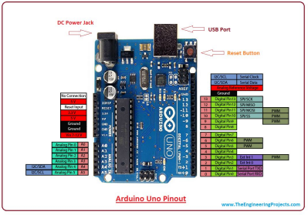 Figure : Arduino UNO pinout

This Arduino board is combined with a total of 30 pins in which 14 digital pins and 6 analog pins allow external connection with the board. The six analog pins marked as A0 to A5 are used to get the analog data from the external devices like analog sensors. There are several I/O digital and analog pins placed on the board which operates at 5V. These pins come with standard operating ratings ranging between 20mA to 40mA. 5V voltage can be supplied by the USB connected with an external device or with the DC power jack which can give voltage from 7V to 20V. Serial communication is carried out through two pins called Pin 0 (Rx) and Pin 1 (Tx). Rx pin is used to receive data while Tx pin is used to transmit data. Others I/O can be workable for serial communication. Arduino UNO is a programmable microcontroller with the ability to interface with other sensors or computers. Serial monitor of the Arduino IDE software used to send or receive text data from the board. It is used to display the output data from the Arduino board.

**Sensors:**

There is several sensors to monitor the person’s condition during the sleep. To monitor and analyses sleep apnea we will use few sensors that will fulfill our goals. We will use Heartrate pulse sensor, AD8232 ECG sensor, Max 30100 Finger Oximeter Heart Rate Module: SPO2, Pulse sensor, Galvanic Skin Response (GSR) Sensor, PIR motion sensor and Sound sensor to monitor the snoring sound of the patient during sleep. These six sensors will monitors the person during the sleep and will provide analog data to the Arduino UNO.

**Heartrate pulse sensor:**

This line shows the number of times your heart beats per minute; also known as your heart rate. Normally, a healthy person’s heart rate ranges anywhere from 60-100 beats per minute (bpm); this varies based on the medications you are on, how much you are moving at a given time, and what type of cardiovascular shape you are in (athletes and very fit people have lower heart rates). When we sleep, it is expected to be at the low end of normal, or even below; for example, a healthy, fit person can have a heart rate of 50-60 bpm while sleeping.

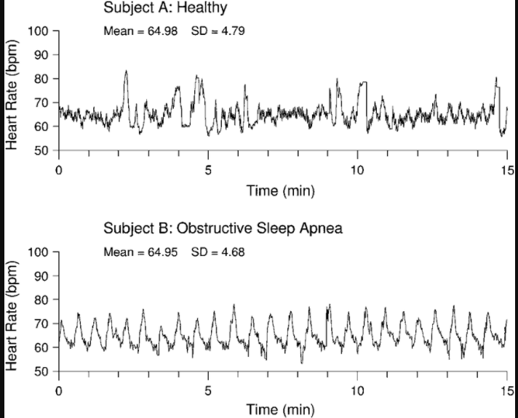

Figure[20] : Heart Rate during sleep.

When a person stop breathing, the heart rate also tends to drop the longer the body is deprived of oxygen. Then, involuntary reflexes cause the person to startle awake at the end of that period of not breathing. When this occurs, the heart rate tends to accelerate quickly and the blood pressure rises.

These are changes that take place acutely when someone stop breathing. However, the body starts to experience chronic effects if someone experience frequent apnea. Data suggests increased risk, particularly when a person stop breathing roughly 30 times or more per hour. But there is likely a risk at even lower frequency rates.

To measure the heart rate the system will contain a heart rate sensor to constantly monitor the person’s heart condition. This is an analog sensor, the sensing part of the sensor will be connected with the body of person. That will pass the analog signal to the Arduino via several wires. The figure given below is the heart pulse sensor [21].

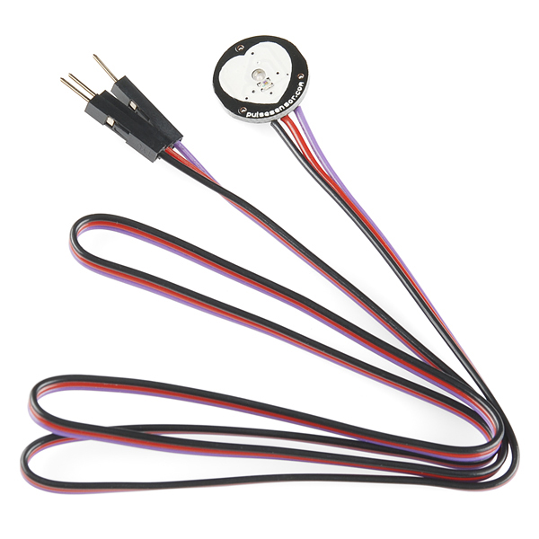

Figure: Heart Pulse Sensor.

The Pulse Sensor Amped is a plug-and-play heart-rate sensor for Arduino. It essentially combines a simple optical heart rate sensor with amplification and noise cancellation circuitry making it fast and easy to get reliable pulse readings. Also, it sips power with just 4mA current draw at 5V so it's great for mobile applications.

**AD8232 ECG sensor:**

An ECG (electrocardiogram) records the electrical activity of a person’s heart at rest. It provides information about heart rate and rhythm, and shows if there is enlargement of the heart due to high blood pressure (hypertension) or evidence of a previous heart attack (myocardial infarction). However, it does not show whether someone have asymptomatic blockages in his heart arteries or predict his risk of a future heart attack. The resting ECG is different from stress or exercise ECG or cardiac imaging test. The figure [22] given below will show the ECG values during sleep.

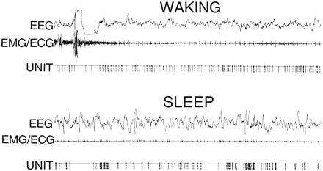

Figure: ECG values during sleep and waking.

To measure someone ECG, the system will contains an AD8232 ECG[23] analog sensor. That sensor will be connected with the body and pass analog signal to the Arduino to convert the signal into digital signal.

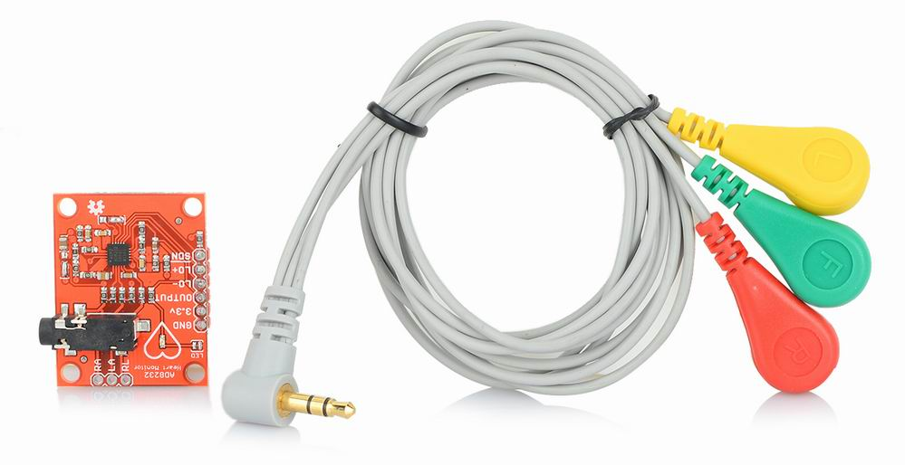

Figure: AD8232 ECG Sensor.

**AD8232 ECG Module** integrated with **AD8232**IC from **Analog Devices**, which is a single-chip designed to extract, amplify, and filter bio-potential signals for bio-potential measurement applications (like ECG and others). ECGs can be extremely noisy so that the AD8232 Single Lead Heart Rate Monitor acts as an op-amp to help obtain a clear signal from the PR and QT Intervals easily.

**Max 30100 Finger Oximeter Heart Rate Module: SPO2:**

Blood oxygen level is the amount of oxygen circulating in the blood. Most of the oxygen is carried by red blood cells, which collect oxygen from the lungs and deliver it to all parts of the body.

The body closely monitors blood oxygen levels to keep them within a specific range, so that there is enough oxygen for the needs of every cell in the body. A person’s blood oxygen level is an indicator of how well the body distributes oxygen from the lungs to the cells, and it can be important for people’s health. A normal blood oxygen level varies between [75 and 100 millimeters of mercury (mm Hg)](https://lunginstitute.com/blog/blood-oxygen-level-oxygen-level-normal/).

A blood oxygen level [below 60 mm Hg](https://lunginstitute.com/blog/blood-oxygen-level-oxygen-level-normal/) is considered low and may require oxygen supplementation, depending on a doctor’s decision and the individual case.

When blood oxygen level is too low compared to the average level of a healthy person, it can be a sign of a condition known as hypoxemia. This means that the body has difficulty delivering oxygen to all of its cells, tissues, and organs. A normal blood oxygen level should be between 94% to 98%. As a result of not breathing for 30 seconds or more during sleep, a person’s sleep apnea oxygen level would drop to 80% or less.

A normal level of oxygen is usually 95% or higher. Some people with chronic lung disease or sleep apnea can have normal levels around 90%. The “SpO2” reading on a pulse oximeter shows the percentage of oxygen in someone’s blood.

SpO2, also known as oxygen saturation, is a measure of the amount of oxygen-carrying hemoglobin in the blood relative to the amount of hemoglobin not carrying oxygen. The body needs there to be a certain level of oxygen in the blood or it will not function as efficiently. In fact, very low levels of SpO2 can result in very serious symptoms. This condition is known as hypoxemia. The figure[24] given below will show the change of Oxygen Saturation during sleep.

.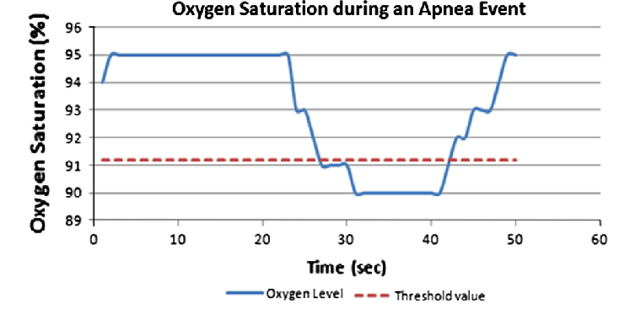

**Figure: Change of SpO2 during sleep apnea.**

Tomeasure the blood oxygen level and Oxygen Saturation (SpO2) the system will contain a sensor based pulse oximeter. MAX30100[25] sensor will be used in the system as the pulse oximeter. It is an integrated pulse Oximetry and heartrate monitor sensor solution. It combines two LEDs, a photodetector, optimized optics, and low-noise analog signal processing to detect pulse Oximetry and heart-rate signals.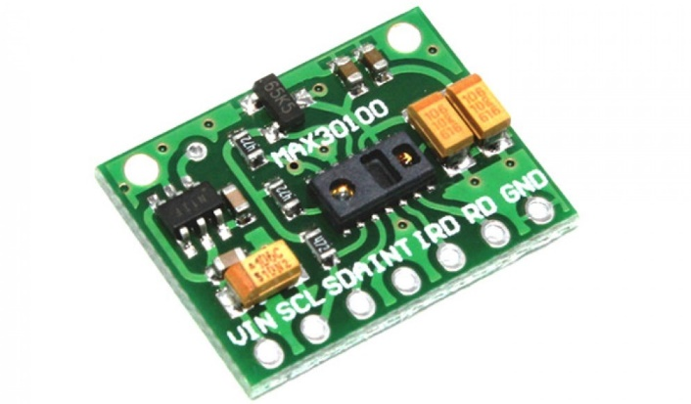

**Figure: Max30100 SpO2 sensor.**

The SpO2 subsystem in the MAX30100 is composed of ambient light cancellation (ALC), 16-bit sigma delta ADC, and proprietary discrete time filter. The figure[25] give below is showing the system block diagram of MX30100.

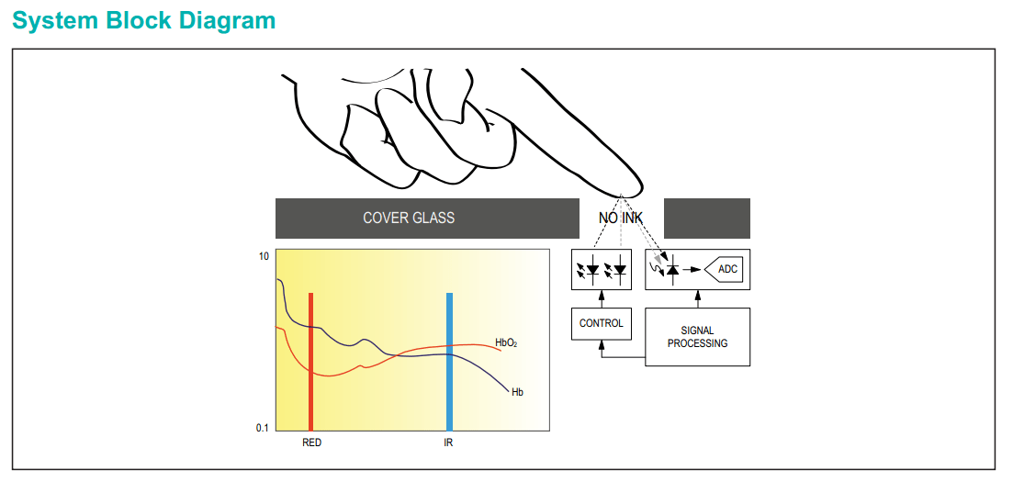

Figure: System block diagram of MAX30100.

The SpO2  ADC is a continuous time oversampling sigma delta converter with up to 16-bit resolution. The ADC out-put data rate can be programmed from 50Hz to 1kHz. The MAX30100 includes a proprietary discrete time filter to reject 50Hz/60Hz interference and low-frequency residual ambient noise.

**Galvanic Skin Response (GSR) Sensor:**

The galvanic skin response (GSR, which falls under the umbrella term of electro dermal activity[26], or EDA) refers to changes in sweat gland activity that are reflective of the intensity of our emotional state, otherwise known as emotional arousal. Galvanic Skin Response originates from the autonomic activation of sweat glands in the skin. The sweating on hands and feet is triggered by emotional stimulation: Whenever we are emotionally aroused, the GSR data shows distinctive patterns that are visible with bare eyes and that can be quantified statistically.

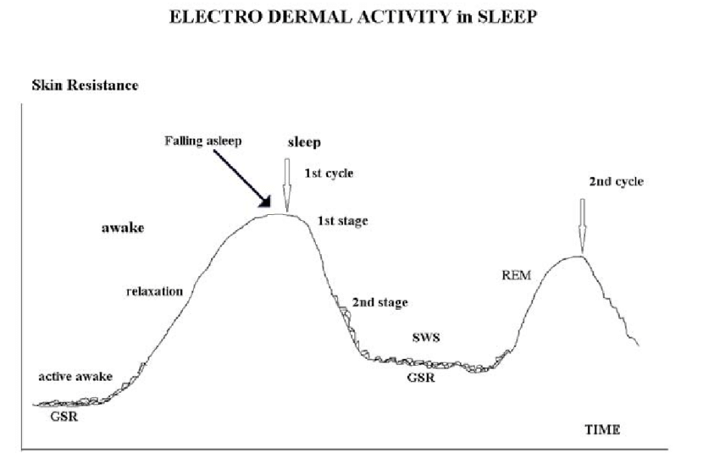

Figure: Electro Dermal Activity in Sleep.

To measure the galvanic skin response during sleep and monitor sleep apnea the system will contains an analog sensor. Galvanic Skin Response (GSR) sensor[27] allows the system to measure sweat gland activity, which is related to emotional arousal. To measure GSR, the system will take advantage of the electrical properties of the skin. Specifically, how the skin resistance varies with sweat gland activity, i.e. the greater sweat gland activity, the more perspiration, and thus, less skin resistance. The most common measure of a GSR signal is not resistance, but conductance. Conductance is the opposite of resistance and is measured in Siemens (Conductance = 1 / Resistance). The conductance makes the signal interpretation easier, since the greater the sweat gland activity, the higher the skin conductance.

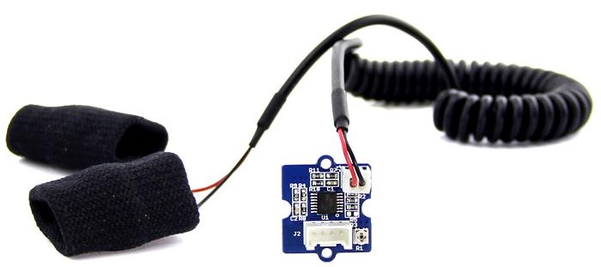

Figure: Galvanic Skin Response(GSR) sensor.

Grove - GSR allows you to spot such strong emotions by simple attaching two electrodes to two fingers on one hand. Strong emotions cause the stimulus that is transmitted to the sympathetic nervous system causing increased secretion of sweat through the sweat glands so it changes the electrical resistance of the skin depending on its moisture. Sensors of this type are used in psychophysiology, they reflect the stress response, experienced emotions, and activity level. It is powered with the voltage of 5 V.

**PIR motion sensor:**

Monitoring the body motion of the person’s during sleep is very important to monitor sleep apnea. PIR sensors[28] allows the system to sense motion, almost always used to detect whether a human has moved in or out of the sensors range. They are small, inexpensive, low-power, easy to use and don't wear out. For that reason they are commonly found in appliances and gadgets used in homes or businesses. They are often referred to as PIR, "Passive Infrared", "Pyroelectric", or "IR motion" sensors.

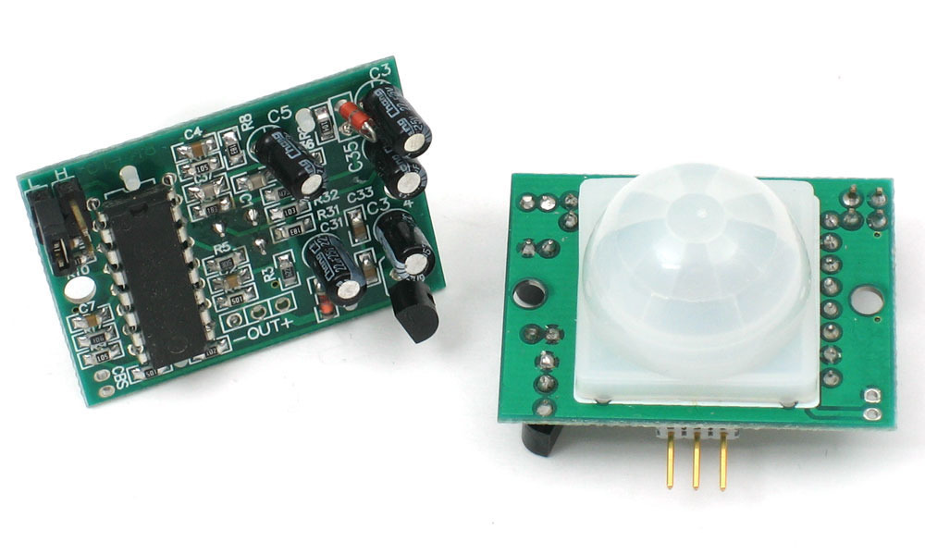

Figure: PIR Sensor

PIRs are basically made of a pyroelectric sensor (which you can see below as the round metal can with a rectangular crystal in the center), which can detect levels of infrared radiation. Everything emits some low level radiation, and the hotter something is, the more radiation is emitted. The sensor in a motion detector is actually split in two halves. The reason for that is that we are looking to detect motion (change) not average IR levels. The two halves are wired up so that they cancel each other out. If one half sees more or less IR radiation than the other, the output will swing high or low.

**Sound Sensor:**

Snoring is the hoarse or harsh sound that occurs when air flows past relaxed tissues in your throat, causing the tissues to vibrate as you breathe. Nearly everyone snores now and then, but for some people it can be a chronic problem. Sometimes it may also indicate a serious health condition. In addition, snoring can be a nuisance to your partner.

Snoring is often associated with a sleep disorder called obstructive sleep apnea (OSA).

OSA-associated snoring is more worrisome from a health perspective. If OSA goes without treatment, it can have major implications for a person’s sleep and overall health. Unchecked OSA is associated with dangerous daytime drowsiness, and serious health conditions including cardiovascular issues, high blood pressure, diabetes, stroke, and depression.

To measure the intensity of the snoring the system will contains an analog Sound Sensor[29] that will measure the snoring sound to determine the snoring during sleep.

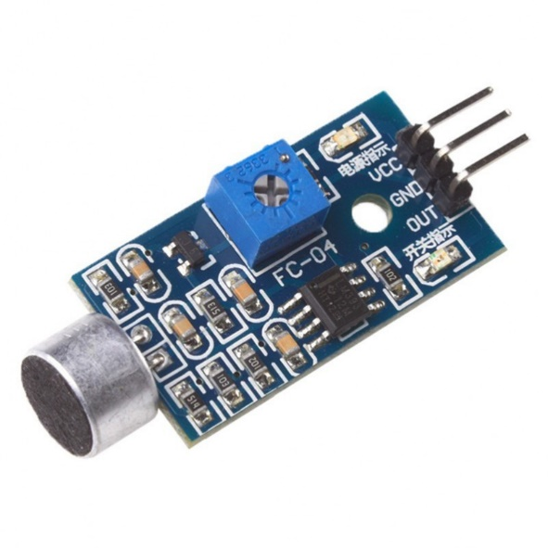

Figure: Sound Sensor.

The sound sensor is a small board that combines a microphone (50Hz-10kHz) and some processing circuitry to convert sound waves into electrical signals.

This electrical signal is fed to on-board LM393 High Precision Comparator to digitize it and is made available at OUT pin.

**Explanation of the functioning of the complete system, and all subsystems:**

**Input Part:**

The input subsystem of the system is basically the analog sensors. Which will connected with the body of the person directly or indirectly. Those sensors will pass data to another subsystem to convert it. The figure given below will show the Input subsystem of the project.

Heart Rate Sensor

AD8232(ECG)

Arduino UNO

MAX30100

GSR Sensor

PIR Motion Sensor

Sound Sensor

Figure: Input Subsystem

**Processing Subsystem:**

This part is the main block of the system. Arduino UNO is the processing subsystem of the system which is connected with the input subsystem to get analog data and with the output subsystem to provide digital data.

Arduino UNO

Output Subsystem

Input Subsystem

Figure: Processing Subsystem.

**Output Subsystem:**

This subsystem is consist with different output layer. Mobile application and a data collector for data analysis is connected with the Arduino Uno via a Bluetooth/Wi-Fi module to collect digital data from the Arduino.

000000

Arduino UNO

Mobile Application

Database/ Data collector

Figure: Output subsystem.

**Diagrams drawn using software showing the layout of the systems:**

Circuit diagram with all six sensors and Arduino Uno is designed using circuito.io[30] an online IoT design platform. The circuit diagram of the system is given below:

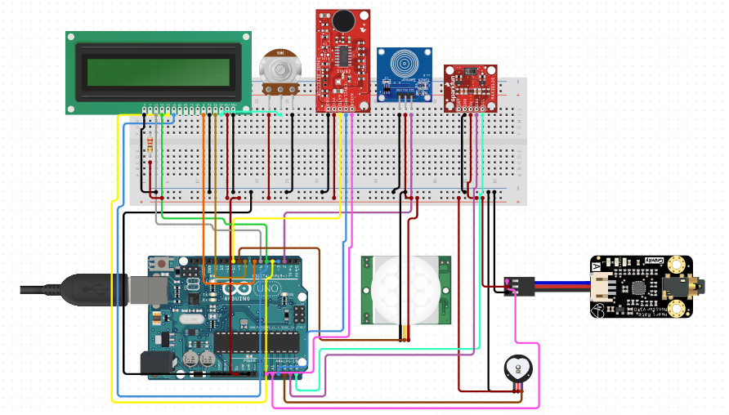

Figure: Circuit Diagram of the full system.

**Diagrams drawn using MS Word or MS Visio showing flow chart for processing.**

The flowchart given below is the flow chart of the system.

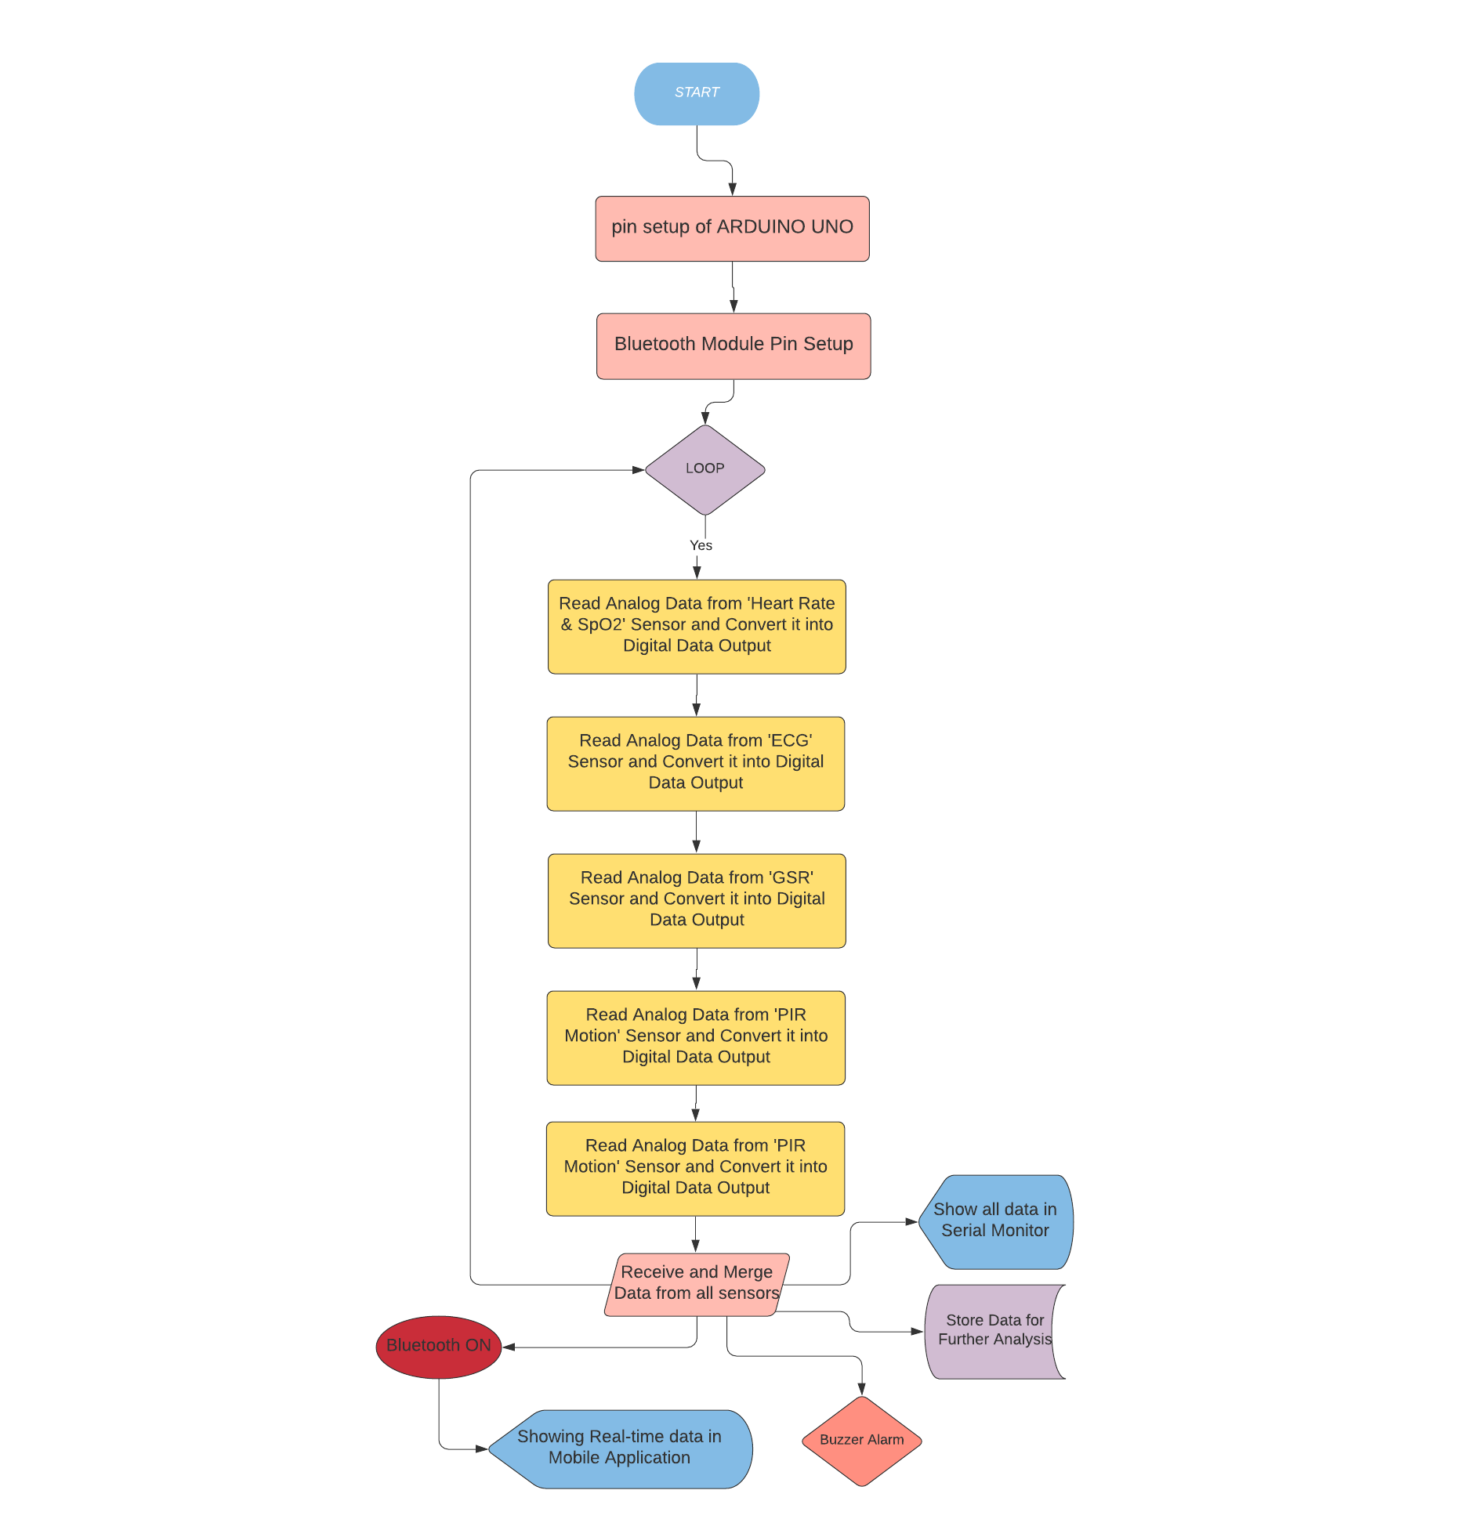

Figure: Flow-Chart of full system.

**Bill of materials required to build the circuit or software system, and the**

**approximate cost (procurement and budget).**

|  |  |  |
| --- | --- | --- |
| Name of Components | Units | Cost |
| 1. Arduino Uno | 1 | 400 Taka |
| 1. Heart rate Sensor | 1 | 300 Taka |
| 1. AD8232 ECG Sensor | 1 | 950 Taka |
| 1. MAX30100 | 1 | 850 Taka |
| 1. PIR Motion Sensor | 1 | 90Taka |
| 1. Sound Sensor | 1 | 150 Taka |
| 1. GSR Sensor | 1 | 1200 Taka |
| 1. Buzzer | 2 | 30 Taka |
| 1. Breadboard | 1 | 90 Taka |
| 1. Jumper Wires | 1 Box | 130 Taka |
| Total = |  | 4190 Taka |

Our component cost is around 4200 taka. But the cost may varied because of improvisation of the project.

MS Project charts including Gantt Charts showing the expected timeline of

Progress or milestones.

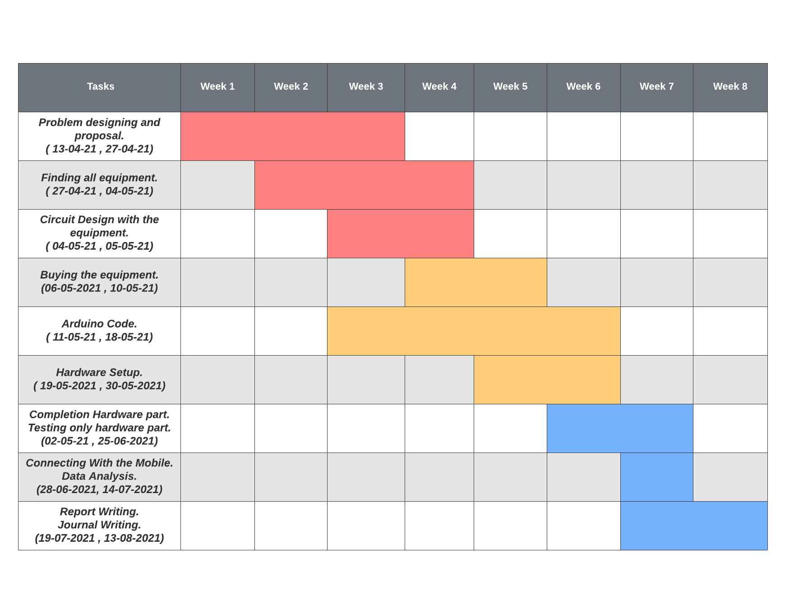

Figure: Gantt chart of timeline of the project.

**Required software tools. Detailed description. What tools and why?**

• Arduino Ide: To load the code to the Arduino Uno to analyze the input data.

• Circuito.io: to simulate the project.

• MS Exel: For the Gantt Charts and Graphs

• MIT App inventor for mobile application.

**Target Population (Users of your system). Detailed description.**

* Our target population for this project is male, obese people of any age, age >25, people with physical complications like Hypertension, Blood glucose, after stroke patients, and so on.

**What makes the solution an ‘innovation’ (Description of innovative and creative aspects)**

In most researches, ECG data and other data used to measure or monitor Sleep Apnea. Mostly were under medical observation in a clinical environment. But our device will help patients to get even better output staying at home and with ease to use. Real  time data will give instant updates about apnea indexes so that patient can take precautionary steps. And for senior citizens and physical/mental disabled, our device is an added benefit at it sends notification data to patient’s concern so that s/he can take care if any difficulties occur at any time.

**How the project will become sustainable? Explain:**

Nowadays sleeping disorder rate are higher than before. More people are suffering from hypertension, stress related problem and heart related problem which occurring those sleep apnea. Our system will be very much sustainable to monitor the sleep apnea and detect specifically the duration of sleep apnea. That system can sustain in higher level. It not can detect sleep apnea but also can inform the patient to discuss with the doctor with data taken from the system. Which can make the life of patient easier. And the project can sustain in future if we add higher technology like high level X-rays and other monitoring system.

**Is there any possibility to scale up the project? Please explain:**

* Yes, there are a lot of ways to scale up this project. One of the approaches I like to discuss is to make a fully automated IOT device where it monitors real-time a person during his sleep when something wrong finds the device and sends a notification to the doctor or any person who can respond to the situation.

**Is there any opportunity of income generation from the project? Please explain:**

* Yes we can generate income from this project. If we can make fully automated devices and risk free devices so that we can sell it to the market with lost cost.

**Do you need financial support for future extension? Please explain:**

* We may need financial support as these sensors and systems are costly, moreover, the clinical environment it needs to sleep apnea detection, is more complex and costly for high level research.

**How will people be benefitted from the project? Explain:**

* By detecting your sleep apnea, it can reduce your risk of heart disease. Sleep apnea is linked to a variety of heart problems because it causes you to stop breathing many times each night. These breathing pauses cause changes in your blood pressure and can reduce your blood oxygen levels. This puts an enormous strain on your heart. Using this device we can give an alert if anything is wrong with your heart rate.[31]
* StrokeCan reduce your risk of stroke, one of the leading causes of death and long-term disability. A stroke is a sudden loss in brain function. It occurs when there is a blockage or rupture in one of the blood vessels leading to the brain. People with untreated sleep apnea are two to four times more likely to have a stroke.
* DiabetesTo treat your sleep apnea can improve insulin sensitivity. Sleep apnea is related to glucose intolerance and insulin resistance, both factors in type 2 diabetes. Untreated sleep apnea increases your risk of getting type 2 diabetes.
* Emotional Stability  
  Untreated sleep apnea increases your risk of depression. Reducing your risk of depression and improving your overall quality of life.

**What are the risks? How the risks will be managed?:**

* Sleep apnea can cause a lot  of risk to human health. Sometimes it causes death. It can cause a heart attack, stop breathing while people are snoring. Also it can cause the stroke as well. So by detecting Sleep apnea we can reduce the risk of people Health [31]. On the other hand the device we create for detecting the sleep apnea has some risks. There are no health risks of using our device. But there may occur some hardware or system bug in this screening process.  Risks like the wire we used may be disconnected from the devices. Sometimes the sensor may stop working with the movement of the patient. Sometimes the data we extract can't come out as predicted values due to external factors like room temperature , humidity, and other factors. Here, we will try to make our device as compacted and as accessible as possible.

**What is the relevance of poverty?**

* Our project may not remove poverty from the society but it can make the health monitoring system much more  cost effective.

**What is the value for money?**

* Devices used in Sleep Apnea screening in the market are much more costly and hard to find onn regular basis [32]. But we’ll try to make our device more gettable, patients as well as normal people can access our device easily, because every single price of the system (sensors, microcontroller, data extraction and so on ) that we kept in mind, and tried to make it as simple and as cheap as possible.

**Unprivileged women and people will benefit?**

* Yes, all of the people benefit from this device. People like old , young can use this device and maintain good health. Also when a woman is pregnant she might be snoring while she sleeps this causes a problem to her health [33]. Using this device, pregnant women can benefit as well.

Disabled will benefit?

* Yes the disabled people will benefit from this project. We have a special feature that, when any alarming data comes during real-time screening, a buzzer will buzz and patient attendants will be notified immediately. So, the physically or mentally disabled will be benefited as they can use this with ease and they shouldn’t have to worry about.

**What is the positive impact on the environment, social, economic, design?**

* Our device has a positive impact on the environment. It is fully environmentally friendly. It has a huge positive impact on society and the economy It helps people to live a good life by giving an alarm about your sleep condition. Introducing this device to the market can contribute to increasing the economy of our county. And the design of the device is very user friendly. People can easily use this device.

**References:**

[1] “Sleep apnea - Symptoms and causes”, 2021. *Mayo Clinic*. [Online] Available at: https://www.mayoclinic.org/diseases-conditions/sleep-apnea/symptoms-causes/syc-2037763

[Accessed: 26 April 2021]

[2] T. Kasai, “Sleep apnea and heart failure”, in *Journal of Cardiology*, vol. 60, no.2, pp.78-85, 2012.

[3] .” ARE YOU SUFFERING FROM ANY OF THESE KINDS OF SLEEP APNEA?”. [Online]. *Asonor*. Available: https://www.asonor.com/blog/are-you-suffering-from-any-of-these-kinds-of-sleep-apnea [Accessed: 26 April 2021].

[4] J. Jin and E. Sánchez-Sinencio, "A Home Sleep Apnea Screening Device With Time-Domain Signal Processing and Autonomous Scoring Capability," in *Proc.* *IEEE Transactions on Biomedical Circuits and Systems*, vol. 9, no. 1, pp. 96-104, Feb. 2015.

[5] A. Malhotra and D. P. White, “Obstructive sleep apnea,” *Lancet*, vol.

360, no. 9328, pp. 237–245, Jul. 2002.

[6] Jesse Crow, 2016. “Sleep Apnea Statistics” [Online]. *Restright Mattress*. Available at: https://restrightmattress.com/sleep-apnea-statistics [Accessed: 26 April 2021].

[7] Mira Rakicevic, “31 Important Sleep Apnea Statistics You Should Know in 2021”. [Online] *Disturbmenot!.* Available: https://disturbmenot.co/sleep-apnea-statistics [Accessed 26 April 2021]

[8] R. Boneberg, A. Pardun, L. Hannemann, O. Hildebrandt, U. Koehler, R. Kinscherf, and W. Hildebrandt, “High Plasma Cystine Levels Are Associated with Blood Pressure and Reversed by CPAP in Patients with Obstructive Sleep Apnea,” in *Journal of Clinical Medicine*, vol. 10, no. 7, p. 1387, Mar. 2021.

[9] G. Cay and K. Mankodiya, "SleepSmart: Smart Mattress Integrated with e-Textiles and IoT Functions for Sleep Apnea Management," in *Proc. 2020 IEEE International Conference on Pervasive Computing and Communications Workshops (PerCom Workshops)*, 2020.

[10] I. Sadek, E. Seet, J. Biswas, B. Abdulrazak and M. Mokhtari, "Nonintrusive Vital Signs Monitoring for Sleep Apnea Patients: A Preliminary Study," in *IEEE Access*, vol. 6, pp. 2506-2514, 2018.

[11] S. H. Hwang et al., "Unconstrained Sleep Apnea Monitoring Using Polyvinylidene Fluoride Film-Based Sensor," in *IEEE Transactions on Biomedical Engineering*, vol. 61, no. 7, pp. 2125-2134, July 2014.

[12] T. Penzel, M. Glos, I. Fietze, S. Herberger and G. Pillar, "Distinguish Obstructive and Central Sleep Apnea by Portable Peripheral Arterial Tonometry*," in *Proc. 2020 42nd Annual International Conference of the IEEE Engineering in Medicine & Biology Society (EMBC)*, 2020.

[13] D. Falie and M. Ichim, "Sleep monitoring and sleep apnea event detection using a 3D camera," in *Proc. 2010 8th International Conference on Communications*, 2010.

[14] E. Dafna, A. Tarasiuk and Y. Zigel, "Sleep-quality assessment from full night audio recordings of sleep apnea patients," in *Proc. 2012 Annual International Conference of the IEEE Engineering in Medicine and Biology Society,* pp. 3660-3663, 2012.

[15] Gouveia, C., Qureshi, H., Kern, R., Liu, S. and Capasso, R., “An assessment of online information related to surgical obstructive sleep apnea treatment”, in *Sleep Science and Practice*, vol. 1, no.1, pp 1-6, 2017.

[16] L. Cen, Z. L. Yu, T. Kluge and W. Ser, "Automatic System for Obstructive Sleep Apnea Events Detection Using Convolutional Neural Network," in Proc. *2018 40th Annual International Conference of the IEEE Engineering in Medicine and Biology Society (EMBC)*, pp. 3975-3978, 2018.

[17] L. Almazaydeh, K. Elleithy and M. Faezipour, "Obstructive sleep apnea detection using SVM-based classification of ECG signal features," in *Proc. 2012 Annual International Conference of the IEEE Engineering in Medicine and Biology Society*, pp. 4938-4941, 2012.

[18] J. P. Kirkness et al., "Developing quantitative physiological phenotypes of sleep apnea for epidemiological studies," in *Proc. 2011 Annual International Conference of the IEEE Engineering in Medicine and Biology Society*, pp. 8319-8322, 2011.

[19] https://components101.com/microcontrollers/arduino-uno

[20] https://www.researchgate.net/profile/Ary-Goldberger-2/publication/6867323/figure/fig3/AS:667799139655687@1536227130176/Original-raw-heart-rate-time-series-from-the-two-subjects-one-healthy-one-during.pbm

[21] https://www.sparkfun.com/products/11574

[22] https://www.jneurosci.org/content/16/10/3500/tab-figures-data

[23] https://techmaharaja.com/wp-content/uploads/2019/11/imagetech.png

[24]https://www.researchgate.net/publication/263965784_Classifying_Obstructive_Sleep_Apnea_Using_Smartphones/figures?lo=1

[25]https://www.electroniclinic.com/max30100-pulse-oximeter-arduino-code-circuit-and-programming/

[26]https://www.researchgate.net/publication/320487158_The_Phenomenon_of_Weak_Unawakening_afferent_Signals_Involvement_in_Synchronization_Mechanisms_of_Neuron_activity_during_delta_Sleep-Unawakening_afferent_Signals_Involvement_in_Synchronization_Mechanis/figures?lo=1

[27] https://wiki.seeedstudio.com/Grove-GSR_Sensor/

[28] https://learn.adafruit.com/pir-passive-infrared-proximity-motion-sensor

[29]https://store.roboticsbd.com/robotics-parts/291-sound-sensor-module-sound-detection-robotics-bangladesh.html

[30] https://www.circuito.io/app?components=512,1331,11021,11574,93712,133979,220687,931983

[31] A. V. Benjafield, N. T Ayas, P. R Eastwood, R. Heinzer, M. S. M. Ip, M. J. Morrell, C. M. Nunez, S. R. Patel, T. Penzel, J.-L. D. Pépin, P. E. Peppard, S. Sinha, S. Tufik, K. Valentine, A. Malhotra, “Estimation of the global prevalence and burden of obstructive sleep apnoea: a literature-based analysis,” in *Lancet Respir. Med*., vol. 7, pp. 687-698, Aug. 2019.

[32] N. Collop, S. L. Tracy, V. Kapur, R. Mehra, D. Kuhlmann, S. A. Fleishman, J. M. Ojile, “Obstructive sleep apnea devices for out-of- center (OOC) testing: technology evaluation,” J. Clin. Sleep Med., vol. 7, pp. 531–548, 2011.

[33] S. Yalamanchali S, V. Farajian, C. Hamilton, T. R. Pott, C. G. Samuelson, M. Friedman, “Diagnosis of obstructive sleep apnea by peripheral arterial tonometry meta-analysis,” JAMA Otolaryngol. Head Neck Surg., vol. 139, pp. 1343-1350, 2013.