Design and Numerical Optimization of a Hybrid PCF-SPR Biosensor with an Explainable GAN-Transformer Framework for Cancer Cell Detection

1. Background

1.1 Introduction to the Subject Area
Photonic crystal fiber-based surface plasmon resonance (PCF-SPR) sensors have attracted considerable research interest because they combine the flexible optical properties of photonic crystal fibers (PCFs) with the sensitivity of surface plasmon resonance (SPR). PCFs contain carefully arranged air holes that enable the control of light propagation and optical mode confinement. When a plasmonic material, such as gold (Au), is incorporated into an appropriate sensor structure, the interactions between the guided optical mode and surface plasmon polaritons can produce resonance features that respond to changes in the refractive index of the surrounding analyte.
PCF-SPR sensors are being investigated for biomedical sensing, including cancer-related applications, because they offer potential advantages such as label-free optical interrogation and sensitivity to changes in analyte properties. However, refractive-index-based sensing alone does not establish the specific biological identity of cancer cells; reliable diagnostic applications require appropriate biological validation.

1.2 Current Research in the Field
Recent research has explored D-shaped PCF-SPR structures, open microchannels, hybrid plasmonic coatings, and numerical optimization to improve resonance characteristics and refractive-index sensing performance. Gold and titanium dioxide (TiO₂) have also been investigated in PCF-SPR configurations. In parallel, machine learning and deep learning methods have been applied to predict optical characteristics, reduce computational demands, and support sensor optimization.
Explainable artificial intelligence (XAI) has been further investigated as a means of interpreting model predictions and identifying influential sensor parameters. Recent studies have demonstrated that PCF-SPR optimization, AI-assisted optical analysis, and cancer-related refractive-index sensing are established research areas. Consequently, a new study must establish its contribution through specific design improvements, a
justified AI methodology, or rigorous comparative evaluation rather than through the combination of familiar components alone.

1.3 Identification of the Research Gap
Although previous studies have investigated several PCF-SPR geometries, plasmonic coatings, and AI-assisted analysis methods, the proposed hybrid configuration requires further investigation to determine whether it provides measurable advantages over the suitable reference designs. The proposed structure combines an upper D-shaped polished surface, an open microchannel, and a lower bowtie-shaped region with separately defined Au–TiO₂ coatings.
The first potential research gap concerns the optical behavior and sensing performance of this configuration. Its influence on mode coupling, resonance characteristics, and refractive index sensitivity must be established through systematic numerical analysis and comparison with appropriate reference geometries.
The second potential research gap concerns the reliability and interpretability of AI-based analysis of simulated plasmonic responses. A GAN-assisted Transformer framework with XAI could be investigated to determine whether synthetic-data augmentation improves predictive performance and whether the model's decisions can be explained through informative spectral features. However, the existence of a specific gap in this exact model combination must be verified through a more comprehensive literature search.

1.4 How the Proposed Work Addresses the Gap
This study proposes to investigate a hybrid PCF-SPR sensor using COMSOL Multiphysics and the finite element method (FEM). The geometric and coating parameters will be varied systematically to characterize the optical mode behavior, resonance response, and refractive-index sensing performance. The optimized configuration will be compared with an appropriate reference sensor to determine whether the proposed geometry offers measurable improvements.
A simulation-derived dataset will subsequently be used to evaluate a GAN-assisted transformer framework. Suitable baseline models will be included to determine whether GAN-based data augmentation provides a meaningful performance improvement. XAI techniques will be applied to investigate the spectral features and parameters that influence model predictions.
The initial study will establish numerical sensing performance and evaluate the feasibility of interpretable AI-based analysis. Claims concerning the identification of specific cancer cell types will depend on the availability of scientifically justified labels and independently validated biological data. However, experimental validation is required before the clinical diagnostic performance can be established.

2. Aim and Objectives

2.1 Research Aim
The aim of this study is to design and numerically investigate a hybrid D-shaped photonic crystal fiber-based surface plasmon resonance (PCF-SPR) biosensor using COMSOL Multiphysics to analyze the optical responses associated with different cancer-cell-related refractive indices. The study will optimize the sensor's structural and material parameters, including the air-hole diameter and the thicknesses of gold (Au) and titanium dioxide (TiO₂) coatings. Furthermore, a GAN-assisted transformer framework integrated with Explainable Artificial Intelligence (XAI) will be developed using simulation-generated optical data to investigate RI-associated spectral patterns, improve predictive performance, and identify the most influential optical features. The study will be limited to numerical simulation and computational analysis without physical sensor fabrication or experimental cancer-cell testing.

2.2 Research Objectives
The specific objectives of this research are:
1. To design a hybrid PCF-SPR sensor incorporating an upper D-shaped polished surface, a middle open microchannel, and a lower bow-tie-shaped region using COMSOL Multiphysics.
2. To investigate the effects of different cancer-cell-associated refractive indices on the effective refractive index, confinement loss, and surface plasmon resonance characteristics of the proposed sensor.
3. To analyze the influence of air-hole diameter and Au and TiO₂ coating thicknesses on the optical performance of the sensor.
4. To optimize the structural and material parameters to achieve improved wavelength sensitivity, amplitude sensitivity, figure of merit (FOM), and refractive index resolution.
5. To generate a structured optical dataset from COMSOL simulations under different geometrical, material, and analyte refractive-index conditions.
6. To develop a GAN-assisted Transformer framework for analyzing simulation-generated optical data and investigating RI-associated spectral patterns.
7. To integrate Explainable Artificial Intelligence (XAI) techniques to identify influential optical features and interpret the predictions of the proposed AI framework.
8. To evaluate the proposed AI framework against suitable machine learning and deep learning baseline models using appropriate performance metrics and data-validation strategies.
9. To compare the proposed sensor with an appropriate reference design to evaluate its numerical sensing performance and potential advantages.

3. Research Questions
This study aims to address the following research questions:

3.1 Sensor Design and Optical Performance
Q1. How does the proposed hybrid D-shaped, open-microchannel, and bow-tie PCF-SPR geometry influence optical mode coupling and surface plasmon resonance characteristics?
Q2. How do the Au and TiO₂ coating thicknesses in the microchannel and bow-tie regions affect resonance characteristics and sensing performance?
Q3. How does the air-hole diameter influence the modal characteristics and resonance behavior?
Q4. How does the sensor respond to changes in analyte refractive index, and what wavelength sensitivity, amplitude sensitivity, figure of merit and resolution can be achieved?
Q5. Does the optimized geometry provide measurable advantages over an appropriate reference sensor?

3.2 AI-Based Analysis and Explainability
Q6. How can Explainable AI (XAI) techniques be integrated with a GAN-Transformer framework to provide interpretable and trustworthy cancer cell detection decisions?
Q7. How can GAN-assisted Transformer models improve the accuracy and reliability of plasmonic biosensor-based cancer cell detection?
Q8. How does the proposed Explainable GAN-Transformer-based plasmonic biosensor compare with state-of-the-art biosensing and AI-based cancer detection methods in terms of accuracy, precision, recall, and explainability?
Q9. How can the most informative plasmonic biosensor features and patterns be identified for accurate cancer cell detection?

4. Research Methodology
This study will follow a numerical and computational approach consisting of sensor design, finite element method (FEM) simulation, parameter optimization, simulation dataset generation, AI model development, and explainability analysis.

4.1 Proposed Sensor Design and COMSOL Simulation
The proposed hybrid photonic crystal fiber-based surface plasmon resonance (PCF-SPR) sensor will be designed using COMSOL Multiphysics. The structure will incorporate an upper D-shaped polished surface, a middle open microchannel, and a lower bow-tie-shaped region. Gold (Au) and titanium dioxide (TiO₂) coatings will be assigned to the designated sensing regions to investigate their effects on plasmonic coupling.
The finite element method (FEM) will be used to investigate the electromagnetic field distribution, effective refractive index, confinement loss, and resonance characteristics. Suitable boundary conditions and perfectly matched layers (PMLs) will be applied. Mesh convergence analysis will be performed to assess numerical reliability.

4.2 Cancer-Cell-Associated Analyte Simulation
Different cancer-cell-associated refractive-index (RI) values or ranges will be collected from published scientific literature. These may represent breast, cervical, lung, and colon cancer-associated analytes, together with normal-cell reference values where reliable data are available.
The analyte refractive index will be varied systematically in the sensing region, and the corresponding resonance wavelengths and optical loss spectra will be obtained from COMSOL simulations.

4.3 Parameter Optimization and Performance Evaluation
A parametric study will be conducted by varying the air-hole diameter, Au coating thickness, TiO₂ coating thickness, and other relevant geometrical parameters. The sensor performance will be evaluated using wavelength sensitivity, amplitude sensitivity, figure of merit (FOM), and refractive-index resolution. The optimized configuration will be selected based on a suitable combination of sensing performance and compared with an appropriate reference design.

4.4 Simulation Dataset Generation
A structured dataset will be generated by exporting the optical responses obtained from COMSOL simulations under different analyte refractive indices and sensor configurations. The dataset will include relevant spectral features, resonance wavelengths, confinement loss, and corresponding sensing parameters. The dataset will be preprocessed and divided into training, validation, and independent testing subsets to prevent data leakage during AI model development.

4.5 GAN-Assisted Transformer Development
A Generative Adversarial Network (GAN) will be investigated to generate additional synthetic optical-response samples using only the training dataset. The generated samples will be evaluated for statistical and spectral consistency with the original simulation data.
A Transformer-based model will then be developed to learn relationships and patterns in the optical-response data. The GAN-assisted Transformer framework will be investigated for refractive-index prediction and, where reliable reference labels are available, classification of cancer-cell-associated RI patterns. Its performance will be compared with suitable machine learning and deep learning baseline models.

4.6 Explainable AI and Model Evaluation
Explainable Artificial Intelligence (XAI) techniques will be applied to interpret the model's predictions. The analysis will identify influential spectral regions and optical parameters contributing to the model output.
The proposed framework will be evaluated using appropriate metrics, including accuracy, precision, recall, F1-score, and regression error metrics where applicable. The numerical simulation and AI analysis results will be examined to assess the potential of the proposed sensor for cancer-cell-associated refractive-index sensing. The proposed workflow will be:
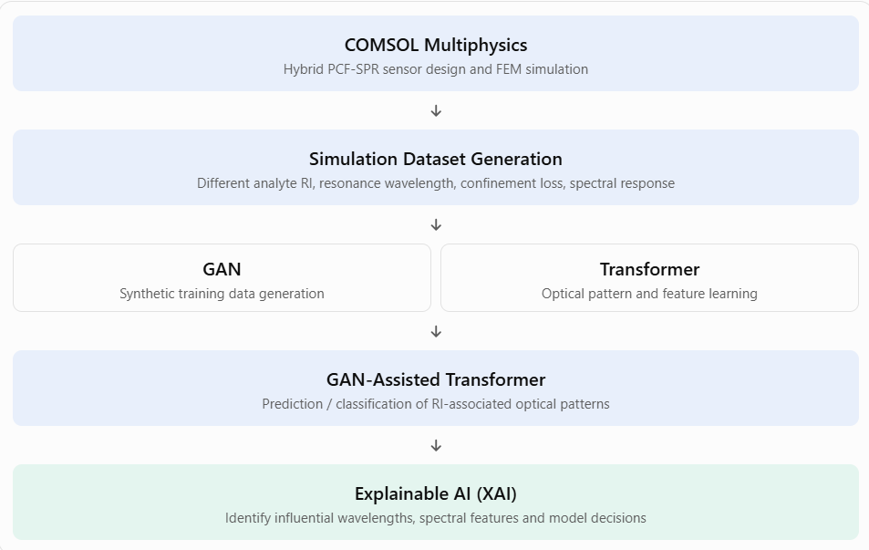

5. Expected Outcomes
The proposed research is expected to produce the following outcomes:

5.1 Anticipated Deliverables
1. A hybrid D-shaped PCF-SPR sensor model incorporating an open microchannel and a bow-tie-shaped region, developed using COMSOL Multiphysics.
2. Numerical characterization of the electromagnetic field distribution, effective refractive index, confinement loss, and surface plasmon resonance behavior of the sensor under different analyte refractive-index conditions.
3. An optimized sensor configuration based on the investigation of air-hole diameter, Au coating thickness, TiO₂ coating thickness, and other relevant geometrical parameters.
4. Quantitative evaluation of wavelength sensitivity, amplitude sensitivity, figure of merit, and refractive-index resolution.
5. A structured simulation-generated optical dataset representing different sensor configurations and cancer cell-associated refractive index conditions.
6. A GAN-assisted Transformer framework for analyzing simulated optical responses, supported by quantitative comparison with appropriate baseline models.
7. An XAI-based interpretation of the AI framework to identify influential optical features and spectral patterns.

5.2 Potential Impact on Cancer-Related Sensing Research
This study is expected to provide a numerical framework for investigating the optical responses of PCF-SPR sensors under different cancer cell-associated refractive index conditions. The integration of GAN-assisted Transformer modeling and XAI may offer additional insight into simulation-based optical data analysis and feature interpretation.
These findings may support future research on computationally optimized plasmonic biosensors and AI-assisted optical sensing. However, the outcomes will represent a numerical proof-of-concept and will not establish experimentally validated cancer cell detection or clinical diagnostic capability.

6. Risk and Mitigation Strategies
Several technical and computational challenges may arise in this study. The potential risks and corresponding mitigation strategies are as follows:

6.1 Potential Challenges
1. Numerical convergence and simulation accuracy:
Complex sensor geometries, thin metallic coatings, and electromagnetic field interactions may cause convergence difficulties or numerical inaccuracies in COMSOL simulations.
2. Weak or unclear resonance characteristics:
The proposed sensor geometry may not produce sufficiently strong or distinguishable resonance responses for certain analyte refractive indices.
3. Parameter optimization complexity:
Multiple geometrical and material parameters may interact, increasing the computational cost and complexity of identifying an optimized configuration.
4. Limited simulation dataset:
Generating a sufficiently diverse and representative dataset through numerical simulations may require substantial computational resources and time.
5. Synthetic-data reliability:
GAN-generated samples may not adequately represent the physical and statistical characteristics of the original simulation data, potentially reducing the reliability of the AI framework.
6. AI model overfitting and generalization:
The GAN-assisted Transformer may overfit the available simulation dataset or perform poorly on previously unseen parameter combinations.

7. Limited cancer-cell classification reliability:
Different cancer cell types may have overlapping refractive-index ranges. Consequently, refractive-index-based optical responses alone may not provide sufficient information for reliable cancer-type identification.

6.2 Mitigation Strategies
1. Conduct mesh convergence studies, verify the boundary conditions, and use suitable PML configurations to improve numerical reliability.
2. Perform systematic parameter sweeps to identify suitable resonance conditions and evaluate alternative geometrical configurations, as necessary.
3. Apply a structured optimization strategy by systematically varying important parameters before performing more focused optimization.
4. Use automated simulation workflows, appropriate parameter ranges, and efficient data extraction techniques to manage computational requirements.
5. Evaluate GAN-generated samples against the original training data using statistical and spectral consistency checks. Restrict synthetic-data generation to the training set.
6. Use independent training, validation, and test datasets, together with baseline comparisons and appropriate regularization, to assess generalization.
7. Use literature-supported refractive index ranges and avoid claiming definitive cancer type classification when the available RI information does not provide sufficient class separation.
This study will remain limited to numerical simulations and computational analysis. Experimental validation and physical sensor fabrication are outside the scope of this study.

8. References
1. Ramola, A., Shakya, A. K., Kumar, V., & Bergman, A. (2025). Recent advances in
photonic crystal fiber-based SPR biosensors: Design strategies, plasmonic materials, and applications. Micromachines, 16(7), 747. https://doi.org/10.3390/mi16070747
2. Khatun, M. R., & Islam, M. S. (2025). Design optimization of high-sensitivity PCF-SPR
biosensor using machine learning and explainable AI. PLOS ONE, 20(9), e0330944. https://doi.org/10.1371/journal.pone.0330944
3. Sobur, M. T. R., Hasan, M. M., Khatun, M. R., Mia, M. M., Islam, W., Iqbal, M. S., &
Hossain, M. M. (2025). Machine learning-enhanced SPR-based optical biosensor for cancer cell detection. Optics & Laser Technology, 192, 113796. https://doi.org/10.1016/j.optlastec.2025.113796
4. Liu, Y., Zhao, Z., & Cao, P. (2026). Deep learning-based open-loop PCF-SPR
biosensor for cancer cell detection. Optical Fiber Technology, 100, 104651. https://doi.org/10.1016/j.yofte.2026.104651
5. Khatun, M. R., & Islam, M. S. (2025). Design optimization of high-sensitivity PCF-SPR
biosensor using machine learning and explainable AI. PLOS ONE, 20(9), e0330944. https://doi.org/10.1371/journal.pone.0330944

