Software Requirements Specification

For

University Online News Site

Prepared By

SHAKIL AHMED MUNNA

North East University Bangladesh

**Introduction :**

**NEUB** News site is Online university News site . Here we find all kinds of the information north east university of Bangladesh and also all kind of activity of university like Sports , Entertainment , ICT or Notices etc . It’s really helpful to all kinds of users who visited this site. The full News site is responsible .So we can see this on a mobile phone, tab, and other devices .

This site also image responsibe .

**Purpose :**

The purpose of this news site is to broadcast all news , information, and activity of our university .we are want to share knowledge ,information and help to people who connected in with neub.

**User classes and Characteristics :**

**Educational level :** Users should be comfortable with the English language.

**Experience :** Users should have information all activity of university .

**View :** Full site is responsible so user can see this site easly in mobile and tab .

**References :**

* PHP: - http://www.trainingwithliveproject.com/
* HTML5: - <http://www.w3schools.com/>
* CSS: - <http://www.w3schools.com/>
* JavaScript and JQ : <https://www.youtube.com/user/flashbuilding/>
* Bootstrap :- <http://www.bootstrap.com/>

**User Documentation :**

 The Site will include user manual. The user manual will include product overview, complete configuration of the used software (such as SQL server), technical details, backup procedure and contact information which will include email address. There will be no online help for the product at this moment. The product will be compatible with the Internet Explorer 6.0 or higher. The databases will be created in the MySQL.

**Assumption and dependencies:**

The assumptions are:-

* + 1. The coding should be error free.
    2. The system should be user friendly so that it is easy to use for the users.
    3. The information of all admin must be stored in a database that is accessible by the website .
    4. The system should have more capacity and provide fast access to the database.

The dependencies are:-

1. The specific hardware and software due to which the product will be run.
2. On the basis of listing requirements and specification the project will be develop and run.
3. The end users (admin) should have proper understanding to the product.
4. The system should have the general report store.Any update regarding the document from the Neub site is to be recorded to the database and the data entered should be correct.

**External interface requirements**

**User interfaces :**

* Any one can visit this News site because there is a no login option in user interfaces .
* In the 1st page we find a breaking news which is this hot news of University . All category news available in the main page .
* Menu is bootstrsp responsible . Mobile device it will be work .
* Different category has a different page . so all same category all news available in same page .
* Notices option view in right all pages .

**Web display nav**

**C:\Users\Shakil\Desktop\3.JPG**

**Moblie display nav**

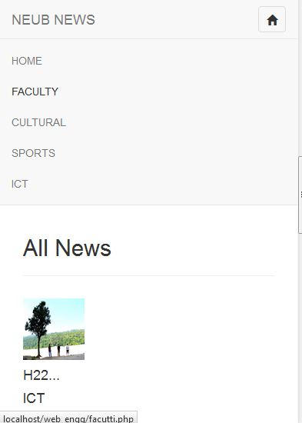

**Main page** 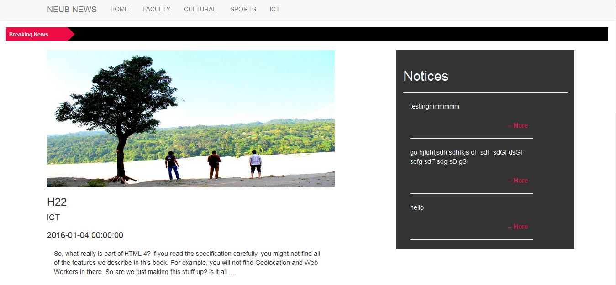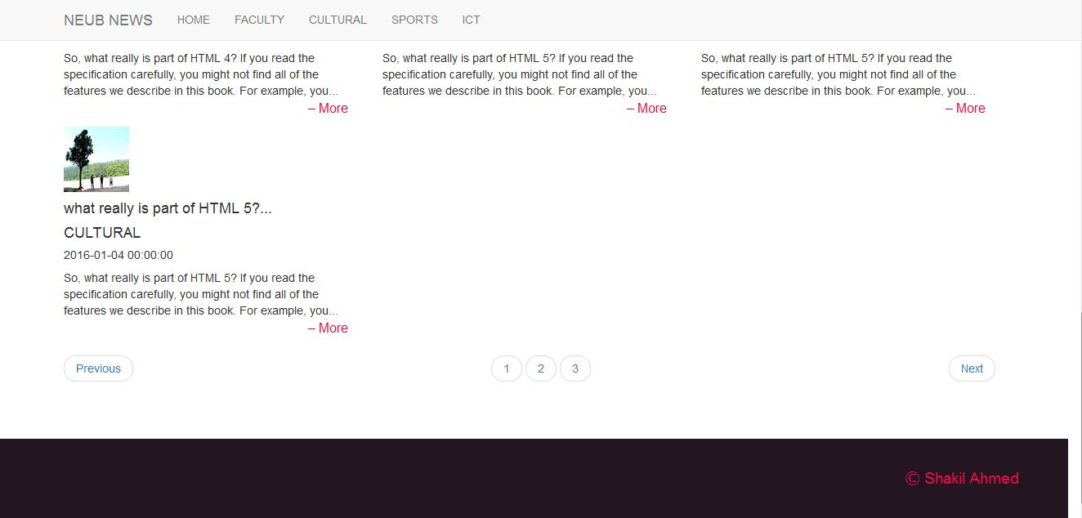

**Responsible Site**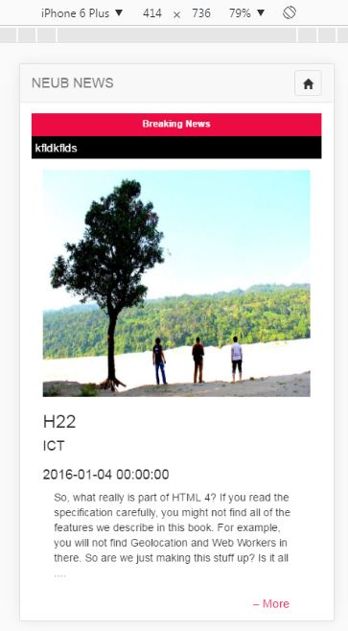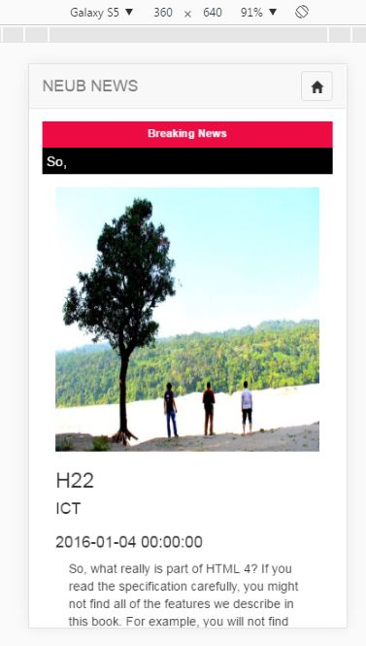

**Hardware and software Interfaces**:

To develop this OES we use HTML PHP and java script and MySQL for the database-tier. So the hardware environment requirements to use of this software are at least Intel Pentium II or equivalent processor, at least 64MB RAM   
but can be the same machine from which the software will run. So, all of these requirements may be a constraint to the clients. There are four software components required for the proposed system. The four components are as follows:  
Operating System  
Web Server  
Database  
Web Browser  
Operating System  
As our system will be platforms independent; so, there is no constraints  
in case of operating system in using this software. Windows and Linux  
operating systems are considered to be extremely stable platforms. One of the advantages of using the Linux operating system is the speed at which performance enhancements and security patches are made available since it is an open source product. Web Server The available web server’s platforms is XAMPP .

**Communication interface:**

The Customer must connect to the Internet to access the Website:

* Dialup Modem of 52 kbps
* Broadband Internet
* Dialup or Broadband Connection with a Internet Provider.

Admin panel description:

Admin is the controller of NEUB News site . Admin can post News , update , delete over all full site control here . Admin can post Notices without page loading .

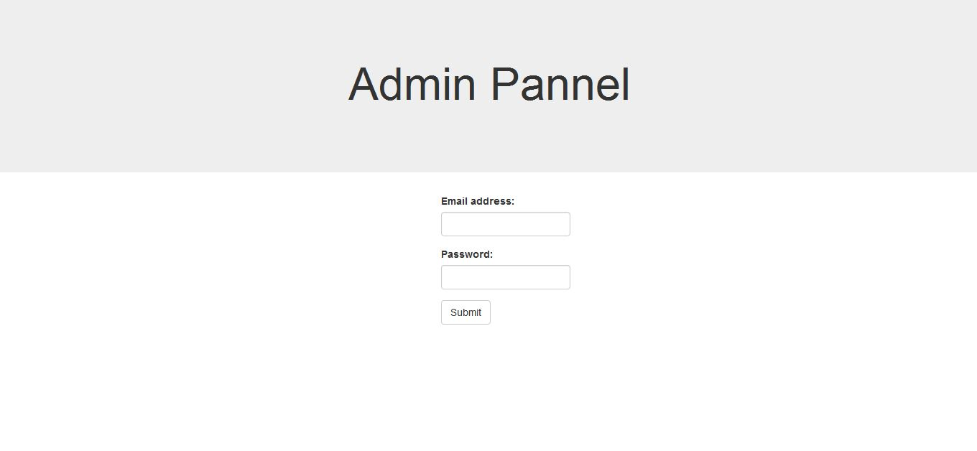

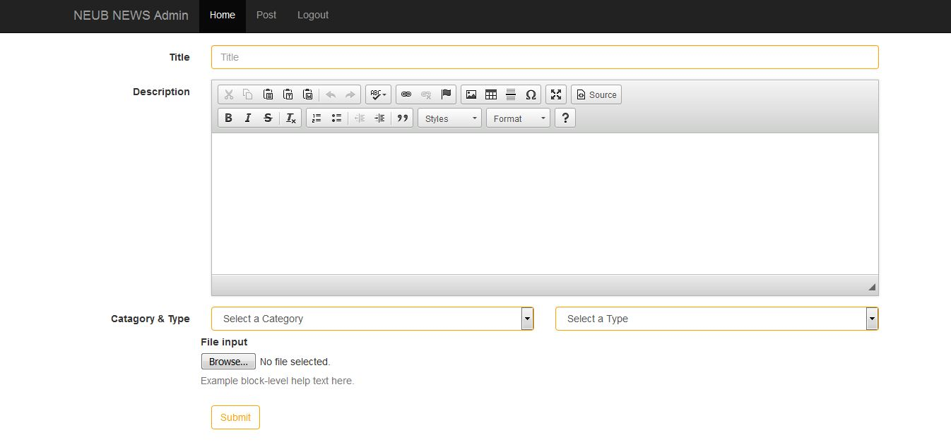

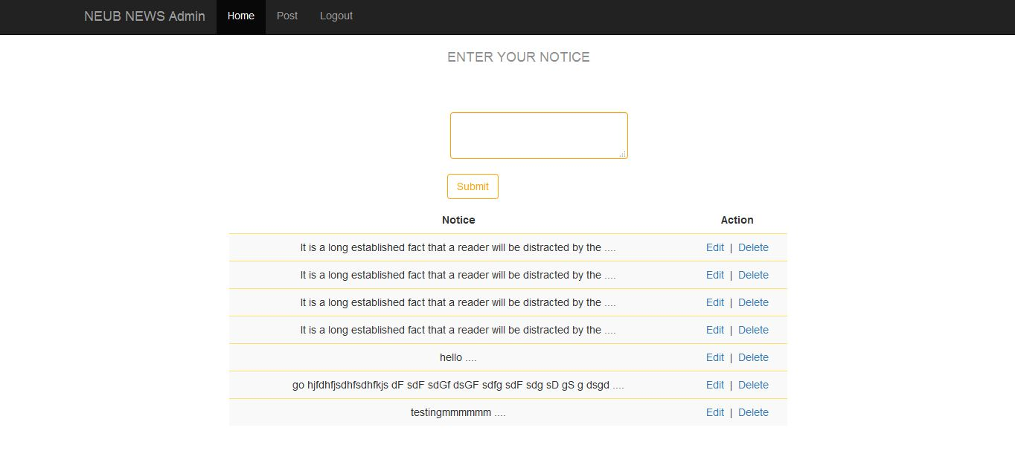

Analysis Models

Design of data base :

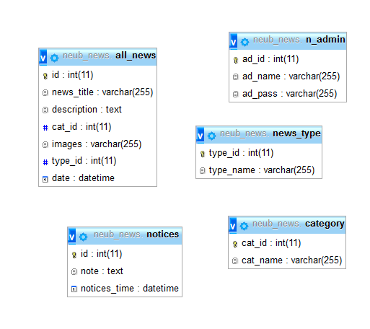

Login table represents admin table :

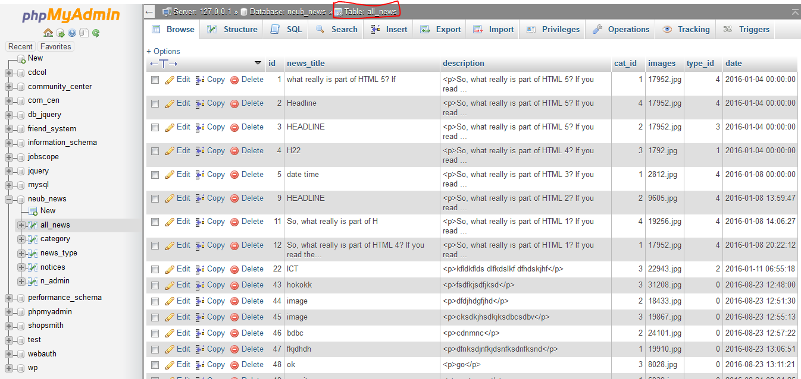

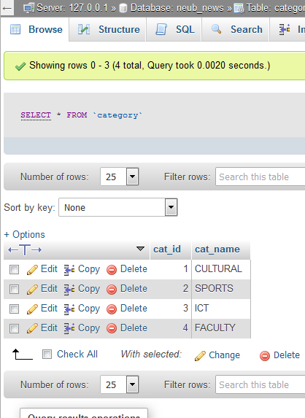

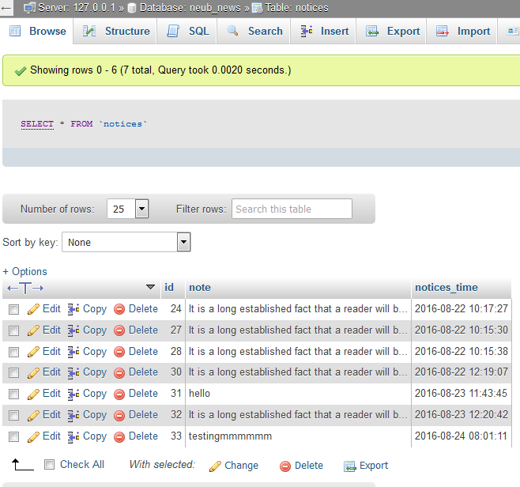

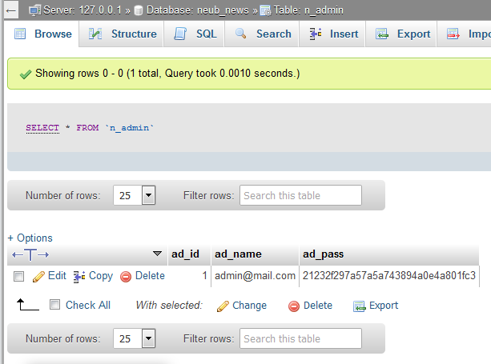

# The end