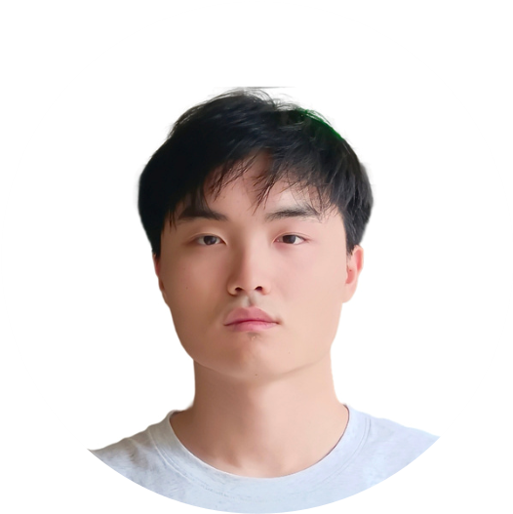
A
versatile
and
conscientious
junior
in
The
Chinese
University
of
Hong Kong majoring in Computational Data Science, highly capable
academic
student
and
proactive
individual,
particularly
excelled
in
statistics and computer science.
PROFILE
Talent Development Scholarship

The Chinese University of Hong Kong
|
2024
CDAS Scholarship

The Chinese University of Hong Kong
|
2023
First Prize in the Olympic Maths Competition in Jiangsu Province

Jiangsu Mathematical Society
|
2022

ZHANG

Yiqun
CONTACT
+852 97471479

+86 150 7085 2710
@link.cuhk.edu.hk
1155210992
EDUCATION
Bachelor of Computational
Data Science
The Chinese University of
Hong Kong
09
/2023
- 08/2027
CGPA: 3.3/4.0
SKILLS
Hard Skills
Soft Skills
Communication and teamwork
skills

Critical problem-solving skills
Excellent
time
management
skills

Programming:
C
,
C++
,
C#,
Python
,
R
,
SAS
Proficient
in
office
software
such as
Word, Excel and Xmind
Languages:
Mandarin
and
English (
IELTS score 7.5
)
AWARDS and ACHIEVEMENTS
EXPERIENCE
GAMES PLAYED
Honor of Kings
Game for Peace
Identity V
...
Software Automation Testing Intern – Gangjutong (Beijing) Technology Co., Ltd
Beijing, China | Jul - Aug 2025
Developed
and
executed
automated
test
scripts,
improving
testing
efficiency and product quality.
Generated detailed test reports using
Allure
framework to enhance test
result visibility.
Selected the course "AR and VR Development," systematically studying
the principles and applications of
AR
and
VR
and achieved a grade of A
Utilized
the
Unity

engine
for
animation
production
and
VR
scene
development and completed projects design.
New Hampshire, USA | Sep – Dec 2025
The Chinese University of Hong Kong – Dartmouth College Exchange Program
WebGPU Graphics Pipeline Development – Independent Project

Hong Kong | Jan - Feb 2026
Developed
a
LEGO
brick
scene
builder
supporting
30+

bricks
with
rotation
logic,
and
OBJ
mesh
loading,
demonstrating
proficiency
in
computer graphics fundamentals.
Built
a
complete
D
3
graphics
rendering
pipeline
from
scratch
using
WebGPU
API, including vertex/fragment shaders, uniform buffers, and
render passes.

