Retail Business Performance Analysis
Business Analysis Report | 2023–2026
Prepared by: Abdul Shakir R
Tools: SQL | Power BI | Excel

Executive Summary
- The analysis evaluated retail business performance across sales, profitability, customers, products, regions, segments, and discount levels for the period 2023–2026.
- The business generated approximately $2.33 million in sales and $292.30K in profit, resulting in an overall profit margin of 12.56% across 5,111 orders and 804 customers.
- Sales performance improved significantly after a decline in 2024. Sales increased by approximately 29.80% in 2025 and a further 21.44% in 2026.
- Profitability, however, varied substantially across categories and regions. Technology generated the highest category profit, while Furniture recorded a significantly lower margin of only 2.61%. At the sub-category level, Tables was the largest loss-making sub-category.
- The analysis also identified a strong relationship between higher discount levels and weaker profitability. Transactions in the high-discount band recorded a substantially negative profit margin.
- Customer and product analysis revealed that high sales do not always translate into high profitability. Several high-revenue customers and products generated negative profit, highlighting opportunities for pricing, discount, and product-level review.

Business Objective
The objective of this analysis is to evaluate overall retail business performance and identify the major factors influencing sales, profitability, customer value, product performance, regional performance, and discount effectiveness.

Key Business Questions
The analysis aims to answer:
- How is overall sales and profit performance changing over time?
- Which regions and customer segments generate the most revenue?
- Which categories and sub-categories are most profitable?
- Which products generate significant losses?
- Which customers contribute the most revenue and profit?
- How does discount level relate to profitability?
- Where should management focus improvement efforts?

Dataset & Methodology
Dataset:
The analysis uses a retail sales dataset containing 10,194 transaction records and 21 attributes.
Major fields include:
Order ID, Order Date, Customer ID, Customer Name, Segment, Region, Product ID, Category, Sub-Category, Sales, Quantity, Discount, Profit
Tools Used
- MySQL — Data analysis, KPI calculations, profitability, customer & product analysis
- Power BI — Interactive dashboards and business insights
Analysis Approach
The analysis focused on sales performance, profitability, customer behaviour, product performance, regional trends, and discount impact.

Overall Business Performance
KPI | Result
Total Sales | $2,326,534.36
Total Profit | $292,296.81
Profit Margin | 12.56%
Total Orders | 5,111
Total Customers | 804
Total Quantity | 38654
Average Order Value | $455.20

Finding:
The business generated $2.33M in sales and $292.30K in profit, with an overall profit margin of 12.56%.
The average order value was approximately $455, indicating that individual orders generated relatively substantial revenue.

Sales Performance
- Yearly Performance:

Year | Sales | YoY Sales Growth
2023 | $494,040 | —
2024 | $472,993 | -4.26%
2025 | $613,934 | +29.80%
2026 | $745,568 | +21.44%

Finding:
- Sales declined slightly in 2024 by 4.26%, followed by strong recovery in 2025 and 2026.
- The strongest annual sales performance occurred in 2026, with approximately $745.57K in sales.

- Regional sales:

Region | Sales | Profit Margin
West | $739,813.61 | 14.98%
East | $691,828.17 | 13.71%
Central | $503,170.67 | 7.92%
South | $391,721.91 | 11.93%

Finding;
- West generated the highest sales and also maintained the strongest regional profit margin.
- Central requires attention because its 7.92% margin is considerably weaker than West and East.

Profitability Analysis
- Category Performance
Category | Sales | Profit | Margin
Technology | $839,893.28 | $146,543.38 | 17.45%
Office Supplies | $731,893.31 | $126,023.44 | 17.22%
Furniture | $754,747.77 | $19,730.00 | 2.61%

Finding:
- Technology generated the highest profit and maintained a strong 17.45% margin.
- Furniture generated substantial sales but only $19.73K profit, resulting in a very low 2.61% margin.

Sub-Category | Profit
Tables | -$17,753.21
Bookcases | -$3,632.07
Supplies | -$1,171.39
- Sub-Category Risks

Key Finding:
- Tables generated the largest sub-category loss at approximately -$17.75K.
- Among the loss-making sub-categories, Tables accounted for approximately 78.7% of the total loss.

Discount Band | Sales | Profit Margin
No Discount | $1,105,323.79 | 29.56%
Low | $856,450.42 | 11.86%
Medium | $235,465.29 | -15.29%
High | $129,294.87 | -77.37%
- Discount & Profitability

Finding:
- Profitability declined substantially as discount levels increased.
- The high-discount band recorded a -77.37% profit margin, while transactions with no discount generated a 29.56% margin.

Customer Analysis
Key Metrics
Metric | Result
Total Customers | 804
Repeat Customers | 792
One-time Customers | 12
Average Customer Revenue | $2,893.70
Average Customer Profit | $363.55

Customer Risk:
Customer Name Sales Profit
Sean Miller $25,043.05 -$1,980.74
Finding:
- The customer analysis demonstrates that revenue contribution alone is not sufficient to determine customer value.
- Some customers generate significant sales while producing negative profit.
- This suggests that management should evaluate customers using both:
Revenue + Profitability, rather than revenue alone.

Customer Segment Analysis
Segment | Sales | Profit | Margin
Consumer | $1,170,659.79 | $136,371.45 | 11.65%
Corporate | $715,806.14 | $94,249.64 | 13.17%
Home Office | $440,068.43 | $61,675.73 | 14.02%

Finding:
- The Consumer segment generates the largest sales and profit contribution.
- However, Home Office has the highest margin at 14.02%, indicating that revenue size and profitability are not necessarily aligned.

Product Performance
Strongest Product Sales Profit
Canon imageCLASS 2200 Advanced Copier $61,599.82 $25,199.93

Finding:
- The Canon imageCLASS 2200 Advanced Copier was the strongest individual product based on both sales and profit.

Loss-Making Products:
299 products with negative profit.
Some important high-sales loss-making products include:
Product | Sales | Profit
Cisco TelePresence EX90 | $22,638 | -$1,811
GBC DocuBind P400 | $17,965 | -$1,878
Lexmark MX611dhe | $16,830 | -$4,590
Cubify CubeX Double Head | $11,100

Finding:
- Several products generate substantial revenue but still produce negative profit.
- This suggests potential issues involving:
- pricing
- discounting
- product costs
- product-level margins
- sales strategy

Key Business Findings:
1. Strong recent sales growth
- Sales increased 29.80% in 2025 and 21.44% in 2026 following a decline in 2024.
2. West is the strongest region
- West generated the highest sales at approximately $739.8K and had the highest regional margin at 14.98%.
3. Furniture has a profitability problem
- Furniture generated $754.7K sales, but only $19.7K profit, resulting in a 2.61% margin.
4. Tables are the largest sub-category loss
- Tables generated approximately -$17.75K profit, accounting for roughly 78.7% of losses among loss-making sub-categories.
5. Higher discounts are associated with weaker profitability
- Profit margin declined from 29.56% with no discount to -77.37% in the high-discount band.
6. High revenue does not always equal high value
- Several high-revenue customers and products generated negative profit.
7. Technology is a major profit driver
- Technology generated approximately $146.5K profit with a 17.45% margin.
8. Large number of products require profitability review
- 299 products generated negative profit, creating opportunities for pricing and product-level optimization.

Overall Finding:
- The business is experiencing strong recent sales growth, but profitability remains uneven across products, categories, regions, and discount levels.
Business Recommendations

1. Review Furniture Profitability
Analyze pricing, product costs, and discounts for Furniture, particularly Tables and Bookcases.
Priority: High

2. Control High Discounts
Review heavily discounted transactions and consider approval thresholds for discounts that significantly reduce margins.
Priority: High

3. Investigate Loss-Making Products
Review the 299 products generating negative profit, prioritizing products with relatively high sales but negative margins.
Priority: High

4. Investigate Central Region
Analyse Central's product mix, discount levels, and customer segments to understand its relatively low 7.92% margin.
Priority: Medium–High

5. Protect High-Margin Categories
Continue supporting strong categories such as Technology and Office Supplies, while monitoring whether additional discounting erodes their margins.
Priority: Medium

6. Measure Customer Value by Profit
Evaluate customers using Revenue + Profit + Order Frequency, rather than revenue alone.
Priority: Medium

Sales and Business Overview:
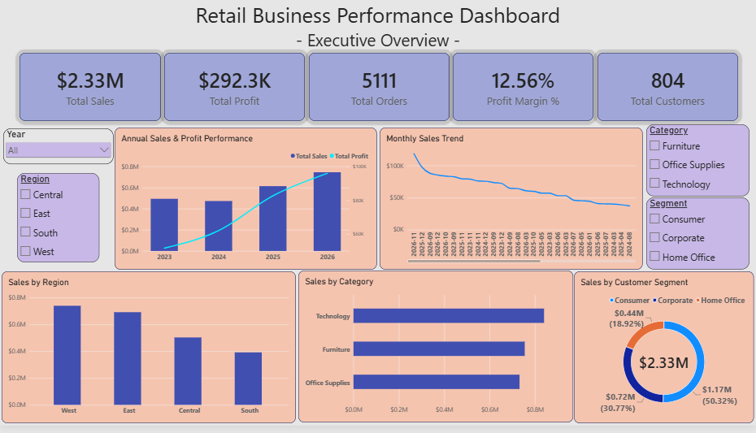

Profitability Analysis:
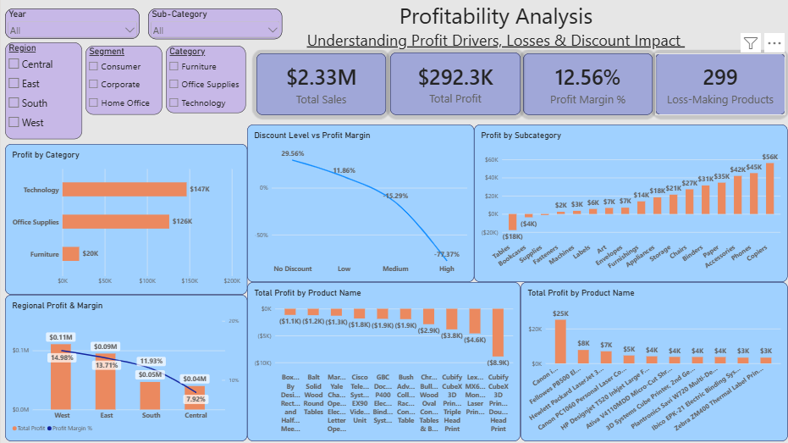

Customer and Product Analysis:
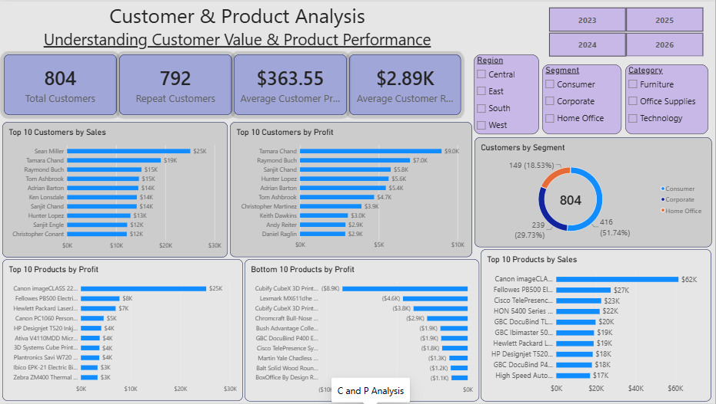

Conclusion:
- The analysis provides a comprehensive view of retail business performance across sales, profitability, customers, products, regions, segments, and discount levels. While the business demonstrates strong sales growth in recent years, profitability remains uneven across products, categories, and regions.
- The most significant opportunities identified include improving Furniture profitability, reviewing high-discount transactions, investigating loss-making products, and evaluating customer value using profitability alongside revenue.
- The Power BI dashboard provides management with an interactive way to monitor these areas and support data-driven decision-making.

Project Tools
MySQL | Power BI | Excel
Key Deliverables
SQL Analysis | Interactive Dashboard | Business Analysis Report

