Chapter 1: Introduction
1.1 Purpose
This Software Requirements Specification (SRS) defines the functional and non-functional requirements for ProcessMind AI, an AI-powered Autonomous Process Intelligence Platform.
The purpose of this document is to provide a complete and unambiguous specification for the design, development, testing, deployment, and maintenance of the platform. It serves as the primary reference for software developers, system architects, UI/UX designers, testers, project managers, stakeholders, and future contributors throughout the software development lifecycle.
This SRS documents the system's objectives, architecture, business requirements, functional modules, interfaces, constraints, security requirements, performance expectations, and quality attributes.
Furthermore, this document establishes a common understanding between all stakeholders regarding the platform's intended behavior, ensuring consistency throughout implementation while minimizing ambiguity and requirement changes.
The specification follows software engineering best practices and is intended to support future product evolution from a Minimum Viable Product (MVP) into a scalable enterprise Software-as-a-Service (SaaS) platform.
1.2 Scope
ProcessMind AI is an AI-powered Process Intelligence Platform designed to transform organizational Standard Operating Procedures (SOPs) into intelligent, executable, and continuously optimized business processes.
Unlike conventional workflow automation systems that require users to manually design workflows, ProcessMind AI leverages Artificial Intelligence to understand natural-language SOPs, automatically generate workflow models, validate process logic, simulate execution outcomes, orchestrate workflow execution, analyze operational performance, and recommend process improvements.
The primary objective of the platform is to bridge the gap between organizational knowledge and operational execution by enabling organizations to convert static documentation into intelligent operational systems.
The initial release (MVP) focuses on demonstrating these capabilities using a Leave Management workflow. However, the platform is designed with a domain-independent architecture, allowing it to support various enterprise business processes, including:
- Human Resource Management
- Procurement Management
- Invoice Processing
- Employee Onboarding
- Compliance Management
- IT Incident Management
- Vendor Approval
- Risk Assessment
- Operations Management
The platform aims to reduce manual effort, improve operational efficiency, enhance process visibility, minimize compliance risks, and support continuous business process optimization through AI-driven intelligence.

1.3 Definitions, Acronyms, and Abbreviations
Term | Definition
AI | Artificial Intelligence
API | Application Programming Interface
SOP | Standard Operating Procedure
SaaS | Software as a Service
JWT | JSON Web Token
RBAC | Role-Based Access Control
CRUD | Create, Read, Update, Delete
BPM | Business Process Management
BPMN | Business Process Model and Notation
UI | User Interface
UX | User Experience
REST | Representational State Transfer
JSON | JavaScript Object Notation
SQL | Structured Query Language
ORM | Object Relational Mapping
MVP | Minimum Viable Product
LLM | Large Language Model
AI Agent | An autonomous software component capable of reasoning, decision-making, and performing tasks using Artificial Intelligence
Workflow | A structured sequence of business activities executed to complete an organizational process
Process Intelligence | The capability of understanding, analyzing, validating, monitoring, optimizing, and improving business processes using AI and operational data
Organizational Knowledge | Business knowledge stored within SOPs, policies, procedures, documentation, and organizational rules
Organizational Digital Twin | A virtual representation of organizational processes used for simulation, prediction, and optimization before implementing operational changes

1.4 References
The design and implementation of ProcessMind AI are guided by established software engineering principles, enterprise architecture practices, workflow management concepts, and modern Artificial Intelligence technologies.
The following standards, methodologies, and technologies are referenced throughout the development of the platform:
Software Engineering Standards
- IEEE 29148 – Systems and Software Engineering Requirements Engineering
- IEEE 1016 – Software Design Description
- IEEE 830 (Legacy Software Requirements Specification Standard)
- ISO/IEC 25010 – Software Product Quality Model
Architectural Principles
- RESTful API Architecture
- Layered Software Architecture
- Clean Architecture
- Domain-Driven Design (DDD)
- SOLID Design Principles
Workflow and Business Process Standards
- Business Process Management (BPM)
- Business Process Model and Notation (BPMN)
- Workflow Orchestration Concepts
- State Machine Design Patterns
Artificial Intelligence Technologies
- Google Gemini Large Language Models
- Prompt Engineering
- AI-assisted Workflow Generation
- AI-powered Process Intelligence
Development Technologies
- Next.js
- React
- Spring Boot
- PostgreSQL
- Docker
- JWT Authentication
1.5 Document Overview
This Software Requirements Specification is organized into multiple chapters to provide a structured description of the ProcessMind AI platform.
The document begins with an overview of the product vision, objectives, and system context before defining detailed functional and non-functional requirements.
Subsequent chapters describe the platform architecture, user roles, business requirements, software modules, database design, AI components, workflow engine, security mechanisms, deployment architecture, and operational constraints.
The specification further includes comprehensive use case descriptions, workflow diagrams, sequence diagrams, state diagrams, database models, API specifications, and acceptance criteria to ensure complete traceability from business objectives to implementation.
The overall structure of this SRS is as follows:
- Chapter 1: Introduction
- Chapter 2: Overall Description
- Chapter 3: System Architecture
- Chapter 4: Business Requirements
- Chapter 5: Functional Requirements
- Chapter 6: AI Functional Requirements
- Chapter 7: Database Requirements
- Chapter 8: REST API Specifications
- Chapter 9: Security Requirements
- Chapter 10: Non-Functional Requirements
- Chapter 11: Use Case Specifications
- Chapter 12: Activity Diagrams
- Chapter 13: Sequence Diagrams
- Chapter 14: State Machine Diagrams
- Chapter 15: Entity Relationship Diagram
- Chapter 16: Deployment Architecture
- Chapter 17: Acceptance Criteria
- Chapter 18: Future Enhancements
This document is intended to evolve alongside the product, providing a comprehensive blueprint for the successful development, deployment, maintenance, and future expansion of ProcessMind AI into a full-scale enterprise Process Intelligence Platform.

Chapter 2: Overall Description
2.1 Product Perspective
ProcessMind AI is an AI-powered Process Intelligence Platform designed to transform organizational knowledge into intelligent, executable, and continuously optimized business processes.
The platform bridges the gap between business documentation and operational execution by enabling organizations to convert Standard Operating Procedures (SOPs) into automated workflows. Unlike traditional workflow automation platforms that require users to manually design process flows, ProcessMind AI leverages Artificial Intelligence to understand SOPs, generate workflows, validate business logic, simulate execution outcomes, orchestrate workflow execution, and recommend process improvements.
ProcessMind AI is designed as a cloud-based Software-as-a-Service (SaaS) platform with a modular and scalable architecture. The system follows a layered architecture consisting of a web-based user interface, backend services, AI intelligence layer, workflow orchestration engine, and data management layer.
The initial release of the platform focuses on Leave Management as the Minimum Viable Product (MVP). However, the architecture is domain-independent and is designed to support multiple enterprise domains, including Human Resources, Procurement, Finance, Compliance, IT Operations, Customer Support, and other workflow-driven business processes.
In the long term, ProcessMind AI aims to evolve into an AI Organizational Operating System capable of understanding, managing, and continuously optimizing organizational operations through intelligent process analysis and automation.

2.2 Product Functions
The primary functions of ProcessMind AI include:
SOP Management
- Upload SOPs in multiple formats (Text, PDF, DOCX)
- Store and manage organizational SOPs
- Maintain version history of SOPs

SOP Intelligence
- Analyze natural-language SOPs using Artificial Intelligence
- Extract business rules, conditions, approvals, and actions
- Convert unstructured procedures into structured process definitions
Workflow Generation
- Automatically generate workflow models from SOPs
- Create decision trees and approval chains
- Visualize generated workflows
Process Validation
- Detect missing approvals
- Detect conflicting business rules
- Identify undefined roles
- Detect circular dependencies
- Validate workflow completeness
Process Simulation
- Simulate workflows using different business scenarios
- Predict workflow execution paths
- Estimate completion times
- Analyze process outcomes before deployment
Workflow Execution
- Execute workflows dynamically
- Manage workflow states
- Route tasks automatically
- Pause and resume workflow execution
- Track workflow progress
Human Approval Management
- Request approvals
- Escalate pending approvals
- Track approval history
- Enforce approval deadlines

Process Analytics
- Monitor workflow performance
- Analyze workflow completion rates
- Measure approval delays
- Identify process bottlenecks
Process Optimization
- Recommend workflow improvements
- Identify redundant process steps
- Suggest approval optimizations
- Improve organizational efficiency
Administration
- Manage users and organizations
- Configure workflows
- Manage roles and permissions
- Configure AI settings
- Monitor platform health
Notification Management
- Email notifications
- In-app notifications
- Workflow status notifications
- Approval reminders
- Escalation notifications
2.3 User Classes and Characteristics
ProcessMind AI supports multiple user roles, each with different responsibilities and system privileges.
System Administrator
The System Administrator manages the overall platform configuration and operational environment.
Responsibilities include:
- Manage organizations
- Configure system settings
- Manage user accounts
- Assign user roles
- Monitor system health
- View audit logs
- Configure AI services
Required Skills:
- Basic system administration knowledge
- Organizational process understanding
Organization Administrator
The Organization Administrator manages business processes within a specific organization.
Responsibilities include:
- Upload SOPs
- Generate workflows
- Deploy workflows
- Manage departments
- Configure approvals
- Monitor organizational workflows
Required Skills:
- Business process management
- Organizational policy knowledge

Process Analyst
The Process Analyst evaluates and improves business processes.
Responsibilities include:
- Review SOPs
- Validate workflows
- Run process simulations
- Analyze workflow performance
- Review optimization recommendations
Required Skills:
- Business analysis
- Process improvement methodologies

Manager / Approver
Managers participate in approval workflows.
Responsibilities include:
- Review approval requests
- Approve or reject business processes
- Track assigned workflows
- Monitor approval history
Required Skills:
- Departmental knowledge
- Organizational decision-making authority
Employee
Employees interact with workflows generated by the platform.
Responsibilities include:
- Submit requests
- Track workflow progress
- Respond to assigned tasks
- View notifications
Required Skills:
- Basic computer literacy
AI Services (External Actor)
Artificial Intelligence services assist the platform by performing reasoning-based operations.
Responsibilities include:
- SOP understanding
- Workflow generation
- Validation reasoning
- Process optimization
- Simulation support

2.4 Operating Environment
ProcessMind AI is designed as a cloud-native web application.
Client Environment
Supported Web Browsers:
- Google Chrome
- Microsoft Edge
- Mozilla Firefox
- Safari
Supported Devices:
- Desktop Computers
- Laptops
- Tablets

Server Environment
Backend:
- Java 21
- Spring Boot
Frontend:
- Next.js
- React
- TypeScript
Database:
- PostgreSQL
AI Services:
- Google Gemini API
Containerization:
- Docker
- Docker Compose

Deployment:
- Vercel (Frontend)
- Render (Backend)
- Neon PostgreSQL (Database)

Network Requirements
- Stable internet connection
- HTTPS-enabled communication
- REST API communication
- Secure authentication
2.5 Assumptions and Dependencies
The development and operation of ProcessMind AI assume the following:
Assumptions
- Users have internet connectivity.
- Organizations possess documented SOPs or business procedures.
- Uploaded SOPs are written in understandable natural language.
- Users have valid system accounts before accessing protected resources.
- AI services are available during workflow generation and validation.
- Users possess basic computer literacy.
- Organizations are willing to digitize business processes.
- System clocks remain synchronized across infrastructure.
Dependencies
The platform depends on:
- Google Gemini API for AI reasoning
- PostgreSQL database availability
- Cloud hosting infrastructure
- Email service provider for notifications
- Internet connectivity
- Modern web browsers

Future versions may additionally depend on:
- Temporal.io
- Neo4j Graph Database
- Enterprise Identity Providers
- Cloud Object Storage
2.6 Constraints
The following constraints apply to ProcessMind AI.
Technical Constraints
- The frontend shall be developed using Next.js and React.
- The backend shall be implemented using Java Spring Boot.
- PostgreSQL shall be used as the primary relational database.
- Artificial Intelligence capabilities shall initially rely on Google Gemini APIs.
- Communication between frontend and backend shall use RESTful APIs.
- The system shall support Docker-based deployment.
Business Constraints
- The initial release shall focus on Leave Management as the primary demonstration domain.
- Workflow execution shall require administrator deployment before becoming active.
- Human approvals shall remain mandatory for configured approval stages.
- AI-generated workflows shall be reviewed by users before deployment.
Operational Constraints
- AI-based features depend on external AI service availability.
- Workflow execution requires continuous backend availability.
- Email notifications require a configured email service.
- Cloud deployment requires internet access.
Security Constraints
- User authentication shall be mandatory.
- Role-Based Access Control (RBAC) shall be enforced.
- Passwords shall never be stored in plain text.
- All communication shall occur over HTTPS.
- Sensitive credentials shall be stored as secure environment variables.

Scalability Constraints
- The MVP is designed for small to medium-sized organizations.
- Future releases shall support multi-tenant enterprise deployments.
- The architecture shall allow horizontal scaling of backend services.
- AI components shall be replaceable without significant changes to the overall system architecture.
This overall description establishes the context, scope, user environment, assumptions, and operational boundaries of ProcessMind AI and provides the foundation for the detailed functional and non-functional requirements described in subsequent chapters.

Chapter 3: System Architecture
3.1 System Architecture Overview
ProcessMind AI follows a modular, cloud-native, layered architecture that separates presentation, business logic, artificial intelligence, workflow orchestration, and data management into independent components.
This architecture promotes scalability, maintainability, security, extensibility, and high system availability while allowing future integration of additional AI services, workflow engines, enterprise systems, and organizational intelligence capabilities.
The platform consists of six primary architectural layers:
- Presentation Layer
- Application Layer
- Process Intelligence Layer
- Workflow Orchestration Layer
- Data Layer
- External Services Layer
Each layer has clearly defined responsibilities and communicates through secure RESTful APIs and internal service interfaces.

3.2 High-Level Architecture
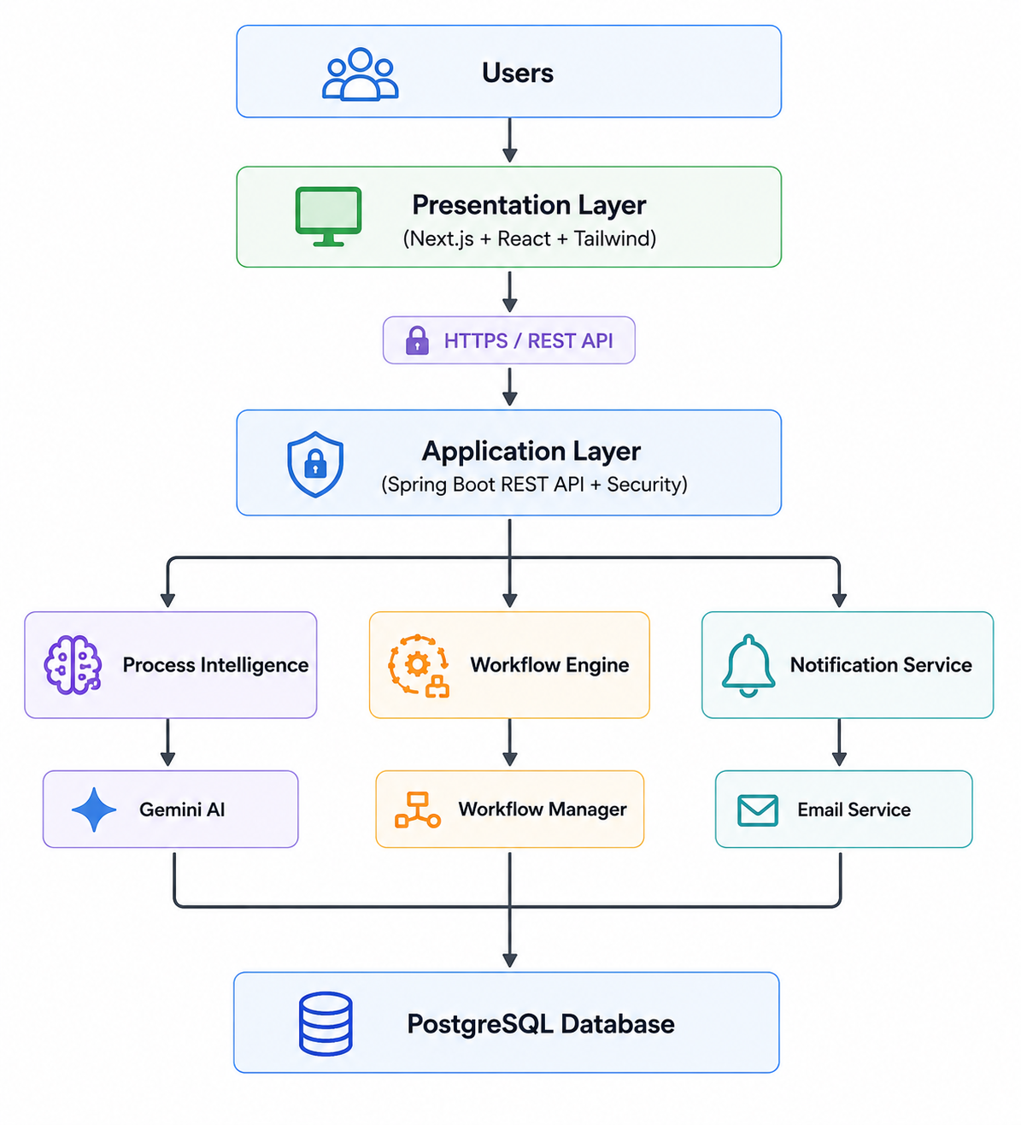
3.3 Architectural Layers
3.3.1 Presentation Layer
Purpose
Provides the graphical user interface through which users interact with the system.
Technologies
- Next.js
- React
- TypeScript
- Tailwind CSS
- React Flow
Responsibilities
- User Authentication
- Dashboard
- SOP Upload
- Workflow Visualization
- Process Simulation Interface
- Approval Dashboard
- Analytics Dashboard
- Administration Panel
- Notification Center
Users
- Employee
- Manager
- Process Analyst
- Organization Administrator
- System Administrator
3.3.2 Application Layer
Purpose
Acts as the central backend responsible for handling business logic and coordinating communication between all system components.
Technologies
- Java 21
- Spring Boot
- Spring Security
- Spring Data JPA
- Hibernate
Responsibilities
- REST API Management
- Authentication
- Authorization
- Request Validation
- Business Logic
- Workflow Coordination
- Database Communication
- External AI Communication
3.3.3 Process Intelligence Layer
Purpose
Provides Artificial Intelligence capabilities for understanding, analyzing, validating, and optimizing business processes.
This layer differentiates ProcessMind AI from traditional workflow automation platforms.
Components
SOP Intelligence Engine
Responsibilities:
- Understand SOPs
- Extract business rules
- Identify approvals
- Identify actions
- Detect dependencies
Workflow Generation Engine
Responsibilities:
- Generate workflow structures
- Create decision trees
- Build workflow graphs
- Generate workflow JSON
Process Validation Engine
Responsibilities:
- Detect logical conflicts
- Detect missing approvals
- Detect undefined roles
- Detect circular dependencies
- Evaluate workflow quality
Process Simulation Engine
Responsibilities:
- Execute virtual workflow scenarios
- Predict workflow outcomes
- Estimate completion time
- Identify execution paths
Process Optimization Engine
Responsibilities:
- Detect bottlenecks
- Recommend workflow improvements
- Reduce approval delays
- Simplify workflows
3.3.4 Workflow Orchestration Layer
Purpose
Executes generated workflows and manages workflow lifecycle.
Components
Workflow Engine
Responsibilities:
- Start workflows
- Execute workflow steps
- Route tasks
- Pause workflows
- Resume workflows
- Complete workflows
Approval Engine
Responsibilities:
- Approval routing
- Approval notifications
- Escalations
- Approval history

State Manager
Responsibilities:
Maintain workflow states:
- Draft
- Active
- Running
- Waiting Approval
- Completed
- Failed
Notification Manager
Responsibilities:
- Email notifications
- In-app notifications
- Approval reminders
- Escalation alerts

3.3.5 Data Layer
Purpose
Store all business and operational data.
Database
PostgreSQL
Stored Data
- Users
- Organizations
- Departments
- SOP Documents
- Workflow Definitions
- Workflow Instances
- Workflow Logs
- Approval Records
- Notifications
- Analytics Data
- Audit Logs
3.3.6 External Services Layer
Artificial Intelligence
Google Gemini API
Responsibilities
- SOP reasoning
- Workflow generation
- Validation reasoning
- Simulation reasoning
- Optimization recommendations

Email Service
Responsibilities
- Send notifications
- Approval requests
- Reminder emails
Cloud Storage (Future)
Responsibilities
- Store uploaded documents
- Archive SOP versions
3.4 Component Interaction
The following sequence describes the interaction among the major components.
- User uploads an SOP.
- Frontend sends the document to the backend.
- Backend forwards the SOP to the SOP Intelligence Engine.
- Gemini AI analyzes the SOP.
- Structured workflow information is returned.
- Workflow Generation Engine creates the workflow.
- Process Validation Engine verifies the workflow.
- Process Simulation Engine performs simulations.
- Administrator reviews the generated workflow.
- Workflow is deployed.
- Workflow Engine executes workflow instances.
- Analytics Engine collects execution data.
- Process Optimization Engine generates recommendations.
3.5 Data Flow
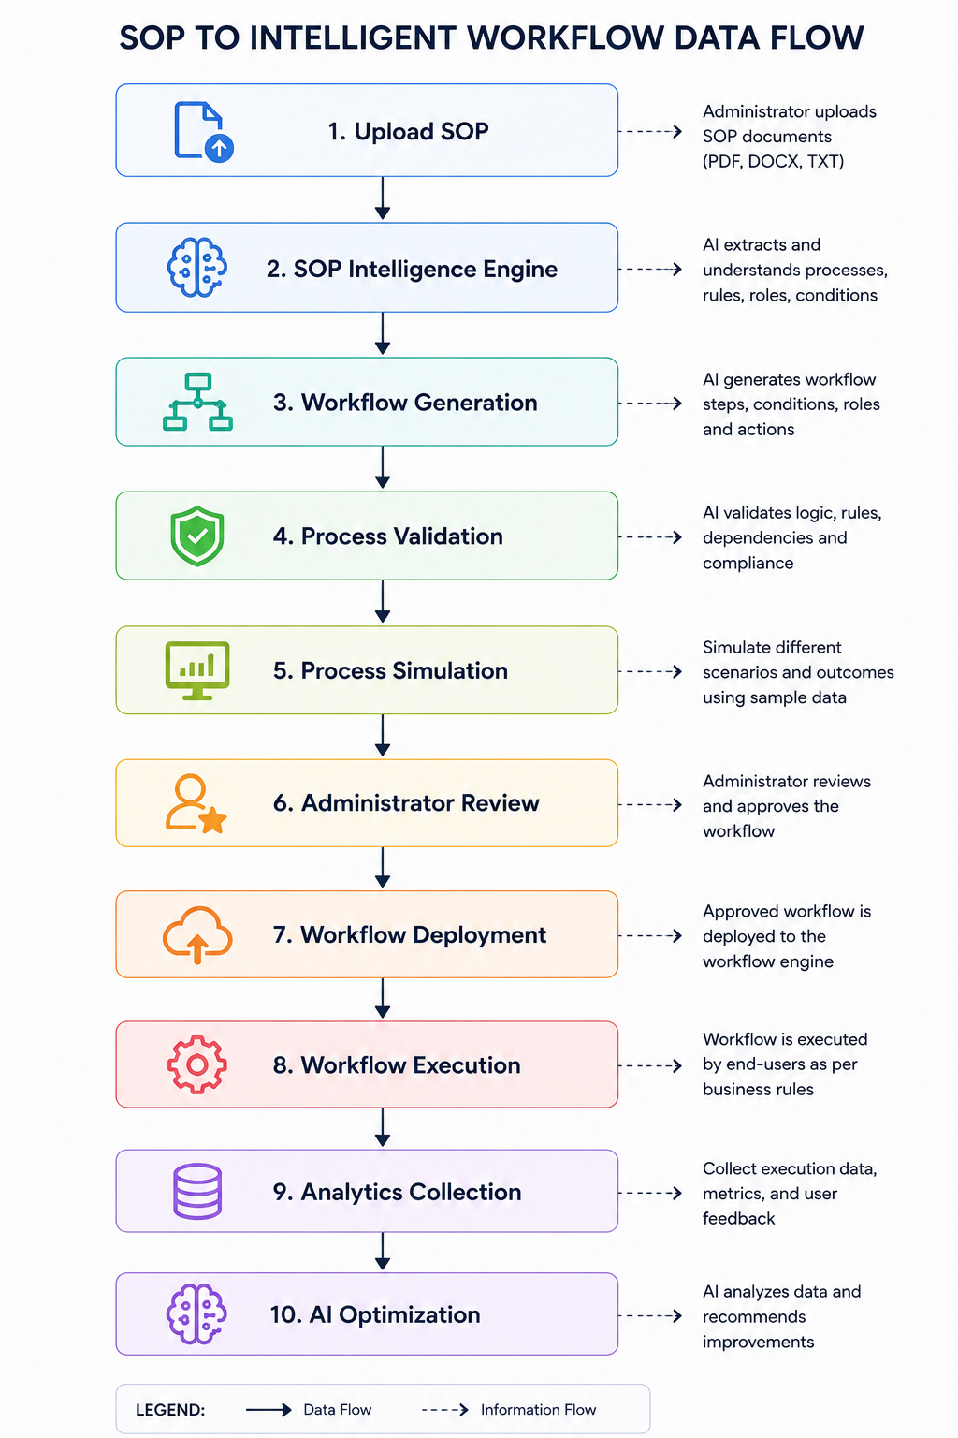

3.6 Deployment Architecture
The platform follows a cloud-native deployment model.
Frontend
- Next.js
- Hosted on Vercel
Backend
- Spring Boot
- Hosted on Render
Database
- PostgreSQL
- Hosted on Neon
AI Services
- Google Gemini API
Containerization
- Docker
- Docker Compose
3.7 Security Architecture
The architecture incorporates multiple security layers.
Authentication
- JWT Authentication
- Spring Security
Authorization
Role-Based Access Control (RBAC)
Password Protection
- BCrypt Hashing
Communication Security
- HTTPS
- Secure REST APIs

Secrets Management
- Environment Variables
- API Keys
- Database Credentials
Audit Logging
All critical operations are logged for traceability.
3.8 Scalability Considerations
The architecture is designed to support future growth.
Horizontal Scaling
Backend services can be replicated.
Database Scaling
PostgreSQL supports replication and future sharding strategies.
AI Provider Abstraction
The AI layer is designed with provider abstraction, allowing Gemini to be replaced or complemented by other AI providers such as OpenAI, Anthropic, or self-hosted models without significant architectural changes.
Future Enterprise Extensions
The architecture supports future integration of:
- Multi-Agent Systems
- Organizational Knowledge Graph
- Organizational Digital Twin
- Process Mining
- Enterprise Identity Providers
- Temporal.io Workflow Orchestration
- Predictive Process Analytics
This modular architecture ensures that ProcessMind AI can evolve from a startup Minimum Viable Product (MVP) into a scalable enterprise Process Intelligence Platform capable of supporting organizations of varying sizes and operational complexity.

Chapter 4: Business Requirements
4.1 Business Overview
Organizations rely on Standard Operating Procedures (SOPs) to define how business processes should be executed. These SOPs are commonly maintained as documents such as PDFs, Word files, spreadsheets, or internal knowledge-base articles.
Although these documents define organizational operations, they are passive and require employees to manually interpret procedures, make decisions, request approvals, and execute tasks. This manual approach often results in inconsistent execution, process delays, compliance risks, operational inefficiencies, and limited visibility into business performance.
ProcessMind AI addresses these challenges by transforming static SOPs into intelligent, executable, and continuously optimized workflows. The platform combines Artificial Intelligence with workflow orchestration to automate process understanding, workflow generation, validation, simulation, execution, monitoring, and optimization.
The platform is designed to reduce operational costs, improve business efficiency, accelerate decision-making, and provide organizations with greater visibility into their operational processes.

4.2 Business Goals
The primary business goals of ProcessMind AI are:
- Enable organizations to digitize business processes from existing SOPs.
- Reduce manual effort involved in interpreting and executing procedures.
- Automate workflow generation using Artificial Intelligence.
- Improve workflow accuracy through automated validation.
- Minimize approval delays and operational bottlenecks.
- Enhance compliance with organizational policies.
- Improve visibility into workflow execution and performance.
- Support continuous process improvement through AI-driven recommendations.
- Provide a scalable Software-as-a-Service (SaaS) platform suitable for organizations of different sizes.

4.3 Business Objectives
The platform shall achieve the following objectives:
BO-001
Automatically convert natural-language SOPs into structured workflow definitions.
Priority: High

BO-002
Reduce the time required to design business workflows compared to manual workflow creation.
Priority: High

BO-003
Detect process design issues before workflow deployment.
Priority: High

BO-004
Allow organizations to simulate workflow behavior prior to deployment.
Priority: High

BO-005
Execute approved workflows using an automated workflow engine.
Priority: High

BO-006
Provide real-time visibility into workflow execution and operational performance.
Priority: High

BO-007
Identify workflow bottlenecks and recommend optimization opportunities using Artificial Intelligence.
Priority: Medium

BO-008
Support multiple business domains through reusable workflow architecture.
Priority: Medium

BO-009
Provide secure, role-based access to organizational resources.
Priority: High

BO-010
Enable future integration with enterprise systems and third-party services.
Priority: Medium

4.4 Business Requirements
BR-001: SOP Digitization
Priority: High
The system shall enable organizations to upload and manage Standard Operating Procedures (SOPs) in digital formats and convert them into structured business process definitions.

BR-002: AI-Powered Process Understanding
Priority: High
The platform shall analyze uploaded SOPs using Artificial Intelligence to identify business rules, conditions, actions, approval chains, roles, and dependencies.

BR-003: Automatic Workflow Generation
Priority: High
The platform shall automatically generate executable workflow models from AI-generated process definitions without requiring manual workflow design.

BR-004: Workflow Validation
Priority: High
The platform shall validate generated workflows to identify logical conflicts, missing approvals, undefined roles, circular dependencies, and incomplete business rules before deployment.

BR-005: Workflow Simulation
Priority: High
The platform shall simulate business workflows using different input scenarios to predict execution outcomes before workflows are deployed into production.

BR-006: Workflow Execution
Priority: High
The platform shall execute approved workflows while maintaining workflow state, routing tasks, and tracking execution progress.

BR-007: Human Approval Management
Priority: High
The platform shall support configurable approval workflows involving managers, department heads, administrators, and other authorized personnel.

BR-008: Organizational Analytics
Priority: High
The platform shall provide dashboards that visualize workflow performance, completion rates, approval delays, execution statistics, and operational metrics.

BR-009: Process Optimization
Priority: Medium
The platform shall analyze workflow execution history and recommend improvements that reduce delays, eliminate redundant activities, and improve operational efficiency.

BR-010: Notification Management
Priority: Medium
The platform shall notify users regarding workflow status changes, approval requests, reminders, escalations, and completed tasks.

BR-011: User and Organization Management
Priority: High
The platform shall provide facilities to manage organizations, departments, users, roles, permissions, and system configurations.

BR-012: Security and Access Control
Priority: High
The platform shall ensure that organizational data is protected using authentication, authorization, encrypted communication, audit logging, and role-based access control mechanisms.

BR-013: Multi-Tenant Architecture
Priority: Medium
The platform shall support multiple organizations while ensuring complete isolation of organizational data and business processes.

BR-014: Scalability
Priority: Medium
The platform shall support increasing numbers of organizations, users, workflows, and process executions without significant degradation in performance.

BR-015: AI Extensibility
Priority: Medium
The platform shall be designed with an abstract AI service layer to allow future integration of multiple AI providers without significant architectural modifications.

4.5 Business Value
The implementation of ProcessMind AI provides measurable business value to organizations.
Expected benefits include:
- Reduced workflow design time.
- Faster process execution.
- Improved operational efficiency.
- Increased process consistency.
- Reduced manual errors.
- Improved compliance with organizational policies.
- Enhanced process transparency.
- Reduced dependency on external business process consultants.
- Continuous AI-driven process optimization.
- Improved decision-making through operational analytics.

4.6 Stakeholders
The primary stakeholders of ProcessMind AI include:
Stakeholder | Responsibility
Organization Owners | Adopt and manage the platform within the organization
Organization Administrators | Configure workflows, users, and system settings
Process Analysts | Analyze, validate, and optimize business processes
Managers | Review and approve workflow requests
Employees | Submit requests and participate in workflows
System Administrators | Maintain the platform infrastructure
Software Developers | Design, implement, and maintain the application
Quality Assurance Engineers | Verify system quality and compliance
Business Analysts | Gather and validate business requirements
Future Investors | Evaluate the business value and scalability of the platform

4.7 Business Success Criteria
ProcessMind AI shall be considered successful when it demonstrates the following outcomes:
- Organizations can successfully upload SOPs and generate workflows automatically.
- Workflow generation significantly reduces manual process design effort.
- Workflow validation identifies logical issues before deployment.
- Simulations accurately predict workflow execution paths.
- Workflow execution operates reliably in production.
- Approval processes are completed efficiently.
- Analytics provide actionable operational insights.
- AI-generated optimization recommendations contribute to measurable process improvements.
- The platform supports multiple organizations securely.
- The system provides a scalable foundation for future enterprise expansion and advanced AI capabilities.
The business requirements defined in this chapter establish the strategic objectives and expected business outcomes of ProcessMind AI. These requirements provide the foundation for the detailed functional requirements described in the following chapters.

Chapter 5: Functional Requirements
5.1 Overview
This chapter specifies the functional requirements of ProcessMind AI. Functional requirements describe the services, behaviors, and operations that the system must perform to satisfy business objectives.
Each functional requirement is assigned a unique identifier (FR-XXX) to support requirement traceability throughout the software development life cycle.
The functional requirements are organized according to the major software modules of the platform.

Functional Modules
The ProcessMind AI platform consists of the following functional modules:
- Authentication and Authorization Module
- User Management Module
- Organization Management Module
- SOP Intelligence Engine
- Workflow Generation Engine
- Process Validation Engine
- Process Simulation Engine
- Workflow Execution Engine
- Human Approval Engine
- Analytics Dashboard
- Process Optimization Engine
- Notification Module
- Administration Module
Each module is described in detail in the following sections.

5.2 Authentication and Authorization Module
5.2.1 Module Description
The Authentication and Authorization Module is responsible for securely identifying users, authenticating their credentials, authorizing access to system resources, and enforcing Role-Based Access Control (RBAC). This module ensures that only authorized users can access protected functionalities while maintaining the confidentiality, integrity, and security of organizational data.

5.2.2 Functional Requirements
Requirement ID | Functional Requirement | Priority
FR-001 | The system shall allow Organization Administrators to register new users within their organization. | High
FR-002 | The system shall allow registered users to log in using their email address and password. | High
FR-003 | The system shall validate user credentials before granting access to the system. | High
FR-004 | The system shall generate a secure JWT access token after successful authentication. | High
FR-005 | The system shall verify the validity of the JWT token before processing every protected API request. | High
FR-006 | The system shall deny access to protected resources when authentication fails. | High
FR-007 | The system shall enforce Role-Based Access Control (RBAC) based on assigned user roles. | High
FR-008 | The system shall allow authenticated users to securely log out of the system. | Medium
FR-009 | The system shall securely hash user passwords using BCrypt before storing them in the database. | High
FR-010 | The system shall never store passwords in plain text. | High
FR-011 | The system shall allow users to change their passwords after successful authentication. | Medium
FR-012 | The system shall provide a secure password reset mechanism for users who forget their passwords. | Medium
FR-013 | The system shall enforce configurable password complexity requirements during password creation and updates. | Medium
FR-014 | The system shall automatically invalidate expired JWT tokens. | High
FR-015 | The system shall terminate user sessions when users log out or when authentication tokens expire. | High
FR-016 | The system shall restrict users from accessing modules outside their assigned permissions. | High
FR-017 | The system shall prevent disabled or inactive user accounts from authenticating. | High
FR-018 | The system shall record all authentication activities, including successful logins, failed login attempts, password changes, and logout events in the audit log. | Medium
FR-019 | The system shall allow administrators to activate, deactivate, suspend, or reactivate user accounts. | Medium
FR-020 | The system shall return appropriate HTTP status codes (401 Unauthorized, 403 Forbidden) for unauthorized access attempts. | High

5.2.3 Supported User Roles
Role | Description
System Administrator | Full access to the entire platform and system configuration.
Organization Administrator | Manages users, SOPs, workflows, departments, and organizational settings.
Process Analyst | Reviews SOPs, validates workflows, performs simulations, and analyzes business processes.
Manager | Reviews and approves workflow requests assigned to them.
Employee | Submits requests, tracks workflow status, and performs assigned workflow tasks.

5.2.4 Preconditions
- Users must have a registered account.
- User account must belong to an active organization.
- Authentication service must be available.
- Database connection must be active.

5.2.5 Postconditions
- Authenticated users receive a valid JWT access token.
- User session is established.
- User role and permissions are loaded.
- Authentication events are recorded in the audit log.
5.2.6 Business Rules
Rule ID | Business Rule
BR-AUTH-001 | Every protected resource shall require authentication.
BR-AUTH-002 | Each user shall belong to exactly one organization.
BR-AUTH-003 | Passwords shall never be stored in plain text.
BR-AUTH-004 | JWT tokens shall have a configurable expiration period.
BR-AUTH-005 | Only authorized administrators may create, activate, suspend, or deactivate user accounts.
BR-AUTH-006 | Access permissions shall be determined solely by assigned user roles.

5.2.7 Exception Handling
Exception | Expected System Response
Invalid email address | Reject authentication and display an appropriate error message.
Incorrect password | Reject authentication without revealing which credential is incorrect.
Expired JWT token | Reject the request and require the user to authenticate again.
Disabled account | Prevent login and notify the user that the account is inactive.
Unauthorized access | Return HTTP 403 (Forbidden).
Missing authentication token | Return HTTP 401 (Unauthorized).
Database unavailable | Return an internal server error and log the incident.

5.2.8 Acceptance Criteria
The Authentication and Authorization Module shall be considered complete when:
- Users can securely authenticate using valid credentials.
- JWT-based authentication functions correctly.
- Role-Based Access Control (RBAC) is enforced across all protected resources.
- Passwords are securely hashed using BCrypt.
- Unauthorized users cannot access restricted modules.
- Authentication events are successfully recorded in the audit log.
- Users can securely log out and terminate active sessions.
5.3 User Management Module
5.3.1 Module Description
The User Management Module enables administrators to manage user accounts within their organizations while allowing users to maintain their personal profiles. The module supports user creation, profile updates, role assignment, account status management, and user search operations.
The module ensures that only authorized administrators can perform administrative user management functions, while individual users are limited to managing their own profile information.

5.3.2 Functional Requirements
Requirement ID | Functional Requirement | Priority
FR-021 | The system shall allow Organization Administrators to create new user accounts. | High
FR-022 | The system shall allow administrators to assign roles during user creation. | High
FR-023 | The system shall validate that each email address is unique within the organization. | High
FR-024 | The system shall automatically generate a unique User ID for every registered user. | High
FR-025 | The system shall allow administrators to update user information. | High
FR-026 | The system shall allow users to update their own profile information. | Medium
FR-027 | The system shall prevent users from modifying their assigned roles. | High
FR-028 | The system shall allow administrators to change user roles. | High
FR-029 | The system shall allow administrators to activate or deactivate user accounts. | High
FR-030 | The system shall allow administrators to temporarily suspend user accounts. | Medium
FR-031 | The system shall allow administrators to permanently delete inactive user accounts. | Medium
FR-032 | The system shall prevent deletion of users who own active workflows unless ownership is transferred. | High
FR-033 | The system shall maintain complete user profile information, including name, email, department, role, and contact information. | Medium
FR-034 | The system shall allow administrators to search users using name, email, department, or role. | Medium
FR-035 | The system shall support filtering users based on account status. | Medium
FR-036 | The system shall display the user's account status (Active, Inactive, Suspended). | Medium
FR-037 | The system shall display each user's assigned role and department. | Medium
FR-038 | The system shall record the account creation date and last login date for every user. | Medium
FR-039 | The system shall maintain an audit history of user account modifications. | High
FR-040 | The system shall prevent duplicate user records from being created. | High

5.3.3 User Information
Each user account shall maintain the following information:
Field | Description
User ID | Unique system-generated identifier
First Name | User's first name
Last Name | User's last name
Email Address | Login email address
Password | Securely hashed password
Role | Assigned system role
Department | Associated department
Contact Number | Optional contact information
Account Status | Active, Inactive, Suspended
Organization | Organization to which the user belongs
Created Date | Account creation timestamp
Last Login | Most recent successful login
Updated Date | Last profile modification timestamp

5.3.4 Preconditions
- Organization exists.
- Administrator is authenticated.
- Administrator has permission to manage users.
- Database connection is available.
5.3.5 Postconditions
- User account is successfully created, updated, suspended, activated, or deleted.
- Audit logs are updated.
- Notifications are generated where applicable.
- Database records are synchronized.
5.3.6 Business Rules
Rule ID | Business Rule
BR-USER-001 | Every user shall belong to exactly one organization.
BR-USER-002 | Every user shall have exactly one primary system role.
BR-USER-003 | Email addresses shall be unique within an organization.
BR-USER-004 | Users shall only modify their own personal profile information.
BR-USER-005 | Only administrators may modify user roles.
BR-USER-006 | Only administrators may deactivate or delete user accounts.
BR-USER-007 | Deleted accounts shall be retained in audit logs for traceability.

5.3.7 Exception Handling
Exception | Expected System Response
Duplicate email address | Reject account creation and display an appropriate validation message.
Invalid user information | Reject submission and display validation errors.
Unauthorized role modification | Return HTTP 403 Forbidden.
Attempt to delete active workflow owner | Prevent deletion and request workflow reassignment.
Database unavailable | Return internal server error and log the incident.

5.3.8 Acceptance Criteria
The User Management Module shall be considered complete when:
- Administrators can successfully create, update, suspend, activate, and delete user accounts.
- Users can update their personal profiles.
- Duplicate user accounts are prevented.
- Role assignments are enforced correctly.
- User search and filtering functions operate correctly.
- All account modifications are recorded in audit logs.
- User information is stored and retrieved accurately.

5.4 Organization Management Module
5.4.1 Module Description
The Organization Management Module enables the creation, configuration, and administration of organizations within the ProcessMind AI platform. It provides complete isolation of organizational data, allowing multiple organizations to securely share the same application infrastructure while ensuring that users can only access resources belonging to their own organization.
The module manages organization profiles, departments, business settings, workflow configurations, subscription information, and organizational preferences.

5.4.2 Functional Requirements
Requirement ID | Functional Requirement | Priority
FR-041 | The system shall allow a System Administrator to register a new organization. | High
FR-042 | The system shall generate a unique Organization ID for every organization. | High
FR-043 | The system shall allow Organization Administrators to update organization information. | High
FR-044 | The system shall allow administrators to configure organization settings. | Medium
FR-045 | The system shall support multiple organizations within the same platform. | High
FR-046 | The system shall isolate data belonging to different organizations. | High
FR-047 | The system shall prevent users from accessing data belonging to other organizations. | High
FR-048 | The system shall allow administrators to create departments within an organization. | High
FR-049 | The system shall allow administrators to update department information. | Medium
FR-050 | The system shall allow administrators to deactivate departments. | Medium
FR-051 | The system shall associate users with departments. | High
FR-052 | The system shall allow administrators to configure organization-specific approval rules. | High
FR-053 | The system shall maintain organization-specific workflow settings. | High
FR-054 | The system shall support organization-specific notification settings. | Medium
FR-055 | The system shall allow administrators to configure business hours and working days. | Medium
FR-056 | The system shall allow administrators to upload organization branding elements such as logos. | Low
FR-057 | The system shall maintain subscription information for each organization. | Medium
FR-058 | The system shall allow administrators to archive inactive organizations. | Low
FR-059 | The system shall maintain audit logs for organization-level changes. | High
FR-060 | The system shall prevent duplicate organization names where configured by business rules. | Medium

5.4.3 Organization Information
Each organization shall maintain the following information:
Field | Description
Organization ID | Unique system-generated identifier
Organization Name | Registered organization name
Industry | Business sector or industry
Registration Number | Organization registration number (optional)
Organization Email | Primary contact email
Contact Number | Primary contact number
Address | Organization address
Logo | Organization logo
Time Zone | Organization time zone
Working Days | Configurable business days
Business Hours | Daily operating hours
Subscription Plan | Current subscription tier
Organization Status | Active, Inactive, Archived
Created Date | Organization creation date
Updated Date | Last modification date

5.4.4 Department Information
Each department shall contain:
Field | Description
Department ID | Unique department identifier
Department Name | Name of the department
Department Manager | Assigned manager
Description | Department description
Organization ID | Associated organization
Status | Active or Inactive

5.4.5 Preconditions
- System Administrator is authenticated.
- Organization registration request is valid.
- Database connection is available.
- Organization information passes validation.

5.4.6 Postconditions
- Organization is successfully created or updated.
- Departments are stored correctly.
- Organization settings are applied.
- Audit logs are updated.
- Organization becomes available for user registration.

5.4.7 Business Rules
Rule ID | Business Rule
BR-ORG-001 | Every organization shall have a unique Organization ID.
BR-ORG-002 | Each user shall belong to only one organization.
BR-ORG-003 | Users shall only access data belonging to their organization.
BR-ORG-004 | Departments shall belong to exactly one organization.
BR-ORG-005 | Organization Administrators shall only manage their own organization.
BR-ORG-006 | System Administrators may manage all organizations.
BR-ORG-007 | Organization settings shall override system defaults where applicable.

5.4.8 Exception Handling
Exception | Expected System Response
Duplicate organization | Reject registration and notify administrator.
Invalid organization information | Display validation errors.
Unauthorized organization access | Return HTTP 403 Forbidden.
Missing required organization data | Prevent organization creation.
Database unavailable | Return internal server error and record the incident.

5.4.9 Acceptance Criteria
The Organization Management Module shall be considered complete when:
- Multiple organizations can be registered successfully.
- Organization data remains completely isolated between tenants.
- Departments can be created, updated, and managed.
- Organization settings are stored and applied correctly.
- Users cannot access resources belonging to another organization.
- Organization administrators can manage only their own organization.
- All organization-level changes are recorded in audit logs.

5.5 SOP Intelligence Engine
5.5.1 Module Description
The SOP Intelligence Engine is the core Artificial Intelligence module of ProcessMind AI. It is responsible for understanding, interpreting, and transforming natural-language Standard Operating Procedures (SOPs) into structured business process definitions that can be used for workflow generation, validation, simulation, and execution.
Unlike traditional workflow platforms that require users to manually create workflows, the SOP Intelligence Engine enables organizations to upload existing SOP documents and automatically extract business logic using Artificial Intelligence.
The engine utilizes Large Language Models (LLMs) to identify business rules, conditions, actions, approvals, roles, dependencies, decision points, and workflow sequences.
The generated structured process definition serves as the foundation for all downstream modules within the platform.
5.5.2 Functional Requirements
Requirement ID | Functional Requirement | Priority
FR-061 | The system shall allow users to upload SOP documents in supported formats. | High
FR-062 | The system shall support Plain Text (.txt) SOP documents. | High
FR-063 | The system shall support PDF documents. | High
FR-064 | The system shall support Microsoft Word (.docx) documents. | High
FR-065 | The system shall validate uploaded document formats before processing. | High
FR-066 | The system shall reject unsupported file formats. | High
FR-067 | The system shall extract readable text from uploaded documents. | High
FR-068 | The system shall preprocess extracted text before AI analysis. | High
FR-069 | The system shall send SOP content to the AI reasoning engine for analysis. | High
FR-070 | The AI shall identify workflow start points. | High
FR-071 | The AI shall identify workflow end points. | High
FR-072 | The AI shall identify business actions described in the SOP. | High
FR-073 | The AI shall identify business conditions within the SOP. | High
FR-074 | The AI shall identify approval requirements. | High
FR-075 | The AI shall identify organizational roles involved in the process. | High
FR-076 | The AI shall identify dependencies between workflow steps. | High
FR-077 | The AI shall detect sequential workflow activities. | High
FR-078 | The AI shall detect conditional branching logic. | High
FR-079 | The AI shall identify parallel workflow activities where applicable. | Medium
FR-080 | The AI shall identify workflow inputs and outputs. | Medium
FR-081 | The AI shall generate a structured process definition in JSON format. | High
FR-082 | The system shall display the extracted process definition for user review. | High
FR-083 | The system shall allow users to manually edit AI-generated process definitions before workflow generation. | High
FR-084 | The system shall store both the original SOP and the extracted process definition. | High
FR-085 | The system shall maintain version history for uploaded SOPs. | Medium
FR-086 | The system shall support re-analysis of updated SOP documents. | Medium
FR-087 | The system shall log AI processing results for auditing purposes. | Medium
FR-088 | The system shall notify users when SOP analysis is completed successfully. | Medium
FR-089 | The system shall display meaningful error messages if AI processing fails. | High
FR-090 | The system shall allow users to retry SOP analysis after correcting errors. | Medium

5.5.3 Input
The SOP Intelligence Engine shall accept the following inputs:
Input | Description
Plain Text | User-entered SOP text
PDF | Uploaded PDF document
DOCX | Uploaded Microsoft Word document
SOP Metadata | Title, description, department, category
Organization Information | Organization context for AI reasoning

5.5.4 Output
The engine shall produce the following outputs:
Output | Description
Structured Workflow JSON | Machine-readable workflow definition
Business Rules | Extracted business logic
Conditions | Decision conditions
Workflow Steps | Ordered list of process activities
Approval Chain | Approval hierarchy
Roles | Organizational roles involved
Dependencies | Relationships between workflow steps
AI Analysis Report | Summary of extracted information

5.5.5 AI Processing Flow
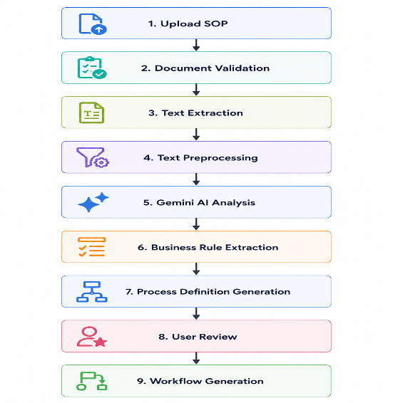

5.5.6 Business Rules
Rule ID | Business Rule
BR-SOP-001 | Only supported document formats shall be processed.
BR-SOP-002 | Uploaded SOP documents shall belong to the user's organization.
BR-SOP-003 | Original SOP documents shall remain unchanged after analysis.
BR-SOP-004 | Users shall review AI-generated process definitions before deployment.
BR-SOP-005 | Every uploaded SOP shall maintain version history.
BR-SOP-006 | AI-generated process definitions may be manually modified before workflow generation.
BR-SOP-007 | AI analysis results shall be stored for future reference and auditing.

5.5.7 Exception Handling
Exception | Expected System Response
Unsupported file format | Reject upload and display supported formats.
Empty document | Reject processing and request valid content.
Corrupted PDF/DOCX | Display document parsing error.
AI service unavailable | Notify user and allow retry later.
AI processing timeout | Cancel processing and display timeout message.
Invalid AI response | Log the error and request manual review.
Network interruption | Preserve uploaded document and resume processing when possible.

5.5.8 Acceptance Criteria
The SOP Intelligence Engine shall be considered complete when:
- Users can successfully upload supported SOP documents.
- Text is correctly extracted from uploaded documents.
- AI accurately identifies business rules, conditions, actions, approvals, and roles.
- Structured process definitions are successfully generated.
- Users can review and edit AI-generated results.
- Original SOP documents and generated process definitions are securely stored.
- SOP version history is maintained.
- AI processing failures are handled gracefully.
- Audit logs capture all SOP analysis activities.

5.6 Workflow Generation Engine
5.6.1 Module Description
The Workflow Generation Engine is responsible for automatically converting structured business process definitions into executable workflow models.
The engine receives AI-generated process definitions from the SOP Intelligence Engine and constructs workflow structures consisting of activities, decision nodes, approval chains, transitions, dependencies, and execution paths.
Unlike traditional workflow platforms that require users to manually design workflows, the Workflow Generation Engine automatically creates workflow diagrams and machine-executable workflow definitions.
The generated workflow serves as the foundation for workflow validation, simulation, execution, monitoring, and optimization.

5.6.2 Functional Requirements
Requirement ID | Functional Requirement | Priority
FR-091 | The system shall generate workflows automatically from AI-generated process definitions. | High
FR-092 | The system shall create workflow start nodes automatically. | High
FR-093 | The system shall create workflow end nodes automatically. | High
FR-094 | The system shall generate sequential workflow activities. | High
FR-095 | The system shall generate decision nodes for conditional logic. | High
FR-096 | The system shall generate approval nodes based on identified approval requirements. | High
FR-097 | The system shall generate parallel execution branches where applicable. | Medium
FR-098 | The system shall automatically connect workflow nodes based on extracted dependencies. | High
FR-099 | The system shall assign execution order to workflow activities. | High
FR-100 | The system shall generate workflow transitions between activities. | High
FR-101 | The system shall assign workflow roles to individual activities. | High
FR-102 | The system shall assign approval responsibilities to workflow steps. | High
FR-103 | The system shall generate workflow metadata including name, description, version, and owner. | Medium
FR-104 | The system shall generate a visual workflow diagram. | High
FR-105 | The system shall allow users to edit generated workflow diagrams before deployment. | High
FR-106 | The system shall support drag-and-drop editing of workflow nodes. | Medium
FR-107 | The system shall allow users to add custom workflow activities manually. | Medium
FR-108 | The system shall allow users to remove generated workflow activities. | Medium
FR-109 | The system shall allow users to modify workflow connections. | Medium
FR-110 | The system shall save workflow definitions in executable JSON format. | High
FR-111 | The system shall support workflow versioning. | Medium
FR-112 | The system shall allow users to duplicate existing workflows. | Low
FR-113 | The system shall maintain draft workflows before deployment. | High
FR-114 | The system shall store workflow generation history. | Medium
FR-115 | The system shall notify users when workflow generation is successfully completed. | Medium

5.6.3 Workflow Components
Each generated workflow shall consist of the following components:
Component | Description
Start Node | Beginning of the workflow
End Node | Completion of the workflow
Activity Node | Business task or operation
Decision Node | Conditional branching
Approval Node | Human approval step
Transition | Connection between workflow nodes
Role Assignment | Responsible organizational role
Conditions | Business rules controlling execution
Workflow Metadata | Name, version, owner, timestamps

5.6.4 Input
The Workflow Generation Engine shall accept:
Input | Description
Process Definition JSON | Structured output from SOP Intelligence Engine
Organization Settings | Organization-specific workflow rules
User Configuration | Optional workflow customization
Approval Rules | Organization approval policies

5.6.5 Output
The engine shall generate:
Output | Description
Workflow Diagram | Visual representation of workflow
Executable Workflow JSON | Machine-readable workflow definition
Activity List | Ordered workflow activities
Decision Tree | Conditional execution logic
Approval Chain | Approval hierarchy
Workflow Metadata | Version, owner, timestamps

5.6.6 Workflow Generation Process
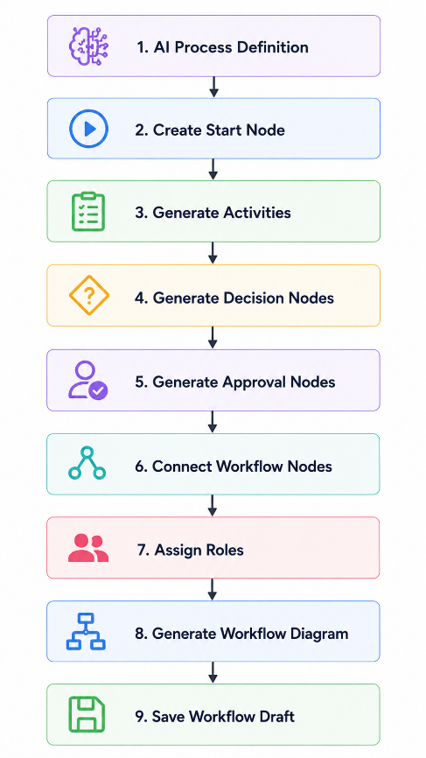
5.6.7 Business Rules
Rule ID | Business Rule
BR-WG-001 | Every workflow shall contain exactly one Start Node.
BR-WG-002 | Every workflow shall contain at least one End Node.
BR-WG-003 | Every workflow activity shall be reachable from the Start Node.
BR-WG-004 | Workflow activities shall follow the execution sequence extracted from the SOP.
BR-WG-005 | Decision nodes shall contain at least two execution paths.
BR-WG-006 | Approval nodes shall have assigned approvers before deployment.
BR-WG-007 | Generated workflows shall remain editable until deployment.
BR-WG-008 | Every workflow version shall be uniquely identifiable.

5.6.8 Exception Handling
Exception | Expected System Response
Missing process definition | Prevent workflow generation and display an error message.
Invalid workflow structure | Reject generation and request manual review.
Missing approval role | Notify user and highlight the affected workflow node.
Circular workflow detected | Stop generation and report validation error.
Database failure | Roll back workflow creation and log the incident.
Workflow generation failure | Preserve input data and allow users to retry.

5.6.9 Acceptance Criteria
The Workflow Generation Engine shall be considered complete when:
- Workflows are automatically generated from AI process definitions.
- Generated workflows accurately represent SOP logic.
- Visual workflow diagrams are displayed successfully.
- Users can edit workflow diagrams before deployment.
- Executable workflow definitions are stored correctly.
- Workflow version history is maintained.
- Workflow generation failures are handled gracefully.
- Generated workflows are ready for validation and simulation.

