Chapter 1: Introduction
1.1 Purpose
This Software Requirements Specification (SRS) defines the functional and non-functional requirements for ProcessMind AI, an AI-powered Autonomous Process Intelligence Platform.
The purpose of this document is to provide a complete and unambiguous specification for the design, development, testing, deployment, and maintenance of the platform. It serves as the primary reference for software developers, system architects, UI/UX designers, testers, project managers, stakeholders, and future contributors throughout the software development lifecycle.
This SRS documents the system's objectives, architecture, business requirements, functional modules, interfaces, constraints, security requirements, performance expectations, and quality attributes.
Furthermore, this document establishes a common understanding between all stakeholders regarding the platform's intended behavior, ensuring consistency throughout implementation while minimizing ambiguity and requirement changes.
The specification follows software engineering best practices and is intended to support future product evolution from a Minimum Viable Product (MVP) into a scalable enterprise Software-as-a-Service (SaaS) platform.
1.2 Scope
ProcessMind AI is an AI-powered Process Intelligence Platform designed to transform organizational Standard Operating Procedures (SOPs) into intelligent, executable, and continuously optimized business processes.
Unlike conventional workflow automation systems that require users to manually design workflows, ProcessMind AI leverages Artificial Intelligence to understand natural-language SOPs, automatically generate workflow models, validate process logic, simulate execution outcomes, orchestrate workflow execution, analyze operational performance, and recommend process improvements.
The primary objective of the platform is to bridge the gap between organizational knowledge and operational execution by enabling organizations to convert static documentation into intelligent operational systems.
The initial release (MVP) focuses on demonstrating these capabilities using a Leave Management workflow. However, the platform is designed with a domain-independent architecture, allowing it to support various enterprise business processes, including:
- Human Resource Management
- Procurement Management
- Invoice Processing
- Employee Onboarding
- Compliance Management
- IT Incident Management
- Vendor Approval
- Risk Assessment
- Operations Management
The platform aims to reduce manual effort, improve operational efficiency, enhance process visibility, minimize compliance risks, and support continuous business process optimization through AI-driven intelligence.

1.3 Definitions, Acronyms, and Abbreviations
Term | Definition
AI | Artificial Intelligence
API | Application Programming Interface
SOP | Standard Operating Procedure
SaaS | Software as a Service
JWT | JSON Web Token
RBAC | Role-Based Access Control
CRUD | Create, Read, Update, Delete
BPM | Business Process Management
BPMN | Business Process Model and Notation
UI | User Interface
UX | User Experience
REST | Representational State Transfer
JSON | JavaScript Object Notation
SQL | Structured Query Language
ORM | Object Relational Mapping
MVP | Minimum Viable Product
LLM | Large Language Model
AI Agent | An autonomous software component capable of reasoning, decision-making, and performing tasks using Artificial Intelligence
Workflow | A structured sequence of business activities executed to complete an organizational process
Process Intelligence | The capability of understanding, analyzing, validating, monitoring, optimizing, and improving business processes using AI and operational data
Organizational Knowledge | Business knowledge stored within SOPs, policies, procedures, documentation, and organizational rules
Organizational Digital Twin | A virtual representation of organizational processes used for simulation, prediction, and optimization before implementing operational changes

1.4 References
The design and implementation of ProcessMind AI are guided by established software engineering principles, enterprise architecture practices, workflow management concepts, and modern Artificial Intelligence technologies.
The following standards, methodologies, and technologies are referenced throughout the development of the platform:
Software Engineering Standards
- IEEE 29148 – Systems and Software Engineering Requirements Engineering
- IEEE 1016 – Software Design Description
- IEEE 830 (Legacy Software Requirements Specification Standard)
- ISO/IEC 25010 – Software Product Quality Model
Architectural Principles
- RESTful API Architecture
- Layered Software Architecture
- Clean Architecture
- Domain-Driven Design (DDD)
- SOLID Design Principles
Workflow and Business Process Standards
- Business Process Management (BPM)
- Business Process Model and Notation (BPMN)
- Workflow Orchestration Concepts
- State Machine Design Patterns
Artificial Intelligence Technologies
- Google Gemini Large Language Models
- Prompt Engineering
- AI-assisted Workflow Generation
- AI-powered Process Intelligence
Development Technologies
- Next.js
- React
- Spring Boot
- PostgreSQL
- Docker
- JWT Authentication
1.5 Document Overview
This Software Requirements Specification is organized into multiple chapters to provide a structured description of the ProcessMind AI platform.
The document begins with an overview of the product vision, objectives, and system context before defining detailed functional and non-functional requirements.
Subsequent chapters describe the platform architecture, user roles, business requirements, software modules, database design, AI components, workflow engine, security mechanisms, deployment architecture, and operational constraints.
The specification further includes comprehensive use case descriptions, workflow diagrams, sequence diagrams, state diagrams, database models, API specifications, and acceptance criteria to ensure complete traceability from business objectives to implementation.
The overall structure of this SRS is as follows:
- Chapter 1: Introduction
- Chapter 2: Overall Description
- Chapter 3: System Architecture
- Chapter 4: Business Requirements
- Chapter 5: Functional Requirements
- Chapter 6: AI Functional Requirements
- Chapter 7: Database Requirements
- Chapter 8: REST API Specifications
- Chapter 9: Security Requirements
- Chapter 10: Non-Functional Requirements
- Chapter 11: Use Case Specifications
- Chapter 12: Activity Diagrams
- Chapter 13: Sequence Diagrams
- Chapter 14: State Machine Diagrams
- Chapter 15: Entity Relationship Diagram
- Chapter 16: Deployment Architecture
- Chapter 17: Acceptance Criteria
- Chapter 18: Future Enhancements
This document is intended to evolve alongside the product, providing a comprehensive blueprint for the successful development, deployment, maintenance, and future expansion of ProcessMind AI into a full-scale enterprise Process Intelligence Platform.

Chapter 2: Overall Description
2.1 Product Perspective
ProcessMind AI is an AI-powered Process Intelligence Platform designed to transform organizational knowledge into intelligent, executable, and continuously optimized business processes.
The platform bridges the gap between business documentation and operational execution by enabling organizations to convert Standard Operating Procedures (SOPs) into automated workflows. Unlike traditional workflow automation platforms that require users to manually design process flows, ProcessMind AI leverages Artificial Intelligence to understand SOPs, generate workflows, validate business logic, simulate execution outcomes, orchestrate workflow execution, and recommend process improvements.
ProcessMind AI is designed as a cloud-based Software-as-a-Service (SaaS) platform with a modular and scalable architecture. The system follows a layered architecture consisting of a web-based user interface, backend services, AI intelligence layer, workflow orchestration engine, and data management layer.
The initial release of the platform focuses on Leave Management as the Minimum Viable Product (MVP). However, the architecture is domain-independent and is designed to support multiple enterprise domains, including Human Resources, Procurement, Finance, Compliance, IT Operations, Customer Support, and other workflow-driven business processes.
In the long term, ProcessMind AI aims to evolve into an AI Organizational Operating System capable of understanding, managing, and continuously optimizing organizational operations through intelligent process analysis and automation.

2.2 Product Functions
The primary functions of ProcessMind AI include:
SOP Management
- Upload SOPs in multiple formats (Text, PDF, DOCX)
- Store and manage organizational SOPs
- Maintain version history of SOPs

SOP Intelligence
- Analyze natural-language SOPs using Artificial Intelligence
- Extract business rules, conditions, approvals, and actions
- Convert unstructured procedures into structured process definitions
Workflow Generation
- Automatically generate workflow models from SOPs
- Create decision trees and approval chains
- Visualize generated workflows
Process Validation
- Detect missing approvals
- Detect conflicting business rules
- Identify undefined roles
- Detect circular dependencies
- Validate workflow completeness
Process Simulation
- Simulate workflows using different business scenarios
- Predict workflow execution paths
- Estimate completion times
- Analyze process outcomes before deployment
Workflow Execution
- Execute workflows dynamically
- Manage workflow states
- Route tasks automatically
- Pause and resume workflow execution
- Track workflow progress
Human Approval Management
- Request approvals
- Escalate pending approvals
- Track approval history
- Enforce approval deadlines

Process Analytics
- Monitor workflow performance
- Analyze workflow completion rates
- Measure approval delays
- Identify process bottlenecks
Process Optimization
- Recommend workflow improvements
- Identify redundant process steps
- Suggest approval optimizations
- Improve organizational efficiency
Administration
- Manage users and organizations
- Configure workflows
- Manage roles and permissions
- Configure AI settings
- Monitor platform health
Notification Management
- Email notifications
- In-app notifications
- Workflow status notifications
- Approval reminders
- Escalation notifications
2.3 User Classes and Characteristics
ProcessMind AI supports multiple user roles, each with different responsibilities and system privileges.
System Administrator
The System Administrator manages the overall platform configuration and operational environment.
Responsibilities include:
- Manage organizations
- Configure system settings
- Manage user accounts
- Assign user roles
- Monitor system health
- View audit logs
- Configure AI services
Required Skills:
- Basic system administration knowledge
- Organizational process understanding
Organization Administrator
The Organization Administrator manages business processes within a specific organization.
Responsibilities include:
- Upload SOPs
- Generate workflows
- Deploy workflows
- Manage departments
- Configure approvals
- Monitor organizational workflows
Required Skills:
- Business process management
- Organizational policy knowledge

Process Analyst
The Process Analyst evaluates and improves business processes.
Responsibilities include:
- Review SOPs
- Validate workflows
- Run process simulations
- Analyze workflow performance
- Review optimization recommendations
Required Skills:
- Business analysis
- Process improvement methodologies

Manager / Approver
Managers participate in approval workflows.
Responsibilities include:
- Review approval requests
- Approve or reject business processes
- Track assigned workflows
- Monitor approval history
Required Skills:
- Departmental knowledge
- Organizational decision-making authority
Employee
Employees interact with workflows generated by the platform.
Responsibilities include:
- Submit requests
- Track workflow progress
- Respond to assigned tasks
- View notifications
Required Skills:
- Basic computer literacy
AI Services (External Actor)
Artificial Intelligence services assist the platform by performing reasoning-based operations.
Responsibilities include:
- SOP understanding
- Workflow generation
- Validation reasoning
- Process optimization
- Simulation support

2.4 Operating Environment
ProcessMind AI is designed as a cloud-native web application.
Client Environment
Supported Web Browsers:
- Google Chrome
- Microsoft Edge
- Mozilla Firefox
- Safari
Supported Devices:
- Desktop Computers
- Laptops
- Tablets

Server Environment
Backend:
- Java 21
- Spring Boot
Frontend:
- Next.js
- React
- TypeScript
Database:
- PostgreSQL
AI Services:
- Google Gemini API
Containerization:
- Docker
- Docker Compose

Deployment:
- Vercel (Frontend)
- Render (Backend)
- Neon PostgreSQL (Database)

Network Requirements
- Stable internet connection
- HTTPS-enabled communication
- REST API communication
- Secure authentication
2.5 Assumptions and Dependencies
The development and operation of ProcessMind AI assume the following:
Assumptions
- Users have internet connectivity.
- Organizations possess documented SOPs or business procedures.
- Uploaded SOPs are written in understandable natural language.
- Users have valid system accounts before accessing protected resources.
- AI services are available during workflow generation and validation.
- Users possess basic computer literacy.
- Organizations are willing to digitize business processes.
- System clocks remain synchronized across infrastructure.
Dependencies
The platform depends on:
- Google Gemini API for AI reasoning
- PostgreSQL database availability
- Cloud hosting infrastructure
- Email service provider for notifications
- Internet connectivity
- Modern web browsers

Future versions may additionally depend on:
- Temporal.io
- Neo4j Graph Database
- Enterprise Identity Providers
- Cloud Object Storage
2.6 Constraints
The following constraints apply to ProcessMind AI.
Technical Constraints
- The frontend shall be developed using Next.js and React.
- The backend shall be implemented using Java Spring Boot.
- PostgreSQL shall be used as the primary relational database.
- Artificial Intelligence capabilities shall initially rely on Google Gemini APIs.
- Communication between frontend and backend shall use RESTful APIs.
- The system shall support Docker-based deployment.
Business Constraints
- The initial release shall focus on Leave Management as the primary demonstration domain.
- Workflow execution shall require administrator deployment before becoming active.
- Human approvals shall remain mandatory for configured approval stages.
- AI-generated workflows shall be reviewed by users before deployment.
Operational Constraints
- AI-based features depend on external AI service availability.
- Workflow execution requires continuous backend availability.
- Email notifications require a configured email service.
- Cloud deployment requires internet access.
Security Constraints
- User authentication shall be mandatory.
- Role-Based Access Control (RBAC) shall be enforced.
- Passwords shall never be stored in plain text.
- All communication shall occur over HTTPS.
- Sensitive credentials shall be stored as secure environment variables.

Scalability Constraints
- The MVP is designed for small to medium-sized organizations.
- Future releases shall support multi-tenant enterprise deployments.
- The architecture shall allow horizontal scaling of backend services.
- AI components shall be replaceable without significant changes to the overall system architecture.
This overall description establishes the context, scope, user environment, assumptions, and operational boundaries of ProcessMind AI and provides the foundation for the detailed functional and non-functional requirements described in subsequent chapters.

Chapter 3: System Architecture
3.1 System Architecture Overview
ProcessMind AI follows a modular, cloud-native, layered architecture that separates presentation, business logic, artificial intelligence, workflow orchestration, and data management into independent components.
This architecture promotes scalability, maintainability, security, extensibility, and high system availability while allowing future integration of additional AI services, workflow engines, enterprise systems, and organizational intelligence capabilities.
The platform consists of six primary architectural layers:
- Presentation Layer
- Application Layer
- Process Intelligence Layer
- Workflow Orchestration Layer
- Data Layer
- External Services Layer
Each layer has clearly defined responsibilities and communicates through secure RESTful APIs and internal service interfaces.

3.2 High-Level Architecture
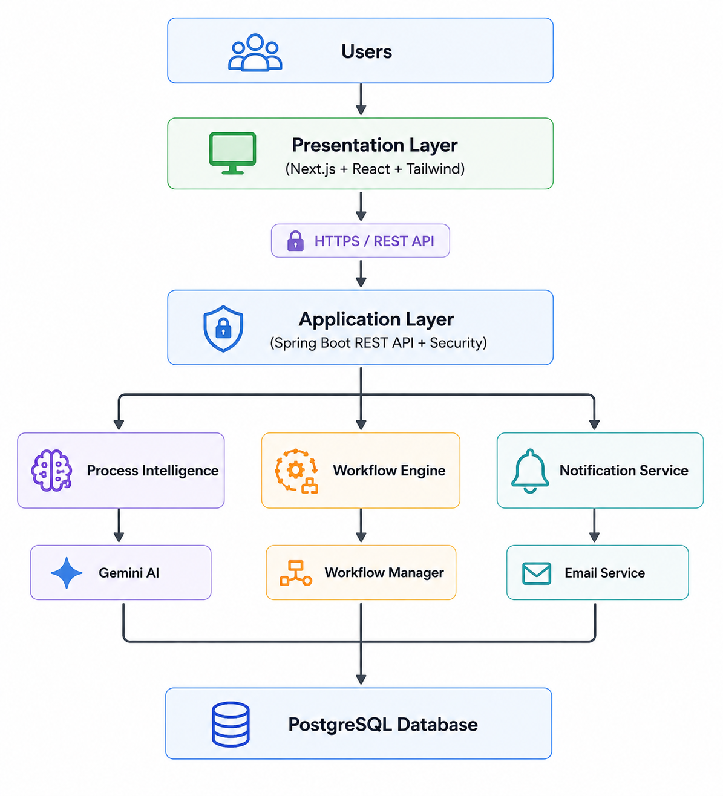
3.3 Architectural Layers
3.3.1 Presentation Layer
Purpose
Provides the graphical user interface through which users interact with the system.
Technologies
- Next.js
- React
- TypeScript
- Tailwind CSS
- React Flow
Responsibilities
- User Authentication
- Dashboard
- SOP Upload
- Workflow Visualization
- Process Simulation Interface
- Approval Dashboard
- Analytics Dashboard
- Administration Panel
- Notification Center
Users
- Employee
- Manager
- Process Analyst
- Organization Administrator
- System Administrator
3.3.2 Application Layer
Purpose
Acts as the central backend responsible for handling business logic and coordinating communication between all system components.
Technologies
- Java 21
- Spring Boot
- Spring Security
- Spring Data JPA
- Hibernate
Responsibilities
- REST API Management
- Authentication
- Authorization
- Request Validation
- Business Logic
- Workflow Coordination
- Database Communication
- External AI Communication
3.3.3 Process Intelligence Layer
Purpose
Provides Artificial Intelligence capabilities for understanding, analyzing, validating, and optimizing business processes.
This layer differentiates ProcessMind AI from traditional workflow automation platforms.
Components
SOP Intelligence Engine
Responsibilities:
- Understand SOPs
- Extract business rules
- Identify approvals
- Identify actions
- Detect dependencies
Workflow Generation Engine
Responsibilities:
- Generate workflow structures
- Create decision trees
- Build workflow graphs
- Generate workflow JSON
Process Validation Engine
Responsibilities:
- Detect logical conflicts
- Detect missing approvals
- Detect undefined roles
- Detect circular dependencies
- Evaluate workflow quality
Process Simulation Engine
Responsibilities:
- Execute virtual workflow scenarios
- Predict workflow outcomes
- Estimate completion time
- Identify execution paths
Process Optimization Engine
Responsibilities:
- Detect bottlenecks
- Recommend workflow improvements
- Reduce approval delays
- Simplify workflows
3.3.4 Workflow Orchestration Layer
Purpose
Executes generated workflows and manages workflow lifecycle.
Components
Workflow Engine
Responsibilities:
- Start workflows
- Execute workflow steps
- Route tasks
- Pause workflows
- Resume workflows
- Complete workflows
Approval Engine
Responsibilities:
- Approval routing
- Approval notifications
- Escalations
- Approval history

State Manager
Responsibilities:
Maintain workflow states:
- Draft
- Active
- Running
- Waiting Approval
- Completed
- Failed
Notification Manager
Responsibilities:
- Email notifications
- In-app notifications
- Approval reminders
- Escalation alerts

3.3.5 Data Layer
Purpose
Store all business and operational data.
Database
PostgreSQL
Stored Data
- Users
- Organizations
- Departments
- SOP Documents
- Workflow Definitions
- Workflow Instances
- Workflow Logs
- Approval Records
- Notifications
- Analytics Data
- Audit Logs
3.3.6 External Services Layer
Artificial Intelligence
Google Gemini API
Responsibilities
- SOP reasoning
- Workflow generation
- Validation reasoning
- Simulation reasoning
- Optimization recommendations

Email Service
Responsibilities
- Send notifications
- Approval requests
- Reminder emails
Cloud Storage (Future)
Responsibilities
- Store uploaded documents
- Archive SOP versions
3.4 Component Interaction
The following sequence describes the interaction among the major components.
- User uploads an SOP.
- Frontend sends the document to the backend.
- Backend forwards the SOP to the SOP Intelligence Engine.
- Gemini AI analyzes the SOP.
- Structured workflow information is returned.
- Workflow Generation Engine creates the workflow.
- Process Validation Engine verifies the workflow.
- Process Simulation Engine performs simulations.
- Administrator reviews the generated workflow.
- Workflow is deployed.
- Workflow Engine executes workflow instances.
- Analytics Engine collects execution data.
- Process Optimization Engine generates recommendations.
3.5 Data Flow
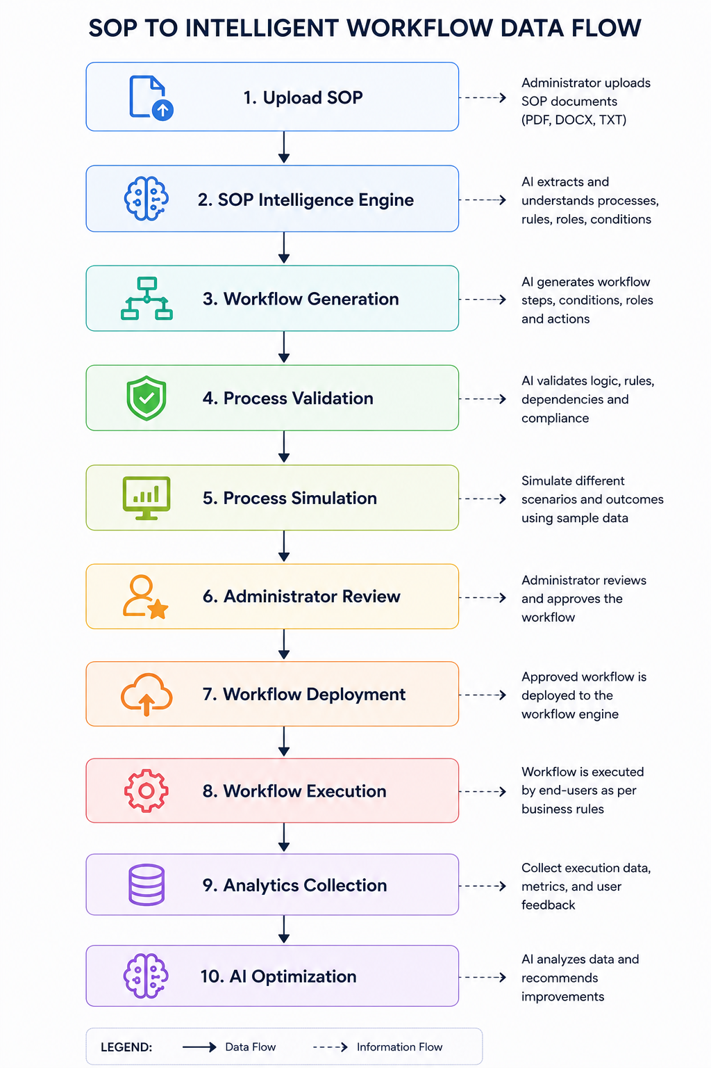

3.6 Deployment Architecture
The platform follows a cloud-native deployment model.
Frontend
- Next.js
- Hosted on Vercel
Backend
- Spring Boot
- Hosted on Render
Database
- PostgreSQL
- Hosted on Neon
AI Services
- Google Gemini API
Containerization
- Docker
- Docker Compose
3.7 Security Architecture
The architecture incorporates multiple security layers.
Authentication
- JWT Authentication
- Spring Security
Authorization
Role-Based Access Control (RBAC)
Password Protection
- BCrypt Hashing
Communication Security
- HTTPS
- Secure REST APIs

Secrets Management
- Environment Variables
- API Keys
- Database Credentials
Audit Logging
All critical operations are logged for traceability.
3.8 Scalability Considerations
The architecture is designed to support future growth.
Horizontal Scaling
Backend services can be replicated.
Database Scaling
PostgreSQL supports replication and future sharding strategies.
AI Provider Abstraction
The AI layer is designed with provider abstraction, allowing Gemini to be replaced or complemented by other AI providers such as OpenAI, Anthropic, or self-hosted models without significant architectural changes.
Future Enterprise Extensions
The architecture supports future integration of:
- Multi-Agent Systems
- Organizational Knowledge Graph
- Organizational Digital Twin
- Process Mining
- Enterprise Identity Providers
- Temporal.io Workflow Orchestration
- Predictive Process Analytics
This modular architecture ensures that ProcessMind AI can evolve from a startup Minimum Viable Product (MVP) into a scalable enterprise Process Intelligence Platform capable of supporting organizations of varying sizes and operational complexity.

Chapter 4: Business Requirements
4.1 Business Overview
Organizations rely on Standard Operating Procedures (SOPs) to define how business processes should be executed. These SOPs are commonly maintained as documents such as PDFs, Word files, spreadsheets, or internal knowledge-base articles.
Although these documents define organizational operations, they are passive and require employees to manually interpret procedures, make decisions, request approvals, and execute tasks. This manual approach often results in inconsistent execution, process delays, compliance risks, operational inefficiencies, and limited visibility into business performance.
ProcessMind AI addresses these challenges by transforming static SOPs into intelligent, executable, and continuously optimized workflows. The platform combines Artificial Intelligence with workflow orchestration to automate process understanding, workflow generation, validation, simulation, execution, monitoring, and optimization.
The platform is designed to reduce operational costs, improve business efficiency, accelerate decision-making, and provide organizations with greater visibility into their operational processes.

4.2 Business Goals
The primary business goals of ProcessMind AI are:
- Enable organizations to digitize business processes from existing SOPs.
- Reduce manual effort involved in interpreting and executing procedures.
- Automate workflow generation using Artificial Intelligence.
- Improve workflow accuracy through automated validation.
- Minimize approval delays and operational bottlenecks.
- Enhance compliance with organizational policies.
- Improve visibility into workflow execution and performance.
- Support continuous process improvement through AI-driven recommendations.
- Provide a scalable Software-as-a-Service (SaaS) platform suitable for organizations of different sizes.

4.3 Business Objectives
The platform shall achieve the following objectives:
BO-001
Automatically convert natural-language SOPs into structured workflow definitions.
Priority: High

BO-002
Reduce the time required to design business workflows compared to manual workflow creation.
Priority: High

BO-003
Detect process design issues before workflow deployment.
Priority: High

BO-004
Allow organizations to simulate workflow behavior prior to deployment.
Priority: High

BO-005
Execute approved workflows using an automated workflow engine.
Priority: High

BO-006
Provide real-time visibility into workflow execution and operational performance.
Priority: High

BO-007
Identify workflow bottlenecks and recommend optimization opportunities using Artificial Intelligence.
Priority: Medium

BO-008
Support multiple business domains through reusable workflow architecture.
Priority: Medium

BO-009
Provide secure, role-based access to organizational resources.
Priority: High

BO-010
Enable future integration with enterprise systems and third-party services.
Priority: Medium

4.4 Business Requirements
BR-001: SOP Digitization
Priority: High
The system shall enable organizations to upload and manage Standard Operating Procedures (SOPs) in digital formats and convert them into structured business process definitions.

BR-002: AI-Powered Process Understanding
Priority: High
The platform shall analyze uploaded SOPs using Artificial Intelligence to identify business rules, conditions, actions, approval chains, roles, and dependencies.

BR-003: Automatic Workflow Generation
Priority: High
The platform shall automatically generate executable workflow models from AI-generated process definitions without requiring manual workflow design.

BR-004: Workflow Validation
Priority: High
The platform shall validate generated workflows to identify logical conflicts, missing approvals, undefined roles, circular dependencies, and incomplete business rules before deployment.

BR-005: Workflow Simulation
Priority: High
The platform shall simulate business workflows using different input scenarios to predict execution outcomes before workflows are deployed into production.

BR-006: Workflow Execution
Priority: High
The platform shall execute approved workflows while maintaining workflow state, routing tasks, and tracking execution progress.

BR-007: Human Approval Management
Priority: High
The platform shall support configurable approval workflows involving managers, department heads, administrators, and other authorized personnel.

BR-008: Organizational Analytics
Priority: High
The platform shall provide dashboards that visualize workflow performance, completion rates, approval delays, execution statistics, and operational metrics.

BR-009: Process Optimization
Priority: Medium
The platform shall analyze workflow execution history and recommend improvements that reduce delays, eliminate redundant activities, and improve operational efficiency.

BR-010: Notification Management
Priority: Medium
The platform shall notify users regarding workflow status changes, approval requests, reminders, escalations, and completed tasks.

BR-011: User and Organization Management
Priority: High
The platform shall provide facilities to manage organizations, departments, users, roles, permissions, and system configurations.

BR-012: Security and Access Control
Priority: High
The platform shall ensure that organizational data is protected using authentication, authorization, encrypted communication, audit logging, and role-based access control mechanisms.

BR-013: Multi-Tenant Architecture
Priority: Medium
The platform shall support multiple organizations while ensuring complete isolation of organizational data and business processes.

BR-014: Scalability
Priority: Medium
The platform shall support increasing numbers of organizations, users, workflows, and process executions without significant degradation in performance.

BR-015: AI Extensibility
Priority: Medium
The platform shall be designed with an abstract AI service layer to allow future integration of multiple AI providers without significant architectural modifications.

4.5 Business Value
The implementation of ProcessMind AI provides measurable business value to organizations.
Expected benefits include:
- Reduced workflow design time.
- Faster process execution.
- Improved operational efficiency.
- Increased process consistency.
- Reduced manual errors.
- Improved compliance with organizational policies.
- Enhanced process transparency.
- Reduced dependency on external business process consultants.
- Continuous AI-driven process optimization.
- Improved decision-making through operational analytics.

4.6 Stakeholders
The primary stakeholders of ProcessMind AI include:
Stakeholder | Responsibility
Organization Owners | Adopt and manage the platform within the organization
Organization Administrators | Configure workflows, users, and system settings
Process Analysts | Analyze, validate, and optimize business processes
Managers | Review and approve workflow requests
Employees | Submit requests and participate in workflows
System Administrators | Maintain the platform infrastructure
Software Developers | Design, implement, and maintain the application
Quality Assurance Engineers | Verify system quality and compliance
Business Analysts | Gather and validate business requirements
Future Investors | Evaluate the business value and scalability of the platform

4.7 Business Success Criteria
ProcessMind AI shall be considered successful when it demonstrates the following outcomes:
- Organizations can successfully upload SOPs and generate workflows automatically.
- Workflow generation significantly reduces manual process design effort.
- Workflow validation identifies logical issues before deployment.
- Simulations accurately predict workflow execution paths.
- Workflow execution operates reliably in production.
- Approval processes are completed efficiently.
- Analytics provide actionable operational insights.
- AI-generated optimization recommendations contribute to measurable process improvements.
- The platform supports multiple organizations securely.
- The system provides a scalable foundation for future enterprise expansion and advanced AI capabilities.
The business requirements defined in this chapter establish the strategic objectives and expected business outcomes of ProcessMind AI. These requirements provide the foundation for the detailed functional requirements described in the following chapters.

Chapter 5: Functional Requirements
5.1 Overview
This chapter specifies the functional requirements of ProcessMind AI. Functional requirements describe the services, behaviors, and operations that the system must perform to satisfy business objectives.
Each functional requirement is assigned a unique identifier (FR-XXX) to support requirement traceability throughout the software development life cycle.
The functional requirements are organized according to the major software modules of the platform.

Functional Modules
The ProcessMind AI platform consists of the following functional modules:
- Authentication and Authorization Module
- User Management Module
- Organization Management Module
- SOP Intelligence Engine
- Workflow Generation Engine
- Process Validation Engine
- Process Simulation Engine
- Workflow Execution Engine
- Human Approval Engine
- Analytics Dashboard
- Process Optimization Engine
- Notification Module
- Administration Module
Each module is described in detail in the following sections.

5.2 Authentication and Authorization Module
5.2.1 Module Description
The Authentication and Authorization Module is responsible for securely identifying users, authenticating their credentials, authorizing access to system resources, and enforcing Role-Based Access Control (RBAC). This module ensures that only authorized users can access protected functionalities while maintaining the confidentiality, integrity, and security of organizational data.

5.2.2 Functional Requirements
Requirement ID | Functional Requirement | Priority
FR-001 | The system shall allow Organization Administrators to register new users within their organization. | High
FR-002 | The system shall allow registered users to log in using their email address and password. | High
FR-003 | The system shall validate user credentials before granting access to the system. | High
FR-004 | The system shall generate a secure JWT access token after successful authentication. | High
FR-005 | The system shall verify the validity of the JWT token before processing every protected API request. | High
FR-006 | The system shall deny access to protected resources when authentication fails. | High
FR-007 | The system shall enforce Role-Based Access Control (RBAC) based on assigned user roles. | High
FR-008 | The system shall allow authenticated users to securely log out of the system. | Medium
FR-009 | The system shall securely hash user passwords using BCrypt before storing them in the database. | High
FR-010 | The system shall never store passwords in plain text. | High
FR-011 | The system shall allow users to change their passwords after successful authentication. | Medium
FR-012 | The system shall provide a secure password reset mechanism for users who forget their passwords. | Medium
FR-013 | The system shall enforce configurable password complexity requirements during password creation and updates. | Medium
FR-014 | The system shall automatically invalidate expired JWT tokens. | High
FR-015 | The system shall terminate user sessions when users log out or when authentication tokens expire. | High
FR-016 | The system shall restrict users from accessing modules outside their assigned permissions. | High
FR-017 | The system shall prevent disabled or inactive user accounts from authenticating. | High
FR-018 | The system shall record all authentication activities, including successful logins, failed login attempts, password changes, and logout events in the audit log. | Medium
FR-019 | The system shall allow administrators to activate, deactivate, suspend, or reactivate user accounts. | Medium
FR-020 | The system shall return appropriate HTTP status codes (401 Unauthorized, 403 Forbidden) for unauthorized access attempts. | High

5.2.3 Supported User Roles
Role | Description
System Administrator | Full access to the entire platform and system configuration.
Organization Administrator | Manages users, SOPs, workflows, departments, and organizational settings.
Process Analyst | Reviews SOPs, validates workflows, performs simulations, and analyzes business processes.
Manager | Reviews and approves workflow requests assigned to them.
Employee | Submits requests, tracks workflow status, and performs assigned workflow tasks.

5.2.4 Preconditions
- Users must have a registered account.
- User account must belong to an active organization.
- Authentication service must be available.
- Database connection must be active.

5.2.5 Postconditions
- Authenticated users receive a valid JWT access token.
- User session is established.
- User role and permissions are loaded.
- Authentication events are recorded in the audit log.
5.2.6 Business Rules
Rule ID | Business Rule
BR-AUTH-001 | Every protected resource shall require authentication.
BR-AUTH-002 | Each user shall belong to exactly one organization.
BR-AUTH-003 | Passwords shall never be stored in plain text.
BR-AUTH-004 | JWT tokens shall have a configurable expiration period.
BR-AUTH-005 | Only authorized administrators may create, activate, suspend, or deactivate user accounts.
BR-AUTH-006 | Access permissions shall be determined solely by assigned user roles.

5.2.7 Exception Handling
Exception | Expected System Response
Invalid email address | Reject authentication and display an appropriate error message.
Incorrect password | Reject authentication without revealing which credential is incorrect.
Expired JWT token | Reject the request and require the user to authenticate again.
Disabled account | Prevent login and notify the user that the account is inactive.
Unauthorized access | Return HTTP 403 (Forbidden).
Missing authentication token | Return HTTP 401 (Unauthorized).
Database unavailable | Return an internal server error and log the incident.

5.2.8 Acceptance Criteria
The Authentication and Authorization Module shall be considered complete when:
- Users can securely authenticate using valid credentials.
- JWT-based authentication functions correctly.
- Role-Based Access Control (RBAC) is enforced across all protected resources.
- Passwords are securely hashed using BCrypt.
- Unauthorized users cannot access restricted modules.
- Authentication events are successfully recorded in the audit log.
- Users can securely log out and terminate active sessions.
5.3 User Management Module
5.3.1 Module Description
The User Management Module enables administrators to manage user accounts within their organizations while allowing users to maintain their personal profiles. The module supports user creation, profile updates, role assignment, account status management, and user search operations.
The module ensures that only authorized administrators can perform administrative user management functions, while individual users are limited to managing their own profile information.

5.3.2 Functional Requirements
Requirement ID | Functional Requirement | Priority
FR-021 | The system shall allow Organization Administrators to create new user accounts. | High
FR-022 | The system shall allow administrators to assign roles during user creation. | High
FR-023 | The system shall validate that each email address is unique within the organization. | High
FR-024 | The system shall automatically generate a unique User ID for every registered user. | High
FR-025 | The system shall allow administrators to update user information. | High
FR-026 | The system shall allow users to update their own profile information. | Medium
FR-027 | The system shall prevent users from modifying their assigned roles. | High
FR-028 | The system shall allow administrators to change user roles. | High
FR-029 | The system shall allow administrators to activate or deactivate user accounts. | High
FR-030 | The system shall allow administrators to temporarily suspend user accounts. | Medium
FR-031 | The system shall allow administrators to permanently delete inactive user accounts. | Medium
FR-032 | The system shall prevent deletion of users who own active workflows unless ownership is transferred. | High
FR-033 | The system shall maintain complete user profile information, including name, email, department, role, and contact information. | Medium
FR-034 | The system shall allow administrators to search users using name, email, department, or role. | Medium
FR-035 | The system shall support filtering users based on account status. | Medium
FR-036 | The system shall display the user's account status (Active, Inactive, Suspended). | Medium
FR-037 | The system shall display each user's assigned role and department. | Medium
FR-038 | The system shall record the account creation date and last login date for every user. | Medium
FR-039 | The system shall maintain an audit history of user account modifications. | High
FR-040 | The system shall prevent duplicate user records from being created. | High

5.3.3 User Information
Each user account shall maintain the following information:
Field | Description
User ID | Unique system-generated identifier
First Name | User's first name
Last Name | User's last name
Email Address | Login email address
Password | Securely hashed password
Role | Assigned system role
Department | Associated department
Contact Number | Optional contact information
Account Status | Active, Inactive, Suspended
Organization | Organization to which the user belongs
Created Date | Account creation timestamp
Last Login | Most recent successful login
Updated Date | Last profile modification timestamp

5.3.4 Preconditions
- Organization exists.
- Administrator is authenticated.
- Administrator has permission to manage users.
- Database connection is available.
5.3.5 Postconditions
- User account is successfully created, updated, suspended, activated, or deleted.
- Audit logs are updated.
- Notifications are generated where applicable.
- Database records are synchronized.
5.3.6 Business Rules
Rule ID | Business Rule
BR-USER-001 | Every user shall belong to exactly one organization.
BR-USER-002 | Every user shall have exactly one primary system role.
BR-USER-003 | Email addresses shall be unique within an organization.
BR-USER-004 | Users shall only modify their own personal profile information.
BR-USER-005 | Only administrators may modify user roles.
BR-USER-006 | Only administrators may deactivate or delete user accounts.
BR-USER-007 | Deleted accounts shall be retained in audit logs for traceability.

5.3.7 Exception Handling
Exception | Expected System Response
Duplicate email address | Reject account creation and display an appropriate validation message.
Invalid user information | Reject submission and display validation errors.
Unauthorized role modification | Return HTTP 403 Forbidden.
Attempt to delete active workflow owner | Prevent deletion and request workflow reassignment.
Database unavailable | Return internal server error and log the incident.

5.3.8 Acceptance Criteria
The User Management Module shall be considered complete when:
- Administrators can successfully create, update, suspend, activate, and delete user accounts.
- Users can update their personal profiles.
- Duplicate user accounts are prevented.
- Role assignments are enforced correctly.
- User search and filtering functions operate correctly.
- All account modifications are recorded in audit logs.
- User information is stored and retrieved accurately.

5.4 Organization Management Module
5.4.1 Module Description
The Organization Management Module enables the creation, configuration, and administration of organizations within the ProcessMind AI platform. It provides complete isolation of organizational data, allowing multiple organizations to securely share the same application infrastructure while ensuring that users can only access resources belonging to their own organization.
The module manages organization profiles, departments, business settings, workflow configurations, subscription information, and organizational preferences.

5.4.2 Functional Requirements
Requirement ID | Functional Requirement | Priority
FR-041 | The system shall allow a System Administrator to register a new organization. | High
FR-042 | The system shall generate a unique Organization ID for every organization. | High
FR-043 | The system shall allow Organization Administrators to update organization information. | High
FR-044 | The system shall allow administrators to configure organization settings. | Medium
FR-045 | The system shall support multiple organizations within the same platform. | High
FR-046 | The system shall isolate data belonging to different organizations. | High
FR-047 | The system shall prevent users from accessing data belonging to other organizations. | High
FR-048 | The system shall allow administrators to create departments within an organization. | High
FR-049 | The system shall allow administrators to update department information. | Medium
FR-050 | The system shall allow administrators to deactivate departments. | Medium
FR-051 | The system shall associate users with departments. | High
FR-052 | The system shall allow administrators to configure organization-specific approval rules. | High
FR-053 | The system shall maintain organization-specific workflow settings. | High
FR-054 | The system shall support organization-specific notification settings. | Medium
FR-055 | The system shall allow administrators to configure business hours and working days. | Medium
FR-056 | The system shall allow administrators to upload organization branding elements such as logos. | Low
FR-057 | The system shall maintain subscription information for each organization. | Medium
FR-058 | The system shall allow administrators to archive inactive organizations. | Low
FR-059 | The system shall maintain audit logs for organization-level changes. | High
FR-060 | The system shall prevent duplicate organization names where configured by business rules. | Medium

5.4.3 Organization Information
Each organization shall maintain the following information:
Field | Description
Organization ID | Unique system-generated identifier
Organization Name | Registered organization name
Industry | Business sector or industry
Registration Number | Organization registration number (optional)
Organization Email | Primary contact email
Contact Number | Primary contact number
Address | Organization address
Logo | Organization logo
Time Zone | Organization time zone
Working Days | Configurable business days
Business Hours | Daily operating hours
Subscription Plan | Current subscription tier
Organization Status | Active, Inactive, Archived
Created Date | Organization creation date
Updated Date | Last modification date

5.4.4 Department Information
Each department shall contain:
Field | Description
Department ID | Unique department identifier
Department Name | Name of the department
Department Manager | Assigned manager
Description | Department description
Organization ID | Associated organization
Status | Active or Inactive

5.4.5 Preconditions
- System Administrator is authenticated.
- Organization registration request is valid.
- Database connection is available.
- Organization information passes validation.

5.4.6 Postconditions
- Organization is successfully created or updated.
- Departments are stored correctly.
- Organization settings are applied.
- Audit logs are updated.
- Organization becomes available for user registration.

5.4.7 Business Rules
Rule ID | Business Rule
BR-ORG-001 | Every organization shall have a unique Organization ID.
BR-ORG-002 | Each user shall belong to only one organization.
BR-ORG-003 | Users shall only access data belonging to their organization.
BR-ORG-004 | Departments shall belong to exactly one organization.
BR-ORG-005 | Organization Administrators shall only manage their own organization.
BR-ORG-006 | System Administrators may manage all organizations.
BR-ORG-007 | Organization settings shall override system defaults where applicable.

5.4.8 Exception Handling
Exception | Expected System Response
Duplicate organization | Reject registration and notify administrator.
Invalid organization information | Display validation errors.
Unauthorized organization access | Return HTTP 403 Forbidden.
Missing required organization data | Prevent organization creation.
Database unavailable | Return internal server error and record the incident.

5.4.9 Acceptance Criteria
The Organization Management Module shall be considered complete when:
- Multiple organizations can be registered successfully.
- Organization data remains completely isolated between tenants.
- Departments can be created, updated, and managed.
- Organization settings are stored and applied correctly.
- Users cannot access resources belonging to another organization.
- Organization administrators can manage only their own organization.
- All organization-level changes are recorded in audit logs.

5.5 SOP Intelligence Engine
5.5.1 Module Description
The SOP Intelligence Engine is the core Artificial Intelligence module of ProcessMind AI. It is responsible for understanding, interpreting, and transforming natural-language Standard Operating Procedures (SOPs) into structured business process definitions that can be used for workflow generation, validation, simulation, and execution.
Unlike traditional workflow platforms that require users to manually create workflows, the SOP Intelligence Engine enables organizations to upload existing SOP documents and automatically extract business logic using Artificial Intelligence.
The engine utilizes Large Language Models (LLMs) to identify business rules, conditions, actions, approvals, roles, dependencies, decision points, and workflow sequences.
The generated structured process definition serves as the foundation for all downstream modules within the platform.
5.5.2 Functional Requirements
Requirement ID | Functional Requirement | Priority
FR-061 | The system shall allow users to upload SOP documents in supported formats. | High
FR-062 | The system shall support Plain Text (.txt) SOP documents. | High
FR-063 | The system shall support PDF documents. | High
FR-064 | The system shall support Microsoft Word (.docx) documents. | High
FR-065 | The system shall validate uploaded document formats before processing. | High
FR-066 | The system shall reject unsupported file formats. | High
FR-067 | The system shall extract readable text from uploaded documents. | High
FR-068 | The system shall preprocess extracted text before AI analysis. | High
FR-069 | The system shall send SOP content to the AI reasoning engine for analysis. | High
FR-070 | The AI shall identify workflow start points. | High
FR-071 | The AI shall identify workflow end points. | High
FR-072 | The AI shall identify business actions described in the SOP. | High
FR-073 | The AI shall identify business conditions within the SOP. | High
FR-074 | The AI shall identify approval requirements. | High
FR-075 | The AI shall identify organizational roles involved in the process. | High
FR-076 | The AI shall identify dependencies between workflow steps. | High
FR-077 | The AI shall detect sequential workflow activities. | High
FR-078 | The AI shall detect conditional branching logic. | High
FR-079 | The AI shall identify parallel workflow activities where applicable. | Medium
FR-080 | The AI shall identify workflow inputs and outputs. | Medium
FR-081 | The AI shall generate a structured process definition in JSON format. | High
FR-082 | The system shall display the extracted process definition for user review. | High
FR-083 | The system shall allow users to manually edit AI-generated process definitions before workflow generation. | High
FR-084 | The system shall store both the original SOP and the extracted process definition. | High
FR-085 | The system shall maintain version history for uploaded SOPs. | Medium
FR-086 | The system shall support re-analysis of updated SOP documents. | Medium
FR-087 | The system shall log AI processing results for auditing purposes. | Medium
FR-088 | The system shall notify users when SOP analysis is completed successfully. | Medium
FR-089 | The system shall display meaningful error messages if AI processing fails. | High
FR-090 | The system shall allow users to retry SOP analysis after correcting errors. | Medium

5.5.3 Input
The SOP Intelligence Engine shall accept the following inputs:
Input | Description
Plain Text | User-entered SOP text
PDF | Uploaded PDF document
DOCX | Uploaded Microsoft Word document
SOP Metadata | Title, description, department, category
Organization Information | Organization context for AI reasoning

5.5.4 Output
The engine shall produce the following outputs:
Output | Description
Structured Workflow JSON | Machine-readable workflow definition
Business Rules | Extracted business logic
Conditions | Decision conditions
Workflow Steps | Ordered list of process activities
Approval Chain | Approval hierarchy
Roles | Organizational roles involved
Dependencies | Relationships between workflow steps
AI Analysis Report | Summary of extracted information

5.5.5 AI Processing Flow
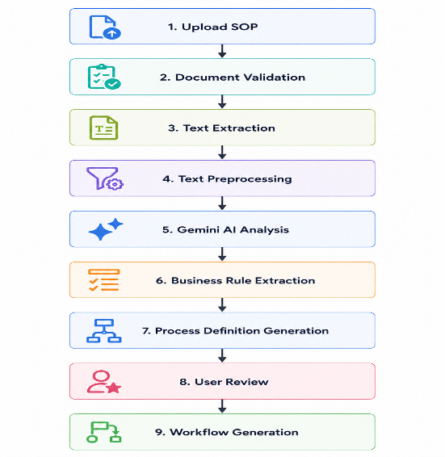

5.5.6 Business Rules
Rule ID | Business Rule
BR-SOP-001 | Only supported document formats shall be processed.
BR-SOP-002 | Uploaded SOP documents shall belong to the user's organization.
BR-SOP-003 | Original SOP documents shall remain unchanged after analysis.
BR-SOP-004 | Users shall review AI-generated process definitions before deployment.
BR-SOP-005 | Every uploaded SOP shall maintain version history.
BR-SOP-006 | AI-generated process definitions may be manually modified before workflow generation.
BR-SOP-007 | AI analysis results shall be stored for future reference and auditing.

5.5.7 Exception Handling
Exception | Expected System Response
Unsupported file format | Reject upload and display supported formats.
Empty document | Reject processing and request valid content.
Corrupted PDF/DOCX | Display document parsing error.
AI service unavailable | Notify user and allow retry later.
AI processing timeout | Cancel processing and display timeout message.
Invalid AI response | Log the error and request manual review.
Network interruption | Preserve uploaded document and resume processing when possible.

5.5.8 Acceptance Criteria
The SOP Intelligence Engine shall be considered complete when:
- Users can successfully upload supported SOP documents.
- Text is correctly extracted from uploaded documents.
- AI accurately identifies business rules, conditions, actions, approvals, and roles.
- Structured process definitions are successfully generated.
- Users can review and edit AI-generated results.
- Original SOP documents and generated process definitions are securely stored.
- SOP version history is maintained.
- AI processing failures are handled gracefully.
- Audit logs capture all SOP analysis activities.

5.6 Workflow Generation Engine
5.6.1 Module Description
The Workflow Generation Engine is responsible for automatically converting structured business process definitions into executable workflow models.
The engine receives AI-generated process definitions from the SOP Intelligence Engine and constructs workflow structures consisting of activities, decision nodes, approval chains, transitions, dependencies, and execution paths.
Unlike traditional workflow platforms that require users to manually design workflows, the Workflow Generation Engine automatically creates workflow diagrams and machine-executable workflow definitions.
The generated workflow serves as the foundation for workflow validation, simulation, execution, monitoring, and optimization.

5.6.2 Functional Requirements
Requirement ID | Functional Requirement | Priority
FR-091 | The system shall generate workflows automatically from AI-generated process definitions. | High
FR-092 | The system shall create workflow start nodes automatically. | High
FR-093 | The system shall create workflow end nodes automatically. | High
FR-094 | The system shall generate sequential workflow activities. | High
FR-095 | The system shall generate decision nodes for conditional logic. | High
FR-096 | The system shall generate approval nodes based on identified approval requirements. | High
FR-097 | The system shall generate parallel execution branches where applicable. | Medium
FR-098 | The system shall automatically connect workflow nodes based on extracted dependencies. | High
FR-099 | The system shall assign execution order to workflow activities. | High
FR-100 | The system shall generate workflow transitions between activities. | High
FR-101 | The system shall assign workflow roles to individual activities. | High
FR-102 | The system shall assign approval responsibilities to workflow steps. | High
FR-103 | The system shall generate workflow metadata including name, description, version, and owner. | Medium
FR-104 | The system shall generate a visual workflow diagram. | High
FR-105 | The system shall allow users to edit generated workflow diagrams before deployment. | High
FR-106 | The system shall support drag-and-drop editing of workflow nodes. | Medium
FR-107 | The system shall allow users to add custom workflow activities manually. | Medium
FR-108 | The system shall allow users to remove generated workflow activities. | Medium
FR-109 | The system shall allow users to modify workflow connections. | Medium
FR-110 | The system shall save workflow definitions in executable JSON format. | High
FR-111 | The system shall support workflow versioning. | Medium
FR-112 | The system shall allow users to duplicate existing workflows. | Low
FR-113 | The system shall maintain draft workflows before deployment. | High
FR-114 | The system shall store workflow generation history. | Medium
FR-115 | The system shall notify users when workflow generation is successfully completed. | Medium

5.6.3 Workflow Components
Each generated workflow shall consist of the following components:
Component | Description
Start Node | Beginning of the workflow
End Node | Completion of the workflow
Activity Node | Business task or operation
Decision Node | Conditional branching
Approval Node | Human approval step
Transition | Connection between workflow nodes
Role Assignment | Responsible organizational role
Conditions | Business rules controlling execution
Workflow Metadata | Name, version, owner, timestamps

5.6.4 Input
The Workflow Generation Engine shall accept:
Input | Description
Process Definition JSON | Structured output from SOP Intelligence Engine
Organization Settings | Organization-specific workflow rules
User Configuration | Optional workflow customization
Approval Rules | Organization approval policies

5.6.5 Output
The engine shall generate:
Output | Description
Workflow Diagram | Visual representation of workflow
Executable Workflow JSON | Machine-readable workflow definition
Activity List | Ordered workflow activities
Decision Tree | Conditional execution logic
Approval Chain | Approval hierarchy
Workflow Metadata | Version, owner, timestamps

5.6.6 Workflow Generation Process
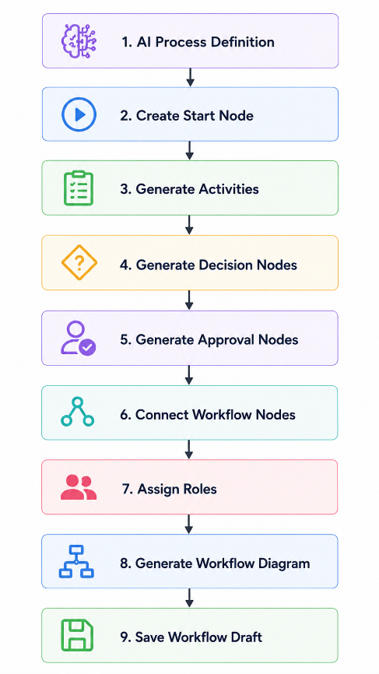
5.6.7 Business Rules
Rule ID | Business Rule
BR-WG-001 | Every workflow shall contain exactly one Start Node.
BR-WG-002 | Every workflow shall contain at least one End Node.
BR-WG-003 | Every workflow activity shall be reachable from the Start Node.
BR-WG-004 | Workflow activities shall follow the execution sequence extracted from the SOP.
BR-WG-005 | Decision nodes shall contain at least two execution paths.
BR-WG-006 | Approval nodes shall have assigned approvers before deployment.
BR-WG-007 | Generated workflows shall remain editable until deployment.
BR-WG-008 | Every workflow version shall be uniquely identifiable.

5.6.8 Exception Handling
Exception | Expected System Response
Missing process definition | Prevent workflow generation and display an error message.
Invalid workflow structure | Reject generation and request manual review.
Missing approval role | Notify user and highlight the affected workflow node.
Circular workflow detected | Stop generation and report validation error.
Database failure | Roll back workflow creation and log the incident.
Workflow generation failure | Preserve input data and allow users to retry.

5.6.9 Acceptance Criteria
The Workflow Generation Engine shall be considered complete when:
- Workflows are automatically generated from AI process definitions.
- Generated workflows accurately represent SOP logic.
- Visual workflow diagrams are displayed successfully.
- Users can edit workflow diagrams before deployment.
- Executable workflow definitions are stored correctly.
- Workflow version history is maintained.
- Workflow generation failures are handled gracefully.
- Generated workflows are ready for validation and simulation.

5.7 Process Validation Engine
5.7.1 Module Description
The Process Validation Engine is responsible for verifying the correctness, completeness, consistency, and quality of AI-generated workflows before deployment.
The engine analyzes workflow structures, business rules, approval chains, execution paths, and organizational constraints to identify logical errors, inconsistencies, missing information, and potential execution failures.
Its primary objective is to ensure that generated workflows are reliable, executable, compliant with organizational policies, and free from structural defects.
The validation engine generates a comprehensive validation report containing detected issues, warnings, recommendations, and an overall workflow quality score.

5.7.2 Functional Requirements
Requirement ID | Functional Requirement | Priority
FR-116 | The system shall validate every generated workflow before deployment. | High
FR-117 | The system shall verify that every workflow contains a Start Node. | High
FR-118 | The system shall verify that every workflow contains at least one End Node. | High
FR-119 | The system shall detect unreachable workflow activities. | High
FR-120 | The system shall detect dead-end workflow paths. | High
FR-121 | The system shall detect circular dependencies between workflow activities. | High
FR-122 | The system shall identify duplicate workflow activities. | Medium
FR-123 | The system shall verify that every approval activity has an assigned approver. | High
FR-124 | The system shall verify that all referenced organizational roles exist. | High
FR-125 | The system shall identify missing workflow transitions. | High
FR-126 | The system shall validate conditional branches for logical consistency. | High
FR-127 | The system shall detect conflicting business rules. | High
FR-128 | The system shall detect overlapping workflow conditions. | High
FR-129 | The system shall identify incomplete workflow definitions. | High
FR-130 | The system shall identify unused workflow activities. | Medium
FR-131 | The system shall verify workflow execution order. | High
FR-132 | The system shall verify workflow dependency relationships. | High
FR-133 | The system shall generate validation warnings for potential risks. | Medium
FR-134 | The system shall generate validation errors for critical workflow issues. | High
FR-135 | The system shall calculate an overall workflow validation score. | Medium
FR-136 | The system shall generate a detailed validation report. | High
FR-137 | The system shall allow users to review validation results before deployment. | High
FR-138 | The system shall prevent deployment when critical validation errors exist. | High
FR-139 | The system shall allow deployment when only warnings are present, subject to administrator approval. | Medium
FR-140 | The system shall maintain validation history for every workflow version. | Medium

5.7.3 Validation Types
The Process Validation Engine shall perform the following validations:
Validation Type | Description
Structural Validation | Validates workflow structure and connectivity
Logical Validation | Detects inconsistent business rules
Approval Validation | Verifies approval chains and approvers
Role Validation | Confirms referenced organizational roles exist
Dependency Validation | Checks workflow dependencies
Execution Validation | Verifies executable workflow paths
Completeness Validation | Ensures all required workflow components exist
Compliance Validation | Validates organization-specific business rules

5.7.4 Validation Report
The validation report shall include:
Report Item | Description
Workflow Name | Name of the workflow
Validation Date | Date and time of validation
Workflow Version | Version being validated
Validation Score | Overall workflow quality score
Errors | Critical issues preventing deployment
Warnings | Non-critical recommendations
Passed Checks | Successful validation checks
Recommendations | Suggested improvements

5.7.5 Validation Workflow
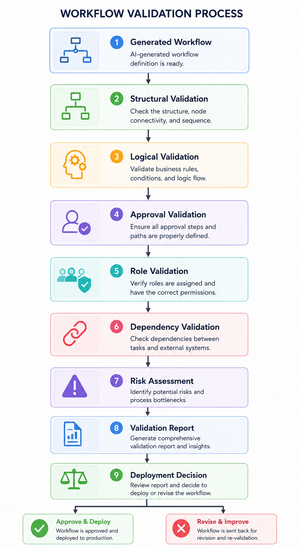
5.7.6 Business Rules
Rule ID | Business Rule
BR-VAL-001 | Every workflow shall pass structural validation before deployment.
BR-VAL-002 | Workflows containing critical validation errors shall not be deployed.
BR-VAL-003 | Every approval activity shall have at least one assigned approver.
BR-VAL-004 | Every workflow activity shall be reachable from the Start Node.
BR-VAL-005 | Every execution path shall eventually reach an End Node.
BR-VAL-006 | Circular workflow dependencies shall not be permitted.
BR-VAL-007 | Validation reports shall be stored for auditing purposes.
BR-VAL-008 | Validation shall be re-executed whenever a workflow is modified.

5.7.7 Exception Handling
Exception | Expected System Response
Missing Start Node | Display validation error and prevent deployment.
Missing End Node | Display validation error and prevent deployment.
Circular dependency detected | Highlight affected workflow nodes and reject deployment.
Undefined organizational role | Display validation warning or error depending on severity.
Missing approval assignment | Prevent deployment until resolved.
Workflow corruption | Reject validation and notify administrator.
Validation engine failure | Log the incident and allow validation retry.

5.7.8 Acceptance Criteria
The Process Validation Engine shall be considered complete when:
- All generated workflows are validated before deployment.
- Structural and logical workflow issues are detected accurately.
- Critical validation errors prevent deployment.
- Validation reports clearly identify issues and recommendations.
- Workflow quality scores are generated successfully.
- Validation history is maintained for all workflow versions.
- Users can review validation results before deployment.
- Validation automatically re-executes after workflow modifications.

5.8 Process Simulation Engine
5.8.1 Module Description
The Process Simulation Engine enables organizations to simulate workflow execution before deployment. It evaluates how workflows behave under different business scenarios by virtually executing workflow logic without affecting production data.
The engine predicts execution paths, approval sequences, completion times, resource utilization, and possible failure points based on user-defined input scenarios and workflow conditions.
Simulation helps organizations validate workflow behavior, reduce operational risks, optimize business processes, and ensure that workflows produce the expected outcomes before being activated.

5.8.2 Functional Requirements
Requirement ID | Functional Requirement | Priority
FR-141 | The system shall allow users to simulate workflows before deployment. | High
FR-142 | The system shall allow users to provide custom input values for simulation. | High
FR-143 | The system shall execute workflow logic using simulation data without modifying production data. | High
FR-144 | The system shall evaluate workflow conditions during simulation. | High
FR-145 | The system shall simulate approval workflows. | High
FR-146 | The system shall simulate conditional branches. | High
FR-147 | The system shall simulate parallel workflow execution where applicable. | Medium
FR-148 | The system shall display the workflow execution path followed during simulation. | High
FR-149 | The system shall estimate workflow completion time. | Medium
FR-150 | The system shall estimate the number of approval steps required. | Medium
FR-151 | The system shall identify workflow bottlenecks during simulation. | Medium
FR-152 | The system shall identify workflow activities that are never executed for the given scenario. | Medium
FR-153 | The system shall display simulation results in a user-friendly format. | High
FR-154 | The system shall generate a simulation report for each execution. | High
FR-155 | The system shall allow users to compare multiple simulation scenarios. | Medium
FR-156 | The system shall support repeated simulations using different input values. | High
FR-157 | The system shall preserve previous simulation history. | Medium
FR-158 | The system shall notify users when simulation is completed successfully. | Medium
FR-159 | The system shall prevent deployment if simulation identifies critical execution failures. | High
FR-160 | The system shall allow users to export simulation reports. | Low

5.8.3 Simulation Inputs
The Process Simulation Engine shall accept the following inputs:
Input | Description
Workflow Definition | Validated workflow selected for simulation
Input Variables | User-provided business values
Simulation Scenario | Test case selected by the user
Organization Settings | Organization-specific rules
Approval Configuration | Approval hierarchy used during simulation

5.8.4 Simulation Outputs
The engine shall generate the following outputs:
Output | Description
Execution Path | Activities executed during simulation
Decision Results | Outcomes of workflow conditions
Approval Chain | Simulated approval sequence
Completion Time | Estimated execution duration
Bottlenecks | Identified process delays
Workflow Status | Simulation result
Simulation Report | Detailed simulation summary

5.8.5 Simulation Workflow
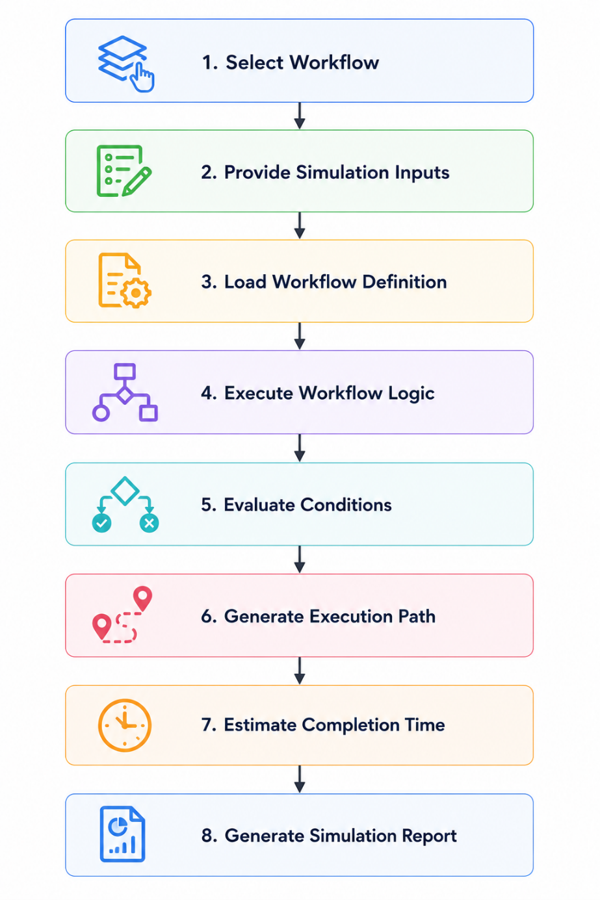

5.8.6 Business Rules
Rule ID | Business Rule
BR-SIM-001 | Simulations shall not modify production workflow data.
BR-SIM-002 | Only validated workflows may be simulated.
BR-SIM-003 | Every simulation shall generate a simulation report.
BR-SIM-004 | Simulation history shall be stored for future reference.
BR-SIM-005 | Multiple simulation scenarios may be executed for the same workflow.
BR-SIM-006 | Critical simulation failures shall be reported before deployment.
BR-SIM-007 | Simulation results shall remain available until manually deleted or archived.

5.8.7 Exception Handling
Exception | Expected System Response
Invalid workflow selected | Prevent simulation and notify the user.
Missing simulation inputs | Display validation errors and request required data.
Simulation execution failure | Stop simulation and display an error message.
Workflow corruption | Reject simulation and log the incident.
System timeout | Cancel simulation and allow the user to retry.
AI reasoning failure | Notify the user and preserve workflow data.

5.8.8 Acceptance Criteria
The Process Simulation Engine shall be considered complete when:
- Users can successfully simulate validated workflows.
- Simulation accurately follows workflow logic.
- Execution paths are displayed correctly.
- Completion time estimates are generated.
- Approval chains are simulated accurately.
- Simulation reports are generated successfully.
- Multiple simulation scenarios can be compared.
- Production workflow data remains unchanged during simulation.
- Critical simulation failures prevent unsafe workflow deployment.

5.9 Workflow Execution Engine
5.9.1 Module Description
The Workflow Execution Engine is responsible for executing deployed workflows in accordance with their defined business logic, workflow structure, approval rules, and organizational policies.
The engine manages the complete lifecycle of workflow instances, including workflow initiation, task routing, state transitions, decision evaluation, approval coordination, exception handling, workflow completion, and execution history.
Each workflow instance is executed independently while maintaining complete traceability, auditability, and data integrity.
The Workflow Execution Engine acts as the operational core of ProcessMind AI and ensures that business processes are executed reliably, consistently, and securely.
5.9.2 Functional Requirements
Requirement ID | Functional Requirement | Priority
FR-161 | The system shall execute only deployed workflows. | High
FR-162 | The system shall create a new workflow instance for each execution request. | High
FR-163 | The system shall assign a unique Workflow Instance ID to every execution. | High
FR-164 | The system shall initialize workflow execution from the Start Node. | High
FR-165 | The system shall execute workflow activities according to the defined execution sequence. | High
FR-166 | The system shall evaluate workflow conditions during execution. | High
FR-167 | The system shall automatically route execution based on condition evaluation results. | High
FR-168 | The system shall create human approval tasks when approval nodes are reached. | High
FR-169 | The system shall pause workflow execution while waiting for required approvals. | High
FR-170 | The system shall resume workflow execution after approval decisions are received. | High
FR-171 | The system shall reject workflows when approval is denied according to workflow rules. | High
FR-172 | The system shall execute parallel workflow branches simultaneously where defined. | Medium
FR-173 | The system shall merge parallel workflow branches before continuing execution. | Medium
FR-174 | The system shall update workflow state after every completed activity. | High
FR-175 | The system shall record execution timestamps for each workflow activity. | High
FR-176 | The system shall assign workflow tasks to the appropriate users or roles. | High
FR-177 | The system shall support reassignment of workflow tasks by authorized users. | Medium
FR-178 | The system shall automatically complete workflow execution when the End Node is reached. | High
FR-179 | The system shall terminate workflow execution if an unrecoverable system error occurs. | High
FR-180 | The system shall maintain complete execution history for every workflow instance. | High
FR-181 | The system shall allow authorized users to view workflow execution progress. | High
FR-182 | The system shall support cancellation of active workflow instances by authorized administrators. | Medium
FR-183 | The system shall maintain workflow execution logs for auditing purposes. | High
FR-184 | The system shall notify users of workflow status changes. | Medium
FR-185 | The system shall automatically archive completed workflow instances based on retention policies. | Medium

5.9.3 Workflow States
Each workflow instance shall maintain one of the following states:
State | Description
Draft | Workflow definition created but not deployed
Active | Workflow deployed and ready for execution
Running | Workflow currently executing
Waiting for Approval | Execution paused pending approval
Completed | Workflow finished successfully
Rejected | Workflow terminated due to rejection
Cancelled | Workflow cancelled by an authorized user
Failed | Workflow terminated due to a system error
Archived | Workflow retained for historical purposes

5.9.4 Execution Inputs
The Workflow Execution Engine shall accept the following inputs:
Input | Description
Workflow Definition | Deployed workflow model
Workflow Instance Request | User request to start workflow
Business Data | Input values required by the workflow
Approval Decisions | Responses from approvers
Organization Configuration | Organization-specific workflow settings

5.9.5 Execution Outputs
The Workflow Execution Engine shall produce:
Output | Description
Workflow Instance | Active workflow execution
Task Assignments | Generated workflow tasks
Approval Requests | Human approval tasks
Workflow Status | Current execution state
Execution History | Complete activity log
Notifications | Workflow events and updates

5.9.6 Workflow Lifecycle
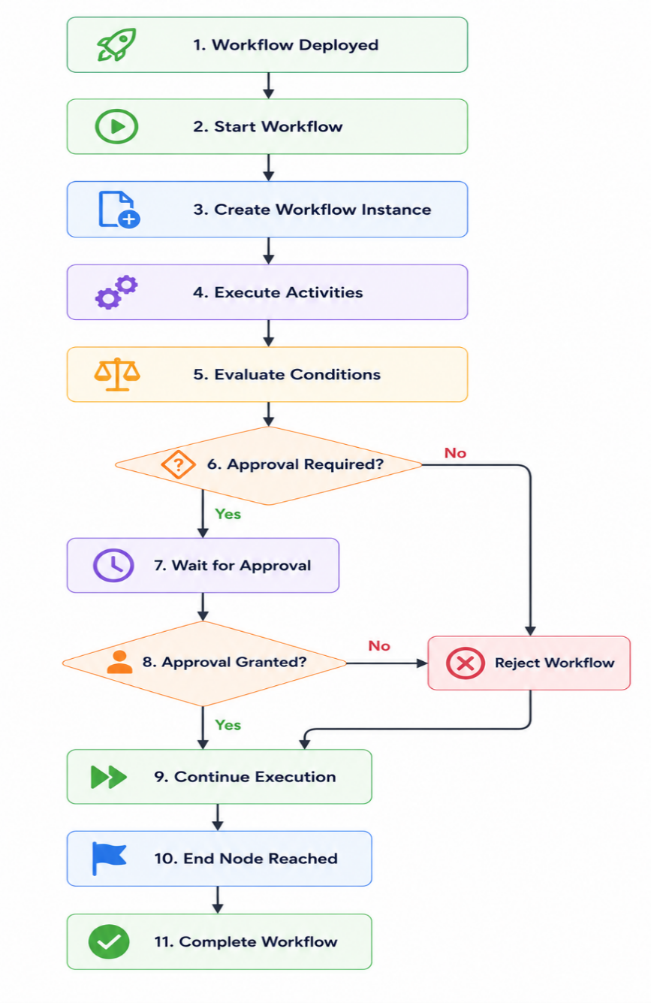
5.9.7 Business Rules
Rule ID | Business Rule
BR-EXEC-001 | Only deployed workflows may be executed.
BR-EXEC-002 | Every workflow execution shall create a unique workflow instance.
BR-EXEC-003 | Workflow execution shall always begin at the Start Node.
BR-EXEC-004 | Workflow execution shall terminate at an End Node, cancellation, rejection, or failure.
BR-EXEC-005 | Approval tasks shall suspend workflow execution until completed.
BR-EXEC-006 | Every workflow activity shall be recorded in the execution history.
BR-EXEC-007 | Workflow execution logs shall be retained for auditing purposes.
BR-EXEC-008 | Only authorized users may cancel active workflow instances.

5.9.8 Exception Handling
Exception | Expected System Response
Workflow not deployed | Prevent execution and notify the user.
Missing workflow input data | Reject execution request and request required information.
Approval timeout | Escalate or terminate according to workflow rules.
System failure during execution | Preserve workflow state and record failure details.
Invalid workflow state | Reject operation and log the incident.
Database failure | Roll back incomplete transactions where applicable.
User assignment unavailable | Notify administrator and pause execution if required.

5.9.9 Acceptance Criteria
The Workflow Execution Engine shall be considered complete when:
- Deployed workflows execute successfully.
- Workflow instances are created correctly.
- Workflow states transition correctly throughout execution.
- Approval stages pause and resume execution appropriately.
- Conditional routing follows workflow logic accurately.
- Execution history is maintained for every workflow instance.
- Workflow cancellation and rejection operate correctly.
- Audit logs accurately record execution events.
- Workflow completion is detected automatically.
- Failed workflow executions are handled gracefully without data corruption.
5.10 Human Approval Engine
5.10.1 Module Description
The Human Approval Engine is responsible for managing approval-based workflow activities within ProcessMind AI. It enables the routing of approval requests to designated users or organizational roles, collects approval decisions, enforces approval rules, manages escalation procedures, and maintains a complete audit trail of all approval activities.
The module supports configurable approval hierarchies, multiple approval levels, sequential and parallel approvals, delegation of approval authority, reminders, deadlines, and escalation mechanisms.
It integrates directly with the Workflow Execution Engine to pause workflow execution until all required approval decisions have been received.
5.10.2 Functional Requirements
Requirement ID | Functional Requirement | Priority
FR-186 | The system shall generate approval requests when a workflow reaches an approval activity. | High
FR-187 | The system shall assign approval requests to the designated approver(s). | High
FR-188 | The system shall support single-level approval workflows. | High
FR-189 | The system shall support multi-level approval workflows. | High
FR-190 | The system shall support sequential approval processes. | High
FR-191 | The system shall support parallel approval processes. | Medium
FR-192 | The system shall allow approvers to approve workflow requests. | High
FR-193 | The system shall allow approvers to reject workflow requests. | High
FR-194 | The system shall allow approvers to request additional information before making a decision. | Medium
FR-195 | The system shall allow approvers to provide comments with approval decisions. | Medium
FR-196 | The system shall record approval timestamps. | High
FR-197 | The system shall record the identity of every approver. | High
FR-198 | The system shall automatically continue workflow execution after all required approvals are received. | High
FR-199 | The system shall terminate or redirect workflows according to configured rejection rules. | High
FR-200 | The system shall support configurable approval deadlines. | Medium
FR-201 | The system shall send reminder notifications for pending approvals. | Medium
FR-202 | The system shall automatically escalate overdue approval requests. | High
FR-203 | The system shall support delegation of approval authority to another authorized user. | Medium
FR-204 | The system shall maintain a complete approval history for each workflow instance. | High
FR-205 | The system shall display the current approval status to authorized users. | High
FR-206 | The system shall prevent unauthorized users from approving workflow requests. | High
FR-207 | The system shall allow administrators to configure approval rules and escalation policies. | Medium
FR-208 | The system shall notify workflow initiators of approval decisions. | Medium
FR-209 | The system shall allow administrators to reassign pending approval requests. | Medium
FR-210 | The system shall maintain audit logs for all approval activities. | High

5.10.3 Approval Types
The system shall support the following approval mechanisms:
Approval Type | Description
Single Approval | One designated approver makes the decision.
Sequential Approval | Multiple approvers review the request in a predefined order.
Parallel Approval | Multiple approvers review the request simultaneously.
Multi-Level Approval | Workflow passes through multiple organizational approval levels.
Delegated Approval | Approval authority is temporarily assigned to another authorized user.

5.10.4 Approval Statuses
Each approval request shall maintain one of the following statuses:
Status | Description
Pending | Waiting for approver action
Approved | Request approved
Rejected | Request rejected
Escalated | Forwarded to a higher authority
Delegated | Assigned to another approver
Expired | Approval deadline exceeded
Cancelled | Approval request cancelled

5.10.5 Approval Workflow
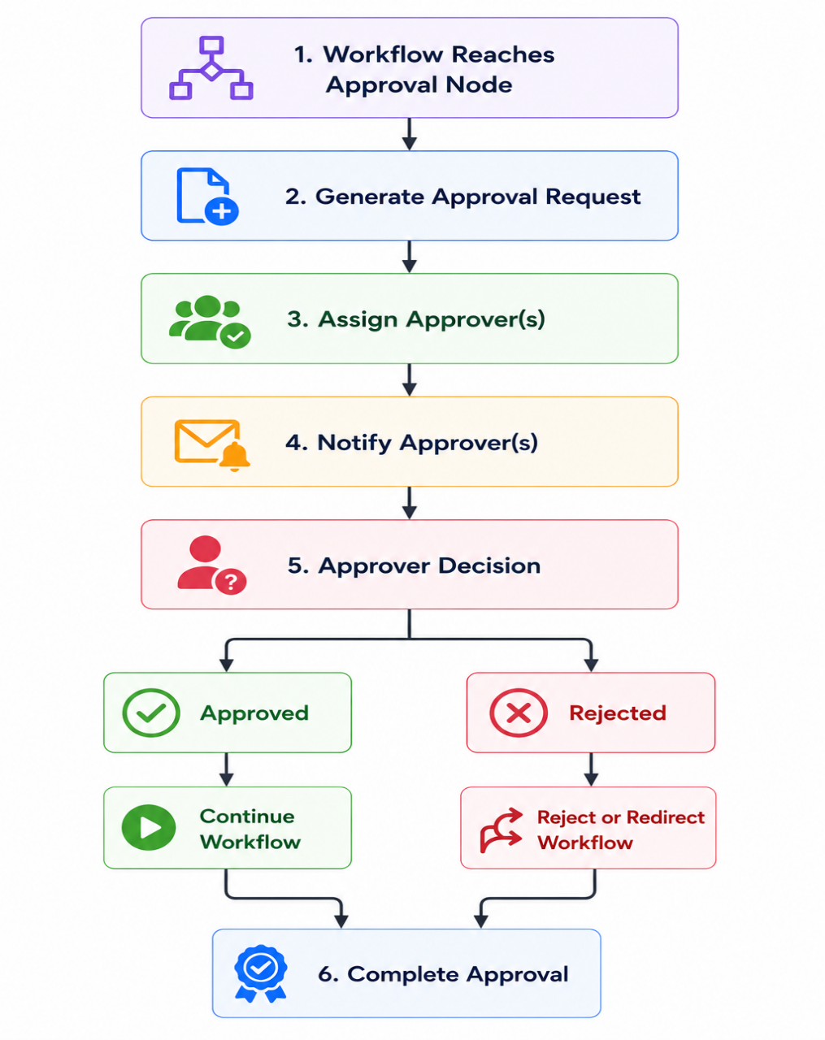
5.10.6 Business Rules
Rule ID | Business Rule
BR-APP-001 | Every approval request shall have at least one assigned approver.
BR-APP-002 | Only authorized approvers may approve or reject requests.
BR-APP-003 | Workflow execution shall remain suspended until required approvals are completed.
BR-APP-004 | Approval comments shall be recorded when provided.
BR-APP-005 | All approval activities shall be stored in the audit log.
BR-APP-006 | Escalation shall occur automatically when approval deadlines are exceeded.
BR-APP-007 | Delegated approvers shall possess equivalent approval permissions.
BR-APP-008 | Approval history shall remain immutable after workflow completion.

5.10.7 Exception Handling
Exception | Expected System Response
Assigned approver does not exist | Prevent workflow execution and notify the administrator.
Unauthorized approval attempt | Reject the request and return HTTP 403 Forbidden.
Approval deadline exceeded | Trigger configured escalation policy.
Delegated approver unavailable | Notify the administrator and request reassignment.
Workflow cancelled during approval | Cancel all pending approval requests.
Notification failure | Log the incident and retry notification delivery.
Database failure | Preserve workflow state and record the error for recovery.

5.10.8 Acceptance Criteria
The Human Approval Engine shall be considered complete when:
- Approval requests are automatically generated during workflow execution.
- Single-level and multi-level approvals function correctly.
- Sequential and parallel approval workflows operate as configured.
- Workflow execution pauses and resumes appropriately.
- Approval deadlines and escalations are enforced.
- Delegation and reassignment functions operate correctly.
- Complete approval histories and audit logs are maintained.
- Unauthorized users cannot approve workflow requests.
- Workflow initiators receive approval outcome notifications.

5.11 Analytics Dashboard
5.11.1 Module Description
The Analytics Dashboard provides real-time visualization and analysis of workflow execution, approval performance, process efficiency, operational trends, and organizational metrics.
The module collects execution data from workflow instances and presents meaningful insights through dashboards, reports, charts, and key performance indicators (KPIs). It enables managers, administrators, and process analysts to monitor business operations, identify bottlenecks, evaluate workflow effectiveness, and support data-driven decision-making.
The Analytics Dashboard also serves as the primary data source for the AI Process Optimization Engine.
5.11.2 Functional Requirements
Requirement ID | Functional Requirement | Priority
FR-211 | The system shall provide a real-time analytics dashboard. | High
FR-212 | The system shall display the total number of active workflows. | High
FR-213 | The system shall display the total number of completed workflows. | High
FR-214 | The system shall display the total number of pending workflows. | High
FR-215 | The system shall display the total number of rejected workflows. | Medium
FR-216 | The system shall calculate workflow completion rates. | High
FR-217 | The system shall calculate average workflow completion time. | High
FR-218 | The system shall calculate average approval processing time. | High
FR-219 | The system shall identify workflow bottlenecks. | High
FR-220 | The system shall identify the most delayed workflow activities. | Medium
FR-221 | The system shall display department-wise workflow statistics. | Medium
FR-222 | The system shall display user workload statistics. | Medium
FR-223 | The system shall display approval performance metrics. | Medium
FR-224 | The system shall display workflow execution trends over time. | Medium
FR-225 | The system shall support filtering analytics by workflow type, department, user, and date range. | High
FR-226 | The system shall allow users to search workflow analytics. | Medium
FR-227 | The system shall generate workflow performance reports. | High
FR-228 | The system shall allow authorized users to export reports in PDF and CSV formats. | Medium
FR-229 | The system shall present analytics using charts, graphs, and summary cards. | Medium
FR-230 | The system shall refresh dashboard data automatically at configurable intervals. | Medium

5.11.3 Dashboard Components
The Analytics Dashboard shall include the following components:
Component | Description
KPI Cards | Display high-level workflow metrics
Workflow Status Summary | Active, Pending, Completed, Rejected workflows
Approval Metrics | Approval counts and processing times
Workflow Trend Charts | Workflow execution over time
Bottleneck Analysis | Delayed workflow activities
Department Statistics | Workflow performance by department
User Performance | Task assignments and workload
Report Center | Exportable analytics reports

5.11.4 Key Performance Indicators (KPIs)
The dashboard shall calculate and display the following KPIs:
KPI | Description
Active Workflows | Number of workflows currently executing
Completed Workflows | Number of successfully completed workflows
Pending Workflows | Number of workflows awaiting action
Rejected Workflows | Number of rejected workflow instances
Average Completion Time | Average duration to complete workflows
Approval Time | Average approval processing time
Bottleneck Count | Number of identified workflow bottlenecks
Workflow Success Rate | Percentage of successfully completed workflows

5.11.5 Analytics Workflow
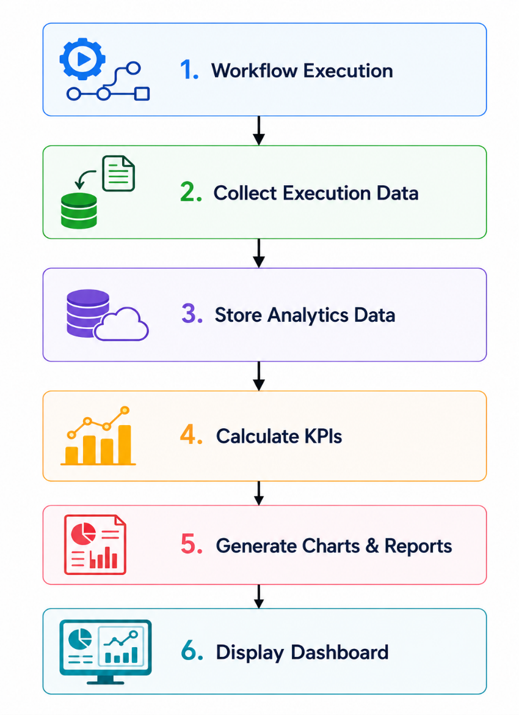

5.11.6 Business Rules
Rule ID | Business Rule
BR-ANA-001 | Dashboard metrics shall reflect the most recent workflow execution data.
BR-ANA-002 | Users shall only access analytics for organizations they belong to.
BR-ANA-003 | Sensitive workflow information shall only be visible to authorized roles.
BR-ANA-004 | KPI calculations shall use verified workflow execution data only.
BR-ANA-005 | Generated reports shall include the report generation timestamp.
BR-ANA-006 | Historical analytics data shall remain available according to organizational retention policies.
BR-ANA-007 | Exported reports shall preserve data integrity and formatting.

5.11.7 Exception Handling
Exception | Expected System Response
No workflow data available | Display an empty-state dashboard with an informative message.
Invalid filter criteria | Reject the request and request valid filter values.
Report generation failure | Notify the user and log the incident.
Export failure | Preserve report data and allow export retry.
Database unavailable | Display a service unavailable message and record the error.
Insufficient permissions | Return HTTP 403 Forbidden.

5.11.8 Acceptance Criteria
The Analytics Dashboard shall be considered complete when:
- Workflow statistics are displayed accurately.
- KPI calculations are correct.
- Dashboard filters function properly.
- Workflow bottlenecks are identified.
- Reports can be generated and exported.
- Analytics update automatically according to configuration.
- Users only access authorized organizational analytics.
- Dashboard performance remains responsive under normal operating conditions.

5.12 Process Optimization Engine
5.12.1 Module Description
The Process Optimization Engine is an AI-powered component responsible for continuously analyzing workflow execution history, identifying operational inefficiencies, and recommending improvements to business processes.
The engine evaluates workflow performance, approval patterns, execution delays, resource utilization, and process bottlenecks to generate intelligent optimization recommendations.
Unlike traditional workflow platforms that only automate predefined workflows, the Process Optimization Engine continuously learns from execution data and assists organizations in improving efficiency, reducing operational costs, minimizing delays, and simplifying business processes.
This module utilizes Artificial Intelligence to support data-driven process improvement while allowing administrators and process analysts to review recommendations before implementation.

5.12.2 Functional Requirements
Requirement ID | Functional Requirement | Priority
FR-231 | The system shall analyze completed workflow execution history. | High
FR-232 | The system shall identify workflow bottlenecks automatically. | High
FR-233 | The system shall identify activities with the longest execution times. | High
FR-234 | The system shall identify approval stages causing significant delays. | High
FR-235 | The system shall detect redundant workflow activities. | Medium
FR-236 | The system shall identify duplicate approval steps. | Medium
FR-237 | The system shall identify frequently rejected workflow paths. | Medium
FR-238 | The system shall recommend workflow simplifications. | High
FR-239 | The system shall recommend approval hierarchy improvements. | Medium
FR-240 | The system shall estimate the expected time savings of recommended improvements. | Medium
FR-241 | The system shall estimate workflow efficiency improvements. | Medium
FR-242 | The system shall prioritize optimization recommendations based on business impact. | Medium
FR-243 | The system shall generate AI-powered optimization reports. | High
FR-244 | The system shall allow users to review optimization recommendations. | High
FR-245 | The system shall allow administrators to accept or reject optimization recommendations. | Medium
FR-246 | The system shall maintain optimization history for each workflow. | Medium
FR-247 | The system shall compare workflow performance before and after optimization. | Medium
FR-248 | The system shall support continuous optimization as workflow execution data increases. | High
FR-249 | The system shall notify administrators when new optimization opportunities are identified. | Medium
FR-250 | The system shall generate an overall workflow efficiency score. | Medium

5.12.3 Optimization Types
The Process Optimization Engine shall support the following optimization analyses:
Optimization Type | Description
Bottleneck Analysis | Identify slow workflow activities
Approval Optimization | Reduce unnecessary approval steps
Workflow Simplification | Remove redundant activities
Time Optimization | Reduce workflow completion time
Resource Optimization | Improve workload distribution
Process Efficiency Analysis | Evaluate overall workflow performance
AI Recommendations | Suggest improvements using AI reasoning

5.12.4 Optimization Inputs
The engine shall analyze:
Input | Description
Workflow Execution History | Historical workflow instances
Approval Records | Approval decisions and durations
Analytics Data | Workflow KPIs
User Activity Logs | Workflow interaction history
Organization Rules | Business constraints and policies

5.12.5 Optimization Outputs
The engine shall generate:
Output | Description
Bottleneck Report | Identified process delays
Optimization Recommendations | AI-generated improvement suggestions
Estimated Time Savings | Predicted reduction in execution time
Efficiency Score | Workflow performance rating
Comparison Report | Before vs. after optimization analysis
Optimization History | Record of previous recommendations

5.12.6 Optimization Workflow
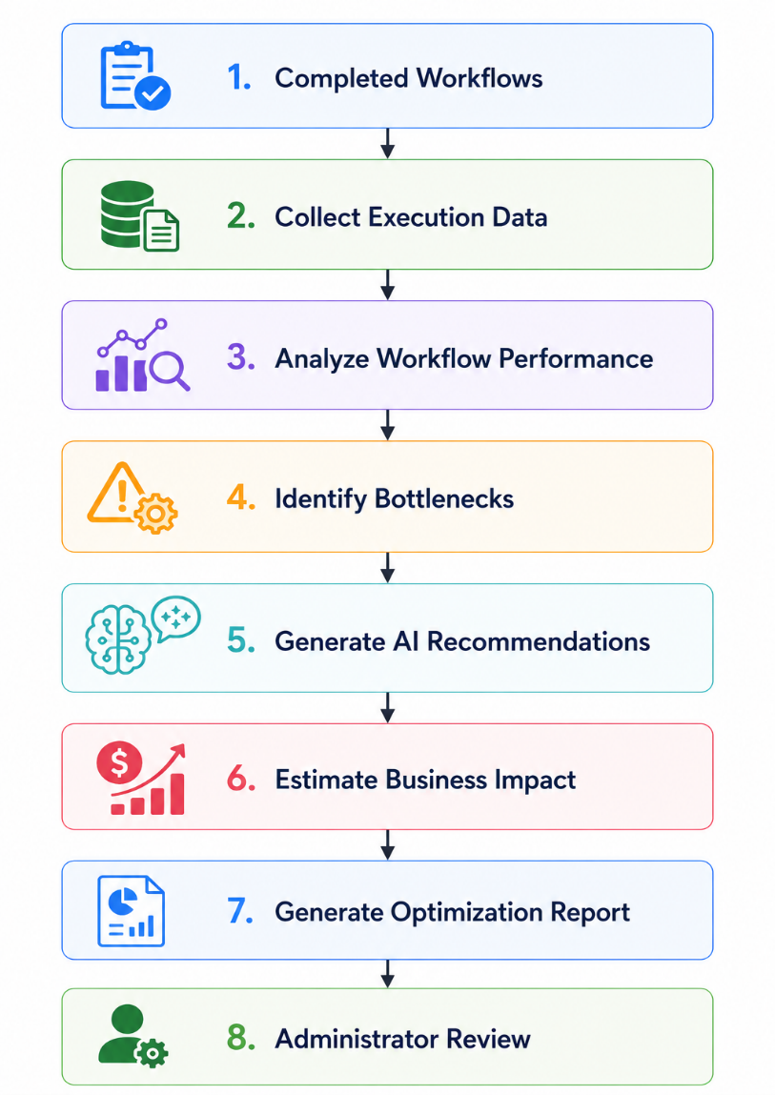

5.12.7 Business Rules
Rule ID | Business Rule
BR-OPT-001 | Optimization recommendations shall be generated using completed workflow execution data only.
BR-OPT-002 | AI recommendations shall not automatically modify deployed workflows.
BR-OPT-003 | Administrators shall review recommendations before implementation.
BR-OPT-004 | Workflow optimization history shall be retained for auditing purposes.
BR-OPT-005 | Optimization reports shall include estimated business impact where applicable.
BR-OPT-006 | The system shall preserve historical workflow versions after optimization.
BR-OPT-007 | Recommendations shall respect organization-specific business rules and compliance requirements.

5.12.8 Exception Handling
Exception | Expected System Response
Insufficient workflow history | Notify the user that additional execution data is required.
AI optimization failure | Preserve existing workflow and log the error.
Missing analytics data | Generate a partial optimization report with appropriate warnings.
Database unavailable | Record the incident and notify the administrator.
Invalid workflow history | Exclude invalid records from analysis and continue processing.
Recommendation generation timeout | Cancel optimization and allow retry.

5.12.9 Acceptance Criteria
The Process Optimization Engine shall be considered complete when:
- Workflow bottlenecks are identified accurately.
- AI-generated recommendations are produced successfully.
- Optimization reports include estimated business impact.
- Administrators can review recommendations before implementation.
- Workflow efficiency scores are calculated correctly.
- Historical optimization records are maintained.
- The system supports continuous optimization as additional workflow data becomes available.
- Optimization recommendations never modify deployed workflows automatically.

5.13 Notification Module
5.13.1 Module Description
The Notification Module is responsible for delivering timely and relevant notifications to users regarding workflow events, approval requests, system activities, and organizational updates.
The module supports multiple notification channels, including in-application notifications and email notifications. It ensures that users are informed about workflow progress, pending tasks, approval requests, deadlines, reminders, escalations, and system events.
The Notification Module integrates with the Workflow Execution Engine, Human Approval Engine, and Administration Module to provide real-time communication throughout the workflow lifecycle.

5.13.2 Functional Requirements
Requirement ID | Functional Requirement | Priority
FR-251 | The system shall generate notifications for workflow status changes. | High
FR-252 | The system shall notify users when a new workflow task is assigned. | High
FR-253 | The system shall notify approvers when an approval request is assigned. | High
FR-254 | The system shall notify workflow initiators when approval decisions are made. | High
FR-255 | The system shall notify users when workflows are completed successfully. | Medium
FR-256 | The system shall notify users when workflows are rejected. | High
FR-257 | The system shall notify administrators when workflow execution fails. | High
FR-258 | The system shall send reminder notifications for pending workflow tasks. | Medium
FR-259 | The system shall send reminder notifications for pending approvals. | Medium
FR-260 | The system shall notify administrators when approval deadlines are exceeded. | Medium
FR-261 | The system shall notify users when workflows are cancelled. | Medium
FR-262 | The system shall support in-application notifications. | High
FR-263 | The system shall support email notifications. | High
FR-264 | The system shall allow users to mark notifications as read or unread. | Medium
FR-265 | The system shall display notification history to users. | Medium
FR-266 | The system shall allow users to delete notifications. | Low
FR-267 | The system shall allow users to configure notification preferences. | Medium
FR-268 | The system shall categorize notifications by type and priority. | Medium
FR-269 | The system shall maintain delivery status for each notification. | Medium
FR-270 | The system shall log notification delivery events for auditing purposes. | Medium

5.13.3 Notification Types
The system shall support the following notification types:
Notification Type | Description
Workflow Assigned | User receives a new workflow task
Approval Request | Approval action is required
Workflow Completed | Workflow finished successfully
Workflow Rejected | Workflow has been rejected
Workflow Cancelled | Workflow has been cancelled
Reminder | Pending task or approval reminder
Escalation | Approval deadline exceeded
System Alert | Important administrative or system event

5.13.4 Notification Channels
Channel | Description
In-App Notification | Displayed within the ProcessMind AI dashboard
Email Notification | Sent to the user's registered email address

5.13.5 Notification Workflow
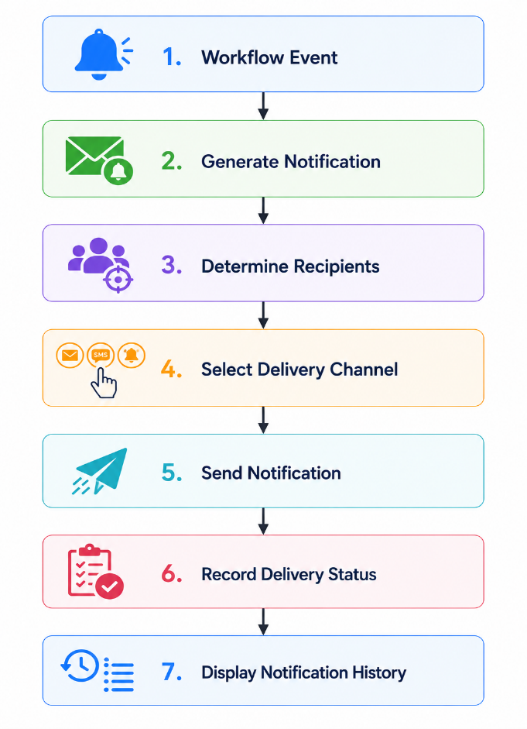

5.13.6 Business Rules
Rule ID | Business Rule
BR-NOT-001 | Notifications shall only be sent to authorized recipients.
BR-NOT-002 | Notification delivery shall be recorded in the audit log.
BR-NOT-003 | Users shall receive only notifications relevant to their assigned workflows and roles.
BR-NOT-004 | Failed notification delivery attempts shall be logged for retry or administrator review.
BR-NOT-005 | Users may configure their personal notification preferences where permitted.
BR-NOT-006 | Notification history shall be retained according to organizational retention policies.
BR-NOT-007 | Critical workflow notifications shall be prioritized over informational notifications.

5.13.7 Exception Handling
Exception | Expected System Response
Email delivery failure | Record the failure and retry according to retry policy.
Invalid recipient | Skip delivery and notify the administrator if necessary.
Notification service unavailable | Queue notifications until the service becomes available.
Database unavailable | Preserve pending notifications and retry later.
User has disabled notification type | Respect user preferences unless the notification is marked as mandatory.
Duplicate notification event | Prevent duplicate notification delivery.

5.13.8 Acceptance Criteria
The Notification Module shall be considered complete when:
- Users receive workflow-related notifications promptly.
- Approval requests trigger notifications correctly.
- Reminder and escalation notifications function as configured.
- In-app and email notifications are delivered successfully.
- Notification preferences are respected.
- Notification history is available to users.
- Delivery events are logged for auditing purposes.
- Failed notification deliveries are handled gracefully.
5.14 Administration Module
5.14.1 Module Description
The Administration Module provides centralized management and configuration capabilities for the ProcessMind AI platform. It enables authorized administrators to manage organizations, users, system settings, AI configurations, workflow configurations, audit logs, monitoring, backups, and platform maintenance.
The module ensures that the platform remains secure, configurable, maintainable, and scalable while supporting operational governance and administrative oversight.
Different administrative capabilities are provided based on administrator roles to maintain security and organizational separation.

5.14.2 Functional Requirements
Requirement ID | Functional Requirement | Priority
FR-271 | The system shall provide an administrative dashboard for authorized administrators. | High
FR-272 | The system shall allow System Administrators to manage organizations. | High
FR-273 | The system shall allow Organization Administrators to manage users within their organization. | High
FR-274 | The system shall allow administrators to configure workflow settings. | High
FR-275 | The system shall allow administrators to configure organization-specific approval policies. | Medium
FR-276 | The system shall allow administrators to configure notification settings. | Medium
FR-277 | The system shall allow administrators to configure AI processing settings. | Medium
FR-278 | The system shall allow administrators to view workflow execution statistics. | Medium
FR-279 | The system shall provide access to system audit logs. | High
FR-280 | The system shall record all administrative actions in audit logs. | High
FR-281 | The system shall allow administrators to search and filter audit logs. | Medium
FR-282 | The system shall display overall platform health status. | Medium
FR-283 | The system shall display AI service availability status. | Medium
FR-284 | The system shall display database connectivity status. | Medium
FR-285 | The system shall allow administrators to configure system maintenance settings. | Low
FR-286 | The system shall allow administrators to archive completed workflows according to retention policies. | Medium
FR-287 | The system shall support manual backup initiation by authorized administrators. | Medium
FR-288 | The system shall support restoration from previously created backups. | Medium
FR-289 | The system shall maintain system configuration version history. | Low
FR-290 | The system shall support future integration of subscription and license management. | Low

5.14.3 Administrative Functions
The Administration Module shall provide the following capabilities:
Function | Description
Organization Management | Create, update, archive, and manage organizations
User Administration | Manage users, roles, and permissions
Workflow Administration | Configure workflow execution settings
AI Configuration | Configure AI-related settings and parameters
Notification Configuration | Configure notification channels and preferences
Audit Management | View and search system audit logs
System Monitoring | Monitor platform health and service availability
Backup & Recovery | Perform backup and restore operations
Configuration Management | Manage system-wide settings
Maintenance | Configure maintenance-related operations

5.14.4 Administrative Roles
Role | Responsibilities
System Administrator | Full access to all organizations, system settings, AI configuration, monitoring, backups, and platform maintenance.
Organization Administrator | Manage users, workflows, departments, and settings within their own organization only.

5.14.5 Administration Workflow
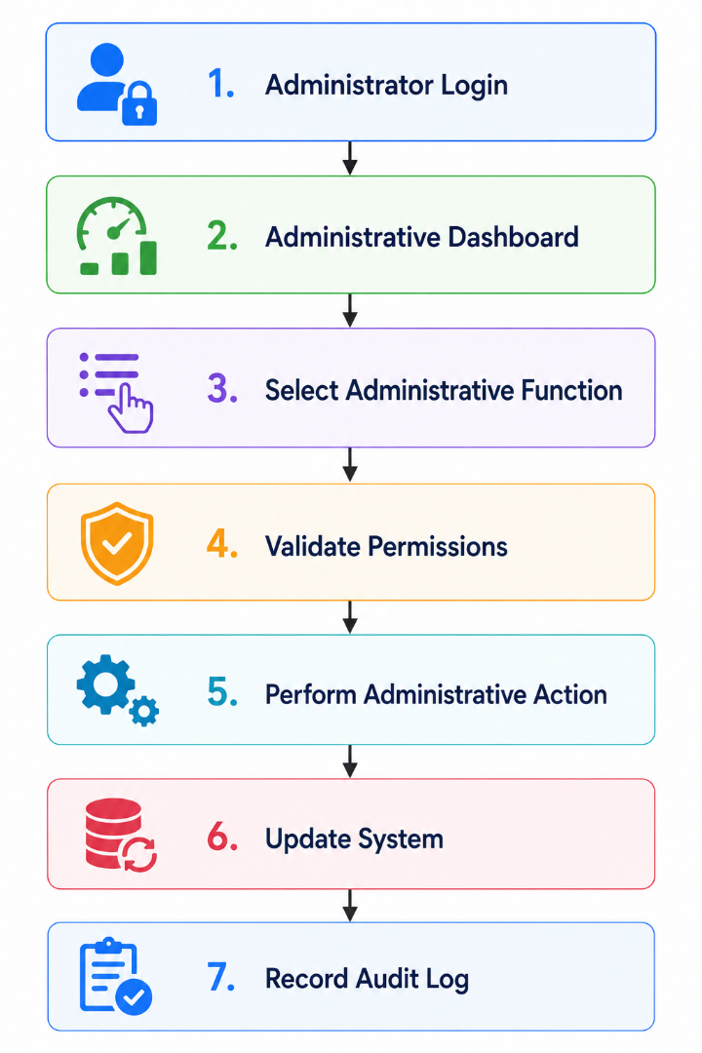
5.14.6 Business Rules
Rule ID | Business Rule
BR-ADM-001 | Only authorized administrators shall access administrative functions.
BR-ADM-002 | Every administrative action shall be recorded in the audit log.
BR-ADM-003 | Organization Administrators shall manage only their own organization.
BR-ADM-004 | System Administrators shall have access to all organizations and platform resources.
BR-ADM-005 | Critical system configuration changes shall require confirmation before being applied.
BR-ADM-006 | Backup and recovery operations shall be available only to authorized administrators.
BR-ADM-007 | Administrative actions shall preserve data integrity and system consistency.

5.14.7 Exception Handling
Exception | Expected System Response
Unauthorized administrative access | Reject the request and return HTTP 403 Forbidden.
Invalid system configuration | Reject the configuration and display validation errors.
Backup failure | Notify the administrator and log the failure.
Restore failure | Preserve existing data and notify the administrator.
Audit log retrieval failure | Display an error message and record the incident.
AI service unavailable | Display service status and disable AI-dependent administrative functions where necessary.
Database unavailable | Prevent configuration changes and notify the administrator.

5.14.8 Acceptance Criteria
The Administration Module shall be considered complete when:
- Authorized administrators can successfully access the administration dashboard.
- Organization and user administration functions operate correctly.
- Workflow and AI settings can be configured securely.
- Audit logs accurately record all administrative activities.
- System health information is available.
- Backup and restore operations function correctly.
- Administrative permissions are enforced according to user roles.
- Unauthorized administrative access is prevented.

Chapter 6: AI Functional Requirements
6.1 Overview
Artificial Intelligence (AI) is the core enabling technology of ProcessMind AI. Unlike traditional workflow automation platforms that require users to manually design and configure workflows, ProcessMind AI leverages AI to understand Standard Operating Procedures (SOPs), reason about business logic, generate workflows, validate process structures, simulate execution scenarios, and recommend process optimizations.
This chapter specifies the functional requirements for all AI-related capabilities within the platform. These requirements define how AI services shall interact with users, workflow components, and organizational data while ensuring reliability, explainability, security, and human oversight.
The AI layer is designed as an independent service abstraction, allowing the platform to support multiple AI providers in the future without requiring significant architectural modifications.
The primary objectives of the AI layer are to:
- Understand natural-language SOPs.
- Extract structured business knowledge.
- Generate executable workflow definitions.
- Validate business process logic.
- Simulate workflow execution.
- Analyze workflow performance.
- Recommend workflow optimizations.
- Assist users through intelligent reasoning and decision support.
The AI layer is intended to augment human decision-making rather than replace it. All AI-generated outputs that affect workflow definitions or business processes shall be subject to user review and approval before deployment.

6.2 AI Architecture
The AI subsystem shall consist of the following logical components:
- AI Service Layer
- Prompt Management
- SOP Understanding Engine
- Workflow Reasoning Engine
- Validation Engine
- Simulation Engine
- Optimization Engine
- AI Response Validator
- AI Provider Interface
These components work together to provide intelligent assistance throughout the workflow lifecycle.

6.3 AI Processing Workflow
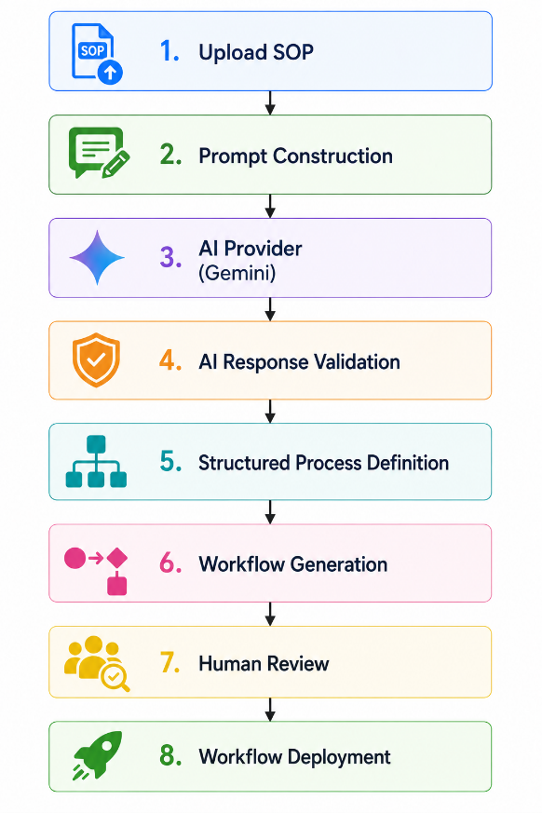
6.4 AI Functional Modules
The AI subsystem consists of the following modules:
- AI Provider Management
- Prompt Management
- SOP Understanding
- AI Workflow Reasoning
- AI Response Validation
- AI Confidence Evaluation
- Human-in-the-Loop Review
- AI Monitoring and Logging
- AI Failure Recovery
- AI Learning and Improvement (Future)
The following sections specify the functional requirements for each module.

6.2 AI Provider Management
6.2.1 Module Description
The AI Provider Management module is responsible for managing communication between ProcessMind AI and external Artificial Intelligence service providers.
The module abstracts AI provider implementations behind a common service interface, enabling the platform to support multiple Large Language Model (LLM) providers without modifying business logic.
The initial implementation shall integrate with the Google Gemini API. However, the architecture shall support future integration with additional AI providers such as OpenAI, Anthropic Claude, Microsoft Azure OpenAI, self-hosted models, and other compatible AI services.
The module is also responsible for managing AI requests, authentication, retries, timeout handling, provider selection, usage monitoring, and error recovery.

6.2.2 Functional Requirements
Requirement ID | Functional Requirement | Priority
AI-FR-001 | The system shall communicate with AI providers through an abstract AI service interface. | High
AI-FR-002 | The system shall support Google Gemini as the default AI provider. | High
AI-FR-003 | The system architecture shall allow future integration of additional AI providers without modifying business logic. | High
AI-FR-004 | The system shall securely store AI provider API credentials using environment variables or a secure secret management mechanism. | High
AI-FR-005 | The system shall authenticate requests before communicating with the AI provider. | High
AI-FR-006 | The system shall validate AI requests before submission. | Medium
AI-FR-007 | The system shall support configurable request timeout values. | Medium
AI-FR-008 | The system shall automatically retry failed AI requests according to configurable retry policies. | Medium
AI-FR-009 | The system shall detect AI service unavailability. | High
AI-FR-010 | The system shall gracefully handle AI provider failures without causing system crashes. | High
AI-FR-011 | The system shall record AI request execution time. | Medium
AI-FR-012 | The system shall record AI response status for monitoring purposes. | Medium
AI-FR-013 | The system shall monitor AI usage statistics. | Medium
AI-FR-014 | The system shall maintain AI request logs for auditing purposes. | Medium
AI-FR-015 | The system shall support configurable AI model selection. | Medium
AI-FR-016 | The system shall prevent unauthorized access to AI provider credentials. | High
AI-FR-017 | The system shall allow administrators to configure AI provider settings. | Medium
AI-FR-018 | The system shall notify administrators when AI provider connectivity fails. | Medium
AI-FR-019 | The system shall support future AI provider failover mechanisms. | Low
AI-FR-020 | The system shall maintain compatibility with future versions of supported AI provider APIs. | Medium

6.2.3 Supported AI Providers
AI Provider | Support Status
Google Gemini | Supported (Default)
OpenAI GPT | Future
Anthropic Claude | Future
Azure OpenAI | Future
Ollama (Local Models) | Future
Custom Enterprise Models | Future

6.2.4 AI Provider Architecture
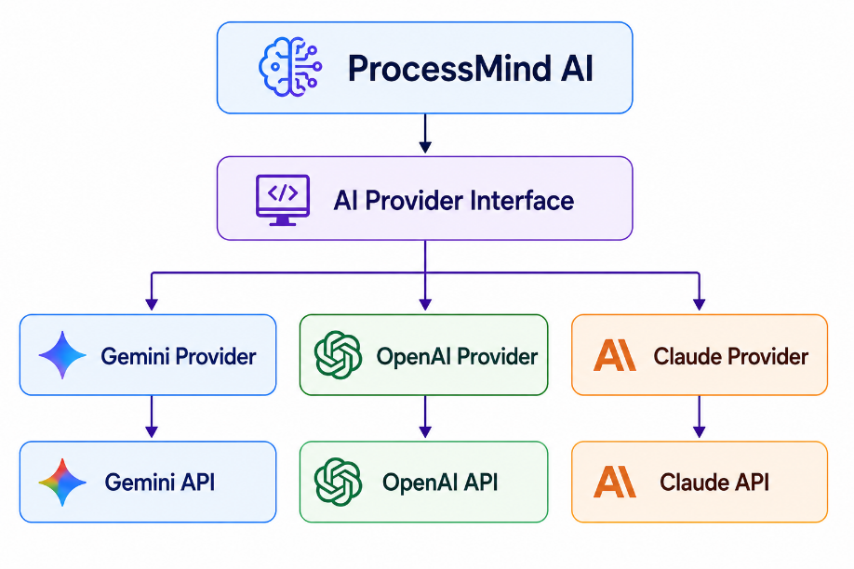

6.2.5 Business Rules
Rule ID | Business Rule
BR-AI-001 | Business logic shall not communicate directly with any AI provider.
BR-AI-002 | AI providers shall be accessed only through the AI Provider Interface.
BR-AI-003 | AI credentials shall never be stored in source code.
BR-AI-004 | AI request failures shall not cause data corruption.
BR-AI-005 | All AI requests shall be logged for monitoring and troubleshooting.
BR-AI-006 | AI provider configuration changes shall be restricted to authorized administrators.

6.2.6 Exception Handling
Exception | Expected System Response
Invalid API credentials | Reject the request, notify the administrator, and log the incident.
AI provider unavailable | Return an appropriate error message and preserve pending requests where applicable.
Request timeout | Retry according to configured retry policy before reporting failure.
Invalid AI response | Reject the response and request regeneration if applicable.
Network failure | Retry the request and log connectivity issues.
Rate limit exceeded | Delay or queue requests according to configured throttling policies.

6.2.7 Acceptance Criteria
The AI Provider Management module shall be considered complete when:
- AI requests are routed through the AI Provider Interface.
- Google Gemini integration functions correctly.
- AI credentials are securely managed.
- AI request failures are handled gracefully.
- AI usage statistics are recorded.
- AI request logs are maintained.
- The architecture supports future integration of additional AI providers without requiring changes to business logic.

6.3 Prompt Management
6.3.1 Module Description
The Prompt Management module is responsible for constructing, managing, validating, versioning, and optimizing prompts used for communication with Artificial Intelligence providers.
Instead of embedding prompts directly within application source code, the system shall maintain prompts as configurable and reusable resources. This enables administrators and developers to improve AI behavior without modifying application logic.
The module supports prompt templates, variable substitution, prompt versioning, prompt validation, prompt testing, and prompt execution history.
Prompt Management ensures consistency, maintainability, and reliability across all AI-powered features within ProcessMind AI.

6.3.2 Functional Requirements
Requirement ID | Functional Requirement | Priority
AI-FR-021 | The system shall maintain prompt templates for all AI-powered operations. | High
AI-FR-022 | The system shall support dynamic variable substitution within prompts. | High
AI-FR-023 | The system shall construct prompts using SOP content and workflow context. | High
AI-FR-024 | The system shall validate prompt completeness before submission to the AI provider. | High
AI-FR-025 | The system shall prevent submission of empty or invalid prompts. | High
AI-FR-026 | The system shall maintain version history for prompt templates. | Medium
AI-FR-027 | The system shall allow administrators to update prompt templates. | Medium
AI-FR-028 | The system shall support multiple prompt templates for different AI tasks. | High
AI-FR-029 | The system shall allow prompt selection based on the requested AI operation. | High
AI-FR-030 | The system shall sanitize user input before constructing prompts. | High
AI-FR-031 | The system shall include organization-specific context when generating prompts where applicable. | Medium
AI-FR-032 | The system shall support configurable AI generation parameters such as temperature and token limits. | Medium
AI-FR-033 | The system shall record prompt execution history for auditing and troubleshooting. | Medium
AI-FR-034 | The system shall allow administrators to test prompt templates before production use. | Medium
AI-FR-035 | The system shall support prompt preview before AI execution. | Medium
AI-FR-036 | The system shall prevent unauthorized modification of production prompt templates. | High
AI-FR-037 | The system shall maintain prompt metadata including version, creator, creation date, and last modification date. | Medium
AI-FR-038 | The system shall support prompt rollback to a previous version. | Low
AI-FR-039 | The system shall log prompt execution failures. | Medium
AI-FR-040 | The system shall reuse standardized prompt templates across multiple AI modules. | High

6.3.3 Prompt Categories
The platform shall maintain separate prompt templates for different AI operations.
Prompt Category | Purpose
SOP Understanding | Extract workflow logic from SOP documents
Workflow Generation | Generate executable workflow definitions
Workflow Validation | Detect workflow issues and inconsistencies
Process Simulation | Simulate workflow execution scenarios
Process Optimization | Generate optimization recommendations
AI Assistant | Respond to user questions and guidance
Report Generation | Generate AI-powered summaries and reports

6.3.4 Prompt Structure
Each prompt template shall contain:
Component | Description
System Instructions | Define AI behavior and response format
Context | Organization and workflow context
User Input | SOP or business process content
Output Format | Expected structured response format
Validation Rules | Constraints applied to AI output

6.3.5 Prompt Processing Workflow
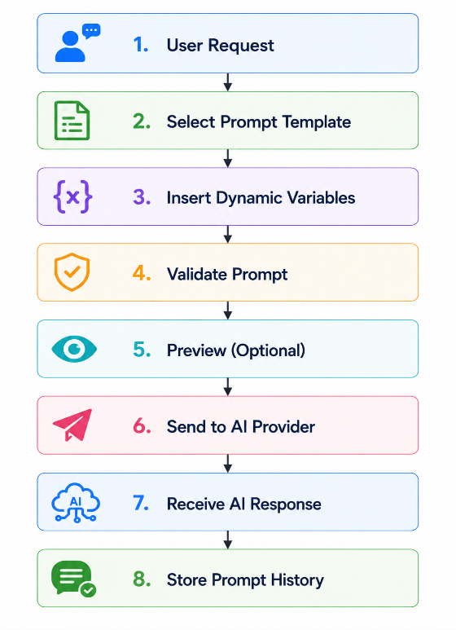

6.3.6 Business Rules
Rule ID | Business Rule
BR-PROMPT-001 | All AI interactions shall use predefined prompt templates.
BR-PROMPT-002 | Prompt templates shall be version-controlled.
BR-PROMPT-003 | Prompt templates shall only be modified by authorized administrators.
BR-PROMPT-004 | User input shall be sanitized before inclusion in prompts.
BR-PROMPT-005 | Prompt execution history shall be retained for auditing and troubleshooting.
BR-PROMPT-006 | Production prompt templates shall be tested before activation.
BR-PROMPT-007 | Prompt rollback shall preserve historical versions.

6.3.7 Exception Handling
Exception | Expected System Response
Missing prompt template | Prevent AI execution and notify the administrator.
Invalid prompt variables | Reject prompt construction and display validation errors.
Unauthorized prompt modification | Return HTTP 403 Forbidden.
Prompt validation failure | Prevent submission to the AI provider.
Prompt execution failure | Log the incident and allow retry.
Prompt version conflict | Preserve the active version and require administrator resolution.
6.3.8 Acceptance Criteria
The Prompt Management module shall be considered complete when:
- Prompt templates are managed independently of application code.
- Dynamic variables are correctly substituted into prompts.
- Prompt templates are version-controlled.
- Prompt validation prevents invalid AI requests.
- Prompt execution history is recorded.
- Administrators can safely manage and test prompt templates.
- Prompt rollback functions correctly.
- Prompt templates are reusable across multiple AI-powered modules.

6.4 SOP Understanding Engine
6.4.1 Module Description
The SOP Understanding Engine is the primary Artificial Intelligence component responsible for interpreting Standard Operating Procedures (SOPs) written in natural language and transforming them into structured business knowledge.
The engine analyzes uploaded SOP documents to identify business activities, decision points, conditions, organizational roles, approval requirements, dependencies, inputs, outputs, exceptions, and business rules.
Rather than simply extracting text, the engine performs semantic reasoning to understand the intent and operational logic of the process. The resulting structured representation serves as the foundation for workflow generation, validation, simulation, execution, and optimization.
The module shall support future enhancements such as multilingual SOP analysis, industry-specific reasoning models, and organization-specific knowledge bases.

6.4.2 Functional Requirements
Requirement ID | Functional Requirement | Priority
AI-FR-041 | The system shall analyze SOP documents written in natural language. | High
AI-FR-042 | The system shall extract business activities from the SOP. | High
AI-FR-043 | The system shall identify workflow start events. | High
AI-FR-044 | The system shall identify workflow end events. | High
AI-FR-045 | The system shall identify decision points and conditional branches. | High
AI-FR-046 | The system shall extract business conditions from the SOP. | High
AI-FR-047 | The system shall identify approval requirements. | High
AI-FR-048 | The system shall identify organizational roles involved in the process. | High
AI-FR-049 | The system shall identify workflow dependencies between activities. | High
AI-FR-050 | The system shall identify workflow inputs and outputs. | Medium
AI-FR-051 | The system shall extract business rules described in the SOP. | High
AI-FR-052 | The system shall identify exception handling procedures described in the SOP. | Medium
AI-FR-053 | The system shall identify required documents and supporting artifacts referenced in the SOP. | Medium
AI-FR-054 | The system shall classify workflow activities according to predefined activity types. | Medium
AI-FR-055 | The system shall detect ambiguous or incomplete SOP instructions. | High
AI-FR-056 | The system shall identify missing process information where possible. | Medium
AI-FR-057 | The system shall generate a structured process representation in JSON format. | High
AI-FR-058 | The system shall assign confidence scores to extracted entities and relationships. | High
AI-FR-059 | The system shall preserve traceability between extracted information and the original SOP text. | High
AI-FR-060 | The system shall allow users to review and edit AI-generated process representations before workflow generation. | High

6.4.3 AI Knowledge Extraction
The SOP Understanding Engine shall extract the following knowledge elements:
Knowledge Element | Description
Workflow Activities | Individual business tasks
Decision Points | Conditional workflow branches
Business Rules | Organizational policies and constraints
Organizational Roles | Users or departments responsible for activities
Approval Requirements | Required approval stages
Dependencies | Relationships between workflow activities
Inputs | Required information for execution
Outputs | Results produced by workflow activities
Exceptions | Error-handling or alternative execution paths
Documents | Forms, invoices, contracts, or other referenced documents

6.4.4 AI Processing Workflow
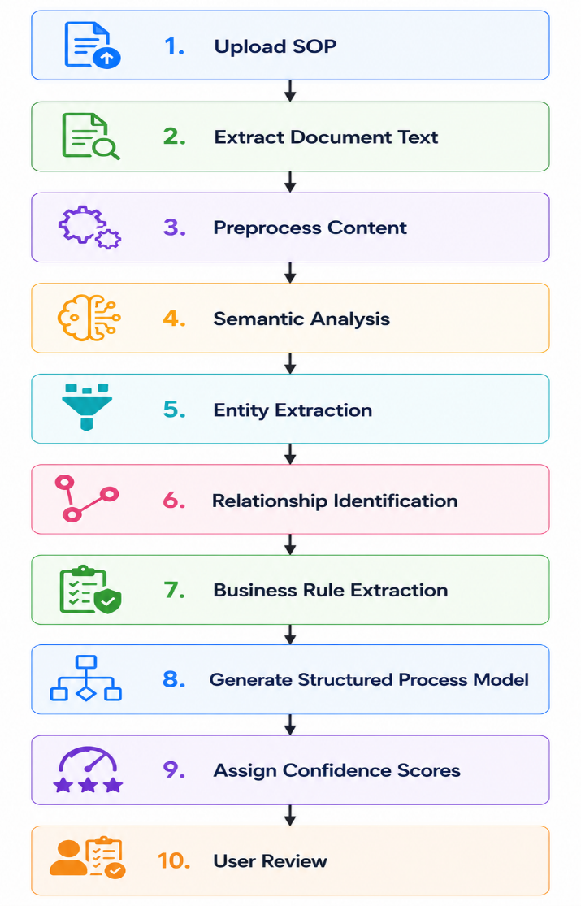
6.4.5 Structured Output Model
The generated process representation shall include:
Output | Description
Workflow Name | Name of the identified process
Activities | Ordered list of workflow tasks
Conditions | Decision logic
Roles | Responsible users or departments
Approvals | Required approval stages
Business Rules | Extracted organizational rules
Dependencies | Relationships among activities
Exceptions | Alternative execution paths
Confidence Scores | AI confidence for extracted information

6.4.6 Business Rules
Rule ID | Business Rule
BR-SOPAI-001 | AI-generated process models shall preserve the meaning of the original SOP.
BR-SOPAI-002 | Confidence scores shall be generated for all extracted entities.
BR-SOPAI-003 | Ambiguous SOP sections shall be highlighted for user review.
BR-SOPAI-004 | Users shall review AI-generated process models before workflow generation.
BR-SOPAI-005 | Original SOP documents shall remain unchanged throughout AI processing.
BR-SOPAI-006 | Traceability shall be maintained between extracted elements and source text.
BR-SOPAI-007 | AI shall not fabricate business rules that are unsupported by the SOP content.

6.4.7 Exception Handling
Exception | Expected System Response
Unsupported language | Notify the user that the language is not currently supported.
Poor document quality | Highlight unreadable sections and request a higher-quality document.
Ambiguous instructions | Flag the affected sections for manual review.
Missing workflow information | Generate a partial process model and report missing elements.
AI interpretation failure | Preserve uploaded data, log the incident, and allow reprocessing.
Invalid AI response | Reject the generated model and request regeneration.

6.4.8 Acceptance Criteria
The SOP Understanding Engine shall be considered complete when:
- SOPs are successfully interpreted into structured process models.
- Workflow activities, roles, approvals, conditions, and business rules are accurately extracted.
- Confidence scores are assigned to extracted information.
- Ambiguous or incomplete instructions are identified.
- Users can review and modify AI-generated outputs.
- Traceability between the original SOP and extracted knowledge is preserved.
- Structured outputs are suitable for downstream workflow generation and validation.

6.5 AI Workflow Reasoning Engine
6.5.1 Module Description
The AI Workflow Reasoning Engine is responsible for transforming structured business knowledge into logically consistent and executable workflow models through Artificial Intelligence reasoning.
Unlike rule-based workflow generators, this module performs semantic reasoning to determine the optimal workflow structure by analyzing business objectives, organizational policies, dependencies, decision logic, approval chains, exceptions, and execution constraints.
The engine acts as an intelligent business analyst by interpreting extracted knowledge, identifying implicit workflow relationships, resolving ambiguities where possible, and constructing workflow models that accurately represent organizational processes.
The generated workflow serves as the primary input for workflow validation, simulation, and execution.

6.5.2 Functional Requirements
Requirement ID | Functional Requirement | Priority
AI-FR-061 | The system shall reason over structured process knowledge to generate executable workflow logic. | High
AI-FR-062 | The system shall determine the optimal execution sequence for workflow activities. | High
AI-FR-063 | The system shall infer missing workflow transitions where sufficient evidence exists. | High
AI-FR-064 | The system shall construct workflow decision trees based on identified business conditions. | High
AI-FR-065 | The system shall identify opportunities for parallel workflow execution. | Medium
AI-FR-066 | The system shall determine approval routing based on extracted organizational roles and business rules. | High
AI-FR-067 | The system shall infer workflow dependencies between activities. | High
AI-FR-068 | The system shall identify alternative execution paths for exception scenarios. | Medium
AI-FR-069 | The system shall reason about workflow termination conditions. | High
AI-FR-070 | The system shall ensure that generated workflows satisfy identified business rules. | High
AI-FR-071 | The system shall identify logical inconsistencies before workflow generation. | High
AI-FR-072 | The system shall recommend clarification when business rules are ambiguous. | High
AI-FR-073 | The system shall generate workflow metadata describing reasoning decisions. | Medium
AI-FR-074 | The system shall provide explanations for AI-generated workflow decisions. | High
AI-FR-075 | The system shall produce machine-readable workflow representations suitable for execution. | High
AI-FR-076 | The system shall preserve reasoning traceability between workflow elements and source SOP content. | High
AI-FR-077 | The system shall assign confidence scores to generated workflow structures. | High
AI-FR-078 | The system shall allow users to review AI reasoning before workflow deployment. | High
AI-FR-079 | The system shall support organization-specific reasoning rules in future releases. | Medium
AI-FR-080 | The system shall generate reasoning logs for auditing and debugging purposes. | Medium

6.5.3 AI Reasoning Capabilities
The AI Workflow Reasoning Engine shall perform the following reasoning tasks:
Reasoning Capability | Description
Process Sequencing | Determine the logical order of activities
Dependency Reasoning | Identify activity dependencies
Decision Reasoning | Build conditional execution paths
Approval Reasoning | Determine approval hierarchy
Exception Reasoning | Handle alternative execution paths
Compliance Reasoning | Ensure workflows satisfy business policies
Optimization Awareness | Generate workflows suitable for later optimization

6.5.4 AI Reasoning Workflow
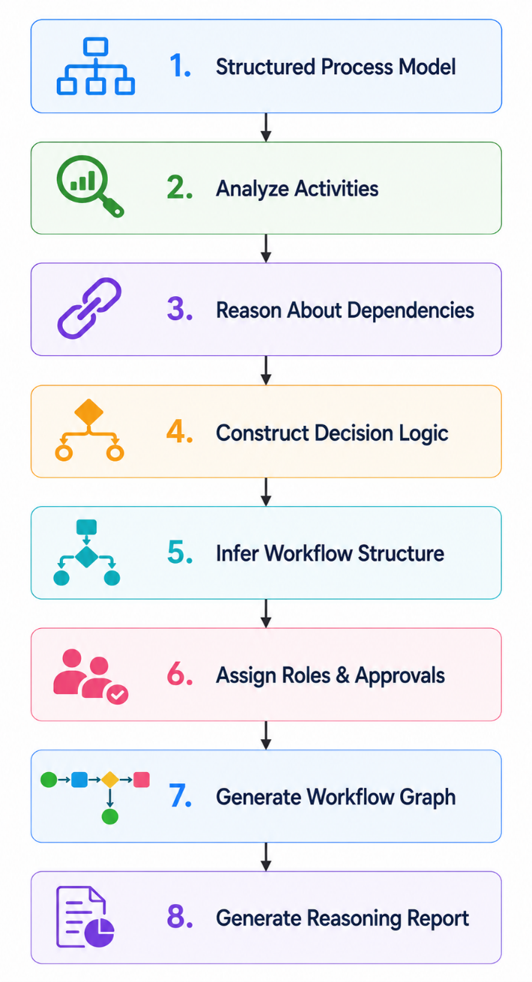

6.5.5 AI Outputs
The engine shall generate the following outputs:
Output | Description
Workflow Graph | AI-generated executable workflow structure
Decision Tree | Conditional workflow logic
Approval Chain | Inferred approval routing
Execution Sequence | Ordered workflow activities
Reasoning Report | Explanation of AI decisions
Confidence Scores | Confidence assigned to workflow components
Traceability Map | Mapping between workflow elements and SOP content

6.5.6 Business Rules
Rule ID | Business Rule
BR-REASON-001 | AI-generated workflows shall remain consistent with the original SOP.
BR-REASON-002 | AI shall provide explanations for significant reasoning decisions.
BR-REASON-003 | Workflow reasoning shall preserve identified business rules and organizational constraints.
BR-REASON-004 | Users shall review AI-generated workflows before deployment.
BR-REASON-005 | Confidence scores shall accompany generated workflow structures.
BR-REASON-006 | AI shall highlight assumptions made during reasoning.
BR-REASON-007 | Traceability between workflow elements and SOP content shall be maintained.

6.5.7 Exception Handling
Exception | Expected System Response
Conflicting business rules | Highlight conflicts and request user review.
Ambiguous workflow sequence | Generate multiple candidate sequences or request clarification.
Missing dependency information | Produce a partial workflow and identify missing information.
AI reasoning failure | Preserve extracted process model and allow regeneration.
Low confidence result | Flag the workflow for mandatory manual review.
Invalid workflow graph | Reject the generated workflow and log the incident.

6.5.8 Acceptance Criteria
The AI Workflow Reasoning Engine shall be considered complete when:
- AI successfully constructs executable workflow logic.
- Workflow sequencing reflects business intent.
- Decision trees and approval paths are generated accurately.
- Reasoning explanations accompany AI-generated workflows.
- Confidence scores are assigned to workflow structures.
- Users can review AI-generated reasoning before deployment.
- Traceability between workflow elements and source SOP content is preserved.
- Generated workflows are compatible with validation, simulation, and execution modules.

6.6 AI Response Validation Engine
6.6.1 Module Description
The AI Response Validation Engine is responsible for validating all responses generated by Artificial Intelligence before they are used by ProcessMind AI.
The engine verifies that AI-generated outputs are syntactically correct, structurally complete, logically consistent, semantically valid, and compliant with system rules.
The validation process prevents malformed, incomplete, hallucinated, or unsafe AI responses from affecting workflow generation, workflow execution, or business operations.
The engine acts as the quality assurance layer between the AI Provider and the remaining system modules.

6.6.2 Functional Requirements
Requirement ID | Functional Requirement | Priority
AI-FR-081 | The system shall validate every AI response before processing it. | High
AI-FR-082 | The system shall verify that AI responses conform to the expected JSON schema. | High
AI-FR-083 | The system shall detect incomplete AI responses. | High
AI-FR-084 | The system shall detect malformed AI responses. | High
AI-FR-085 | The system shall validate required workflow fields. | High
AI-FR-086 | The system shall validate workflow relationships and dependencies. | High
AI-FR-087 | The system shall validate approval structures generated by AI. | High
AI-FR-088 | The system shall validate extracted business rules for completeness. | Medium
AI-FR-089 | The system shall detect contradictory workflow logic. | High
AI-FR-090 | The system shall detect duplicate workflow activities generated by AI. | Medium
AI-FR-091 | The system shall detect unsupported workflow constructs. | Medium
AI-FR-092 | The system shall validate workflow graph connectivity. | High
AI-FR-093 | The system shall reject AI responses that fail validation. | High
AI-FR-094 | The system shall request AI regeneration when validation fails. | Medium
AI-FR-095 | The system shall allow manual review of rejected AI responses. | Medium
AI-FR-096 | The system shall log all validation failures. | Medium
AI-FR-097 | The system shall assign a validation status to every AI response. | Medium
AI-FR-098 | The system shall support configurable validation rules. | Low
AI-FR-099 | The system shall generate detailed validation reports for AI outputs. | Medium
AI-FR-100 | The system shall maintain validation history for audit and troubleshooting purposes. | Medium

6.6.3 Validation Types
The AI Response Validation Engine shall perform the following validations:
Validation Type | Description
Schema Validation | Verify JSON structure and required fields
Syntax Validation | Detect malformed responses
Logical Validation | Detect inconsistent workflow logic
Semantic Validation | Ensure AI output matches business intent
Dependency Validation | Verify workflow relationships
Approval Validation | Validate approval chains
Safety Validation | Detect unsafe or prohibited content
Completeness Validation | Ensure all required information is present

6.6.4 AI Validation Workflow
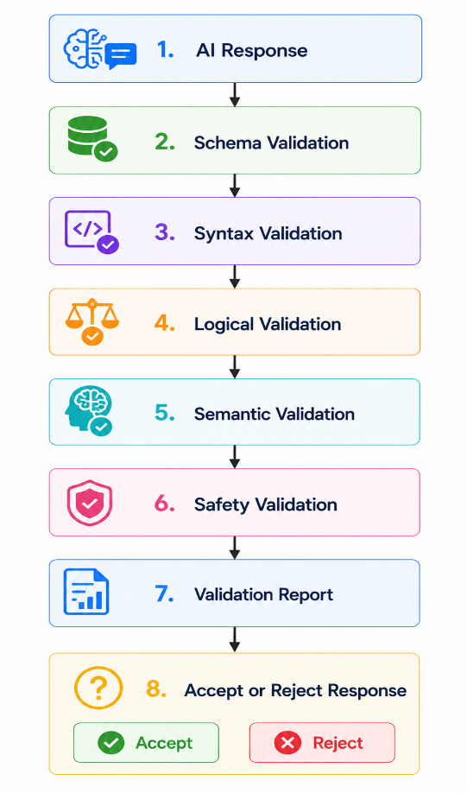

6.6.5 Validation Status
Each AI response shall receive one of the following validation statuses:
Status | Description
Valid | Response passed all validation checks
Valid with Warnings | Minor issues detected but response is acceptable
Review Required | Manual review is required before use
Invalid | Response failed validation and cannot be used
Regeneration Required | AI response must be regenerated

6.6.6 Business Rules
Rule ID | Business Rule
BR-AIVAL-001 | Every AI response shall undergo validation before use.
BR-AIVAL-002 | Invalid AI responses shall never be used for workflow generation or execution.
BR-AIVAL-003 | AI responses failing validation shall be logged for analysis.
BR-AIVAL-004 | Critical validation failures shall trigger AI response regeneration.
BR-AIVAL-005 | Manual review shall be required for low-confidence or partially valid responses.
BR-AIVAL-006 | Validation reports shall be retained for auditing purposes.
BR-AIVAL-007 | Validation rules shall be configurable by authorized administrators where supported.

6.6.7 Exception Handling
Exception | Expected System Response
Invalid JSON response | Reject the response and request regeneration.
Missing required fields | Mark the response as invalid and notify the user.
Contradictory workflow logic | Prevent processing and require manual review.
Unsupported output format | Reject the response and log the incident.
Validation engine failure | Stop downstream processing and notify the administrator.
AI regeneration failure | Preserve previous valid data and request user intervention.

6.6.8 Acceptance Criteria
The AI Response Validation Engine shall be considered complete when:
- Every AI response is validated before use.
- Invalid responses are rejected automatically.
- Validation reports accurately identify detected issues.
- AI regeneration is triggered when required.
- Validation history is maintained for auditing.
- Manual review is supported for uncertain AI outputs.
- Only validated AI outputs proceed to downstream workflow generation and execution.

6.7 AI Confidence Evaluation
6.7.1 Module Description
The AI Confidence Evaluation module is responsible for measuring the reliability of AI-generated outputs and determining the level of human intervention required before the outputs are accepted by the system.
For every AI-generated response, the module calculates confidence scores based on multiple evaluation criteria, including response completeness, consistency, validation results, reasoning quality, semantic alignment with the original SOP, and historical AI performance.
The calculated confidence score enables ProcessMind AI to distinguish between highly reliable AI outputs that may proceed with minimal intervention and lower-confidence outputs that require additional review or clarification.
This module improves transparency, trustworthiness, and governance while supporting responsible AI practices.

6.7.2 Functional Requirements
Requirement ID | Functional Requirement | Priority
AI-FR-101 | The system shall calculate a confidence score for every AI-generated response. | High
AI-FR-102 | The system shall calculate confidence scores using multiple evaluation criteria. | High
AI-FR-103 | The system shall evaluate semantic similarity between the AI response and the original SOP. | High
AI-FR-104 | The system shall incorporate AI Response Validation results into the confidence score. | High
AI-FR-105 | The system shall reduce confidence scores when inconsistencies are detected. | High
AI-FR-106 | The system shall increase confidence scores when all validation checks pass successfully. | Medium
AI-FR-107 | The system shall assign confidence scores to individual workflow components. | Medium
AI-FR-108 | The system shall assign an overall confidence score to the generated workflow. | High
AI-FR-109 | The system shall categorize confidence levels (High, Medium, Low). | High
AI-FR-110 | The system shall require manual review for AI outputs below a configurable confidence threshold. | High
AI-FR-111 | The system shall display confidence scores to authorized users. | High
AI-FR-112 | The system shall record confidence evaluation history. | Medium
AI-FR-113 | The system shall support configurable confidence thresholds. | Medium
AI-FR-114 | The system shall explain the primary factors affecting confidence scores. | High
AI-FR-115 | The system shall notify users when low-confidence results require review. | Medium
AI-FR-116 | The system shall support confidence recalculation after manual edits. | Medium
AI-FR-117 | The system shall preserve confidence evaluation reports for auditing. | Medium
AI-FR-118 | The system shall allow administrators to configure confidence evaluation policies. | Low
AI-FR-119 | The system shall maintain traceability between confidence scores and evaluated AI outputs. | Medium
AI-FR-120 | The system shall prevent automatic deployment of workflows that fail confidence policy requirements. | High

6.7.3 Confidence Levels
The system shall classify AI confidence into the following categories:
Confidence Level | Score Range | Description
High | 90–100% | AI output is highly reliable and requires minimal review.
Medium | 70–89% | AI output is acceptable but should be reviewed before deployment.
Low | Below 70% | AI output requires mandatory manual review and correction.

6.7.4 Confidence Evaluation Criteria
The confidence score shall consider the following factors:
Evaluation Criterion | Description
Response Completeness | Presence of all required workflow information
Structural Validity | Compliance with expected workflow schema
Logical Consistency | Absence of conflicting workflow logic
Semantic Accuracy | Alignment with the original SOP
Business Rule Compliance | Compliance with extracted business rules
Validation Results | Outcome of AI Response Validation
Historical Performance | Previous AI accuracy for similar workflows

6.7.5 Confidence Evaluation Workflow
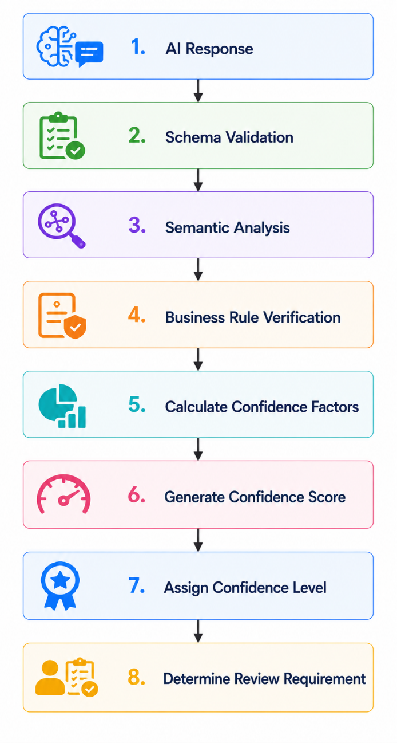

6.7.6 Business Rules
Rule ID | Business Rule
BR-CONF-001 | Every AI-generated response shall receive a confidence score.
BR-CONF-002 | Low-confidence responses shall require manual review before workflow generation.
BR-CONF-003 | Confidence scores shall be recalculated whenever AI outputs are modified.
BR-CONF-004 | Confidence evaluation reports shall be retained for auditing purposes.
BR-CONF-005 | Administrators may configure confidence thresholds within defined system limits.
BR-CONF-006 | Confidence evaluation shall consider both AI-generated content and validation results.
BR-CONF-007 | Confidence scores shall not replace human review where organizational policies require manual approval.

6.7.7 Exception Handling
Exception | Expected System Response
Confidence calculation failure | Prevent automatic workflow progression and notify the administrator.
Missing validation results | Delay confidence evaluation until validation is completed.
Invalid confidence score | Reject the evaluation and log the incident.
Threshold configuration error | Apply system default thresholds and notify the administrator.
Evaluation engine failure | Require manual review of AI outputs before further processing.

6.7.8 Acceptance Criteria
The AI Confidence Evaluation module shall be considered complete when:
- Every AI-generated response receives a confidence score.
- Confidence scores accurately reflect validation outcomes.
- Low-confidence outputs are automatically flagged for manual review.
- Confidence reports explain key factors influencing the score.
- Confidence thresholds are configurable by administrators.
- Confidence evaluation history is maintained for auditing.
- Workflow deployment complies with confidence evaluation policies.

6.8 Human-in-the-Loop (HITL) Review
6.8.1 Module Description
The Human-in-the-Loop (HITL) Review module ensures that human users remain responsible for reviewing, validating, correcting, and approving AI-generated outputs before they are used in business operations.
Rather than replacing human expertise, ProcessMind AI augments human decision-making by generating intelligent recommendations while allowing authorized users to review and modify AI outputs.
The module supports collaborative review, manual corrections, approval workflows, feedback collection, and traceability of all user interventions. It provides transparency into AI reasoning and ensures accountability for AI-assisted business decisions.

6.8.2 Functional Requirements
Requirement ID | Functional Requirement | Priority
AI-FR-121 | The system shall require human review for AI outputs that fall below the configured confidence threshold. | High
AI-FR-122 | The system shall allow authorized users to review AI-generated workflow definitions before deployment. | High
AI-FR-123 | The system shall display AI reasoning explanations during review. | High
AI-FR-124 | The system shall display confidence scores for AI-generated workflow elements. | High
AI-FR-125 | The system shall allow reviewers to edit AI-generated workflow components. | High
AI-FR-126 | The system shall allow reviewers to modify business rules generated by AI. | Medium
AI-FR-127 | The system shall allow reviewers to modify approval chains before deployment. | Medium
AI-FR-128 | The system shall allow reviewers to accept AI recommendations without modification. | Medium
AI-FR-129 | The system shall allow reviewers to reject AI-generated outputs. | High
AI-FR-130 | The system shall require reviewers to provide a reason when rejecting AI-generated outputs. | Medium
AI-FR-131 | The system shall record all manual modifications made to AI-generated content. | High
AI-FR-132 | The system shall maintain version history for reviewed AI outputs. | High
AI-FR-133 | The system shall recalculate confidence scores after manual modifications where applicable. | Medium
AI-FR-134 | The system shall collect reviewer feedback regarding AI output quality. | Medium
AI-FR-135 | The system shall maintain complete review history for auditing purposes. | High
AI-FR-136 | The system shall identify the reviewer responsible for approving AI-generated outputs. | High
AI-FR-137 | The system shall support multiple review cycles before workflow deployment. | Medium
AI-FR-138 | The system shall prevent deployment of AI-generated workflows until mandatory reviews are completed. | High
AI-FR-139 | The system shall notify reviewers when AI-generated outputs require review. | Medium
AI-FR-140 | The system shall generate review reports summarizing reviewer decisions and modifications. | Medium

6.8.3 Review Actions
Authorized reviewers shall be able to perform the following actions:
Action | Description
Accept | Approve AI-generated output without changes
Edit | Modify AI-generated workflow elements
Reject | Reject AI-generated output
Request Regeneration | Request the AI to generate a new result
Add Comments | Provide reviewer comments and feedback
Save Draft | Save review progress before completion

6.8.4 Review Workflow
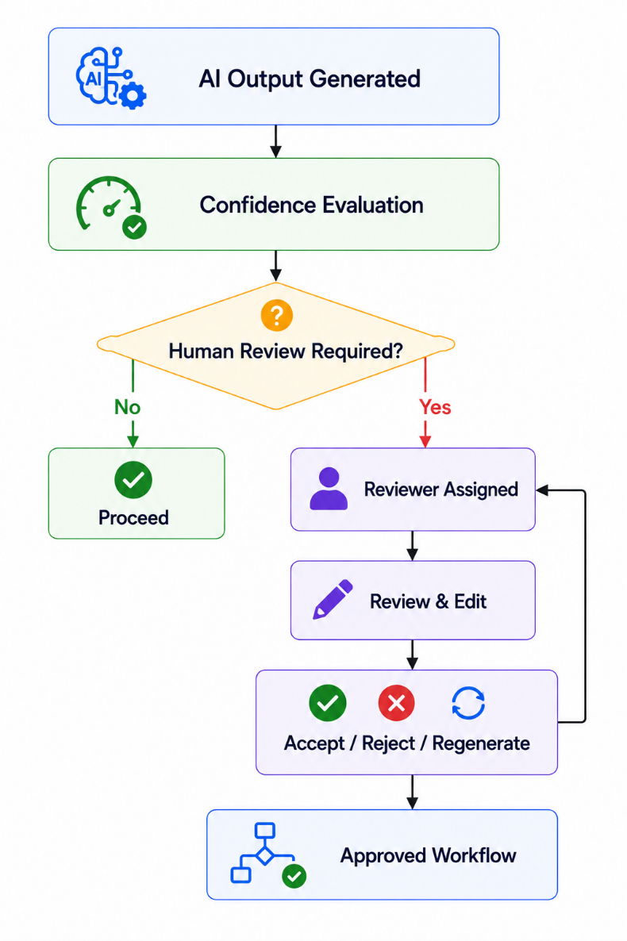

6.8.5 Review Information
The review interface shall display:
Information | Description
Original SOP | Uploaded source document
AI Output | Generated workflow or analysis
Confidence Scores | AI confidence for each component
AI Reasoning | Explanation of AI decisions
Validation Results | AI Response Validation findings
Reviewer Comments | Comments from reviewers
Version History | Previous review versions

6.8.6 Business Rules
Rule ID | Business Rule
BR-HITL-001 | AI-generated workflows requiring review shall not be deployed until approved by an authorized reviewer.
BR-HITL-002 | Manual modifications shall be recorded with user identity and timestamp.
BR-HITL-003 | Every rejection shall include a reviewer-provided reason.
BR-HITL-004 | Review history shall be retained for auditing purposes.
BR-HITL-005 | Reviewer permissions shall be enforced using Role-Based Access Control (RBAC).
BR-HITL-006 | AI reasoning explanations shall be available during the review process.
BR-HITL-007 | Manual edits shall not overwrite previous versions of AI-generated outputs.

6.8.7 Exception Handling
Exception | Expected System Response
Unauthorized review attempt | Reject the request and return HTTP 403 Forbidden.
Missing reviewer comments on rejection | Prevent submission until a reason is provided.
Concurrent review conflict | Notify reviewers and require conflict resolution.
Version conflict | Preserve both versions and request manual reconciliation.
Review session timeout | Save draft changes where possible and notify the reviewer.
Review history unavailable | Log the incident and notify the administrator.

6.8.8 Acceptance Criteria
The Human-in-the-Loop Review module shall be considered complete when:
- Authorized users can review AI-generated outputs.
- AI reasoning and confidence scores are displayed during review.
- Users can edit, accept, reject, or regenerate AI-generated results.
- Manual modifications are recorded with full traceability.
- Review history and version history are maintained.
- Mandatory reviews prevent deployment until completed.
- Reviewer feedback is captured for future analysis.
- All review activities are recorded for auditing.

6.9 AI Monitoring and Logging
6.9.1 Module Description
The AI Monitoring and Logging module is responsible for continuously monitoring, recording, and analyzing all AI-related activities within ProcessMind AI.
The module provides operational visibility into AI service performance, request processing, response quality, latency, resource utilization, token consumption, API usage, costs, and system health.
Monitoring data enables administrators to identify performance issues, troubleshoot failures, optimize AI usage, evaluate service reliability, and ensure compliance with organizational governance policies.
Comprehensive logging also supports auditing, debugging, incident investigation, and continuous improvement of AI-powered features.

6.9.2 Functional Requirements
Requirement ID | Functional Requirement | Priority
AI-FR-141 | The system shall log every AI request submitted to an AI provider. | High
AI-FR-142 | The system shall log every AI response received from an AI provider. | High
AI-FR-143 | The system shall record AI request timestamps. | High
AI-FR-144 | The system shall record AI response times. | High
AI-FR-145 | The system shall monitor AI request latency. | High
AI-FR-146 | The system shall record AI processing duration for each request. | High
AI-FR-147 | The system shall record AI provider information for every request. | Medium
AI-FR-148 | The system shall monitor AI API success and failure rates. | High
AI-FR-149 | The system shall record AI request and response sizes. | Medium
AI-FR-150 | The system shall monitor token consumption for each AI request. | Medium
AI-FR-151 | The system shall estimate AI usage costs where supported by the provider. | Medium
AI-FR-152 | The system shall monitor AI provider availability. | High
AI-FR-153 | The system shall generate alerts for repeated AI failures. | High
AI-FR-154 | The system shall log AI validation failures. | Medium
AI-FR-155 | The system shall log confidence evaluation results. | Medium
AI-FR-156 | The system shall maintain AI operational metrics. | Medium
AI-FR-157 | The system shall allow administrators to search AI logs. | Medium
AI-FR-158 | The system shall support configurable AI log retention periods. | Low
AI-FR-159 | The system shall generate AI performance reports. | Medium
AI-FR-160 | The system shall display AI monitoring dashboards for administrators. | Medium

6.9.3 AI Metrics
The monitoring module shall collect the following operational metrics:
Metric | Description
Total AI Requests | Total number of AI requests processed
Successful Requests | Number of successful AI responses
Failed Requests | Number of failed AI requests
Average Response Time | Average AI response latency
Average Processing Time | Total AI processing duration
Token Usage | Tokens consumed per request and overall
Estimated AI Cost | Estimated API usage cost
Validation Success Rate | Percentage of responses passing validation
Average Confidence Score | Average confidence across AI outputs
Provider Availability | AI service uptime and availability

6.9.4 Monitoring Workflow
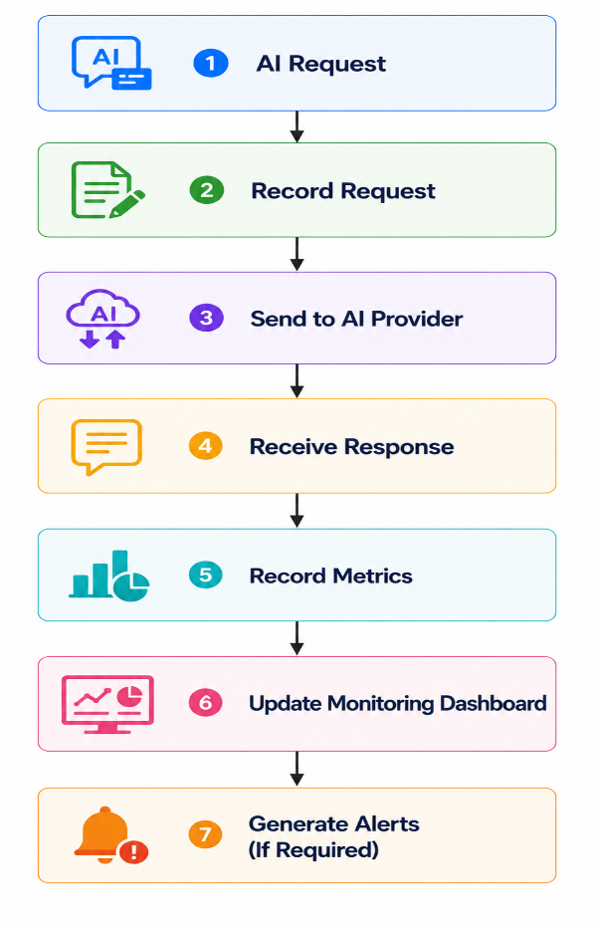
6.9.5 Log Information
Each AI log entry shall include:
Field | Description
Request ID | Unique identifier
Timestamp | Request and response time
User ID | Requesting user
Organization ID | Organization initiating the request
AI Provider | AI service used
AI Model | Model used for processing
Prompt Template Version | Version of prompt template used
Response Status | Success or failure
Response Time | Processing latency
Confidence Score | AI confidence evaluation
Validation Status | Validation result
Error Details | Failure information (if applicable)

6.9.6 Business Rules
Rule ID | Business Rule
BR-MON-001 | Every AI request shall be logged.
BR-MON-002 | AI logs shall not expose sensitive information such as API keys or user passwords.
BR-MON-003 | Monitoring data shall only be accessible to authorized administrators.
BR-MON-004 | Critical AI failures shall trigger administrator alerts.
BR-MON-005 | AI operational metrics shall be retained according to organizational retention policies.
BR-MON-006 | AI monitoring shall not significantly impact application performance.
BR-MON-007 | Monitoring dashboards shall display near real-time operational metrics.

6.9.7 Exception Handling
Exception | Expected System Response
AI logging failure | Continue AI processing and log the failure through the system logging service.
Monitoring service unavailable | Buffer monitoring events and synchronize them when the service becomes available.
Dashboard data unavailable | Display the most recent available metrics and notify administrators.
Metric calculation failure | Mark affected metrics as unavailable and record the incident.
Log storage failure | Notify administrators and preserve logs in temporary storage where possible.

6.9.8 Acceptance Criteria
The AI Monitoring and Logging module shall be considered complete when:
- All AI requests and responses are logged.
- AI performance metrics are collected accurately.
- Token usage and estimated costs are monitored.
- AI monitoring dashboards display operational metrics.
- Critical AI failures trigger alerts.
- Administrators can search and review AI logs.
- Monitoring data is retained according to configured policies.
- Sensitive information is protected within AI logs.

6.10 AI Failure Recovery
6.10.1 Module Description
The AI Failure Recovery module is responsible for detecting, managing, and recovering from failures that occur during AI processing.
The module ensures that temporary AI service interruptions, invalid responses, provider outages, timeout errors, and communication failures do not compromise the integrity, availability, or reliability of ProcessMind AI.
Recovery strategies include automatic retries, request queuing, fallback mechanisms, user notifications, manual intervention, and comprehensive failure logging.
The module enhances system resilience by allowing business operations to continue safely while minimizing the impact of AI service disruptions.
6.10.2 Functional Requirements
Requirement ID | Functional Requirement | Priority
AI-FR-161 | The system shall detect AI service failures automatically. | High
AI-FR-162 | The system shall detect AI request timeouts. | High
AI-FR-163 | The system shall detect malformed AI responses. | High
AI-FR-164 | The system shall automatically retry failed AI requests according to configurable retry policies. | High
AI-FR-165 | The system shall stop retrying after the maximum retry limit is reached. | Medium
AI-FR-166 | The system shall preserve the original user request when AI processing fails. | High
AI-FR-167 | The system shall queue failed AI requests for later retry where appropriate. | Medium
AI-FR-168 | The system shall notify users when AI processing cannot be completed. | High
AI-FR-169 | The system shall notify administrators of repeated AI service failures. | High
AI-FR-170 | The system shall log all AI failures for auditing and troubleshooting. | High
AI-FR-171 | The system shall prevent partially generated workflows from being deployed. | High
AI-FR-172 | The system shall allow users to manually restart failed AI operations. | Medium
AI-FR-173 | The system shall support configurable recovery policies. | Medium
AI-FR-174 | The system shall maintain recovery history for failed AI operations. | Medium
AI-FR-175 | The system shall support future failover to alternative AI providers. | Low
AI-FR-176 | The system shall preserve workflow state during AI recovery operations. | High
AI-FR-177 | The system shall generate recovery reports for administrators. | Medium
AI-FR-178 | The system shall support graceful degradation when AI services are unavailable. | High
AI-FR-179 | The system shall allow manual completion of AI-assisted processes when recovery is not possible. | Medium
AI-FR-180 | The system shall ensure that AI failures do not corrupt workflow or organizational data. | High

6.10.3 Failure Types
The AI Failure Recovery module shall handle the following failure categories:
Failure Type | Description
Provider Unavailable | AI service cannot be reached
Network Failure | Communication failure between the application and AI provider
Timeout | AI response exceeds configured timeout
Invalid Response | Malformed or incomplete AI output
Rate Limit Exceeded | AI provider rejects requests due to usage limits
Authentication Failure | Invalid or expired API credentials
Internal AI Error | AI provider returns an internal server error

6.10.4 Recovery Workflow
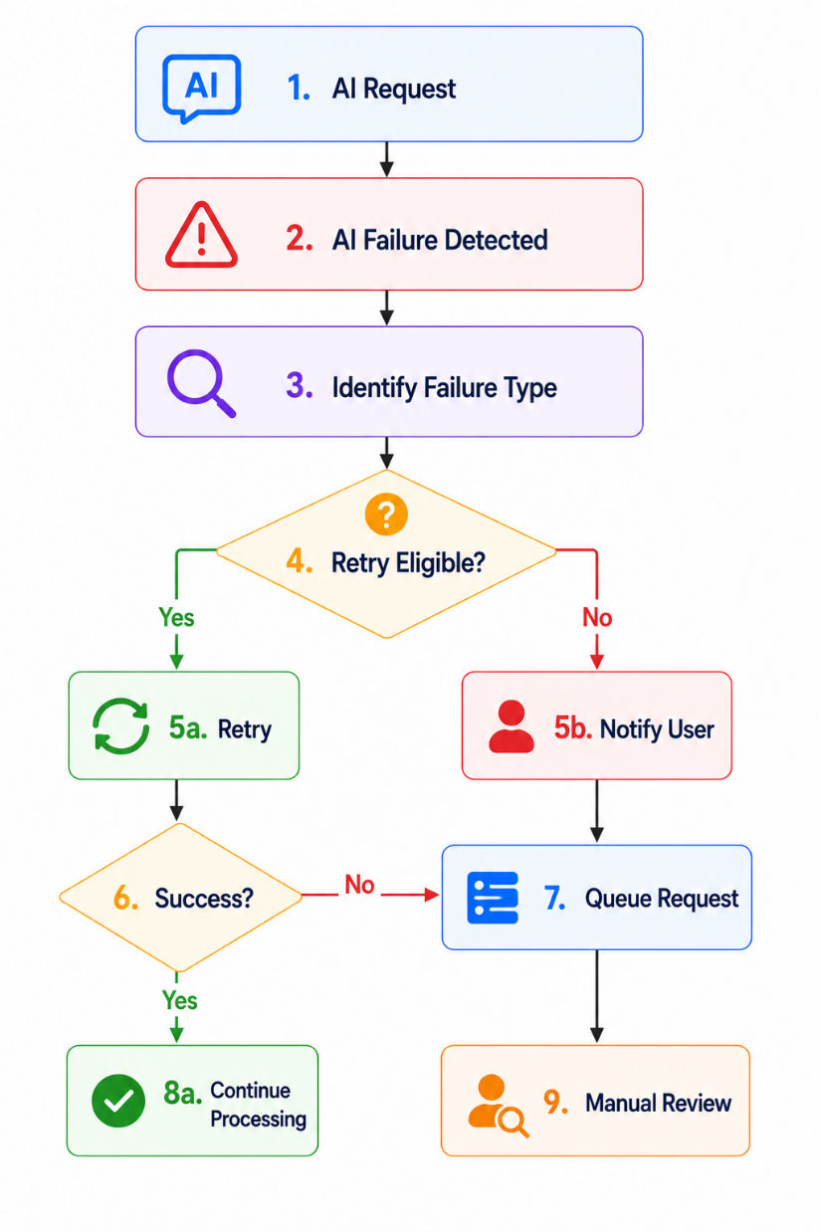

6.10.5 Recovery Strategies
Strategy | Description
Automatic Retry | Retry transient failures using configurable policies
Request Queue | Store eligible failed requests for later processing
Manual Retry | Allow users or administrators to restart failed operations
Graceful Degradation | Disable AI-dependent features while allowing other system functions to continue
Provider Failover | Route requests to an alternative AI provider (future enhancement)
Manual Completion | Allow users to complete processes without AI assistance

6.10.6 Business Rules
Rule ID | Business Rule
BR-REC-001 | AI failures shall not corrupt workflow or organizational data.
BR-REC-002 | Failed AI requests shall be logged with complete diagnostic information.
BR-REC-003 | Maximum retry attempts shall be configurable.
BR-REC-004 | Users shall be informed when AI processing cannot be completed.
BR-REC-005 | Administrators shall be notified of repeated or critical AI failures.
BR-REC-006 | Workflow execution shall not continue using invalid AI-generated outputs.
BR-REC-007 | Recovery operations shall preserve auditability and traceability.

6.10.7 Exception Handling
Exception | Expected System Response
Retry limit exceeded | Stop retry attempts, notify the user, and log the incident.
Recovery queue unavailable | Record the failure and require manual retry.
Provider failover unavailable | Continue with manual recovery procedures.
Persistent AI outage | Enable graceful degradation and notify administrators.
Corrupted recovery data | Reject recovery and preserve original workflow data.
Recovery service failure | Log the incident and require administrator intervention.

6.10.8 Acceptance Criteria
The AI Failure Recovery module shall be considered complete when:
- AI failures are detected automatically.
- Retry policies are executed correctly.
- Failed requests can be queued and retried.
- Users and administrators receive appropriate notifications.
- Workflow and organizational data remain protected during failures.
- Recovery history is maintained.

Chapter 7: Database Requirements
7.1 Database Overview
7.1.1 Purpose
The database is responsible for securely storing, organizing, and managing all persistent data required by ProcessMind AI.
It serves as the central repository for organizational information, user accounts, Standard Operating Procedures (SOPs), AI-generated process definitions, workflow configurations, workflow execution history, approval records, analytics data, notifications, audit logs, and system configuration.
The database shall provide high data integrity, consistency, security, scalability, and availability while supporting concurrent access by multiple organizations in a multi-tenant Software-as-a-Service (SaaS) environment.

7.1.2 Database Management System
The primary database management system shall be:
Property | Specification
Database Management System | PostgreSQL
Database Type | Relational Database Management System (RDBMS)
Deployment | Cloud-hosted PostgreSQL
ORM Framework | Spring Data JPA / Hibernate
SQL Standard | PostgreSQL SQL
Transaction Support | ACID Compliant
Multi-Tenant Support | Shared Database with Tenant Isolation

7.1.3 Database Objectives
The database shall support the following objectives:
- Store organizational business information securely.
- Maintain workflow execution history.
- Store AI-generated workflow definitions.
- Preserve workflow version history.
- Maintain complete audit trails.
- Support workflow analytics.
- Enable AI optimization using historical workflow data.
- Ensure data consistency across all modules.
- Support future scalability and enterprise integrations.

7.1.4 Data Categories
The database shall store the following categories of information:
Data Category | Description
Organization Data | Organizations, departments, settings
User Data | Users, roles, permissions, profiles
Authentication Data | Login credentials, sessions, tokens
SOP Data | Uploaded SOP documents and versions
AI Data | AI requests, responses, prompts, confidence scores
Workflow Data | Workflow definitions, versions, diagrams
Execution Data | Workflow instances, task execution history
Approval Data | Approval requests and decisions
Notification Data | User notifications
Analytics Data | Workflow metrics and reports
Audit Data | System audit logs
Configuration Data | System settings and AI configurations

7.1.5 Database Architecture
The database architecture follows a normalized relational design to minimize redundancy while maintaining high performance and scalability.
The architecture consists of multiple logical domains:
- Authentication Domain
- Organizations Domain
- Workflow Domain
- AI Domain
- Execution Domain
- Analytics Domain
- Administration Domain
Each domain contains related entities that collectively support the platform's business processes.

7.1.6 Multi-Tenant Database Strategy
ProcessMind AI shall implement a shared database with logical tenant isolation.
Each organization shall have its own isolated data while sharing the same database infrastructure.
Every organization-owned record shall contain an Organization ID to enforce tenant isolation.
The application layer shall ensure that users can access only data belonging to their own organization.

7.1.7 Data Integrity
The database shall enforce the following integrity requirements:
- Primary Key constraints
- Foreign Key constraints
- Unique constraints
- Check constraints
- NOT NULL constraints
- Referential integrity
- Transaction consistency

7.1.8 Transaction Management
The database shall support ACID transactions.
Every critical operation, including workflow deployment, approval processing, user creation, workflow execution, and AI result storage, shall execute within transactional boundaries to ensure data consistency.
Transactions shall be rolled back automatically if any operation fails.

7.1.9 Database Scalability
The database architecture shall support future growth through:
- Database indexing
- Connection pooling
- Read replicas
- Database partitioning
- Horizontal scaling (future)
- Query optimization
- Efficient transaction management

7.1.10 Database Security
The database shall implement the following security measures:
- Encrypted database connections (TLS)
- Password hashing using BCrypt
- Role-based database access
- Secure credential management
- Audit logging
- Backup encryption
- Protection against SQL Injection through parameterized queries and ORM frameworks

7.1.11 Database Backup
The platform shall support:
- Automatic scheduled backups
- Manual backups
- Point-in-time recovery (where supported)
- Backup verification
- Disaster recovery procedures

7.1.12 Database Retention Policy
Historical records shall be retained according to configurable organizational policies.
Retention policies shall apply to:
- Workflow history
- AI logs
- Audit logs
- Notifications
- Analytics data
- Approval history
Archived data shall remain accessible to authorized administrators where required.

7.1.13 Acceptance Criteria
The database shall be considered compliant when:
- Data integrity is maintained.
- Multi-tenant isolation is enforced.
- Transactions execute reliably.
- Database performance meets system requirements.
- Backup and recovery procedures function successfully.
- Security controls protect sensitive information.
- Historical data is retained according to configured policies.

7.2 Entity Definitions
7.2.1 Overview
The ProcessMind AI database is organized into logical business domains. Each entity represents a business object required to support workflow management, AI processing, user management, analytics, notifications, approvals, and system administration.
The database follows normalization principles (up to Third Normal Form where applicable) while maintaining performance through appropriate indexing and optimized relationships.
The primary domains are:
- Identity & Access Management
- Organization Management
- SOP Management
- Workflow Management
- Workflow Execution
- AI Management
- Analytics
- Notification
- Administration
- Audit & Logging

Identity & Access Management
Entity: Organization
Purpose
Stores information about organizations (tenants) using ProcessMind AI.
Primary Key
- organization_id (UUID)
Attributes
Attribute | Type | Description
organization_id | UUID | Unique identifier
organization_name | VARCHAR(255) | Organization name
organization_code | VARCHAR(50) | Unique organization code
industry | VARCHAR(100) | Industry sector
email | VARCHAR(255) | Contact email
phone | VARCHAR(30) | Contact phone
address | TEXT | Address
subscription_plan | VARCHAR(50) | Current subscription
status | ENUM | Active, Suspended, Archived
created_at | TIMESTAMP | Creation date
updated_at | TIMESTAMP | Last update
Relationships
- One Organization → Many Departments
- One Organization → Many Users
- One Organization → Many SOPs
- One Organization → Many Workflows

Entity: Department
Purpose
Stores organizational departments.
Primary Key
department_id
Foreign Keys
organization_id
Attributes
- department_name
- description
- manager_id
- status
- created_at
Relationships
- One Organization → Many Departments
- One Department → Many Users

Entity: Role
Purpose
Stores application roles.
Examples
- Super Admin
- Organization Admin
- Process Manager
- Employee
- Reviewer
- Approver
Primary Key
role_id
Entity: Permission
Purpose
Stores system permissions.
Examples
- CREATE_WORKFLOW
- DELETE_SOP
- DEPLOY_WORKFLOW
- MANAGE_USERS
Primary Key
permission_id

Entity: RolePermission
Purpose
Many-to-Many relationship between Roles and Permissions.

Entity: User
Purpose
Stores user accounts.
Primary Key
user_id
Foreign Keys
- organization_id
- department_id
- role_id
Attributes
- first_name
- last_name
- email
- password_hash
- profile_picture
- designation
- status
- last_login
- created_at
Relationships
- User creates SOPs
- User owns workflows
- User approves requests
- User reviews AI output

SOP Management
Entity: SOP
Purpose
Stores uploaded Standard Operating Procedures.
Attributes
- sop_id
- organization_id
- title
- description
- current_version
- status
- uploaded_by
- uploaded_at

Entity: SOPVersion
Purpose
Stores version history.
Attributes
- version_number
- file_location
- extracted_text
- ai_processing_status
- created_at

Workflow Management
Entity: Workflow
Purpose
Stores workflow definitions.
Attributes
- workflow_id
- organization_id
- sop_id
- workflow_name
- status
- created_by
- created_at

Entity: WorkflowVersion
Purpose
Stores workflow versions.
Attributes
- workflow_json
- version_number
- validation_score
- confidence_score
- deployment_status

Entity: WorkflowNode
Purpose
Stores workflow nodes.
Examples
- Task
- Approval
- Decision
- Start
- End
Attributes
- node_type
- position
- label
- configuration

Entity: WorkflowEdge
Purpose
Stores connections between nodes.
Attributes
- source_node
- target_node
- condition
- priority

Workflow Execution
Entity: WorkflowInstance
Purpose
Stores every workflow execution.
Attributes
- instance_id
- workflow_version
- initiated_by
- status
- started_at
- completed_at

Entity: WorkflowTask
Purpose
Stores runtime tasks.
Attributes
- task_name
- assigned_user
- status
- due_date
- completed_at
Entity: ApprovalRequest
Purpose
Stores approval requests.
Attributes
- approver_id
- approval_level
- decision
- comments
- decided_at

Entity: ApprovalHistory
Purpose
Stores approval history.

AI Domain
Entity: AIRequest
Purpose
Stores every request sent to Gemini.
Attributes
- request_id
- prompt_template
- request_payload
- model
- token_count
- status

Entity: AIResponse
Purpose
Stores AI responses.
Attributes
- response_text
- confidence
- latency
- validation_status

Entity: PromptTemplate
Purpose
Stores prompt templates.
Attributes
- template_name
- version
- template_body
- task_type
- status

Entity: PromptVersion
Purpose
Stores prompt version history.

Entity: AIValidationResult
Purpose
Stores validation reports.
Attributes
- schema_status
- logical_status
- semantic_status
- validation_score

Entity: AIConfidence
Purpose
Stores confidence evaluations.
Attributes
- confidence_score
- confidence_level
- explanation

Entity: AIReview
Purpose
Stores Human-in-the-Loop review.
Attributes
- reviewer
- decision
- comments
- reviewed_at

Analytics
Entity: AnalyticsRecord
Purpose
Stores workflow analytics.
Metrics
- completion_time
- approval_time
- bottlenecks
- execution_count

Entity: OptimizationRecommendation
Purpose
Stores AI optimization suggestions.
Attributes
- recommendation
- estimated_time_saved
- estimated_cost_saved
- accepted

Notifications
Entity: Notification
Purpose
Stores notifications.
Attributes
- title
- message
- recipient
- channel
- status

Administration
Entity: SystemConfiguration
Purpose
Stores system-wide settings.
Examples
- AI timeout
- Retry policy
- Confidence threshold
- Notification configuration
Entity: OrganizationSettings
Purpose
Stores organization-specific settings.

Audit
Entity: AuditLog
Purpose
Stores every important system event.
Examples
- Login
- Workflow deployed
- Approval
- AI review
- User creation
Attributes
- action
- actor
- timestamp
- IP address
- entity_type
- entity_id

Entity: ActivityLog
Purpose
Stores general user activities.

Entity: ErrorLog
Purpose
Stores application errors.

Entity: SystemHealth
Purpose
Stores monitoring metrics.
Examples
- CPU
- Memory
- AI latency
- API uptime

Entity Relationship Summary
Domain | Entities
Identity & Access | Organization, Department, User, Role, Permission, RolePermission
SOP | SOP, SOPVersion
Workflow | Workflow, WorkflowVersion, WorkflowNode, WorkflowEdge
Execution | WorkflowInstance, WorkflowTask, ApprovalRequest, ApprovalHistory
AI | AIRequest, AIResponse, PromptTemplate, PromptVersion, AIValidationResult, AIConfidence, AIReview
Analytics | AnalyticsRecord, OptimizationRecommendation
Notification | Notification
Administration | SystemConfiguration, OrganizationSettings
Audit | AuditLog, ActivityLog, ErrorLog, SystemHealth

7.3 Relationship Specifications
7.3.1 Overview
This section defines the relationships among the database entities used within ProcessMind AI.
Relationships establish referential integrity between entities and ensure that business data remains consistent throughout the lifecycle of organizations, users, workflows, AI processing, approvals, analytics, and system administration.
All relationships shall be enforced through foreign key constraints unless otherwise specified.

7.3.2 Organization Relationships
Organization → Department
Property | Value
Relationship Type | One-to-Many (1:N)
Parent Entity | Organization
Child Entity | Department
Foreign Key | Department.organization_id
Description
An organization may contain multiple departments.
Each department shall belong to exactly one organization.

Organization → User
Property | Value
Relationship Type | One-to-Many
Foreign Key | User.organization_id
Each organization may contain multiple users.
Each user belongs to exactly one organization.

Organization → SOP
Property | Value
Relationship Type | One-to-Many
Foreign Key | SOP.organization_id
Each organization may own multiple SOPs.

Organization → Workflow
Property | Value
Relationship Type | One-to-Many
Foreign Key | Workflow.organization_id
Each organization may own multiple workflows.

7.3.3 Department Relationships
Department → User
Property | Value
Relationship Type | One-to-Many
Foreign Key | User.department_id
A department may contain multiple users.
Each user belongs to one department.

7.3.4 Role Relationships
Role → User
Property | Value
Relationship Type | One-to-Many
Foreign Key | User.role_id
Each role may be assigned to multiple users.

Role → Permission
Property | Value
Relationship Type | Many-to-Many
Junction Entity | RolePermission
A role may contain multiple permissions.
A permission may belong to multiple roles.

7.3.5 SOP Relationships
SOP → SOPVersion
Property | Value
Relationship Type | One-to-Many
Foreign Key | SOPVersion.sop_id
Each SOP may have multiple versions.

SOP → Workflow
Property | Value
Relationship Type | One-to-Many
Foreign Key | Workflow.sop_id
One SOP may generate multiple workflow versions over time.

7.3.6 Workflow Relationships
Workflow → WorkflowVersion
Property | Value
Relationship Type | One-to-Many
Foreign Key | WorkflowVersion.workflow_id
A workflow may contain multiple versions.

WorkflowVersion → WorkflowNode
Property | Value
Relationship Type | One-to-Many
Foreign Key | WorkflowNode.workflow_version_id
Each workflow version contains multiple workflow nodes.

WorkflowNode → WorkflowEdge
Property | Value
Relationship Type | One-to-Many (Source Node)
Each workflow node may connect to multiple outgoing edges.

WorkflowEdge → WorkflowNode
Property | Value
Relationship Type | Many-to-One (Target Node)
Each workflow edge connects to one destination node.

7.3.7 Workflow Execution Relationships
WorkflowVersion → WorkflowInstance
Property | Value
Relationship Type | One-to-Many
Each deployed workflow version may be executed many times.

WorkflowInstance → WorkflowTask
Property | Value
Relationship Type | One-to-Many
Each workflow execution generates multiple runtime tasks.

WorkflowTask → ApprovalRequest
Property | Value
Relationship Type | One-to-One or One-to-Many
Approval tasks generate one or more approval requests.

ApprovalRequest → ApprovalHistory
Property | Value
Relationship Type | One-to-Many
Each approval request maintains its approval history.

7.3.8 AI Relationships
PromptTemplate → AIRequest
Property | Value
Relationship Type | One-to-Many
One prompt template may generate many AI requests.

AIRequest → AIResponse
Property | Value
Relationship Type | One-to-One
Each AI request produces one AI response.

AIResponse → AIValidationResult
Property | Value
Relationship Type | One-to-One
Every AI response has one validation result.

AIResponse → AIConfidence
Property | Value
Relationship Type | One-to-One
Each AI response receives one confidence evaluation.

AIResponse → AIReview
Property | Value
Relationship Type | One-to-Many
AI responses may undergo multiple review cycles.

7.3.9 Analytics Relationships
WorkflowInstance → AnalyticsRecord
Property | Value
Relationship Type | One-to-One
Each completed workflow execution contributes one analytics record.

Workflow → OptimizationRecommendation
Property | Value
Relationship Type | One-to-Many
A workflow may receive multiple optimization recommendations over time.

7.3.10 Notification Relationships
User → Notification
Property | Value
Relationship Type | One-to-Many
Each user may receive multiple notifications.

7.3.11 Audit Relationships
User → AuditLog
Property | Value
Relationship Type | One-to-Many
Every user action may create an audit log entry.

User → ActivityLog
Property | Value
Relationship Type | One-to-Many
User activities shall be recorded for operational monitoring.

SystemConfiguration → OrganizationSettings
Property | Value
Relationship Type | One-to-Many
Global system settings provide defaults for organization-specific settings.

7.3.12 Relationship Summary
Parent Entity | Child Entity | Cardinality
Organization | Department | 1:N
Organization | User | 1:N
Organization | SOP | 1:N
Organization | Workflow | 1:N
Department | User | 1:N
Role | User | 1:N
Role | Permission | M:N
SOP | SOPVersion | 1:N
SOP | Workflow | 1:N
Workflow | WorkflowVersion | 1:N
WorkflowVersion | WorkflowNode | 1:N
WorkflowNode | WorkflowEdge | 1:N
WorkflowVersion | WorkflowInstance | 1:N
WorkflowInstance | WorkflowTask | 1:N
WorkflowTask | ApprovalRequest | 1:N
ApprovalRequest | ApprovalHistory | 1:N
PromptTemplate | AIRequest | 1:N
AIRequest | AIResponse | 1:1
AIResponse | AIValidationResult | 1:1
AIResponse | AIConfidence | 1:1
AIResponse | AIReview | 1:N
WorkflowInstance | AnalyticsRecord | 1:1
Workflow | OptimizationRecommendation | 1:N
User | Notification | 1:N
User | AuditLog | 1:N
User | ActivityLog | 1:N

7.3.13 Acceptance Criteria
The relationship model shall be considered complete when:
- All entities are connected through defined relationships.
- Referential integrity is enforced using foreign keys.
- Cardinality accurately reflects business rules.
- No orphan records exist for mandatory relationships.
- Relationship definitions align with the Entity Relationship Diagram (ERD).
- Multi-tenant isolation is maintained across all organization-owned entities.

7.4 Data Dictionary
7.4.1 Overview
The Data Dictionary defines the metadata of all database entities used within ProcessMind AI. It specifies the structure, data types, constraints, default values, and descriptions of database attributes to ensure consistency during implementation and maintenance.
All database objects shall follow standardized naming conventions and data integrity rules.

7.4.2 Naming Conventions
Item | Convention | Example
Tables | Singular PascalCase | User, WorkflowInstance
Columns | snake_case | organization_id
Primary Keys | <entity>_id | user_id
Foreign Keys | <referenced_entity>_id | workflow_id
Boolean Fields | Prefix with is_ or has_ | is_active
Date Fields | Suffix _at | created_at
Version Fields | Suffix _version | prompt_version

7.4.3 Standard Data Types
PostgreSQL Type | Usage
UUID | Primary and foreign keys
VARCHAR(n) | Short text
TEXT | Long text
BOOLEAN | True/False values
INTEGER | Numeric counters
BIGINT | Large numeric values
DECIMAL | Percentages and monetary values
TIMESTAMP WITH TIME ZONE | Date and time
DATE | Calendar date
JSONB | AI responses, workflow definitions, metadata
BYTEA | Binary files (if stored in DB)
ENUM | Controlled value lists
7.4.4 Standard Audit Columns
Unless otherwise specified, every business entity shall include the following audit attributes.
Column | Type | Nullable | Description
created_at | TIMESTAMP | No | Record creation timestamp
updated_at | TIMESTAMP | No | Last modification timestamp
created_by | UUID | Yes | User who created the record
updated_by | UUID | Yes | User who last modified the record
version | INTEGER | No | Optimistic locking version
is_deleted | BOOLEAN | No | Soft delete indicator

7.4.5 Entity Data Dictionary
Organization
Column | Type | Nullable | Constraints | Description
organization_id | UUID | No | PK | Organization identifier
organization_name | VARCHAR(255) | No | Unique | Organization name
organization_code | VARCHAR(50) | No | Unique | Internal organization code
industry | VARCHAR(100) | Yes | — | Industry sector
email | VARCHAR(255) | No | Unique | Contact email
phone | VARCHAR(30) | Yes | — | Contact number
address | TEXT | Yes | — | Organization address
subscription_plan | VARCHAR(50) | No | — | Subscription plan
status | ENUM | No | — | Organization status

Department
Column | Type | Nullable | Constraints | Description
department_id | UUID | No | PK | Department identifier
organization_id | UUID | No | FK | Parent organization
department_name | VARCHAR(255) | No | — | Department name
manager_id | UUID | Yes | FK | Department manager
description | TEXT | Yes | — | Department description
status | ENUM | No | — | Department status

User
Column | Type | Nullable | Constraints | Description
user_id | UUID | No | PK | User identifier
organization_id | UUID | No | FK | Organization
department_id | UUID | Yes | FK | Department
role_id | UUID | No | FK | Assigned role
first_name | VARCHAR(100) | No | — | First name
last_name | VARCHAR(100) | No | — | Last name
email | VARCHAR(255) | No | Unique | Login email
password_hash | VARCHAR(255) | No | — | BCrypt password
designation | VARCHAR(100) | Yes | — | Job title
status | ENUM | No | — | User status
last_login | TIMESTAMP | Yes | — | Last login

SOP
Column | Type | Nullable | Constraints | Description
sop_id | UUID | No | PK | SOP identifier
organization_id | UUID | No | FK | Organization
title | VARCHAR(255) | No | — | SOP title
description | TEXT | Yes | — | Description
current_version | INTEGER | No | — | Current version
uploaded_by | UUID | No | FK | User who uploaded
status | ENUM | No | — | SOP status

Workflow
Column | Type | Nullable | Constraints | Description
workflow_id | UUID | No | PK | Workflow identifier
organization_id | UUID | No | FK | Organization
sop_id | UUID | No | FK | Source SOP
workflow_name | VARCHAR(255) | No | — | Workflow name
status | ENUM | No | — | Workflow status
current_version | INTEGER | No | — | Active version

WorkflowVersion
Column | Type | Nullable | Constraints | Description
workflow_version_id | UUID | No | PK | Version identifier
workflow_id | UUID | No | FK | Parent workflow
version_number | INTEGER | No | — | Version number
workflow_definition | JSONB | No | — | Complete workflow graph
confidence_score | DECIMAL(5,2) | Yes | — | AI confidence
validation_score | DECIMAL(5,2) | Yes | — | Validation score
deployment_status | ENUM | No | — | Deployment state

WorkflowInstance
Column | Type | Nullable | Constraints | Description
workflow_instance_id | UUID | No | PK | Workflow execution
workflow_version_id | UUID | No | FK | Workflow version
initiated_by | UUID | No | FK | Initiating user
status | ENUM | No | — | Execution status
started_at | TIMESTAMP | No | — | Start time
completed_at | TIMESTAMP | Yes | — | Completion time

AIRequest
Column | Type | Nullable | Constraints | Description
ai_request_id | UUID | No | PK | AI request
prompt_template_id | UUID | No | FK | Prompt used
provider | VARCHAR(100) | No | — | Gemini/OpenAI
model | VARCHAR(100) | No | — | Model name
prompt | TEXT | No | — | Submitted prompt
status | ENUM | No | — | Request status

AIResponse
Column | Type | Nullable | Constraints | Description
ai_response_id | UUID | No | PK | AI response
ai_request_id | UUID | No | FK | Related request
response | JSONB | No | — | Structured response
confidence_score | DECIMAL(5,2) | Yes | — | AI confidence
validation_status | ENUM | No | — | Validation result
latency_ms | INTEGER | Yes | — | Processing latency

Notification
Column | Type | Nullable | Constraints | Description
notification_id | UUID | No | PK | Notification
user_id | UUID | No | FK | Recipient
title | VARCHAR(255) | No | — | Notification title
message | TEXT | No | — | Content
channel | ENUM | No | — | Email/In-App
status | ENUM | No | — | Delivery status

AuditLog
Column | Type | Nullable | Constraints | Description
audit_log_id | UUID | No | PK | Audit entry
user_id | UUID | Yes | FK | User
action | VARCHAR(255) | No | — | Performed action
entity_type | VARCHAR(100) | No | — | Affected entity
entity_id | UUID | Yes | — | Affected record
ip_address | VARCHAR(50) | Yes | — | Source IP
timestamp | TIMESTAMP | No | — | Event time

7.4.6 Common Constraints
Constraint | Description
Primary Key | Every entity shall have a UUID primary key.
Foreign Key | Referential integrity shall be enforced.
Unique | Emails, organization codes, and role names shall be unique.
NOT NULL | Mandatory business fields shall not be null.
CHECK | Enum values and numeric ranges shall be validated.
Soft Delete | Business entities shall use logical deletion where appropriate.

7.4.7 Acceptance Criteria
The data dictionary shall be considered complete when:
- Every major entity has documented attributes.
- Data types align with PostgreSQL standards.
- Constraints enforce business rules.
- Naming conventions are applied consistently.
- Audit columns are standardized across business entities.
- The documented schema aligns with the ER Diagram and implementation.

7.5 Constraints & Integrity Rules
7.5.1 Overview
The database shall enforce integrity constraints to ensure that all stored information remains accurate, consistent, reliable, and compliant with business rules.
Constraints shall be implemented using PostgreSQL constraint mechanisms, transaction management, application-level validation, and database triggers where appropriate.
These rules apply across all ProcessMind AI modules, including authentication, workflow management, AI processing, approvals, analytics, notifications, and auditing.

7.5.2 Entity Integrity
Every entity shall have a unique primary key.
Rule ID | Constraint
DB-CON-001 | Every table shall contain exactly one Primary Key.
DB-CON-002 | Primary Keys shall use UUID data type.
DB-CON-003 | Primary Keys shall never be updated after record creation.
DB-CON-004 | Primary Keys shall uniquely identify every record.

7.5.3 Referential Integrity
Foreign Key relationships shall ensure valid relationships between entities.
Rule ID | Constraint
DB-CON-005 | Every Foreign Key shall reference an existing Primary Key.
DB-CON-006 | Orphan records shall not be permitted.
DB-CON-007 | Referential integrity shall be enforced using PostgreSQL Foreign Keys.
DB-CON-008 | Invalid Foreign Key values shall be rejected.

7.5.4 Mandatory Fields
Required business information shall not be omitted.
Rule ID | Constraint
DB-CON-009 | Mandatory fields shall be defined using NOT NULL constraints.
DB-CON-010 | Business-critical entities shall not be created with incomplete information.
DB-CON-011 | Required relationships shall exist before dependent records are created.
Examples include:
- Organization Name
- User Email
- Workflow Name
- Workflow Status
- AI Request Status

7.5.5 Uniqueness Constraints
Certain business attributes shall remain unique.
Rule ID | Constraint
DB-CON-012 | Organization Code shall be unique.
DB-CON-013 | User Email shall be unique within the system.
DB-CON-014 | Role Name shall be unique.
DB-CON-015 | Permission Name shall be unique.
DB-CON-016 | Prompt Template Name and Version combination shall be unique.

7.5.6 Domain Constraints
Column values shall comply with predefined domains.
Rule ID | Constraint
DB-CON-017 | ENUM values shall only contain predefined values.
DB-CON-018 | Confidence Score shall be between 0 and 100.
DB-CON-019 | Validation Score shall be between 0 and 100.
DB-CON-020 | Retry Count shall be zero or greater.
DB-CON-021 | Workflow Version Number shall be greater than zero.

7.5.7 Business Integrity Rules
Business processes shall maintain logical consistency.
Rule ID | Constraint
DB-CON-022 | Every Workflow shall belong to one Organization.
DB-CON-023 | Every Workflow Version shall belong to one Workflow.
DB-CON-024 | Every Workflow Instance shall reference a deployed Workflow Version.
DB-CON-025 | Every Approval Request shall reference an existing Workflow Task.
DB-CON-026 | Every AI Response shall reference an existing AI Request.
DB-CON-027 | Every Notification shall reference an existing User.
DB-CON-028 | Every Audit Log entry shall reference a valid system event.

7.5.8 Cascade Rules
The database shall apply controlled cascading operations.
Parent Entity | Child Entity | Delete Behavior
Organization | Department | RESTRICT
Organization | User | RESTRICT
Organization | Workflow | RESTRICT
SOP | SOP Version | CASCADE
Workflow | Workflow Version | CASCADE
Workflow Version | Workflow Node | CASCADE
Workflow Version | Workflow Instance | RESTRICT
Workflow Instance | Workflow Task | CASCADE
Workflow Task | Approval Request | CASCADE
AI Request | AI Response | CASCADE
Explanation
Historical business records shall not be deleted automatically unless explicitly permitted by business policy.

7.5.9 Soft Delete Policy
To preserve historical information:
Rule ID | Constraint
DB-CON-029 | Business entities shall use logical deletion where appropriate.
DB-CON-030 | Deleted records shall remain available for auditing.
DB-CON-031 | Soft-deleted records shall be excluded from normal queries.
Entities using soft delete include:
- User
- Workflow
- SOP
- Organization
- Notification

7.5.10 Transaction Integrity
Critical business operations shall execute atomically.
Rule ID | Constraint
DB-CON-032 | Workflow deployment shall execute within a single transaction.
DB-CON-033 | Approval processing shall execute within a single transaction.
DB-CON-034 | User creation shall execute within a single transaction.
DB-CON-035 | AI processing results shall be stored atomically.
DB-CON-036 | Failed transactions shall be rolled back automatically.

7.5.11 Optimistic Locking
To prevent concurrent update conflicts:
Rule ID | Constraint
DB-CON-037 | Business entities shall support optimistic locking.
DB-CON-038 | Record version numbers shall be incremented after successful updates.
DB-CON-039 | Conflicting updates shall be rejected and require retry.

7.5.12 Audit Integrity
Audit information shall remain immutable.
Rule ID | Constraint
DB-CON-040 | Audit Log records shall not be modified after creation.
DB-CON-041 | Audit Log records shall not be physically deleted.
DB-CON-042 | Every administrative operation shall generate an audit record.

7.5.13 Multi-Tenant Integrity
Tenant isolation shall be enforced.
Rule ID | Constraint
DB-CON-043 | Every organization-owned record shall contain Organization ID.
DB-CON-044 | Users shall access only data belonging to their organization.
DB-CON-045 | Cross-organization access shall be prohibited except for System Administrators.

7.5.14 Data Validation Rules
Application-level validation shall complement database constraints.
Examples include:
Field | Validation Rule
Email | Valid email format
Password | Minimum security requirements
Confidence Score | 0–100
Workflow Name | Maximum 255 characters
Prompt Template | Cannot be empty
API Key | Must conform to configured provider requirements

7.5.15 Acceptance Criteria
The database integrity model shall be considered complete when:
- Primary and foreign key constraints are enforced.
- Referential integrity prevents orphan records.
- Business rules are reflected through database constraints.
- Transactions preserve consistency.
- Soft deletion preserves historical records.
- Audit data remains immutable.
- Tenant isolation is maintained.
- Concurrent updates are handled safely through optimistic locking.

7.6 Indexing Strategy
7.6.1 Overview
The Indexing Strategy defines how database indexes shall be designed and maintained to optimize query performance, reduce response times, and support efficient data retrieval.
Indexes shall be created for frequently queried columns, foreign keys, search fields, and analytical operations while balancing read performance with write overhead.
The strategy shall be periodically reviewed and optimized based on application usage patterns.

7.6.2 Objectives
The indexing strategy shall achieve the following objectives:
- Improve query execution performance.
- Reduce response time for user operations.
- Optimize workflow search and filtering.
- Accelerate AI log retrieval.
- Improve analytics performance.
- Support efficient multi-tenant data access.
- Minimize unnecessary full table scans.
7.6.3 Primary Key Indexes
Every Primary Key shall be indexed automatically.
Index ID | Entity | Indexed Column
IDX-PK-001 | Organization | organization_id
IDX-PK-002 | Department | department_id
IDX-PK-003 | User | user_id
IDX-PK-004 | SOP | sop_id
IDX-PK-005 | Workflow | workflow_id
IDX-PK-006 | WorkflowVersion | workflow_version_id
IDX-PK-007 | WorkflowInstance | workflow_instance_id
IDX-PK-008 | AIRequest | ai_request_id
IDX-PK-009 | AIResponse | ai_response_id
IDX-PK-010 | Notification | notification_id

7.6.4 Foreign Key Indexes
Foreign Keys shall be indexed to improve join performance.
Index ID | Indexed Column
IDX-FK-001 | organization_id
IDX-FK-002 | department_id
IDX-FK-003 | role_id
IDX-FK-004 | workflow_id
IDX-FK-005 | workflow_version_id
IDX-FK-006 | sop_id
IDX-FK-007 | user_id
IDX-FK-008 | ai_request_id
IDX-FK-009 | prompt_template_id

7.6.5 Unique Indexes
The following business attributes shall be uniquely indexed.
Column | Reason
organization_code | Organization identification
email | User authentication
role_name | RBAC
permission_name | Permission management
prompt_name + version | Prompt versioning

7.6.6 Search Indexes
The following fields shall be indexed to support search functionality.
Entity | Indexed Field | Purpose
SOP | title | SOP search
Workflow | workflow_name | Workflow search
User | first_name | User lookup
User | last_name | User lookup
Department | department_name | Department search
Notification | title | Notification search

7.6.7 Multi-Tenant Indexes
Since ProcessMind AI is a SaaS application, Organization ID shall be indexed.
Entity | Indexed Field
User | organization_id
Department | organization_id
SOP | organization_id
Workflow | organization_id
WorkflowInstance | organization_id
Notification | organization_id
AuditLog | organization_id
This allows rapid filtering of organization-specific data.
7.6.8 Composite Indexes
Composite indexes shall optimize common filtering scenarios.
Composite Index | Purpose
(organization_id, email) | User authentication
(organization_id, workflow_name) | Workflow search
(organization_id, status) | Active workflow retrieval
(workflow_version_id, status) | Workflow execution lookup
(assigned_user_id, status) | Pending task retrieval
(approver_id, status) | Pending approvals
(user_id, created_at) | Notification history

7.6.9 Full-Text Search Indexes
The platform shall support PostgreSQL Full-Text Search for textual content.
Entity | Indexed Fields
SOP | title + extracted_text
Workflow | workflow_name + description
PromptTemplate | template_name + template_body
AuditLog | action
Notification | title + message
This enables:
- Keyword search
- Phrase search
- AI document search
- SOP lookup

7.6.10 JSONB Indexes
JSONB columns shall use GIN indexes.
Entity | JSON Column | Index Type
WorkflowVersion | workflow_definition | GIN
AIResponse | response | GIN
SystemConfiguration | configuration | GIN
These indexes support efficient querying within structured JSON data.

7.6.11 Analytics Indexes
The following indexes shall improve reporting performance.
Indexed Column | Purpose
created_at | Time-series reports
completed_at | Workflow analytics
status | Dashboard statistics
confidence_score | AI analytics
validation_status | AI monitoring
execution_time | Performance analysis

7.6.12 Audit Indexes
Audit queries shall be optimized using indexes.
Indexed Column | Purpose
timestamp | Audit history
user_id | User activity
entity_type | Entity filtering
action | Audit reporting

7.6.13 AI Monitoring Indexes
Indexes shall support AI monitoring dashboards.
Indexed Column | Purpose
provider | Provider performance
model | Model comparison
latency_ms | Performance metrics
request_timestamp | AI timeline
validation_status | Validation analytics

7.6.14 Index Maintenance
The database shall support periodic index maintenance.
Maintenance activities include:
- Rebuilding fragmented indexes.
- Updating PostgreSQL statistics using ANALYZE.
- Reclaiming storage using VACUUM.
- Monitoring unused indexes.
- Removing redundant indexes.
These tasks shall be scheduled during low-traffic periods to minimize operational impact.

    - Business Rules
Rule ID | Rule
DB-IDX-001 | Primary Keys shall always be indexed.
DB-IDX-002 | Foreign Keys shall be indexed unless justified otherwise.
DB-IDX-003 | Frequently searched columns shall be indexed.
DB-IDX-004 | Full-text indexes shall support document search.
DB-IDX-005 | JSONB fields shall use GIN indexes where querying is required.
DB-IDX-006 | Indexes shall be periodically reviewed for effectiveness.
DB-IDX-007 | Indexes shall not be created unnecessarily to avoid write-performance degradation.

7.6.16 Acceptance Criteria
The indexing strategy shall be considered complete when:
- Primary and foreign key indexes exist.
- Frequently executed queries use appropriate indexes.
- Search operations complete efficiently.
- Analytics queries perform within acceptable response times.
- Multi-tenant filtering is optimized.
- Full-text search supports SOP discovery.
- JSONB queries perform efficiently.
- Index maintenance procedures are documented and implemented.

7.7 Backup & Recovery Requirements
7.7.1 Overview
The Backup and Recovery Requirements define the strategies, policies, and procedures used to protect organizational data against accidental deletion, system failures, hardware failures, software defects, cyberattacks, and natural disasters.
The backup system shall ensure that critical business data can be restored with minimal data loss and acceptable service downtime.
These requirements apply to all persistent data managed by ProcessMind AI, including organizational data, workflows, SOPs, AI processing records, approvals, audit logs, notifications, and analytics.

7.7.2 Objectives
The backup and recovery strategy shall achieve the following objectives:
- Protect organizational data.
- Minimize service interruption.
- Reduce data loss.
- Support disaster recovery.
- Ensure business continuity.
- Maintain regulatory compliance.
- Verify backup integrity.

7.7.3 Backup Scope
The following data shall be included in scheduled backups.
Data Category | Included
Organizations | Yes
Users | Yes
Departments | Yes
Roles & Permissions | Yes
SOPs | Yes
Workflow Definitions | Yes
Workflow Versions | Yes
Workflow Execution History | Yes
Approval Records | Yes
AI Requests | Yes
AI Responses | Yes
Prompt Templates | Yes
Notifications | Yes
Analytics Data | Yes
Audit Logs | Yes
System Configuration | Yes
Organization Settings | Yes

7.7.4 Backup Types
The system shall support the following backup strategies.
Backup Type | Description
Full Backup | Complete database backup
Incremental Backup | Backup of changes since the previous backup
Differential Backup | Backup of changes since the last full backup
Configuration Backup | System and application configuration
File Backup | Uploaded SOP documents and related files

7.7.5 Backup Schedule
The following backup schedule shall be implemented.
Backup Type | Frequency
Full Backup | Weekly
Incremental Backup | Daily
Configuration Backup | After configuration changes
File Backup | Daily
Audit Log Archive | Monthly
The schedule may be modified by authorized administrators.

7.7.6 Recovery Objectives
The platform shall define recovery objectives.
Metric | Target
Recovery Point Objective (RPO) | ≤ 24 hours
Recovery Time Objective (RTO) | ≤ 4 hours
Backup Verification | 100% successful verification
Backup Availability | 99.9%
Note: These values represent initial deployment targets and may be adjusted for production environments based on organizational service-level agreements (SLAs).
7.7.7 Recovery Process
The recovery process shall follow the sequence below.
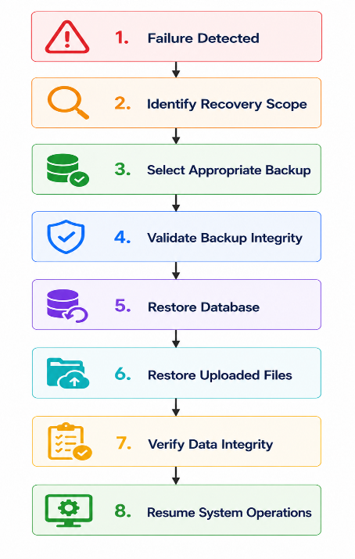
7.7.8 Backup Security
The following security controls shall apply.
Requirement | Description
Encryption | Backups shall be encrypted at rest.
Secure Transfer | Backup transmission shall use encrypted communication channels (TLS).
Access Control | Only authorized administrators may access backups.
Integrity Verification | Backup integrity shall be verified before restoration.
Backup Logging | All backup operations shall be logged.

7.7.9 Backup Retention Policy
The system shall retain backups according to the following policy.
Backup Type | Retention Period
Daily Backups | 30 days
Weekly Backups | 12 weeks
Monthly Backups | 12 months
Annual Backups | 7 years (configurable)
Retention periods may be adjusted to comply with organizational or regulatory requirements.

7.7.10 Disaster Recovery
The disaster recovery strategy shall support:
- Database recovery.
- File storage recovery.
- Configuration restoration.
- AI configuration recovery.
- Workflow restoration.
- Audit log preservation.
- Notification recovery.
Recovery procedures shall be documented and periodically tested.

7.7.11 Recovery Validation
After restoration, the following validation checks shall be performed.
Validation | Description
 | Verify referential integrity and constraints
Workflow Integrity | Verify workflow definitions and versions
User Accounts | Verify user authentication data
AI Data | Verify AI requests and responses
Audit Logs | Verify audit history
File Storage | Verify uploaded SOP documents
The system shall not return to production until validation is successfully completed.
7.7.12 Business Rules
Rule ID | Rule
DB-BKP-001 | Scheduled backups shall execute automatically according to the configured schedule.
DB-BKP-002 | Backup files shall be encrypted.
DB-BKP-003 | Backup integrity shall be verified before restoration.
DB-BKP-004 | Only authorized administrators shall perform restore operations.
DB-BKP-005 | All backup and recovery operations shall be recorded in the audit log.
DB-BKP-006 | Backup failures shall generate administrator alerts.
DB-BKP-007 | Disaster recovery procedures shall be tested periodically.

7.7.13 Exception Handling
Exception | Expected System Response
Backup failure | Log the failure, notify administrators, and retry according to the backup policy.
Backup corruption | Reject the backup and restore from the most recent verified backup.
Insufficient storage | Notify administrators and suspend new backups until storage is available.
Recovery validation failure | Prevent production use until validation succeeds.
Unauthorized restore attempt | Reject the request and record the incident in the audit log.
File restoration failure | Continue database recovery where safe and report missing files.

7.7.14 Acceptance Criteria
The backup and recovery strategy shall be considered complete when:
- Scheduled backups execute successfully.
- Backup files are encrypted and protected.
- Backup integrity is verified before restoration.
- Recovery procedures restore all required data.
- Recovery objectives (RPO/RTO) are met under normal operating conditions.
- Backup and recovery events are recorded in audit logs.
- Disaster recovery procedures are documented and tested periodically.

7.8 Data Retention & Archival Policy
7.8.1 Overview
The Data Retention and Archival Policy defines how ProcessMind AI manages the lifecycle of stored data throughout its existence.
The policy ensures that business information is retained for operational, legal, auditing, and analytical purposes while preventing unnecessary database growth.
Data shall progress through the following lifecycle:
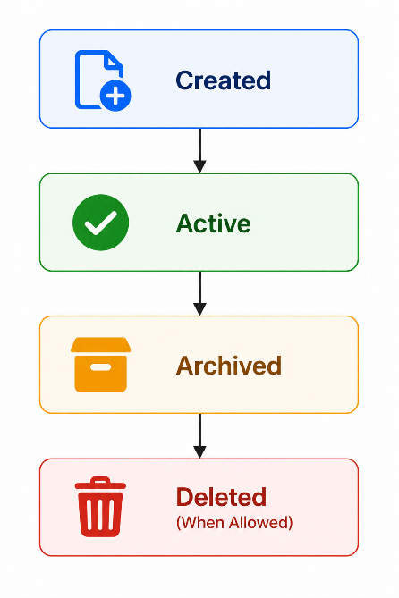
The policy applies to all organizations using the platform while allowing organization-specific retention settings where supported.

7.8.2 Objectives
The retention policy shall:
- Preserve important business records.
- Reduce database storage growth.
- Improve database performance.
- Maintain auditability.
- Support regulatory compliance.
- Reduce operational costs.
- Enable historical analytics.

7.8.3 Data Classification
All stored data shall be classified according to its business importance.
Classification | Description
Operational Data | Data actively used by the application
Historical Data | Completed workflows and historical records
Audit Data | Security and audit information
AI Processing Data | AI requests, responses, prompts, confidence scores
Configuration Data | Organization and system settings
Temporary Data | Cached or intermediate processing data

7.8.4 Retention Periods
The default retention periods shall be as follows.
Data Category | Retention Period | Archive | Permanent Deletion
Organizations | Lifetime | No | Administrator only
Users | Lifetime (while active) | Yes | Configurable
SOPs | Lifetime | Yes | Administrator only
Workflow Definitions | Lifetime | Yes | Administrator only
Workflow Execution History | 5 Years | Yes | Configurable
Approval History | 5 Years | Yes | Configurable
AI Requests | 2 Years | Yes | Configurable
AI Responses | 2 Years | Yes | Configurable
Prompt Templates | Lifetime | Yes | Never (default)
Notifications | 1 Year | Yes | Automatic
Analytics Records | 5 Years | Yes | Configurable
Audit Logs | 7 Years | Yes | Restricted
Error Logs | 1 Year | Yes | Automatic
System Health Metrics | 1 Year | Yes | Automatic
These values represent recommended defaults and may be overridden by organizational or regulatory policies where permitted.

7.8.5 Archival Strategy
Archived data shall:
- Remain read-only.
- Be removed from active operational queries.
- Remain searchable by authorized users.
- Be restorable when required.
- Maintain referential integrity.
Archived data may be stored in:
- Archive database
- Cold storage
- Encrypted object storage
- Long-term backup storage
7.8.6 Data Lifecycle
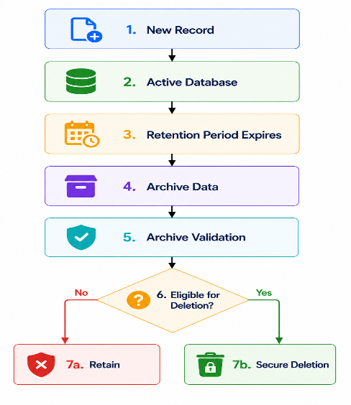
7.8.7 Archival Rules
Rule ID | Rule
DB-ARC-001 | Only completed workflow instances may be archived.
DB-ARC-002 | Archived records shall remain read-only.
DB-ARC-003 | Archived records shall preserve relationships with associated entities.
DB-ARC-004 | Archived data shall remain available for reporting and auditing where authorized.
DB-ARC-005 | Archiving shall not interrupt active system operations.
DB-ARC-006 | Archival operations shall be logged.

7.8.8 Secure Deletion
When permanent deletion is permitted:
- The deletion shall comply with organizational retention policies.
- All related records shall be handled according to referential integrity rules.
- Deletion operations shall be audited.
- Sensitive data shall be securely erased where applicable.
Deletion shall not occur for records subject to:
- Active legal holds.
- Compliance requirements.
- Pending investigations.
- Ongoing workflow execution.

7.8.9 Business Rules
Rule ID | Rule
DB-RET-001 | Active workflow data shall never be archived.
DB-RET-002 | Archived data shall remain immutable unless restored.
DB-RET-003 | Retention policies shall be configurable by authorized administrators within permitted limits.
DB-RET-004 | Audit logs shall not be deleted before the configured retention period expires.
DB-RET-005 | Archival and deletion operations shall generate audit log entries.
DB-RET-006 | Archived data shall remain encrypted while stored.
DB-RET-007 | Restored archived records shall preserve their original identifiers and relationships.

7.8.10 Exception Handling
Exception | Expected System Response
Archive operation failure | Log the incident, notify the administrator, and retry according to policy.
Archive storage unavailable | Delay archival and retain data in the active database until storage becomes available.
Restore failure | Preserve archived data and notify the administrator.
Attempt to delete protected records | Reject the request and record the event.
Retention policy conflict | Apply the stricter policy and notify administrators.
Archive integrity verification failure | Prevent archival completion until verification succeeds.

7.8.11 Acceptance Criteria
The Data Retention and Archival Policy shall be considered complete when:
- Data retention periods are enforced according to policy.
- Eligible data is archived automatically or through authorized administrative actions.
- Archived data remains secure, immutable, and recoverable.
- Permanent deletion occurs only when permitted.
- Retention, archival, restoration, and deletion events are recorded in audit logs.
- The policy supports organizational and regulatory compliance requirements.

7.9 Database Security Requirements
7.9.1 Overview
The Database Security Requirements define the controls, policies, and mechanisms used to protect the confidentiality, integrity, and availability of data stored within ProcessMind AI.
The database security architecture shall implement defense-in-depth principles through authentication, authorization, encryption, auditing, network security, tenant isolation, and secure database configuration.
These requirements apply to all database environments, including development, testing, staging, and production.

7.9.2 Security Objectives
The database security architecture shall achieve the following objectives:
- Protect sensitive organizational data.
- Prevent unauthorized database access.
- Ensure tenant isolation.
- Maintain data integrity.
- Protect credentials and secrets.
- Support auditing and forensic investigations.
- Comply with security best practices.

7.9.3 Authentication
Database authentication shall comply with the following requirements.
Requirement ID | Requirement
DB-SEC-001 | Every database connection shall be authenticated.
DB-SEC-002 | Database credentials shall not be stored in source code.
DB-SEC-003 | Database credentials shall be stored using secure environment variables or a secrets management solution.
DB-SEC-004 | Administrative database accounts shall be restricted to authorized administrators.
DB-SEC-005 | Shared administrator accounts shall not be used.

7.9.4 Authorization
Access shall follow the principle of least privilege.
Requirement ID | Requirement
DB-SEC-006 | Database roles shall grant only the minimum required privileges.
DB-SEC-007 | Application service accounts shall not possess superuser privileges.
DB-SEC-008 | Database administrators shall use separate administrative accounts.
DB-SEC-009 | Privileged operations shall be restricted to authorized personnel.
DB-SEC-010 | Database permissions shall be reviewed periodically.

7.9.5 Encryption
Sensitive information shall be protected through encryption.
Requirement | Description
Encryption in Transit | All database communication shall use TLS.
Encryption at Rest | Database storage and backups shall be encrypted.
Password Storage | User passwords shall be stored using BCrypt hashes.
API Credentials | API keys and secrets shall be encrypted or securely managed.

7.9.6 Multi-Tenant Security
Tenant isolation shall be enforced.
Requirement ID | Requirement
DB-SEC-011 | Every organization-owned record shall include an Organization ID.
DB-SEC-012 | Cross-tenant data access shall be prohibited.
DB-SEC-013 | Tenant isolation shall be enforced at the application layer.
DB-SEC-014 | PostgreSQL Row-Level Security (RLS) should be used in production deployments where appropriate.

7.9.7 Data Integrity
The following controls shall protect database integrity.
Requirement ID | Requirement
DB-SEC-015 | Foreign key constraints shall be enforced.
DB-SEC-016 | Database transactions shall comply with ACID properties.
DB-SEC-017 | Optimistic locking shall prevent concurrent update conflicts.
DB-SEC-018 | Audit records shall be immutable.

7.9.8 Secure Database Configuration
The database shall be configured securely.
Security measures include:
- Disable unnecessary database extensions.
- Restrict remote administrative access.
- Use secure configuration defaults.
- Apply security patches regularly.
- Enable database activity logging.
- Disable unused accounts.
- Rotate credentials periodically.

7.9.9 Audit Logging
The database shall maintain security-relevant audit records.
Logged Event
Authentication attempts
Failed login attempts
Administrative actions
Privilege changes
Backup operations
Restore operations
Schema modifications
Sensitive data access
Audit logs shall be protected against unauthorized modification.

7.9.10 Network Security
Database servers shall be protected using network security controls.
These include:
- Firewall restrictions.
- Private network deployment.
- VPN or secure administrative access where required.
- IP allowlists for administrative connections.
- Network segmentation between application and database layers.

7.9.11 Security Monitoring
The system shall monitor:
- Unauthorized login attempts.
- Failed authentication events.
- Suspicious database activity.
- Privilege escalation attempts.
- Excessive query rates.
- Database availability.
- Storage utilization.
Critical events shall generate alerts for administrators.

7.9.12 Business Rules
Rule ID | Rule
DB-SEC-BR-001 | Database credentials shall never be exposed in application source code.
DB-SEC-BR-002 | Sensitive data shall be encrypted during transmission and storage where appropriate.
DB-SEC-BR-003 | Users shall access only data belonging to their organization unless explicitly authorized.
DB-SEC-BR-004 | Administrative database operations shall be audited.
DB-SEC-BR-005 | Security logs shall be retained according to organizational retention policies.
DB-SEC-BR-006 | Database security controls shall be reviewed periodically.
DB-SEC-BR-007 | Security incidents shall be investigated and documented.

7.9.13 Exception Handling
Exception | Expected System Response
Invalid database credentials | Reject the connection attempt and log the event.
Unauthorized data access attempt | Deny access, generate an audit record, and notify administrators where appropriate.
TLS negotiation failure | Reject the connection and require a secure connection.
Database account lockout | Prevent authentication until administrative review or configured unlock conditions are met.
Security configuration error | Prevent deployment where possible and notify administrators.
Suspected compromise | Trigger incident response procedures and increase monitoring.

7.9.14 Acceptance Criteria
The database security requirements shall be considered complete when:
- All database connections are authenticated and encrypted.
- Database credentials are securely managed.
- Tenant isolation is enforced.
- Role-based access controls are implemented.
- Security-relevant events are audited.
- Database configurations follow secure defaults.
- Sensitive information is protected in transit and at rest.
- Security monitoring detects and reports critical events.
Chapter 8: REST API Specifications
8.1 API Overview
8.1.1 Purpose
The REST API provides a standardized interface for communication between the ProcessMind AI frontend, backend services, AI modules, and future third-party integrations.
The API enables secure access to system resources while enforcing authentication, authorization, validation, auditing, and tenant isolation.
All APIs shall follow REST architectural principles and return structured JSON responses.

8.1.2 Objectives
The API shall:
- Enable secure client-server communication.
- Support CRUD operations.
- Support AI-powered business operations.
- Maintain stateless communication.
- Support integration with future systems.
- Enforce authorization policies.
- Maintain backward compatibility.

8.1.3 Architecture
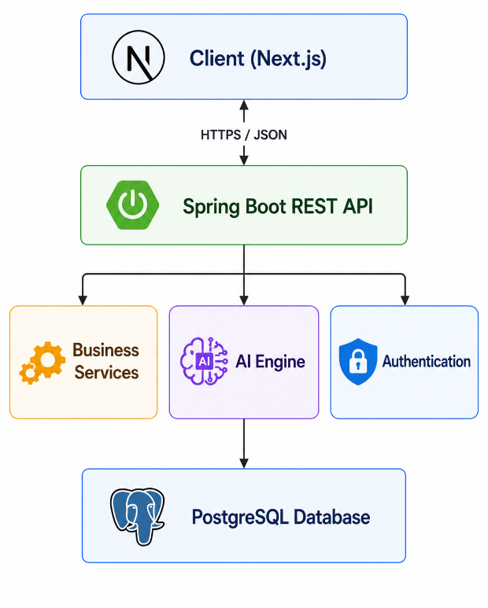

8.1.4 API Principles
The API shall adhere to the following principles:
- RESTful resource design.
- Stateless requests.
- JSON request and response bodies.
- Standard HTTP methods.
- Consistent error responses.
- Secure authentication.
- API versioning.
- Idempotent operations where applicable.

8.1.5 Base URL
Environment | Base URL
Development | http://localhost:8080/api/v1
Staging | https://staging.processmind.ai/api/v1
Production | https://api.processmind.ai/api/v1

8.1.6 Supported HTTP Methods
Method | Purpose
GET | Retrieve resources
POST | Create resources
PUT | Replace resources
PATCH | Partial updates
DELETE | Remove resources (logical deletion where applicable)

8.1.7 Content Types
Type | Usage
application/json | Standard request and response format
multipart/form-data | File uploads (e.g., SOP documents)
application/pdf | Download reports
application/octet-stream | File downloads

8.1.8 API Versioning
The API shall use URI-based versioning.
Example:
/ api / v1 / workflows
/ api / v2 / workflows
New versions shall not break existing client applications unless explicitly documented.

8.1.9 Authentication
The API shall require authentication using JWT (JSON Web Token).
Protected endpoints shall require the following header:
Authorization: Bearer <JWT_TOKEN>
Public endpoints (example: login and registration) shall not require authentication.

8.1.10 Authorization
Authorization shall be enforced using Role-Based Access Control (RBAC).
Example roles:
- System Administrator
- Organization Administrator
- Process Manager
- Reviewer
- Approver
- Employee
Access to endpoints shall be restricted based on assigned roles and organization membership.

8.1.11 Standard Success Response
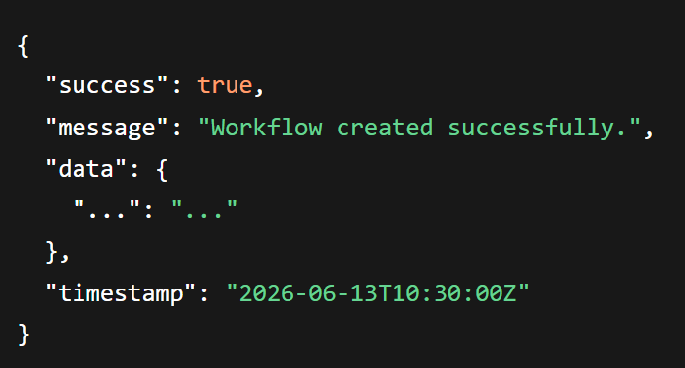
8.1.12 Standard Error Response
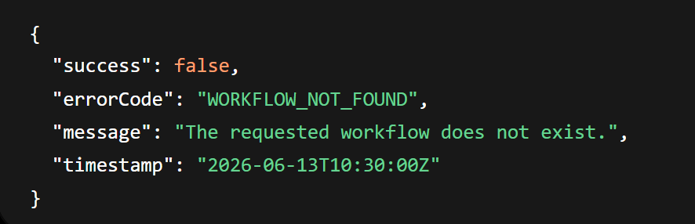
8.1.13 Standard HTTP Status Codes
Status Code | Meaning
200 OK | Request successful
201 Created | Resource created
204 No Content | Successful request with no response body
400 Bad Request | Invalid request
401 Unauthorized | Authentication required
403 Forbidden | Insufficient permissions
404 Not Found | Resource not found
409 Conflict | Business rule conflict
422 Unprocessable Entity | Validation failed
429 Too Many Requests | Rate limit exceeded
500 Internal Server Error | Unexpected server error
503 Service Unavailable | Temporary service outage

8.1.14 Request Validation
All incoming requests shall be validated before processing.
Validation shall include:
- Required fields.
- Data types.
- Maximum lengths.
- Business rules.
- File size.
- File type.
- Tenant ownership verification.
Invalid requests shall return appropriate error responses.

8.1.15 API Security
The API shall implement:
- HTTPS-only communication.
- JWT authentication.
- RBAC authorization.
- Request validation.
- SQL injection prevention.
- Cross-Site Scripting (XSS) protection.
- Cross-Origin Resource Sharing (CORS) configuration.
- Rate limiting.
- Audit logging.
- Input sanitization.

8.1.16 Rate Limiting
To prevent abuse, rate limits shall be applied.
Endpoint Category | Default Limit
Authentication | 10 requests/minute/IP
AI Processing | 30 requests/minute/user
Standard API | 120 requests/minute/user
File Upload | 20 requests/hour/user
These limits shall be configurable by administrators.

8.1.17 Business Rules
Rule ID | Rule
API-BR-001 | All protected endpoints shall require JWT authentication.
API-BR-002 | Users shall only access resources belonging to their organization.
API-BR-003 | All requests and responses shall use JSON unless file transfer is required.
API-BR-004 | Validation errors shall return structured error responses.
API-BR-005 | All API requests shall be logged for auditing where appropriate.
API-BR-006 | API versioning shall preserve backward compatibility.
API-BR-007 | Sensitive information shall never be exposed in API responses.

8.1.18 Acceptance Criteria
The REST API specification shall be considered complete when:
- All endpoints follow RESTful conventions.
- Authentication and authorization are enforced.
- Requests and responses follow standardized formats.
- Versioning supports backward compatibility.
- Validation protects the system from invalid input.
- API security measures are implemented.
- Rate limiting protects against abuse.
- API behavior is fully documented.

8.2 Authentication & Authorization APIs
8.2.1 Module Overview
The Authentication & Authorization API module provides secure user authentication, session management, password management, token management, and role-based authorization.
Authentication shall be implemented using JWT (JSON Web Token) with refresh tokens.
Passwords shall be securely hashed using BCrypt before storage.
All protected endpoints shall require a valid JWT access token.

8.2.2 API Endpoints
Method | Endpoint | Description | Authentication
POST | /auth/register | Register organization and administrator | No
POST | /auth/login | User login | No
POST | /auth/logout | Logout current user | Yes
POST | /auth/refresh-token | Refresh expired access token | Yes (Refresh Token)
POST | /auth/forgot-password | Request password reset | No
POST | /auth/reset-password | Reset password | No (Valid Reset Token)
POST | /auth/change-password | Change current password | Yes
GET | /auth/profile | Retrieve authenticated user profile | Yes
PATCH | /auth/profile | Update authenticated user profile | Yes
POST | /auth/verify-email | Verify email address | No
POST | /auth/resend-verification | Resend verification email | No

8.2.3 Register Organization
Endpoint
POST /api/v1/auth/register
Description
Creates a new organization along with its first Organization Administrator account.

Request Body
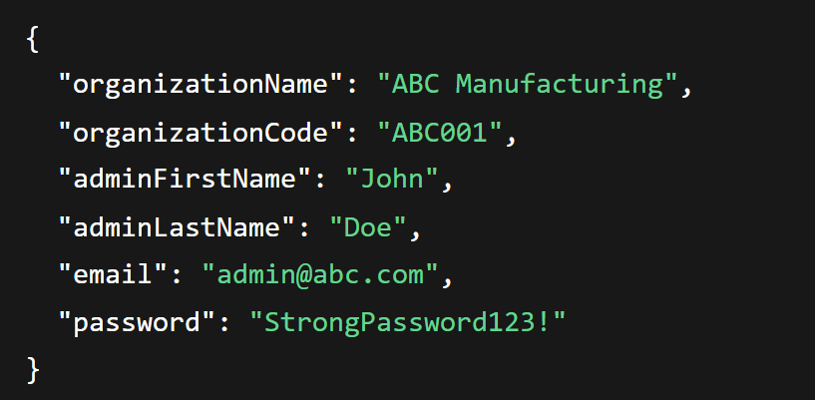
Successful Response
201 Created
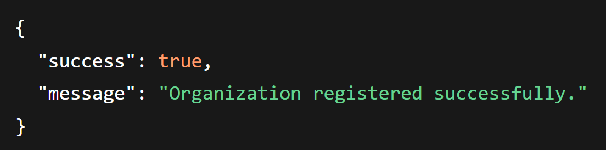
Validation Rules
- Organization name is required.
- Organization code must be unique.
- Email must be unique.
- Password shall satisfy password policy.
Error Responses
HTTP Code | Reason
400 | Invalid request
409 | Organization already exists
422 | Validation failed

8.2.4 Login
Endpoint
POST /api/v1/auth/login
Request
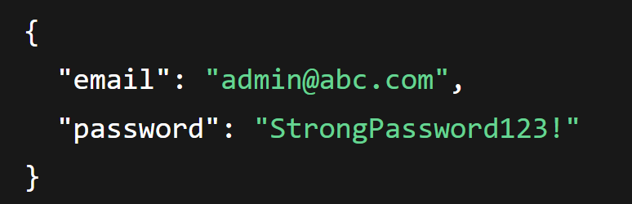
Response
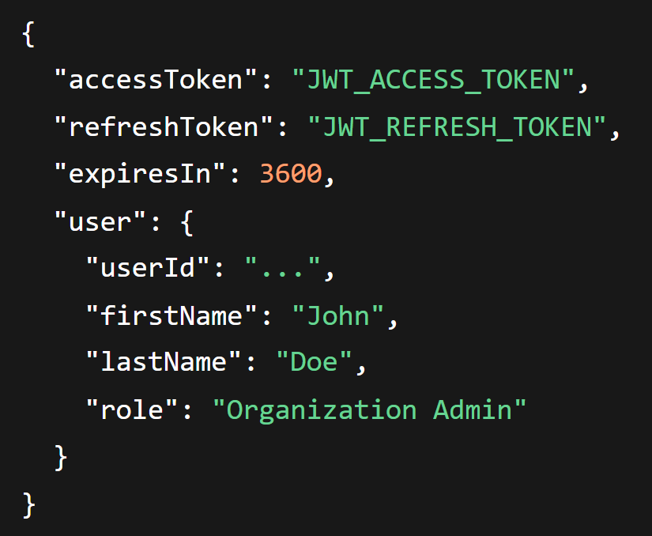
Business Rules
- Account must be active.
- Email must be verified (if enabled).
- Failed login attempts shall be monitored.
- JWT access token shall be issued upon successful authentication.

8.2.5 Logout
Endpoint
POST /api/v1/auth/logout
Description
Terminates the current authenticated session.
Authorization
Bearer Token Required
Response
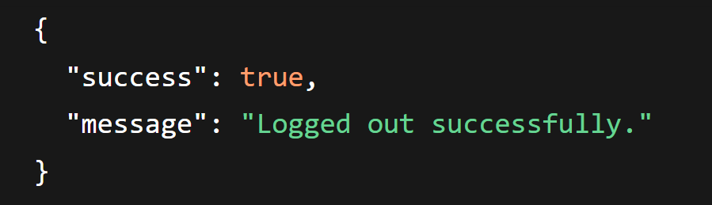
8.2.6 Refresh Token
Endpoint
POST /api/v1/auth/refresh-token
Purpose
Generates a new access token using a valid refresh token.
Response
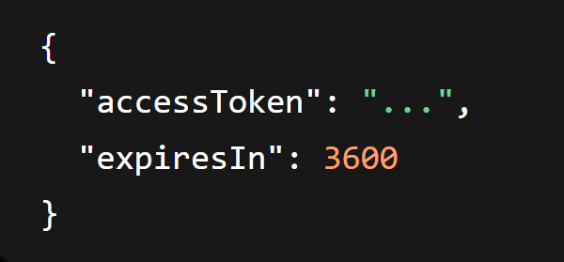
8.2.7 Forgot Password
Endpoint
POST /api/v1/auth/forgot-password
Request
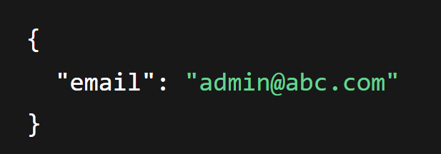
Response
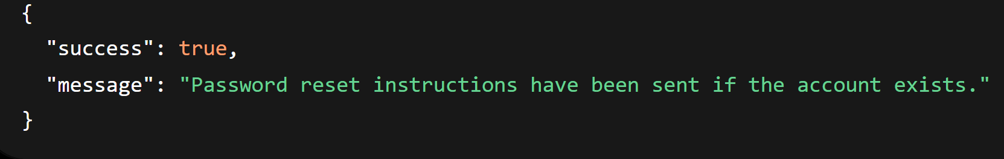
Security Note: The response shall not reveal whether the email address exists in the system.

8.2.8 Reset Password
Endpoint
POST /api/v1/auth/reset-password
Request
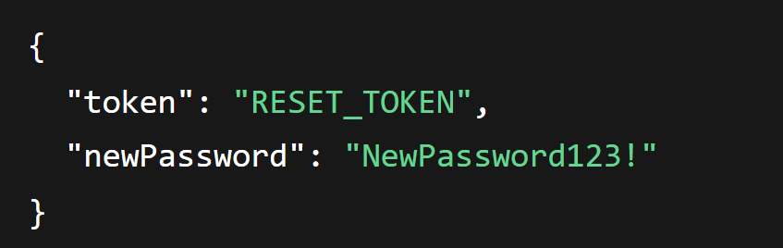
Business Rules
- Reset token must be valid.
- Reset token must not be expired.
- New password must satisfy password policy.

8.2.9 Change Password
Endpoint
POST /api/v1/auth/change-password
Authorization
Bearer Token Required
Request
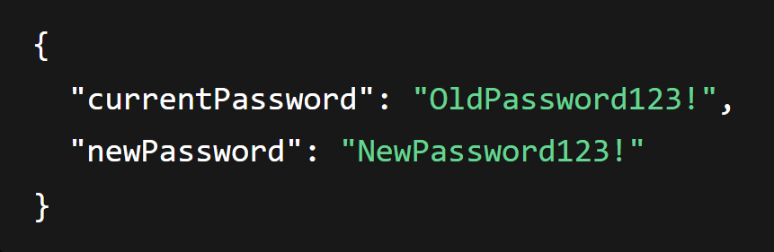
Response
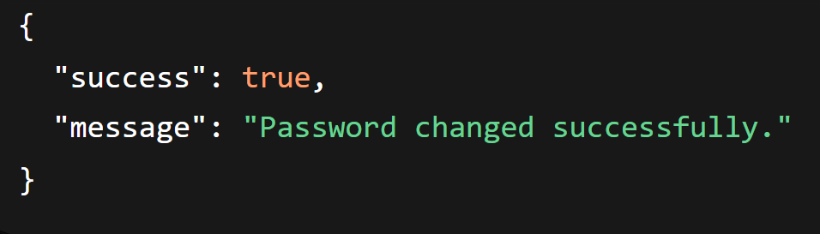

8.2.10 Get Profile
Endpoint
GET /api/v1/auth/profile
Authorization
Bearer Token Required
Response
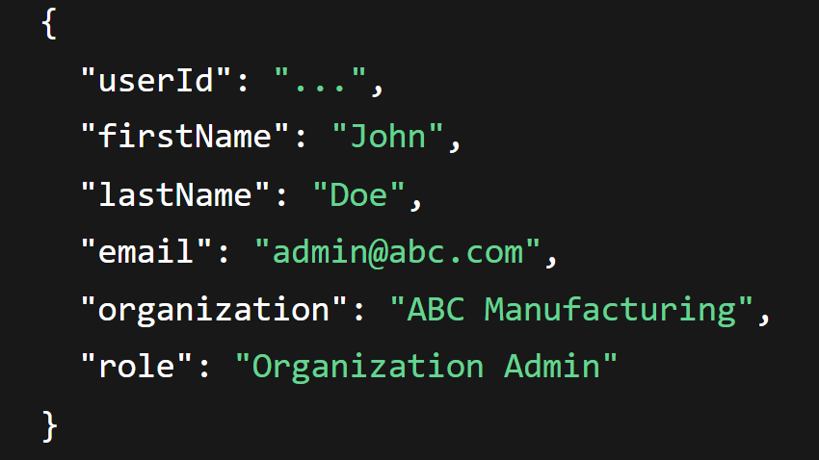
8.2.11 Update Profile
Endpoint
PATCH /api/v1/auth/profile
Request
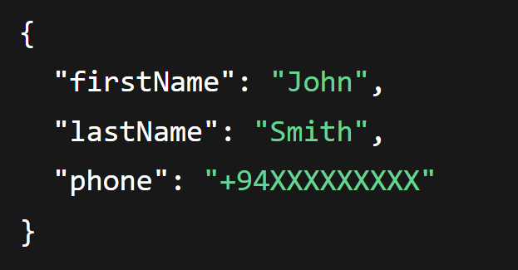
Response
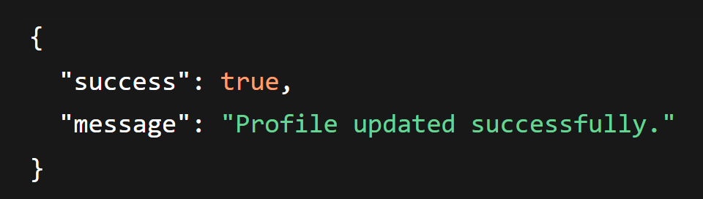

8.2.12 Verify Email
Endpoint
POST /api/v1/auth/verify-email
Purpose
Verifies a user's email address using a verification token.

8.2.13 Resend Verification Email
Endpoint
POST /api/v1/auth/resend-verification
Purpose
Sends a new verification email to an unverified user.

8.2.14 Authentication Flow
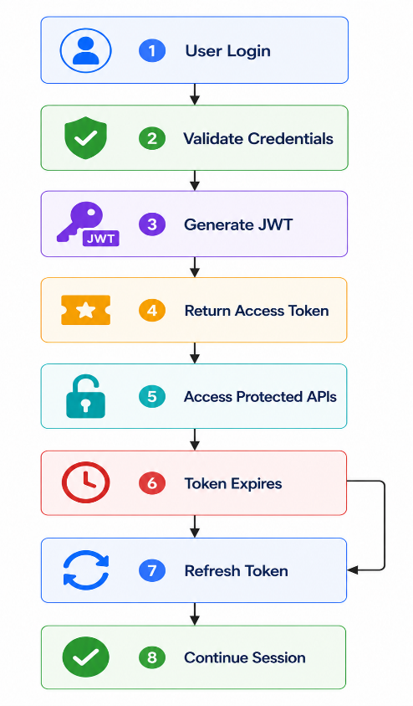

8.2.15 Security Requirements
- Passwords shall be hashed using BCrypt.
- JWT tokens shall be digitally signed.
- Refresh tokens shall be securely stored.
- Login attempts shall be rate-limited.
- Failed login attempts shall be logged.
- Password reset tokens shall expire after a configurable period (example: 15–30 minutes).
- Authentication events shall generate audit log entries.

8.2.16 Business Rules
Rule ID | Rule
AUTH-BR-001 | Email addresses shall be unique across the system.
AUTH-BR-002 | Passwords shall never be stored in plain text.
AUTH-BR-003 | Protected APIs shall require a valid JWT access token.
AUTH-BR-004 | Users shall only access resources belonging to their organization.
AUTH-BR-005 | Authentication events shall be recorded in the audit log.
AUTH-BR-006 | User accounts may be temporarily locked after repeated failed login attempts.
AUTH-BR-007 | Refresh tokens shall be invalidated on logout or explicit revocation.

8.2.17 Error Responses
HTTP Status | Error Code | Description
400 | INVALID_REQUEST | Request payload is invalid.
401 | INVALID_CREDENTIALS | Incorrect email or password.
401 | TOKEN_EXPIRED | Access token has expired.
401 | INVALID_TOKEN | JWT or refresh token is invalid.
403 | ACCOUNT_LOCKED | User account is temporarily locked.
403 | EMAIL_NOT_VERIFIED | Email verification is required.
404 | USER_NOT_FOUND | Requested user does not exist.
409 | DUPLICATE_EMAIL | Email address is already registered.
422 | VALIDATION_FAILED | Input validation failed.

8.2.18 Acceptance Criteria
The Authentication & Authorization API module shall be considered complete when:
- Users can securely register and authenticate.
- JWT access and refresh token workflows function correctly.
- Password management features operate securely.
- Role-based authorization is enforced.
- Authentication events are audited.
- Account security measures (rate limiting, lockout, password hashing) are implemented.
- All endpoints return standardized success and error responses.

8.3 Organization Management APIs
8.3.1 Module Overview
The Organization Management API enables administrators to manage organizations, departments, organization settings, subscription information, and organizational preferences.
These APIs support the multi-tenant architecture of ProcessMind AI by ensuring that each organization operates within an isolated environment while allowing authorized administrators to manage organization-specific resources.
Only authorized users with the appropriate administrative privileges shall access these endpoints.

8.3.2 API Endpoints
Organization APIs
Method | Endpoint | Description | Authorization
GET | /organizations | Retrieve organizations (System Admin only) | System Admin
GET | /organizations/{organizationId} | Retrieve organization details | Organization Admin / System Admin
POST | /organizations | Create a new organization | System Admin
PUT | /organizations/{organizationId} | Update organization information | Organization Admin
DELETE | /organizations/{organizationId} | Soft delete organization | System Admin
PATCH | /organizations/{organizationId}/status | Activate or suspend organization | System Admin

Department APIs
Method | Endpoint | Description | Authorization
GET | /departments | List departments | Organization Admin
GET | /departments/{departmentId} | Retrieve department details | Organization Admin
POST | /departments | Create department | Organization Admin
PUT | /departments/{departmentId} | Update department | Organization Admin
DELETE | /departments/{departmentId} | Delete department | Organization Admin

Organization Settings APIs
Method | Endpoint | Description | Authorization
GET | /organization-settings | Retrieve organization settings | Organization Admin
PUT | /organization-settings | Update organization settings | Organization Admin
GET | /organization-settings/ai | Retrieve AI configuration | Organization Admin
PUT | /organization-settings/ai | Update AI configuration | Organization Admin
GET | /organization-settings/security | Retrieve security settings | Organization Admin
PUT | /organization-settings/security | Update security settings | Organization Admin

Subscription APIs
Method | Endpoint | Description | Authorization
GET | /subscriptions | Retrieve subscription information | Organization Admin
PUT | /subscriptions | Update subscription information | System Admin
GET | /subscriptions/usage | Retrieve current usage statistics | Organization Admin

8.3.3 Request Validation
The Organization Management APIs shall validate:
- Organization name.
- Organization code uniqueness.
- Department names.
- Organization ownership.
- Subscription limits.
- Organization status.
- User permissions.

8.3.4 Business Rules
Rule ID | Rule
ORG-BR-001 | Each organization shall have a unique organization code.
ORG-BR-002 | Users shall access only their own organization's resources unless they are System Administrators.
ORG-BR-003 | Organizations with active workflows shall not be permanently deleted.
ORG-BR-004 | Department names shall be unique within an organization.
ORG-BR-005 | Organization status changes shall be recorded in the audit log.
ORG-BR-006 | Organization settings shall only be modified by Organization Administrators or System Administrators.
ORG-BR-007 | Subscription limits shall be enforced before creating new users, workflows, or AI processing tasks where applicable.

8.3.5 Error Responses
HTTP Status | Error Code | Description
400 | INVALID_REQUEST | Invalid request payload.
401 | UNAUTHORIZED | Authentication required.
403 | FORBIDDEN | Insufficient permissions.
404 | ORGANIZATION_NOT_FOUND | Organization does not exist.
409 | DUPLICATE_ORGANIZATION_CODE | Organization code already exists.
422 | VALIDATION_FAILED | Validation rules failed.

8.3.6 Acceptance Criteria
The Organization Management API module shall be considered complete when:
- Organizations can be created, updated, retrieved, and managed securely.
- Departments can be managed within their respective organizations.
- Organization settings are configurable by authorized administrators.
- Subscription information and usage statistics are accessible.
- Multi-tenant isolation is enforced.
- All operations are validated and audited.

8.4 User & Role Management APIs
8.4.1 Module Overview
The User & Role Management API provides secure management of users, roles, permissions, departments, and access rights within an organization.
The module enables administrators to create and manage user accounts, assign organizational roles, configure permissions, and enforce Role-Based Access Control (RBAC).
All operations shall be restricted according to the authenticated user's privileges and organizational scope.

8.4.2 User Management APIs
Method | Endpoint | Description | Authorization
GET | /users | Retrieve all users | Organization Admin
GET | /users/{userId} | Retrieve user details | Organization Admin
POST | /users | Create a new user | Organization Admin
PUT | /users/{userId} | Update user information | Organization Admin
PATCH | /users/{userId}/status | Activate, suspend, or deactivate a user | Organization Admin
DELETE | /users/{userId} | Soft delete a user | Organization Admin
GET | /users/search | Search users | Organization Admin
GET | /users/me | Retrieve current authenticated user | Authenticated User
PATCH | /users/me | Update own profile | Authenticated User
POST | /users/bulk-import | Import users from CSV/Excel | Organization Admin
GET | /users/export | Export users | Organization Admin

8.4.3 Role Management APIs
Method | Endpoint | Description | Authorization
GET | /roles | Retrieve available roles | Organization Admin
GET | /roles/{roleId} | Retrieve role details | Organization Admin
POST | /roles | Create custom role | Organization Admin
PUT | /roles/{roleId} | Update role | Organization Admin
DELETE | /roles/{roleId} | Delete custom role | Organization Admin
POST | /roles/{roleId}/clone | Clone an existing role | Organization Admin

8.4.4 Permission Management APIs
Method | Endpoint | Description | Authorization
GET | /permissions | Retrieve all permissions | Organization Admin
GET | /roles/{roleId}/permissions | Retrieve permissions assigned to a role | Organization Admin
PUT | /roles/{roleId}/permissions | Update role permissions | Organization Admin

8.4.5 User Role Assignment APIs
Method | Endpoint | Description | Authorization
POST | /users/{userId}/roles | Assign role to user | Organization Admin
DELETE | /users/{userId}/roles/{roleId} | Remove role from user | Organization Admin
GET | /users/{userId}/roles | Retrieve assigned roles | Organization Admin

8.4.6 Department Assignment APIs
Method | Endpoint | Description | Authorization
POST | /users/{userId}/department | Assign user to department | Organization Admin
PATCH | /users/{userId}/department | Transfer user to another department | Organization Admin
DELETE | /users/{userId}/department | Remove department assignment | Organization Admin

8.4.7 User Search & Filtering APIs
The API shall support searching and filtering users by:
- Name
- Email
- Department
- Role
- Status
- Organization
- Created Date
Example:
GET /users?role = Reviewer&status = ACTIVE&page = 1&size = 20
Pagination, sorting, and filtering shall be supported for all list endpoints.

8.4.8 Request Validation
The User & Role Management APIs shall validate:
- Unique email addresses.
- Required user information.
- Valid department assignment.
- Valid role assignment.
- Existing permissions.
- Organization ownership.
- Password policy (where applicable).

8.4.9 Business Rules
Rule ID | Rule
USER-BR-001 | User email addresses shall be unique within the system.
USER-BR-002 | Users shall belong to exactly one organization.
USER-BR-003 | Users may belong to one department at a time.
USER-BR-004 | Only authorized administrators may create or modify user accounts.
USER-BR-005 | Role assignments shall comply with RBAC policies.
USER-BR-006 | System-defined roles shall not be deleted.
USER-BR-007 | Deleted users shall be soft-deleted to preserve audit history.
USER-BR-008 | Bulk user imports shall validate all records before processing.
USER-BR-009 | Changes to roles and permissions shall be recorded in the audit log.
USER-BR-010 | Users shall not access resources outside their organization.

8.4.10 Error Responses
HTTP Status | Error Code | Description
400 | INVALID_REQUEST | Invalid request payload.
401 | UNAUTHORIZED | Authentication required.
403 | FORBIDDEN | Insufficient permissions.
404 | USER_NOT_FOUND | Requested user does not exist.
404 | ROLE_NOT_FOUND | Requested role does not exist.
404 | DEPARTMENT_NOT_FOUND | Requested department does not exist.
409 | DUPLICATE_EMAIL | Email address already exists.
409 | ROLE_ALREADY_ASSIGNED | Role is already assigned to the user.
422 | VALIDATION_FAILED | Request validation failed.

8.4.11 Acceptance Criteria
The User & Role Management API module shall be considered complete when:
- Users can be created, updated, searched, and managed.
- Departments and roles can be assigned appropriately.
- Permissions are managed through RBAC.
- Bulk import and export operations function correctly.
- Multi-tenant isolation is enforced.
- All administrative operations are audited.
- Search, filtering, pagination, and sorting work consistently across endpoints.

8.5 SOP Management APIs
8.5.1 Module Overview
The SOP Management API provides endpoints for uploading, managing, versioning, analyzing, approving, searching, and archiving Standard Operating Procedures (SOPs).
The module serves as the entry point to the AI-powered process intelligence pipeline. Uploaded SOPs are securely stored, version-controlled, and processed by the AI engine to extract business knowledge and generate workflow definitions.
The module supports document lifecycle management while maintaining complete version history and auditability.

8.5.2 SOP Management APIs
Method | Endpoint | Description | Authorization
GET | /sops | Retrieve all SOPs | Organization User
GET | /sops/{sopId} | Retrieve SOP details | Organization User
POST | /sops | Upload a new SOP | Process Manager
PUT | /sops/{sopId} | Update SOP metadata | Process Manager
DELETE | /sops/{sopId} | Archive or soft delete SOP | Organization Admin
GET | /sops/search | Search SOPs | Organization User
GET | /sops/filter | Filter SOPs | Organization User

8.5.3 SOP Version APIs
Method | Endpoint | Description | Authorization
GET | /sops/{sopId}/versions | Retrieve all SOP versions | Organization User
GET | /sops/{sopId}/versions/{versionId} | Retrieve a specific version | Organization User
POST | /sops/{sopId}/versions | Upload a new SOP version | Process Manager
POST | /sops/{sopId}/versions/{versionId}/restore | Restore a previous version | Process Manager

8.5.4 AI Processing APIs
Method | Endpoint | Description | Authorization
POST | /sops/{sopId}/analyze | Analyze SOP using AI | Process Manager
GET | /sops/{sopId}/analysis | Retrieve AI analysis | Organization User
POST | /sops/{sopId}/reanalyze | Re-run AI analysis | Process Manager
GET | /sops/{sopId}/confidence | Retrieve AI confidence scores | Organization User
GET | /sops/{sopId}/validation | Retrieve AI validation results | Organization User

8.5.5 SOP Comparison APIs
Method | Endpoint | Description | Authorization
GET | /sops/{sopId}/compare/{versionId} | Compare SOP versions | Organization User
GET | /sops/{sopId}/changes | View version history and changes | Organization User

8.5.6 SOP Approval APIs
Method | Endpoint | Description | Authorization
POST | /sops/{sopId}/submit | Submit SOP for approval | Process Manager
POST | /sops/{sopId}/approve | Approve SOP | Approver
POST | /sops/{sopId}/reject | Reject SOP | Approver
GET | /sops/pending-approvals | Retrieve pending SOP approvals | Approver

8.5.7 SOP Archive APIs
Method | Endpoint | Description | Authorization
POST | /sops/{sopId}/archive | Archive SOP | Organization Admin
POST | /sops/{sopId}/restore | Restore archived SOP | Organization Admin
GET | /sops/archived | Retrieve archived SOPs | Organization Admin

8.5.8 Document Upload Requirements
The API shall support:
Feature | Requirement
Supported Formats | PDF, DOCX, TXT
Maximum File Size | Configurable (Default: 25 MB)
Virus Scanning | Required before storage
Duplicate Detection | Optional
Version Control | Automatic
Metadata Extraction | Automatic

8.5.9 Search & Filtering
The API shall support searching by:
- SOP Title
- Department
- Owner
- Status
- Version
- Upload Date
- Tags
- Keywords
Pagination and sorting shall be available for all list operations.

8.5.10 Business Rules
Rule ID | Rule
SOP-BR-001 | Every SOP shall belong to one organization.
SOP-BR-002 | Every uploaded SOP shall create an initial version.
SOP-BR-003 | Previous SOP versions shall remain immutable.
SOP-BR-004 | Only authorized users may upload or modify SOPs.
SOP-BR-005 | AI analysis shall only begin after successful document validation.
SOP-BR-006 | Unsupported document formats shall be rejected.
SOP-BR-007 | Every SOP modification shall generate an audit log entry.
SOP-BR-008 | Archived SOPs shall remain available for authorized retrieval.
SOP-BR-009 | AI-generated analysis shall be associated with the specific SOP version analyzed.
SOP-BR-010 | Organization users shall only access SOPs belonging to their organization.

8.5.11 Error Responses
HTTP Status | Error Code | Description
400 | INVALID_FILE | Unsupported or malformed document.
400 | FILE_TOO_LARGE | File exceeds the configured size limit.
401 | UNAUTHORIZED | Authentication required.
403 | FORBIDDEN | Insufficient permissions.
404 | SOP_NOT_FOUND | SOP does not exist.
409 | DUPLICATE_VERSION | Duplicate SOP version detected.
415 | UNSUPPORTED_MEDIA_TYPE | Unsupported file format.
422 | AI_ANALYSIS_FAILED | AI processing could not complete successfully.

8.5.12 Acceptance Criteria
The SOP Management API module shall be considered complete when:
- SOPs can be uploaded, versioned, searched, and archived.
- AI analysis can be initiated and retrieved.
- SOP versions are immutable and restorable.
- Approval workflows function correctly.
- Search and filtering operate efficiently.
- Audit logs record all significant operations.
- Multi-tenant access restrictions are enforced.

8.6 Workflow Management APIs
8.6.1 Module Overview
The Workflow Management API provides endpoints for creating, generating, editing, validating, simulating, deploying, publishing, importing, exporting, and managing workflows.
The module enables both AI-generated and manually designed workflows while maintaining version control, validation, execution readiness, and auditability.
Every workflow shall progress through a controlled lifecycle from creation to retirement.

8.6.2 Workflow Lifecycle
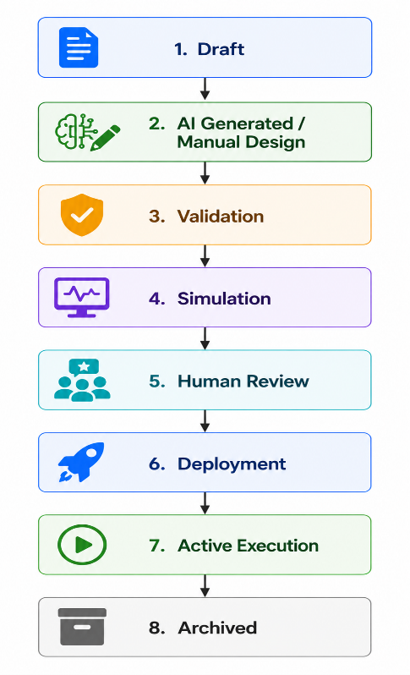

8.6.3 Workflow Management APIs
Method | Endpoint | Description | Authorization
GET | /workflows | Retrieve workflows | Organization User
GET | /workflows/{workflowId} | Retrieve workflow details | Organization User
POST | /workflows | Create workflow manually | Process Manager
PUT | /workflows/{workflowId} | Update workflow | Process Manager
DELETE | /workflows/{workflowId} | Archive workflow | Organization Admin
GET | /workflows/search | Search workflows | Organization User
GET | /workflows/filter | Filter workflows | Organization User

8.6.4 AI Workflow Generation APIs
Method | Endpoint | Description | Authorization
POST | /workflows/generate | Generate workflow from SOP | Process Manager
POST | /workflows/{workflowId}/regenerate | Regenerate workflow using AI | Process Manager
GET | /workflows/{workflowId}/reasoning | Retrieve AI reasoning report | Organization User
GET | /workflows/{workflowId}/confidence | Retrieve AI confidence scores | Organization User
GET | /workflows/{workflowId}/validation | Retrieve AI validation report | Organization User

8.6.5 Workflow Editing APIs
Method | Endpoint | Description | Authorization
PATCH | /workflows/{workflowId}/nodes | Add or modify workflow nodes | Process Manager
PATCH | /workflows/{workflowId}/edges | Add or modify workflow connections | Process Manager
PATCH | /workflows/{workflowId}/business-rules | Update business rules | Process Manager
PATCH | /workflows/{workflowId}/approvals | Configure approval steps | Process Manager
PATCH | /workflows/{workflowId}/settings | Update workflow settings | Process Manager

8.6.6 Workflow Version APIs
Method | Endpoint | Description | Authorization
GET | /workflows/{workflowId}/versions | Retrieve workflow versions | Organization User
POST | /workflows/{workflowId}/versions | Create workflow version | Process Manager
GET | /workflows/{workflowId}/versions/{versionId} | Retrieve version details | Organization User
POST | /workflows/{workflowId}/versions/{versionId}/restore | Restore workflow version | Process Manager
GET | /workflows/{workflowId}/history | Retrieve workflow history | Organization User

8.6.7 Workflow Validation APIs
Method | Endpoint | Description | Authorization
POST | /workflows/{workflowId}/validate | Validate workflow | Process Manager
GET | /workflows/{workflowId}/validation-report | Retrieve validation report | Organization User
GET | /workflows/{workflowId}/errors | Retrieve validation errors | Organization User
GET | /workflows/{workflowId}/warnings | Retrieve validation warnings | Organization User

8.6.8 Workflow Simulation APIs
Method | Endpoint | Description | Authorization
POST | /workflows/{workflowId}/simulate | Run workflow simulation | Process Manager
GET | /workflows/{workflowId}/simulation | Retrieve simulation results | Organization User
GET | /workflows/{workflowId}/bottlenecks | Retrieve detected bottlenecks | Organization User
GET | /workflows/{workflowId}/performance | Retrieve predicted performance metrics | Organization User

8.6.9 Workflow Deployment APIs
Method | Endpoint | Description | Authorization
POST | /workflows/{workflowId}/deploy | Deploy workflow | Organization Admin
POST | /workflows/{workflowId}/undeploy | Undeploy workflow | Organization Admin
GET | /workflows/deployed | Retrieve deployed workflows | Organization User
GET | /workflows/{workflowId}/deployment-status | Retrieve deployment status | Organization User

8.6.10 Workflow Import & Export APIs
Method | Endpoint | Description | Authorization
POST | /workflows/import | Import workflow | Process Manager
GET | /workflows/{workflowId}/export/json | Export as JSON | Organization User
GET | /workflows/{workflowId}/export/pdf | Export documentation | Organization User
GET | /workflows/{workflowId}/export/bpmn | Export BPMN 2.0 | Organization User

8.6.11 Workflow Search & Filtering
The API shall support searching by:
- Workflow Name
- SOP
- Department
- Status
- Owner
- Version
- Tags
- Creation Date
- Deployment Status
Pagination, filtering, and sorting shall be supported for all list endpoints.

8.6.12 Business Rules
Rule ID | Rule
WF-BR-001 | Every workflow shall belong to one organization.
WF-BR-002 | Every workflow shall be associated with an SOP.
WF-BR-003 | Workflow versions shall be immutable after deployment.
WF-BR-004 | Workflows shall pass validation before deployment.
WF-BR-005 | Simulation shall not modify production workflow data.
WF-BR-006 | AI-generated workflows shall support manual editing before deployment.
WF-BR-007 | Workflow deployment shall generate audit log entries.
WF-BR-008 | Only one active version of a workflow may be deployed at a time.
WF-BR-009 | Archived workflows shall not accept new executions.
WF-BR-010 | Users shall only access workflows belonging to their organization.

8.6.13 Error Responses
HTTP Status | Error Code | Description
400 | INVALID_WORKFLOW | Invalid workflow definition.
401 | UNAUTHORIZED | Authentication required.
403 | FORBIDDEN | Insufficient permissions.
404 | WORKFLOW_NOT_FOUND | Workflow does not exist.
409 | WORKFLOW_ALREADY_DEPLOYED | Active deployment already exists.
409 | VALIDATION_FAILED | Workflow contains validation errors.
422 | SIMULATION_FAILED | Workflow simulation failed.
500 | DEPLOYMENT_ERROR | Unexpected deployment failure.

8.6.14 Acceptance Criteria
The Workflow Management API module shall be considered complete when:
- Workflows can be created manually and generated by AI.
- Version control preserves workflow history.
- Validation identifies structural and business-rule issues.
- Simulations predict workflow behavior without affecting production data.
- Deployment enforces validation and approval requirements.
- Import and export operations support standard formats.
- Workflow lifecycle transitions are controlled and auditable.
- Multi-tenant access restrictions are enforced.

8.7 Workflow Execution APIs
8.7.1 Module Overview
The Workflow Execution API provides endpoints for executing deployed workflows, managing workflow instances, assigning and completing tasks, processing approvals, handling workflow exceptions, monitoring execution status, and maintaining execution history.
The module enables organizations to execute business processes consistently while ensuring traceability, accountability, and real-time monitoring.
Only deployed workflows may be executed.

8.7.2 Workflow Execution Lifecycle
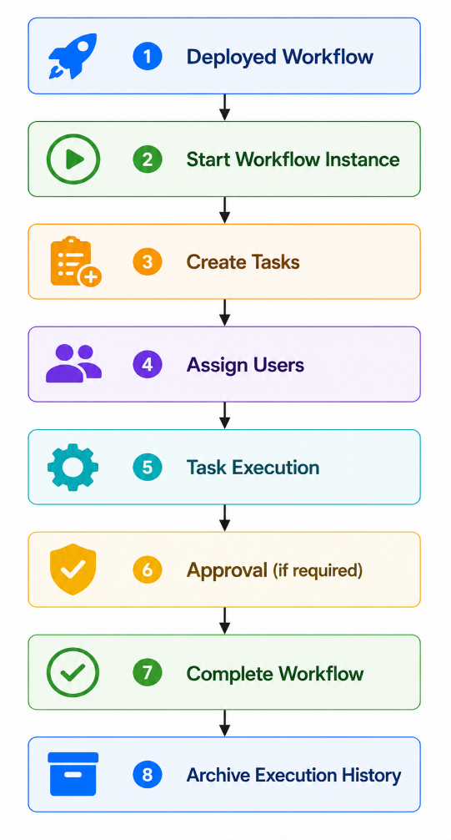

8.7.3 Workflow Instance APIs
Method | Endpoint | Description | Authorization
POST | /workflow-instances | Start a new workflow instance | Organization User
GET | /workflow-instances | Retrieve workflow instances | Organization User
GET | /workflow-instances/{instanceId} | Retrieve workflow instance details | Organization User
PATCH | /workflow-instances/{instanceId} | Update workflow instance metadata | Process Manager
DELETE | /workflow-instances/{instanceId} | Cancel workflow instance | Process Manager

8.7.4 Task Management APIs
Method | Endpoint | Description | Authorization
GET | /tasks | Retrieve assigned tasks | Authenticated User
GET | /tasks/{taskId} | Retrieve task details | Task Assignee
PATCH | /tasks/{taskId}/claim | Claim an unassigned task | Authorized User
PATCH | /tasks/{taskId}/start | Start task execution | Task Assignee
PATCH | /tasks/{taskId}/complete | Complete task | Task Assignee
PATCH | /tasks/{taskId}/reassign | Reassign task | Process Manager
PATCH | /tasks/{taskId}/delegate | Delegate task | Process Manager
PATCH | /tasks/{taskId}/cancel | Cancel task | Process Manager

8.7.5 Approval APIs
Method | Endpoint | Description | Authorization
GET | /approvals | Retrieve pending approvals | Approver
GET | /approvals/{approvalId} | Retrieve approval details | Approver
POST | /approvals/{approvalId}/approve | Approve request | Approver
POST | /approvals/{approvalId}/reject | Reject request | Approver
POST | /approvals/{approvalId}/request-changes | Request modifications | Approver
GET | /approvals/history | Retrieve approval history | Process Manager

8.7.6 Workflow Control APIs
Method | Endpoint | Description | Authorization
PATCH | /workflow-instances/{instanceId}/pause | Pause workflow execution | Process Manager
PATCH | /workflow-instances/{instanceId}/resume | Resume workflow execution | Process Manager
PATCH | /workflow-instances/{instanceId}/terminate | Terminate workflow | Organization Admin
PATCH | /workflow-instances/{instanceId}/restart | Restart workflow | Process Manager

8.7.7 Workflow Monitoring APIs
Method | Endpoint | Description | Authorization
GET | /workflow-instances/{instanceId}/status | Retrieve execution status | Organization User
GET | /workflow-instances/{instanceId}/timeline | Retrieve execution timeline | Organization User
GET | /workflow-instances/{instanceId}/activities | Retrieve executed activities | Organization User
GET | /workflow-instances/{instanceId}/logs | Retrieve execution logs | Process Manager

8.7.8 Exception Management APIs
Method | Endpoint | Description | Authorization
GET | /workflow-instances/{instanceId}/exceptions | Retrieve execution exceptions | Process Manager
POST | /workflow-instances/{instanceId}/retry | Retry failed execution step | Process Manager
POST | /workflow-instances/{instanceId}/skip-task | Skip task (authorized only) | Organization Admin
POST | /workflow-instances/{instanceId}/manual-intervention | Trigger manual intervention | Process Manager

8.7.9 Execution History APIs
Method | Endpoint | Description | Authorization
GET | /workflow-history | Retrieve execution history | Organization User
GET | /workflow-history/{instanceId} | Retrieve execution history details | Organization User
GET | /workflow-history/export | Export execution history | Organization Admin

8.7.10 Search & Filtering
Workflow execution APIs shall support searching and filtering by:
- Workflow Name
- Workflow Instance ID
- Status
- Assigned User
- Department
- Priority
- Due Date
- Start Date
- Completion Date
- Approval Status
Pagination, sorting, and filtering shall be supported.

8.7.11 Business Rules
Rule ID | Rule
EXEC-BR-001 | Only deployed workflows may be executed.
EXEC-BR-002 | Each workflow instance shall reference a deployed workflow version.
EXEC-BR-003 | Tasks shall only be completed by authorized assignees or delegated users.
EXEC-BR-004 | Workflow execution history shall be immutable.
EXEC-BR-005 | Approval decisions shall be permanently recorded.
EXEC-BR-006 | Paused workflows shall not continue until resumed.
EXEC-BR-007 | Cancelled workflows shall not resume without an explicit restart action.
EXEC-BR-008 | Every execution event shall generate an audit log entry.
EXEC-BR-009 | Manual interventions shall require appropriate authorization and justification.
EXEC-BR-010 | Users shall only access workflow instances belonging to their organization.

8.7.12 Error Responses
HTTP Status | Error Code | Description
400 | INVALID_STATE | Workflow is not in a valid state for the requested operation.
401 | UNAUTHORIZED | Authentication required.
403 | FORBIDDEN | User lacks the required permissions.
404 | WORKFLOW_INSTANCE_NOT_FOUND | Workflow instance does not exist.
404 | TASK_NOT_FOUND | Task does not exist.
404 | APPROVAL_NOT_FOUND | Approval request does not exist.
409 | TASK_ALREADY_COMPLETED | Task has already been completed.
409 | WORKFLOW_PAUSED | Workflow is currently paused.
422 | APPROVAL_REQUIRED | Required approval has not been completed.

8.7.13 Acceptance Criteria
The Workflow Execution API module shall be considered complete when:
- Deployed workflows can be executed successfully.
- Workflow instances and tasks are created and managed correctly.
- Approval processes function according to configured workflows.
- Execution state transitions (pause, resume, terminate, restart) operate correctly.
- Execution history is preserved and immutable.
- Exceptions can be managed through controlled recovery mechanisms.
- Audit logs capture all execution-related events.
- Multi-tenant access restrictions are enforced.

8.8 AI Processing APIs
8.8.1 Module Overview
The AI Processing API provides intelligent services for document understanding, workflow generation, reasoning, validation, confidence evaluation, optimization, Human-in-the-Loop (HITL) review, AI monitoring, and AI provider management.
These APIs orchestrate communication between the application and supported AI providers while ensuring secure, auditable, and reliable AI-assisted business process automation.
All AI operations shall be logged, versioned, and traceable.

8.8.2 AI Service Categories
The AI Processing APIs are organized into the following service groups:
- SOP Understanding
- Workflow Generation
- AI Reasoning
- AI Validation
- Confidence Evaluation
- Human-in-the-Loop Review
- AI Optimization
- AI Monitoring
- AI Provider Management
- Prompt Management

8.8.3 SOP Understanding APIs
Method | Endpoint | Description | Authorization
POST | /ai/sop/analyze | Analyze uploaded SOP | Process Manager
GET | /ai/sop/{analysisId} | Retrieve analysis results | Organization User
POST | /ai/sop/reanalyze | Re-run SOP analysis | Process Manager
GET | /ai/sop/{analysisId}/entities | Retrieve extracted entities | Organization User
GET | /ai/sop/{analysisId}/business-rules | Retrieve extracted business rules | Organization User

8.8.4 Workflow Generation APIs
Method | Endpoint | Description | Authorization
POST | /ai/workflows/generate | Generate workflow from SOP | Process Manager
POST | /ai/workflows/regenerate | Regenerate workflow | Process Manager
GET | /ai/workflows/{generationId} | Retrieve generated workflow | Organization User
GET | /ai/workflows/{generationId}/reasoning | Retrieve AI reasoning | Organization User

8.8.5 AI Validation APIs
Method | Endpoint | Description | Authorization
POST | /ai/validate | Validate AI-generated workflow | Process Manager
GET | /ai/validation/{validationId} | Retrieve validation report | Organization User
GET | /ai/validation/{validationId}/errors | Retrieve validation errors | Organization User
GET | /ai/validation/{validationId}/warnings | Retrieve validation warnings | Organization User

8.8.6 Confidence Evaluation APIs
Method | Endpoint | Description | Authorization
GET | /ai/confidence/{analysisId} | Retrieve confidence scores | Organization User
GET | /ai/confidence/{analysisId}/details | Retrieve confidence breakdown | Organization User

8.8.7 Human-in-the-Loop (HITL) APIs
Method | Endpoint | Description | Authorization
GET | /ai/reviews/pending | Retrieve AI outputs awaiting review | Reviewer
GET | /ai/reviews/{reviewId} | Retrieve review details | Reviewer
POST | /ai/reviews/{reviewId}/approve | Approve AI output | Reviewer
POST | /ai/reviews/{reviewId}/reject | Reject AI output | Reviewer
POST | /ai/reviews/{reviewId}/request-changes | Request AI regeneration or manual edits | Reviewer

8.8.8 AI Optimization APIs
Method | Endpoint | Description | Authorization
POST | /ai/optimize | Generate workflow optimization suggestions | Process Manager
GET | /ai/optimizations/{optimizationId} | Retrieve optimization results | Organization User
POST | /ai/optimizations/{optimizationId}/apply | Apply accepted optimization | Process Manager

8.8.9 AI Monitoring APIs
Method | Endpoint | Description | Authorization
GET | /ai/metrics | Retrieve AI performance metrics | Organization Admin
GET | /ai/usage | Retrieve AI usage statistics | Organization Admin
GET | /ai/logs | Retrieve AI processing logs | Organization Admin
GET | /ai/failures | Retrieve AI failure history | Organization Admin
GET | /ai/providers/status | Retrieve AI provider health | Organization Admin

8.8.10 Prompt Management APIs
Method | Endpoint | Description | Authorization
GET | /ai/prompts | Retrieve prompt templates | Organization Admin
POST | /ai/prompts | Create prompt template | Organization Admin
PUT | /ai/prompts/{promptId} | Update prompt template | Organization Admin
GET | /ai/prompts/{promptId}/versions | Retrieve prompt version history | Organization Admin

8.8.11 AI Provider Management APIs
Method | Endpoint | Description | Authorization
GET | /ai/providers | List configured AI providers | System Admin
POST | /ai/providers | Register AI provider | System Admin
PATCH | /ai/providers/{providerId} | Update provider configuration | System Admin
DELETE | /ai/providers/{providerId} | Remove AI provider | System Admin
POST | /ai/providers/{providerId}/test | Test provider connectivity | System Admin

8.8.12 Business Rules
Rule ID | Rule
AI-BR-001 | All AI requests shall be authenticated and authorized.
AI-BR-002 | AI operations shall be associated with a specific organization and user.
AI-BR-003 | Every AI request and response shall be logged for auditing.
AI-BR-004 | AI-generated workflows shall undergo validation before deployment.
AI-BR-005 | Confidence scores shall be available for AI-generated outputs.
AI-BR-006 | Human review shall be required when confidence falls below configurable thresholds.
AI-BR-007 | AI optimization suggestions shall require user approval before application.
AI-BR-008 | AI provider failures shall trigger recovery and retry mechanisms where appropriate.
AI-BR-009 | Prompt templates shall be version-controlled.
AI-BR-010 | Sensitive organizational data shall not be exposed outside configured AI processing policies.

8.8.13 Error Responses
HTTP Status | Error Code | Description
400 | INVALID_AI_REQUEST | AI request payload is invalid.
401 | UNAUTHORIZED | Authentication required.
403 | FORBIDDEN | User lacks permission.
404 | ANALYSIS_NOT_FOUND | Requested analysis does not exist.
409 | AI_PROVIDER_UNAVAILABLE | Configured AI provider is unavailable.
422 | AI_VALIDATION_FAILED | AI output failed validation.
429 | AI_RATE_LIMIT_EXCEEDED | AI request rate limit exceeded.
500 | AI_PROCESSING_ERROR | Unexpected AI processing failure.
503 | AI_SERVICE_UNAVAILABLE | AI service temporarily unavailable.

8.8.14 Acceptance Criteria
The AI Processing API module shall be considered complete when:
- SOPs can be analyzed successfully.
- AI-generated workflows can be created and retrieved.
- Validation and confidence evaluation operate correctly.
- Human-in-the-Loop review workflows are supported.
- AI optimization recommendations can be generated and applied.
- AI provider configurations can be managed securely.
- AI usage, monitoring, and failure data are available.
- All AI activities are logged and auditable.

8.9 Analytics & Reporting APIs
8.9.1 Module Overview
The Analytics & Reporting API provides endpoints for retrieving operational metrics, workflow performance, AI analytics, organizational KPIs, dashboards, reports, and predictive insights.
The module enables organizations to monitor business processes, evaluate AI performance, identify bottlenecks, measure productivity, and make data-driven decisions.
All analytics shall be generated using organization-specific data while maintaining tenant isolation and auditability.
8.9.2 Analytics Categories
The platform shall provide analytics in the following categories:
- Executive Dashboard
- Workflow Performance
- AI Performance
- Task Performance
- User Productivity
- Approval Analytics
- SLA Compliance
- Resource Utilization
- Organization KPIs
- Predictive Analytics

8.9.3 Dashboard APIs
Method | Endpoint | Description | Authorization
GET | /analytics/dashboard | Retrieve executive dashboard | Organization Admin
GET | /analytics/dashboard/workflows | Workflow dashboard | Process Manager
GET | /analytics/dashboard/ai | AI dashboard | Organization Admin
GET | /analytics/dashboard/tasks | Task dashboard | Process Manager
GET | /analytics/dashboard/users | User productivity dashboard | Organization Admin

8.9.4 Workflow Analytics APIs
Method | Endpoint | Description | Authorization
GET | /analytics/workflows | Workflow performance summary | Process Manager
GET | /analytics/workflows/{workflowId} | Workflow performance details | Process Manager
GET | /analytics/workflows/bottlenecks | Detect workflow bottlenecks | Process Manager
GET | /analytics/workflows/trends | Workflow execution trends | Organization Admin
GET | /analytics/workflows/comparison | Compare workflows | Organization Admin

8.9.5 AI Analytics APIs
Method | Endpoint | Description | Authorization
GET | /analytics/ai | AI performance summary | Organization Admin
GET | /analytics/ai/providers | Compare AI providers | System Admin
GET | /analytics/ai/models | Compare AI models | System Admin
GET | /analytics/ai/confidence | Confidence score analytics | Organization Admin
GET | /analytics/ai/failures | AI failure analytics | Organization Admin

8.9.6 Task & User Analytics APIs
Method | Endpoint | Description | Authorization
GET | /analytics/tasks | Task completion statistics | Process Manager
GET | /analytics/tasks/overdue | Overdue task analytics | Process Manager
GET | /analytics/users/productivity | User productivity metrics | Organization Admin
GET | /analytics/users/workload | User workload distribution | Organization Admin

8.9.7 KPI APIs
Method | Endpoint | Description | Authorization
GET | /analytics/kpis | Retrieve organization KPIs | Organization Admin
GET | /analytics/kpis/{kpiId} | Retrieve KPI details | Organization Admin
POST | /analytics/kpis | Create custom KPI | Organization Admin
PUT | /analytics/kpis/{kpiId} | Update KPI | Organization Admin
DELETE | /analytics/kpis/{kpiId} | Delete custom KPI | Organization Admin

8.9.8 Report Generation APIs
Method | Endpoint | Description | Authorization
POST | /reports/generate | Generate report | Organization User
GET | /reports/{reportId} | Retrieve generated report | Organization User
GET | /reports/history | Retrieve report history | Organization User
DELETE | /reports/{reportId} | Delete generated report | Organization User

8.9.9 Report Export APIs
Method | Endpoint | Description | Authorization
GET | /reports/{reportId}/pdf | Export report as PDF | Organization User
GET | /reports/{reportId}/excel | Export report as Excel | Organization User
GET | /reports/{reportId}/csv | Export report as CSV | Organization User
GET | /reports/{reportId}/json | Export report as JSON | Organization User

8.9.10 Scheduled Report APIs
Method | Endpoint | Description | Authorization
POST | /reports/schedules | Schedule report generation | Organization Admin
GET | /reports/schedules | Retrieve scheduled reports | Organization Admin
PUT | /reports/schedules/{scheduleId} | Update report schedule | Organization Admin
DELETE | /reports/schedules/{scheduleId} | Delete report schedule | Organization Admin

8.9.11 Predictive Analytics APIs
Method | Endpoint | Description | Authorization
GET | /analytics/predictions/workload | Predict future workload | Organization Admin
GET | /analytics/predictions/bottlenecks | Predict workflow bottlenecks | Process Manager
GET | /analytics/predictions/sla-risk | Predict SLA violations | Organization Admin
GET | /analytics/predictions/optimization | Predict optimization opportunities | Process Manager

8.9.12 Business Rules
Rule ID | Rule
ANA-BR-001 | Analytics shall only include data belonging to the authenticated organization.
ANA-BR-002 | Historical analytics shall remain available according to the configured retention policy.
ANA-BR-003 | Report generation shall be logged for auditing purposes.
ANA-BR-004 | KPI calculations shall use validated operational data.
ANA-BR-005 | Predictive analytics shall clearly distinguish forecasts from historical metrics.
ANA-BR-006 | Scheduled reports shall execute according to configured schedules.
ANA-BR-007 | Exported reports shall respect user authorization and data access policies.
ANA-BR-008 | AI analytics shall include provider, model, latency, confidence, and failure metrics.
ANA-BR-009 | Dashboard data shall be refreshed according to configurable intervals.
ANA-BR-010 | Generated reports shall remain accessible according to retention policies.

8.9.13 Error Responses
HTTP Status | Error Code | Description
400 | INVALID_REPORT_REQUEST | Invalid report parameters.
401 | UNAUTHORIZED | Authentication required.
403 | FORBIDDEN | User lacks required permissions.
404 | REPORT_NOT_FOUND | Requested report does not exist.
404 | KPI_NOT_FOUND | Requested KPI does not exist.
409 | REPORT_ALREADY_RUNNING | Report generation is already in progress.
422 | ANALYTICS_DATA_UNAVAILABLE | Required analytics data is unavailable.
500 | REPORT_GENERATION_FAILED | Unexpected report generation failure.

8.9.14 Acceptance Criteria
The Analytics & Reporting API module shall be considered complete when:
- Executive dashboards provide real-time operational insights.
- Workflow and AI performance metrics are available.
- KPI management supports organizational customization.
- Reports can be generated, scheduled, and exported in multiple formats.
- Predictive analytics provide actionable forecasts.
- Analytics respect tenant isolation and authorization rules.
- Reporting activities are fully audited.

8.10 Notification & Communication APIs
8.10.1 Module Overview
The Notification & Communication API provides endpoints for managing in-app notifications, email notifications, workflow alerts, approval requests, AI processing updates, system announcements, communication templates, and user notification preferences.
The module ensures that users receive timely and relevant information while allowing organizations to configure delivery channels and notification policies.
Notifications shall support both real-time and asynchronous delivery mechanisms.

8.10.2 Notification Categories
The platform shall support the following notification categories:
- Workflow Notifications
- Task Notifications
- Approval Notifications
- AI Processing Notifications
- System Notifications
- Security Notifications
- Administrative Announcements
- SLA & Deadline Alerts

8.10.3 Notification APIs
Method | Endpoint | Description | Authorization
GET | /notifications | Retrieve notifications | Authenticated User
GET | /notifications/{notificationId} | Retrieve notification details | Authenticated User
PATCH | /notifications/{notificationId}/read | Mark notification as read | Authenticated User
PATCH | /notifications/read-all | Mark all notifications as read | Authenticated User
DELETE | /notifications/{notificationId} | Delete notification | Authenticated User
GET | /notifications/unread-count | Retrieve unread notification count | Authenticated User

8.10.4 Workflow Notification APIs
Method | Endpoint | Description | Authorization
GET | /notifications/workflows | Retrieve workflow notifications | Organization User
POST | /notifications/workflows/test | Send test workflow notification | Organization Admin

8.10.5 Approval Notification APIs
Method | Endpoint | Description | Authorization
GET | /notifications/approvals | Retrieve approval notifications | Approver
POST | /notifications/approvals/remind | Send approval reminder | Process Manager

8.10.6 AI Notification APIs
Method | Endpoint | Description | Authorization
GET | /notifications/ai | Retrieve AI processing notifications | Organization User
POST | /notifications/ai/test | Send AI notification test | Organization Admin

8.10.7 Email Communication APIs
Method | Endpoint | Description | Authorization
POST | /communications/email/send | Send email | Organization Admin
GET | /communications/email/history | Retrieve email history | Organization Admin
POST | /communications/email/test | Send test email | Organization Admin

8.10.8 Notification Preference APIs
Method | Endpoint | Description | Authorization
GET | /notification-preferences | Retrieve user preferences | Authenticated User
PUT | /notification-preferences | Update notification preferences | Authenticated User
PATCH | /notification-preferences/channels | Configure notification channels | Authenticated User

8.10.9 Communication Template APIs
Method | Endpoint | Description | Authorization
GET | /communication-templates | Retrieve templates | Organization Admin
POST | /communication-templates | Create template | Organization Admin
PUT | /communication-templates/{templateId} | Update template | Organization Admin
DELETE | /communication-templates/{templateId} | Delete template | Organization Admin

8.10.10 WebSocket APIs
The platform shall support WebSocket communication for real-time updates.
Endpoint | Description
/ ws / notifications | Real-time user notifications
/ ws / workflows | Workflow execution updates
/ ws /tasks | Task assignment updates
/ ws / approvals | Approval status updates
/ ws / system | System announcements

8.10.11 Supported Notification Channels
Channel | Supported
In-App Notification | Yes
Email | Yes
WebSocket (Real-Time) | Yes
Push Notification (Future) | Planned
SMS (Future) | Planned
Microsoft Teams (Future) | Planned
Slack (Future) | Planned
WhatsApp Business (Future) | Planned

8.10.12 Business Rules
Rule ID | Rule
NOT-BR-001 | Notifications shall only be delivered to authorized recipients.
NOT-BR-002 | Users may configure notification preferences and delivery channels.
NOT-BR-003 | Critical security notifications shall not be disabled.
NOT-BR-004 | Workflow and approval events shall automatically generate notifications.
NOT-BR-005 | AI processing completion or failure shall generate notifications where configured.
NOT-BR-006 | Communication templates shall support version control.
NOT-BR-007 | Notification delivery failures shall be logged and retried according to policy.
NOT-BR-008 | Notification history shall be retained according to the configured retention policy.
NOT-BR-009 | Real-time notifications shall be delivered through WebSocket when available.
NOT-BR-010 | Users shall only receive notifications related to their organization and assigned responsibilities.

8.10.13 Error Responses
HTTP Status | Error Code | Description
400 | INVALID_NOTIFICATION | Invalid notification request.
401 | UNAUTHORIZED | Authentication required.
403 | FORBIDDEN | User lacks permission.
404 | NOTIFICATION_NOT_FOUND | Notification does not exist.
409 | TEMPLATE_CONFLICT | Communication template conflict detected.
422 | DELIVERY_FAILED | Notification delivery failed.
500 | COMMUNICATION_ERROR | Unexpected communication service failure.

8.10.14 Acceptance Criteria
The Notification & Communication API module shall be considered complete when:
- Users receive workflow, task, approval, and AI notifications.
- Notification preferences are configurable.
- Communication templates are reusable and manageable.
- Email delivery is supported.
- Real-time updates are available through WebSockets.
- Notification history is retained according to policy.
- Delivery failures are monitored and logged.
- Multi-tenant isolation is maintained.

8.11 Administration APIs
8.11.1 Module Overview
The Administration API provides endpoints for system configuration, platform administration, AI provider management, subscription management, audit logging, backup and recovery, health monitoring, diagnostics, and maintenance.
These APIs are primarily intended for System Administrators and Organization Administrators, depending on the operation.
Administrative operations are security-sensitive and shall be fully audited.

8.11.2 System Configuration APIs
Method | Endpoint | Description | Authorization
GET | /admin/system-config | Retrieve system configuration | System Admin
PUT | /admin/system-config | Update system configuration | System Admin
GET | /admin/system-config/security | Retrieve security configuration | System Admin
PUT | /admin/system-config/security | Update security configuration | System Admin
GET | /admin/system-config/ai | Retrieve AI configuration | System Admin
PUT | /admin/system-config/ai | Update AI configuration | System Admin

8.11.3 Organization Administration APIs
Method | Endpoint | Description | Authorization
GET | /admin/organizations | Retrieve all organizations | System Admin
GET | /admin/organizations/{organizationId} | Retrieve organization details | System Admin
PATCH | /admin/organizations/{organizationId}/status | Activate or suspend organization | System Admin
GET | /admin/organizations/{organizationId}/usage | Retrieve organization usage statistics | System Admin

8.11.4 AI Provider Administration APIs
Method | Endpoint | Description | Authorization
GET | /admin/ai/providers | Retrieve configured AI providers | System Admin
POST | /admin/ai/providers | Register AI provider | System Admin
PUT | /admin/ai/providers/{providerId} | Update provider configuration | System Admin
DELETE | /admin/ai/providers/{providerId} | Remove AI provider | System Admin
POST | /admin/ai/providers/{providerId}/health-check | Test provider connectivity | System Admin

8.11.5 Subscription & Licensing APIs
Method | Endpoint | Description | Authorization
GET | /admin/subscriptions | Retrieve subscriptions | System Admin
GET | /admin/subscriptions/{subscriptionId} | Retrieve subscription details | System Admin
PUT | /admin/subscriptions/{subscriptionId} | Update subscription | System Admin
GET | /admin/licenses | Retrieve license information | System Admin
PUT | /admin/licenses/{licenseId} | Update license | System Admin

8.11.6 Audit Management APIs
Method | Endpoint | Description | Authorization
GET | /admin/audit-logs | Retrieve audit logs | System Admin
GET | /admin/audit-logs/{logId} | Retrieve audit log details | System Admin
GET | /admin/activity-logs | Retrieve activity logs | System Admin
GET | /admin/security-events | Retrieve security events | System Admin

8.11.7 Backup & Recovery APIs
Method | Endpoint | Description | Authorization
POST | /admin/backups | Create manual backup | System Admin
GET | /admin/backups | Retrieve backup history | System Admin
POST | /admin/backups/{backupId}/restore | Restore backup | System Admin
DELETE | /admin/backups/{backupId} | Delete backup | System Admin

8.11.8 System Monitoring APIs
Method | Endpoint | Description | Authorization
GET | /admin/health | Retrieve overall system health | System Admin
GET | /admin/metrics | Retrieve platform metrics | System Admin
GET | /admin/database/status | Retrieve database health | System Admin
GET | /admin/storage/status | Retrieve storage usage | System Admin
GET | /admin/ai/status | Retrieve AI service status | System Admin

8.11.9 Maintenance APIs
Method | Endpoint | Description | Authorization
POST | /admin/cache/clear | Clear application cache | System Admin
POST | /admin/indexes/rebuild | Rebuild search indexes | System Admin
POST | /admin/system/restart-services | Restart background services | System Admin
GET | /admin/system/version | Retrieve system version | System Admin

8.11.10 Diagnostics APIs
Method | Endpoint | Description | Authorization
GET | /admin/diagnostics | Retrieve diagnostic report | System Admin
GET | /admin/logs/errors | Retrieve application errors | System Admin
GET | /admin/logs/performance | Retrieve performance logs | System Admin
GET | /admin/logs/integration | Retrieve integration logs | System Admin

8.11.11 Business Rules
Rule ID | Rule
ADM-BR-001 | Administrative APIs shall only be accessible to authorized administrators.
ADM-BR-002 | All administrative actions shall generate audit log entries.
ADM-BR-003 | Backup restoration shall require confirmation and appropriate authorization.
ADM-BR-004 | System configuration changes shall be versioned and traceable.
ADM-BR-005 | AI provider changes shall be validated before activation.
ADM-BR-006 | Critical maintenance operations shall notify affected administrators.
ADM-BR-007 | Health monitoring APIs shall provide real-time system status.
ADM-BR-008 | System diagnostics shall not expose sensitive information to unauthorized users.
ADM-BR-009 | Subscription and licensing changes shall take effect according to defined business policies.
ADM-BR-010 | Administrative access shall respect the principle of least privilege.

8.11.12 Error Responses
HTTP Status | Error Code | Description
400 | INVALID_ADMIN_REQUEST | Invalid administrative request.
401 | UNAUTHORIZED | Authentication required.
403 | FORBIDDEN | Administrative privileges required.
404 | RESOURCE_NOT_FOUND | Requested administrative resource not found.
409 | CONFIGURATION_CONFLICT | Configuration conflict detected.
422 | VALIDATION_FAILED | Administrative validation failed.
500 | ADMIN_OPERATION_FAILED | Unexpected administrative operation failure.

8.11.13 Acceptance Criteria
The Administration API module shall be considered complete when:
- System configuration can be managed securely.
- Organizations, AI providers, subscriptions, and licenses can be administered.
- Backup and recovery operations function correctly.
- Audit logs and security events are accessible to authorized administrators.
- Health monitoring and diagnostics provide accurate system information.
- Maintenance operations are controlled and audited.
- Administrative actions follow the principle of least privilege.

Chapter 9 – Security Requirements
9.1 Security Overview
9.1.1 Purpose
The Security Requirements define the policies, controls, and mechanisms implemented to protect ProcessMind AI against unauthorized access, data breaches, cyberattacks, system misuse, and operational failures.
The security architecture shall ensure the confidentiality, integrity, availability, accountability, and privacy of organizational data while supporting secure AI-assisted workflow automation.
Security controls shall be applied consistently across all system components, including:
- Web Application
- REST APIs
- AI Services
- Database
- File Storage
- Authentication Services
- Workflow Engine
- Notification Services
- Administrative Interfaces

9.1.2 Security Objectives
The platform shall achieve the following security objectives.
Objective | Description
Confidentiality | Prevent unauthorized access to organizational data.
Integrity | Prevent unauthorized modification of data.
Availability | Ensure continuous access to services.
Authentication | Verify user identities securely.
Authorization | Restrict access according to permissions.
Accountability | Record security-relevant activities through audit logging.
Privacy | Protect organizational and user information.
Resilience | Continue operating safely during failures or attacks.

9.1.3 Security Principles
The security architecture shall follow these principles:
- Zero Trust Architecture
- Least Privilege
- Defense in Depth
- Secure by Default
- Fail Secure
- Separation of Duties
- Multi-Layer Security
- Continuous Monitoring
- Secure AI Processing
- Privacy by Design

9.1.4 Security Architecture
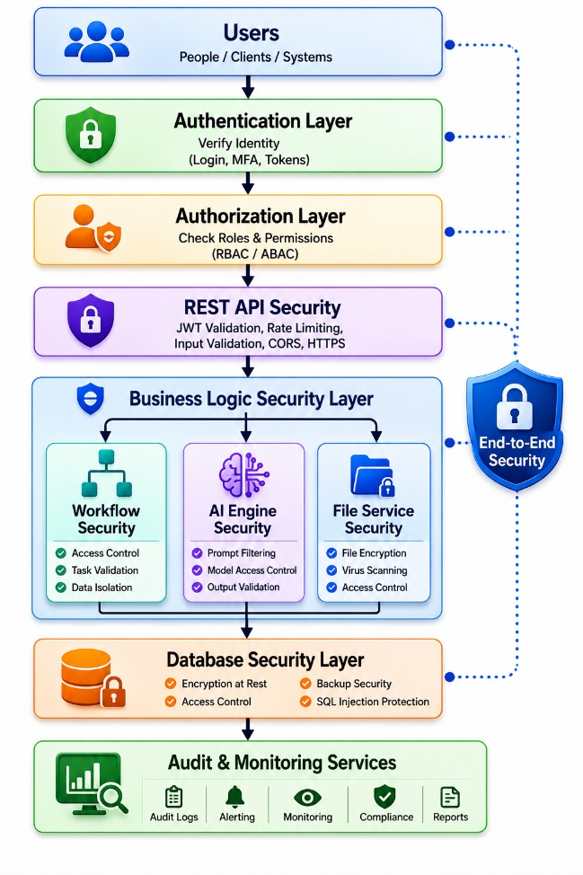
9.1.5 Security Domains
The security architecture consists of the following domains.
Domain | Purpose
Identity Security | Authentication and identity management
Access Security | Role-Based Access Control (RBAC)
API Security | Secure API communication
Application Security | Secure application logic
Database Security | Data protection and integrity
AI Security | Secure AI interactions and prompt handling
Infrastructure Security | Server and deployment security
Network Security | Secure communications
Audit Security | Monitoring and forensic capabilities
Incident Response | Detection and response to security events

9.1.6 Protected Assets
The following assets shall be protected.
Asset | Protection Required
User Accounts | Authentication and authorization
Passwords | Secure hashing
JWT Tokens | Digital signing and expiration
SOP Documents | Encryption and access control
Workflow Definitions | Authorization and version control
AI Requests | Secure transmission
AI Responses | Validation and auditing
Organizational Data | Tenant isolation
Audit Logs | Integrity protection
System Configuration | Administrative controls
API Keys | Secure storage
Backups | Encryption and restricted access

9.1.7 Threat Categories
The platform shall protect against:
- Unauthorized access
- Credential theft
- SQL Injection
- Cross-Site Scripting (XSS)
- Cross-Site Request Forgery (CSRF) (where applicable)
- Broken authentication
- Broken access control
- Prompt injection
- AI output manipulation
- Malware uploads
- Denial-of-Service (DoS)
- Brute-force attacks
- Session hijacking
- Data leakage
- Insider threats
- Supply chain vulnerabilities

9.1.8 Security Standards
The platform shall be designed in alignment with recognized security standards and best practices.
Standard | Purpose
OWASP Top 10 | Web application security
OWASP ASVS | Application Security Verification Standard
NIST Cybersecurity Framework | Security governance
NIST SP 800-63 | Digital identity guidelines
CWE Top 25 | Common software weaknesses
CIS Benchmarks | Secure system configuration
JWT Best Practices | Secure token management

Future Enterprise Compliance (Optional):
- ISO/IEC 27001
- SOC 2 Type II
- GDPR
- HIPAA (if healthcare customers are supported)

9.1.9 Security Responsibilities
Role | Responsibilities
System Administrator | Platform security configuration
Organization Administrator | Organization-level security policies
Process Manager | Secure workflow management
Reviewer | Validate AI-generated outputs
Employee | Follow security policies
Security Administrator (Future) | Incident response and monitoring

9.1.10 General Security Requirements
Requirement ID | Requirement
SEC-GEN-001 | All communications shall use HTTPS/TLS.
SEC-GEN-002 | Sensitive data shall be protected during transmission and storage.
SEC-GEN-003 | Authentication shall be required for all protected resources.
SEC-GEN-004 | Authorization shall follow RBAC principles.
SEC-GEN-005 | All security-relevant events shall be logged.
SEC-GEN-006 | Security configurations shall be centrally managed.
SEC-GEN-007 | The principle of least privilege shall be enforced.
SEC-GEN-008 | Security controls shall be periodically reviewed and updated.
SEC-GEN-009 | Security incidents shall be monitored and investigated.
SEC-GEN-010 | Tenant isolation shall be maintained across all system layers.

9.1.11 Business Rules
Rule ID | Rule
SEC-BR-001 | Every authenticated user shall belong to exactly one organization unless assigned as a System Administrator.
SEC-BR-002 | Security events shall generate audit log entries.
SEC-BR-003 | Administrative operations shall require elevated privileges.
SEC-BR-004 | AI operations shall comply with organizational security policies.
SEC-BR-005 | Sensitive credentials shall never be exposed in application code or API responses.
SEC-BR-006 | Security configurations shall support future compliance requirements.
SEC-BR-007 | Security controls shall remain effective during system failures wherever feasible.

9.1.12 Acceptance Criteria
The security architecture shall be considered complete when:
- Security principles are consistently applied across all system components.
- Protected assets are secured according to organizational policies.
- Authentication and authorization mechanisms are enforced.
- Communications are encrypted.
- Security events are logged and monitored.
- Multi-tenant isolation is maintained.
- The platform follows recognized security best practices.
- Security responsibilities are clearly defined.

9.2 Authentication Security
9.2.1 Overview
Authentication Security defines the controls and mechanisms used to verify user identities and protect authentication credentials within ProcessMind AI.
The authentication framework shall ensure that only authorized users gain access to protected system resources while preventing credential theft, brute-force attacks, session hijacking, and unauthorized account access.
Authentication shall be implemented using secure industry-standard mechanisms and continuously monitored for suspicious activities.
9.2.2 Authentication Methods
The platform shall support the following authentication methods.
Authentication Method | Supported
Email and Password | Yes
JWT Access Tokens | Yes
JWT Refresh Tokens | Yes
Multi-Factor Authentication (Future) | Planned
Single Sign-On (SSO) (Future) | Planned
OAuth 2.0 / OpenID Connect (Future) | Planned
WebAuthn / Passkeys (Future) | Planned

9.2.3 Password Policy
User passwords shall comply with the following policy.
Requirement | Value
Minimum Length | 12 characters
Maximum Length | 128 characters
Uppercase Letter | Required
Lowercase Letter | Required
Numeric Character | Required
Special Character | Required
Common Password Check | Required
Password Reuse | Last 5 passwords shall not be reused
Password Expiration | Configurable (disabled by default)
Passwords shall never be stored or transmitted in plain text.

9.2.4 Credential Storage
Authentication credentials shall be protected using secure storage mechanisms.
Requirement ID | Requirement
AUTH-SEC-001 | Passwords shall be hashed using BCrypt.
AUTH-SEC-002 | Plain-text passwords shall never be stored.
AUTH-SEC-003 | Authentication secrets shall be stored securely using environment variables or a secrets management solution.
AUTH-SEC-004 | JWT signing keys shall be protected and rotated periodically.

9.2.5 JWT Token Security
The platform shall use JSON Web Tokens (JWT) for stateless authentication.
Requirement | Description
Access Token | Short-lived authentication token
Refresh Token | Used to obtain new access tokens
Digital Signature | Required
Token Expiration | Configurable
Token Revocation | Supported on logout and administrative revocation
Access tokens shall contain only the minimum claims required for authorization.
Sensitive information shall not be stored within JWT payloads.

9.2.6 Session Management
The platform shall manage authenticated sessions securely.
Requirement ID | Requirement
AUTH-SEC-005 | Sessions shall expire automatically after the configured inactivity period.
AUTH-SEC-006 | Logout shall invalidate refresh tokens.
AUTH-SEC-007 | Multiple concurrent sessions may be allowed based on organizational policy.
AUTH-SEC-008 | Session identifiers shall be unpredictable and cryptographically secure.
AUTH-SEC-009 | Administrators shall be able to revoke active sessions.

9.2.7 Account Protection
The platform shall protect accounts from unauthorized access.
Requirement ID | Requirement
AUTH-SEC-010 | Failed login attempts shall be monitored.
AUTH-SEC-011 | Accounts shall be temporarily locked after repeated failed login attempts.
AUTH-SEC-012 | Lockout duration shall be configurable.
AUTH-SEC-013 | Suspicious authentication attempts shall be logged.
AUTH-SEC-014 | Brute-force protection mechanisms shall be implemented.

9.2.8 Password Reset Security
Password reset operations shall be secured.
Requirement ID | Requirement
AUTH-SEC-015 | Password reset tokens shall be randomly generated.
AUTH-SEC-016 | Reset tokens shall expire after a configurable period.
AUTH-SEC-017 | Reset tokens shall be single-use.
AUTH-SEC-018 | Password reset requests shall not reveal whether an account exists.
AUTH-SEC-019 | Successful password resets shall invalidate existing refresh tokens.

9.2.9 Email Verification
The platform may require email verification before account activation.
Requirement ID | Requirement
AUTH-SEC-020 | Email verification tokens shall expire after a configurable period.
AUTH-SEC-021 | Verification tokens shall be single-use.
AUTH-SEC-022 | Email verification events shall be logged.

9.2.10 Multi-Factor Authentication (Future)
The platform architecture shall support future MFA implementation.
Supported methods may include:
- Time-Based One-Time Passwords (TOTP)
- Email verification codes
- SMS verification codes (optional)
- Hardware security keys (WebAuthn/FIDO2)
- Authenticator applications
MFA shall be configurable at the organization level.

9.2.11 Authentication Monitoring
The authentication subsystem shall monitor:
- Successful logins
- Failed login attempts
- Password reset requests
- Account lockouts
- Session revocations
- Token refresh events
- Suspicious authentication activity
Critical events shall generate administrator alerts where configured.

9.2.12 Business Rules
Rule ID | Rule
AUTH-BR-001 | Every user shall authenticate before accessing protected resources.
AUTH-BR-002 | Passwords shall comply with the configured password policy.
AUTH-BR-003 | Passwords shall never be stored or transmitted in plain text.
AUTH-BR-004 | Refresh tokens shall be revoked upon logout or administrative action.
AUTH-BR-005 | Failed authentication attempts shall be recorded in audit logs.
AUTH-BR-006 | Account lockout thresholds shall be configurable.
AUTH-BR-007 | Authentication credentials shall be protected according to industry best practices.

9.2.13 Exception Handling
Exception | Expected System Response
Invalid credentials | Reject authentication and increment failed-attempt counter.
Expired JWT access token | Return an authentication error and require token refresh.
Invalid refresh token | Reject token renewal and require re-authentication.
Locked account | Deny access until lockout conditions are satisfied or administrative action is taken.
Expired password reset token | Reject the reset request and require a new reset token.
Compromised session detected | Revoke affected sessions, log the incident, and notify administrators where appropriate.

9.2.14 Acceptance Criteria
The authentication security requirements shall be considered complete when:
- Passwords comply with the configured security policy.
- Credentials are securely stored using strong hashing algorithms.
- JWT authentication is implemented securely.
- Sessions are managed and revoked appropriately.
- Brute-force protection and account lockout mechanisms operate correctly.
- Password reset and email verification processes are secure.
- Authentication events are monitored and audited.
- The architecture supports future Multi-Factor Authentication (MFA).

9.3 Authorization Security
9.3.1 Overview
Authorization Security defines the mechanisms used to control access to system resources after successful authentication.
The authorization framework shall ensure that authenticated users can access only the resources and operations explicitly permitted by their assigned roles, permissions, organization membership, and resource ownership.
The platform shall implement Role-Based Access Control (RBAC) with support for future Attribute-Based Access Control (ABAC) extensions.

9.3.2 Authorization Model
The platform shall implement Role-Based Access Control (RBAC).
User
│
▼
Assigned Role
│
▼
Assigned Permissions
│
▼
Authorized Resources
Future versions may extend this model using:
- Attribute-Based Access Control (ABAC)
- Policy-Based Access Control (PBAC)
- Context-Aware Authorization

9.3.3 Default System Roles
Role | Description
System Administrator | Full platform administration
Organization Administrator | Organization management
Process Manager | SOP and workflow management
Reviewer | Human review of AI outputs
Approver | Workflow approval authority
Employee | Standard workflow execution
Read-Only Auditor | Read-only access to reports and audit data
Organizations may define additional custom roles where permitted.

9.3.4 Permission Categories
Permissions shall be grouped into logical categories.
Category | Examples
User Management | Create User, Update User, Delete User
Organization Management | Manage Organization, Departments
SOP Management | Upload, Edit, Archive SOP
Workflow Management | Create, Deploy, Archive Workflow
Workflow Execution | Execute, Pause, Resume Workflow
AI Management | Generate Workflow, Review AI Output
Reporting | View Reports, Export Reports
Administration | Configure System, Manage AI Providers
Security | View Audit Logs, Manage Security Policies

9.3.5 Authorization Requirements
Requirement ID | Requirement
AUTHZ-SEC-001 | Every protected operation shall require authorization.
AUTHZ-SEC-002 | Authorization decisions shall be based on assigned roles and permissions.
AUTHZ-SEC-003 | Unauthorized requests shall be rejected.
AUTHZ-SEC-004 | Administrative operations shall require elevated privileges.
AUTHZ-SEC-005 | Authorization shall be enforced at the API and business service layers.

9.3.6 Least Privilege
The platform shall implement the Principle of Least Privilege.
Requirement ID | Requirement
AUTHZ-SEC-006 | Users shall receive only the permissions necessary for their responsibilities.
AUTHZ-SEC-007 | Administrative privileges shall be granted only to authorized users.
AUTHZ-SEC-008 | Default user accounts shall not receive elevated permissions.

9.3.7 Multi-Tenant Authorization
Tenant isolation shall be enforced.
Requirement ID | Requirement
AUTHZ-SEC-009 | Users shall only access resources belonging to their organization.
AUTHZ-SEC-010 | Cross-tenant access shall be prohibited except for System Administrators.
AUTHZ-SEC-011 | Every organization-owned resource shall validate tenant ownership before access.
AUTHZ-SEC-012 | Tenant isolation shall be enforced consistently across APIs, services, and data access layers.

9.3.8 Resource Ownership
Certain resources shall enforce ownership rules.
Resource | Ownership Rule
User Profile | User may update own profile
Workflow | Owner or authorized manager may modify
SOP | Authorized owner or Process Manager may modify
Reports | Accessible according to organization permissions
Notifications | Visible only to intended recipients

9.3.9 Administrative Separation
Administrative responsibilities shall be separated to reduce risk.
Administrative Role | Scope
System Administrator | Platform-wide administration
Organization Administrator | Organization-specific administration
Process Manager | Workflow and SOP administration
Security Administrator (Future) | Security policies and incident management
No single administrative role should receive unnecessary permissions beyond its defined scope.

9.3.10 Fine-Grained Authorization
The platform shall support authorization based on:
- User role
- Organization
- Department
- Resource ownership
- Workflow state
- Approval stage
- Resource sensitivity
Future releases may include contextual authorization based on device, network, and time.

9.3.11 Authorization Auditing
The following events shall be recorded.
- Permission changes
- Role assignments
- Administrative actions
- Access denials
- Privileged operations
- Authorization failures
- Resource access by privileged users

9.3.12 Business Rules
Rule ID | Rule
AUTHZ-BR-001 | Every protected resource shall enforce authorization checks.
AUTHZ-BR-002 | Users shall only access resources belonging to their organization.
AUTHZ-BR-003 | Roles shall determine default permissions.
AUTHZ-BR-004 | Permission assignments shall be auditable.
AUTHZ-BR-005 | Administrative operations shall require elevated privileges.
AUTHZ-BR-006 | Authorization failures shall be logged.
AUTHZ-BR-007 | Resource ownership shall be validated before modification or deletion.
AUTHZ-BR-008 | Custom roles shall not exceed the maximum permission scope defined by organizational policy.

9.3.13 Exception Handling
Exception | Expected System Response
Missing permission | Reject the request with an authorization error.
Cross-tenant access attempt | Deny access, log the event, and notify administrators where appropriate.
Invalid role assignment | Reject the operation and return a validation error.
Unauthorized administrative action | Deny the operation and create an audit record.
Resource ownership violation | Prevent the operation and return an authorization error.
Permission evaluation failure | Deny access by default (fail secure) and log the incident.

9.3.14 Acceptance Criteria
The authorization security requirements shall be considered complete when:
- Role-Based Access Control (RBAC) is consistently enforced.
- Users can only access authorized resources.
- Multi-tenant isolation prevents cross-organization access.
- Administrative privileges are separated appropriately.
- Authorization failures are logged and auditable.
- Resource ownership rules are enforced.
- The system follows the Principle of Least Privilege.
- The architecture supports future fine-grained authorization models.

9.4 Data Protection Security
9.4.1 Overview
Data Protection Security defines the policies, controls, and mechanisms used to protect organizational data throughout its lifecycle—from creation and storage to transmission, archival, backup, and secure deletion.
The platform shall ensure that sensitive information remains confidential, accurate, and available only to authorized users.
Data protection controls shall apply consistently across:
- Web Application
- REST APIs
- AI Processing Services
- PostgreSQL Database
- File Storage
- Backups
- Analytics
- Audit Logs

9.4.2 Data Classification
All information managed by the platform shall be classified according to its sensitivity.
Classification | Description | Examples
Public | Information intended for unrestricted access | Public documentation, product information
Internal | Information used within an organization | Workflow metadata, department lists
Confidential | Sensitive organizational information | SOPs, workflow definitions, reports
Restricted | Highly sensitive information | Password hashes, API keys, encryption secrets, audit logs
Security controls shall increase according to the classification level.

9.4.3 Encryption in Transit
All communications shall be encrypted.
Requirement ID | Requirement
DATA-SEC-001 | All HTTP communication shall use HTTPS (TLS 1.2 or higher; TLS 1.3 preferred).
DATA-SEC-002 | Communication between application services shall use encrypted channels where applicable.
DATA-SEC-003 | Database connections shall use TLS in production environments.
DATA-SEC-004 | AI provider communications shall use secure HTTPS connections.

9.4.4 Encryption at Rest
Sensitive information shall be protected while stored.
Requirement ID | Requirement
DATA-SEC-005 | Database storage shall support encryption at rest.
DATA-SEC-006 | Uploaded SOP documents shall be stored in encrypted storage.
DATA-SEC-007 | Backup files shall be encrypted before storage.
DATA-SEC-008 | Encryption keys shall not be stored with encrypted data.

9.4.5 Key Management
Cryptographic keys shall be managed securely.
Requirement ID | Requirement
DATA-SEC-009 | Encryption keys shall be stored using a secure secrets management solution or equivalent.
DATA-SEC-010 | Keys shall be rotated periodically according to organizational policy.
DATA-SEC-011 | Access to encryption keys shall be restricted to authorized components and administrators.
DATA-SEC-012 | Key usage shall be logged where appropriate.

9.4.6 Sensitive Data Handling
Sensitive information shall receive additional protection.
Data Type | Protection
Passwords | BCrypt hashing
JWT Signing Keys | Secure secret storage
API Keys | Encrypted or managed through a secrets manager
Refresh Tokens | Secure storage and revocation support
SOP Documents | Encryption and access control
AI Requests | Secure transmission
AI Responses | Organization isolation and audit logging
Audit Logs | Integrity protection and restricted access
Sensitive information shall never be exposed in logs, error messages, or API responses.

9.4.7 File Protection
Uploaded documents shall be protected.
Requirement ID | Requirement
DATA-SEC-013 | Uploaded files shall undergo malware scanning before storage.
DATA-SEC-014 | Supported file types shall be validated before processing.
DATA-SEC-015 | File size limits shall be enforced.
DATA-SEC-016 | Access to uploaded files shall require authorization.

9.4.8 Backup Protection
Backups shall be secured throughout their lifecycle.
Requirement ID | Requirement
DATA-SEC-017 | Backup files shall be encrypted.
DATA-SEC-018 | Backup access shall be restricted to authorized administrators.
DATA-SEC-019 | Backup restoration shall be audited.
DATA-SEC-020 | Backup integrity shall be verified before restoration.

9.4.9 Data Masking
Sensitive information shall be masked where full disclosure is unnecessary.
Examples include:
- Partial email addresses
- Partial phone numbers
- API keys
- Access tokens
- Secret configuration values
Only authorized users may view complete sensitive information where required.

9.4.10 Secure Deletion
The platform shall securely delete information when permitted by retention policies.
Requirement ID | Requirement
DATA-SEC-021 | Deleted data shall comply with configured retention policies.
DATA-SEC-022 | Secure deletion shall be logged.
DATA-SEC-023 | Data subject to legal or compliance requirements shall not be deleted prematurely.
DATA-SEC-024 | Temporary processing data shall be removed after use according to policy.

9.4.11 Data Integrity
The platform shall protect against unauthorized modification.
Requirement ID | Requirement
DATA-SEC-025 | Referential integrity shall be enforced.
DATA-SEC-026 | Database transactions shall comply with ACID principles.
DATA-SEC-027 | Audit records shall be immutable.
DATA-SEC-028 | Workflow versions shall remain immutable after deployment.

9.4.12 Business Rules
Rule ID | Rule
DATA-BR-001 | Sensitive organizational data shall be protected according to its classification.
DATA-BR-002 | Encryption shall be used for sensitive data in transit and at rest where appropriate.
DATA-BR-003 | Encryption keys shall be managed separately from encrypted data.
DATA-BR-004 | Uploaded files shall be validated before storage and processing.
DATA-BR-005 | Backup operations shall preserve confidentiality and integrity.
DATA-BR-006 | Secure deletion shall follow retention and compliance policies.
DATA-BR-007 | Sensitive information shall not be exposed through logs or API responses.
DATA-BR-008 | Tenant isolation shall be maintained throughout the data lifecycle.

9.4.13 Exception Handling
Exception | Expected System Response
Encryption failure | Reject the operation where encryption is required, log the incident, and notify administrators.
Invalid file upload | Reject the upload and return a validation error.
Malware detected | Quarantine or reject the file and record the event.
Backup integrity verification failure | Prevent restoration and require a verified backup.
Unauthorized access to sensitive data | Deny access, generate an audit log entry, and notify administrators where appropriate.
Key management failure | Prevent cryptographic operations that depend on the unavailable key material and raise an administrative alert.

9.4.14 Acceptance Criteria
The data protection security requirements shall be considered complete when:
- Sensitive data is classified and protected appropriately.
- Encryption is applied during transmission and storage where required.
- Encryption keys are securely managed.
- Uploaded files are validated and protected.
- Backup data is encrypted and recoverable.
- Sensitive information is masked when appropriate.
- Secure deletion complies with retention policies.
- Data integrity controls protect against unauthorized modification.

9.5 Network & Infrastructure Security
9.5.1 Overview
Network & Infrastructure Security defines the controls, configurations, and operational practices used to protect the infrastructure hosting ProcessMind AI.
The infrastructure shall be designed using a defense-in-depth strategy, ensuring that failures in one security layer do not compromise the entire platform.
Security controls shall protect:
- Client communications
- Application servers
- API services
- AI integration services
- PostgreSQL database
- File storage
- Background workers
- Monitoring services
- Administrative interfaces

9.5.2 Network Architecture
The production environment shall follow a layered architecture.
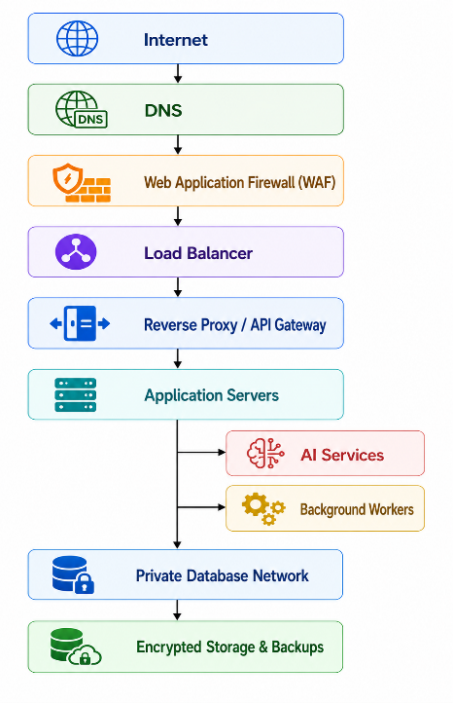
The database and internal services shall not be directly accessible from the public internet.

9.5.3 Secure Communication
All network communications shall be encrypted.
Requirement ID | Requirement
NET-SEC-001 | HTTPS shall be enforced for all client-server communication.
NET-SEC-002 | TLS 1.2 or higher shall be required (TLS 1.3 preferred).
NET-SEC-003 | HTTP requests shall be redirected to HTTPS.
NET-SEC-004 | Internal service communication shall use encrypted channels where applicable.

9.5.4 Firewall Requirements
The infrastructure shall implement firewall protection.
Requirement ID | Requirement
NET-SEC-005 | Only required ports shall be exposed publicly.
NET-SEC-006 | Database ports shall not be publicly accessible.
NET-SEC-007 | Administrative interfaces shall be restricted.
NET-SEC-008 | Firewall rules shall be reviewed periodically.

9.5.5 Reverse Proxy & API Gateway Security
The reverse proxy or API gateway shall provide:
- HTTPS termination
- Request routing
- Rate limiting
- Request size limits
- Security header injection
- API authentication forwarding
- Request logging
- WebSocket support
- Protection against malformed requests

9.5.6 Infrastructure Isolation
Infrastructure components shall be isolated.
Component | Isolation Requirement
Database | Private network only
File Storage | Restricted access
AI Services | Controlled API access
Background Workers | Internal network
Monitoring Services | Administrative access only
Backup Storage | Separate protected storage

9.5.7 Secrets Management
Sensitive configuration values shall be protected.
Requirement ID | Requirement
NET-SEC-009 | Secrets shall not be stored in source code repositories.
NET-SEC-010 | Environment variables or a dedicated secrets manager shall be used.
NET-SEC-011 | API keys shall be rotated periodically.
NET-SEC-012 | Access to secrets shall follow the principle of least privilege.

9.5.8 Container & Runtime Security
If deployed using containers, the platform shall follow secure container practices.
Requirement ID | Requirement
NET-SEC-013 | Containers shall run with non-root users where feasible.
NET-SEC-014 | Container images shall be scanned for known vulnerabilities.
NET-SEC-015 | Unnecessary services and packages shall be removed from container images.
NET-SEC-016 | Container runtime permissions shall be minimized.

9.5.9 Availability & DDoS Protection
The infrastructure shall support high availability and resilience.
Security measures include:
- Load balancing
- Automatic health checks
- Horizontal scaling
- Rate limiting
- Traffic filtering
- DDoS mitigation (through the hosting provider or CDN)
- Automatic service recovery where supported

9.5.10 Infrastructure Monitoring
Infrastructure monitoring shall include:
- CPU utilization
- Memory utilization
- Disk usage
- Database availability
- API availability
- AI provider connectivity
- Network latency
- SSL/TLS certificate status
- Error rates
Critical failures shall generate administrator alerts.

9.5.11 Logging & Monitoring
Infrastructure events shall be logged.
Examples include:
- Service startup and shutdown
- Configuration changes
- Deployment events
- Firewall events
- Reverse proxy events
- Infrastructure errors
- Security events
Logs shall be protected from unauthorized modification.

9.5.12 Business Rules
Rule ID | Rule
NET-BR-001 | All production traffic shall use HTTPS.
NET-BR-002 | Internal infrastructure components shall not be directly accessible from the public internet unless explicitly required.
NET-BR-003 | Secrets shall be stored securely and never committed to version control.
NET-BR-004 | Firewall configurations shall follow the principle of least privilege.
NET-BR-005 | Infrastructure changes shall be documented and auditable.
NET-BR-006 | Monitoring systems shall continuously assess infrastructure health.
NET-BR-007 | Security events shall trigger alerts according to configured policies.
NET-BR-008 | Infrastructure shall support scalable deployment without reducing security controls.

9.5.13 Exception Handling
Exception | Expected System Response
TLS certificate expired | Reject insecure connections where appropriate, generate alerts, and require certificate renewal.
Firewall misconfiguration | Log the issue, notify administrators, and prevent deployment where automated validation is available.
Service unavailable | Redirect traffic to healthy instances where applicable and notify administrators.
Secret retrieval failure | Prevent dependent services from starting or performing sensitive operations until secrets are available.
DDoS attack detected | Apply traffic mitigation controls and continue serving legitimate users where possible.
Infrastructure health check failure | Mark the affected service as unhealthy and initiate configured recovery procedures.

9.5.14 Acceptance Criteria
The network and infrastructure security requirements shall be considered complete when:
- All external communications use HTTPS.
- Network segmentation protects internal services.
- Firewall rules restrict unnecessary access.
- Secrets are securely managed.
- Container and runtime environments follow secure configurations.
- Infrastructure monitoring detects failures and security events.
- High-availability mechanisms support continuous operation.
- Administrative interfaces are protected from unauthorized access.

9.6 Application Security
9.6.1 Overview
Application Security defines the controls, secure development practices, and runtime protections implemented to safeguard ProcessMind AI against application-layer attacks.
The platform shall follow Secure Software Development Lifecycle (SSDLC) principles and implement security controls throughout development, testing, deployment, and maintenance.
Application security requirements apply to:
- Next.js Web Application
- Spring Boot Backend
- REST APIs
- AI Processing Services
- File Upload Services
- Background Processing Services
- Administrative Interfaces

9.6.2 Secure Development Principles
The application shall follow these principles:
- Secure by Design
- Secure by Default
- Defense in Depth
- Least Privilege
- Input Validation
- Output Encoding
- Fail Secure
- Separation of Duties
- Secure Error Handling
- Security Logging

9.6.3 Input Validation
All externally supplied input shall be validated before processing.
Requirement ID | Requirement
APP-SEC-001 | All request parameters shall be validated on the server.
APP-SEC-002 | Client-side validation shall improve usability but shall not replace server-side validation.
APP-SEC-003 | Input length, type, format, and range shall be validated.
APP-SEC-004 | Invalid input shall be rejected with standardized error responses.
APP-SEC-005 | Unexpected fields shall be ignored or rejected according to API specifications.

9.6.4 Output Encoding
Application responses shall safely render user-supplied content.
Requirement ID | Requirement
APP-SEC-006 | Dynamic content displayed in the user interface shall be properly encoded.
APP-SEC-007 | User-generated content shall not be rendered as executable code.
APP-SEC-008 | HTML injection shall be prevented.

9.6.5 SQL Injection Protection
The platform shall protect against SQL injection attacks.
Requirement ID | Requirement
APP-SEC-009 | Parameterized queries or ORM mechanisms shall be used for database access.
APP-SEC-010 | Dynamic SQL construction using untrusted input shall be prohibited.
APP-SEC-011 | Database errors shall not expose implementation details.

9.6.6 Cross-Site Scripting (XSS) Protection
The application shall prevent execution of malicious scripts.
Requirement ID | Requirement
APP-SEC-012 | User input displayed in web pages shall be encoded appropriately.
APP-SEC-013 | Rich-text content shall be sanitized before rendering.
APP-SEC-014 | A Content Security Policy (CSP) shall be implemented where feasible.

9.6.7 Cross-Site Request Forgery (CSRF)
For browser-based interactions, the platform shall mitigate CSRF risks.
Requirement ID | Requirement
APP-SEC-015 | CSRF protection shall be implemented for cookie-based authenticated requests.
APP-SEC-016 | Stateless JWT APIs shall be designed to minimize CSRF exposure.
APP-SEC-017 | State-changing operations shall require appropriate authentication and authorization.

9.6.8 File Upload Security
The platform shall securely process uploaded documents.
Requirement ID | Requirement
APP-SEC-018 | Uploaded files shall be validated against allowed file types.
APP-SEC-019 | File size limits shall be enforced.
APP-SEC-020 | Uploaded files shall undergo malware scanning before processing.
APP-SEC-021 | File names shall be sanitized before storage.
APP-SEC-022 | Uploaded files shall not be executed by the application server.

9.6.9 API Security
Application APIs shall implement appropriate protections.
Requirement ID | Requirement
APP-SEC-023 | All protected APIs shall require authentication.
APP-SEC-024 | Authorization shall be evaluated before business logic execution.
APP-SEC-025 | Rate limiting shall protect against abuse.
APP-SEC-026 | API responses shall not expose sensitive internal information.

9.6.10 Dependency Management
Third-party software dependencies shall be managed securely.
Requirement ID | Requirement
APP-SEC-027 | Dependencies shall originate from trusted sources.
APP-SEC-028 | Known vulnerable dependencies shall be updated or replaced promptly.
APP-SEC-029 | Dependency vulnerability scanning shall be integrated into the development process.

9.6.11 Secure Error Handling
The platform shall provide secure error responses.
Requirement ID | Requirement
APP-SEC-030 | Internal implementation details shall not be exposed to users.
APP-SEC-031 | Detailed stack traces shall only be available in development environments.
APP-SEC-032 | Errors shall be logged securely for troubleshooting and auditing.

9.6.12 Secure Coding Practices
The development team shall follow secure coding practices.
These include:
- Code reviews.
- Static code analysis.
- Security testing.
- Principle of least privilege.
- Secure session handling.
- Avoidance of hardcoded secrets.
- Proper exception handling.

9.6.13 Vulnerability Management
The platform shall support continuous vulnerability management.
Activities include:
- Dependency vulnerability scanning.
- Static Application Security Testing (SAST).
- Dynamic Application Security Testing (DAST).
- Penetration testing.
- Security patch management.
- Remediation tracking.

9.6.14 Business Rules
Rule ID | Rule
APP-BR-001 | All externally supplied input shall be validated before processing.
APP-BR-002 | Database access shall use parameterized queries or ORM frameworks.
APP-BR-003 | User-generated content shall be encoded or sanitized before rendering.
APP-BR-004 | File uploads shall comply with validation and malware scanning policies.
APP-BR-005 | Application APIs shall enforce authentication and authorization.
APP-BR-006 | Sensitive implementation details shall not be exposed in error messages.
APP-BR-007 | Vulnerability management shall be performed continuously throughout the software lifecycle.
APP-BR-008 | Secure coding practices shall be followed across all application components.

9.6.15 Exception Handling
Exception | Expected System Response
Invalid input | Reject the request with a standardized validation error.
SQL injection attempt | Reject the request, log the event, and continue normal operation.
XSS payload detected | Sanitize or reject the input according to application policy.
Malware detected in uploaded file | Reject or quarantine the file and notify administrators where appropriate.
Dependency vulnerability identified | Assess severity, apply mitigation, and update the affected dependency as soon as practical.
Unexpected application exception | Return a generic error response, log diagnostic information securely, and preserve application stability.

9.6.16 Acceptance Criteria
The application security requirements shall be considered complete when:
- Input validation protects all externally supplied data.
- Output encoding and sanitization prevent script injection.
- Database interactions are protected from SQL injection.
- File uploads are validated and scanned.
- APIs enforce authentication and authorization.
- Dependencies are monitored for vulnerabilities.
- Error handling prevents disclosure of sensitive information.
- Secure development practices are consistently applied.

9.7 AI Security
9.7.1 Overview
AI Security defines the policies, controls, and governance mechanisms used to securely integrate Artificial Intelligence into ProcessMind AI.
The objective is to ensure that AI-assisted business process automation remains secure, reliable, explainable, auditable, and aligned with organizational policies.
AI security controls shall apply to:
- SOP Analysis
- Workflow Generation
- AI Reasoning
- AI Validation
- AI Optimization
- AI Chat
- AI Agents
- Prompt Management
- AI Provider Integrations

9.7.2 AI Security Objectives
The AI subsystem shall achieve the following objectives.
Objective | Description
Confidentiality | Protect organizational information processed by AI services.
Integrity | Prevent unauthorized modification of AI inputs and outputs.
Availability | Ensure AI services remain available and resilient.
Explainability | Provide reasoning and confidence information where applicable.
Human Oversight | Enable human review of important AI decisions.
Auditability | Maintain complete records of AI interactions.
Responsible AI | Support fair, transparent, and accountable AI usage.

9.7.3 AI Request Security
AI requests shall be protected before transmission.
Requirement ID | Requirement
AI-SEC-001 | AI requests shall be transmitted over encrypted channels.
AI-SEC-002 | Requests shall be associated with an authenticated user and organization.
AI-SEC-003 | Requests shall be validated before being sent to AI providers.
AI-SEC-004 | Sensitive information shall be minimized before transmission where feasible.

9.7.4 Prompt Security
The platform shall protect prompt construction and execution.
Requirement ID | Requirement
AI-SEC-005 | Prompt templates shall be version-controlled.
AI-SEC-006 | Prompt templates shall only be modified by authorized administrators.
AI-SEC-007 | Dynamic prompt variables shall be validated before insertion.
AI-SEC-008 | Prompt execution shall be logged.

9.7.5 Prompt Injection Protection
The platform shall implement safeguards against prompt injection attacks.
Requirement ID | Requirement
AI-SEC-009 | User-supplied content shall be clearly separated from system instructions.
AI-SEC-010 | AI outputs shall not automatically override system policies or business rules.
AI-SEC-011 | AI instructions requesting privileged operations shall require authorization outside the model response.
AI-SEC-012 | Potential prompt injection attempts shall be detected, logged, and flagged for review where appropriate.

9.7.6 AI Output Validation
AI-generated outputs shall be validated before operational use.
Requirement ID | Requirement
AI-SEC-013 | AI-generated workflows shall undergo validation before deployment.
AI-SEC-014 | Confidence scores shall accompany AI-generated outputs where supported.
AI-SEC-015 | AI-generated business rules shall be reviewed before activation.
AI-SEC-016 | Validation failures shall prevent automatic deployment.

9.7.7 Human-in-the-Loop (HITL)
Human oversight shall remain part of critical AI-assisted decisions.
Requirement ID | Requirement
AI-SEC-017 | Low-confidence AI outputs shall require human review.
AI-SEC-018 | High-risk workflow modifications shall require approval before activation.
AI-SEC-019 | Human reviewers shall be able to approve, reject, or modify AI-generated outputs.
AI-SEC-020 | Human decisions shall be recorded in audit logs.

9.7.8 AI Provider Security
External AI providers shall be integrated securely.
Requirement ID | Requirement
AI-SEC-021 | API keys shall be securely managed.
AI-SEC-022 | Provider communications shall use encrypted connections.
AI-SEC-023 | AI provider availability shall be monitored.
AI-SEC-024 | Provider failures shall trigger retry or fallback mechanisms where configured.

9.7.9 AI Governance
The platform shall support responsible AI governance.
Governance includes:
- AI model version tracking.
- Prompt version management.
- AI provider version tracking.
- Human review records.
- Decision traceability.
- Policy compliance.

9.7.10 AI Audit Logging
The following AI events shall be recorded.
- AI request submission
- Prompt template version used
- AI provider and model used
- Response time
- Confidence score
- Validation results
- Human review decisions
- Workflow deployment approval
- AI failures
Audit records shall be protected from unauthorized modification.

9.7.11 AI Abuse Prevention
The platform shall implement safeguards against misuse.
Requirement ID | Requirement
AI-SEC-025 | AI APIs shall enforce authentication and authorization.
AI-SEC-026 | AI requests shall be rate-limited.
AI-SEC-027 | Excessive or suspicious AI usage shall be monitored.
AI-SEC-028 | Organizations shall only access their own AI processing data.

9.7.12 Responsible AI Principles
The platform shall promote responsible AI by:
- Keeping humans responsible for final business decisions.
- Providing transparency into AI-generated recommendations.
- Supporting explainability where technically feasible.
- Preventing AI from bypassing security or authorization controls.
- Allowing organizations to review and validate AI outputs before operational deployment.

9.7.13 Business Rules
Rule ID | Rule
AI-BR-001 | AI shall assist decision-making but shall not bypass mandatory approval workflows.
AI-BR-002 | AI-generated workflows shall require validation before production deployment.
AI-BR-003 | AI processing shall respect tenant isolation.
AI-BR-004 | Prompt templates shall be managed under version control.
AI-BR-005 | Prompt injection protections shall be applied to AI interactions.
AI-BR-006 | AI provider credentials shall be securely managed.
AI-BR-007 | Human review shall remain available for configurable high-risk operations.
AI-BR-008 | AI activities shall be fully auditable.

9.7.14 Exception Handling
Exception | Expected System Response
AI provider unavailable | Retry according to policy or fail over to an alternative provider if configured.
Prompt injection attempt detected | Reject or isolate the request, log the event, and notify administrators where appropriate.
AI validation failure | Prevent deployment or execution of the generated output until resolved.
Low-confidence AI output | Route the result to Human-in-the-Loop review.
AI provider timeout | Cancel the request after the configured timeout and return an appropriate error response.
AI model version mismatch | Log the event, maintain compatibility where possible, and require administrative review if necessary.

9.7.15 Acceptance Criteria
The AI security requirements shall be considered complete when:
- AI communications are encrypted.
- Prompt templates are securely managed.
- Prompt injection protections are implemented.
- AI-generated outputs undergo validation.
- Human review is supported for configurable scenarios.
- AI provider integrations are securely managed.
- AI activities are fully audited.
- Responsible AI principles are consistently applied.

9.8 Audit Logging & Monitoring Security
9.8.1 Overview
Audit Logging & Monitoring Security defines the policies, controls, and mechanisms used to record, monitor, protect, and analyze security-related and operational events within ProcessMind AI.
The platform shall maintain comprehensive audit trails to support security investigations, compliance requirements, operational monitoring, and forensic analysis.
Audit logging shall apply to all major platform components, including:
- Authentication Services
- Authorization Services
- Workflow Management
- Workflow Execution
- AI Processing
- Administrative Operations
- Database Operations
- File Management
- REST APIs

9.8.2 Audit Objectives
The audit subsystem shall achieve the following objectives.
Objective | Description
Accountability | Identify who performed an action.
Traceability | Reconstruct system events accurately.
Integrity | Protect audit logs from unauthorized modification.
Compliance | Support organizational and regulatory requirements.
Security Monitoring | Detect suspicious activities.
Incident Investigation | Support forensic analysis after security incidents.

9.8.3 Events to be Logged
The following categories of events shall be audited.
Category | Examples
Authentication | Login, logout, failed login, password reset
Authorization | Permission changes, access denials
User Management | User creation, updates, deletion
Organization Management | Organization creation, suspension
SOP Management | Upload, update, archive
Workflow Management | Creation, deployment, archival
Workflow Execution | Start, completion, cancellation
AI Processing | Prompt execution, AI responses, validation
Administration | Configuration changes, backups, restores
Security | Account lockout, suspicious activity
System | Service startup, shutdown, deployment

9.8.4 Audit Log Contents
Each audit record shall contain the following information.
Field | Description
Event ID | Unique identifier
Timestamp | Date and time (UTC)
User ID | Authenticated user
Organization ID | Associated organization
Event Type | Category of event
Resource Type | Resource affected
Resource ID | Unique resource identifier
Action | Operation performed
Result | Success or failure
Client IP Address | Originating IP address
User Agent | Client application details
Additional Metadata | Optional contextual information

9.8.5 Log Integrity
Audit logs shall be protected against tampering.
Requirement ID | Requirement
AUD-SEC-001 | Audit logs shall be append-only.
AUD-SEC-002 | Audit records shall not be modified or deleted by standard users.
AUD-SEC-003 | Administrative access to audit logs shall be restricted.
AUD-SEC-004 | Audit logs shall be included in backup procedures.

9.8.6 Monitoring
The platform shall continuously monitor:
- Authentication failures
- Account lockouts
- Authorization failures
- AI provider failures
- Workflow execution failures
- API errors
- Infrastructure health
- Database availability
- High resource utilization
- Security events
Monitoring shall support configurable thresholds and alerts.

9.8.7 Security Alerts
The platform shall generate alerts for significant events.
Examples include:
- Multiple failed login attempts
- Suspicious authentication activity
- Privilege escalation attempts
- Cross-tenant access attempts
- AI provider outages
- Backup failures
- Database connectivity failures
- Excessive API requests
- Unusual administrative activity
Alerts may be delivered through:
- In-app notifications
- Email
- WebSocket notifications
- External monitoring platforms (future)

9.8.8 Log Retention
Audit logs shall be retained according to organizational policy.
Log Type | Default Retention
Authentication Logs | 2 years
Security Logs | 7 years
Audit Logs | 7 years
Workflow Execution Logs | 5 years
AI Processing Logs | 2 years
System Logs | 1 year
Error Logs | 1 year
Retention periods shall be configurable where permitted.

9.8.9 Log Access Control
Access to audit logs shall follow RBAC.
Role | Access Level
System Administrator | Full access
Organization Administrator | Organization-specific logs
Security Administrator (Future) | Security logs
Auditor | Read-only access
Standard User | No direct access

9.8.10 Business Rules
Rule ID | Rule
AUD-BR-001 | Security-relevant events shall be recorded automatically.
AUD-BR-002 | Audit logs shall be immutable after creation.
AUD-BR-003 | Audit records shall include sufficient information for investigation.
AUD-BR-004 | Audit logs shall be protected from unauthorized access.
AUD-BR-005 | Monitoring shall detect abnormal system behavior.
AUD-BR-006 | Critical security events shall generate alerts.
AUD-BR-007 | Audit log retention shall follow configured policies.
AUD-BR-008 | Monitoring failures shall be reported to administrators.

9.8.11 Exception Handling
Exception | Expected System Response
Audit logging failure | Record the failure in system diagnostics, alert administrators, and continue operation where safe.
Monitoring service unavailable | Continue collecting logs locally where possible and notify administrators.
Unauthorized audit log access | Deny access, log the attempt, and generate a security alert.
Log storage nearing capacity | Generate warnings and initiate configured retention or archival procedures.
Alert delivery failure | Retry delivery according to policy and record the failure.
Time synchronization issue | Log the discrepancy and use synchronized system time where available.

9.8.12 Acceptance Criteria
The audit logging and monitoring security requirements shall be considered complete when:
- Security and operational events are recorded automatically.
- Audit logs are immutable and protected.
- Monitoring detects significant operational and security events.
- Critical events generate alerts.
- Audit log retention complies with organizational policies.
- Access to audit information follows RBAC.
- Monitoring supports incident investigation and operational analysis.

9.9 Incident Response & Security Acceptance Criteria
9.9.1 Overview
Incident Response defines the procedures, responsibilities, and controls for identifying, responding to, containing, recovering from, and documenting security incidents affecting ProcessMind AI.
The objective is to minimize operational disruption, protect organizational data, preserve evidence, and continuously improve the platform's security posture.
Incident response applies to:
- Authentication systems
- Authorization systems
- REST APIs
- AI services
- Workflow engine
- Database
- File storage
- Infrastructure
- Administrative services

9.9.2 Security Incident Classification
Security incidents shall be classified according to severity.
Severity | Description | Example
Critical | Immediate threat affecting confidentiality, integrity, or availability | Database compromise, ransomware, tenant data exposure
High | Significant security event requiring urgent action | Administrative account compromise, AI provider credential leakage
Medium | Limited security impact | Repeated failed login attempts, abnormal API usage
Low | Minor security issue | Single authentication failure, isolated validation error
Informational | Non-security operational event | Normal administrative configuration update
Incident priority shall determine escalation procedures and response timelines.

9.9.3 Incident Response Lifecycle
The platform shall support the following incident response process.
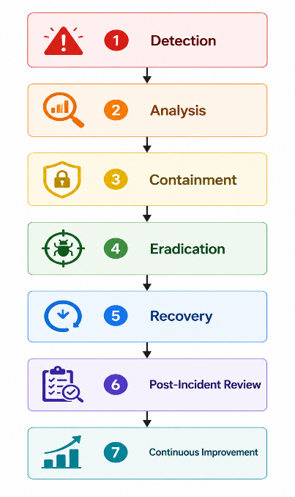
9.9.4 Incident Detection
Potential security incidents may be detected through:
- Authentication monitoring
- Audit logs
- Infrastructure monitoring
- AI monitoring
- API monitoring
- Database monitoring
- User reports
- Automated alerts
- External monitoring systems
Detection mechanisms shall generate alerts according to configured severity levels.

9.9.5 Incident Containment
Upon confirmation of an incident, the platform shall support appropriate containment actions.
Examples include:
- Disable compromised user accounts.
- Revoke JWT refresh tokens.
- Block suspicious IP addresses.
- Suspend affected API keys.
- Isolate compromised services.
- Temporarily disable affected AI providers.
- Prevent execution of affected workflows.
Containment actions shall be proportionate to the severity of the incident.

9.9.6 Recovery
Recovery procedures shall restore normal operations while preserving system integrity.
Recovery activities may include:
- Restore verified backups.
- Rotate compromised credentials.
- Redeploy affected services.
- Restore AI provider connectivity.
- Validate database integrity.
- Verify workflow consistency.
- Resume suspended workflows where appropriate.
Recovery actions shall be documented.

9.9.7 Post-Incident Review
Every significant security incident shall undergo a documented review.
The review shall include:
- Root cause analysis.
- Timeline reconstruction.
- Impact assessment.
- Corrective actions.
- Preventive actions.
- Lessons learned.
- Verification of implemented improvements.

9.9.8 Security Testing
The platform shall undergo regular security testing.
Test Type | Purpose
Unit Security Testing | Validate security-related code paths
Integration Security Testing | Verify secure interactions between components
Authentication Testing | Validate login and session controls
Authorization Testing | Verify RBAC and access controls
API Security Testing | Validate REST API protections
File Upload Testing | Verify upload restrictions and malware handling
AI Security Testing | Validate AI-specific safeguards
Penetration Testing | Simulate real-world attacks
Regression Security Testing | Ensure fixes do not introduce new vulnerabilities

9.9.9 Security Metrics
The platform shall track security-related metrics.
Examples include:
- Failed authentication rate
- Account lockout frequency
- API abuse attempts
- Authorization failures
- AI provider failure rate
- Detected prompt injection attempts
- Average incident response time
- Mean Time to Detect (MTTD)
- Mean Time to Respond (MTTR)
- Vulnerability remediation time
These metrics shall support continuous improvement.

9.9.10 Business Rules
Rule ID | Rule
SEC-IR-001 | Security incidents shall be classified according to severity.
SEC-IR-002 | Critical incidents shall generate immediate alerts.
SEC-IR-003 | Incident response activities shall be documented.
SEC-IR-004 | Recovery shall preserve data integrity and auditability.
SEC-IR-005 | Significant incidents shall undergo post-incident review.
SEC-IR-006 | Security testing shall be performed throughout the software lifecycle.
SEC-IR-007 | Security metrics shall be monitored and reviewed periodically.
SEC-IR-008 | Corrective actions shall be tracked until completion.

9.9.11 Exception Handling
Exception | Expected System Response
Monitoring service unavailable | Continue collecting available local logs, notify administrators, and restore monitoring as soon as practical.
False positive security alert | Document the investigation outcome and update detection rules if appropriate.
Backup restoration failure during recovery | Halt the recovery process, preserve available evidence, and use the most recent verified backup where possible.
Compromised administrative account | Immediately revoke active sessions, rotate credentials, and initiate administrative review.
AI provider security incident | Suspend or isolate the affected provider according to organizational policy and switch to an approved alternative if available.
Incomplete incident information | Continue investigation while preserving evidence and documenting assumptions.

9.9.12 Security Acceptance Criteria
The overall security architecture of ProcessMind AI shall be considered acceptable when:
Identity & Access Security
- Authentication is securely implemented.
- RBAC authorization is consistently enforced.
- Multi-tenant isolation prevents unauthorized cross-organization access.
- Administrative privileges follow the Principle of Least Privilege.

Data Security
- Sensitive information is encrypted during transmission and storage where required.
- Backups are protected.
- Secure deletion complies with retention policies.
- Sensitive information is not exposed through logs or APIs.

Application Security
- Input validation protects against malicious input.
- SQL injection and XSS protections are implemented.
- File upload security controls operate correctly.
- Dependency vulnerabilities are monitored and addressed.

AI Security
- Prompt security controls are implemented.
- Prompt injection protections are active.
- AI-generated outputs are validated.
- Human-in-the-Loop review supports configurable high-risk operations.
- AI activities are fully auditable.

Operational Security
- Security monitoring detects significant events.
- Audit logs are immutable.
- Critical alerts are generated appropriately.
- Incident response procedures are documented and tested.

Infrastructure Security
- HTTPS is enforced.
- Internal services are protected.
- Secrets are securely managed.
- Infrastructure monitoring is operational.

Compliance & Governance
- Security controls align with recognized industry best practices.
- Security testing is performed throughout development and deployment.
- Security incidents are documented and reviewed.
- Continuous improvement processes are established.

Chapter 10 – Non-Functional Requirements
10.1 Performance Requirements
10.1.1 Overview
Performance Requirements define the measurable operational characteristics that ProcessMind AI shall satisfy under expected workloads.
The platform shall provide responsive user interactions, efficient AI processing, scalable workflow execution, and reliable API performance while maintaining system stability.
Performance requirements apply to:
- Web Application
- REST APIs
- AI Processing Engine
- Workflow Execution Engine
- Database
- Analytics Engine
- Notification Services
- Background Processing Services

10.1.2 Performance Objectives
The platform shall achieve the following objectives.
Objective | Description
Responsiveness | Provide fast response times for user operations.
Throughput | Process large numbers of concurrent requests efficiently.
Scalability | Maintain performance as workload increases.
Stability | Continue operating under sustained load.
Resource Efficiency | Optimize CPU, memory, storage, and network utilization.

10.1.3 User Interface Performance
Requirement ID | Requirement
PERF-001 | Standard page navigation shall complete within 2 seconds under normal operating conditions.
PERF-002 | Dashboard loading shall complete within 3 seconds for typical datasets.
PERF-003 | Search results shall begin displaying within 2 seconds for indexed data.
PERF-004 | UI interactions shall remain responsive during background processing.

10.1.4 REST API Performance
Requirement ID | Requirement
PERF-005 | Standard CRUD API requests shall complete within 500 ms under normal load.
PERF-006 | Authentication requests shall complete within 1 second.
PERF-007 | API responses shall support compression where appropriate.
PERF-008 | Long-running operations shall use asynchronous processing where applicable.

10.1.5 AI Processing Performance
Because AI response times vary by provider and workload, targets should be defined as operational goals rather than hard guarantees.
Requirement ID | Requirement
PERF-009 | AI analysis requests shall provide progress feedback for long-running operations.
PERF-010 | AI workflow generation should complete within acceptable operational targets based on document size and provider performance.
PERF-011 | AI validation shall execute asynchronously for computationally intensive tasks where appropriate.
PERF-012 | AI provider latency shall be monitored continuously.

10.1.6 Workflow Execution Performance
Requirement ID | Requirement
PERF-013 | Workflow instance creation shall complete within 2 seconds under normal conditions.
PERF-014 | Task assignment shall occur within 1 second after workflow progression.
PERF-015 | Workflow state changes shall be persisted reliably before confirmation is returned.
PERF-016 | Concurrent workflow execution shall be supported without degrading system stability.

10.1.7 Database Performance
Requirement ID | Requirement
PERF-017 | Frequently executed queries shall be optimized using appropriate indexing.
PERF-018 | Database connection pooling shall be implemented.
PERF-019 | Long-running queries shall be monitored and optimized.
PERF-020 | Database transactions shall maintain ACID properties while minimizing lock contention.

10.1.8 Scalability Targets
The architecture shall support horizontal scaling.
Component | Scalability Requirement
Web Servers | Horizontal scaling supported
API Servers | Horizontal scaling supported
Background Workers | Horizontal scaling supported
Notification Services | Horizontal scaling supported
AI Processing | Multiple provider instances supported
The platform shall be designed so that capacity can increase without requiring major architectural changes.

10.1.9 Resource Utilization
The platform shall monitor:
- CPU utilization
- Memory utilization
- Disk usage
- Network utilization
- Database connection usage
- Queue length
- AI provider response time
Thresholds shall be configurable.

10.1.10 Performance Monitoring
The following metrics shall be collected continuously.
Metric
- API response time
- Page load time
- Workflow execution time
- AI processing duration
- Database query latency
- Error rate
- Concurrent users
- Throughput (requests/second)
- Queue processing time
- Resource utilization

10.1.11 Business Rules
Rule ID | Rule
PERF-BR-001 | Performance targets shall be monitored continuously.
PERF-BR-002 | Long-running operations shall not block unrelated user interactions.
PERF-BR-003 | Performance monitoring data shall support capacity planning.
PERF-BR-004 | Performance degradation beyond configured thresholds shall generate alerts.
PERF-BR-005 | Resource utilization shall remain within acceptable operational limits under expected workloads.
PERF-BR-006 | Performance optimizations shall not compromise security or data integrity.

10.1.12 Exception Handling
Exception | Expected System Response
High API latency | Record performance metrics, notify administrators if thresholds are exceeded, and apply scaling policies where configured.
AI provider slowdown | Inform users of processing status, continue monitoring, and switch providers if failover is configured.
Database performance degradation | Detect long-running queries, log the issue, and initiate performance diagnostics.
Queue backlog | Increase worker capacity where possible or notify administrators.
Resource exhaustion | Apply configured scaling or throttling policies while preserving system stability.

10.1.13 Acceptance Criteria
The performance requirements shall be considered complete when:
- User interactions remain responsive under expected workloads.
- REST APIs satisfy defined response-time objectives under normal operating conditions.
- AI processing provides progress visibility and reliable completion.
- Workflow execution performs consistently.
- Database operations remain efficient.
- Performance metrics are continuously monitored.
- Scalability mechanisms support increasing workloads without major architectural changes.

10.2 Reliability Requirements
10.2.1 Overview
Reliability Requirements define the characteristics and mechanisms that enable ProcessMind AI to operate consistently and correctly over time, despite hardware failures, software defects, network interruptions, or third-party service outages.
The platform shall be designed to minimize service interruptions, prevent data corruption, and recover gracefully from failures while maintaining data integrity and user confidence.
Reliability requirements apply to:
- Web Application
- REST APIs
- Workflow Engine
- AI Processing Engine
- Database
- Notification Services
- Background Workers
- File Storage

10.2.2 Reliability Objectives
The platform shall achieve the following objectives.
Objective | Description
Fault Tolerance | Continue operating despite component failures where feasible.
Data Consistency | Preserve accurate and consistent business data.
Service Resilience | Recover gracefully from failures.
Error Recovery | Detect and recover from recoverable failures.
Business Continuity | Minimize disruption to business operations.

10.2.3 Fault Tolerance
The platform shall tolerate recoverable failures.
Requirement ID | Requirement
REL-001 | Failure of one application instance shall not stop the entire service.
REL-002 | Background worker failures shall not affect active user sessions.
REL-003 | Temporary AI provider failures shall not corrupt workflow data.
REL-004 | Recoverable failures shall be detected automatically where possible.

10.2.4 Error Recovery
The system shall recover from transient failures whenever appropriate.
Requirement ID | Requirement
REL-005 | Transient failures may be retried using configurable retry policies.
REL-006 | Failed background jobs shall support controlled retry mechanisms.
REL-007 | Recoverable API failures shall return standardized error responses.
REL-008 | Recovery attempts shall be logged for auditing and diagnostics.

10.2.5 Data Consistency
The platform shall maintain consistent business data.
Requirement ID | Requirement
REL-009 | Database transactions shall satisfy ACID properties.
REL-010 | Partial workflow updates shall not leave inconsistent system states.
REL-011 | Workflow version history shall remain consistent after recovery.
REL-012 | Backup restoration shall preserve referential integrity.

10.2.6 AI Service Reliability
Because AI services depend on external providers, the platform shall implement resilience mechanisms.
Requirement ID | Requirement
REL-013 | AI provider failures shall be detected automatically.
REL-014 | Retry policies shall be configurable for transient AI failures.
REL-015 | AI processing failures shall not affect unrelated workflows.
REL-016 | Users shall receive meaningful status updates during AI processing interruptions.

10.2.7 Graceful Degradation
When non-critical services become unavailable, the platform shall continue providing core functionality where possible.
Examples include:
Service Failure | Expected Behavior
AI provider unavailable | Continue allowing manual workflow creation and editing.
Email service unavailable | Queue notifications for later delivery and continue workflow execution.
Analytics unavailable | Continue workflow operations while temporarily disabling analytics.
Report generation unavailable | Delay report generation without affecting operational workflows.

10.2.8 Service Resilience
The platform shall support resilient service operation.
Requirement ID | Requirement
REL-017 | Health checks shall monitor critical services.
REL-018 | Failed services shall be restartable without affecting stored data.
REL-019 | Critical failures shall generate administrator alerts.
REL-020 | Recovery procedures shall be documented and periodically tested.

10.2.9 Reliability Monitoring
The following reliability indicators shall be monitored:
- Service availability
- API success rate
- Workflow execution success rate
- AI provider availability
- Background job success rate
- Database availability
- Queue processing health
- Error frequency
- Retry frequency
Monitoring thresholds shall be configurable.

10.2.10 Business Rules
Rule ID | Rule
REL-BR-001 | Recoverable failures shall be retried according to configured policies.
REL-BR-002 | Data consistency shall be preserved during failure recovery.
REL-BR-003 | Workflow execution shall remain isolated from unrelated service failures.
REL-BR-004 | AI provider failures shall not prevent manual workflow management.
REL-BR-005 | Recovery activities shall be logged.
REL-BR-006 | Reliability metrics shall be continuously monitored.
REL-BR-007 | Critical failures shall trigger operational alerts.
REL-BR-008 | Recovery procedures shall be validated periodically.

10.2.11 Exception Handling
Exception | Expected System Response
AI provider outage | Retry according to policy or switch to an alternative provider if configured.
Database connection interruption | Retry connections where appropriate and prevent partial transactions.
Background worker failure | Reassign pending jobs and restart the worker where possible.
Notification delivery failure | Queue notifications for later retry without interrupting workflow execution.
Workflow execution error | Roll back incomplete operations where appropriate and preserve execution history.
File storage temporary outage | Delay affected operations, notify users, and resume automatically when storage becomes available.

10.2.12 Acceptance Criteria
The reliability requirements shall be considered complete when:
- The platform detects and handles recoverable failures appropriately.
- Data consistency is maintained during failures and recovery.
- AI provider interruptions do not compromise unrelated business operations.
- Core functionality continues during non-critical service outages.
- Reliability metrics are continuously monitored.
- Recovery procedures are documented and tested.
- Operational alerts are generated for critical failures.

10.3 Availability Requirements
10.3.1 Overview
Availability Requirements define the characteristics and mechanisms that ensure ProcessMind AI remains accessible and operational for authorized users with minimal service interruption.
The platform shall support high availability through redundancy, monitoring, automated recovery, and disaster recovery planning.
Availability requirements apply to:
- Web Application
- REST APIs
- AI Processing Services
- Workflow Engine
- Database
- Notification Services
- Background Workers
- Storage Services

10.3.2 Availability Objectives
The platform shall achieve the following objectives.
Objective | Description
High Availability | Minimize unplanned service interruptions.
Business Continuity | Maintain critical operations during component failures.
Rapid Recovery | Restore services quickly after failures.
Fault Isolation | Prevent failures from affecting unrelated services.
Operational Resilience | Support continuous business operations.

10.3.3 Service Availability Targets
The following service availability targets are defined.
Service | Target Availability
Web Application | ≥ 99.9% monthly uptime
REST APIs | ≥ 99.9% monthly uptime
Authentication Services | ≥ 99.95% monthly uptime
Workflow Engine | ≥ 99.9% monthly uptime
Database Services | ≥ 99.95% monthly uptime
AI Processing Services | Best effort, subject to external AI provider availability
Notification Services | ≥ 99.5% monthly uptime
Availability targets exclude scheduled maintenance windows.

10.3.4 High Availability Architecture
The production deployment shall support redundant components where appropriate 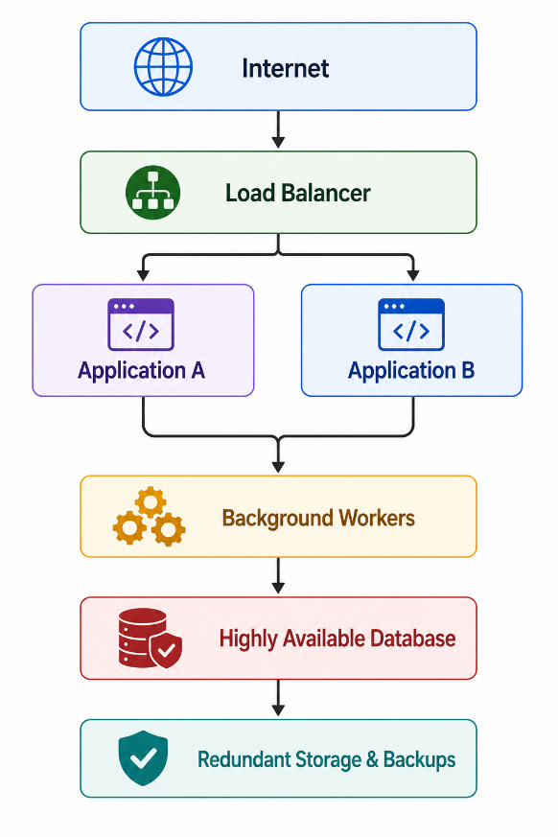
This architecture enables continued service if a single application instance becomes unavailable.

10.3.5 Planned Maintenance
Planned maintenance activities shall minimize service disruption.
Requirement ID | Requirement
AVAIL-001 | Scheduled maintenance shall be announced in advance where applicable.
AVAIL-002 | Maintenance activities shall be planned to minimize user impact.
AVAIL-003 | Maintenance windows shall be documented.
AVAIL-004 | Critical security patches may be applied outside normal maintenance windows if necessary.

10.3.6 Failover
The platform shall support failover for critical services.
Requirement ID | Requirement
AVAIL-005 | Application instances shall support automatic restart where possible.
AVAIL-006 | Load balancers shall route traffic away from unhealthy instances.
AVAIL-007 | AI provider failover may be supported if multiple providers are configured.
AVAIL-008 | Background processing shall resume automatically after recoverable failures.

10.3.7 Backup & Disaster Recovery
The platform shall support disaster recovery procedures.
Requirement ID | Requirement
AVAIL-009 | Regular backups shall be performed according to the backup policy.
AVAIL-010 | Backup restoration procedures shall be tested periodically.
AVAIL-011 | Disaster recovery procedures shall be documented.
AVAIL-012 | Recovery operations shall preserve data integrity.

10.3.8 Recovery Objectives
The platform shall define operational recovery objectives.
Objective | Target
Recovery Time Objective (RTO) | ≤ 4 hours
Recovery Point Objective (RPO) | ≤ 15 minutes
Critical Security Incident Response | Immediate containment, followed by recovery according to incident response procedures
These values may be refined according to deployment architecture and customer service-level agreements.

10.3.9 Availability Monitoring
The platform shall continuously monitor:
- Service uptime
- API availability
- Database availability
- AI provider connectivity
- Background worker status
- Storage availability
- Backup success
- Health check status
- SSL/TLS certificate validity
Monitoring failures shall generate alerts.

10.3.10 Business Rules
Rule ID | Rule
AVAIL-BR-001 | Critical services shall be monitored continuously.
AVAIL-BR-002 | Unhealthy services shall be removed from active traffic where supported.
AVAIL-BR-003 | Backup procedures shall support disaster recovery.
AVAIL-BR-004 | Availability metrics shall be reviewed regularly.
AVAIL-BR-005 | Planned maintenance shall be documented.
AVAIL-BR-006 | Recovery procedures shall preserve system integrity.
AVAIL-BR-007 | Critical failures shall trigger operational alerts.
AVAIL-BR-008 | Disaster recovery plans shall be periodically validated.

10.3.11 Exception Handling
Exception | Expected System Response
Application instance failure | Remove the instance from service, restart it if possible, and continue serving requests through healthy instances.
Database failover event | Redirect traffic to the standby database where configured and preserve transactional integrity.
AI provider outage | Notify users, retry according to policy, or switch to an alternative provider if configured.
Storage service interruption | Delay affected operations until storage is restored while preserving queued work where possible.
Backup failure | Generate an alert, investigate the cause, and perform a successful backup as soon as practical.
Load balancer failure | Activate redundancy where available and notify administrators immediately.

10.3.12 Acceptance Criteria
The availability requirements shall be considered complete when:
- Critical services satisfy defined availability targets.
- High-availability architecture supports continued operation during component failures.
- Failover mechanisms function correctly.
- Backup and disaster recovery procedures are documented and tested.
- Recovery objectives are measurable and achievable.
- Availability monitoring provides timely alerts.
- Planned maintenance minimizes disruption to users.

10.4 Scalability Requirements
10.4.1 Overview
Scalability Requirements define the ability of ProcessMind AI to efficiently handle increasing workloads, user growth, organizational expansion, and larger data volumes while maintaining acceptable performance and reliability.
The platform shall support both horizontal and vertical scaling and shall be designed using cloud-native architectural principles.
Scalability requirements apply to:
- Web Application
- REST APIs
- Workflow Engine
- AI Processing Services
- Database
- File Storage
- Notification Services
- Background Workers

10.4.2 Scalability Objectives
The platform shall achieve the following objectives.
Objective | Description
User Growth | Support increasing numbers of users and organizations.
Workload Growth | Handle increased workflow executions and AI requests.
Data Growth | Efficiently manage expanding databases and file storage.
Resource Elasticity | Increase or decrease computing resources based on demand.
Cost Efficiency | Scale resources without unnecessary operational costs.

10.4.3 Horizontal Scalability
The platform shall support horizontal scaling.
Requirement ID | Requirement
SCALE-001 | Multiple application server instances shall be supported.
SCALE-002 | REST API services shall operate behind a load balancer.
SCALE-003 | Background worker instances shall scale independently.
SCALE-004 | Stateless application services shall enable efficient horizontal scaling.

10.4.4 Vertical Scalability
The platform shall support vertical scaling where appropriate.
Requirement ID | Requirement
SCALE-005 | Application servers shall support increased CPU and memory allocation.
SCALE-006 | Database resources shall be expandable according to workload requirements.
SCALE-007 | AI processing resources shall be configurable based on processing demand.

10.4.5 Concurrent User Support
The architecture shall support concurrent users.
Requirement ID | Requirement
SCALE-008 | The platform shall support multiple concurrent authenticated users.
SCALE-009 | Concurrent workflow execution shall not compromise data consistency.
SCALE-010 | User sessions shall remain isolated and secure.
SCALE-011 | System responsiveness shall be maintained under expected concurrent workloads.
Note: Exact user capacity depends on deployment infrastructure and hardware resources.

10.4.6 AI Workload Scalability
AI processing shall support increasing workloads.
Requirement ID | Requirement
SCALE-012 | AI requests shall be processed asynchronously where appropriate.
SCALE-013 | Multiple AI requests may be processed concurrently subject to configured resource limits.
SCALE-014 | AI provider utilization shall be monitored to support capacity planning.
SCALE-015 | AI processing queues shall support scalable background execution.

10.4.7 Database Scalability
The database architecture shall support growth.
Requirement ID | Requirement
SCALE-016 | Database indexing shall support efficient query execution.
SCALE-017 | Connection pooling shall optimize database utilization.
SCALE-018 | Database maintenance operations shall support long-term growth.
SCALE-019 | Database storage shall be expandable without application redesign.

10.4.8 Storage Scalability
The platform shall support scalable storage.
Requirement ID | Requirement
SCALE-020 | SOP document storage shall support organizational growth.
SCALE-021 | Backup storage shall expand according to retention policies.
SCALE-022 | Uploaded files shall be managed independently from application servers.
SCALE-023 | Storage capacity shall be monitored continuously.

10.4.9 Queue Scalability
Background processing shall scale independently.
Requirement ID | Requirement
SCALE-024 | AI processing queues shall support multiple workers.
SCALE-025 | Notification queues shall support concurrent processing.
SCALE-026 | Report generation queues shall support asynchronous execution.
SCALE-027 | Queue backlogs shall be monitored and managed.

10.4.10 Auto-Scaling
The architecture shall support automatic scaling where infrastructure permits.
Requirement ID | Requirement
SCALE-028 | Application instances may scale automatically based on CPU, memory, or request load.
SCALE-029 | Background workers may scale based on queue length.
SCALE-030 | Scaling events shall be logged for operational analysis.
SCALE-031 | Auto-scaling policies shall be configurable.

10.4.11 Capacity Planning
The platform shall support ongoing capacity planning.
Monitoring shall include:
- Number of organizations
- Active users
- Concurrent sessions
- Workflow executions
- AI request volume
- Storage utilization
- Database growth
- API throughput
- Queue depth
- Network utilization
Capacity reports shall assist administrators in forecasting future infrastructure requirements.

10.4.12 Business Rules
Rule ID | Rule
SCALE-BR-001 | The platform shall support horizontal scaling of stateless services.
SCALE-BR-002 | Data consistency shall be maintained during scaling operations.
SCALE-BR-003 | Auto-scaling shall not compromise security controls.
SCALE-BR-004 | AI processing shall remain isolated from unrelated workloads.
SCALE-BR-005 | Queue processing shall scale independently of user-facing services.
SCALE-BR-006 | Capacity planning metrics shall be collected continuously.
SCALE-BR-007 | Scaling operations shall be transparent to end users wherever possible.
SCALE-BR-008 | Storage expansion shall not require application redesign.

10.4.13 Exception Handling
Exception | Expected System Response
Sudden increase in user traffic | Apply auto-scaling policies where available and continue monitoring system health.
AI processing queue overload | Scale background workers where possible, prioritize queued jobs, and inform users of expected delays.
Database resource exhaustion | Generate alerts, optimize resource usage, and expand capacity according to operational procedures.
Storage nearing capacity | Notify administrators and initiate storage expansion according to policy.
Auto-scaling failure | Continue operating with available resources, record the event, and notify administrators.
Queue processing bottleneck | Redistribute work across available workers and monitor queue recovery.

10.4.14 Acceptance Criteria
The scalability requirements shall be considered complete when:
- Stateless application components support horizontal scaling.
- Vertical scaling can increase available computing resources without application redesign.
- The platform maintains acceptable performance under increasing workloads.
- AI processing, background workers, and notification services scale independently.
- Database and storage architectures support long-term growth.
- Auto-scaling policies operate correctly where supported.
- Capacity planning metrics are continuously collected and reviewed.

10.5 Maintainability Requirements
10.5.1 Overview
Maintainability Requirements define the characteristics that enable ProcessMind AI to be efficiently maintained, enhanced, tested, and supported throughout its lifecycle.
The platform shall adopt modular software architecture, coding standards, automated testing, documentation, and continuous integration practices to facilitate long-term evolution.
Maintainability applies to:
- Frontend Application
- Backend Services
- REST APIs
- AI Processing Components
- Workflow Engine
- Database
- Infrastructure Configuration
- CI/CD Pipeline

10.5.2 Maintainability Objectives
The platform shall achieve the following objectives.
Objective | Description
Modularity | Separate functionality into independent components.
Readability | Maintain clear and understandable source code.
Extensibility | Support future features with minimal impact.
Testability | Enable efficient automated and manual testing.
Reusability | Promote reuse of software components.

10.5.3 Modular Architecture
The platform shall follow a modular architecture.
Requirement ID | Requirement
MAINT-001 | System functionality shall be organized into independent modules.
MAINT-002 | Modules shall communicate through well-defined interfaces.
MAINT-003 | Changes within one module should minimize impacts on unrelated modules.
MAINT-004 | Business logic shall remain independent of presentation concerns.

10.5.4 Coding Standards
The development team shall follow consistent coding standards.
Requirement ID | Requirement
MAINT-005 | Source code shall follow agreed project coding conventions.
MAINT-006 | Source code shall use meaningful identifiers and consistent naming.
MAINT-007 | Complex business logic shall include appropriate documentation.
MAINT-008 | Deprecated functionality shall be identified before removal.

10.5.5 Documentation
The platform shall maintain comprehensive documentation.
Required documentation includes:
- Software Requirements Specification (SRS)
- Software Architecture Document (SAD)
- API Documentation (OpenAPI/Swagger)
- Database Documentation
- Deployment Guide
- Administrator Guide
- User Manual
- Developer Guide
- Release Notes
- Change Log
Documentation shall be updated as part of the software development lifecycle.

10.5.6 Logging
Application logging shall support maintenance and troubleshooting.
Requirement ID | Requirement
MAINT-009 | Operational logs shall support diagnostics.
MAINT-010 | Error logs shall provide sufficient technical information for troubleshooting without exposing sensitive data.
MAINT-011 | Log formats shall remain consistent across services.
MAINT-012 | Log verbosity shall be configurable.

10.5.7 Configuration Management
Application configuration shall be centrally managed.
Requirement ID | Requirement
MAINT-013 | Environment-specific configuration shall be externalized from source code.
MAINT-014 | Configuration changes shall be documented.
MAINT-015 | Sensitive configuration values shall be managed securely.
MAINT-016 | Default configurations shall support secure deployment.

10.5.8 Testing
The platform shall support comprehensive testing.
Requirement ID | Requirement
MAINT-017 | Unit testing shall be performed for core business logic.
MAINT-018 | Integration testing shall verify interactions between components.
MAINT-019 | End-to-end testing shall validate major business workflows.
MAINT-020 | Regression testing shall be performed before major releases.
MAINT-021 | Automated testing shall be integrated into the development workflow.

10.5.9 Version Control
The project shall use version control.
Requirement ID | Requirement
MAINT-022 | Source code shall be managed using Git.
MAINT-023 | Releases shall be versioned according to an agreed versioning.
MAINT-024 | Source code changes shall be traceable through commit history.
MAINT-025 | Release artifacts shall be reproducible.

10.5.10 CI/CD Support
The development process shall support continuous integration and deployment.
Requirement ID | Requirement
MAINT-026 | Automated builds shall validate code changes.
MAINT-027 | Automated tests shall execute during the CI pipeline.
MAINT-028 | Deployment processes shall be repeatable and documented.
MAINT-029 | Build failures shall prevent deployment to production.

10.5.11 Technical Debt Management
The development team shall actively manage technical debt.
Activities include:
- Regular code refactoring.
- Removal of obsolete components.
- Dependency updates.
- Architecture reviews.
- Performance optimization.
- Security improvements.
Technical debt shall be tracked and prioritized during project planning.

10.5.12 Business Rules
Rule ID | Rule
MAINT-BR-001 | Software modules shall remain loosely coupled and highly cohesive.
MAINT-BR-002 | Documentation shall be maintained alongside software changes.
MAINT-BR-003 | Source code shall follow established coding standards.
MAINT-BR-004 | Automated testing shall support software quality.
MAINT-BR-005 | Configuration shall be externalized from application code.
MAINT-BR-006 | Releases shall be version-controlled and traceable.
MAINT-BR-007 | Technical debt shall be monitored and managed continuously.
MAINT-BR-008 | CI/CD pipelines shall enforce quality gates before deployment.

10.5.13 Exception Handling
Exception | Expected System Response
Build failure | Stop the CI/CD pipeline, report the failure, and prevent deployment.
Automated test failure | Block deployment until the failure is resolved or an approved exception process is followed.
Configuration error | Prevent application startup where the configuration is invalid and log diagnostic information.
Documentation outdated | Flag the discrepancy during review and update documentation before release where required.
Dependency incompatibility | Prevent deployment until compatibility is restored or the dependency is replaced.
Logging configuration failure | Fall back to a safe default logging configuration and notify administrators.

10.5.14 Acceptance Criteria
The maintainability requirements shall be considered complete when:
- The application follows a modular architecture.
- Coding standards are consistently applied.
- Documentation is complete and maintained.
- Logging supports diagnostics and troubleshooting.
- Configuration is externalized and securely managed.
- Automated testing is integrated into development.
- Version control and release management are implemented.
- CI/CD pipelines enforce quality controls before deployment

10.6 Usability Requirements
10.6.1 Overview
Usability Requirements define the characteristics that ensure ProcessMind AI is easy to learn, efficient to use, accessible, and provides a consistent user experience across supported devices and user roles.
The user interface shall support users with varying levels of technical expertise while enabling efficient completion of business tasks.
Usability requirements apply to:
- Web Application
- Dashboard
- Workflow Designer
- AI Assistant
- Administration Console
- Reporting Interface
- Mobile Web Browsers

10.6.2 Usability Objectives
The platform shall achieve the following objectives.
Objective | Description
Learnability | New users should learn the system quickly.
Efficiency | Frequent tasks should require minimal effort.
Consistency | Similar actions should behave consistently throughout the system.
Accessibility | The platform should be usable by people with diverse abilities.
User Satisfaction | Users should have a positive experience while using the platform.

10.6.3 User Interface Design Principles
The user interface shall follow these principles:
- Consistent navigation
- Responsive design
- Clear visual hierarchy
- Minimal unnecessary complexity
- Predictable interactions
- Immediate feedback for user actions
- Error prevention where possible
- Accessible color contrast
- Readable typography
- Mobile-friendly layouts

10.6.4 Navigation
Requirement ID | Requirement
USE-001 | Navigation shall remain consistent throughout the platform.
USE-002 | Users shall be able to access major functions within a minimal number of navigation steps.
USE-003 | Breadcrumbs or equivalent navigation aids shall be provided where appropriate.
USE-004 | Frequently used features shall be easily accessible.

10.6.5 User Experience
Requirement ID | Requirement
USE-005 | The system shall provide immediate visual feedback after user actions.
USE-006 | Long-running operations shall display progress indicators.
USE-007 | Confirmation dialogs shall be presented before irreversible operations.
USE-008 | The interface shall minimize unnecessary user input by using defaults and reusable selections where appropriate.

10.6.6 Responsive Design
The platform shall support responsive layouts.
Requirement ID | Requirement
USE-009 | The user interface shall adapt to common desktop screen resolutions.
USE-010 | The application shall remain usable on tablets.
USE-011 | Core functionality shall be accessible on modern mobile web browsers where supported.
USE-012 | Layouts shall adjust without requiring horizontal scrolling under normal conditions.

10.6.7 Accessibility
The platform shall support accessible design practices.
Requirement ID | Requirement
USE-013 | User interface components shall be keyboard accessible where practical.
USE-014 | Images conveying important information shall include descriptive alternative text where applicable.
USE-015 | Color shall not be the sole means of conveying important information.
USE-016 | Text shall maintain sufficient contrast against its background.
USE-017 | Form controls shall have clear labels and validation messages.
The platform should be designed with consideration for the principles of WCAG 2.1 Level AA where feasible.

10.6.8 Error Messages
Requirement ID | Requirement
USE-018 | Error messages shall clearly describe the problem.
USE-019 | Error messages shall provide guidance for resolving the issue where appropriate.
USE-020 | Error messages shall not expose sensitive technical details.
USE-021 | Validation errors shall identify the affected input field whenever possible.

10.6.9 Help & Documentation
The platform shall provide user assistance.
Examples include:
- User Guide
- Administrator Guide
- Context-sensitive help
- Tooltips
- Frequently Asked Questions (FAQ)
- Guided onboarding for new users (future enhancement)

10.6.10 Internationalization & Localization
The platform architecture shall support future internationalization.
Requirement ID | Requirement
USE-022 | User-visible text shall support localization.
USE-023 | Date and time formats shall be configurable according to user or organization preferences.
USE-024 | Number and currency formatting shall support regional settings where applicable.

10.6.11 User Satisfaction Metrics
The organization may monitor:
- Task completion time
- User error rate
- Navigation efficiency
- Help request frequency
- Feature adoption
- User feedback
- Customer satisfaction surveys
These metrics shall support continuous usability improvements.

10.6.12 Business Rules
Rule ID | Rule
USE-BR-001 | User interfaces shall maintain a consistent design language.
USE-BR-002 | Critical user actions shall require confirmation where appropriate.
USE-BR-003 | Long-running operations shall provide progress feedback.
USE-BR-004 | Error messages shall assist users without exposing sensitive system information.
USE-BR-005 | Core functionality shall remain usable across supported devices.
USE-BR-006 | Accessibility shall be considered during interface design.
USE-BR-007 | User assistance resources shall be available for common tasks.
USE-BR-008 | Localization support shall be considered for future releases.

10.6.13 Exception Handling
Exception | Expected System Response
Invalid user input | Highlight the affected fields, display clear validation messages, and preserve entered data where appropriate.
Long-running operation | Display progress indicators or status updates until completion or failure.
Network interruption | Inform the user of the connectivity issue and allow retry where appropriate.
Unsupported browser feature | Notify the user of limited functionality and recommend a supported browser if necessary.
Accessibility limitation detected | Provide an accessible alternative where feasible or document the limitation.
Missing help content | Direct users to the general documentation or support resources until the specific content is available.

10.6.14 Acceptance Criteria
The usability requirements shall be considered complete when:
- Navigation is consistent and intuitive.
- The interface provides clear feedback for user actions.
- Responsive layouts function correctly across supported devices.
- Accessibility considerations are incorporated into the design.
- Error messages are informative and user-friendly.
- Help resources are available for common tasks.
- The architecture supports future localization and internationalization.
- User satisfaction metrics can be collected and analyzed.

10.7 Compatibility Requirements
10.7.1 Overview
Compatibility Requirements define the environments, platforms, technologies, and external systems that ProcessMind AI shall support.
The platform shall maintain consistent functionality and performance across supported browsers, operating systems, cloud infrastructure, databases, AI providers, and third-party integrations.
Compatibility requirements apply to:
- Web Application
- Backend Services
- REST APIs
- AI Processing
- Database
- Cloud Infrastructure
- Third-Party Integrations

10.7.2 Compatibility Objectives
The platform shall achieve the following objectives.
Objective | Description
Cross-Platform Support | Operate consistently across supported operating systems and browsers.
Technology Interoperability | Integrate with external services using standard protocols.
API Compatibility | Provide stable and versioned APIs.
Cloud Compatibility | Support deployment on modern cloud platforms.
Future Extensibility | Allow integration with additional technologies in future releases.

10.7.3 Supported Web Browsers
The platform shall support current stable versions of the following browsers.
Browser | Support Level
Google Chrome | Full Support
Microsoft Edge | Full Support
Mozilla Firefox | Full Support
Safari | Full Support
Opera | Best Effort
Older browser versions may provide reduced functionality.

10.7.4 Supported Operating Systems
The web application shall support modern operating systems capable of running supported browsers.
Operating System | Support Level
Windows 10/11 | Full Support
macOS | Full Support
Linux (Desktop) | Full Support
Android | Supported through mobile web browsers
iOS | Supported through mobile web browsers

10.7.5 Device Compatibility
The platform shall support the following device categories.
Device | Support Level
Desktop Computers | Full Support
Laptop Computers | Full Support
Tablets | Full Support
Smartphones | Core functionality supported through responsive web design

10.7.6 Database Compatibility
The platform shall support the following database technologies.
Database | Support Level
PostgreSQL | Primary Supported Database
MySQL (Future) | Planned
Microsoft SQL Server (Future) | Planned
The application architecture shall isolate database-specific implementation details where practical.

10.7.7 Cloud Compatibility
The platform shall support deployment on modern cloud infrastructure.
Cloud Platform | Support Level
Self-Hosted VPS | Supported
Docker-Based Deployment | Fully Supported
Kubernetes | Supported
Amazon Web Services (AWS) | Supported
Microsoft Azure | Supported
Google Cloud Platform (GCP) | Supported
The deployment architecture shall remain cloud-provider independent where feasible.

10.7.8 AI Provider Compatibility
The AI integration layer shall support multiple providers.
AI Provider | Support Level
Google Gemini | Primary Supported Provider
OpenAI | Future Integration
Anthropic Claude | Future Integration
Local LLMs (Ollama, etc.) | Future Integration
Azure OpenAI | Future Integration
The platform shall abstract provider-specific implementations to simplify future integrations.

10.7.9 API Compatibility
Requirement ID | Requirement
COMP-001 | REST APIs shall use standard HTTP methods.
COMP-002 | JSON shall be the primary request and response format.
COMP-003 | APIs shall support versioning.
COMP-004 | Backward compatibility should be maintained where practical during API evolution.

10.7.10 Third-Party Integration Compatibility
The platform architecture shall support integration with external systems.
Potential integrations include:
- Email services
- Identity providers
- ERP systems
- HR systems
- CRM platforms
- Document management systems
- Business intelligence platforms
- Collaboration platforms (Microsoft Teams, Slack)
Integration shall be performed through secure REST APIs or other standardized interfaces.

10.7.11 File Format Compatibility
The platform shall support the following document formats.
File Format | Purpose
PDF | SOP uploads
DOCX | SOP uploads
TXT | Plain text SOPs
CSV | Report export
XLSX | Report export
JSON | API data exchange
Additional formats may be supported in future releases.

10.7.12 Business Rules
Rule ID | Rule
COMP-BR-001 | The platform shall support all officially supported browsers consistently.
COMP-BR-002 | APIs shall follow open standards and maintain version compatibility where practical.
COMP-BR-003 | AI provider implementations shall be replaceable without major architectural changes.
COMP-BR-004 | Cloud deployment shall not depend on vendor-specific features unless explicitly documented.
COMP-BR-005 | External integrations shall use secure, documented interfaces.
COMP-BR-006 | Supported file formats shall be validated before processing.
COMP-BR-007 | Compatibility requirements shall be reviewed when introducing new platform dependencies.

10.7.13 Exception Handling
Exception | Expected System Response
Unsupported browser | Inform the user that some functionality may be unavailable and recommend a supported browser.
Unsupported file format | Reject the upload and display the list of supported formats.
Incompatible API version | Return a standardized API version error and guide clients toward supported versions.
AI provider incompatibility | Disable the affected integration, log the issue, and continue operating with supported providers where available.
Cloud platform limitation | Document the limitation and provide deployment guidance where feasible.
Third-party integration failure | Isolate the failure, log diagnostic information, and continue core platform operations where possible.

10.7.14 Acceptance Criteria
The compatibility requirements shall be considered complete when:
- The platform operates consistently across supported browsers and operating systems.
- Responsive design supports desktop, tablet, and mobile web browsers.
- PostgreSQL is fully supported as the primary database.
- Deployment is supported on modern cloud infrastructure and container platforms.
- The AI integration layer supports Google Gemini and can be extended to additional providers.
- APIs are versioned and follow standard HTTP and JSON conventions.
- Third-party integrations use standardized and secure interfaces.
- Supported file formats are validated and processed correctly.

10.8 Portability Requirements
10.8.1 Overview
Portability Requirements define the ability of ProcessMind AI to be deployed, migrated, configured, and operated across different computing environments with minimal changes.
The platform shall support portable deployment, configuration, data migration, and infrastructure independence to facilitate future growth and customer-specific deployment requirements.
Portability requirements apply to:
- Web Application
- Backend Services
- Database
- AI Integration Layer
- Infrastructure Configuration
- File Storage
- Deployment Pipeline

10.8.2 Portability Objectives
The platform shall achieve the following objectives.
Objective | Description
Deployment Portability | Deploy across multiple environments with minimal changes.
Cloud Independence | Avoid unnecessary dependence on a specific cloud provider.
Configuration Portability | Allow environment-specific configuration without code modifications.
Data Portability | Support import and export of organizational data.
Migration Support | Facilitate migration between supported environments.

10.8.3 Deployment Portability
Requirement ID | Requirement
PORT-001 | The platform shall support deployment using Docker containers.
PORT-002 | Deployment procedures shall be documented.
PORT-003 | Application components shall be deployable independently where practical.
PORT-004 | Production, staging, testing, and development environments shall use consistent deployment processes.

10.8.4 Environment Portability
The platform shall support multiple environments.
Environment | Supported
Local Development | Yes
Testing | Yes
Staging | Yes
Production | Yes
On-Premises | Supported
Cloud Deployment | Supported
Environment-specific settings shall be externalized through configuration.

10.8.5 Containerization
The application shall support containerized deployment.
Requirement ID | Requirement
PORT-005 | Application services shall support Docker-based deployment.
PORT-006 | Container images shall remain environment-independent where feasible.
PORT-007 | Configuration shall be injected during deployment rather than embedded in container images.
PORT-008 | Container images shall be version-controlled.

10.8.6 Data Portability
The platform shall support secure movement of organizational data.
Requirement ID | Requirement
PORT-009 | Organizations shall be able to export authorized business data.
PORT-010 | Data imports shall validate integrity before processing.
PORT-011 | Data exports shall preserve referential integrity where applicable.
PORT-012 | Export formats shall use open, documented standards where practical.

10.8.7 Backup Portability
The backup architecture shall support migration and recovery.
Requirement ID | Requirement
PORT-013 | Backup files shall support restoration into supported deployment environments.
PORT-014 | Backup procedures shall be documented.
PORT-015 | Backup integrity shall be verified before restoration.
PORT-016 | Backup metadata shall accompany backup data where required for restoration.

10.8.8 Configuration Portability
The platform shall separate configuration from application code.
Requirement ID | Requirement
PORT-017 | Environment variables shall control environment-specific settings.
PORT-018 | Sensitive configuration values shall be externalized.
PORT-019 | Default configuration templates shall be provided.
PORT-020 | Configuration changes shall not require application recompilation.

10.8.9 Vendor Independence
The platform architecture shall minimize vendor lock-in.
Examples include:
- Standard REST APIs
- OpenAPI specifications
- Docker containers
- PostgreSQL
- Open authentication standards
- Cloud-neutral deployment architecture
Vendor-specific implementations shall be isolated behind abstraction layers where practical.

10.8.10 Migration Support
The platform shall support migration activities.
Supported migration scenarios include:
- Development to production
- VPS to cloud infrastructure
- Cloud provider migration
- Database migration (supported databases)
- AI provider replacement
- Infrastructure upgrades
Migration procedures shall be documented and tested where practical.

10.8.11 Business Rules
Rule ID | Rule
PORT-BR-001 | Deployment shall support multiple environments using the same application codebase.
PORT-BR-002 | Configuration shall be externalized from application binaries.
PORT-BR-003 | Data portability shall preserve integrity and security.
PORT-BR-004 | Vendor-specific implementations shall be isolated where practical.
PORT-BR-005 | Migration procedures shall be documented.
PORT-BR-006 | Backup portability shall support disaster recovery objectives.
PORT-BR-007 | Containerization shall simplify deployment and migration.

10.8.12 Exception Handling
Exception | Expected System Response
Invalid configuration during deployment | Stop deployment, report validation errors, and prevent startup until configuration is corrected.
Failed data migration | Roll back the migration where supported, preserve source data, and log detailed diagnostics.
Backup restoration incompatibility | Reject the restoration, report compatibility issues, and recommend supported recovery procedures.
Missing environment variables | Prevent application startup and identify the missing configuration values.
Unsupported deployment platform | Notify administrators of unsupported requirements and provide deployment guidance where possible.
Container image incompatibility | Reject deployment and require a compatible image version.

10.8.13 Acceptance Criteria
The portability requirements shall be considered complete when:
- The platform can be deployed consistently across supported environments.
- Docker-based deployment is supported.
- Environment-specific configuration is externalized.
- Organizational data can be securely exported and imported where authorized.
- Backup and restoration procedures support migration and disaster recovery.
- Vendor-specific dependencies are minimized.
- Migration procedures are documented and validated.

10.9 Accessibility Requirements
10.9.1 Overview
Accessibility Requirements define the characteristics that enable ProcessMind AI to be used effectively by individuals with diverse abilities and assistive technologies.
The platform shall incorporate accessibility principles into its user interface, interactions, navigation, and content presentation to provide an inclusive user experience.
Accessibility requirements apply to:
- Web Application
- Dashboard
- Workflow Designer
- AI Assistant
- Reports
- Administration Console
- Forms
- Data Tables

10.9.2 Accessibility Objectives
The platform shall achieve the following objectives.
Objective | Description
Inclusive Design | Support users with diverse abilities.
Keyboard Accessibility | Enable operation without a pointing device.
Assistive Technology Support | Support commonly used assistive technologies where applicable.
Readability | Present information clearly and legibly.
Accessible Navigation | Ensure users can navigate efficiently throughout the platform.

10.9.3 Accessibility Standard
The platform should be designed with consideration for the principles of WCAG 2.1 Level AA where feasible.
Accessibility shall include:
- Perceivable content
- Operable interfaces
- Understandable interactions
- Robust implementation compatible with assistive technologies

10.9.4 Keyboard Accessibility
Requirement ID | Requirement
ACC-001 | All major interactive functions shall be operable using a keyboard.
ACC-002 | Keyboard focus shall remain visible.
ACC-003 | Keyboard navigation order shall follow a logical sequence.
ACC-004 | Keyboard users shall not become trapped within interface components.

10.9.5 Screen Reader Support
Requirement ID | Requirement
ACC-005 | Form controls shall have accessible labels.
ACC-006 | Images conveying important information shall include descriptive alternative text.
ACC-007 | Headings shall follow a logical hierarchy.
ACC-008 | Dynamic content updates should notify assistive technologies where appropriate.

10.9.6 Color & Contrast
Requirement ID | Requirement
ACC-009 | Color shall not be the sole means of conveying important information.
ACC-010 | Text and interface elements shall maintain sufficient contrast against their backgrounds.
ACC-011 | Status indicators shall include text or icons in addition to color where practical.

10.9.7 Accessible Forms
Requirement ID | Requirement
ACC-012 | Required fields shall be clearly identified.
ACC-013 | Validation errors shall identify affected fields.
ACC-014 | Validation messages shall provide guidance for correction.
ACC-015 | Form controls shall have associated labels.

10.9.8 Responsive Accessibility
The platform shall maintain accessibility across supported devices.
Requirement ID | Requirement
ACC-016 | Responsive layouts shall preserve accessibility features.
ACC-017 | Touch targets shall be appropriately sized on touch-enabled devices.
ACC-018 | Zooming shall not prevent access to core functionality under supported conditions.

10.9.9 Accessible Content
The platform shall present content clearly.
Examples include:
- Plain language where appropriate.
- Consistent terminology.
- Clear instructions.
- Readable typography.
- Predictable layouts.
- Consistent icons.

10.9.10 Accessibility Testing
Accessibility shall be evaluated during development.
Testing activities may include:
- Keyboard-only navigation testing.
- Screen reader testing.
- Color contrast verification.
- Responsive accessibility testing.
- Manual accessibility review.
- Automated accessibility scanning.

10.9.11 Business Rules
Rule ID | Rule
ACC-BR-001 | Accessibility shall be considered during interface design and implementation.
ACC-BR-002 | Keyboard accessibility shall be maintained for major platform functionality.
ACC-BR-003 | User interfaces shall not rely solely on color to communicate important information.
ACC-BR-004 | Forms shall provide clear validation and guidance.
ACC-BR-005 | Accessibility testing shall be incorporated into quality assurance activities.
ACC-BR-006 | Responsive layouts shall preserve accessibility features.
ACC-BR-007 | Accessibility improvements shall be considered during future feature development.

10.9.12 Exception Handling
Exception | Expected System Response
Missing alternative text | Flag the issue during quality assurance and require correction before release where applicable.
Keyboard navigation issue | Record the defect, prioritize remediation, and verify accessibility before deployment.
Insufficient color contrast | Identify the issue through design review or testing and update the interface accordingly.
Screen reader compatibility issue | Investigate the affected component, implement corrective changes, and retest with assistive technologies.
Accessibility regression | Prevent release until the regression is resolved or an approved exception process is followed.

10.9.13 Acceptance Criteria
The accessibility requirements shall be considered complete when:
- Major platform functionality is accessible using a keyboard.
- Forms include accessible labels and validation messages.
- User interfaces maintain sufficient color contrast.
- Accessibility is preserved across supported responsive layouts.
- Accessibility testing is integrated into quality assurance.
- The platform is designed with consideration for WCAG 2.1 Level AA principles where feasible.
- Accessibility improvements are incorporated into future platform enhancements.

10.10 Compliance Requirements
10.10.1 Overview
Compliance Requirements define the legal, regulatory, organizational, and technical obligations that ProcessMind AI shall support throughout its lifecycle.
The platform shall be designed to facilitate compliance with applicable security, privacy, operational, and software engineering best practices while allowing organizations to implement additional compliance controls according to their specific requirements.
Compliance requirements apply to:
- Web Application
- REST APIs
- AI Processing
- Database
- Workflow Engine
- File Storage
- Audit Logging
- Infrastructure
- Administrative Operations

10.10.2 Compliance Objectives
The platform shall achieve the following objectives.
Objective | Description
Regulatory Readiness | Support future regulatory compliance where applicable.
Security Compliance | Follow recognized security best practices.
Privacy Protection | Protect personal and organizational information.
Audit Readiness | Maintain sufficient evidence for audits and investigations.
Responsible AI | Promote transparent and accountable AI usage.

10.10.3 Legal & Regulatory Compliance
The platform architecture shall support compliance with applicable laws and regulations.
Potential examples include:
Regulation / Framework | Applicability
GDPR | Organizations operating in applicable jurisdictions
ISO/IEC 27001 | Information security management (future organizational certification)
SOC 2 | Service organization controls (future)
Local Data Protection Laws | According to deployment jurisdiction
Support for a specific regulation depends on deployment configuration, organizational processes, and legal obligations.

10.10.4 Privacy Requirements
Requirement ID | Requirement
COMP-NFR-001 | Personal information shall be processed according to applicable privacy requirements.
COMP-NFR-002 | Access to personal information shall follow authorization policies.
COMP-NFR-003 | Audit logs shall record access to sensitive resources where appropriate.
COMP-NFR-004 | Data retention and deletion shall follow organizational policies and applicable legal requirements.

10.10.5 Software Licensing Compliance
The development team shall manage software licenses appropriately.
Requirement ID | Requirement
COMP-NFR-005 | Third-party software shall be used according to applicable license terms.
COMP-NFR-006 | Open-source dependencies shall be reviewed periodically.
COMP-NFR-007 | License compliance shall be verified during release preparation.

10.10.6 Security Compliance
The platform shall align with recognized security practices.
Examples include:
- OWASP Top 10
- OWASP ASVS
- NIST Cybersecurity Framework
- Secure coding guidelines
- Security testing practices
These frameworks provide guidance rather than mandatory certification requirements.

10.10.7 AI Governance Compliance
AI-assisted functionality shall support responsible governance.
Requirement ID | Requirement
COMP-NFR-008 | AI-generated outputs shall remain subject to organizational review where configured.
COMP-NFR-009 | AI processing activities shall be auditable.
COMP-NFR-010 | AI provider information and model versions shall be traceable.
COMP-NFR-011 | Human oversight shall remain available for configurable high-risk operations.

10.10.8 Audit Compliance
The platform shall maintain sufficient records to support audits.
Audit capabilities shall include:
- Authentication history
- Administrative actions
- Workflow execution history
- AI processing history
- Configuration changes
- Security events
- System activities
Audit information shall be protected from unauthorized modification.

10.10.9 Compliance Monitoring
The platform shall support compliance monitoring.
Monitoring activities include:
- Security policy compliance
- Audit log review
- Configuration review
- Backup verification
- Vulnerability management
- Access review
- AI governance review
Organizations may define additional monitoring procedures according to internal policies.

10.10.10 Business Rules
Rule ID | Rule
COMP-BR-001 | Compliance-related activities shall be documented where applicable.
COMP-BR-002 | Security controls shall support organizational compliance objectives.
COMP-BR-003 | Audit records shall support compliance verification.
COMP-BR-004 | AI governance shall support transparency and accountability.
COMP-BR-005 | Software licensing obligations shall be respected.
COMP-BR-006 | Privacy controls shall be enforced according to organizational policies and applicable legal requirements.
COMP-BR-007 | Compliance monitoring shall be performed periodically.
COMP-BR-008 | Compliance requirements shall be reviewed as regulations and organizational needs evolve.

10.10.11 Exception Handling
Exception | Expected System Response
Missing audit records | Record the issue, investigate the cause, and notify authorized administrators.
Privacy policy violation | Restrict the affected operation where appropriate, log the event, and initiate administrative review.
License compliance issue | Review the affected dependency, assess impact, and resolve the licensing concern before release.
AI governance policy violation | Prevent or suspend the affected AI operation until compliance requirements are satisfied.
Configuration non-compliance | Report the issue through compliance monitoring and require corrective action.
Expired security certificate or credential | Generate an alert and require renewal according to operational procedures.

10.10.12 Acceptance Criteria
The compliance requirements shall be considered complete when:
- The platform architecture supports applicable legal and regulatory requirements.
- Privacy controls protect sensitive information.
- Security controls align with recognized industry best practices.
- AI governance supports transparency, accountability, and human oversight.
- Audit records provide sufficient evidence for operational and compliance reviews.
- Software licensing obligations are managed appropriately.
- Compliance monitoring activities are documented and periodically reviewed.

