SDP – Software Development Plane
Project Flow Diagram
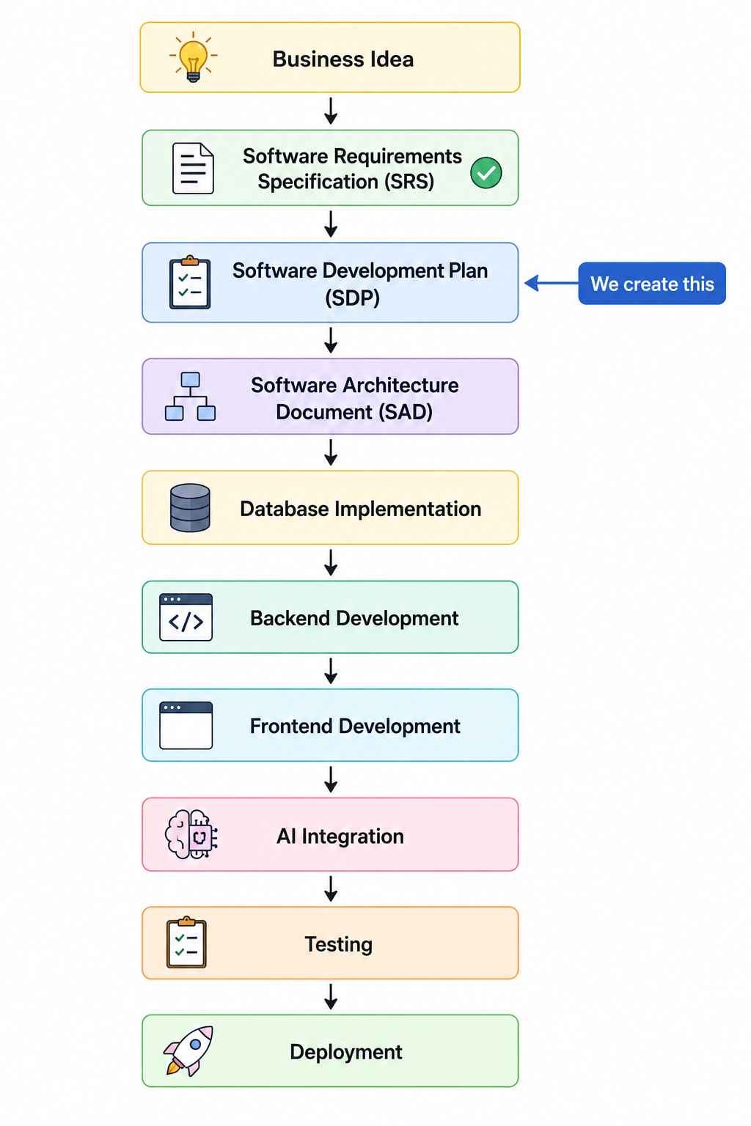

Chapter | Title
1 | Introduction
2 | Development Methodology
3 | Technology Stack & Development Environment
4 | Software Architecture
5 | Work Breakdown Structure (WBS)
6 | Requirement Traceability Matrix (RTM)
7 | Database Development Plan
8 | Backend Development Plan
9 | Frontend Development Plan
10 | AI Development Plan
11 | REST API Development Plan
12 | UI Development Plan
13 | Security Implementation Plan
14 | Testing Strategy
15 | Deployment Plan
16 | Risk Management
17 | Project Timeline & Milestones
18 | Definition of Done
19 | Maintenance & Future Development
20 | Appendices

Chapter 1 – Introduction
1.1 Purpose
The purpose of this Software Development Plan (SDP) is to define the implementation strategy, development methodology, project organization, and execution plan for the ProcessMind AI platform. This document serves as the primary guide for the software development lifecycle and provides a structured roadmap for transforming the approved Software Requirements Specification (SRS) into a fully functional software system.
The SDP establishes the development approach, implementation sequence, technical architecture, project milestones, resource planning, quality assurance strategy, testing procedures, deployment methodology, and maintenance considerations required to successfully develop ProcessMind AI.
Unlike the Software Requirements Specification, which defines what the system shall accomplish, this Software Development Plan defines how the system will be designed, implemented, tested, deployed, and maintained. It provides developers, project supervisors, and stakeholders with a comprehensive implementation framework that ensures all functional and non-functional requirements identified in the SRS are developed systematically and traceably.
This document also establishes the relationship between software requirements, implementation tasks, database design, backend services, frontend components, artificial intelligence modules, REST APIs, testing activities, deployment processes, and project deliverables. Through a structured Work Breakdown Structure (WBS) and Requirements Traceability Matrix (RTM), every implementation activity is mapped directly to one or more requirements defined in the Software Requirements Specification.
The Software Development Plan further defines the project's development standards, coding practices, version control strategy, continuous integration approach, security implementation plan, risk management procedures, and quality assurance activities. These guidelines ensure consistency throughout the development lifecycle while reducing implementation risks and improving software quality.
This document shall be used throughout the project lifecycle as the authoritative implementation reference for ProcessMind AI. All software development activities, design decisions, testing procedures, deployment operations, and project milestones shall conform to the processes and standards defined within this Software Development Plan.

1.2 Scope
This Software Development Plan covers the complete implementation of ProcessMind AI, an AI-powered Business Process Automation platform designed to transform organizational Standard Operating Procedures (SOPs) into intelligent, executable workflows through artificial intelligence.
The scope of this document includes the planning, design, implementation, testing, deployment, and maintenance activities required to develop the software system described in the Software Requirements Specification. The project encompasses the development of a multi-tenant Software-as-a-Service (SaaS) platform using a modern web-based architecture consisting of a Next.js frontend, Spring Boot backend, PostgreSQL database, and Google Gemini AI integration.
The implementation scope includes the development of the following major software components:
- Project foundation and system architecture
- Multi-tenant organization management
- Authentication and Role-Based Access Control (RBAC)
- User, department, and role management
- SOP document management and version control
- AI-powered SOP Intelligence Engine
- Workflow Generation Engine
- Workflow Intelligence Engine, including validation, simulation, and optimization services
- Workflow Execution Engine
- Task assignment and approval management
- Notification services
- Analytics and reporting dashboard
- Administration and system configuration
- Audit logging and monitoring
- RESTful API services
- Database implementation and migration
- Security implementation
- Automated testing and quality assurance
- Containerized deployment and production infrastructure
This Software Development Plan also defines the implementation order of software modules, development milestones, testing activities, deployment procedures, documentation standards, and project management practices necessary to ensure successful completion of the project.
Activities outside the scope of this document include future enhancements identified in the SRS, third-party enterprise integrations not required for the initial release, native mobile application development, advanced AI model customization, and large-scale commercial production support beyond the academic implementation.

1.3 Objectives
The primary objective of this Software Development Plan is to provide a structured, traceable, and manageable approach for developing ProcessMind AI in accordance with the approved Software Requirements Specification.
The specific objectives of this Software Development Plan are to:
- Establish a standardized software development process for the implementation of ProcessMind AI.
- Define the technical architecture, development methodology, and implementation strategy for all software components.
- Organize the project into manageable development phases, milestones, and implementation tasks.
- Ensure complete traceability between software requirements, implementation activities, database design, APIs, user interface components, testing procedures, and deployment artifacts.
- Define software engineering standards, coding conventions, documentation practices, and quality assurance procedures to be followed throughout the project lifecycle.
- Establish a comprehensive Work Breakdown Structure (WBS) that decomposes the project into well-defined development activities.
- Provide a Requirements Traceability Matrix (RTM) to ensure every functional and non-functional requirement identified in the SRS is implemented and verified.
- Define implementation strategies for backend services, frontend components, artificial intelligence modules, workflow engines, and supporting infrastructure.
- Establish testing strategies, deployment procedures, risk management plans, and project acceptance criteria.
- Deliver a high-quality, secure, maintainable, scalable, and production-ready software system that satisfies the business objectives and technical requirements of ProcessMind AI.

Chapter 2 – Development Methodology
2.1 Overview
This chapter defines the software development methodology, project management approach, development lifecycle, version control strategy, coding standards, and implementation workflow that will be followed throughout the development of ProcessMind AI.
The objective of this methodology is to ensure that the software is developed in a structured, iterative, and traceable manner while maintaining high software quality, minimizing project risks, and ensuring complete alignment with the approved Software Requirements Specification (SRS).
The development methodology emphasizes continuous integration, modular implementation, incremental delivery, frequent testing, and requirement traceability. Every software component shall be implemented according to the development phases and milestones defined in this Software Development Plan.

2.2 Software Development Methodology
ProcessMind AI shall be developed using the Agile Software Development Methodology with an Iterative and Incremental Development Model.
The Agile approach has been selected because the project consists of multiple interconnected software modules, including artificial intelligence services, workflow automation, REST APIs, frontend applications, and backend services. Incremental implementation enables each module to be developed, tested, and integrated independently while reducing technical risks and facilitating continuous improvement.
Each development iteration shall produce a functional software increment that can be tested, reviewed, and integrated into the overall system.
The development process will emphasize:
- Incremental feature delivery
- Continuous testing
- Frequent integration
- Modular software architecture
- Requirement traceability
- Continuous documentation
- Regular project reviews

2.3 Software Development Life Cycle (SDLC)
The development of ProcessMind AI shall follow the Software Development Life Cycle illustrated below.
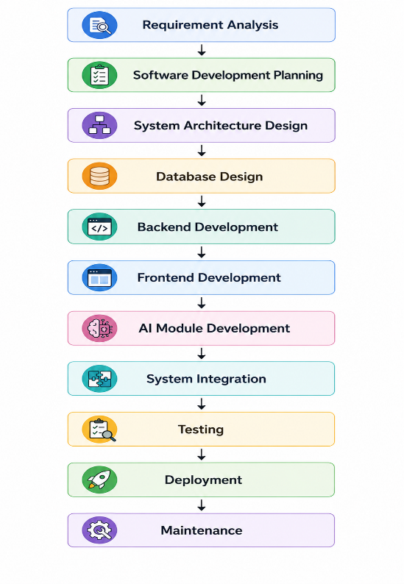
Each phase shall produce verified deliverables before the project progresses to the next phase.

2.4 Incremental Development Strategy
The software shall be implemented incrementally according to functional dependency.
The implementation sequence is defined as follows:
- Project Foundation
- Identity and Security Platform
- Organization Management
- SOP Management
- Artificial Intelligence Platform
- SOP Intelligence Engine
- Workflow Generation Engine
- Workflow Intelligence Engine
- Workflow Execution Engine
- Analytics Platform
- Administration Platform
- Testing and Deployment
Each completed increment shall produce a working subsystem that can be independently tested and integrated with previously completed components.
2.5 Development Workflow
Every software feature shall follow the same development workflow.
- Analyze related requirements from the SRS.
- Design the database changes.
- Design backend architecture.
- Implement backend services.
- Develop REST APIs.
- Develop frontend user interface.
- Integrate frontend with backend.
- Implement automated tests.
- Perform manual verification.
- Update documentation.
- Commit code to the repository.
- Merge into the development branch after successful review.
This workflow shall be repeated for every implementation milestone.
2.6 Version Control Strategy
The project shall use Git as the version control system.
The following branching strategy shall be adopted:
- main – Stable production-ready code
- develop – Active development branch
- feature/* – Individual feature implementation
- bugfix/* – Bug corrections
- release/* – Release preparation
- hotfix/* – Production issue resolution
Every code change shall be committed with meaningful commit messages and associated with a specific development task or milestone.
Pull requests shall be reviewed before merging into the develop or main branches.

2.7 Coding Standards
To ensure software consistency and maintainability, the following coding standards shall be followed:
Backend (Spring Boot)
- Follow Java naming conventions.
- Apply SOLID design principles.
- Use dependency injection.
- Separate controller, service, repository, and domain layers.
- Validate all incoming requests.
- Implement centralized exception handling.
- Document REST APIs using OpenAPI/Swagger.
Frontend (Next.js)
- Use TypeScript for all components.
- Create reusable React components.
- Maintain consistent folder structures.
- Use Tailwind CSS utility classes consistently.
- Implement responsive layouts.
- Follow React best practices and hooks.
Database
- Use descriptive table and column names.
- Apply normalization up to Third Normal Form (3NF).
- Define primary keys, foreign keys, and indexes.
- Use migration scripts for schema changes.
General
- Write clean, readable, and maintainable code.
- Include meaningful comments where necessary.
- Avoid duplicated logic.
- Follow consistent formatting throughout the project.

2.8 Continuous Integration Strategy
Continuous Integration (CI) shall be adopted throughout the project.
Each implementation shall include:
- Source code validation
- Automated build
- Static code analysis
- Unit testing
- Integration testing
- Security checks
- Build artifact generation
Code shall only be merged after successful completion of the automated validation pipeline.
2.9 Documentation Strategy
Documentation shall be maintained continuously throughout the software development lifecycle.
The following documents shall be updated whenever relevant changes occur:
- Software Development Plan
- Software Architecture Document
- Database Documentation
- REST API Documentation
- User Manual
- Administrator Guide
- Deployment Guide
- Release Notes
- Change Log
Documentation shall remain synchronized with the implemented software.

2.10 Quality Assurance Strategy
Software quality shall be maintained through continuous verification and validation activities.
Quality assurance activities include:
- Code reviews
- Unit testing
- Integration testing
- System testing
- User Acceptance Testing (UAT)
- Security testing
- Performance testing
- Regression testing
Defects identified during testing shall be corrected before progressing to the next development milestone.
2.11 Deliverables
The development methodology shall produce the following deliverables:
- Project source code
- Database schema
- Backend application
- Frontend application
- REST APIs
- AI integration modules
- Automated test suites
- Deployment configuration
- Technical documentation
- User documentation
- Final deployable software system

Chapter 3 – Technology Stack & Development Environment
3.1 Overview
This chapter defines the technologies, frameworks, development tools, software environments, and supporting infrastructure used for the implementation of ProcessMind AI.
The selected technology stack is based on modern software engineering principles and supports the project's objectives of scalability, maintainability, security, performance, and extensibility. All development activities shall utilize the technologies defined in this chapter unless formally approved changes are made during the project lifecycle.

3.2 Technology Selection Criteria
The technologies selected for ProcessMind AI satisfy the following criteria:
- Enterprise-grade reliability
- Strong community and ecosystem support
- Long-term maintainability
- Scalability for SaaS applications
- Security best practices
- AI integration capabilities
- Cloud-native deployment compatibility
- High developer productivity
- Cross-platform compatibility

3.3 System Architecture Stack
Layer | Technology
Frontend | Next.js 15
UI Framework | React 19
Programming Language | TypeScript
Styling | Tailwind CSS
Workflow Designer | React Flow
Backend | Spring Boot 3.x
Programming Language | Java 21
ORM | Spring Data JPA (Hibernate)
Security | Spring Security + JWT
Database | PostgreSQL
AI Platform | Google Gemini API
API Style | RESTful APIs
Documentation | OpenAPI / Swagger
Build Tool | Maven
Version Control | Git
Containerization | Docker
Backend Deployment | Render
Frontend Deployment | Vercel
Database Hosting | Neon PostgreSQL

3.4 Backend Development Environment
The backend application shall be developed using Java and the Spring Boot framework.
Technologies
Component | Technology
Java Version | Java 21
Framework | Spring Boot 3.x
Build Tool | Maven
ORM | Hibernate
Dependency Injection | Spring IoC
Security | Spring Security
Authentication | JWT
Validation | Jakarta Bean Validation
Documentation | Swagger/OpenAPI
Logging | SLF4J + Logback
Testing | JUnit 5, Mockito
Responsibilities
The backend is responsible for:
- Business logic
- Authentication and authorization
- AI integration
- Workflow execution
- Database access
- REST API services
- Security
- Audit logging

3.5 Frontend Development Environment
The frontend shall be implemented using Next.js and React.
Technologies
Component | Technology
Framework | Next.js 15
UI Library | React 19
Language | TypeScript
Styling | Tailwind CSS
Workflow Visualization | React Flow
State Management | Zustand
Form Validation | React Hook Form + Zod
API Communication | Axios
Charts | Recharts
Responsibilities
The frontend is responsible for:
- User interface
- Workflow designer
- Dashboards
- Forms
- Reports
- Notifications
- User experience

3.6 Database Environment
The application shall use PostgreSQL as the primary relational database.
Database Technologies
Component | Technology
Database | PostgreSQL
Migration Tool | Flyway
Database Administration | pgAdmin
Connection Pool | HikariCP
Database Responsibilities
- Data persistence
- Multi-tenant storage
- Transaction management
- Workflow storage
- AI history
- Audit logs
- Reporting data

3.7 Artificial Intelligence Environment
The AI capabilities shall be implemented using Google Gemini.
AI Components
Component | Technology
AI Provider | Google Gemini API
Prompt Engine | Custom Prompt Templates
Response Processing | Structured JSON Parsing
AI Logging | Database Storage
Retry Strategy | Exponential Backoff
AI Responsibilities
- SOP analysis
- Business rule extraction
- Workflow generation
- Workflow validation
- Workflow simulation
- Process optimization

3.8 Development Tools
Tool | Purpose
IntelliJ IDEA | Backend development
Visual Studio Code | Frontend development
Postman / Bruno | API testing
Git | Version control
GitHub | Source code hosting
Docker Desktop | Container management
pgAdmin | Database management
Mermaid / Draw.io | Architecture and UML diagrams

3.9 Development Environment Configuration
The project shall maintain separate environments for:
Environment | Purpose
Local Development | Feature implementation
Testing | Functional and integration testing
Staging | Pre-production validation
Production | Live deployment
Each environment shall maintain its own configuration using environment variables.

3.10 Coding Standards & Best Practices
The development team shall follow the following engineering principles:
- SOLID Principles
- DRY (Don't Repeat Yourself)
- KISS (Keep It Simple)
- Clean Architecture
- Domain-Driven Design (where appropriate)
- RESTful API conventions
- Secure coding practices
- Consistent naming conventions
- Code reviews before integration

3.11 Third-Party Dependencies
The project may utilize the following third-party libraries:
Backend
- Spring Boot Starter Web
- Spring Security
- Spring Data JPA
- Flyway
- Lombok
- MapStruct
- JWT Library
- OpenAPI

Frontend
- React Flow
- Axios
- Zustand
- React Hook Form
- Zod
- Recharts
- Lucide React
- Sonner
Only actively maintained and compatible library versions shall be adopted.

3.12 Deliverables
Completion of this chapter provides:
- Approved technology stack
- Development environment configuration
- Tool selection
- Framework selection
- Programming standards
- Infrastructure baseline
- Dependency standards
These technologies shall form the foundation for all subsequent implementation activities.

Chapter 4 – Software Architecture
4.1 Overview
This chapter defines the software architecture of ProcessMind AI and establishes the structural blueprint that guides the implementation of the system. It describes the architectural style, major software components, module organization, dependency management, communication patterns, and implementation principles that shall be followed throughout the software development lifecycle.
ProcessMind AI shall be implemented as a modern multi-tenant Software-as-a-Service (SaaS) platform using a layered architecture combined with Clean Architecture principles. The architecture separates business logic from infrastructure concerns, enabling scalability, maintainability, extensibility, and independent evolution of software components.
The architecture has been designed to support artificial intelligence services, workflow automation, secure authentication, multi-tenant data isolation, RESTful APIs, and cloud-native deployment while minimizing coupling between system modules.
All implementation activities shall conform to the architectural decisions defined in this chapter.
4.2 Architectural Goals
The software architecture of ProcessMind AI has been designed to achieve the following objectives:
- Maintain a clear separation of concerns between presentation, application, domain, and infrastructure layers.
- Support modular development and independent evolution of software components.
- Ensure maintainability through Clean Architecture and SOLID principles.
- Enable secure multi-tenant data isolation.
- Support scalable AI-powered workflow automation.
- Facilitate future extension through loosely coupled modules.
- Minimize dependencies between business logic and external technologies.
- Enable independent testing of business logic.
- Support cloud-native deployment and containerization.
- Ensure complete traceability between software architecture and the Software Requirements Specification.

4.3 High-Level Architecture
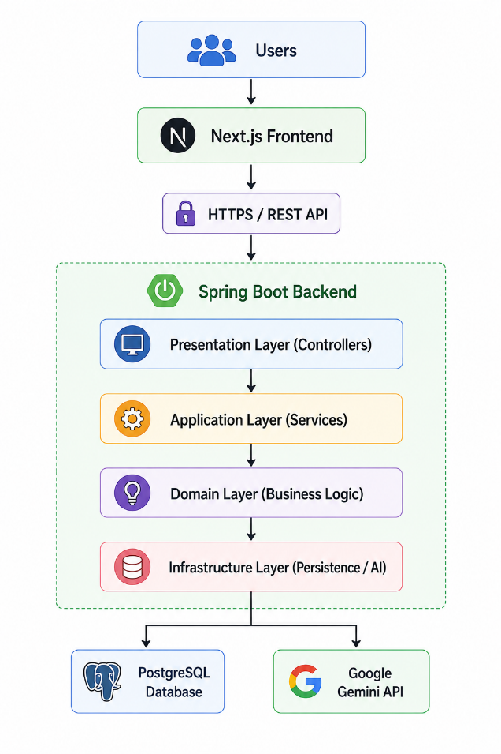
4.4 Architectural Style
ProcessMind AI adopts a combination of the following architectural styles:
Layered Architecture
The system is organized into logical layers that separate user interaction, application services, business rules, and infrastructure concerns.
Clean Architecture
Business rules remain independent of frameworks, databases, and user interface technologies.
Modular Monolith
Although the application is deployed as a single backend service during the initial release, it shall be internally organized into independent business modules. This architecture simplifies development while allowing future migration to microservices if required.
REST-Based Client-Server Architecture
Communication between the frontend and backend shall occur exclusively through secure RESTful APIs using JSON payloads.
Event-Oriented Internal Processing
Internal workflow execution, notification generation, audit logging, and AI processing shall utilize application events where appropriate to reduce coupling between modules.
4.5 Major Software Modules
This is one of the most important sections.
Module | Responsibility
Authentication Module | Authentication, JWT, RBAC
Organization Module | Multi-tenant organization management
User Management Module | Users, profiles, departments
SOP Management Module | Upload, versioning, storage
AI Platform Module | Gemini integration, prompt management
SOP Intelligence Engine | Extract business process information
Workflow Generation Engine | Generate executable workflows
Workflow Intelligence Engine | Validation, simulation, optimization
Workflow Execution Engine | Execute workflows
Task Management Module | User task assignment
Approval Module | Approval workflow
Notification Module | Email and in-app notifications
Analytics Module | KPIs and dashboards
Administration Module | System configuration
Audit Module | Audit logging
Monitoring Module | Health and metrics

4.6 Backend Layered Architecture
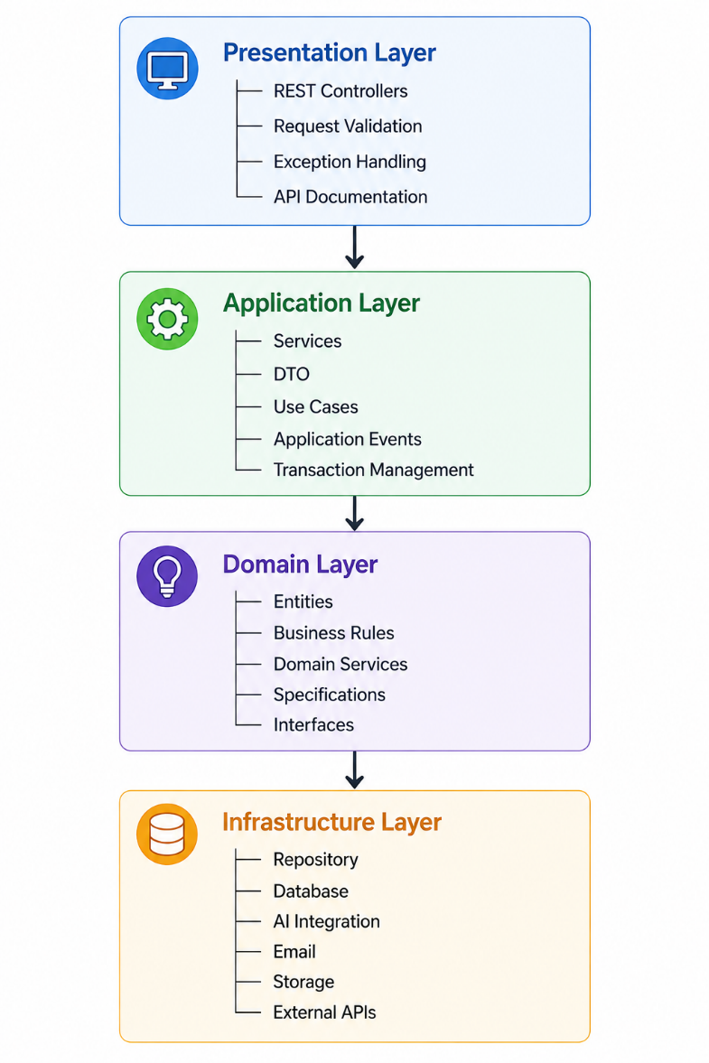
4.7 Backend Package Structure
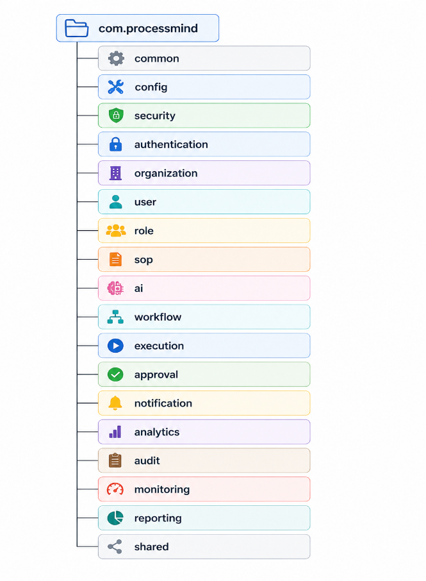
Every module shall contain:
- Controller
- Service
- dto
- entity
- repository
- mapper
- validator
- exception
- event

4.8 Frontend Architecture
app/
components/
features/
hooks/
services/
store/
types/
utils/
styles/
Feature folders
- authentication
- dashboard
- organization
- users
- sop
- workflow
- analytics
- settings
- notifications

4.9 Database Architecture
The database shall follow a multi-tenant relational model.
Core domains:
Organization
│
├── Users
├── Departments
├── SOP
├── Workflow
├── Tasks
├── Reports
├── Notifications
└── Audit Logs
Every business entity shall reference its owning Organization to enforce tenant isolation.

4.10 AI Architecture
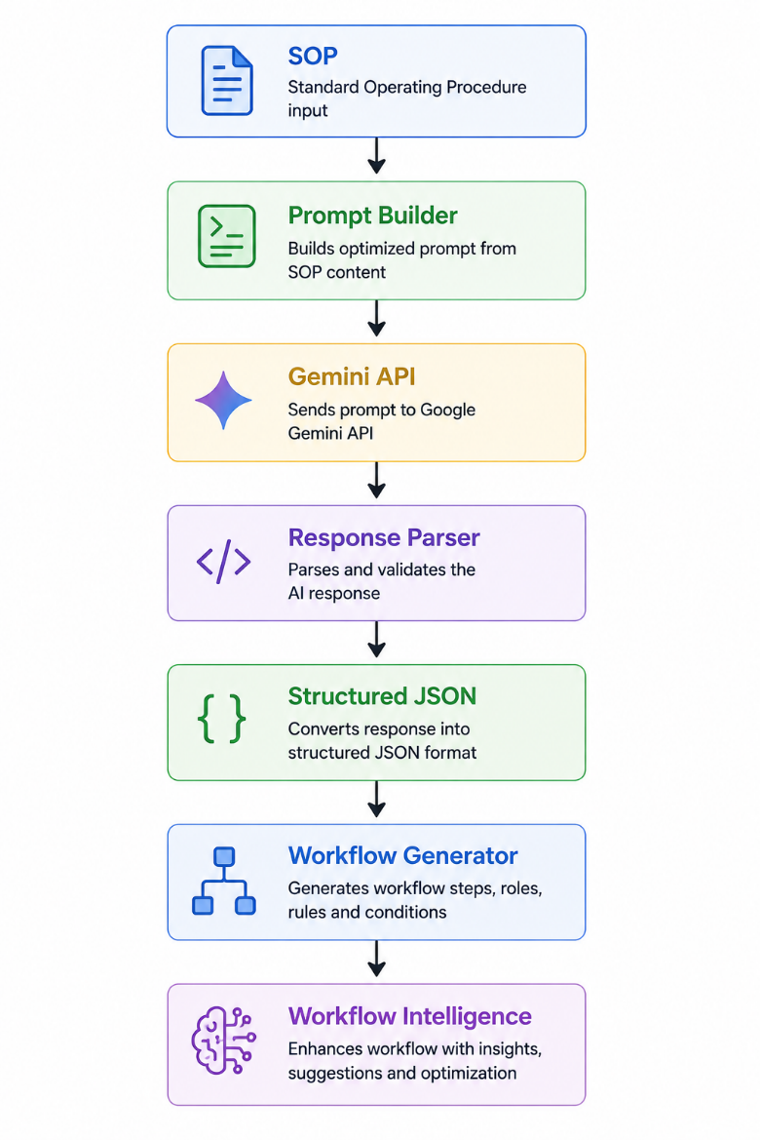
4.11 Workflow Engine Architecture
This is the heart of the project.
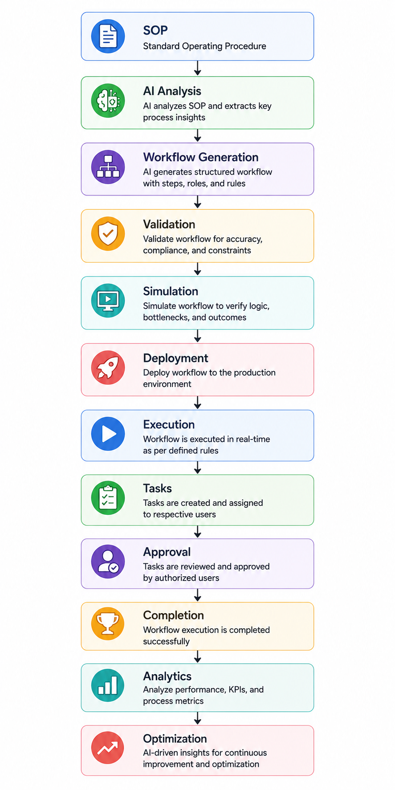

4.12 Dependency Rules
The following dependency rules shall be enforced:
- Controllers shall depend only on application services.
- Application services shall depend only on domain interfaces.
- Domain logic shall not depend on frameworks.
- Infrastructure components shall implement domain interfaces.
- Frontend components shall communicate only through REST APIs.
- AI integrations shall be isolated behind service abstractions.
- Database access shall occur exclusively through repositories.

4.13 Design Patterns
The implementation shall adopt the following design patterns where appropriate:
Pattern | Purpose
Repository | Data access abstraction
Service Layer | Business logic
Factory | AI request creation
Strategy | AI provider abstraction
Builder | Prompt construction
Observer | Notifications and events
Singleton | Configuration management
Adapter | External AI integration
DTO | Data transfer between layers

4.14 Architectural Principles
The implementation shall follow these principles:
- SOLID Principles
- DRY (Don't Repeat Yourself)
- KISS (Keep It Simple)
- Separation of Concerns
- Dependency Inversion
- Single Responsibility
- Open/Closed Principle
- Composition over Inheritance
- Fail Fast
- Secure by Design

Chapter 5 – Work Breakdown Structure (WBS)
5.1 Overview
The Work Breakdown Structure (WBS) defines the implementation roadmap for ProcessMind AI. It organizes the software development process into logical phases and milestones based on architectural dependencies and business functionality defined in the Software Requirements Specification (SRS).
The WBS provides a structured approach to software implementation by dividing the project into independently testable phases. Each phase produces a functional subsystem that can be verified before proceeding to subsequent phases, reducing integration risks and ensuring continuous project progress.
The development roadmap follows an incremental implementation strategy in which foundational components are completed before dependent modules are introduced. This approach ensures that all software modules are developed in the correct dependency order while maintaining alignment with the system architecture and functional requirements.

5.2 Development Strategy
The implementation of ProcessMind AI shall follow an Incremental and Dependency-Driven Development Strategy.
The project is divided into twelve development phases. Each phase consists of one or more implementation milestones and concludes with a working subsystem that can be demonstrated, tested, and validated independently.
Each phase shall include:
- Requirement analysis
- Database implementation
- Backend development
- Frontend development
- REST API implementation
- Integration testing
- Documentation updates
A subsequent phase shall begin only after the current phase has satisfied its acceptance criteria.

5.3 Development Phases
Phase | Development Area | Expected Outcome
Phase 1 | Foundation Platform | Development environment and system architecture established
Phase 2 | Identity & Multi-Tenant Platform | Secure authentication and tenant isolation operational
Phase 3 | Organization Management Platform | Organizations, users, and roles fully manageable
Phase 4 | SOP Management Platform | SOP documents uploaded, versioned, and managed
Phase 5 | AI Foundation Platform | AI services integrated and operational
Phase 6 | SOP Intelligence Platform | SOPs transformed into structured business processes
Phase 7 | Workflow Design Platform | AI-generated workflows created and editable
Phase 8 | Workflow Intelligence Platform | Workflows validated, simulated, optimized, and deployed
Phase 9 | Workflow Execution Platform | Business workflows executed automatically
Phase 10 | Business Operations Platform | Analytics, reporting, and notifications operational
Phase 11 | Administration Platform | Administrative functions and monitoring completed
Phase 12 | Quality Assurance & Deployment | System tested, deployed, and documented

5.4 Development Roadmap
Phase 1 – Foundation Platform
Objective
Establish the complete software development environment and project architecture.
Major Activities
- Initialize backend application
- Initialize frontend application
- Configure PostgreSQL
- Configure Docker
- Implement project architecture
- Configure logging
- Configure exception handling
- Configure Swagger/OpenAPI
- Configure environment variables
Deliverables
- Spring Boot project
- Next.js project
- PostgreSQL database connection
- Docker environment
- API documentation
- Health check endpoint
Testable Outcome
- Backend starts successfully.
- Frontend runs successfully.
- Database connection is established.
- Swagger documentation is accessible.
- Health check API returns a successful response.

Phase 2 – Identity & Multi-Tenant Platform
Objective
Implement secure authentication, authorization, and tenant isolation.
Major Activities
- User management foundation
- Organization management foundation
- JWT authentication
- Refresh token management
- Role-Based Access Control (RBAC)
- Session management
- Password recovery
Deliverables
- Authentication APIs
- Authorization middleware
- Login interface
- Protected routes
Testable Outcome
- Users can register and log in.
- JWT authentication is operational.
- Protected APIs require authentication.
- Users access only their own organization's data.

Phase 3 – Organization Management Platform
Objective
Implement organization structure and user administration.
Major Activities
- Department management
- Team management
- User management
- Role assignment
- Organization settings
- User profiles
Deliverables
- Organization management module
- User administration module
- Department management module
Testable Outcome
- Organization administrators can create departments.
- Users can be added and assigned roles.
- Organization settings can be configured.

Phase 4 – SOP Management Platform
Objective
Implement document management for Standard Operating Procedures.
Major Activities
- SOP upload
- File validation
- Version management
- File preview
- Search and filtering
- Metadata management
Deliverables
- SOP repository
- File storage module
- Version management module
Testable Outcome
- SOP documents can be uploaded.
- Version history is maintained.
- SOPs can be searched and viewed.

Phase 5 – AI Foundation Platform
Objective
Establish reusable AI infrastructure.
Major Activities
- Gemini API integration
- Prompt template management
- AI request handling
- Response processing
- AI history
- Retry mechanisms
Deliverables
- AI service layer
- Prompt engine
- AI logging
Testable Outcome
- The system successfully communicates with the Gemini API.
- AI responses are received, validated, and stored.

Phase 6 – SOP Intelligence Platform
Objective
Convert SOP documents into structured business process information.
Major Activities
- Activity extraction
- Role extraction
- Business rule extraction
- Condition extraction
- JSON generation
- Review interface
Deliverables
- SOP Intelligence Engine
- Process model generation
Testable Outcome
- Uploaded SOPs are analyzed.
- Activities, roles, and business rules are extracted.
- Structured process data is generated for review.

Phase 7 – Workflow Design Platform
Objective
Generate editable workflows from AI-generated process information.
Major Activities
- Workflow generation
- Workflow editor
- React Flow integration
- Workflow versioning
- Draft management
Deliverables
- Workflow Designer
- Workflow repository
Testable Outcome
- AI-generated workflows are displayed visually.
- Users can edit and save workflow drafts.

Phase 8 – Workflow Intelligence Platform
Objective
Prepare workflows for production deployment.
Major Activities
- Workflow validation
- Workflow simulation
- AI optimization
- Deployment management
- Version control
Deliverables
- Workflow Intelligence Engine
Testable Outcome
- Workflows are validated successfully.
- Simulation executes correctly.
- Optimization recommendations are generated.
- Validated workflows can be deployed.

Phase 9 – Workflow Execution Platform
Objective
Execute deployed workflows automatically.
Major Activities
- Workflow execution engine
- Task management
- Assignment engine
- Approval processing
- Workflow history
- Execution dashboard
Deliverables
- Workflow Execution Engine
Testable Outcome
- Users receive assigned tasks.
- Workflow progresses automatically.
- Approval stages execute correctly.
- Workflow execution history is recorded.

Phase 10 – Business Operations Platform
Objective
Provide operational insights and communication services.
Major Activities
- Notifications
- Analytics
- Dashboards
- KPI calculations
- Report generation
Deliverables
- Analytics dashboard
- Reporting module
- Notification service
Testable Outcome
- Dashboards display workflow metrics.
- Reports are generated successfully.
- Users receive workflow notifications.

Phase 11 – Administration Platform
Objective
Provide platform administration and operational monitoring.
Major Activities
- System configuration
- Audit logging
- Health monitoring
- AI configuration
- Feature management
Deliverables
- Administration console
- Monitoring dashboard
Testable Outcome
- Administrators manage system settings.
- Audit logs are searchable.
- System health information is available.

Phase 12 – Quality Assurance & Deployment
Objective
Prepare the system for production release.
Major Activities
- Unit testing
- Integration testing
- System testing
- Performance testing
- Security testing
- Deployment
- Documentation

Deliverables
- Production-ready application
- Deployment environment
- Technical documentation
Testable Outcome
- All planned test cases pass.
- Application is deployed successfully.
- All core business processes execute successfully in the production environment.

5.5 Phase Dependency Matrix
Phase | Depends On
Phase 1 | None
Phase 2 | Phase 1
Phase 3 | Phase 2
Phase 4 | Phase 3
Phase 5 | Phase 4
Phase 6 | Phase 5
Phase 7 | Phase 6
Phase 8 | Phase 7
Phase 9 | Phase 8
Phase 10 | Phase 9
Phase 11 | Phase 10
Phase 12 | All Previous Phases

5.6 Development Completion Criteria
A development phase shall be considered complete only when:
- All planned functionality has been implemented.
- Database changes have been applied successfully.
- Backend services are operational.
- Frontend interfaces are integrated.
- REST APIs are tested and documented.
- Integration tests pass successfully.
- The defined testable outcome has been demonstrated.
- Documentation has been updated.
5.7 Chapter Summary
This chapter establishes the implementation roadmap for ProcessMind AI by organizing software development into twelve sequential phases. Each phase delivers a complete and independently testable subsystem, ensuring incremental progress, controlled integration, and continuous verification throughout the development lifecycle.

