Allison, Shakira, and Gracie Final Stat 345 Project

2025-04-11

### Overview:

* We decided to look at the Top Country Songs of each decade since 1960
* We then looked for repetition in titles and phrases over each decade
  + Looking at graphs of our findings we are able to draw conclusions about repetition

### Repetition in Country Songs

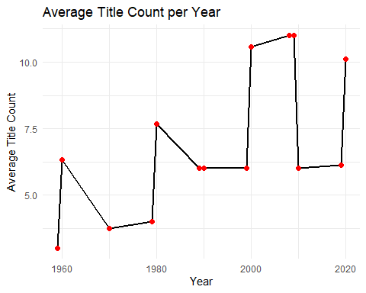

Looking at the graph above, we can see a general increase in the average title usage in country songs across the decades since 1960. On the x-axis we see the years from 1960 to 2020 and on the y-axis we see the average title count in the lyrics for the top country songs. We can see notable spikes in 2000, 2010, and in 2020, which took place after large dips. We can also see 20 years of mostly stable trends from 1960 to 1980, with a peak at 1980. Overall, there is a little trend in the average title counts over the decades with 2020’s counts being much greater than 1960’s.

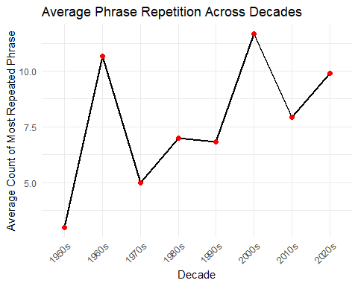

Looking at this visual, we can see that there has been an overall increase in phrase repetition in country songs since the 1950s.The x-axis is the decades, while y-axis is the average count of most popular repeated phrases. The 2000’s has the highest spike of the average count of most repeated phrases in songs, which was greater than 10.0. The 2010’s then still have a slight dip, but the overall trends are increasing from the 1950’s to the 2020’s.

# Extending Our Findings

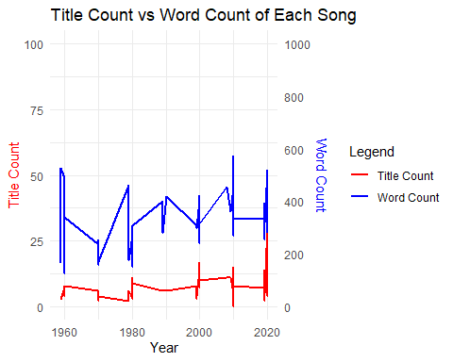

The above graph shows the count for both titles and words of country songs over time. We can see that the word and title counts show many fluctuations. Both title and word count tend to show peaks in the same areas, which can lead us to conclude that title count may be higher for certain country songs because they have more words.There also seem to be some peaks after 2000 which could indicate an increase in word count along with title usuage in the lyrics.

### Conclusion

For our final project, we focused on the top country songs from the 1960s to 2020. For our first repetition analysis we looked at the average title count per decade. For our second repetition analysis we looked at average phrase repetition across decades. We also extended our project to include a third graph which looks at title count vs word count for each song over time. For the average title count per year, we can see a general increase in title count over time, with significant peaks in the 2000s. The highest peaks in this data show over ten times for the average title count. For the average phrase repetition graph, we can see an overall increase from the 1960s to the 2020s. From this graph, we do see significant peaks in the 1960s and 2000s, showing an average count of repeated phrases of over ten. These peaks could reflect cultural trends and phrases that caused these peaks of phrase repetition. We can see an increase in songs being more repetitive through the second graph, through the clear trend of the phrase repetition in songs since the 1970s. Both graphs show an increase in activity, which can support the idea that as the repetition of song titles increases, we also see the repetition of phrases. This is also supported by the third graph, as we can see spikes in both title and word count at the corresponding times. Overall, we can see repetition has increasing trends in the top country songs from the 1960s to the 2020s.