DRAINAGE SENSOR PLACEMENT FOR URBAN FLOOD MONITORING
KCCA / Kampala Context Technical Note and Field Prototype Schematics
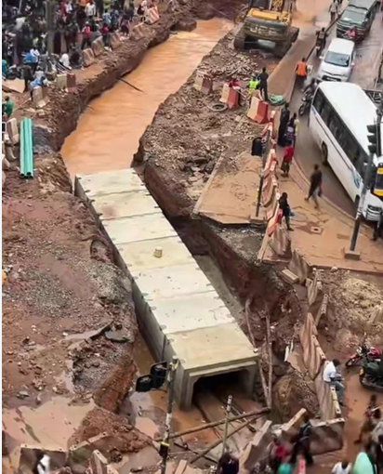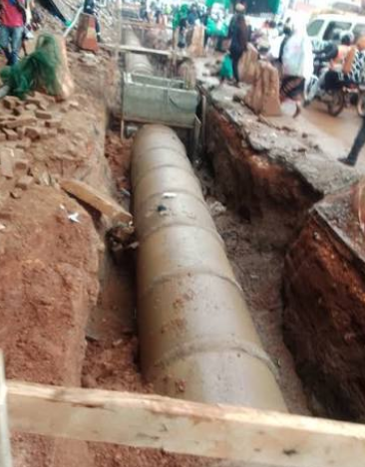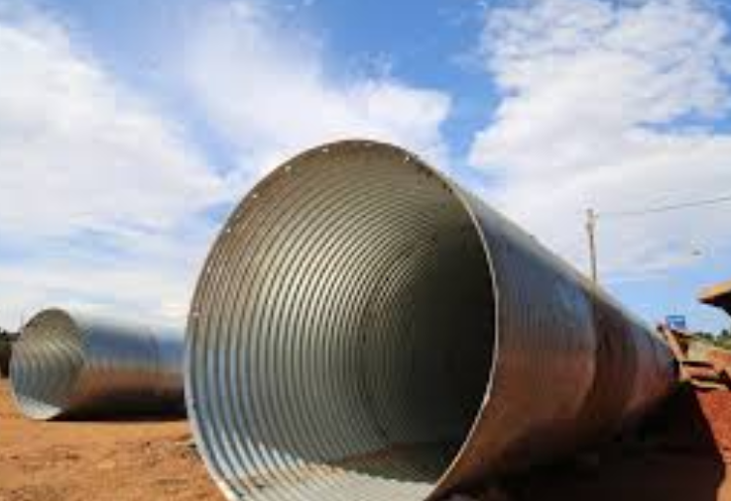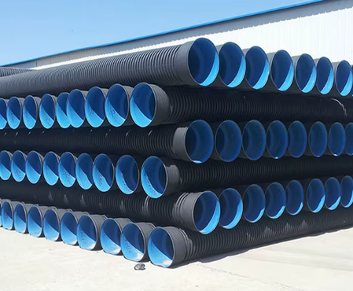
Purpose: To identify practical drainage structures, sensor locations, mounting arrangements, sensing principles, and field-maintenance considerations for a first water-level monitoring prototype in Kampala.

Executive Summary
For a first field prototype, an existing box culvert or stable open drainage channel at a documented flooding/blackspot location is a practical test site. The preferred first sensor arrangement is a non-contact ultrasonic water-level sensor mounted above the water surface, protected in a weatherproof/tamper-resistant enclosure. A pressure sensor can be used as a reference/validation instrument, preferably protected in a stilling arrangement, while cheap radar is better treated as a later-stage option until its field performance is demonstrated.
- Measure water level where it is hydraulically meaningful; do not place the primary sensor directly in the trash/silt accumulation zone.
- Use the sensor to observe the hydraulic effect of obstruction rather than physically placing the sensor in the obstruction.
- Where possible, use upstream and downstream measurements to calculate
- Select an existing, stable structure rather than a drainage section scheduled for reconstruction.

Kampala/KCCA Drainage Context
KCCA drainage works include primary and secondary drainage channels, community/tertiary drains, road crossings and box culverts. KCCA's current strategic planning documents include continued investment in blackspot/road-crossing box culverts and community drains. Consequently, the exact geometry at an individual site must be confirmed from approved drawings or a site survey rather than assuming one universal Kampala drain size.

Relevant Drainage Structures and Typical Sensor Opportunity
Drainage situation | Likely structure | Sensor sees water | Main trash/silt concern
Roadside/local runoff | Open rectangular/trapezoidal channel | At a representative upstream or stable section | Floating litter and sediment at low points
Community/local drainage | Community/tertiary drain | At a protected wall/overhead section | Household waste, sediment, vegetation
Road crossing | Box culvert | Preferably upstream of/near the crossing, clear of direct splash | Debris at inlet and sediment on invert
Smaller crossing | Pipe culvert | At an accessible upstream chamber/opening | Blockage and sediment at inlet
Major channel | Primary/secondary channel | Stable section with defined reference level | Large debris, erosion, sedimentation
Indicative dimensions should not be treated as site specifications. The Uganda Urban Roads Design Manual includes example rectangular drain sections such as shown below subject to hydraulic design. For road culverts, national drainage guidance identifies 600 mm as a minimum pipe-culvert diameter under roads in the cited guidance, with hydraulic/self-scouring considerations.

Minimum Standard Culvert Sizes
Under road infrastructure in Uganda, culverts must meet the following minimum physical dimensions:
- Pipe Culverts: Minimum diameter of 600 mm (0.6 m) or its equivalent in corrugated metal pipe arches.
- Precast Concrete Box / Portal Culverts: Minimum opening size of 600 mm × 450 mm.
  - Exception: This may be reduced to 450 mm × 400 mm if self-scouring flow velocities are achieved to remain maintenance-free.

Standard Design Dimensions & Capacity Ranges
For major urban centres with developed infrastructure like Kampala, the manual specifies kerb inlets, cross culverts, and underground pipe/box systems. The standard design charts and capacity tables cover the following ranges:
- Concrete Pipe Culverts: Standard nominal diameters in the design capacity tables include 30" (750 mm), 36" (900 mm), 42" (1050 mm), and 48" (1200 mm), configured as single, double, or triple barrels.
- Box Culverts: Standard design tables provide for spans ranging from 1.0 m to 6.0 m and heights from 0.9 m to 4.5 m. (For instance, standard design examples in the manual use box culverts sized 2135 mm × 1830 mm and 3.0 m × 2.0 m).
- Slab Culverts: Standard multi-opening designs typically utilize openings of 3.0 m span × 2.0 m height.

Recommended First-Build Sensor Location
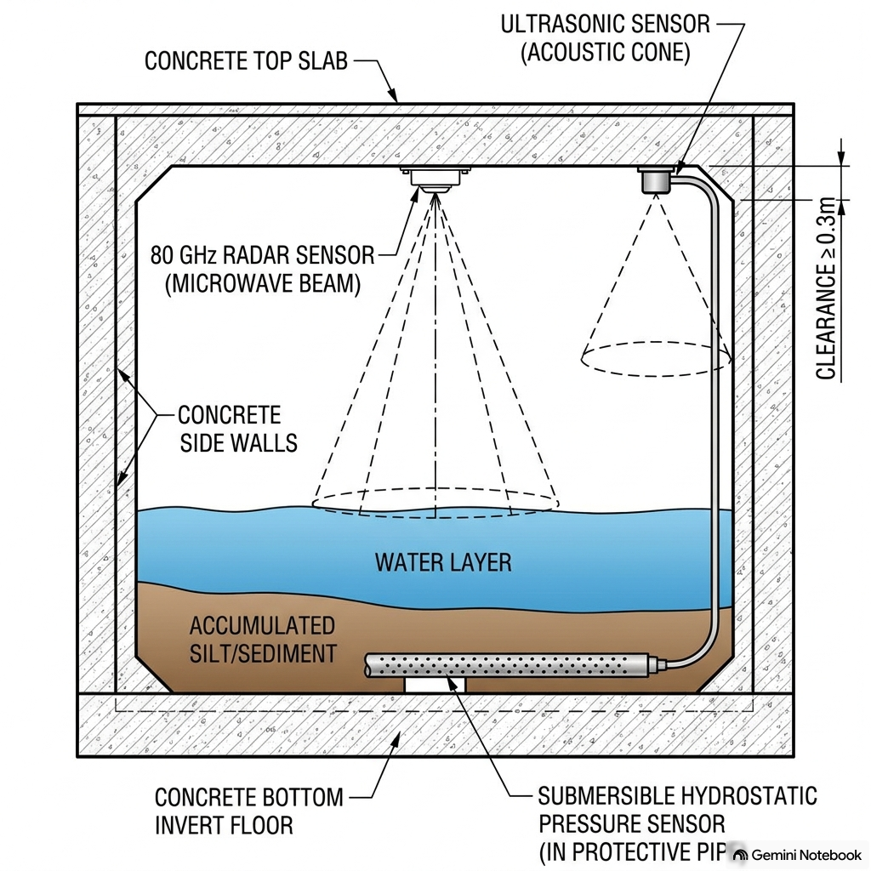

Implementing level and blockage monitoring on a box culvert involves deploying either overhead non-contact sensors or submerged contact devices based on site hydraulics and environmental constraints:
- Overhead 80 GHz Radar Sensors: Non-contact radar level transmitters are installed on the culvert roof or headwall, emitting high-frequency microwave pulses straight down to the water surface to determine water level via electromagnetic time-of-flight. Radar implementation is ideal for severe storm conditions because 80 GHz microwave pulses penetrate heavy surface foam, steam, condensation, and rapid air/temperature fluctuations without signal degradation, offering non-contact operation with high precision (down to ±2 mm) and zero risk of sensor fouling from debris.
- Overhead Ultrasonic Sensors: Acoustic time-of-flight sensors are mounted on top mounting brackets or threaded ceiling fittings facing perpendicular to the water line. To ensure accurate echo detection, ultrasonic transducers must be installed away from turbulent inlet splash zones, positioned at least 0.3 m away from concrete sidewalls to prevent false structural reflections, and mounted high enough so maximum flood levels never intrude into the sensor's required blind/dead zone; in areas with persistent surface foam or wave turbulence, the sensor can be mounted inside a perforated vertical standpipe.
- Submersible Hydrostatic Pressure Transmitters: Submersible pressure sensors offer a contact-based alternative by resting directly along the culvert invert (channel floor) inside a protective, anti-pollution guide tube. These units utilize piezoresistive or ceramic sensing diaphragms to measure the hydrostatic pressure exerted by the overlying water column, outputting standard 4-20 mA or RS485 digital signals to continuously track water depth directly from the bed

How are the sensor Mounted in the system

Use Side-Mount Brackets
- For open walls, tanks, and sumps, sensors are mounted using dedicated side-mount wall brackets (such as LVM-30 series brackets) attached directly to the vertical wall.
- The sensor threads into a plastic reducer bushing or fitting on the bracket arm, which extends out horizontally over the water surface.

Maintain Minimum Wall Distance (Clearance)
- Non-contact sensors (ultrasonic and radar) emit a beam cone and must not be mounted flush against the wall or too close to side surfaces.
- Distance Requirements: Mount the sensor at least 2 to 3 inches (5 to 7.6 cm) away from smooth side walls. If the wall is made of rough concrete, maintain a distance of at least 0.3 m (approx. 12 inches) to prevent false echo reflections from the wall surface.

Ensure Perpendicular Alignment
- The transducer face must be aligned perpendicular to the liquid surface (pointing straight down).
- The sensor should never be mounted at an angle relative to the water line, as tilted sensors reflect acoustic/radar pulses away rather than receiving return echoes.

Cable Protection & Drip Loops on Walls
- When running sensor cables along outdoor or wet walls, seal all conduit entries and cable glands to prevent water ingress.
- Drip Loops: Bend the signal cable downwards in a loop before it enters the electronics or junction enclosure to prevent rainwater or condensation from flowing down the cable into the housing

Note:
For reliable detection of both flooding and silt accumulation in a box culvert, the 80 GHz Non-Contact Radar Level Sensor is the strongest recommendation.
Here is a breakdown of how the three options compare for this specific application:
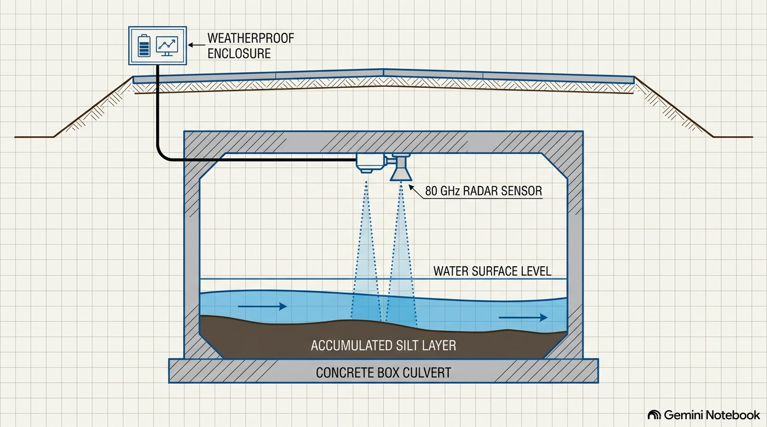

Top Recommendation: 80 GHz Non-Contact Radar Sensor
- Flood Detection Performance: During severe storm events, floodwater creates heavy surface foam, splash turbulence, steam, and rapid air temperature swings. An 80 GHz radar sensor emits high-frequency electromagnetic microwave pulses that penetrate foam, condensation, and temperature variations without signal degradation or false echoes. It delivers continuous, high-precision level measurements (down to ±2 mm).
- Silt Accumulation Detection: Because radar is mounted on the culvert roof or top headwall, it measures the clearance distance down to the floor during dry or low-flow conditions. As sediment and silt accumulate on the bed, the measured distance decreases, allowing real-time tracking of silt depth without physical contact.
- Maintenance & Reliability: Unaffected by sticky, dirty, or corrosive media, radar has zero moving parts, does not wear or clog, and offers the lowest long-term maintenance requirements.

Why Submersible Pressure Transmitters are NOT Advised for Silt Monitoring
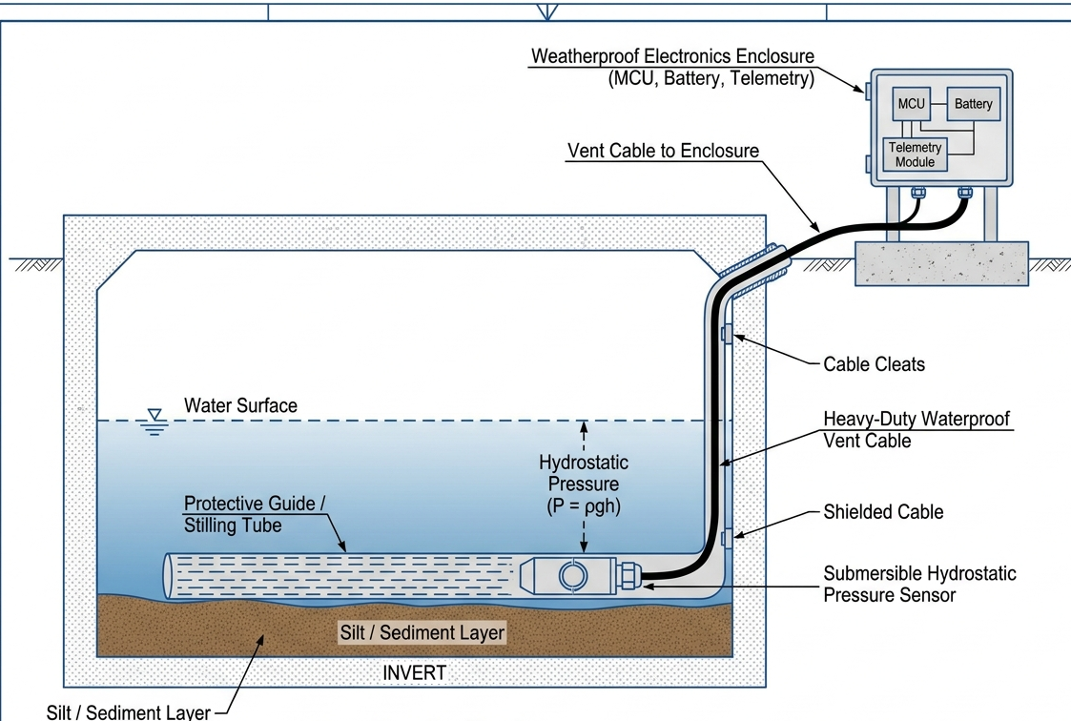
- Submersible hydrostatic pressure sensors are contact-based devices designed to rest on the culvert bed.
- In culverts prone to siltation, sand, mud, and sediment settle around the sensor, easily burying or clogging the pressure diaphragm. Exposure to dirty, sticking, or scaling bed materials causes sensor drift, signal error, or physical failure.

3Secondary Option: Non-Contact Ultrasonic Sensors
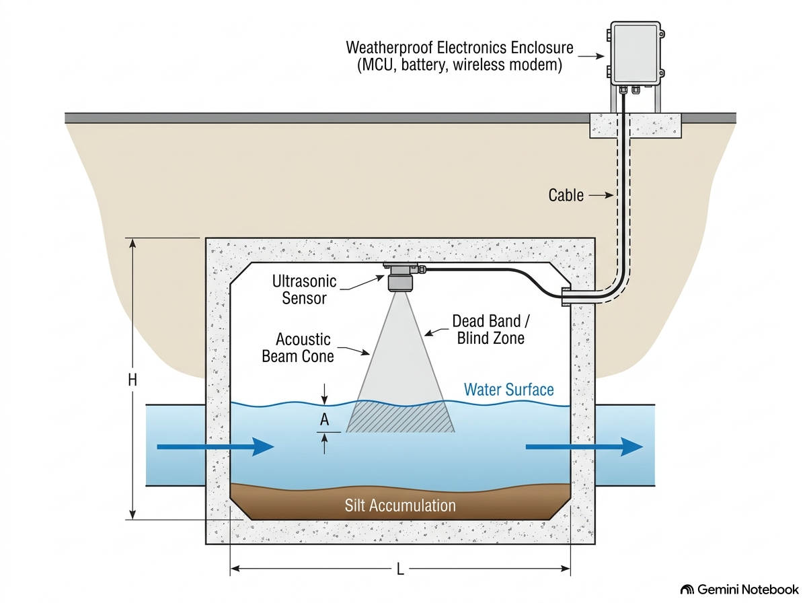
- Ultrasonic sensors provide a non-contact alternative at a lower initial cost.
- Drawbacks in Floods: Acoustic waves rely on sound propagation through air, making them sensitive to air temperature changes. Furthermore, heavy surface foam and violent water turbulence reflect or absorb sound waves, creating false echoes or signal loss.
- Mitigation: If ultrasonic sensors are chosen for budget reasons, they should be installed with a perforated guide pipe (stilling tube) to dampen surface turbulence and foam.

Summary Conclusion
The 80 GHz Non-Contact Radar Sensor is the most robust, low-maintenance choice for box culverts. It reliably captures high flood levels through heavy storm turbulence while tracking bed sediment buildup during low flows without any risk of sensor burial or fouling

Upstream and Downstream Monitoring Concept
A two-point configuration is useful when the research question concerns blockage, restriction or sedimentation. The upstream level can rise relative to the downstream level when the hydraulic resistance of the crossing increases. The difference can be represented as:
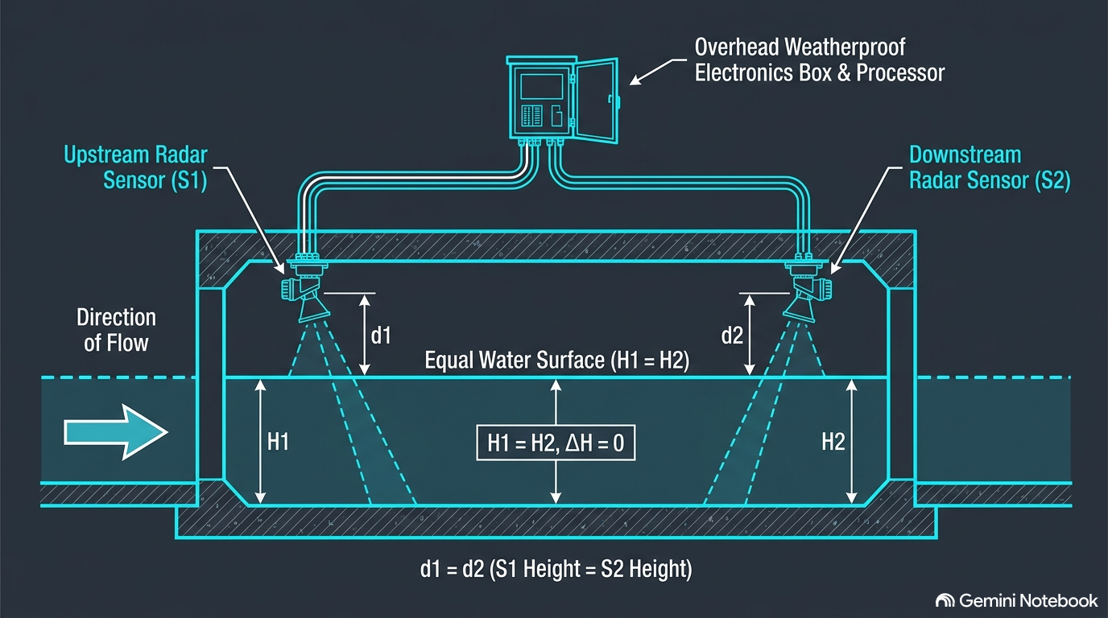

Where the Sensor Should NOT Go
- Directly on the culvert invert where silt accumulates.
- Immediately at the culvert entrance where branches, plastic and splash strike the sensor.
- In the centre of the flow where cleaning equipment can hit it.
- In a location that must be removed for routine desilting.
- At a drainage section that is about to be reconstructed, widened or replaced.
- In a visibly accessible position where the electronics can easily be stolen or tampered with.

Construction and Maintenance Considerations
KCCA undertakes routine drainage maintenance, including manual and mechanised desilting/clearing, and has also involved communities, local leaders and private-sector partners in drainage and waste-management activities. The prototype therefore has to be designed around maintenance operations, not merely hydraulic measurement.

Threat | What can happen | Design response
Internal Structural Echoes & Condensation | Microwave beam reflecting off concrete sidewalls/ribs causes false level readings; moisture on the antenna causes signal attenuation. | Use high-frequency 80 GHz radar with a narrow beam angle (e.g., 3°), mount along the center ceiling slab away from walls, utilize hydrophobic PTFE/PFA antenna material, and enable software false-echo masking.

Alternative Radar-Specific Threat Entries (if needed for your design matrix):
Threat | What can happen | Design response
Culvert Submersion / Over-topping Flood | Severe floodwaters rise to the ceiling slab, completely submerging the sensor unit. | Specify an IP68-rated, fully-potted housing (e.g., CPVC / 316SS) with sealed waterproof cable glands, and configure fail-safe full-scale output alerts.
Dielectric Constant Variations (Low Reflectivity) | Very clear or low-dielectric liquids reflect weak microwave echo signals back to the sensor. | Utilize FMCW 80 GHz radar with high signal processing gain (TVG) and calibrate sensitivity thresholds for open-channel water

Environmental and Security Stress Test
Threat | What can happen | Design response
Splash/turbulence | False or unstable ultrasonic readings | Move sensor away from inlet splash; use rigid overhead mounting.
Trash/debris | Sensor blocked or physically struck | Keep sensing path out of debris accumulation zone.
Silt | Pressure sensor buried; invert measurement changes | Use overhead ultrasonic or protected pressure arrangement.
Sun/heat/UV | Enclosure and electronics degrade | Use suitable weather-resistant enclosure and shielding.
Theft/vandalism | Sensor or electronics removed | Lockable enclosure, concealed/protected cable, tamper-resistant mounting.
Desilting | Maintenance crew damages or removes sensor | Mount outside normal shovel/cleaning path; coordinate with maintenance team.

Effect of Ongoing KCCA Drainage Construction
Ongoing construction changes the site-selection logic. A newly constructed or actively reconstructed drain can change its cross-section, invert level, inlet geometry and hydraulic behaviour. For a first study, choose an existing structure with stable geometry and documented flooding history. Record the as-built dimensions and take photographs/survey points before installation.
- Confirm whether the selected structure is scheduled for reconstruction.
- Record channel/culvert width, height, invert condition and sediment depth.
- Identify the nearest upstream and downstream access points.
- Document existing trash accumulation and signs of previous desilting.
- Record rainfall/flow conditions during each sensor test.
- If construction is unavoidable, treat the construction stage as a separate experimental condition rather than mixing different geometries.

Suggested First Prototype Configuration
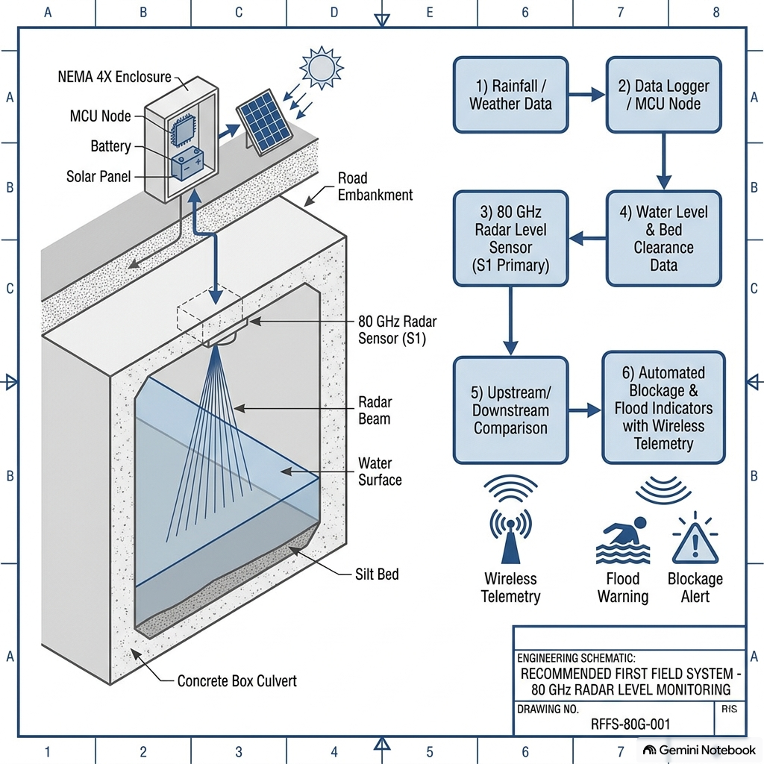

Practical Research Variables
- Water level H (m)
- Upstream water level H_upstream (m)
- Downstream water level H_downstream (m)
- Head difference ΔH (m)
- Rainfall intensity (mm/h), where available
- Sediment depth (mm or m)
- Observed debris/trash condition
- Culvert/channel dimensions
- Time/date and maintenance events
- Sensor quality flag / confidence indicator

Key Engineering Takeaway
The strongest first-build concept is not simply 'put a sensor in a blackspot.' It is to select a stable drainage structure where water level has a clear hydraulic meaning, install the sensor where maintenance and debris are least likely to damage it, and collect measurements that can be related to flooding, obstruction and drainage performance.

References
- Kampala Capital City Authority (KCCA), KCCA Strategic Plan 2025/26–2029/30 – drainage, blackspot/road-crossing box culvert and community-drain programmes.
- KCCA, KCCA-KIIDP2 Terms of Reference for diagnostic assessment, modelling and mapping of sub-surface storm-water drainage – drainage planning/design context.
- KCCA, 2026 drainage/flood preparedness communications – routine and mechanised drainage maintenance/desilting.
- Uganda Urban Roads Design Manual (MoWT), Part 1 – indicative urban drainage section examples and design context.
- Uganda Drainage Design Manual / national road drainage guidance – culvert sizing and hydraulic/self-scouring considerations.
- Hunan MAC Sensor Co., Ltd. (2025, October 15). How to use, install and maintain ultrasonic level sensor? MACSENSOR. https://www.macsensor.com/info/how-to-use-install-and-maintain-ultrasonic-le-103166307.html
- Icon Process Controls. (2025, June 10). A complete guide to radar liquid level sensors: Precision measurement for complex applications. https://iconprocon.com/blog_post/a-complete-guide-to-radar-liquid-level-sensors-precision-measurement-for-complex-applications/
- Li, O. (2026, August 19). Pressure sensor: The ultimate guide for beginners. GAMICOS. https://www.gamicos.com/Newsinfo/The-Ultimate-Guide-to-Pressure-Sensor
- Ministry of Works and Transport. (2010, January). Road design manual volume II: Drainage design manual. Republic of Uganda.
- Omega Engineering. (n.d.). LVCN210, LVCN318 & LVCN414 series ultrasonic level sensor user's guide (Manual No. M4462). Omega Engineering, Inc.
- Toa, M., & Whitehead, A. (2021, December). Ultrasonic sensing basics (Application Report No. SLAA907D). Texas Instruments.

Note: Dimensions and site suitability must be verified against the approved design drawings, hydraulic calculations, site survey and the responsible authority before field installation.

