**Question:**

Print the tree nodes in pre-order?

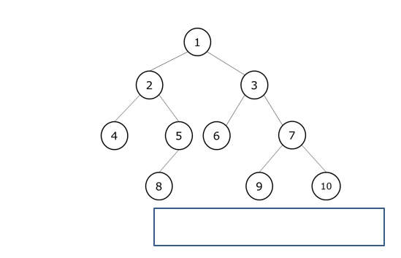

***Pre-Order Traversal***

***Node, Left, right.***

1,2,4,5,8,3,6,7,9,10