EMiF Project 2 Report: Has the Structure of Risk in Financial Markets Changed Since COVID-19?
Group Members:[Add names]
Group Number:[Add if applicable]
Date:[Add date]
1. Introduction
The COVID-19 shock was a turning point for financial markets. Volatility increased quickly, cross-asset relationships became less stable, and many portfolios that usually looked diversified suddenly behaved differently. Because of this, an important question emerges: did markets only experience a temporary stress event, or did the structure of risk itself change after COVID-19?
This report studies that question using only the dataset provided for the project (Data.xlsx). In this analysis, the structure of risk is examined through three dimensions. First, I look at individual asset risk, especially volatility and downside risk. Second, I analyze co-movements across assets through correlation patterns. Third, I study the role of common market drivers using principal component analysis (PCA). Looking at these three angles together makes it possible to go beyond simple market description and build an evidence-based answer.
The baseline split is pre-COVID versus post-COVID, with 11 March 2020 as the main breakpoint, corresponding to the WHO pandemic declaration. This choice is economically meaningful and is complemented by robustness checks with alternative break dates.
Overall, the results suggest that risk structure changed after COVID-19, but not in a uniform way. Some assets became riskier while others became less volatile, and average correlations did not increase everywhere. At the same time, common factor concentration became stronger in the post-COVID period. For this reason, the final answer of the report is yes, partially.
2. Literature Review
The literature on financial crises generally shows that large shocks can modify risk dynamics for a long period, not only during the panic phase. In many episodes, volatility rises quickly, return distributions become more asymmetric, and extreme moves become more frequent. This is directly related to our project because it suggests that post-crisis risk should be studied as a structural issue, not only as a short-term reaction.
Another important strand of literature focuses on correlation and diversification. A common result is that co-movements tend to change under stress, but not always in the same way across all markets. Some asset classes become more tightly connected, while others decouple. For portfolio management, this means that average correlation alone is not enough: it is also necessary to look at where correlations increase and where they decrease.
The factor-model literature is also useful for our research question. PCA-based studies often find that after major shocks, a larger share of returns is explained by a small number of common factors. In practical terms, this implies that portfolio risk becomes more concentrated and more sensitive to broad market drivers, even if individual assets seem diversified on paper.
Based on these contributions, this report tests four simple hypotheses. H1: post-COVID volatility and downside risk increased for a meaningful subset of assets. H2: the correlation structure changed between the pre- and post-COVID periods. H3: common factor concentration increased after COVID-19. H4: the main conclusions remain valid under alternative breakpoints and robustness checks.
3. Data
The analysis is based exclusively on the file Data.xlsx provided for the project. No external dataset is added at any stage, in order to remain fully consistent with the assignment rules and to keep the empirical design reproducible.
The dataset includes daily series from 4 January 1990 to 24 April 2026 and covers several market segments: equities (S&P500, Eurostoxx 50, Hang Seng, MSCI EM, SMI), government rates (US 10-year yield and German 10-year yield), commodities (oil futures and gold), foreign exchange (EURUSD, USDJPY, USDCHF), and credit (US IG bonds and US HY bonds).
Because these series have different statistical properties, transformations are asset-specific. Price-like series are converted into log returns. Government yields are transformed into daily changes in basis points. Oil futures are treated separately using an asinh-difference transformation, which is more robust when prices become very low or negative, as observed during the COVID period. After all transformations, observations with missing values are removed so that all variables are aligned on a common daily sample.
The main pre/post split is set at 11 March 2020, which corresponds to the WHO pandemic declaration. This date is a natural economic breakpoint for a global risk-regime comparison. To avoid relying too much on a single cut-off, additional robustness checks are performed with alternative break dates.
One limitation of the dataset is that it mixes return-type variables with yield-change variables, which can complicate direct magnitude comparisons across all assets. Another limitation is that the results may be sensitive to specific crisis outliers, especially for oil. For this reason, robustness checks include an exclusion of oil futures to test whether the main conclusions still hold.
4. Methodology
The empirical strategy is organized around the same three dimensions introduced earlier: risk levels, co-movements, and common factors. The objective is to compare these dimensions before and after COVID-19 in a way that is transparent and reproducible.
First, I compute standard risk metrics for each asset in the pre- and post-COVID samples. These include annualized volatility, skewness, excess kurtosis, historical VaR (5%), and historical CVaR (5%). Volatility captures the overall amplitude of fluctuations, while VaR and CVaR focus on downside tail behavior. Together, these indicators help identify whether post-COVID risk became higher, more asymmetric, or more extreme for each asset.
Second, I analyze dependence across markets through correlation matrices. I compare full pre- and post-COVID matrices, then summarize the change using average pairwise correlation. Since average correlation can hide important details, I also compute block-level correlations (within and between equities, yields, commodities, FX, and credit). This makes it possible to see whether diversification changed globally or only in specific segments.
Third, I apply principal component analysis (PCA) to standardized returns. Standardization is important because it prevents high-volatility assets from dominating the decomposition mechanically. I then compare explained variance ratios before and after COVID-19, with particular attention to PC1 and to PC1+PC2. If these shares increase, it means that a larger part of market variation is driven by common shocks.
Fourth, I add a rolling analysis with a 252-day window. I estimate rolling annualized volatility for each asset and rolling average pairwise correlation across all assets. This step complements the static pre/post split by showing how risk structure evolves through time and whether changes around 2020 are temporary or persistent.
Finally, I run robustness checks. The first check repeats the full comparison with alternative breakpoints (24 February 2020, 11 March 2020, 23 March 2020, and 1 June 2020). The second check re-estimates the key outputs after excluding oil futures, to verify that the main conclusions are not driven by one extreme series.
Overall, this methodology keeps the analysis simple but rigorous: each tool is chosen for a clear reason, and each result can be directly linked back to the main research question.
5. Empirical Results
5.1 Setup for the Comparison
The baseline empirical comparison uses the 11 March 2020 breakpoint and splits the sample into 6,064 pre-COVID observations and 1,268 post-COVID observations. All reported figures and tables in this section are generated directly from the project code pipeline (main.py and src modules), which ensures reproducibility between the notebook outputs and the text interpretation.
The objective is not to prove that all risk measures moved in one direction, but to identify whether the structure of risk changed. In practice, this means checking whether the post-COVID period shows a different configuration across four layers: standalone risk, cross-asset dependence, factor concentration, and time variation.
5.2 Standalone Risk: Volatility and Tails
The first result is heterogeneity. Out of 14 assets, exactly 7 show an increase in annualized volatility and 7 show a decrease. This already suggests that post-COVID risk is a reallocation phenomenon rather than a pure risk-level shock.
At asset level, the largest volatility increase is oil futures (+1182.7%), followed by US HY bonds (+53.2%) and US IG bonds (+39.6%). On the downside, the strongest volatility reductions are USDCHF (-29.1%), EURUSD (-21.1%), and SMI (-14.2%). Equities are mixed overall, with S&P500 up (+19.1%) but Eurostoxx 50, Hang Seng, MSCI EM, and SMI lower versus pre-COVID values.
Class-level patterns are also informative. On average, credit risk rises strongly, yields rise moderately, FX volatility declines, and equities are close to flat/slightly lower as a block. Commodities show the highest increase, but this is mostly driven by oil outliers. This is visible in the difference between median and mean volatility change percentages: the median change is close to zero, while the mean is inflated by extreme observations.
Tail risk confirms that the post-COVID regime remains fragile in stress episodes. CVaR(5%) becomes more negative for several assets, meaning that when losses occur in the worst 5% of cases, their expected severity is often higher than before. This effect is especially visible for oil and credit.
Interpretation: COVID did not create a uniform new volatility level for all markets; it changed where downside risk is concentrated. For portfolio construction, this means that risk budgeting by asset class is more relevant than a single global volatility indicator.
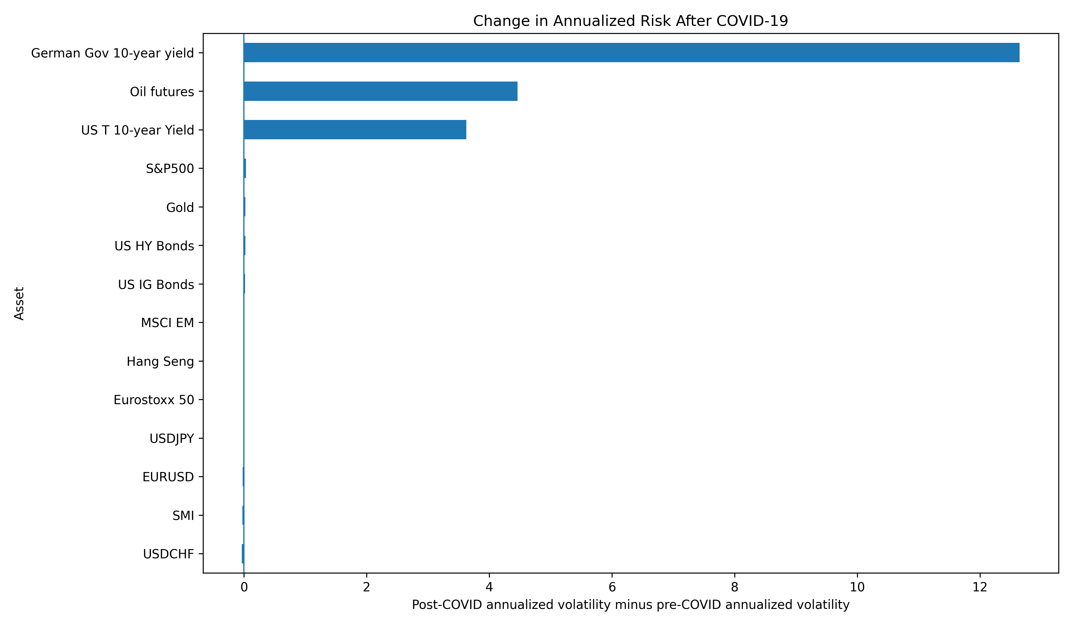
Figure 1. Change in annualized volatility (post-COVID minus pre-COVID) by asset. Source: authors' calculations from Data.xlsx (generated file: results/figures/volatility_change_pre_post.png).
Asset | Vol_ann_pre | Vol_ann_post | Vol_change_% | VaR_5_post | CVaR_5_post
S&P500 | 0.1735 | 0.2067 | 0.1914 | -0.0175 | -0.0304
Eurostoxx 50 | 0.2077 | 0.1989 | -0.0424 | -0.0172 | -0.0292
Hang Seng | 0.2442 | 0.2365 | -0.0318 | -0.0219 | -0.0309
MSCI EM | 0.1796 | 0.1755 | -0.0227 | -0.0165 | -0.0256
SMI | 0.1743 | 0.1496 | -0.1418 | -0.0134 | -0.0216
US T 10-year Yield | 92.5748 | 96.2001 | 0.0392 | -9.5320 | -13.5702
German Gov 10-year yield | 69.2791 | 81.9287 | 0.1826 | -7.8615 | -12.2206
Oil futures | 0.3771 | 4.8371 | 11.8266 | -0.0404 | -0.1946
Gold | 0.1557 | 0.1793 | 0.1518 | -0.0175 | -0.0272
EURUSD | 0.0969 | 0.0764 | -0.2115 | -0.0076 | -0.0102
USDJPY | 0.1051 | 0.0953 | -0.0936 | -0.0097 | -0.0143
US IG Bonds | 0.0468 | 0.0653 | 0.3961 | -0.0062 | -0.0093
US HY Bonds | 0.0409 | 0.0627 | 0.5321 | -0.0049 | -0.0094
USDCHF | 0.1137 | 0.0806 | -0.2912 | -0.0081 | -0.0118
Table 1. Pre/post comparison of volatility, skewness, kurtosis, VaR(5%), and CVaR(5%) by asset (results/tables/risk_comparison_pre_post.csv).
5.3 Co-Movement Structure: Correlations and Diversification
At aggregate level, average pairwise correlation decreases from 0.1022 to 0.0842 (change: -0.0180). Taken alone, this could suggest improved diversification potential after COVID. However, this aggregate number hides important internal rotations.
Block-level results show a very asymmetric picture. Within-block correlation increases strongly in credit (+0.3063) and yields (+0.1530), while commodities within-block correlation declines sharply (-0.1942). Between blocks, equities vs credit rises (+0.1767), but equities vs yields declines (-0.1274). FX internal correlation remains negative and becomes slightly more negative.
The key message is that diversification did not simply improve or deteriorate; it was reconfigured. Some combinations became less useful exactly where concentration risk matters (for example, inside credit), while others became less synchronized. For a portfolio manager, this means correlations should be monitored by block rather than only through one average cross-asset metric.
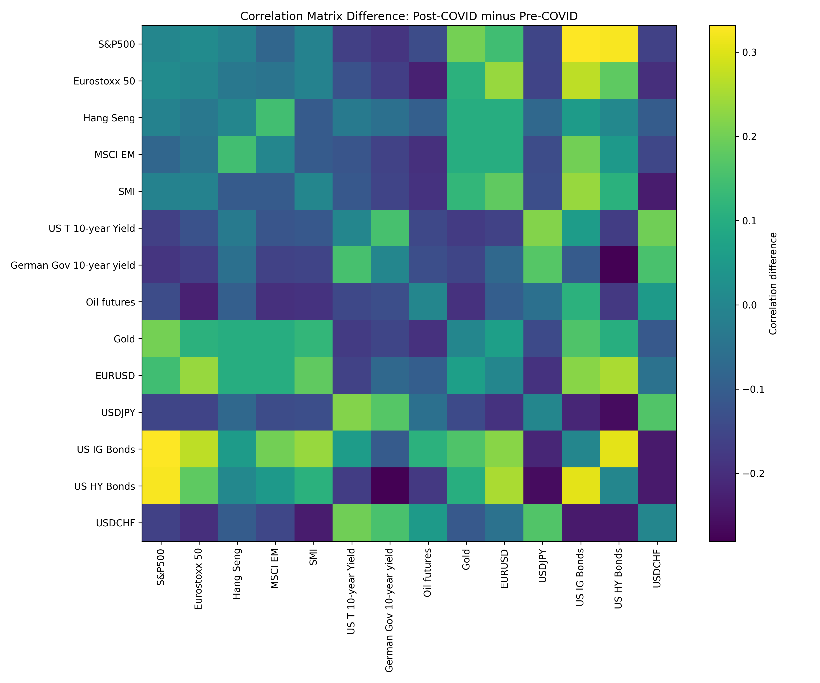
Figure 2. Heatmap of correlation changes (post-COVID minus pre-COVID) across all assets (results/figures/correlation_difference_heatmap.png).
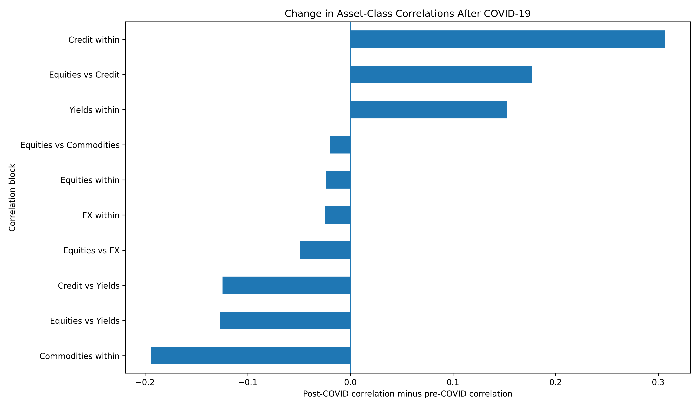
Figure 3. Change in within-block and between-block correlations (results/figures/block_correlation_change.png).
Average_correlation_pre | Average_correlation_post | Change
0.1022 | 0.0842 | -0.0180
Table 2. Average pairwise correlation summary pre vs post (results/tables/correlation_summary.csv).
Block | Correlation_pre | Correlation_post | Change
Equities within | 0.4783 | 0.4550 | -0.0233
Yields within | 0.5024 | 0.6553 | 0.1530
Commodities within | 0.1839 | -0.0103 | -0.1942
FX within | -0.2063 | -0.2314 | -0.0251
Credit within | 0.2503 | 0.5566 | 0.3063
Equities vs Yields | 0.1620 | 0.0346 | -0.1274
Equities vs Credit | 0.1375 | 0.3142 | 0.1767
Equities vs Commodities | 0.0641 | 0.0440 | -0.0201
Equities vs FX | 0.0819 | 0.0328 | -0.0491
Credit vs Yields | -0.3339 | -0.4585 | -0.1246
Table 3. Block-level correlation summary pre vs post (results/tables/block_correlation_summary.csv).
5.4 Factor Concentration: PCA Evidence
PCA results indicate stronger common-factor dominance after COVID. The explained variance of PC1 increases from 25.81% to 29.46% (+3.65 percentage points). The combined explained variance of PC1 and PC2 increases from 43.45% to 50.32% (+6.87 percentage points).
Economically, this means that a larger fraction of total market variation is captured by a smaller number of latent drivers in the post-COVID sample. Even when average correlations are not uniformly higher, portfolios can still be more exposed to common shocks if factor concentration rises.
The loading structure also changes. Before COVID, the strongest absolute loadings on PC1 are mostly equity indices, whereas after COVID the dominant absolute loadings include credit and FX exposures in addition to equities. This suggests a shift in what defines the first common factor.
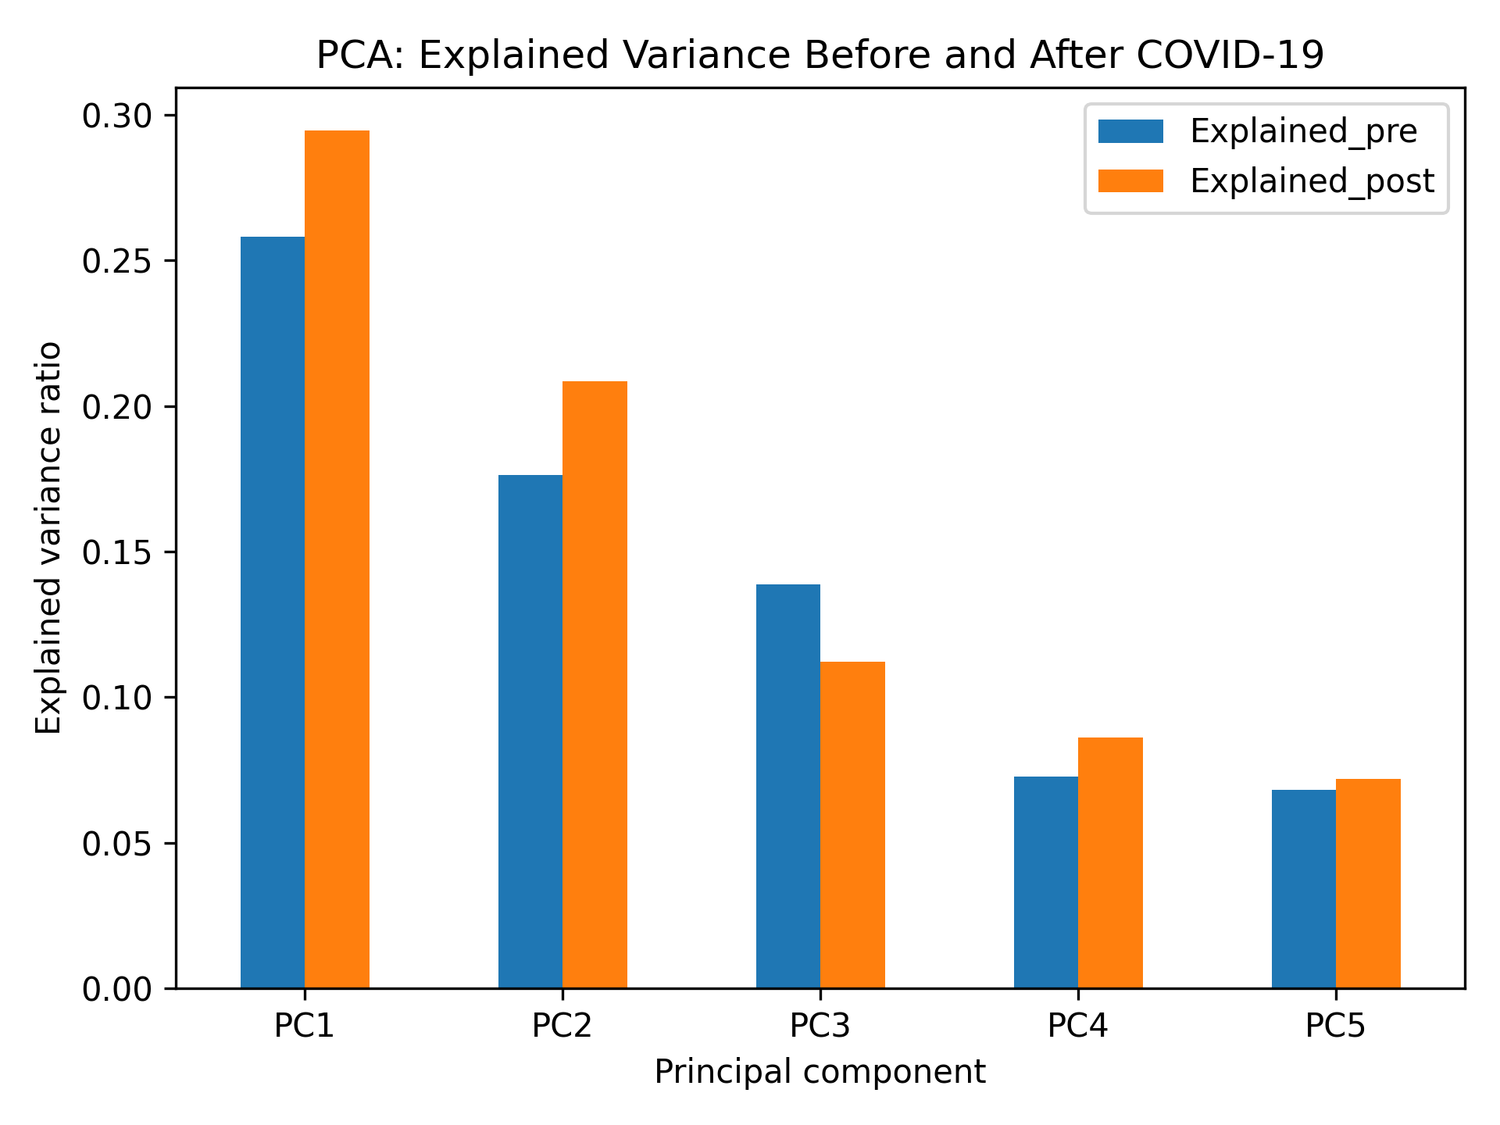
Figure 4. Explained variance ratios for principal components before and after COVID (results/figures/pca_explained_variance_pre_post.png).
Component | Explained_pre | Explained_post | Change
PC1 | 0.2581 | 0.2946 | 0.0365
PC2 | 0.1764 | 0.2086 | 0.0322
PC3 | 0.1387 | 0.1123 | -0.0264
PC4 | 0.0728 | 0.0863 | 0.0135
PC5 | 0.0682 | 0.0720 | 0.0038
PC6 | 0.0561 | 0.0537 | -0.0023
PC7 | 0.0503 | 0.0468 | -0.0035
PC8 | 0.0475 | 0.0323 | -0.0152
PC9 | 0.0395 | 0.0271 | -0.0124
PC10 | 0.0350 | 0.0213 | -0.0137
PC11 | 0.0195 | 0.0146 | -0.0049
PC12 | 0.0184 | 0.0129 | -0.0055
PC13 | 0.0124 | 0.0108 | -0.0015
PC14 | 0.0072 | 0.0068 | -0.0004
Table 4. PCA explained variance comparison (results/tables/pca_explained_variance_comparison.csv), with supporting loading tables in pca_loadings_pre.csv and pca_loadings_post.csv.
5.5 Time Variation: Rolling Evidence
Static pre/post tests are useful, but they cannot show how quickly risk structure changes over time. The rolling analysis addresses this point with a 252-day window.
Rolling average correlation reaches its maximum on 12 March 2020 (0.2505), very close to the WHO breakpoint, which confirms the intensity of the shock period. After the acute phase, correlation declines but does not follow a simple straight-line normalization. The series exhibits long phases of reconfiguration, with regime-like behavior rather than immediate reversion.
An additional perspective is obtained by comparing sub-period means: correlation is elevated around the crisis window (2018-2021), then moderates in the later post-COVID years. This dynamic is consistent with a shock-repricing phase followed by a new but less extreme equilibrium.
The rolling volatility figure for selected assets supports the same conclusion: volatility spikes are not synchronized in exactly the same way across asset classes, and post-2020 stabilization levels differ by market.
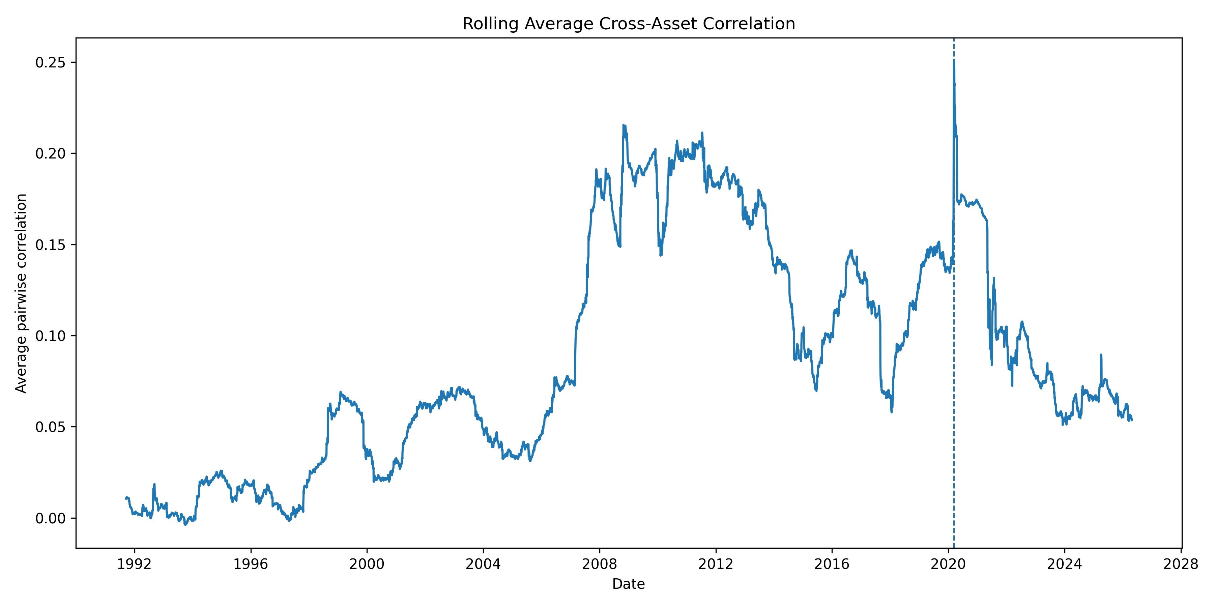
Figure 5. Rolling average cross-asset correlation, 252-day window (results/figures/rolling_average_correlation.png).
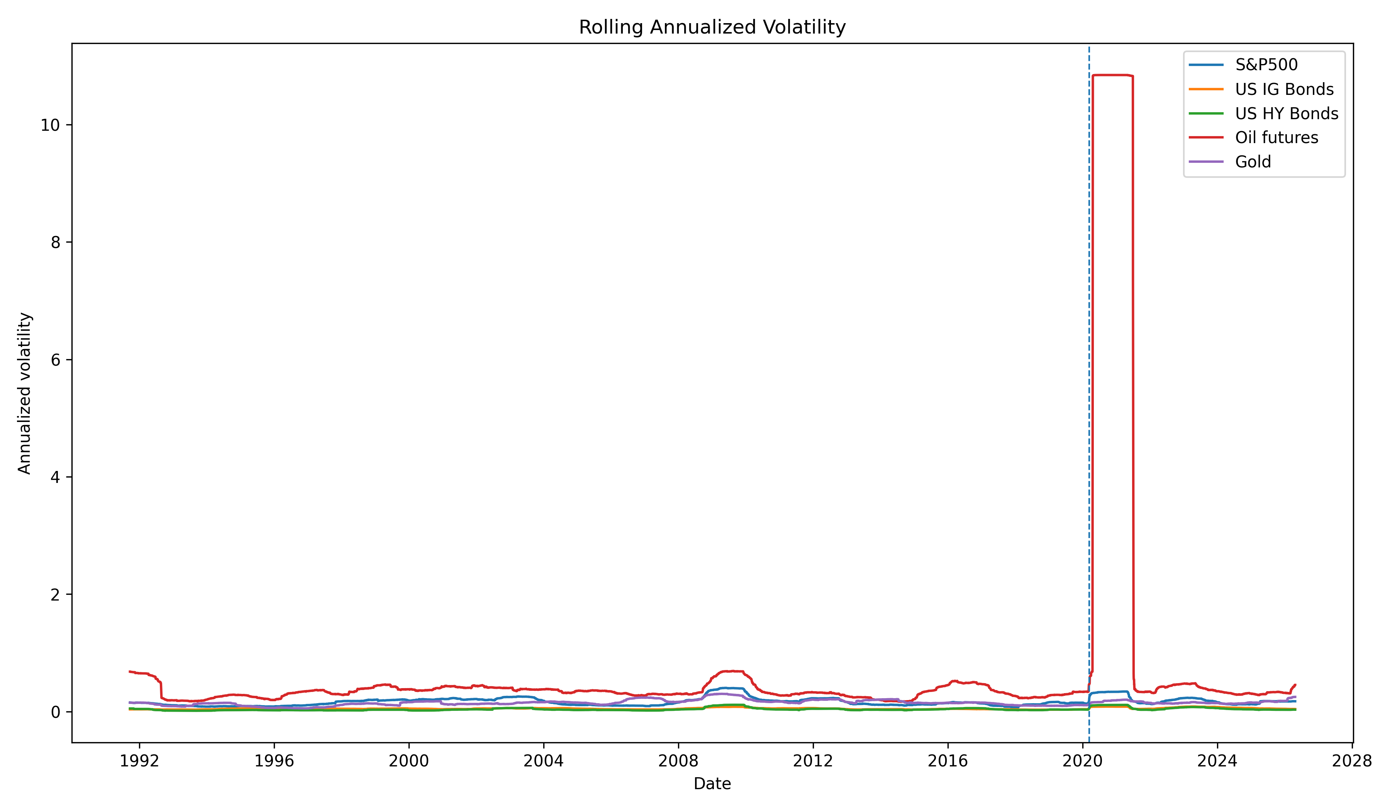
Figure 6. Rolling annualized volatility for selected assets, 252-day window (results/figures/rolling_volatility_selected_assets.png).
Rolling correlation statistic | Value
Mean pre-COVID | 0.0877
Mean post-COVID | 0.0958
Maximum (2020-03-12) | 0.2505
Minimum (1993-09-30) | -0.0038
Table 5. Rolling average correlation series (results/tables/rolling_average_correlation.csv).
5.6 Robustness and Stress Testing of the Main Result
To avoid over-dependence on one date definition, the analysis is repeated with four breakpoints: 24 February 2020, 11 March 2020, 23 March 2020, and 1 June 2020. Two key findings remain stable across all cases: (i) average correlation change remains negative; (ii) PC1 explained variance change remains positive.
More precisely, average correlation change ranges from -0.0048 to -0.0320, while PC1 change ranges from +0.0327 to +0.0374. The same direction is preserved when considering PC1+PC2 explained variance.
The no-oil robustness check is also informative. Without oil futures, the correlation change becomes close to zero (-0.0020), but factor concentration still increases (PC1 and PC1+PC2 both rise). This indicates that oil amplifies some magnitudes, but does not create the core structural result by itself.
Overall, robustness checks support the same narrative: post-COVID risk structure differs from pre-COVID risk structure, with reorganization in co-movements and higher factor concentration.
Breakpoint | Average_corr_change | PC1_change | PC1_PC2_change
2020-02-24 | -0.0048 | 0.0327 | 0.0778
2020-03-11 | -0.0180 | 0.0365 | 0.0687
2020-03-23 | -0.0320 | 0.0334 | 0.0583
2020-06-01 | -0.0173 | 0.0374 | 0.0544
Table 6. Breakpoint robustness summary (results/tables/breakpoint_robustness.csv).
Unnamed: 0 | Average_correlation_pre | Average_correlation_post | Change
0.0000 | 0.1030 | 0.1010 | -0.0020
Table 7. Correlation summary without oil futures (results/tables/correlation_summary_no_oil.csv).
Component | Explained_pre | Explained_post | Change
PC1 | 0.2740 | 0.3172 | 0.0432
PC2 | 0.1892 | 0.2244 | 0.0352
PC3 | 0.1462 | 0.1209 | -0.0253
PC4 | 0.0735 | 0.0928 | 0.0193
PC5 | 0.0619 | 0.0579 | -0.0040
PC6 | 0.0603 | 0.0512 | -0.0090
PC7 | 0.0523 | 0.0348 | -0.0176
PC8 | 0.0428 | 0.0292 | -0.0136
PC9 | 0.0378 | 0.0229 | -0.0148
PC10 | 0.0210 | 0.0157 | -0.0053
PC11 | 0.0198 | 0.0139 | -0.0059
PC12 | 0.0133 | 0.0116 | -0.0017
PC13 | 0.0077 | 0.0073 | -0.0004
Table 8. PCA comparison without oil futures (results/tables/pca_comparison_no_oil.csv).
5.7 Interim Answer to the Research Question
Taken together, the empirical evidence points to a structural change after COVID-19, but not a one-dimensional one. The main change is not that everything became permanently more volatile or permanently more correlated. Instead, the evidence supports a reallocation of risk across markets, a reshaping of dependence patterns, and a stronger role for common factors. This is why the empirical answer at this stage is yes, partially.

