 

**Placement Empowerment Program**

***Cloud Computing and DevOps Centre***

Automate File Copying with a Script

Create a script to copy files from one folder to another automatically.

Name: Shakthi Lakshmanan V Department: CSE



**Introduction:**

Automating repetitive tasks, like copying files, can save you a lot of time, reduce mistakes, and make your work more efficient. This is especially useful when you need to manage backups, organize files, or sync data between different folders. In this **Proof of Concept (PoC)**, we'll show you how to automatically copy files from one folder to another using a simple script.

**Overview:**

This script helps you copy files automatically from a **source folder** to a **destination folder**. It makes sure all the files in the source folder are copied correctly and efficiently, without any data loss. You can customize this script to fit your needs. For example, you might want to only copy certain types of files (like images or documents), or you might want to copy files that were recently modified.

You can write this script using different programming languages such as **Python**, **Shell scripting**, or **PowerShell**, depending on your operating system.

**Objectives:**

The goal of this task is to make your file management process easier and more efficient. Here are the key objectives:

1. **Simplify File Management:**
   * Instead of manually copying or moving files, this automation will do it for you. You don’t have to worry about forgetting files or wasting time on this task.
2. **Improve Efficiency:**
   * By automating the copying process, you can save time and focus on other important tasks. The script will run automatically, so you don’t have to manually trigger it.
3. **Ensure Data Integrity:**
   * The script will make sure that your files are copied correctly without any corruption or loss of data. This means the files will stay just as they were in the source folder.
4. **Customizable Workflow:**
   * You can adjust the script to meet your specific needs. For example, you can choose to copy only certain types of files (e.g., pictures or documents) or files that have been recently changed.
5. **Scalable Solution:**
   * This automation can be scaled to handle large numbers of files. As your file management needs grow, the script can handle the increased workload without slowing down.

**Step-by-Step Overview**

**Step 1 :**

Create two folders named Source and Destination

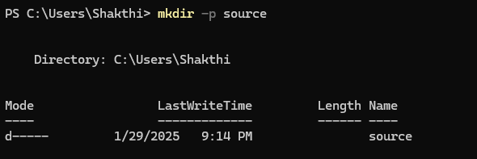

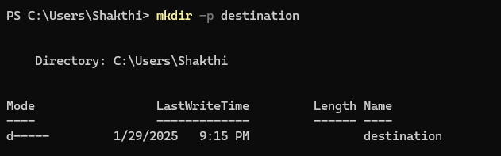

**Step 2 :** Store some files inside it to automate it

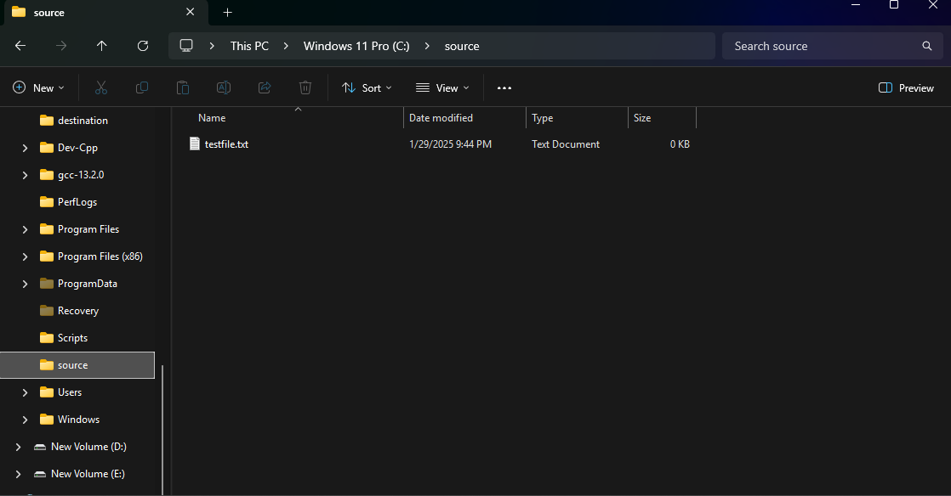

### ****Step 3:** Open Notepad**

Press **Win + R**, type notepad, and hit **Enter**.

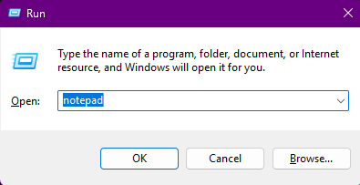

**Step 4 :** Write the Script into the notepad

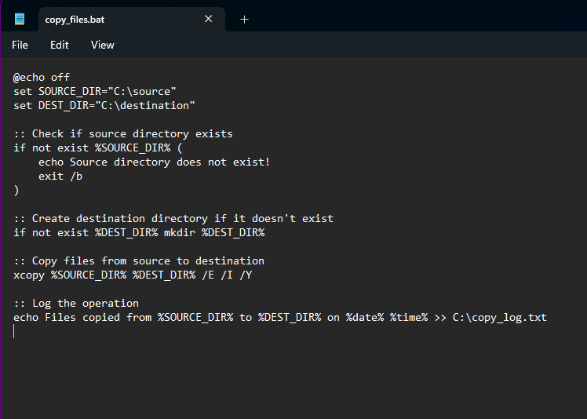

**Step 5 :** Then save the file in scripts folder with .bat extension (eg : copy_files.bat) so the file looks like this

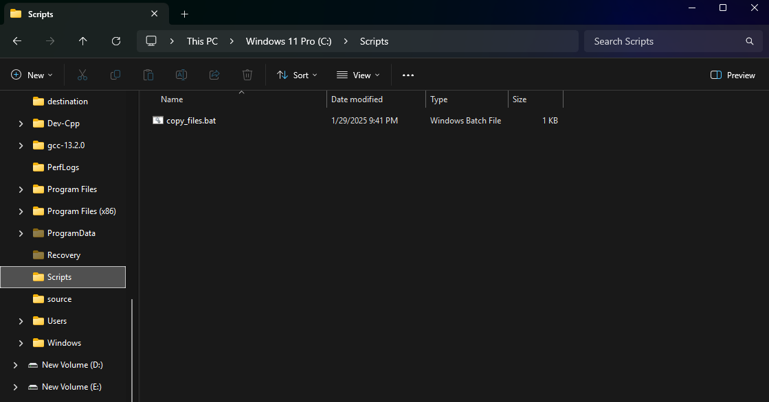

**Step 6 :**

Press **Win + R** on your keyboard.

A small "Run" dialog box will pop up.

Type **taskschd.msc** (without quotes) in the Run box.

Press Enter or click OK.This will open the Task Scheduler window.

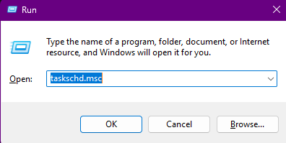

**Step 7:**

In the Task Scheduler window, look to the right-hand side for a button called **"**Create Basic Task**"**. Click it.

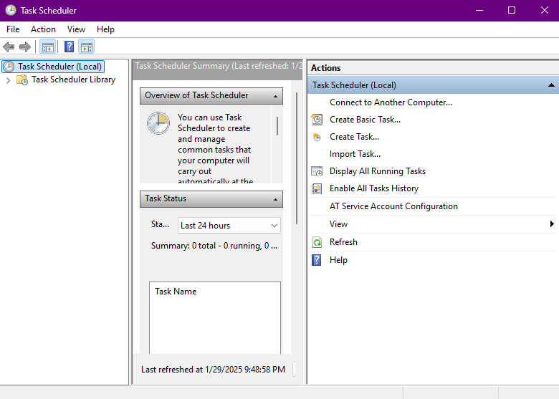

**Step 8:**

1. Enter a Name for the Task:

For example: "File Copy".(This can be anything that helps you remember what the task does.)

1. Click Next to continue.

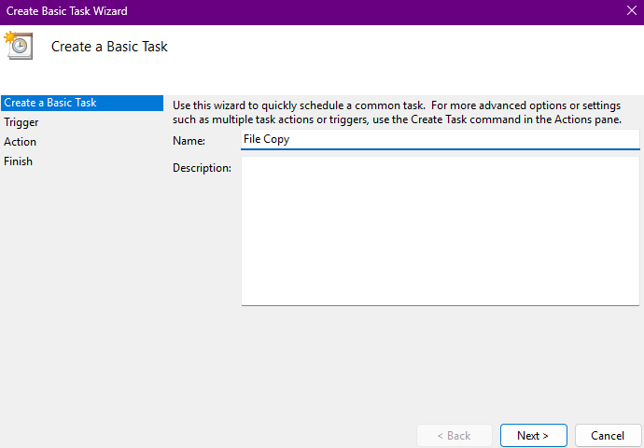

**Step 9 :**

Choose a Schedule:

You will see options like:

Daily (runs every day).

Weekly (runs once a week).

One time (runs only once at a specific time).

Choose what works for you (e.g., Daily) and click Next.

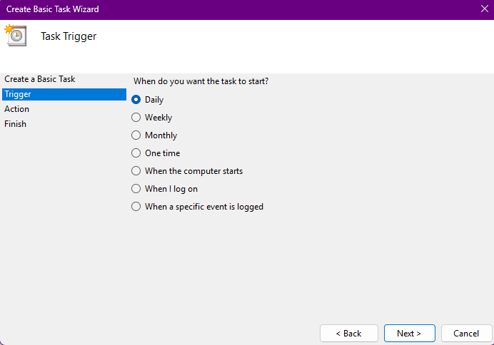

**Step 10 :**

Set the Time and Frequency:

If you chose Daily, specify:

The start date (it defaults to today).

The time (e.g., 7:00 AM).

Click Next to move on.

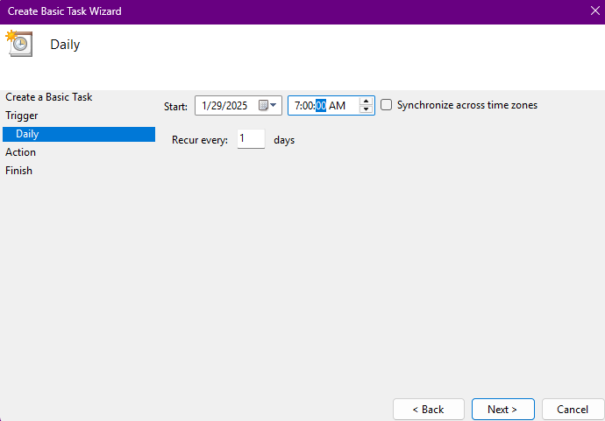

**Step 11 :**

Set the Action

Now, we tell Task Scheduler what to do when it runs.

Select "Start a Program":

On the "Action" screen, select the option **"**Start a Program**"** and click Next.

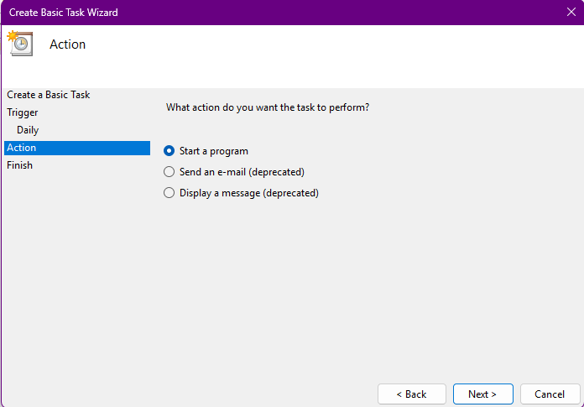

**Step 12 :**

Point to the Program or Script:

In the Program/script field, click **Browse** and navigate to the location of your .bat file.

Click Next.

Review and Finish

Click **Finish** to save and schedule the task.

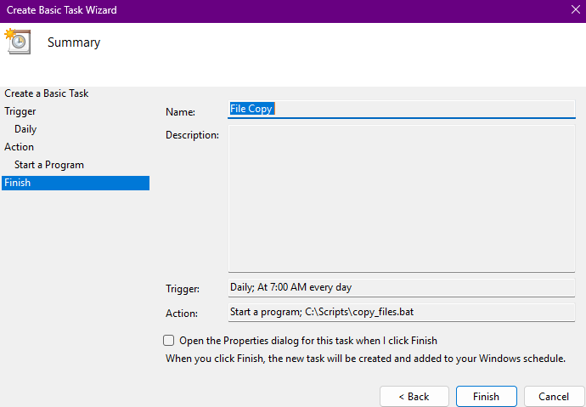

**Step 13 :**

In Task Scheduler, go to the **Task Scheduler Library** (on the left-hand side).

Find your task (it should have the name you gave it, e.g., "Automate File Copying").

Right-click the task and select **Run**.

This will manually trigger the task immediately.

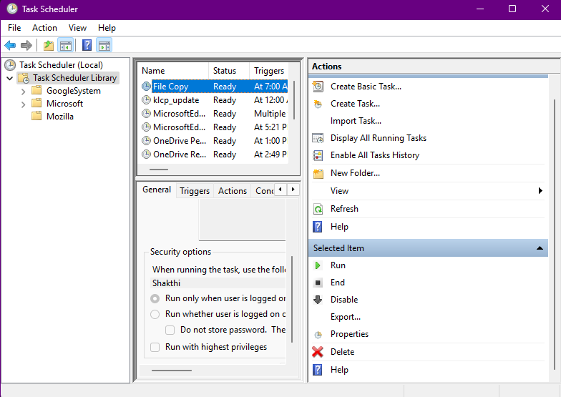

**Step 14 :**

If your task was set up to copy files, go to the destination folder and confirm that the files have been copied.

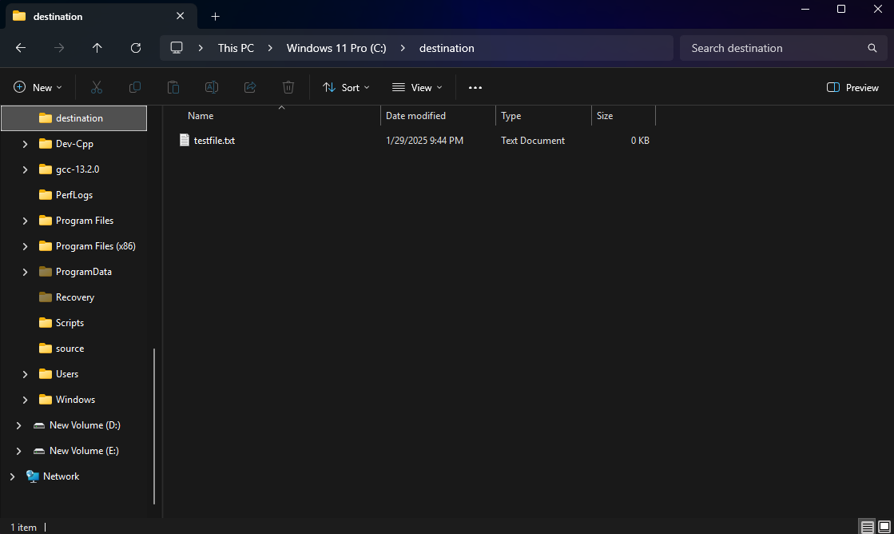

**Outcome**

By completing this Proof of Concept (PoC) of automating a task using Task Scheduler, you will:

1. Successfully set up an automated task that triggers on a schedule or when manually run.

2. Execute a batch script to copy files from a source folder to a destination folder automatically.

3. Understand how to use Task Scheduler to automate repetitive tasks in Windows.

4. Gain familiarity with task triggers, actions, and conditions in Task Scheduler.

5. Save time and ensure consistent execution of file operations without manual intervention.

6. Optionally test the task to verify that it runs as expected and achieves the desired outcome.

7. Enhance your workflow automation skills with practical hands-on experience.