 

# Placement Empowerment Program

***Cloud Computing and DevOps Centre***

Create a Simple Backup Script: Create a script that backs up your entire Git repository to a local folder daily

Name: Shakthi Lakshmanan V Department: CSE



### ****Introduction****

Backing up your Git repository is essential to prevent data loss caused by accidental deletions, hardware failures, or repository corruption. Losing important code can slow down development, so having a reliable backup system ensures your work is always safe. Automating this process saves time and guarantees that updates are regularly stored without manual effort.

### ****Overview****

This guide explains how to set up an **automated Git backup system** on a Windows computer using a **batch script and Task Scheduler**. The batch script will:

* Pull the latest changes from the GitHub repository.
* Store the updated repository in a local backup folder.
* Compress the repository into a **timestamped zip file** for easy access.

By using **Task Scheduler**, this script will run daily, ensuring your repository is always backed up without requiring manual execution.

### ****Key Components****

1. **Batch Script (.bat file):** Automates the cloning, updating, and backup of the repository.
2. **Task Scheduler:** Runs the script automatically at a set time every day.

### ****Objectives****

* **Automate daily backups** to keep the latest version of your repository.
* **Prevent data loss** by creating regular, secure backups.
* **Maintain organized backups** with timestamps for easy retrieval.
* **Eliminate manual effort** using Task Scheduler.

### ****Why It’s Important****

* **Disaster Recovery:** Restore lost or corrupted files quickly.
* **Version History:** Keep track of all changes over time.
* **Efficiency:** Focus on development instead of managing backups manually.
* **Better Organization:** Timestamped backups help track updates easily.

# Step-by-Step Overview

## Step 1:

Create a folder named Backup Folder to store your Backup files

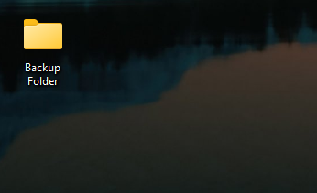

## Step 2:

Open Notepad and type this script . Make sure that in set REPO_URL give the URL of the repository you want to backup and in set BACK_DIR give the file path of the folder which you created in first step . Then save it as **.bat format** (eg:backup.bat) in Desktop

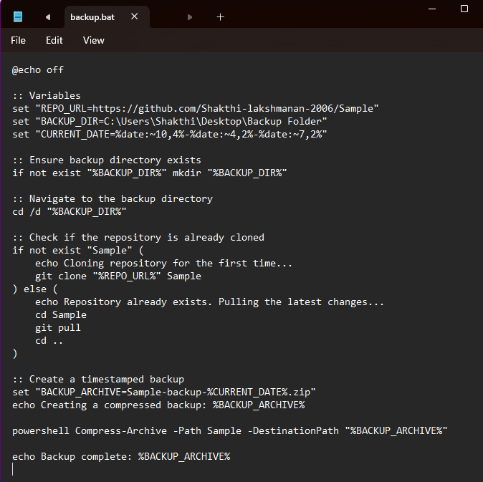

## Step 3:

Press **Win + R** on your keyboard.

A small "Run" dialog box will pop up.

Type **taskschd.msc** (without quotes) in the Run box.

Press Enter or click OK.This will open the Task Scheduler window.

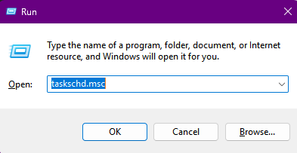

## Step 4:

In the Task Scheduler window, look to the right-hand side for a button called **"**Create Basic Task**"**.

Click it.

A wizard will open to guide you through the setup.

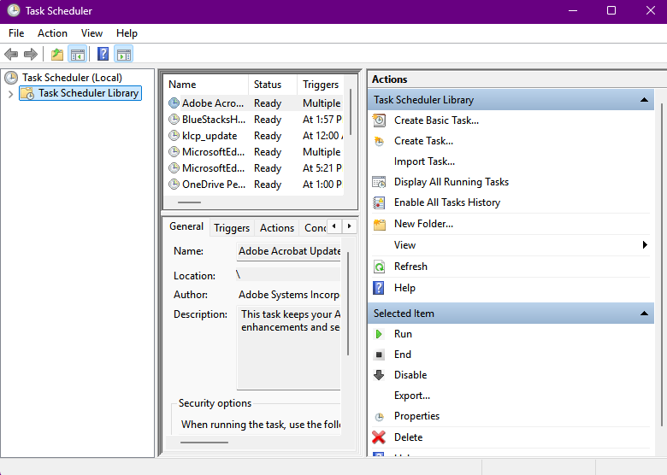

## Step 5:

1. Enter a Name for the Task:

For example: "GitRepositoryBackup".(This can be anything that helps you remember what the task does.)

Optionally, you can add a description like "Backsup files daily".

1. Click Next to continue.

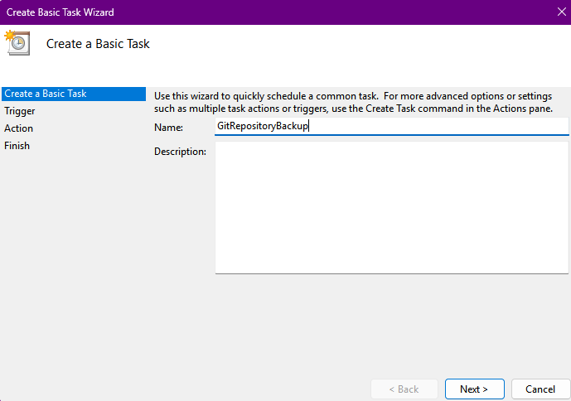

## Step 6:

Choose a Schedule:

You will see options like: Daily (runs every day).

Weekly (runs once a week).

One time (runs only once at a specific time).

Choose what works for you (e.g., Daily) and click Next.

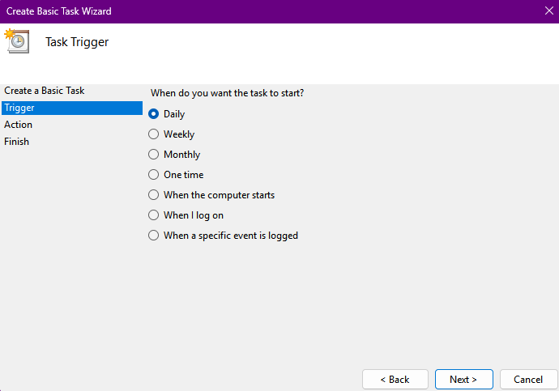

## Step 7:

Set the Time and Frequency:

If you chose Daily, specify:

The start date (it defaults to today).

The time (e.g., 06:20 PM). Click Next to move on.

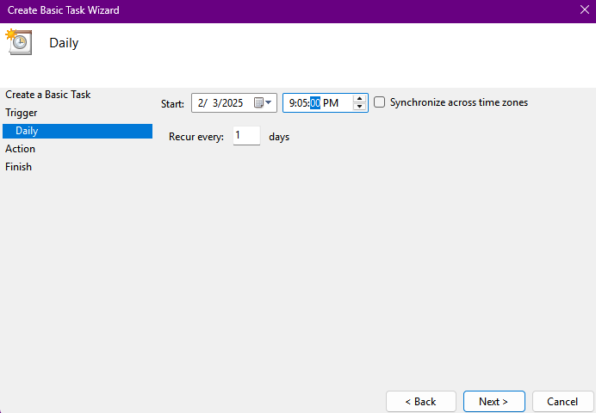

## Step 8:

Set the Action

Now, we tell Task Scheduler what to do when it runs.

Select "Start a Program":

On the "Action" screen, select the option **"**Start a Program**"** and click Next.

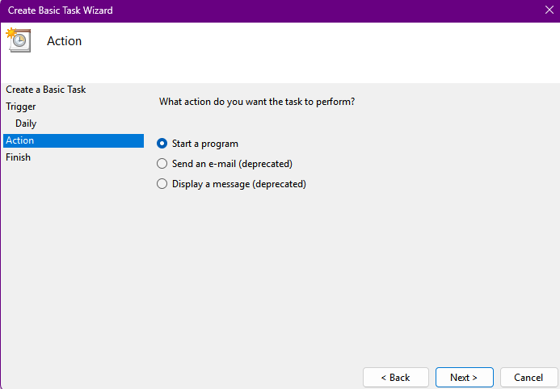

## Step 9:

Point to the Program or Script:

In the Program/script field, click **Browse** and navigate to the location of your .bat file.

Example: If your script is named backup.bat and saved on the desktop, navigate to that file and select it.

Click Next.

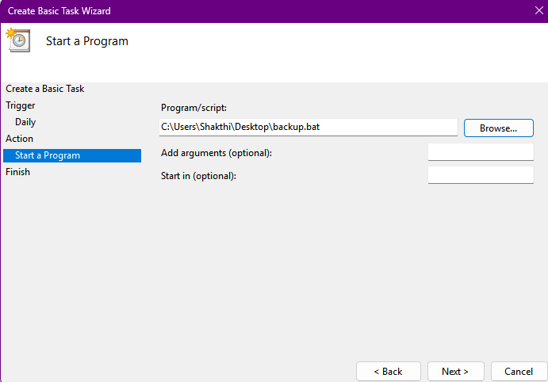

## Step 10:

Review and Finish

Click **Finish** to save and schedule the task.

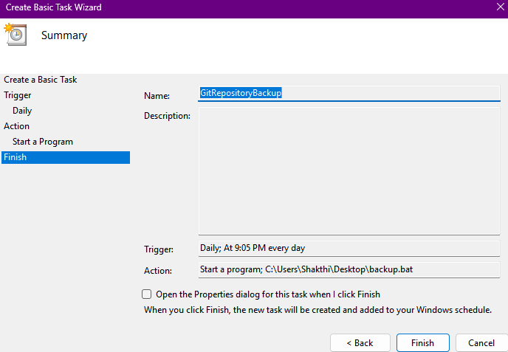

## Step 11:

In Task Scheduler, go to the **Task Scheduler Library** (on the left- hand side).

Find your task (it should have the name you gave it, e.g., "GitRepositoryBackup").

Right-click the task and select **Run**.

This will manually trigger the task immediately

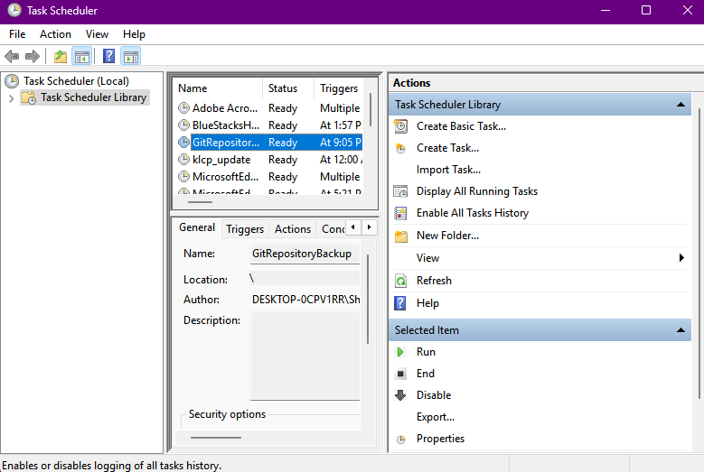

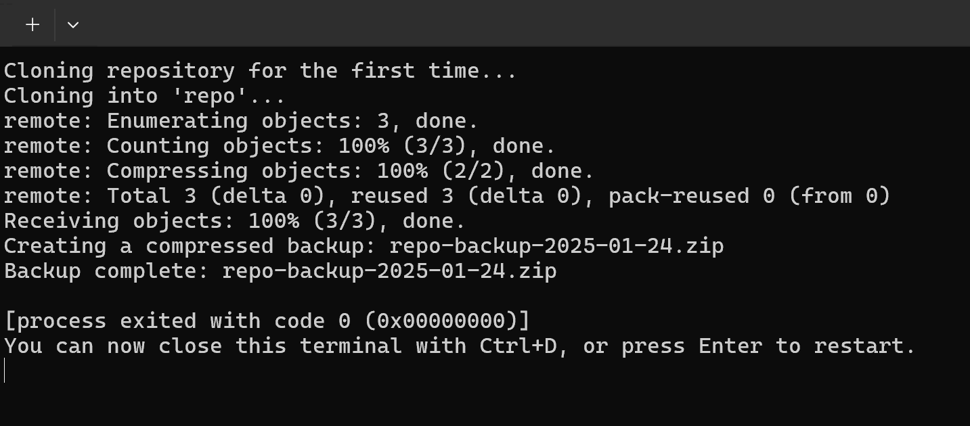

## Step 12:

Now u can see the folder which you created (GitHub Backup Folder) in the first step will now contains the files which is in your repository.

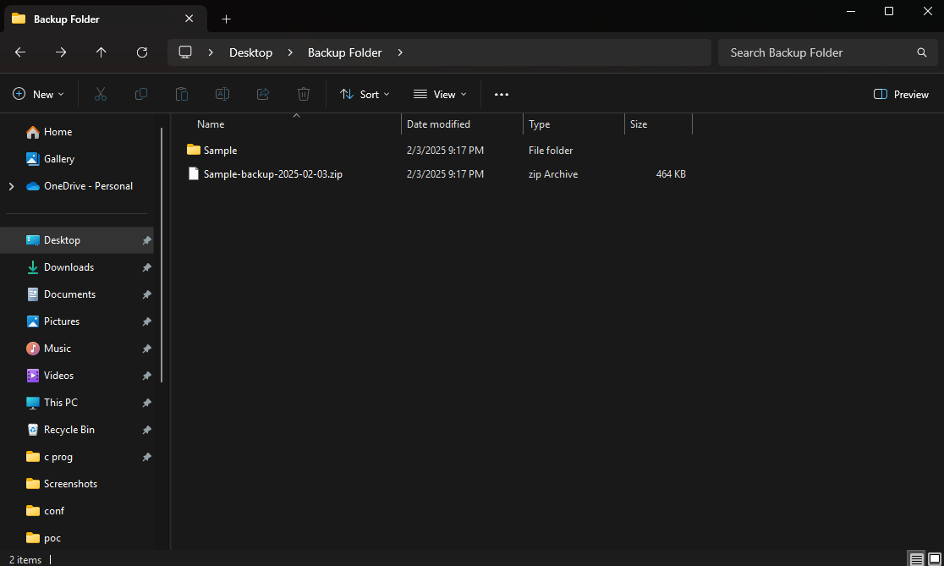

## Outcomes

By completing this Proof of Concept (PoC) of automating Git repository backups, you will:

**Successfully implement a backup system for Git repositories**: Automate the process of creating daily backups for your Git repositories, ensuring that all updates and changes are securely stored in a local folder.

### Master the use of batch scripting for task automation:

Learn to create and execute a .bat script that clones, pulls updates, and compresses a Git repository into timestamped backup archives.

### Understand Task Scheduler's automation capabilities:

Gain practical experience with Task Scheduler, learning how to set triggers, define actions, and configure conditions to automate repetitive tasks seamlessly on a Windows system.