 

# Placement Empowerment Program

***Cloud Computing and DevOps Centre***

Set Up a Virtual Machine in the Cloud Create a free- tier AWS account. Launch a virtual machine and SSH into it.

Name: Shakthi Lakshmanan V Department:CSE



## 

## **Introduction**

This Proof of Concept (POC) explores the process of setting up a virtual machine (VM) using the AWS Free Tier. Virtual machines are essential in cloud computing, allowing users to deploy and manage computing resources without physical hardware. This POC serves as a beginner-friendly exercise to understand cloud infrastructure and create a simple, cost-effective computing environment using AWS EC2.

## **Overview**

This POC provides a step-by-step guide to:

1. Creating a free AWS account.
2. Launching a virtual machine using AWS EC2.
3. Configuring and securing the instance with a key pair and a security group.
4. Connecting to the VM via SSH from a Windows system.

It offers hands-on experience with AWS infrastructure and fundamental cloud computing tasks.

## **Objectives**

1. **Understand AWS EC2 Basics** – Learn how to create, configure, and manage an EC2 instance.
2. **Practice Secure Connections** – Use SSH to securely connect to the instance.
3. **Gain Hands-On Experience** – Explore AWS tools for managing cloud resources.
4. **Optimize Free Tier Usage** – Learn to use AWS Free Tier effectively to avoid extra costs.

## **Importance**

* **Fundamental Cloud Skill** – Launching and managing VMs is a key skill for cloud professionals.
* **Hands-on Learning** – Enhances practical knowledge of AWS, security configurations, and SSH connections.
* **Scalability & Flexibility** – Demonstrates the advantages of cloud-based infrastructure over traditional setups.
* **Cost-Effective Exploration** – Leverage AWS Free Tier for learning without financial risk.
* **Career Growth** – Valuable for IT, cloud computing, and DevOps professionals.

# Step-by-Step Overview

## Step 1:

1. Go to [AWS Management Console](https://aws.amazon.com/console/).
2. Enter your username and password to log in.

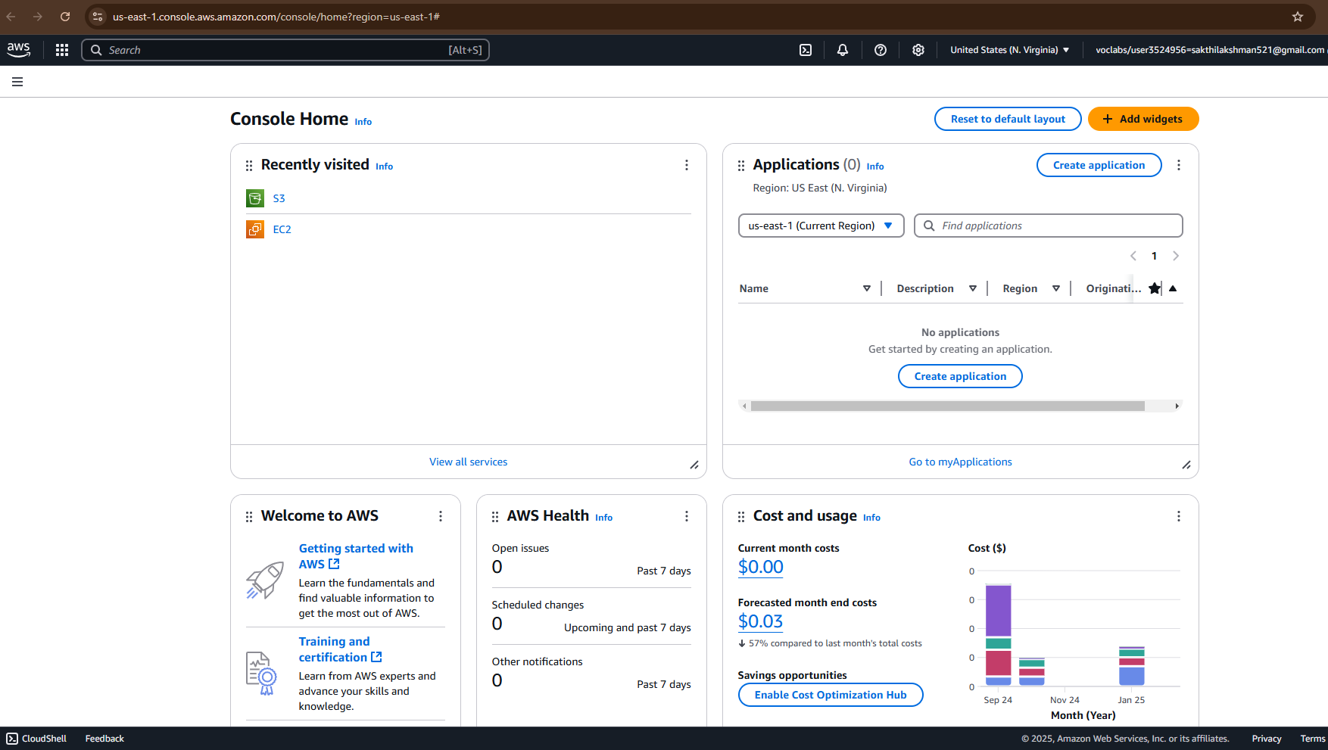

## Step 2:

## Navigate to the AWS Management Console and search for **EC2**.

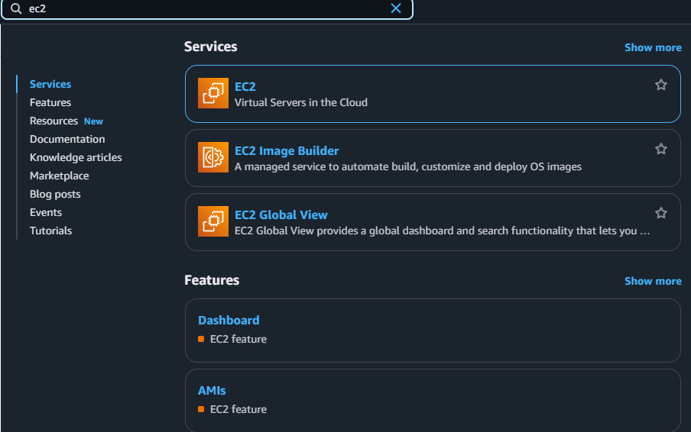

## Step 3:

Click **Launch Instances**.

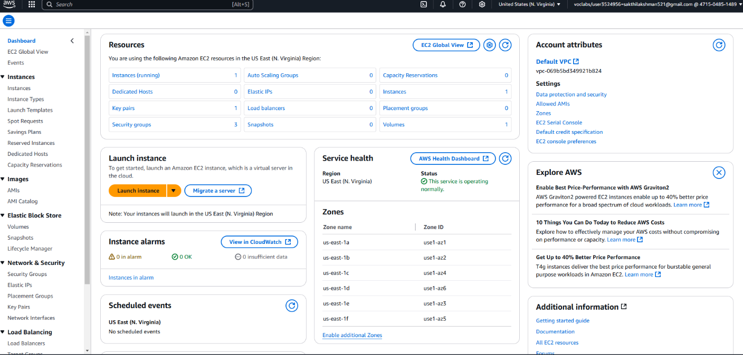

## Step 4:

1. Choose **Amazon Linux 2023 Free Tier AMI** or **Ubuntu Free Tier AMI**.
2. Select the **t2.micro** instance type (free tier).
3. Configure security group:

Allow **SSH** (Port 22) from your IP.

1. Add a key pair:

If you don’t have one, create a new key pair and download it as a .pem file.

1. Click **Launch Instance**.

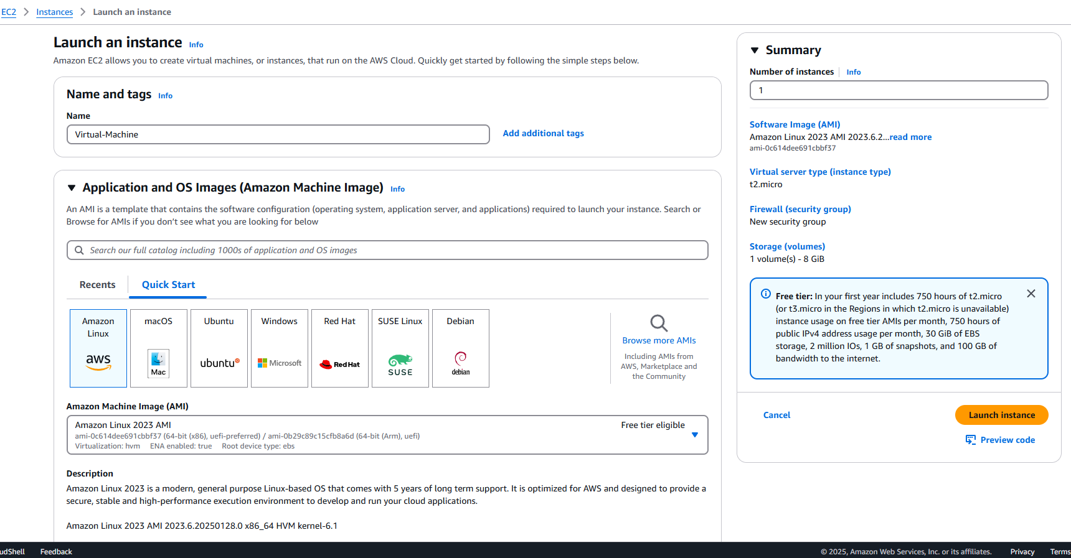

## Step 5:

Check your running instance in the Instances section . Select your Instance and click the Connect Option.

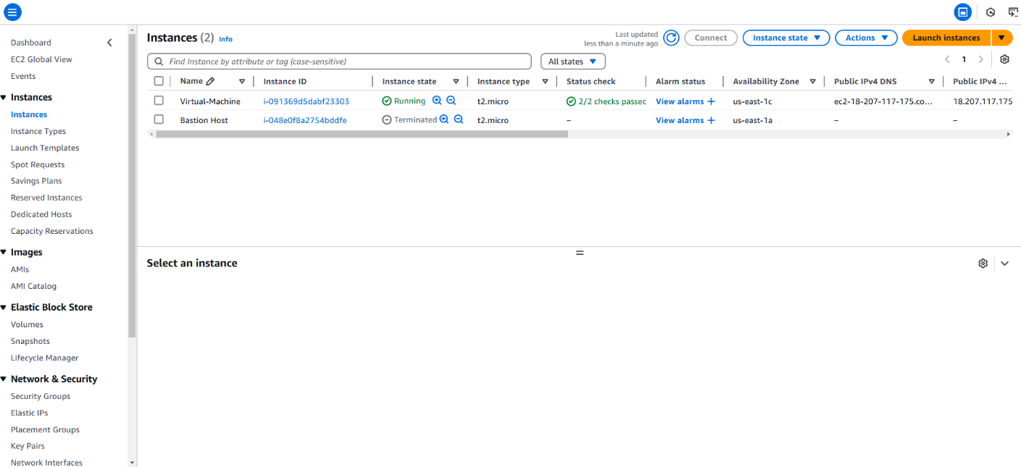

## Step 6:

Go to the SSH client section, and copy the command provided under the 'Example' section.

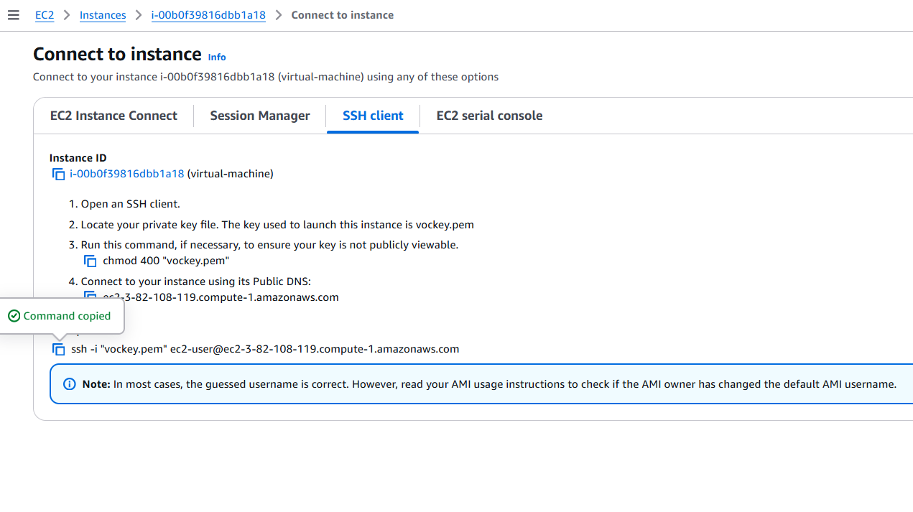

## Step 7:

Open PowerShell, navigate to the Downloads folder. Run the SSH command from the EC2 Connect section, replace the key name with your downloaded key (e.g., new.pem), press Enter, and type yes when prompted.

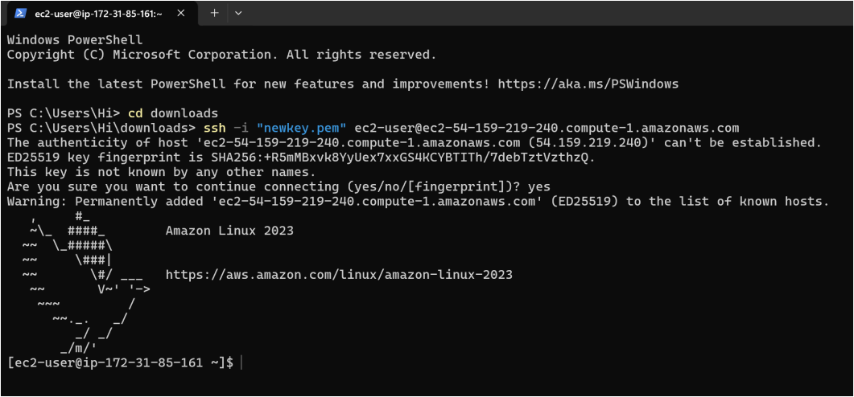

Successfully completed the setup of a virtual machine in AWS.

# Outcome

By completing this PoC of setting up a virtual machine in AWS, you will:

1. Create and configure a free AWS account to use cloud resources within the Free Tier.
2. Launch an EC2 instance with Amazon Linux or Ubuntu as the operating system.
3. Generate and manage a secure key pair for SSH access to your EC2 instance.
4. Configure a security group to allow SSH connections to your instance from your IP address.
5. Successfully connect to the EC2 instance via SSH using the public IP address.
6. Gain hands-on experience with AWS EC2 and foundational cloud computing concepts.