CNS – IMPORTANT
UNIT – 1
1.List and explain the categories of passive and active security attacks. 13 marks
Below is a well-structured 13-mark answer, written in exam-oriented language, suitable for CNS (1904005) – Unit I.

Categories of Passive and Active Security Attacks
A security attack is any action that compromises the confidentiality, integrity, or availability of information. According to the OSI Security Architecture, attacks are broadly classified into Passive attacks and Active attacks.

1. Passive Attacks
Definition
A passive attack is an attack in which the attacker monitors or eavesdrops on the communication without altering the data. The main goal is to obtain information secretly.
Characteristics
- No modification of data
- Difficult to detect
- Targets confidentiality
- Prevention is possible using encryption
Categories of Passive Attacks
(a) Release of Message Contents
In this attack, the attacker gains access to the actual content of messages being transmitted.
Examples:
- Reading emails
- Intercepting passwords
- Capturing confidential files during transmission
Impact:
Loss of confidentiality of sensitive information.

(b) Traffic Analysis
Even if data is encrypted, an attacker can analyze communication patterns such as:
- Message length
- Frequency
- Timing
- Source and destination addresses
Examples:
- Identifying communication between a user and a bank
- Inferring military or business activity from traffic volume
Impact:
Sensitive information can be inferred without decrypting data.

Summary of Passive Attacks
Type | Objective | Affects
Release of message contents | Steal actual data | Confidentiality
Traffic analysis | Infer information | Confidentiality

2. Active Attacks
Definition
An active attack involves modification, fabrication, or disruption of data or services. The attacker attempts to alter system resources or operations.
Characteristics
- Data is modified or destroyed
- Easier to detect than passive attacks
- Targets integrity, authentication, and availability
- Difficult to prevent completely

Categories of Active Attacks
(a) Masquerade
An attacker pretends to be a legitimate user to gain unauthorized access.
Examples:
- Using stolen login credentials
- IP spoofing
Impact:
Breaks authentication and trust.

(b) Replay Attack
A valid data transmission is captured and retransmitted later to produce an unauthorized effect.
Examples:
- Replaying authentication messages
- Reusing session tokens
Impact:
Unauthorized access without knowing credentials.

(c) Modification of Messages
The attacker alters the message contents during transmission.
Examples:
- Changing transaction amount in online banking
- Modifying commands sent to servers
Impact:
Loss of data integrity.

(d) Denial of Service (DoS)
The attacker prevents legitimate users from accessing network resources.
Examples:
- Flooding a server with fake requests
- Distributed DoS (DDoS) attacks
Impact:
Loss of availability of services.

Summary of Active Attacks
Type | Objective | Affects
Masquerade | Impersonation | Authentication
Replay | Reuse valid data | Authentication
Message modification | Alter data | Integrity
DoS | Disrupt service | Availability

Comparison of Passive and Active Attacks
Feature | Passive Attack | Active Attack
Data modification | No | Yes
Detection | Difficult | Easier
Prevention | Encryption | Authentication, IDS
Security goal affected | Confidentiality | Integrity, Availability

Conclusion
Passive attacks aim to observe information secretly, while active attacks attempt to alter or disrupt communication. A strong network security system must use encryption, authentication, intrusion detection, and access control mechanisms to defend against both types of attacks.

2. (i) What is Steganography? Briefly examine any three techniques. (7) (ii) What is mono-alphabetic cipher? Examine how it differs from Caesar cipher? 13 mark question
(i) Steganography and Its Techniques
Steganography is the practice of hiding secret information within an ordinary medium—such as images, audio, video, or text files—so that not only is the content concealed but the presence of a message itself is undetectable to an observer. Derived from the Greek words for "covered writing," steganography has evolved from ancient practices like invisible ink to sophisticated digital techniques today.​
Detailed Techniques
- Least Significant Bit (LSB) Technique:
This is the most common method, especially with images and audio files. Here, the least significant bits (the smallest value bits) of pixel or sound sample data are replaced with the bits of the secret message. This change is so minimal that it cannot be detected by the human eye or ear, making it highly effective for covert communication and watermarking.​
- Text Steganography:
It involves embedding secret information within text documents. This can be done using techniques such as inserting hidden messages in whitespace patterns, changing the formatting of certain characters, or using the first letter of each word or sentence to spell out a secret. This method is subtle and can escape notice unless the observer knows what to look for.​
- Audio and Video Steganography:
With audio, information is hidden in sound files using techniques similar to LSB but applied to digital audio waveforms. With video steganography, secret data is embedded across several video frames, possibly utilizing color, timing, or compression artifacts. Both aim to distribute the hidden information so that it is imperceptible through standard playback.​
Other Forms: Frequency domain embedding (hiding information in transformed data such as DCT coefficients used in JPEG images), palette-based techniques (using indexed color representations in GIFs), and network/protocol steganography (embedding data in network protocol headers) expand the arsenal of digital steganography tools.​
(ii) Mono-Alphabetic Cipher vs. Caesar Cipher
Mono-Alphabetic Cipher
A mono-alphabetic cipher is a substitution cipher where every letter of the plaintext is substituted by another fixed letter from the alphabet based on a key, which represents a scrambled version of the standard alphabet. Each plaintext letter always maps to the same ciphertext letter, and the mapping does not change throughout the message.​
- Key Space: The number of possible keys in a mono-alphabetic cipher is 26! (factorial), making brute-force attacks much more difficult than with simpler ciphers.
Caesar Cipher
The Caesar cipher is a special, much simpler form of a mono-alphabetic cipher. Each letter of plaintext is shifted by a fixed number of positions along the alphabet; for example, with a shift of 3, A becomes D, B becomes E, etc. The mapping is uniform and predictable for every letter, unlike the arbitrary mapping in the generic mono-alphabetic cipher.​
- Key Space: Only 25 possible keys (one for each shift), making brute-force attacks trivial.
Feature | Mono-Alphabetic Cipher | Caesar Cipher
Mapping | Arbitrary (fixed key) | Fixed shift pattern
Number of keys | 26! | 25
Example Mapping for 'A' | Could be any letter | D (if shift = 3)
Security | High (if key is random) | Low (susceptible to brute force and frequency analysis)
Key difference: The Caesar cipher is a fixed subset of the mono-alphabetic cipher (one rule: shift by n), while a mono-alphabetic cipher can use any rearrangement of the alphabet as its rule, vastly increasing the key space but still vulnerable to frequency analysis attacks
Difference from Caesar Cipher:
Feature | Caesar Cipher | Mono-alphabetic Cipher
Type of shift | Fixed shift (e.g., +3) | Arbitrary substitution (random mapping)
Key space | Only 25 possible keys | 26! (factorial) possible mappings → much larger
Security | Easy to break using frequency analysis | Harder but still vulnerable to frequency analysis
Example | A → D, B → E | A → Q, B → M, C → R, etc.

UNIT – 2
1. Explain the RC4 method used for encryption and decryption.
RC4 Method for Encryption and Decryption
1. Introduction
RC4 (Rivest Cipher 4) is one of the most widely used stream ciphers in cryptography. It was designed by Ron Rivest in 1987 and kept secret until it was leaked in 1994. Unlike block ciphers such as DES or AES, RC4 is a stream cipher that encrypts data one byte at a time. It is simple, fast in software, and was used in protocols such as SSL/TLS, WEP, WPA, and Microsoft Office encryption.
2. Principles of RC4
- RC4 uses a variable key size (from 40 bits up to 2048 bits).
- It is based on key-dependent permutation and pseudo-random generation.
- Encryption and decryption are performed using the bitwise XOR operation with a generated keystream.
- Since XOR is reversible, the same operation is used for both encryption and decryption.
3. Components of RC4
RC4 consists of two main algorithms:
- Key Scheduling Algorithm (KSA) – initializes the cipher state using the secret key.
- Pseudo-Random Generation Algorithm (PRGA) – produces the keystream for encryption/decryption.
4. Working of RC4
Step 1: Initialization
- RC4 maintains a state array S of size 256 (values 0 to 255).
- A temporary array T is also created using the secret key.
- Example: If the key length = 5 bytes, then T[0]..T[255] is filled with repeating key values.
Step 2: Key Scheduling Algorithm (KSA)
- The array S is permuted based on the key.
- Pseudocode:
- for i = 0 to 255:
- S[i] = i
- T[i] = K[i mod keylength]
- j = 0
- for i = 0 to 255:
- j = (j + S[i] + T[i]) mod 256
- swap(S[i], S[j])
- After this, the array S is a scrambled version of numbers 0–255, depending on the key.
Step 3: Pseudo-Random Generation Algorithm (PRGA)
- Produces a keystream byte for each plaintext byte.
- Pseudocode:
- i = 0, j = 0
- while generating keystream:
- i = (i + 1) mod 256
- j = (j + S[i]) mod 256
- swap(S[i], S[j])
- t = (S[i] + S[j]) mod 256
- K = S[t] // Keystream byte
- This keystream byte K is XORed with plaintext byte P to produce ciphertext byte C.
Formula:
$$C_{i}=P_{i}⊕K_{i}$$
For decryption:
$$P_{i}=C_{i}⊕K_{i}$$
Since XOR is reversible, encryption and decryption use the same process.
5. Example
Suppose the plaintext is:
P = [65, 66, 67] (ASCII for "ABC")
And assume the keystream generated is:
K = [21, 56, 90]
Then ciphertext is:
- C1 = 65 ⊕ 21 = 84
- C2 = 66 ⊕ 56 = 122
- C3 = 67 ⊕ 90 = 25
So the encrypted text is [84, 122, 25].
During decryption, XORing the ciphertext with the same keystream gives back the original plaintext.
6. Strengths of RC4
- Very simple and efficient in software.
- Variable key size (40–2048 bits).
- Used in popular protocols (SSL/TLS, WEP, WPA, etc.).
- Symmetric: same algorithm for encryption and decryption.
7. Weaknesses of RC4
- Key scheduling is weak: first few bytes of the keystream are biased.
- Vulnerable to attacks if not properly used (e.g., WEP was broken due to weak RC4 implementation).
- Modern standards like AES have replaced RC4 because of better security.
8. Applications
- Previously used in TLS/SSL for web encryption.
- Wireless security protocols (WEP, WPA).
- Microsoft Office and PDF encryption.
- Secure communications in lightweight systems (though now discouraged).
9. Conclusion
RC4 is a fast, simple stream cipher based on key-dependent permutations and XOR operations. It was widely used due to its efficiency, but weaknesses in its key scheduling and keystream bias led to practical attacks. Today, RC4 is considered deprecated in modern cryptography, but it remains an important cipher for understanding stream encryption principles.

2. Illustrate Evaluation criteria for AES

Evaluation Criteria for AES
The Advanced Encryption Standard (AES) was selected through an open competition organized by NIST (National Institute of Standards and Technology) in the late 1990s. More than 15 algorithms were submitted by researchers worldwide, and after multiple rounds of public evaluation, Rijndael was finally chosen as AES in 2001.
To ensure that the selected cipher was both secure and practical, NIST laid down a set of evaluation criteria. These criteria helped to compare different candidate algorithms fairly and select the one best suited for standardization.
The major evaluation criteria for AES are:

1. Security (Most Important Criterion)
- Security was the top priority in AES selection.
- The algorithm must resist all known forms of cryptanalytic attacks such as:
  - Differential cryptanalysis
  - Linear cryptanalysis
  - Interpolation attacks
  - Square attacks
- The design should also provide resistance against future attacks that may emerge.
- Key sizes of 128, 192, and 256 bits were required, ensuring different levels of security.
- Rijndael (AES) showed no practical vulnerabilities and strong resistance to cryptanalysis.

2. Cost (Efficiency in Software & Hardware)
- The algorithm must be efficient on:
  - Software platforms (C, Java, etc.)
  - Hardware platforms (FPGA, ASIC, smart cards).
- It should require low memory, low power consumption, and minimal gate count in hardware implementations.
- Rijndael was particularly attractive because:
  - It has low computational cost.
  - It is suitable for both 8-bit smart cards and high-performance processors.

3. Algorithm & Implementation Characteristics
- Simplicity: The design should be easy to understand, implement, and verify.
- Flexibility: The cipher should work efficiently across a wide range of applications.
- Scalability: Ability to scale with longer key lengths without significant performance loss.
- In-place operation: Rijndael’s structure allowed encryption and decryption to be done with minimal memory requirements.
- Parallelism: AES supports parallel processing, which increases speed in modern CPUs.

4. Randomness and Avalanche Effect
- A small change in the input (plaintext or key) must produce a drastically different output (ciphertext).
- AES satisfied the avalanche criterion, meaning one bit change in plaintext/key results in significant ciphertext change.
- This property ensures unpredictability and strengthens resistance against statistical attacks.

5. Suitability for Different Environments
- AES had to be practical in a variety of devices such as:
  - Smart cards (low-memory, low-power devices).
  - Routers and network equipment (high throughput).
  - General computing devices (PCs, servers).
- Rijndael performed efficiently across constrained and high-performance environments, making it versatile.

6. Ease of Analysis
- The design should be transparent to allow cryptographers worldwide to analyze it thoroughly.
- Rijndael had a clean mathematical structure based on substitution–permutation networks (SPN).
- This transparency allowed confidence in its long-term security.

Conclusion
The evaluation criteria for AES emphasized security first, followed by efficiency, cost, flexibility, and suitability across environments. Rijndael excelled in all aspects, showing:
- Strong resistance to cryptanalysis.
- High performance on both hardware and software.
- Low resource consumption.
- Scalability with multiple key lengths.
Because of these factors, Rijndael was selected as AES in 2001 and remains one of the most widely used encryption standards globally today.

- https://www.geeksforgeeks.org/computer-networks/data-encryption-standard-des-set-1/

- https://www.geeksforgeeks.org/computer-networks/advanced-encryption-standard-aes/

UNIT – 4
Explain in detail about X.509 authentication services.(13marks)
Below is a clear, exam-oriented 13-mark answer for X.509 Authentication Services, written in simple language and proper structure.

X.509 Authentication Services

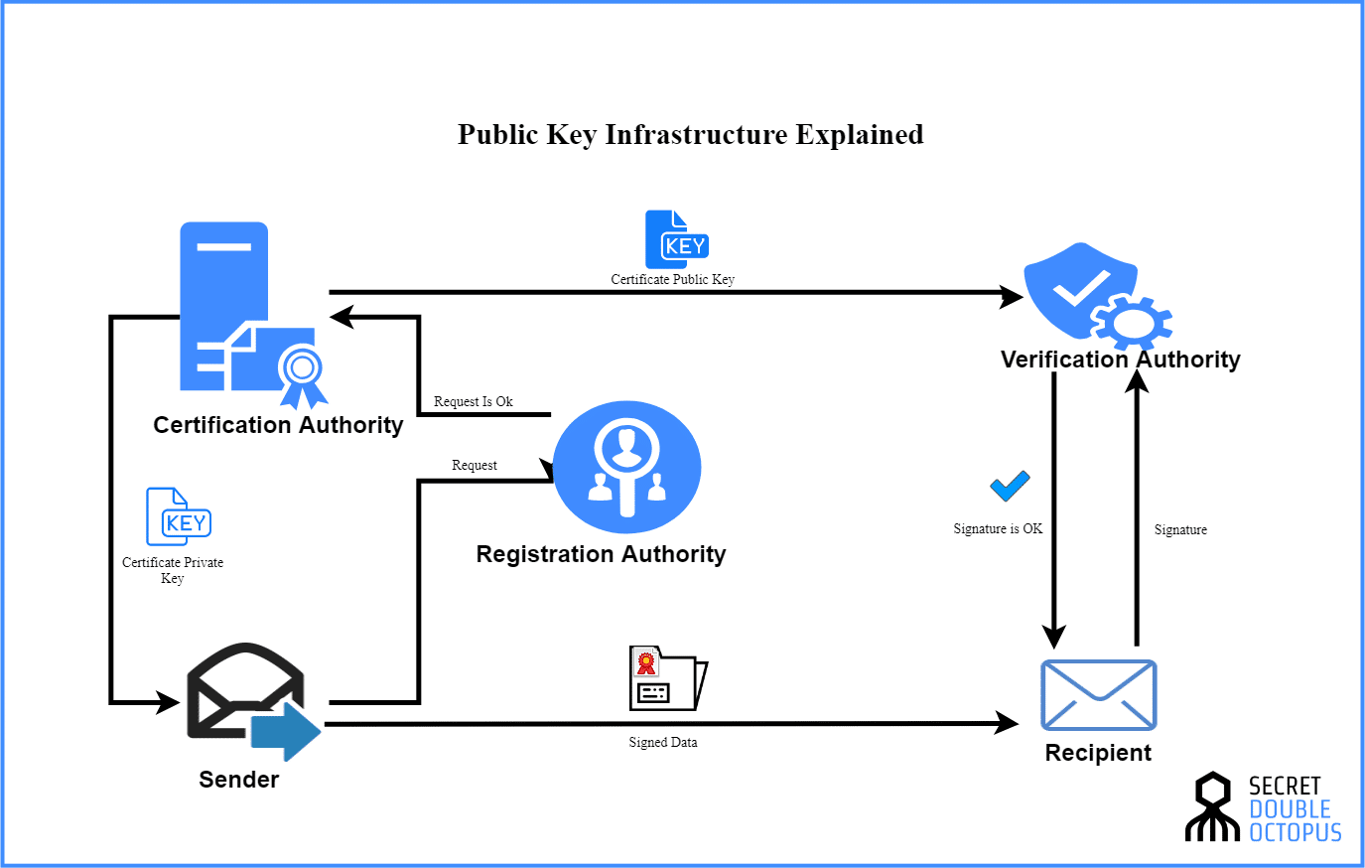
4
1. Introduction
X.509 is an international standard that defines a public key authentication framework. It is widely used in network security, secure e-mail, SSL/TLS, VPNs, and digital signatures.
The main objective of X.509 is to provide strong authentication using digital certificates issued by a trusted Certificate Authority (CA).

2. Purpose of X.509 Authentication
X.509 authentication services aim to:
- Verify the identity of communicating entities
- Support secure key exchange
- Enable digital signatures
- Prevent impersonation attacks
- Ensure data integrity and trust

3. X.509 Certificate
An X.509 certificate binds a user’s identity with their public key and is digitally signed by a trusted CA.
Basic Components of an X.509 Certificate:
- Version – X.509 version number
- Serial Number – Unique ID assigned by CA
- Signature Algorithm – Algorithm used by CA
- Issuer – Certificate Authority name
- Validity Period – Start and expiry date
- Subject – Owner of the certificate
- Subject Public Key Info – Public key and algorithm
- Extensions – Usage constraints (key usage, policies)
- Digital Signature – CA’s signature for verification

4. X.509 Authentication Model
The X.509 model is based on Public Key Infrastructure (PKI).
Main Entities:
- Certificate Authority (CA) – Issues and signs certificates
- Registration Authority (RA) – Verifies user identity
- End User – Certificate holder
- Repository – Stores certificates and revocation lists

5. Types of X.509 Authentication
X.509 supports three authentication mechanisms:
(i) One-Way Authentication
- Used when only one party is authenticated
- Example: Client authenticates server (HTTPS)
- Uses timestamp and digital signature to prevent replay attacks
(ii) Two-Way (Mutual) Authentication
- Both parties authenticate each other
- Ensures mutual trust
- Common in secure enterprise communication
(iii) Three-Way Authentication
- Includes an additional message exchange
- Prevents replay and delay attacks
- Ensures session freshness

6. Authentication Process Using X.509
- Sender sends its X.509 certificate
- Receiver verifies:
  - CA signature
  - Certificate validity period
  - Revocation status (CRL/OCSP)
- Public key from certificate is trusted
- Authentication is successfully completed

7. Certificate Revocation
Certificates may be revoked due to:
- Private key compromise
- Change in user details
- CA compromise
Revocation Methods:
- Certificate Revocation List (CRL)
- Online Certificate Status Protocol (OCSP)

8. Applications of X.509 Authentication
- SSL/TLS secure web communication
- Secure e-mail (S/MIME)
- VPN authentication
- Code signing
- Blockchain and PKI-based systems

9. Advantages of X.509
- Strong authentication
- Globally accepted standard
- Scalable trust model
- Supports encryption and digital signatures

10. Limitations of X.509
- Complex certificate management
- Dependence on trusted CA
- Revocation checking overhead

11. Conclusion
X.509 authentication services provide a robust and standardized framework for secure identity verification in networks. By using digital certificates and PKI, X.509 ensures authentication, integrity, trust, and non-repudiation, making it a cornerstone of modern network security.

2.Explain briefly about the architecture and certification mechanisms in Kerberos and X.509. (13marks)
Below is a brief but complete 13-mark exam answer explaining architecture and certification mechanisms in Kerberos and X.509, with clear headings and comparison-ready points.

Kerberos and X.509: Architecture & Certification Mechanisms

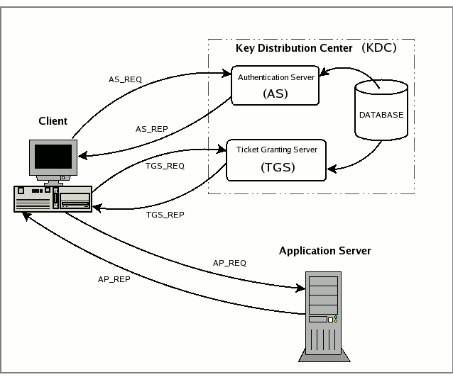

1. Kerberos
1.1 Architecture of Kerberos
Kerberos is a symmetric key–based network authentication system that uses tickets and a trusted third party.
Main Components:
- Client (User) – Requests access to network services
- Application Server (Service Server) – Provides requested service
- Key Distribution Center (KDC) – Trusted authority consisting of:
  - Authentication Server (AS)
  - Ticket Granting Server (TGS)
Architecture Flow (Summary):
- Client authenticates to AS
- AS issues Ticket Granting Ticket (TGT)
- Client presents TGT to TGS
- TGS issues Service Ticket
- Client accesses service using service ticket

1.2 Certification / Authentication Mechanism in Kerberos
- Uses shared secret keys (no public key by default)
- Tickets act as proof of identity
- Time stamps prevent replay attacks
- Password is never sent over the network
Types of Tickets:
- Ticket Granting Ticket (TGT)
- Service Ticket
Key Features:
- Mutual authentication
- Centralized authentication
- Session keys for secure communication


2. X.509
2.1 Architecture of X.509
X.509 is a public key–based authentication framework built on Public Key Infrastructure (PKI).
Main Components:
- Certificate Authority (CA) – Issues and signs certificates
- Registration Authority (RA) – Verifies user identity
- End Entity (User/Server) – Uses certificate
- Repository – Stores certificates and revocation lists
Architecture Flow (Summary):
- User requests certificate
- CA issues X.509 digital certificate
- Certificate is used for authentication
- Receiver verifies CA signature
2.2 Certification Mechanism in X.509
- Uses digital certificates
- Based on public key cryptography
- Certificate binds identity + public key
- CA digitally signs the certificate
Verification Includes:
- CA signature validation
- Validity period check
- Revocation check (CRL / OCSP)
Authentication Types:
- One-way authentication
- Two-way (mutual) authentication
- Three-way authentication
3. Comparison: Kerberos vs X.509 (Architecture & Certification)
Aspect | Kerberos | X.509
Cryptography | Symmetric key | Public key
Trusted Authority | KDC (AS + TGS) | Certificate Authority
Credentials | Tickets | Digital Certificates
Password Transmission | Never sent | Not required
Scalability | Limited (local domain) | Highly scalable
Revocation | Ticket expiration | CRL / OCSP
Common Use | LAN, enterprise networks | Internet, SSL/TLS

4. Advantages (Brief)
Kerberos
- Fast authentication
- Strong replay attack protection
- Efficient in closed networks
X.509
- Global trust model
- Strong identity binding
- Widely used in web security
5. Conclusion
Kerberos provides ticket-based symmetric authentication suitable for controlled environments, while X.509 offers certificate-based public key authentication ideal for large-scale and Internet-based systems. Both play a crucial role in secure network authentication.

3.Explain SHA 1 in detail with neat diagram. (13marks)
Below is a complete, exam-ready 13-mark answer for SHA-1, with clear explanation and a neat diagram.

1. Introduction
SHA-1 (Secure Hash Algorithm-1) is a cryptographic hash function designed by the National Security Agency (NSA) and standardized by NIST.
It converts a message of any length into a fixed 160-bit (20-byte) hash value, called a message digest.
SHA-1 is used to ensure:
- Data integrity
- Authentication
- Digital signatures

2. Features of SHA-1
- Input: Message of arbitrary length
- Output: 160-bit hash value
- Block size: 512 bits
- Word size: 32 bits
- Number of rounds: 80 rounds
- One-way function (irreversible)

3. Overall Working of SHA-1
SHA-1 works in five major steps:
- Message Padding
- Message Parsing
- Initialization of Hash Values
- Compression Function (80 rounds)
- Final Hash Generation

4. Message Padding
The message is padded so that its length becomes congruent to 448 mod 512.
Padding Steps:
- Append a single ‘1’ bit
- Append required number of ‘0’ bits
- Append 64-bit representation of original message length
👉 Result: Message length becomes a multiple of 512 bits.

5. Message Parsing
- The padded message is divided into 512-bit blocks
- Each block is further divided into 16 words of 32 bits each
(W₀, W₁, …, W₁₅)

6. Initialization of Hash Buffers
SHA-1 uses five 32-bit registers initialized with predefined constants:
- A = 67452301
- B = EFCDAB89
- C = 98BADCFE
- D = 10325476
- E = C3D2E1F0

7. Message Schedule Expansion
The 16 words are expanded into 80 words using:
$$W_{t}=(W_{t-3}⊕W_{t-8}⊕W_{t-14}⊕W_{t-16})≪1$$
(for t = 16 to 79)

8. Compression Function (80 Rounds)
Each block is processed in 80 rounds, divided into 4 stages of 20 rounds each.
For each round:
$$TEMP=(A≪5)+f(B,C,D)+E+W_{t}+K_{t}$$
Registers are updated:
- E = D
- D = C
- C = B << 30
- B = A
- A = TEMP
Boolean Functions Used:
- Rounds 0–19: (B ∧ C) ∨ (¬B ∧ D)
- Rounds 20–39: B ⊕ C ⊕ D
- Rounds 40–59: (B ∧ C) ∨ (B ∧ D) ∨ (C ∧ D)
- Rounds 60–79: B ⊕ C ⊕ D

9. Constants Used
Each stage uses a constant K:
- 0–19: 5A827999
- 20–39: 6ED9EBA1
- 40–59: 8F1BBCDC
- 60–79: CA62C1D6

10. Final Hash Generation
After processing all message blocks:
- The values of A, B, C, D, E are added to the initial hash values
- The final output is a 160-bit message digest

11. Neat Diagram (Exam Representation)
Message
↓
Padding → Parsing (512-bit blocks)
↓
Initialize A, B, C, D, E
↓
80 Rounds Compression Function
↓
Final 160-bit Hash Output

12. Applications of SHA-1
- Digital signatures
- Message authentication
- File integrity checking
- Version control systems (older Git versions)

13. Limitations of SHA-1
- Vulnerable to collision attacks
- No longer recommended for secure systems
- Replaced by SHA-256 / SHA-3

14. Conclusion
SHA-1 is a widely studied cryptographic hash algorithm that produces a 160-bit hash using message padding, block processing, and iterative compression. Although historically important, SHA-1 is now considered cryptographically weak and has been replaced by stronger algorithms.

UNIT – 5
1. Explain the working of SET with neat diagram. (13marks)
Below is an exam-ready 13-mark answer for CNS 👇

Secure Electronic Transaction (SET) – Working (13 Marks)
Introduction
Secure Electronic Transaction (SET) is a security protocol developed by Visa and MasterCard to protect credit card transactions over the Internet.
SET ensures confidentiality, integrity, authentication, and non-repudiation during online payments.

Objectives of SET
SET provides the following security services:
- Confidentiality – Card details are encrypted and hidden from the merchant.
- Integrity – Ensures transaction data is not altered.
- Authentication – Verifies cardholder and merchant using digital certificates.
- Non-repudiation – Prevents denial of transaction by any party.

Entities Involved in SET
- Cardholder – Customer using a credit card
- Merchant – Online seller
- Issuer Bank – Cardholder’s bank
- Acquirer Bank – Merchant’s bank
- Payment Gateway – Processes payment authorization
- Certificate Authority (CA) – Issues digital certificates

Working of SET (Step-by-Step)
1. Certificate Generation
- Cardholder and merchant obtain digital certificates from a trusted CA.
- Certificates contain public keys used for authentication.

2. Purchase Request
- Cardholder selects goods and places an order.
- Two types of information are created:
  - Order Information (OI) → product details
  - Payment Information (PI) → card number, expiry date

3. Dual Signature Creation
- Cardholder hashes OI and PI separately.
- Both hashes are combined and encrypted using the cardholder’s private key.
- This creates a Dual Signature, which:
  - Allows the merchant to read OI only
  - Allows the bank to read PI only

4. Sending Purchase Request
The cardholder sends the following to the merchant:
- Order Information (OI)
- Encrypted Payment Information (PI)
- Dual Signature
- Cardholder’s Digital Certificate

5. Merchant Verification
- Merchant verifies the cardholder certificate.
- Merchant forwards encrypted PI and dual signature to the payment gateway.

6. Payment Authorization
- Payment gateway decrypts PI.
- Issuer bank verifies card details and availability of funds.
- Authorization response (approved/declined) is sent back.

7. Order Confirmation
- Merchant confirms the order to the cardholder.
- Goods/services are delivered.

Neat Diagram – SET Transaction Flow
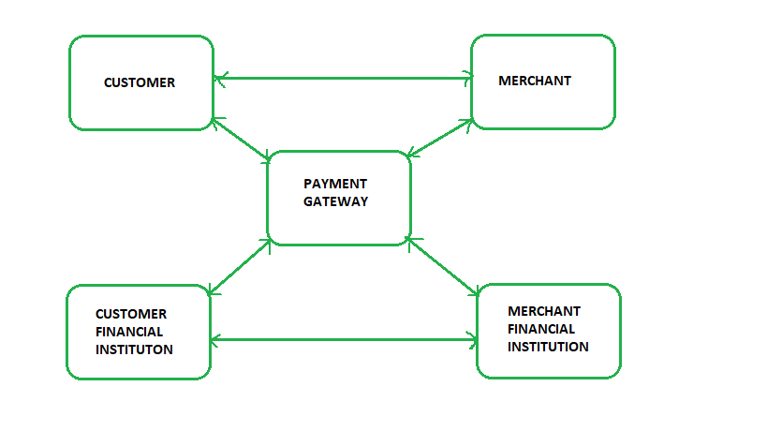
Cryptographic Techniques Used
Technique | Purpose
RSA | Key exchange & digital signatures
DES / AES | Data encryption
SHA-1 | Hashing for integrity
Digital Certificates | Authentication

Advantages of SET
- High level of security
- Protects cardholder privacy
- Prevents fraud
- Strong authentication mechanism

Limitations of SET
- Complex implementation
- High computational overhead
- Requires digital certificates
- Not user-friendly

Conclusion
SET is a highly secure protocol for online credit card transactions. Although it offers excellent security through encryption, certificates, and dual signatures, its complexity limited widespread adoption. However, SET laid the foundation for modern secure payment systems.

2.Interpret the different types of virus in detail. Suggest scenarios for deploying these types in network. (13marks)
Computer Virus – Types and Deployment Scenarios (13 Marks)
Introduction
A computer virus is a malicious program that attaches itself to a legitimate file or program and spreads by replication, causing damage to data, systems, or networks. Viruses are often deployed by attackers to disrupt services, steal information, or gain unauthorized control over systems.

1. File Infector Virus
Description
- Attaches itself to executable files such as .exe, .com
- Activates when the infected program is executed
- Spreads to other executable files on the same system
Network Deployment Scenario
- An attacker sends an infected software installer through email
- When users execute the file, multiple systems in the corporate LAN become infected
Example: Jerusalem virus

2. Boot Sector Virus
Description
- Infects the Master Boot Record (MBR) or boot sector
- Loads into memory during system startup
- Difficult to detect once active
Network Deployment Scenario
- Infected USB drives used across multiple office systems
- Virus spreads when systems boot from infected media
Example: Brain virus

3. Macro Virus
Description
- Written using macro languages (e.g., MS Word, Excel macros)
- Infects documents rather than executables
- Executes when a document is opened
Network Deployment Scenario
- Shared documents on a company file server
- One infected document spreads virus to multiple users opening it
Example: Melissa virus

4. Multipartite Virus
Description
- Combines characteristics of file infector and boot sector viruses
- Infects both boot sector and program files
- Very difficult to remove
Network Deployment Scenario
- Used in mixed OS environments where shared storage and executable files are common
- Spreads rapidly in enterprise networks

5. Polymorphic Virus
Description
- Changes its code signature every time it infects a new system
- Uses encryption and mutation techniques
- Evades signature-based antivirus detection
Network Deployment Scenario
- Deployed in networks with outdated antivirus systems
- Used to maintain long-term presence without detection

6. Metamorphic Virus
Description
- Rewrites its entire code with each infection
- No consistent signature
- More advanced than polymorphic viruses
Network Deployment Scenario
- Targeted attacks on critical infrastructure
- Used in Advanced Persistent Threats (APT)

7. Stealth Virus
Description
- Hides itself by intercepting system calls
- Masks file size or modification changes
- Avoids detection by security software
Network Deployment Scenario
- Installed on servers to avoid detection during routine scans
- Useful for espionage attacks

8. Resident Virus
Description
- Loads into system memory
- Infects files automatically when accessed
- Continues functioning even after host program ends
Network Deployment Scenario
- Deployed on shared network systems
- Spreads silently across network resources

9. Non-Resident Virus
Description
- Does not remain in memory
- Executes, infects files, and exits
- Less complex than resident viruses
Network Deployment Scenario
- Spread via removable media or email attachments
- Causes quick damage and disappears

Neat Diagram – Virus Infection in Network
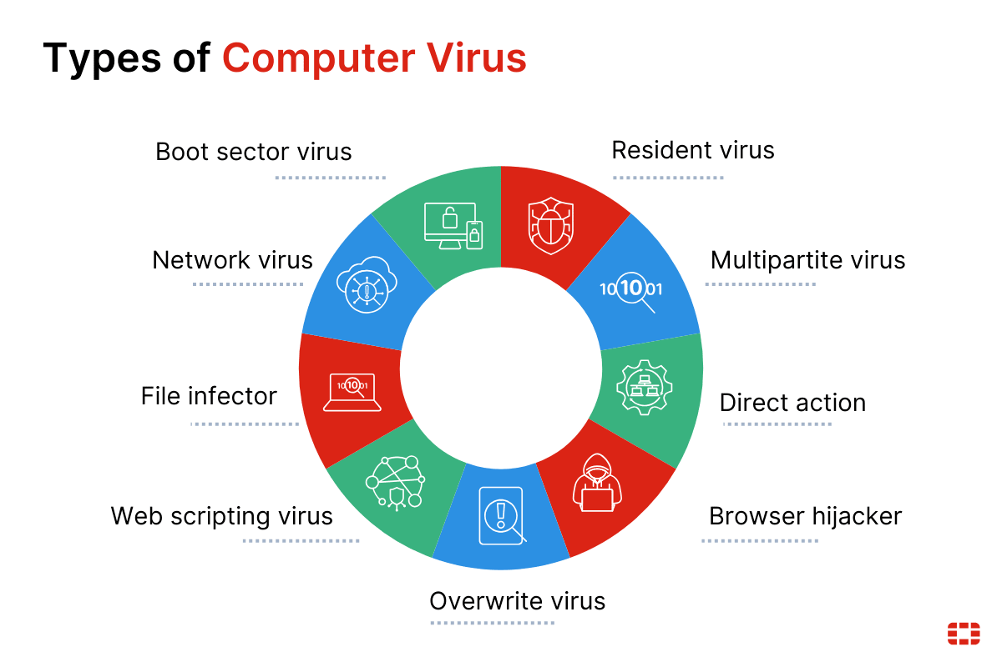
Summary Table
Virus Type | Key Feature | Deployment Scenario
File Infector | Infects executables | Email attachments
Boot Sector | Infects MBR | USB / bootable media
Macro | Infects documents | Shared office files
Multipartite | Dual infection | Enterprise networks
Polymorphic | Changes signature | Long-term attacks
Metamorphic | Rewrites code | APT attacks
Stealth | Hides presence | Server espionage
Resident | Memory-based | Network file access
Non-Resident | Temporary execution | Removable media

Conclusion
Different types of viruses are designed to exploit specific network weaknesses such as shared resources, removable media, outdated antivirus systems, and user trust. Understanding these virus types and their deployment scenarios helps organizations design effective security strategies and countermeasures.
3.Illustrate the various types of firewalls with neat diagrams. (13marks)
Below is a complete, exam-ready 13-mark answer for CNS with clear explanations and neat diagrams 👇

Firewalls – Types with Neat Diagrams (13 Marks)
Introduction
A firewall is a security mechanism that monitors, filters, and controls network traffic based on predefined security rules. Firewalls act as a barrier between trusted internal networks and untrusted external networks (Internet), preventing unauthorized access and attacks.

1. Packet Filtering Firewall
Explanation
- Operates at Network Layer (Layer 3) and Transport Layer (Layer 4)
- Filters packets based on:
  - Source & destination IP address
  - Port numbers
  - Protocol type (TCP/UDP/ICMP)
- Stateless in nature
Neat Diagram
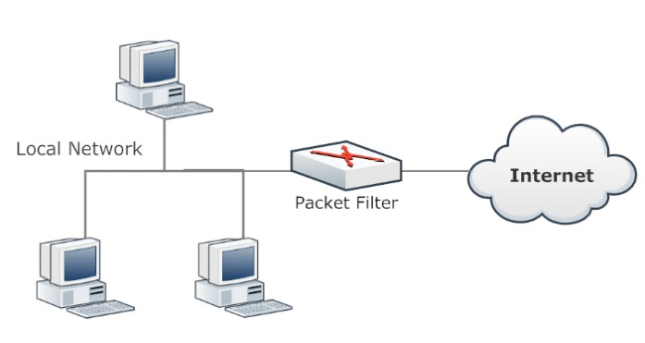

Advantages
- Fast and simple
- Low cost
Limitations
- Cannot inspect packet payload
- Vulnerable to IP spoofing

2. Stateful Inspection Firewall
Explanation
- Tracks the state of active connections
- Maintains a state table
- Allows only packets belonging to a valid session
Neat Diagram
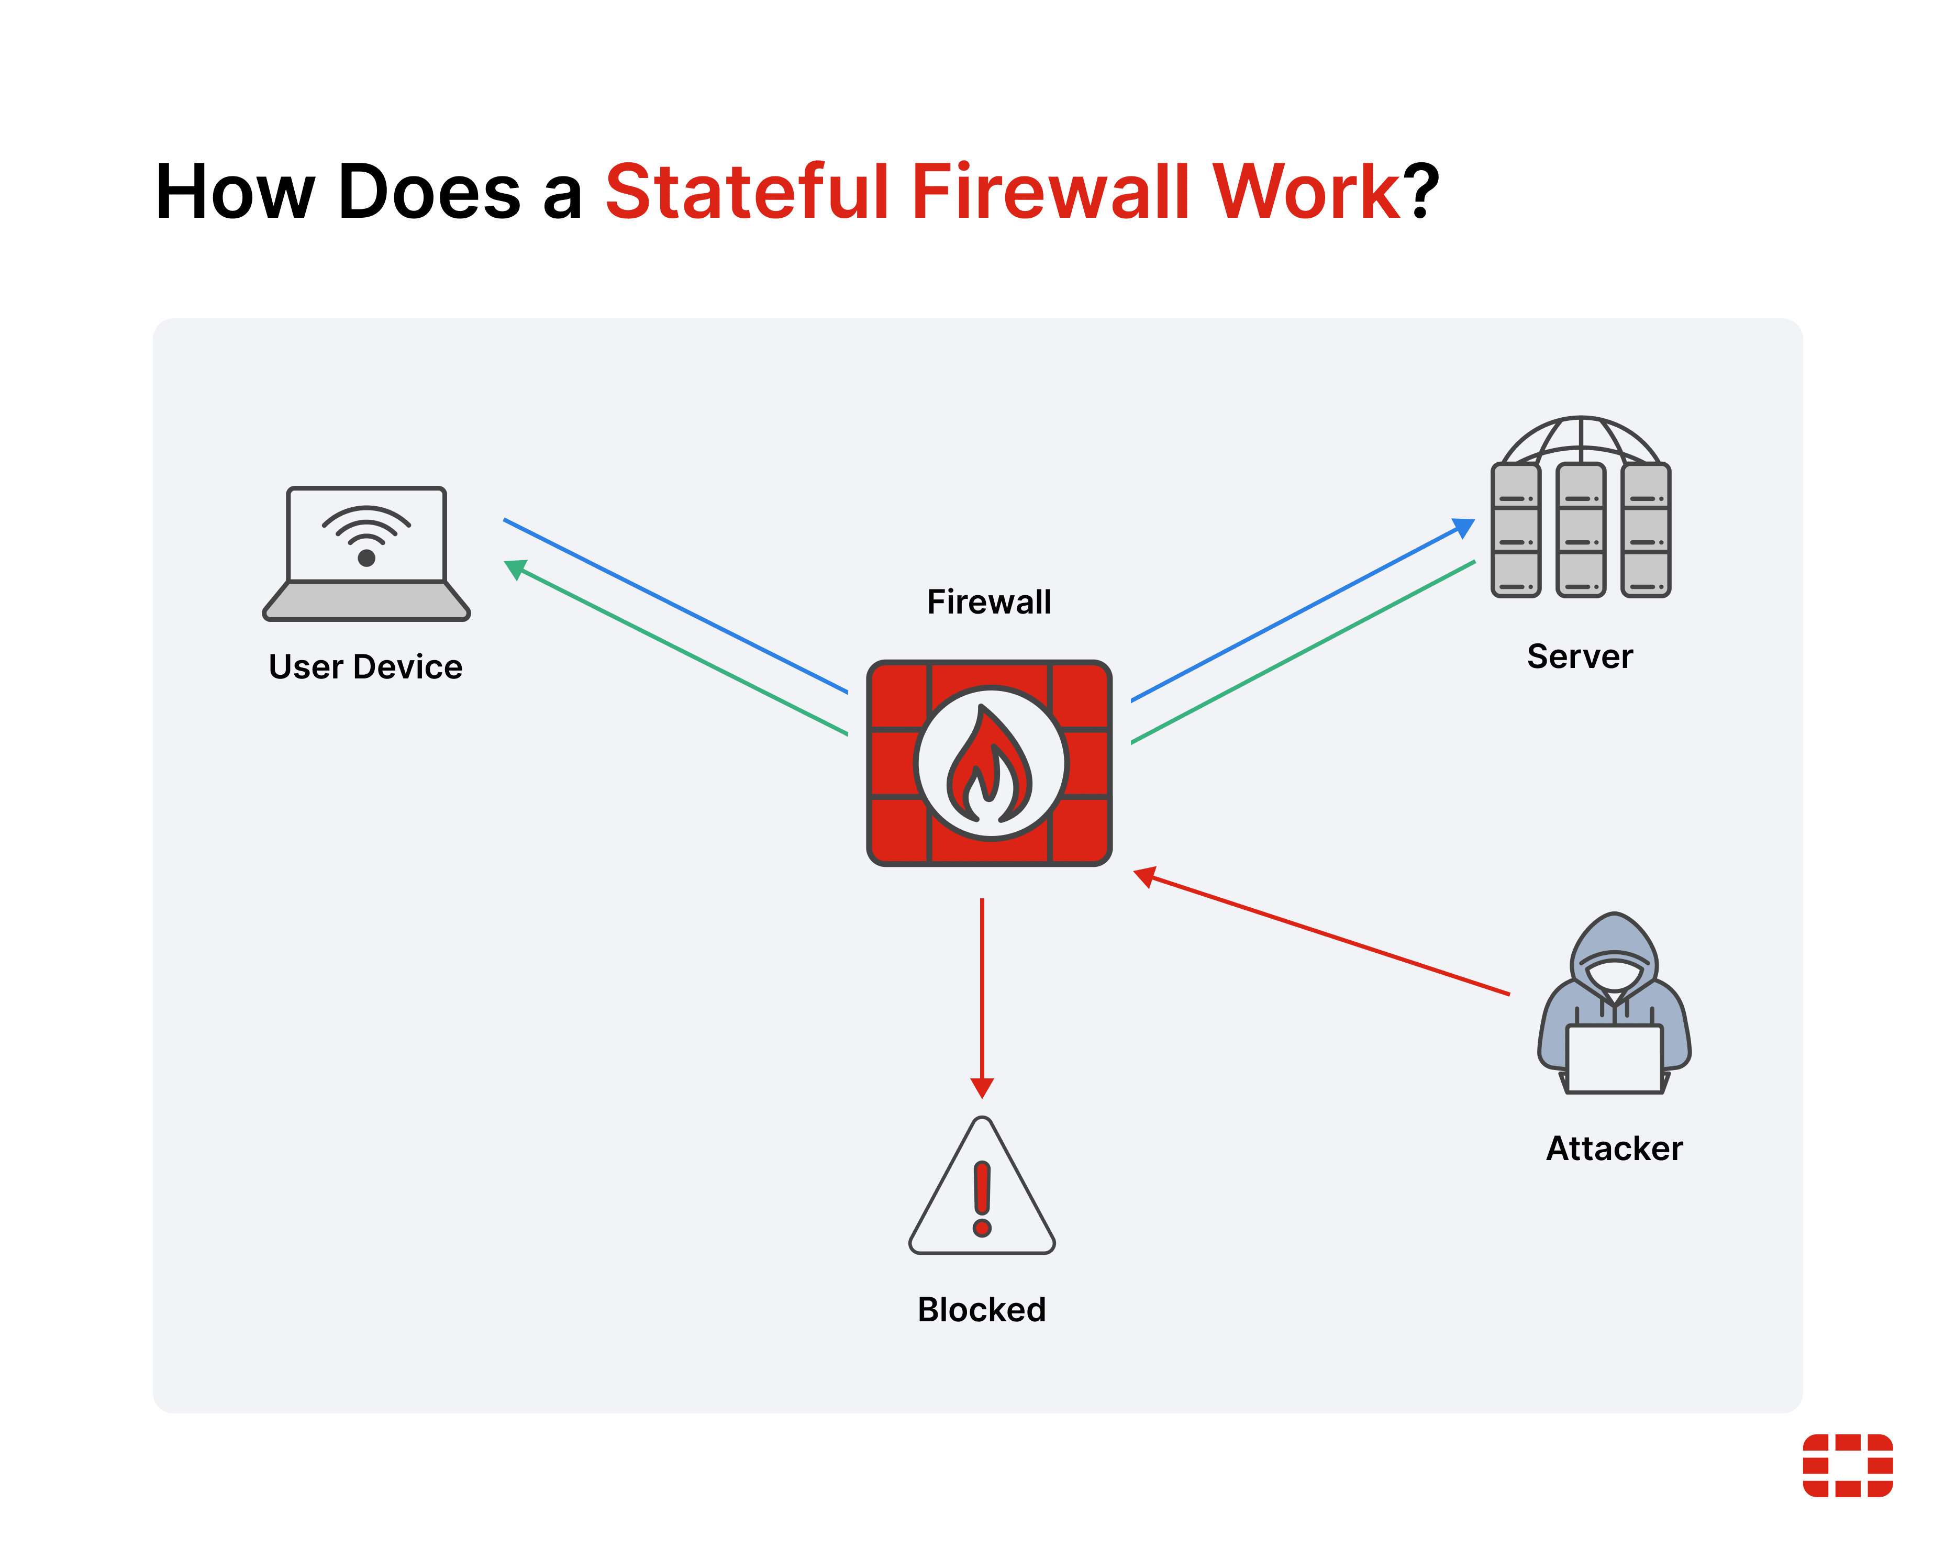
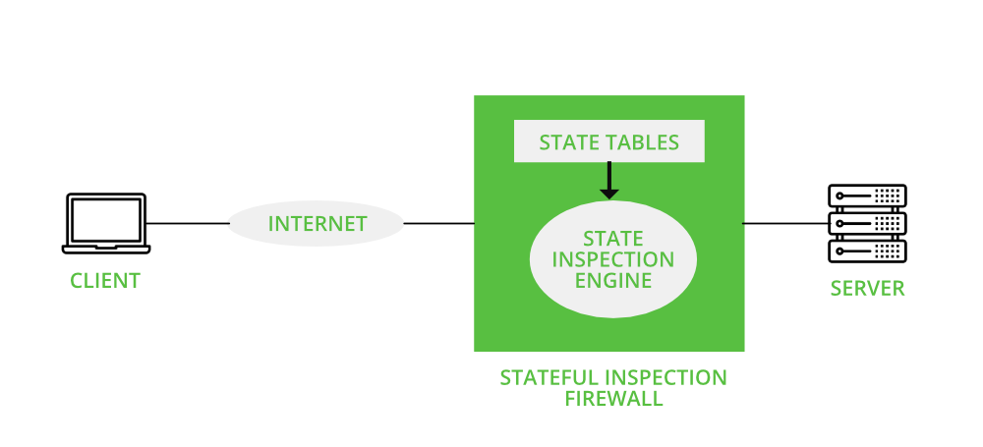
Advantages
- Better security than packet filtering
- Prevents spoofed packets
Limitations
- More resource-intensive

3. Application Level Gateway (Proxy Firewall)
Explanation
- Operates at Application Layer (Layer 7)
- Acts as an intermediary between client and server
- Inspects full packet content
Neat Diagram

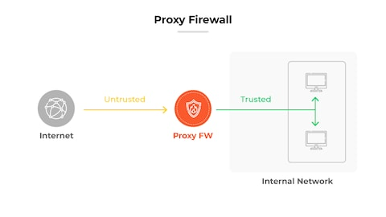
Advantages
- High security
- Prevents application-layer attacks
Limitations
- Slower performance
- Requires application-specific configuration

4. Circuit Level Gateway
Explanation
- Operates at Session Layer
- Monitors TCP handshakes
- Does not inspect packet content
Neat Diagram

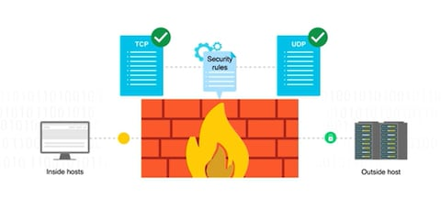
Advantages
- Hides internal network
- Low overhead
Limitations
- Cannot filter application data

5. Next-Generation Firewall (NGFW)
Explanation
- Combines:
  - Stateful inspection
  - Deep Packet Inspection (DPI)
  - Intrusion Prevention System (IPS)
  - Application awareness
Neat Diagram
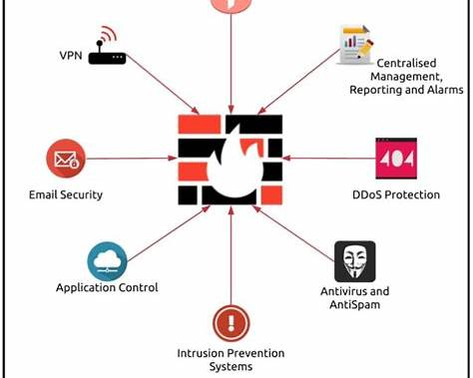

Advantages
- Advanced threat detection
- Application-level control
Limitations
- Expensive
- Complex management

6. Hardware Firewall
Explanation
- Dedicated physical device
- Used in enterprises and data centers
- Protects entire network
Neat Diagram
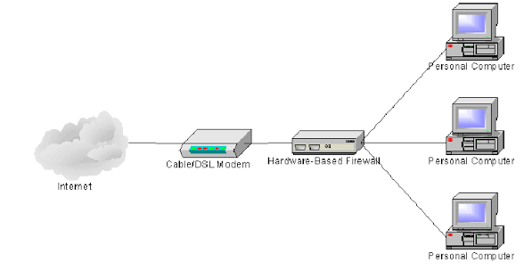

7. Software Firewall
Explanation
- Installed on individual systems
- Protects single host
- Common in personal computers
Neat Diagram
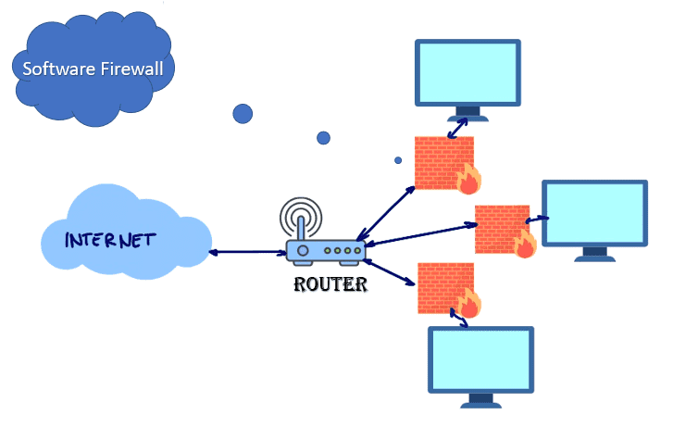

Comparison Table
Firewall Type | OSI Layer | Security Level
Packet Filtering | L3/L4 | Low
Stateful Inspection | L3–L4 | Medium
Application Gateway | L7 | High
Circuit Level | Session | Medium
NGFW | Multi-Layer | Very High

Conclusion
Firewalls are essential components of network security. Each firewall type provides different levels of protection, and modern networks often deploy multiple firewalls together to form a layered defense strategy.

4.Illustrate PGP cryptographic functions in detail with suitable block diagrams. (13marks)
Below is a complete, exam-ready 13-mark answer for CNS with clear explanation and suitable block diagrams 👇

PGP (Pretty Good Privacy) – Cryptographic Functions (13 Marks)
Introduction
Pretty Good Privacy (PGP) is a widely used cryptographic system designed to provide security for e-mail communication and data storage.
PGP uses a hybrid cryptographic approach, combining symmetric encryption, public-key encryption, hashing, and digital signatures to ensure secure communication.

Security Services Provided by PGP
PGP provides the following major cryptographic services:
- Authentication
- Confidentiality
- Integrity
- Non-repudiation
- Compression
- E-mail compatibility

1. Authentication (Digital Signature)
Function
- Sender creates a hash of the message using SHA-1
- Hash is encrypted using the sender’s private key
- Encrypted hash forms the digital signature
- Receiver decrypts it using sender’s public key and verifies integrity
Purpose
✔ Ensures message is from a legitimate sender
✔ Prevents message modification

2. Confidentiality (Message Encryption)
Function
- Message is encrypted using a symmetric session key (IDEA/AES)
- Session key is encrypted using receiver’s public key
- Only receiver can decrypt session key using private key
Purpose
✔ Protects message from unauthorized access

3. Compression
Function
- Message is compressed before encryption
- Uses ZIP compression
Purpose
✔ Reduces message size
✔ Improves cryptographic strength

4. E-mail Compatibility (Radix-64 Encoding)
Function
- Binary encrypted data is converted into ASCII format
- Uses Radix-64 (Base64) encoding
Purpose
✔ Allows secure transmission over email systems

5. Key Management
Function
- Uses public-key rings and private-key rings
- Supports key generation, storage, revocation, and trust levels
Purpose
✔ Manages encryption and signature keys efficiently

PGP Cryptographic Operation – Sender Side

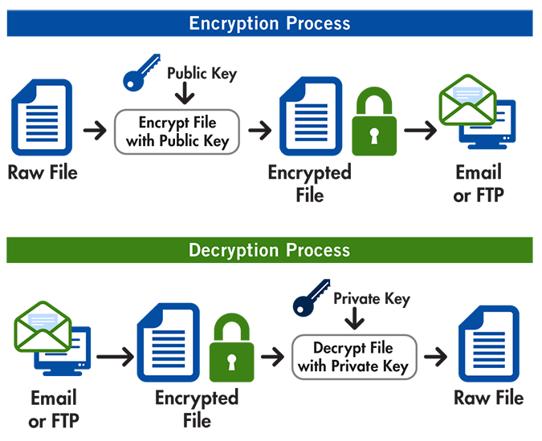

Steps
- Message is hashed (SHA-1)
- Hash encrypted with sender’s private key → Digital Signature
- Message + signature compressed
- Compressed data encrypted using symmetric session key
- Session key encrypted using receiver’s public key
- Output encoded using Radix-64

PGP Cryptographic Operation – Receiver Side
Steps
- Radix-64 decoding
- Session key decrypted using receiver’s private key
- Message decrypted using session key
- Message decompressed
- Hash verified using sender’s public key

Algorithms Used in PGP
Function | Algorithm
Hashing | SHA-1
Symmetric Encryption | IDEA / AES
Asymmetric Encryption | RSA
Encoding | Radix-64

Advantages of PGP
- Strong security using hybrid encryption
- Widely used for secure e-mail
- Supports digital signatures
- Efficient key management

Limitations of PGP
- Complex for beginners
- Manual trust management
- SHA-1 is now considered weak

Conclusion
PGP is a powerful cryptographic system that integrates hashing, symmetric encryption, public-key encryption, compression, and digital signatures to provide end-to-end secure communication. Its hybrid design makes it efficient and secure for e-mail and data protection.

