WFM_Management Final project

1. Login Page

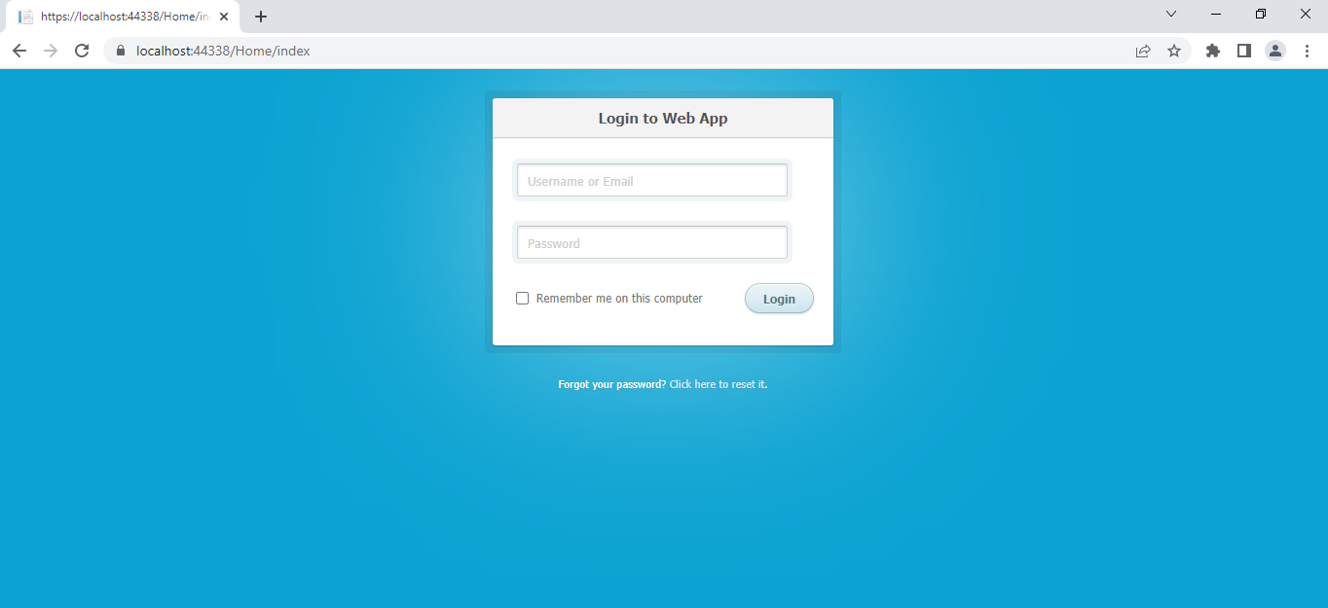

This is the User Login Page.

1. Manager Login Page:

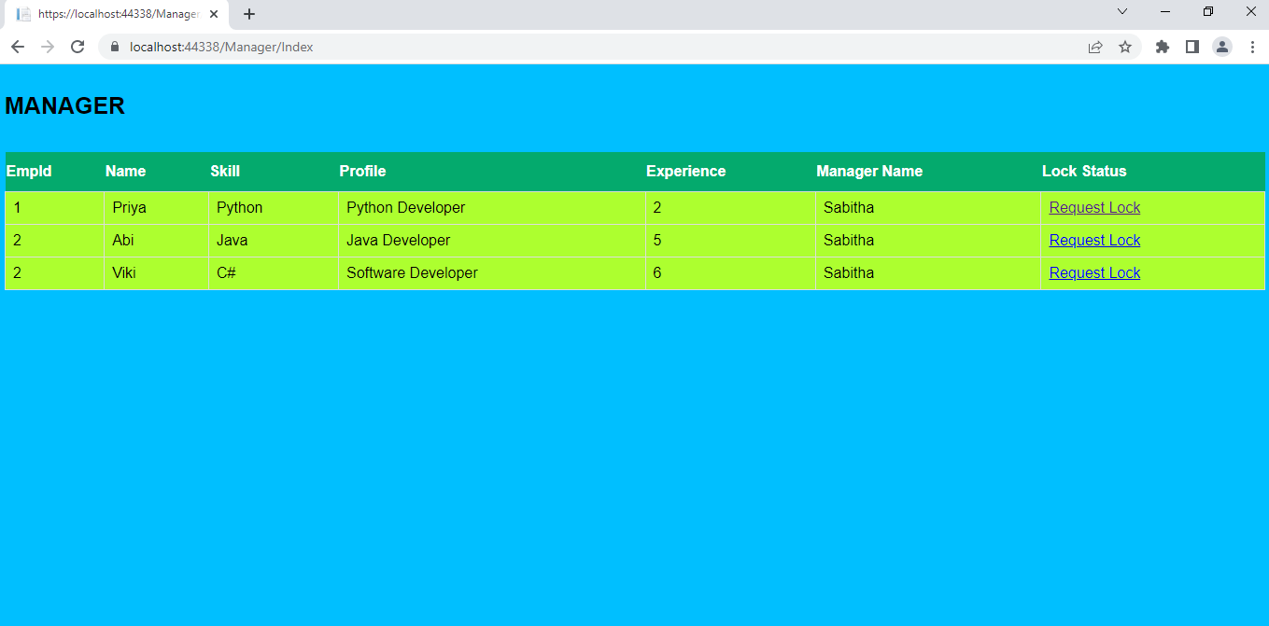

Once the Manager User login Manager Screen will display

1. Manager Edit Screen:

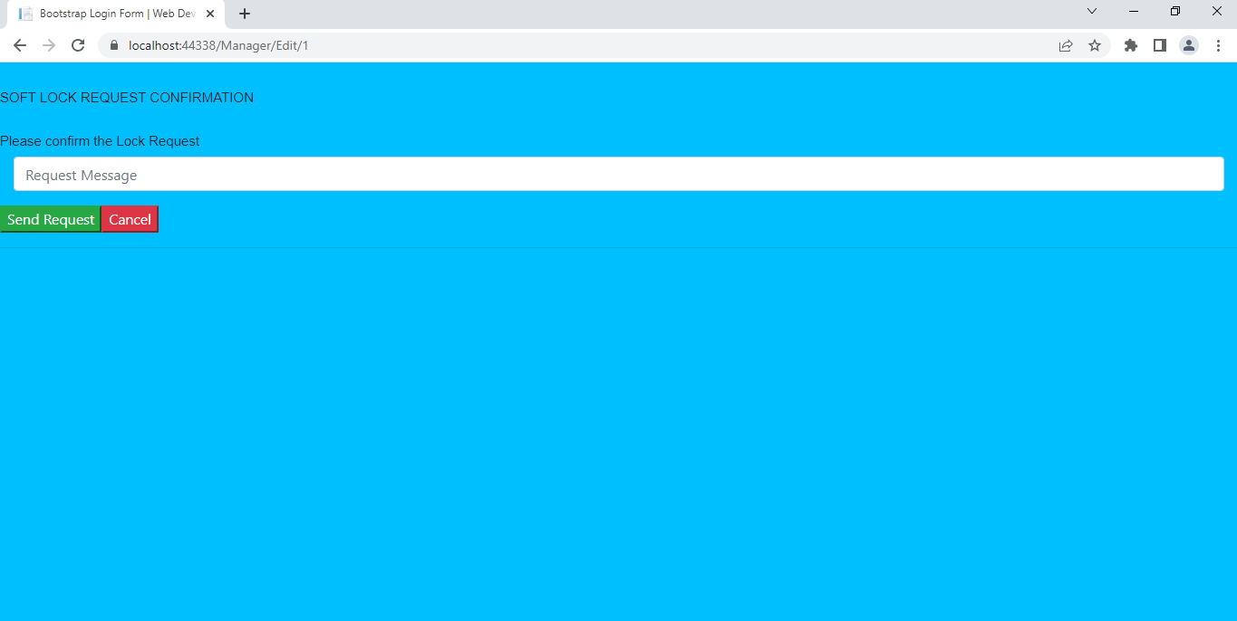

In the Manager Screen once Soft Lock request clicked it displays this screen.

1. WFM Manager Screen:

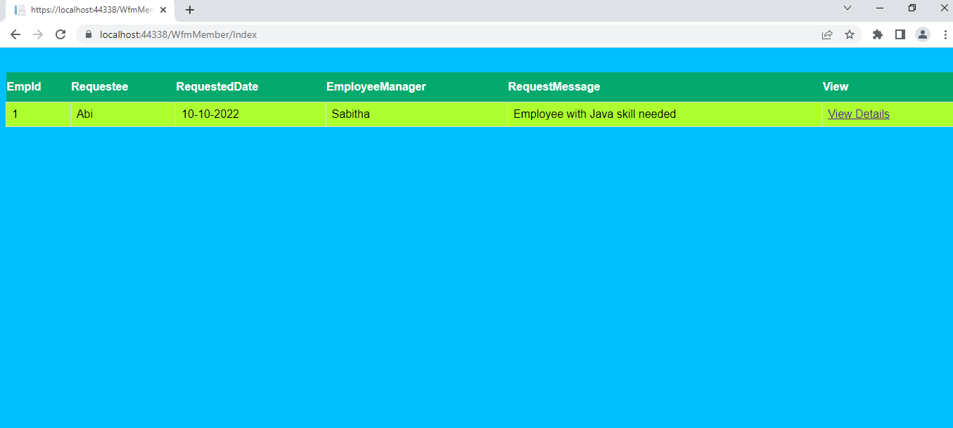

Once logged in as Wfm Member , this screen will be displayed.

1. WFM Manager Edit Screen:

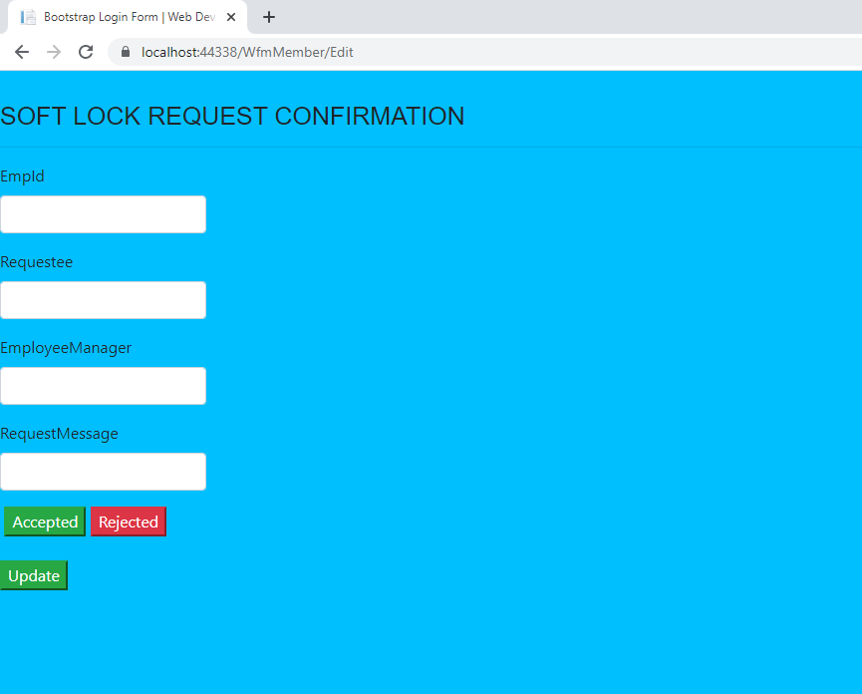

Once View Details clicked in the WFM Manager Screen it displays this edit Screen.