

See discussions, stats, and author profiles for this publication at: [https://www.researchgate.net/publication/271178592](https://www.researchgate.net/publication/271178592_PDA_Based_Academic_Time_Table_Management_System?enrichId=rgreq-05dc4119425c5d9e484fec7cf011df03-XXX&enrichSource=Y292ZXJQYWdlOzI3MTE3ODU5MjtBUzoxODc5NzkzNjQ1NzcyODBAMTQyMTgyOTE4MTA4Mg%3D%3D&el=1_x_2&_esc=publicationCoverPdf)

[PDA Based Academic Time Table Management System](https://www.researchgate.net/publication/271178592_PDA_Based_Academic_Time_Table_Management_System?enrichId=rgreq-05dc4119425c5d9e484fec7cf011df03-XXX&enrichSource=Y292ZXJQYWdlOzI3MTE3ODU5MjtBUzoxODc5NzkzNjQ1NzcyODBAMTQyMTgyOTE4MTA4Mg%3D%3D&el=1_x_3&_esc=publicationCoverPdf)

**Conference Paper** · February 2010

DOI: 10.13140/2.1.2296.8640

CITATIONS

0

READS

3,364

**2 authors:**

[Jitendra V. Tembhurne](https://www.researchgate.net/profile/Jitendra-Tembhurne?enrichId=rgreq-05dc4119425c5d9e484fec7cf011df03-XXX&enrichSource=Y292ZXJQYWdlOzI3MTE3ODU5MjtBUzoxODc5NzkzNjQ1NzcyODBAMTQyMTgyOTE4MTA4Mg%3D%3D&el=1_x_5&_esc=publicationCoverPdf)

Indian Institute of Information Technology Nagpur

**28** PUBLICATIONS **146** CITATIONS

[Dilipkumar Borikar](https://www.researchgate.net/profile/Dilipkumar-Borikar?enrichId=rgreq-05dc4119425c5d9e484fec7cf011df03-XXX&enrichSource=Y292ZXJQYWdlOzI3MTE3ODU5MjtBUzoxODc5NzkzNjQ1NzcyODBAMTQyMTgyOTE4MTA4Mg%3D%3D&el=1_x_5&_esc=publicationCoverPdf)

[Shri Ramdeobaba Kamla Nehru Engineering College](https://www.researchgate.net/institution/Shri_Ramdeobaba_Kamla_Nehru_Engineering_College?enrichId=rgreq-05dc4119425c5d9e484fec7cf011df03-XXX&enrichSource=Y292ZXJQYWdlOzI3MTE3ODU5MjtBUzoxODc5NzkzNjQ1NzcyODBAMTQyMTgyOTE4MTA4Mg%3D%3D&el=1_x_6&_esc=publicationCoverPdf)

**10** PUBLICATIONS **5** CITATIONS

[SEE PROFILE](https://www.researchgate.net/profile/Jitendra-Tembhurne?enrichId=rgreq-05dc4119425c5d9e484fec7cf011df03-XXX&enrichSource=Y292ZXJQYWdlOzI3MTE3ODU5MjtBUzoxODc5NzkzNjQ1NzcyODBAMTQyMTgyOTE4MTA4Mg%3D%3D&el=1_x_7&_esc=publicationCoverPdf)

[SEE PROFILE](https://www.researchgate.net/profile/Dilipkumar-Borikar?enrichId=rgreq-05dc4119425c5d9e484fec7cf011df03-XXX&enrichSource=Y292ZXJQYWdlOzI3MTE3ODU5MjtBUzoxODc5NzkzNjQ1NzcyODBAMTQyMTgyOTE4MTA4Mg%3D%3D&el=1_x_7&_esc=publicationCoverPdf)

**Some of the authors of this publication are also working on these related projects:**

GCD Computation [View project](https://www.researchgate.net/project/GCD-Computation?enrichId=rgreq-05dc4119425c5d9e484fec7cf011df03-XXX&enrichSource=Y292ZXJQYWdlOzI3MTE3ODU5MjtBUzoxODc5NzkzNjQ1NzcyODBAMTQyMTgyOTE4MTA4Mg%3D%3D&el=1_x_9&_esc=publicationCoverPdf)

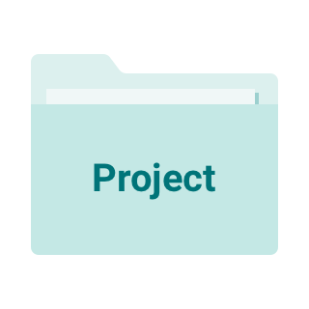

Text Summarization [View project](https://www.researchgate.net/project/Text-Summarization-3?enrichId=rgreq-05dc4119425c5d9e484fec7cf011df03-XXX&enrichSource=Y292ZXJQYWdlOzI3MTE3ODU5MjtBUzoxODc5NzkzNjQ1NzcyODBAMTQyMTgyOTE4MTA4Mg%3D%3D&el=1_x_9&_esc=publicationCoverPdf)

All content following this page was uploaded by [Jitendra V. Tembhurne](https://www.researchgate.net/profile/Jitendra-Tembhurne?enrichId=rgreq-05dc4119425c5d9e484fec7cf011df03-XXX&enrichSource=Y292ZXJQYWdlOzI3MTE3ODU5MjtBUzoxODc5NzkzNjQ1NzcyODBAMTQyMTgyOTE4MTA4Mg%3D%3D&el=1_x_10&_esc=publicationCoverPdf) on 21 January 2015.

The user has requested enhancement of the downloaded file.

**PDA Based Academic Time Table Management System**

1Jitendra V. Tembhurne, 2Dilipkumar A. Borikar

1Department of Computer Technology,

Kavikulguru Institute of Technology & Science, Ramtek, Nagpur , Maharashtra, India [jitendratembhurne@gmail.com](mailto:jitendratembhurne@gmail.com)

2Department of Information Technology,

Kavikulguru Institute of Technology & Science, Ramtek, Nagpur , Maharashtra, India [d.a.borikar@gmail.com](mailto:d.a.borikar@gmail.com)

***Abstract-- “Even a single second cannot come back since time does not wait for anyone”. The time tabling problem is well known and much research has been done about it. For the head of any institution it is difficult to monitor every activity such as the time table of each class, lectures are engaged or not, lecturer delivering the class. This work is designed to overcome all such difficulties. Emphasis has been given on easy to use interfaces. The menu- driven screens have detailed explanations and offer several options. It will provide all the information’s on fingertips and help in saving the time, and better monitoring. It is to be built in visual studio and further will be tested on cellular emulator. Cellular emulator is a software-based emulator to help developers and tester to develop and test windows mobile platform application. It is an attempt to build an application, which will be used in; Personal Digital Assistant (PDA) and thus no documentation will be required.***

***Keywords--*** Academic time table, PDA system, Emulator

**I INTRODUCTION**

The main problem faced can be related to an institution, a particular staff member who is assigned the job of the maintenance of the time table needs to access the same desktop PC on which the complete time table of the college is loaded along with the database related to the time table. This makes the maintenance of the time table very much cumbersome and inflexible. Another problem that is faced is use of paper and a large amount of documents. The assigned staff needs to handle all these papers and documents and take care of all these necessary items all the time. Sometimes there may be missing of the necessary data which will lead to the complete loss of data and the time table, then we have to be created again. Handling the papers also lead to more time taking. The head of the institution going through the inspection timings in the institute can’t carry all the papers or even can’t access the particular desktop containing the time table in order to have an idea of the scheduled lecture or some other event. The approach is to build an application that will be made to run on a handheld device, PDA. The head of the institution can access the time table anytime and from anywhere within the institution. It is also not a big deal for the head of the institution to carry a simple and a small PDA. The head of the institution can maintain the complete schedule just on a single click and can access the complete

schedule of the institution on his fingertips. Another big benefit to using a PDA over a paper planner is the ability to backup the information on a PDA. Missing of any paper will not lead to the complete loss of the database related to the time table and less time will be required in the accessing of the information. The PDA will increase the portability and the flexibility of the system.

## Existing application on PDA

In [1], examines the implementation of a PDA requirement at a leading US based medical school over three years. It explicates the complexity of diffusing a nomadic technology even in an educational environment generally receptive to new technologies. The authors conclude that while PDA's are successfully integrated in clinical settings, their value in medical education is less unambiguous. An implementation of PDA system, for detection of emergency situation, was developed using 3-axis accelelerometer in [2]. The signal were acquired from the 3-axis accelerometer, and then transmitted to the PDA through Bluetooth module. This system can classify the human activity, and also detect the emergency state like falls. When fall occurs, the system generates the alarm on the PDA [2].

In the Netherlands, the department of Cardiology, PDA’s are used to support the cardiologist in the medical decision making process. Also various medical PDA applications are evaluated and distributed locally for promotion, please refer [1]. Home power consumption tends to grow in proportion to the increase in the number of large-sized electric home appliances. An embedded system without any new additional wiring has been developed for home power management. By using Power Line Communication (PLC) technology, electric home appliances can be controlled and monitored through domestic power lines by using PDA interface [3]. As part of contribution to the RealityGrid project developed a computational steering client that can be used on a PDA from any wireless access point. This development has the potential to free the application scientist from the desktop as the only means of steering simulations. The PDA steerer is used to interactively steer compute intensive simulations in OGSI::Lite from a living room, a lecture theatre, whilst on AccessGrid and even from a garden. In [5] [7] ,is a discussion of the practical human computer interaction issues

of the PDA client and the practical software engineering issues in developing it in .Net using OGSI::Lite

In [4], implemented a mobile inventory management system in PDA and track the performance of each product using a web application.

## PDA and PALM OS

A ***Personal Digital Assistant (PDA)*** is a handheld computer, also known as a palmtop computer. Newer, PDAs audio capabilities, web browsers, access the Internet, intranets or extranets via Wi-Fi, or Wireless Wide Area Networks (WWANs) and also employ touch screen technology.

The benefits of using a PDA;

1) Monochrome or color screens with resolutions up to 480x320. 2) Handwriting recognition input system called Graffiti 2 and HotSync technology for synchronization with desktop computers. 3) TCP/IP network access, Serial port/USB, and Infrared, Bluetooth and Wi-Fi connections.

1. Expansion memory card support.

***Palm OS*** (also known as Garnet OS) is an embedded operating system. The palm operating system is simple [8] [9], provides single-tasking environment to allow launching of full screen applications with a basic, common GUI set. Palm OS is designed for ease of use with a touch screen- based graphical user interface. It is provided with a suite of basic applications for personal information management. Later versions of the OS have been extended to power. Palm OS is a proprietary, embedded operating system to power mobile devices [5][7].

Section 2 deals with the proposed system and architecture of the system. Section 3 gives the system description. In section 4 the results and discussion are given. Section 5 contains the conclusion and future work of proposed system.

**II PROPOSED SYSTEM AND ARCHITECTURE**

## Design of user interface

In this one user interface is created which, will be used by the valid administrator. This administrator is authorized to access the Database or the time table information of the institution. The same concept and services that is already used on the desktop for the purpose of time table maintenance is used on the palmtop. After creating the user interface then different forms are created. Some of the proposed forms are login- form, main-form etc.

## Connectivity with database

Linking of the database with the different created forms will be performed. Data Provider provides access to data source that is SQL server i.e. it provides object to achieve functionalities like opening and closing connection, retrieve data and update data. A Dataset represents a collection of Data Tables objects shown in figure 1.1, together with the relationships and constraints that bind the various tables together. Data adapter acts as a bridge between data store and

data set or in short it provides logic that would get data from the data source and populates the tables in the Dataset.

ROOM MASTER

:

*ROOM ID ROOM NO DESCRIPTION

TTTRANSACTION: DAY

9:00TO9:55

9:55TO10:50

.

.

.

.

. SEMESTER SECTION DEPTID

PROFESSOR MASTER:

*PROFESSOR ID PROFESSOR NAME ADDRESS

CITY PHONE NO DEPT ID

DEPT MASTER:

*DEPT_ID DEPT NAME DEPT DESCRIPTION

# Figure 1.1 Database Relations

CLASS MASTER:

*CLASS ID CLASS NAME

TIME TABLE:

SUBJECT SUB TYPE CLASS NAME SEMESTER ROOM ID

PROFESSOR ID SUJECT ID

## Testing with emulator

Starting with debugging the application is deployed on the emulator. While deploying various emulation options are provided. The user can pick any of the emulator. Now the complete system will be made to run on the selected emulator. If the proposed system runs successfully on the emulator then only the application will be allowed to run on any type of PDAs[5] [7].

**III SYSTEM DESCRIPTIONS**

The figure 1.2 shows the system architecture to build the system as follows;

## User Interface

*Microsoft Visual Studio* is an Integrated Development Environment (IDE) used to develop console and GUI applications along with Windows Forms applications, and web services in both native code together with managed code for all platforms supported by Microsoft Windows, Windows Mobile, Windows CE, .NET Framework, .NET Compact Framework and Microsoft Silver light. ADO.NET is the data

access model for .NET-based applications. It can be used to access relational database systems, SQL Server 2005, Oracle etc.

## Database Management

*SQL Server 2005* used to provide native support for managing XML data, in addition to relational data. SQL Server 2005 has also been enhanced with new indexing algorithms and better error recovery systems.

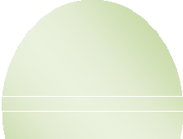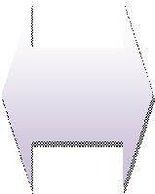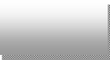

User Interface

Data Retrieval

Data base

Process Control System

Time Table Management Process

Emulator

Output on PDA

Emulation

# Fig: 1.2 System Architecture

Testing

## Testing

The testing of implemented system is done by emulation by emulator and than deployment is done on PDA.

An ***emulator*** duplicates the functions of the one system using a different system, so that the second system behaves like the first system.

Structure of emulator;

An emulator is divided into modules that correspond roughly to the emulated computer’s subsystems. Most often, an emulator will be composed of the following modules:

1. A CPU emulators or CPU simulator.
2. A memory subsystem module.
3. Various I/O devices emulators.
4. Buses are often not emulated, either for reasons of performance or simplicity, and virtual peripherals communicate directly with the CPU or the memory subsystem.

**IV RESULTS AND DISCUSSION**

The fig 1.3 shows user login where, the user will enter the user name and password provided by administrator. Fig 1.4 shows main form having three main Menu. 1) The Search option having three subitems i.e. searching with Semester- wise, Room-wise and, the Complete-Time-Table. 2) Master option having four subitems i.e. Subject, Professor, Room, Department provides respected information. 3) Report option generates reports Subject-wise, Professor-wise and, Department-wise.

The figure 1.5 displays the list of subjects and its type of a particular semester as per user’s request. Similarly list of professors of a particular department can also be checked. The system requests the user to enter the semester and department for the result of complete time table of the semester as shown in fig 1.6. Figure 1.6 displays complete time table according to user’s request. Similarly the system provides time table information according to Room No and Time.

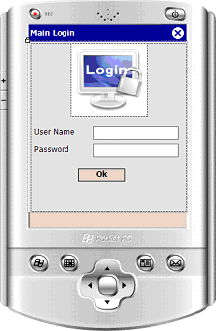

# Figure 1.3 User Login

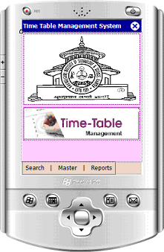

**Figure 1.4 Main Menus**

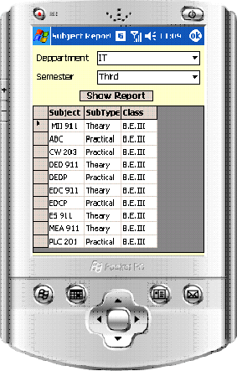

# Figure 1.5 Lists of Subjects for Semester

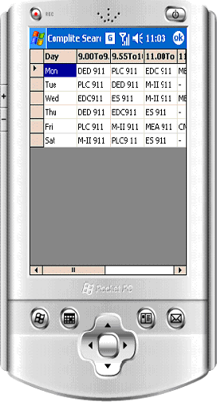

**Figure 1.6 Complete Semester Time Table**

**V CONCLUSION AND FUTURE WORK**

This methodology is an effective and efficient way to maintain and provide required information from the system as per the need of head of institution. The proposed system reduces combustness of manual system with cutting edge technology that helps to visualize the complicacies of time table. All the modules that have been designed helped to retrieve data according to the given information available like Room No, Semester or Time.

The proposed system can be extended to make it web based.

**REFERENCES**

1. ET van der Velde, DE Atsma, R Hoekema, JE Luijten, CI Buddelmeijer, HJ Sprijt, NHJJ van der Putten, “ A Multicenter PDA Project to Support the Clinical Decision Process”, Int’l Conf. Computers in cardiology, pp.177-179, 2004.
2. Ah-young Jeon, In-cheol Kim, Jae-hee Jung, Soo-young Ye, Jae-hyung Kim, Ki-gon Nam, Seoung-wan Baik, Jung- hoon Rp, and Gye-rok Jeon, “Implementation of the Personal Emergency Reponse System”, World Academy of Science, Engineering and Technology, July 31,2007.
3. Chia-Hung Lien, Hsien-Chung Chen, Ying-Wen Bai, and Ming-Bo Lin, “ Power Monitoring and Control for Electric Home Appliances Based on Power Line Communication”, IEEE Int’l Instrumentation and Measurement Tech. Conf., May 12-15, 2008.
4. Sebastian Albert, ”PDA Driven Warehouse Inventory Management System”.
5. LabVIEW PDA Module Release Notes, Version 7.0, April 2003.
6. S. P. Nee and R. S. Kalawsky, Developing a Roaming PDA-Based Interface for a Steering Client for OGSI::Lite using .Net: Practical Lessons Learned, June 25th 2004.
7. Getting Started with the LabVIEW PDA Module, Version 7.1, April 2004.
8. Sean Buckley,” Palm OS Desktop HOWTO”, v2.0.1, 03 March 2002.
9. Jan Schaumann,” Palm OS Emulator HOWTO”, Dec 2000.

[View publication stats](https://www.researchgate.net/publication/271178592)