


VISVESVARAYA TECHNOLOGICAL UNIVERSITY

Jnana Sangama, Machhe Belagavi - 590018

Course Project Report

on
Predictive Market Demand Analysis in E-Commerce Using Linear Regression and Support Vector Machine (SVM)

Course Title: Machine Learning
Course Code: CSE23602

Submitted by
Ranna | 1GA23CS135
Shakthi Vel K | 1GA23CS151
Veeru Gowda G R | 1GA23CS191

Under the Guidance of

Dr. Manjunath C R
Professor

Department of Computer Science and Engineering

Global Academy of Technology
Rajarajeshwari Nagar, Bengaluru - 560 098

2025-2026



GLOBAL ACADEMY OF TECHNOLOGY
Autonomous Institute, Affiliated to VTU, Approved by AICTE, New Delhi Rajarajeshwari Nagar, Bengaluru - 560 098
Department of Computer Science and Engineering

CERTIFICATE

Certified that the Course Project work entitled Predictive Market Demand Analysis in E-Commerce Using Linear Regression and Support Vector Machine (SVM) has been successfully carried out at Global Academy of Technology by Ranna bearing 1GA23CS135, Shakthi Vel K bearing 1G23CS151,Veeru Gowda G R bearing 1GA23CS191 bonafide students of Global Academy of Technology in partial fulfillment of the requirements of final year degree in Bachelor of Engineering in Computer Science and Engineering during Academic Year 2025-26. The Machine Learning Project report has been approved as it satisfies the academic requirements in respect of project work for the award of the degree.

——————————

Dr Manjunath C R
Professor
Dept. of CSE, GAT

ABSTRACT
The rapid growth of e-commerce platforms has increased the need for accurate demand forecasting to support financial planning, inventory management, and business decision-making. Traditional forecasting techniques often fail to handle dynamic market conditions, seasonal variations, and complex customer purchasing patterns, leading to inaccurate predictions and operational inefficiencies. The objective of this project is to develop a machine learning-based demand forecasting system for e-commerce analytics using Linear Regression and Support Vector Machine (SVM) models.
The proposed system uses the dataset “indian_ecommerce_pricing_revenue_growth_36_months”, which contains information related to pricing, revenue, product categories, and monthly growth trends over thirty-six months. Data preprocessing techniques such as handling missing values, normalization, and feature selection are planned to improve data quality and model performance. Linear Regression will be used to identify linear relationships in the dataset, while Support Vector Machine with an RBF kernel will be applied to capture non-linear patterns and improve prediction accuracy.
The methodology follows a structured workflow consisting of data collection, preprocessing, feature selection, model training, prediction, and evaluation. Performance will be analyzed using evaluation metrics such as RMSE, MAE, and R² score. The expected outcome of the project is an efficient and scalable forecasting system capable of improving demand prediction accuracy in e-commerce environments.
The proposed system can support applications such as inventory optimization, revenue analysis, financial planning, and supply chain management. In the future, the project can be extended by integrating deep learning models, customer sentiment analysis, and real-time market data to further enhance forecasting performance.

CHAPTER 1
INTRODUCTION

Project Overview
The rapid growth of e-commerce platforms has increased the importance of data-driven business decision-making in finance and retail management. Demand forecasting plays a major role in predicting future sales, optimizing inventory, and improving revenue management. In modern e-commerce systems, inaccurate demand prediction can lead to overstocking, stock shortages, financial loss, and inefficient supply chain operations. Therefore, intelligent forecasting systems are required to improve prediction accuracy and support business planning.
The purpose of this project is to develop a Machine Learning-based demand forecasting system using Linear Regression and Support Vector Machine (SVM). The system focuses on analyzing e-commerce pricing and revenue data to predict future demand trends. The proposed solution uses the dataset “indian_ecommerce_pricing_revenue_growth_36_months” and applies machine learning algorithms to identify patterns and relationships in the data. The system aims to improve forecasting accuracy, reduce manual effort, and support efficient financial and inventory management.

Background of the Project
In the current e-commerce environment, businesses generate large amounts of transactional and pricing data daily. Organizations rely on forecasting methods to estimate future demand and maintain proper inventory levels. Traditional forecasting systems mainly depend on statistical and manual approaches, which often fail to handle changing customer behavior, seasonal variations, and complex market trends.
Existing systems generally use historical sales analysis and simple time-series methods for prediction. Although these approaches are easy to implement, they provide limited accuracy when dealing with large-scale and dynamic datasets. Businesses often face problems such as inaccurate demand estimation, excess inventory, delayed decision-making, and financial inefficiencies.
The increasing availability of large datasets and advancements in machine learning have created the need for automated and intelligent forecasting systems. Machine learning models can analyze both linear and non-linear relationships in data, making them more suitable for modern e-commerce analytics.

Problem Definition
The existing demand forecasting systems face several limitations in predicting accurate market demand. Traditional and manual approaches are unable to effectively handle complex and non-linear relationships present in e-commerce data. These systems often produce inaccurate forecasts due to changing market trends, seasonal fluctuations, and variations in pricing and revenue patterns.
The major problems identified in the current system include low prediction accuracy, high dependency on manual analysis, inefficient inventory management, and difficulty in handling large datasets. Incorrect forecasting can result in overstocking or understocking, which directly affects business revenue and operational efficiency. Existing methods also require more processing time and lack scalability for real-time analytics.

Proposed System
The proposed system is a Machine Learning-based demand forecasting solution designed for e-commerce analytics. The system uses Linear Regression and Support Vector Machine (SVM) algorithms to predict future demand based on pricing and revenue-related features.
The technologies and tools planned for the project include Python, Pandas, NumPy, Matplotlib, Scikit-learn, and Google Colab. The dataset used is “indian_ecommerce_pricing_revenue_growth_36_months,” which contains information related to pricing, revenue, and monthly growth trends.
The proposed system addresses the limitations of traditional forecasting methods by automating prediction processes and improving accuracy through machine learning models. Linear Regression is used to identify linear relationships, while SVM handles non-linear patterns in the dataset. The system provides functionalities such as data preprocessing, feature selection, model training, prediction, and performance evaluation.

Objectives of the Project
- To design and develop an intelligent demand forecasting system for e-commerce analytics.
- To improve forecasting accuracy using Machine Learning algorithms such as Linear Regression and SVM.
- To automate the existing manual forecasting process.
- To reduce processing time and human effort in demand analysis.
- To provide reliable support for inventory and financial decision-making

  - Scope of the Project
The project focuses on demand forecasting in the e-commerce domain using machine learning techniques. The system can be used for predicting revenue and analyzing demand trends based on historical pricing and sales-related data. The proposed solution is useful for e-commerce businesses, retailers, financial analysts, and inventory management teams.
The project scope includes data preprocessing, model training, prediction, and performance evaluation. In the future, the system can be enhanced by integrating real-time market data, customer sentiment analysis, and advanced deep learning models for higher prediction accuracy.
  - Applications of the Project
- E-commerce demand forecasting
- Inventory management and stock planning
- Financial and revenue analysis
- Supply chain optimization
- Business decision-making support
- Retail sales trend analysis
The system can help organizations improve operational efficiency and reduce financial risks associated with inaccurate demand prediction.
  - Advantages of the Proposed System
- Improved prediction accuracy using Machine Learning algorithms
- Faster processing and automated forecasting
- Reduced manual effort and operational complexity
- Better scalability for large datasets
- Efficient handling of e-commerce data
- Support for informed financial and inventory decisions
- Ability to analyze both linear and non-linear demand patterns
  - Organization of the Report
The report is organized into different chapters to provide a clear understanding of the project development process and implementation details.
- Chapter 1 – Introduction:
Presents the project overview, problem definition, objectives, scope, and importance of the proposed system.
- Chapter 2 – Related Work:
Discusses existing systems, previous research works, methodologies used by other researchers, and limitations identified in earlier approaches.
- Chapter 3 – System Design:
Explains the proposed methodology, workflow, architecture, system diagrams, and module descriptions of the project.
- Chapter 4 – Implementation:
Describes the practical implementation of the project using Google Colab, Python libraries, dataset handling, preprocessing, and model development.
- Chapter 5 – Testing and Result Analysis:
Presents testing procedures, evaluation metrics, graphical analysis, confusion matrix, Type I and Type II errors, and performance results obtained from the model.
- Chapter 6 – Conclusions:
Summarizes the overall project work, achievements, obtained results.

CHAPTER 2
RELATED WORK

System Study

Overview of Existing Work

Table 2.1: Literature Survey Table

Sl. No. | Title of the Paper and Year | Methodology and Datasets Used | Merits | Limitations
1 | Review and Analysis of AI Methods for Demand Forecasting in Supply Chain Management (2021) | Literature review of AI and ML forecasting models using supply chain datasets from multiple research studies | Provides comprehensive comparison of AI forecasting methods | Does not implement a specific forecasting model
2 | Machine Learning in Demand Forecasting (2020) | Hybrid SVM with ARIMA and Holt-Winters using 1C retail company dataset from Kaggle | Hybrid SVM-ARIMA achieved better accuracy | High computational complexity and parameter tuning
3 | Demand Forecasting Based on Machine Learning Algorithms on Customer Information (2021) | KNN, Decision Tree, Gradient Boosting, MLP, and ELM using Black Friday customer dataset | Neural network models achieved high prediction accuracy | Dataset specific and lacks hybrid modeling
4 | Machine Learning Implementation for Demand Forecasting in Supply Chain Management (2022) | ARIMA and XGBoost hybrid forecasting using Kaggle retail demand dataset | Hybrid approach improved forecasting performance | Requires extensive preprocessing and tuning
5 | Machine Learning and Deep Learning Models for Demand Forecasting in Supply Chain Management: A Critical Review (2024) | Review of ML and DL models using 119 research papers from SCOPUS database | Detailed analysis of ML, DL, and hybrid models | No experimental implementation provided
6 | Demand Forecasting for E-Commerce Platforms (2022) | SARIMA and LSTM models using e-commerce sales dataset with 10,000+ records | SARIMA produced lower RMSE and stable forecasting | Limited features and small dataset scope
7 | SmartMart – An Automated Shopping Mart with Blink and Facial Recognition for Payment (2023) | Facial recognition and blink detection using Firebase database and mobile application | Enables automated and contactless shopping | Depends on camera quality and lighting conditions
8 | Machine Learning for Demand Forecasting in Manufacturing (2023) | Regression, neural networks, and ensemble models using manufacturing and retail datasets | Improves forecasting accuracy and scalability | High computational cost and overfitting risk
9 | Multivariate SVR Demand Forecasting for Beauty Products Based on Online Reviews (2023) | Multivariate SVR with sentiment analysis using online beauty product review dataset | Customer sentiment improved prediction accuracy | Complex feature extraction and data dependency
10 | A Hybrid Machine Learning Model for Demand Forecasting: Combination of K-Means, Elastic-Net, and Gaussian Process Regression (2023) | Hybrid model using clustering, feature selection, and GPR on sales forecasting dataset | Reduced RMSE and improved forecasting accuracy | Complex implementation and high processing cost

E-Commerce Market Growth Analysis
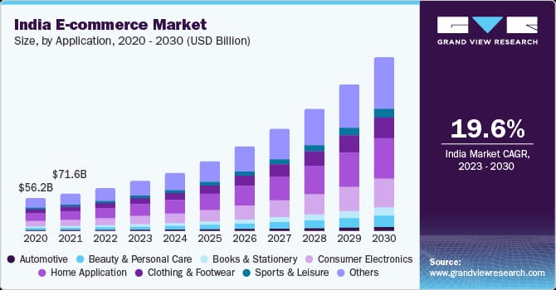
Figure. 2.1. India E-Commerce Market Size by Application (2020–2030)

Figure 2.1 illustrates the growth of the Indian e-commerce market by application from 2020 to 2030. Recent studies indicate that the Indian e-commerce industry is experiencing rapid growth, thereby increasing the importance of intelligent demand forecasting systems. According to market analysis reports, the Indian e-commerce market is projected to grow at a Compound Annual Growth Rate (CAGR) of 19.6% during the period 2023–2030. This growth is primarily driven by sectors such as electronics, clothing and footwear, beauty and personal care, and home applications. As the volume of online transactions continues to rise, businesses increasingly require accurate forecasting systems to manage inventory, optimize revenue, and improve supply chain efficiency [11].
The increasing market size highlights the need for Machine Learning-based forecasting systems capable of handling large-scale and dynamic e-commerce data. Traditional forecasting methods are insufficient for predicting rapidly changing customer demand patterns. Therefore, modern studies focus on applying machine learning and hybrid forecasting models such as Linear Regression, Support Vector Machine (SVM), LSTM, and hybrid AI approaches to improve prediction accuracy and business decision-making.

Research Gap Identification
Existing demand forecasting systems mainly use statistical and machine learning models such as ARIMA, Linear Regression, Decision Trees, LSTM, and SVM for sales prediction in e-commerce platforms [1][2][3]. Although these models improve forecasting accuracy, many systems still depend heavily on historical sales data and fail to handle dynamic market trends, pricing changes, and customer behavior effectively [4]. Some advanced deep learning and hybrid models provide better accuracy but require high computational resources, large datasets, and complex parameter tuning [5][10].
Previous studies also show limitations related to scalability, interpretability, and real-time forecasting. Deep learning models such as LSTM increase training complexity, while hybrid systems are difficult to maintain [5][6]. In addition, some works focus mainly on manufacturing or sentiment analysis rather than practical e-commerce financial analytics [8][9].
Therefore, there is a need for a simpler and more efficient forecasting system that balances accuracy and computational efficiency. The proposed system addresses this gap by combining Linear Regression and Support Vector Machine (SVM) to capture both linear and non-linear patterns in e-commerce data, improving forecasting accuracy and supporting better financial and inventory management.

CHAPTER 3

SYSTEM DESIGN

Proposed Methodology
The proposed system is designed to perform demand forecasting for e-commerce analytics using Machine Learning techniques. The dataset used for the project is “indian_ecommerce_pricing_revenue_growth_36_months”, collected from CSV-based e-commerce data sources. The methodology follows a structured workflow to improve prediction accuracy and support financial decision-making.
The first step is Dataset Collection, where the dataset containing pricing and customer-related information is loaded into Google Colab. Next, Data Preprocessing is performed to prepare the dataset for analysis. This includes handling missing values, removing duplicates, formatting categorical data, and normalizing numerical features.
In the Feature Selection stage, important features such as Category, Brand Type, Zone, Sales Event, Base Price, Discount, Final Price, and Customer Age are selected for model training. The dataset is then divided into training and testing datasets using an 80:20 ratio.
The project uses Linear Regression and Support Vector Machine (SVM) algorithms for prediction. Linear Regression identifies linear relationships, while SVM captures non-linear patterns in the data using the RBF kernel. The models are trained using training data and tested using testing data.
Model performance is evaluated using metrics such as RMSE, MAE, Accuracy, Precision, Recall, and R² Score. Finally, the trained models generate demand predictions, and the results are analyzed using graphs and evaluation reports.
  - System Architecture.
The proposed system architecture for the e-commerce demand forecasting project is designed to perform accurate prediction of product demand using Machine Learning techniques. The architecture consists of multiple modules that work together in a sequential manner to process data, train models, evaluate performance, and generate final predictions. Figure 3.1 illustrates the complete architecture flow of the proposed system.
The process begins with the Dataset Collection Module, where the e-commerce transactional dataset containing 36 months of data, 30,600 records, and 16 features is collected and loaded into the system. The dataset contains important attributes such as Category, Brand Type, Zone, Sales Event, Base Price, Discount, Final Price, and Customer Age.
The collected data is passed to the Data Preprocessing Module, where categorical variables are encoded and numerical features are normalized. This stage also handles missing values, duplicate removal, and data formatting to improve data quality and model performance.
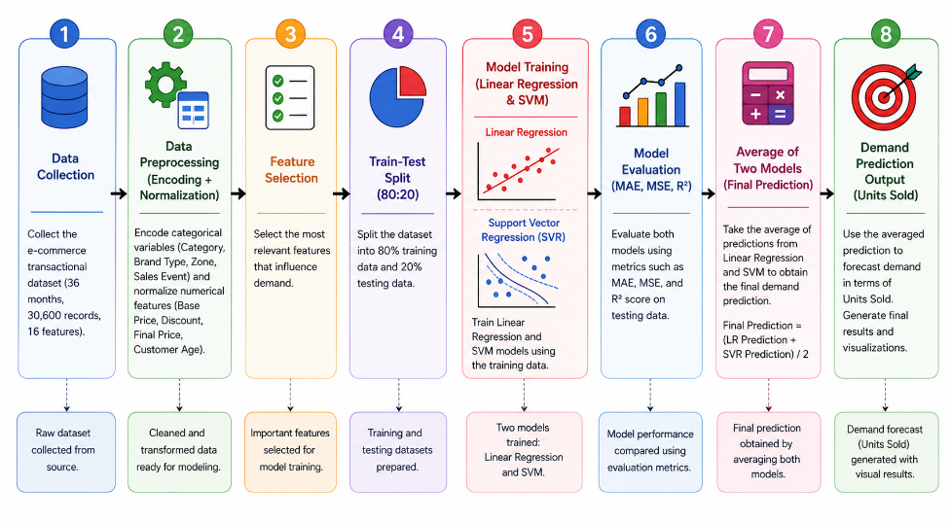
Figure 3.1: Demand Forecasting System
Next, the processed data enters the Feature Selection Module, where the most relevant features influencing product demand are selected for model training. After feature selection, the dataset is divided into training and testing datasets using an 80:20 ratio in the Train-Test Split Module.
In the Model Training Module, two Machine Learning algorithms, namely Linear Regression and Support Vector Machine (SVM), are trained using the training dataset. Linear Regression captures linear relationships, while SVM handles non-linear demand patterns.
The trained models are then evaluated in the Model Evaluation Module using performance metrics such as MAE, MSE, and R² Score. Finally, the predictions generated by both models are averaged to produce the final demand prediction output in terms of units sold. The system provides efficient demand forecasting and supports better business decision-making.
  - Flow Diagram
The flow diagram represents the complete execution workflow of the proposed e-commerce demand forecasting system. Figure 3.2 illustrates the sequence of operations performed from data loading to final prediction generation.
The process starts with loading the e-commerce transactional dataset into the system. In the preprocessing stage, missing values and duplicate records are handled, and categorical variables are encoded. The data is then cleaned and normalized to improve consistency and model performance.
Next, important features influencing demand are selected for training the Machine Learning models. The dataset is divided into training and testing datasets using an 80:20 ratio. The system then trains two Machine Learning models, namely Linear Regression and Support Vector Machine (SVM), using the training dataset.
After training, both models are tested using testing data, and their performance is evaluated using metrics such as MAE, MSE, and R² Score. The prediction outputs generated by Linear Regression and SVM are averaged to produce the final demand prediction. Finally, the system displays prediction results and performance visualizations.
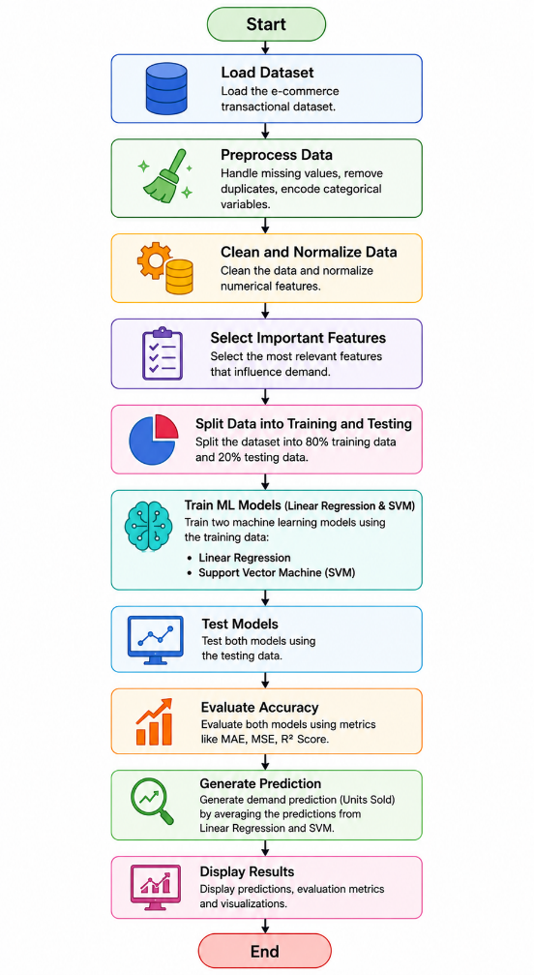
Figure 3.2: Flow Diagram of the Demand Forecasting System
  - Module Description

Module 1 – Dataset Collection
This module collects and loads the dataset from CSV files or public e-commerce datasets into Google Colab for analysis.

Module 2 – Data Preprocessing
This module handles missing values, duplicate records, formatting issues, categorical encoding, and normalization to improve data quality.

Module 3 – Feature Engineering
This module selects important features such as Category, Brand Type, Zone, Sales Event, Base Price, Discount, Final Price, and Customer Age for better prediction performance.

Module 4 – Model Training
This module trains Machine Learning algorithms such as Linear Regression and SVM using training data.

Module 5 – Model Evaluation
This module evaluates model performance using metrics such as RMSE, MAE, Accuracy, Precision, Recall, and R² Score.

Module 6 – Prediction Module
This module generates final demand predictions and displays graphical analysis of forecasting results.

  - Algorithm Design
The project uses two Machine Learning algorithms for demand forecasting:
- Linear Regression
Linear Regression is used to identify linear relationships between input features and target variables. It predicts demand based on the relationship between pricing, revenue, and growth-related features. The algorithm is simple, fast, and easy to interpret.
- Support Vector Machine (SVM)
Support Vector Machine (SVM) is used to handle non-linear relationships in the dataset. The model uses the RBF kernel to improve prediction accuracy by mapping data into higher-dimensional space. SVM is effective for complex demand patterns and provides better generalization performance compared to traditional models.
Both algorithms are trained and evaluated to compare their forecasting performance for e-commerce analytics.

CHAPTER 4

IMPLEMENTATION

Development Environment
The development environment for the proposed e-commerce demand forecasting system consists of software tools, Machine Learning libraries, and data processing technologies used for model development, training, testing, and visualization. The project is implemented using Python in the Google Colab platform, which provides an efficient cloud-based environment for Machine Learning experimentation and execution.
Table 4.1 Development Tools and Technologies
Tool / Technology | Purpose
Google Colab | Project development and execution
Python | Programming language used for implementation
Pandas | Data loading, preprocessing, and manipulation
NumPy | Numerical computations and array operations
Matplotlib | Data visualization and graphical analysis
Scikit-learn | Machine Learning model implementation
Linear Regression | Demand prediction using linear relationships
Support Vector Machine (SVM) | Demand prediction using non-linear patterns
CSV Dataset | Storage and input of e-commerce transactional data
  - Dataset Description
The dataset used for the proposed demand forecasting system is collected from a Kaggle e-commerce dataset named “indian_ecommerce_pricing_revenue_growth_36_months”. The dataset contains transactional and pricing-related information used for predicting product demand in e-commerce platforms.
- Dataset Details
- Dataset collected from Kaggle dataset.
- Contains approximately 30,600 records collected over 36 months.
- The dataset includes both categorical and numerical attributes related to e-commerce transactions and customer behavior.
- Features Used
The important features used for the project are:
- Category
- Brand Type
- Zone
- Sales Event
- Base Price
- Discount
- Final Price
- Customer Age
These features are used as input variables for training the Machine Learning models. The target output of the system is demand prediction in terms of units sold. The dataset supports both linear and non-linear analysis, making it suitable for implementing Linear Regression and Support Vector Machine (SVM) algorithms for demand forecasting.
  - Data Preprocessing Implementation
Data preprocessing was performed using Python libraries such as Pandas and Scikit-learn in Google Colab. The dataset was checked for missing values and duplicate records. The preprocessing results showed that there were no missing values in the dataset attributes such as category, brand_type, zone, sales_event, base_price, discount_percent, final_price, customer_age, and units_sold.
Duplicate records were removed, and the cleaned dataset contained 30,600 rows. Categorical features including category, brand_type, zone, and sales_event were converted into numerical format using One-Hot Encoding. After encoding, the dataset shape became (30600, 18).
The feature matrix X contained 17 input features, while the target vector Y contained the units_sold values. The dataset was divided into training and testing datasets using an 80:20 ratio, resulting in 24,480 training rows and 6,120 testing rows.
Feature scaling was applied to numerical attributes such as base_price, discount_percent, final_price, and customer_age to improve model performance and maintain data consistency.
Preprocessing Results
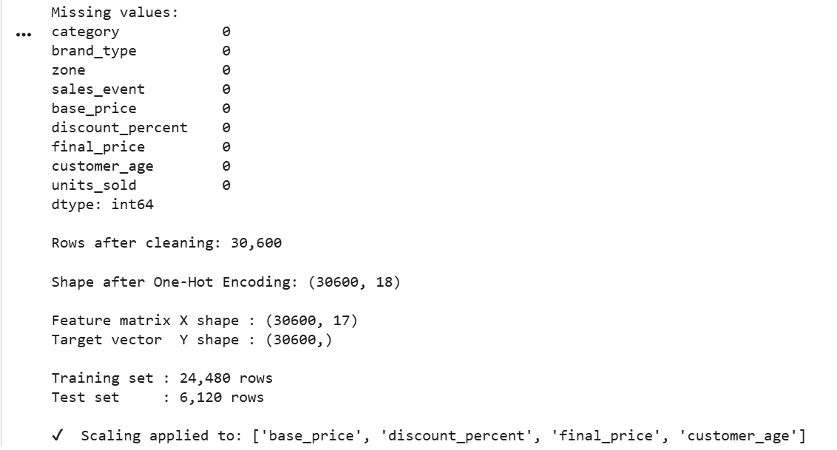
Figure 4.1 Data Preprocessing Results and Dataset Statistics

  - Model Implementation
The proposed demand forecasting system uses two Machine Learning algorithms, namely Linear Regression and Support Vector Machine (SVM), for training and prediction. Both models were trained using the scaled training dataset after preprocessing and feature selection.
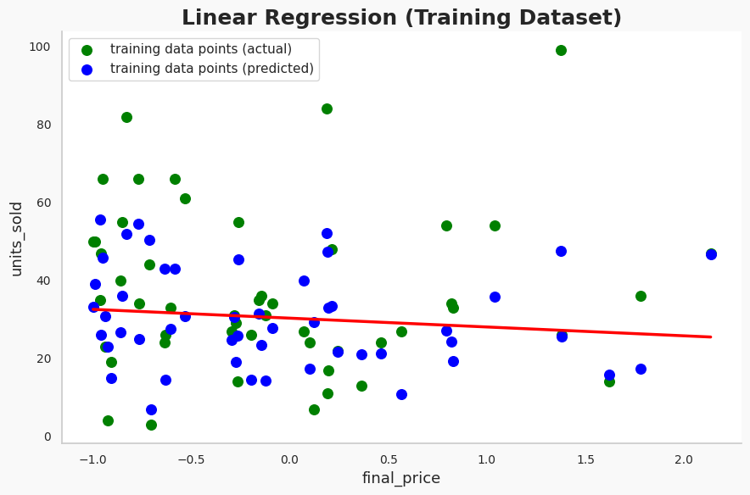
Figure 4.2: Linear Regression Training Graph (Actual vs Predicted Values)
The Linear Regression training graph shown in Figure 4.2 represents the relationship between the feature final_price and the target variable units_sold. The green points represent the actual training data values, while the blue points represent the predicted values generated by the Linear Regression model. The red line indicates the best-fit regression line learned during training. The graph shows that the model attempts to capture the overall linear trend between final price and units sold.
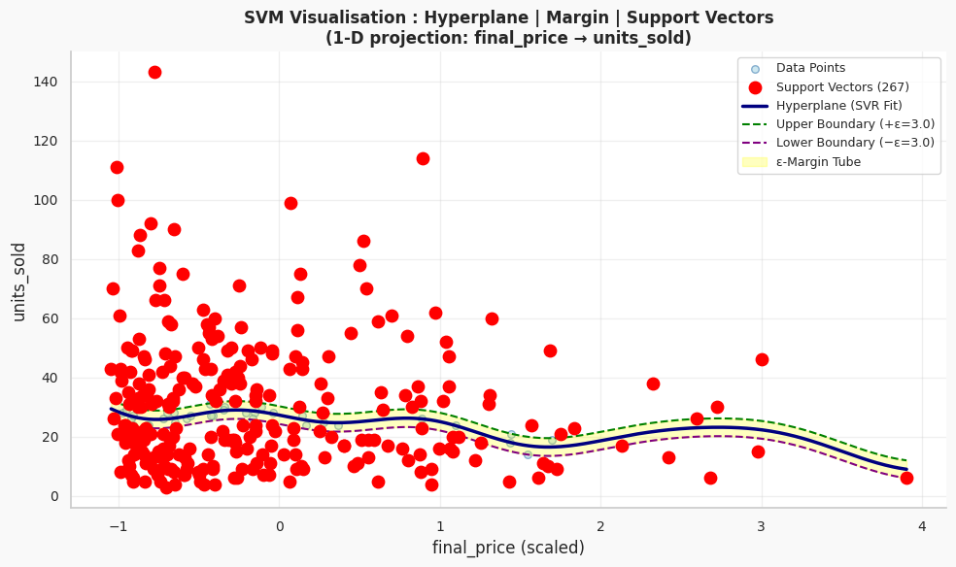
Figure 4.3: SVR Training Visualization
The SVM training visualization shown in Figure 4.3 illustrates the Support Vector Regression (SVR) model using the RBF kernel. The graph displays the hyperplane, margin boundaries, and support vectors used during training. The red highlighted points represent the support vectors that influence the prediction boundary. The blue curve represents the SVR fitted model, while the green and purple dashed lines indicate the upper and lower margin boundaries. This graph demonstrates the ability of SVM to capture non-linear demand patterns in the dataset.
  - Visualization and Output
The proposed system generates prediction results and visual representations for demand forecasting using Linear Regression and Support Vector Regression (SVR). The user provides input details such as category, brand type, zone, sales event, base price, discount percentage, and customer age through the prediction module.
For the given input, the system calculates the final price after applying the discount and generates demand predictions using both Machine Learning models. The Linear Regression model predicted 37.8 units sold, while the SVR (RBF Kernel) model predicted 33.9 units sold. The final prediction was obtained by averaging both model outputs, resulting in an average prediction of 35.9 units sold, which was rounded to 36 units.
The system also performs demand classification using a threshold value of 30 units. Since the predicted demand exceeded the threshold, the result was classified as High Demand for both models and the averaged prediction.
shows the comparison of prediction outputs generated by Linear Regression, SVR, and the averaged prediction model.
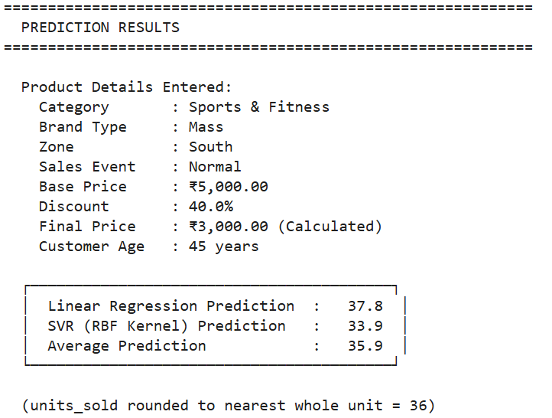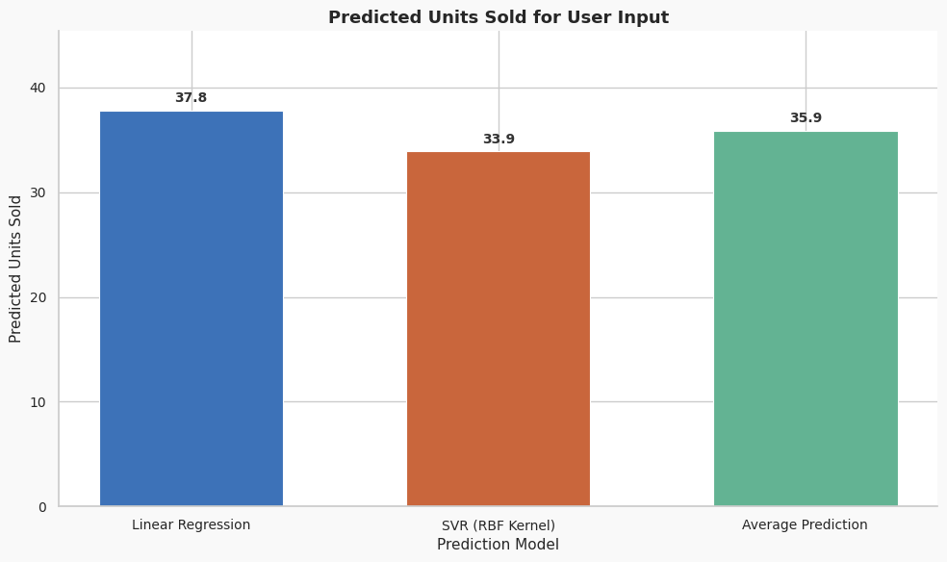
Figure 4.4: Prediction Results and Comparison of Predicted Units Sold

CHAPTER 5
TESTING
  - Result Analysis
Testing was carried out using the testing dataset to evaluate the performance of the Linear Regression and Support Vector Regression (SVR) models. The trained models generated prediction outputs for units sold, and the predicted values were compared with the actual demand values present in the dataset.
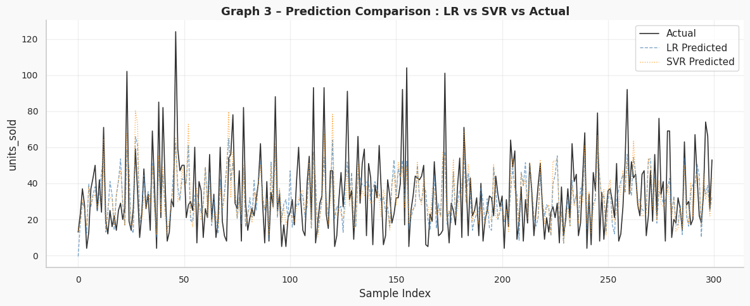
Figure 5.1: Prediction Comparison – LR vs SVR vs Actual
Figure 5.1 shows the comparison between actual values and predicted values generated by Linear Regression and SVR models. The graph indicates that both models follow the overall trend of demand patterns. However, slight variations can be observed between actual and predicted outputs due to non-linear variations and dynamic pricing behavior in the dataset.
  - Test Cases and Validation
Different test scenarios were used to validate the functionality and performance of the proposed demand forecasting system. The validation process ensured that the system correctly handled preprocessing, prediction generation, and model evaluation for different input conditions.
The system was tested using valid datasets, datasets with preprocessing requirements, and different user input combinations for prediction generation. The obtained outputs were compared with the expected outputs to verify system correctness and forecasting reliability.
Validation Process
- Dataset loaded and validated successfully
- Missing values and duplicate records checked during preprocessing
- Features encoded and normalized correctly
- Linear Regression and SVR models trained successfully
- Prediction outputs generated correctly
- Evaluation metrics calculated properly

Table 5.1: Test Cases and Validation Results
Test Case | Input Data | Expected Result | Obtained Result | Status
TC1 | Valid dataset | Correct prediction generation | Correct prediction generated | Pass
TC2 | Dataset preprocessing | Missing values and duplicates handled properly | Successfully handled | Pass
TC3 | Encoded categorical data | Numerical conversion successful | Successfully encoded | Pass
TC4 | Training dataset | Model trained successfully | Model trained successfully | Pass
TC5 | User product input | Demand prediction generated | Prediction generated | Pass
TC6 | Evaluation metrics | Correct MAE, MSE, RMSE, R² output | Metrics generated correctly | Pass
TC7 | Demand classification | High/Low demand classification | Classification generated | Pass
TC8 | Unknown input combinations | Prediction generated without errors | Successfully predicted | Pass
  - Regression Performance Metrics
Regression metrics were used to measure the prediction error and forecasting accuracy of the Linear Regression and SVR models. As shown in Figure 5.2, the error comparison graph presents the MAE, MSE, and RMSE values of both models.
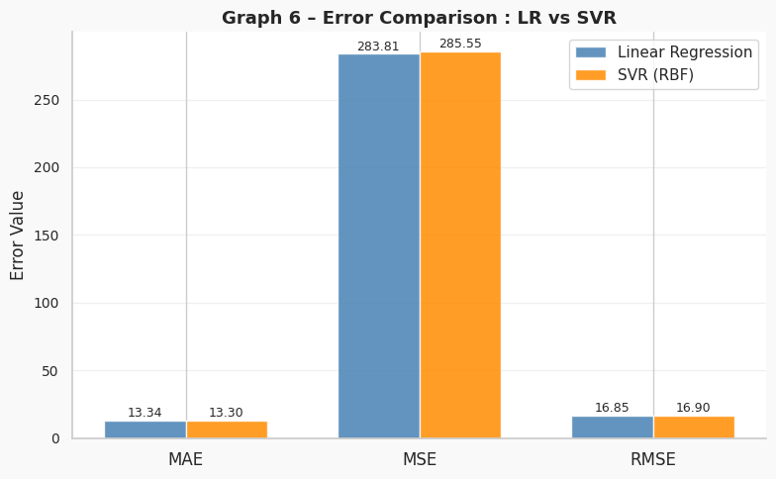
Figure 5.2: Error Comparison between LR and SVR
Mean Absolute Error (MAE)
MAE measures the average absolute difference between actual and predicted values.
- Linear Regression MAE : 13.3367
- SVR MAE : 13.3003
SVR achieved a slightly lower MAE value.
Mean Squared Error (MSE)
MSE measures the average squared prediction error.
- Linear Regression MSE : 283.8068
- SVR MSE : 285.5472
Linear Regression achieved a slightly lower MSE value.
Root Mean Squared Error (RMSE)
RMSE represents the square root of MSE and measures prediction error deviation.
- Linear Regression RMSE : 16.8466
- SVR RMSE : 16.8981
Linear Regression achieved a slightly lower RMSE value.
R² Score
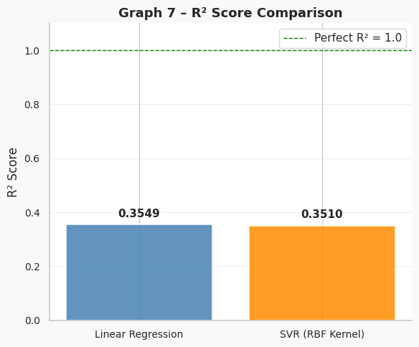
Figure 5.3: R² Score Comparison
R² Score indicates how well the model explains the variance in the dataset. Higher R² values indicate better model fitting and forecasting capability. As shown in Figure 5.3, the Linear Regression model achieved a slightly higher R² Score compared to the SVR model.
- Linear Regression R² Score : 0.3549
- SVR R² Score : 0.3510
Linear Regression achieved a slightly better R² Score, indicating marginally better variance explanation in the dataset.
  - Classification Performance Metrics
Classification metrics were used to evaluate the demand classification performance of the Linear Regression and Support Vector Regression (SVR) models after converting prediction outputs into High Demand and Low Demand categories. As shown in Figure 5.4, the comparison graph illustrates the Accuracy, Precision, Recall, and F1-Score values of both models.

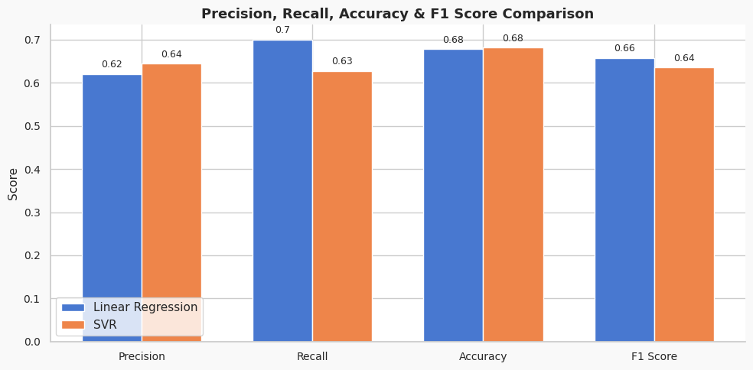
Figure 5.4: Precision, Recall, Accuracy, and F1-Score Comparison
Accuracy
Accuracy measures the overall correctness of the classification model.
- Linear Regression Accuracy : 0.6776
- SVR Accuracy : 0.6815
SVR achieved slightly better accuracy compared to Linear Regression.
Precision
Precision indicates how many predicted high-demand products were actually high demand.
- Linear Regression Precision : 0.6206
- SVR Precision : 0.6442
SVR achieved better precision and reduced false positive predictions.
Recall
Recall measures the ability of the model to correctly identify actual high-demand products.
- Linear Regression Recall : 0.6996
- SVR Recall : 0.6273
Linear Regression achieved higher recall compared to SVR.
F1-Score
F1-Score provides a balanced evaluation of Precision and Recall.
- Linear Regression F1-Score : 0.6578
- SVR F1-Score : 0.6356
Linear Regression achieved a slightly higher F1-Score.
  - Confusion Matrix Analysis
Confusion matrix analysis was performed to evaluate the classification performance of the Linear Regression and Support Vector Regression (SVR) models after converting the regression outputs into demand categories using a threshold value of 30 units. The predictions were classified into High Demand and Low Demand categories.

For the Linear Regression model, the confusion matrix produced the following results as shown in Figure 5.5:
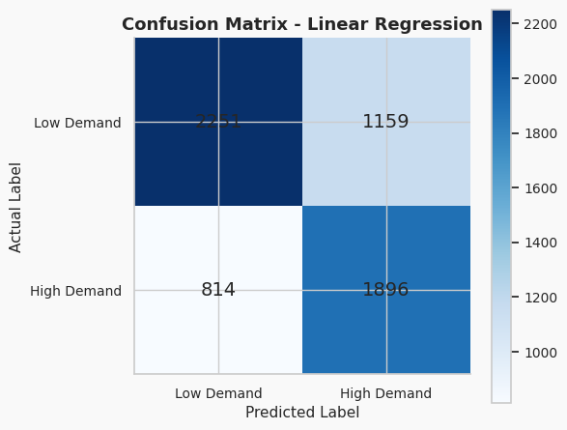
Figure 5.5: Confusion Matrix – Linear Regression
- True Positives (TP): 1896
- True Negatives (TN): 2251
- False Positives (FP): 1159
- False Negatives (FN): 814
The model achieved better recall by correctly identifying more high-demand products. However, the higher false positive value indicates more overstocking predictions
For the SVR (RBF Kernel) model, the confusion matrix produced the following results as shown in Figure 5.6:
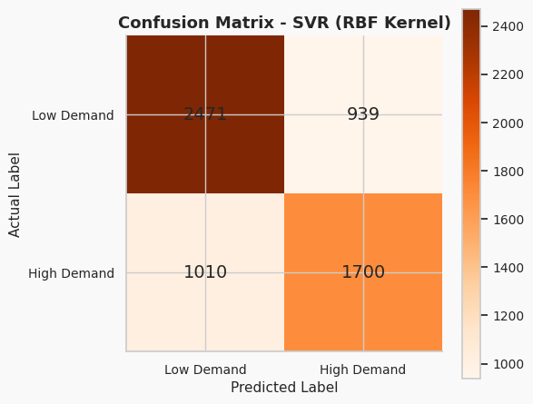
Figure 5.6: Confusion Matrix - SVR (RBF Kernel)
- True Positives (TP): 1700
- True Negatives (TN): 2471
- False Positives (FP): 939
- False Negatives (FN): 1010
The SVR model achieved lower false positives and better true negative classification, reducing overstocking errors. However, it produced slightly higher false negatives compared to Linear Regression
The confusion matrix analysis shows that both models provide balanced classification performance with small variations in prediction behavior.
  - Error Analysis
Error analysis was performed to study the prediction errors generated by the Linear Regression and Support Vector Regression (SVR) models. The analysis focused on Type 1 Error and Type 2 Error after converting regression outputs into demand classification categories. As shown in Figure 5.7, the comparison graph illustrates the Type 1 and Type 2 error values of both models.
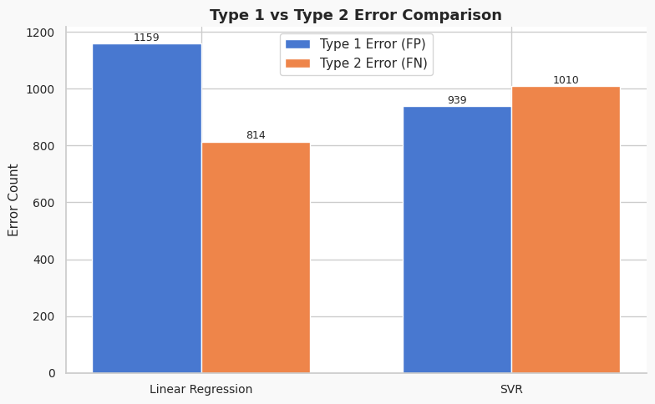
Figure 5.7: Type I vs Type II Error Comparison
- Type 1 Error (False Positive) represents overstocking, where the model predicts high demand even when the actual demand is low.
- Type 2 Error (False Negative) represents understocking, where the model predicts low demand even when the actual demand is high.
For the Linear Regression model, the Type 1 Error value was 1159, while the Type 2 Error value was 814. This indicates that the model produced more overstocking predictions but fewer understocking cases.
For the SVR model, the Type 1 Error value was 939, while the Type 2 Error value was 1010. This indicates that SVR reduced overstocking errors but slightly increased understocking predictions.
The analysis shows that Linear Regression performed better in identifying high-demand products, while SVR performed better in reducing false positive predictions. Both models demonstrated balanced performance for e-commerce demand forecasting.

CHAPTER 6
CONCLUSIONS
The project successfully implemented a Machine Learning-based demand forecasting system for e-commerce analytics using Linear Regression and Support Vector Regression (SVR) algorithms. The main objective of the project was to predict product demand accurately using pricing, customer, and sales-related features from the dataset “indian_ecommerce_pricing_revenue_growth_36_months.” The system addressed the problem of inaccurate demand forecasting, which affects inventory management, financial planning, and business decision-making in e-commerce platforms.
The project methodology included dataset collection, data preprocessing, feature selection, model training, prediction generation, and performance evaluation. Python libraries such as Pandas, NumPy, Matplotlib, and Scikit-learn were used in Google Colab for implementation. Important features such as Category, Brand Type, Zone, Sales Event, Base Price, Discount, Final Price, and Customer Age were used for training the models.
The evaluation results showed that both Linear Regression and SVR models achieved reliable forecasting performance with similar MAE, MSE, RMSE, Accuracy, Precision, Recall, and F1-Score values. Linear Regression achieved better recall and R² Score, while SVR reduced false positive predictions and improved accuracy. The final prediction was generated by averaging the outputs of both models to improve prediction reliability.
The developed system reduced manual effort, improved forecasting efficiency, and demonstrated the practical application of Machine Learning techniques in e-commerce demand prediction. The project also highlighted the importance of combining linear and non-linear models for better forecasting performance and decision-making support.

REFERENCES
- Review and Analysis of AI Methods for Demand Forecasting in Supply Chain Management, 2021.
- Learning in Demand Forecasting, 2020.
- Demand Forecasting Based on Machine Learning Algorithms on Customer Information, 2021.
- Machine Learning Implementation for Demand Forecasting in Supply Chain Management, 2022.
- Machine Learning and Deep Learning Models for Demand Forecasting in Supply Chain Management: A Critical Review, 2024.
- Demand Forecasting for E-Commerce Platforms, 2022.
- SmartMart – An Automated Shopping Mart with Blink and Facial Recognition for Payment, 2023.
- Machine Learning for Demand Forecasting in Manufacturing, 2023.
- Multivariate SVR Demand Forecasting for Beauty Products Based on Online Reviews, 2023.
- A Hybrid Machine Learning Model for Demand Forecasting: Combination of K-Means, Elastic-Net, and Gaussian Process Regression, 2023.
- Grand View Research, India E-commerce Market Size, by Application, 2020–2030 (USD Billion), available at: Grand View Research

