**WORKSHEET-2**

**DEEP LEARNING**

**Q1 to Q8 are MCQs with only one correct answer. Choose the correct option.**

1. Operations in the neural networks can performed ?
   1. serially B) parallely

C) serially or parallely D) None of the above

Answer 1. B

1. Who proposed the first perceptron model and when?
   1. Rosenblatt, 1958 B) McCulloch-pitts, 1958 C) John Hopfield, 1982 D) McCulloch-

pitts, 1982

Answer 2. C

1. Which one of these plots represents a ReLU activation function?
   1. 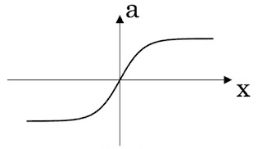 B) 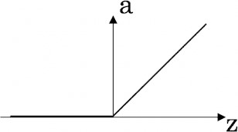

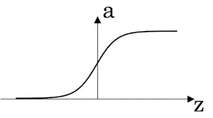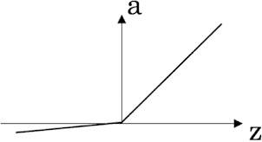

C) D)

Answer 3. A

1. In a simple artificial neural network with 5 neurons in the input layer, 8 neurons in the hidden layer and 3 neurons in the output layer. What is the size of the weight matrices between hidden-output layers and input- hidden layers?
   1. [3×8], [5×8] B) [8×3], [5×8] C) [5×8], [8×5] D) [8×3], [5×3]

Answer 4. C

1. What is a dead unit in a neural network?
   1. A unit which does not respond completely to any of the training patterns
   2. The unit which produces the biggest sum-squared error
   3. A unit which doesn’t update during training by any of its neighbour
   4. None of these

Answer 5 C

1. Which of the following functions can be used as an activation function if we wish to predict the probabilities of n classes such that sum of all n probabilities is equal to 1?
   1. sigmoid B) softmax

C) tanh D) ReLU

Answer 6. B

1. The amount of output of one unit received by another unit depends on what?
   1. output unit B) input unit

C) activation values D) weights

Answer 7 . D

1. What is asynchronous update in neural networks?
   1. output units are updated parallely B) output units are updated sequentially

C) either sequentially or parallely D) None of the above

Answer 8. D

**Q9 and Q10 are MCQs with one or more correct answers. Choose all the correct options.**

1. Which of the following techniques can be used to reduce overfitting in a neural network?
   1. EarlyStopping B) Dropout

C) checkpoints D) ReduceLROnPlateau

Answer 9 A and B

1. Why is an RNN used for machine translation, say translating English to Hindi? A) It can be trained as a supervised learning problem.
   1. It is strictly more powerful than a Convolutional Neural Network
   2. It is applicable when the input/output is a sequence (e.g., a sequence of words)
   3. RNNs represent the recurrent process of Idea->Code->Experiment->Idea->....

Answer 10. C and D

**Q11 to Q15 are subjective answer type question. Answer them briefly.**

1. The output of a perceptron is calculated as follows:

*n*

*y*  *f* (*b*  *wi xi* )

*i* 1

Where *f* (*x*) is the activation function. If you want to build a perceptron which gives an output for linear

# WORKSHEET

regression, what will be the activation function you would use?

1. What will happen if we use very large or very small learning rates?

Answer 12. A **learning rate** that is **too large can** cause the model **to** converge **too** quickly **to** a suboptimal solution, whereas a **learning rate** that is **too small can** cause the process **to** get stuck

1. Below is a diagram if a single artificial neuron:





The node has three inputs x = (x1, x2, x3) that receive only binary signals (either 0 or

1)

. How many different

input patterns this node can receive? What if the node had four, five inputs? Can you give a formula that

computes the number of binary input patterns for a given number of inputs?

14.

What Are Vanishing and Exploding

Gradients?

15

55.

What Is

the Difference Between Epoch, Batch, and Iteration in Deep

Learning

?

