WORKSHEET-3

**SQL**

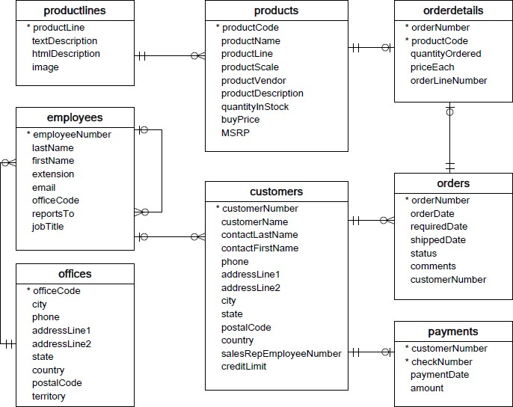**Refer the following ERD and answer all the questions in this worksheet. You have to write the queries using mysql for the required Operation.**

* **Customers**: stores customer’s data.
* **Products**: stores a list of scale model cars.
* **ProductLines**: stores a list of product line categories.
* **Orders**: stores sales orders placed by customers.
* **OrderDetails**: stores sales order line items for each sales order.
* **Payments**: stores payments made by customers based on their accounts.
* **Employees**: stores all employee information as well as the organization structure such as who reports to whom.
* **Offices**: stores sales office data.
  1. Write SQL query to create table **Customers.**

CREATE TABLE CUSTOMERS (CUSTOMER_NUMBER INT,CUSTOMER_NAME VARCHAR(255),CONTACTLASTNAME VARCHAR(255),CONTACTFIRSTNAME VARCHAR(255),PHONE INT,ADDRESSLINE1 VARCHAR(255),ADDRESSLINE2 VARCHAR (255),CITY VARCHAR(255),STATE VARCHAR(255),POSTALCODE INT,COUNTRY VARCHAR(255),SALES_REP_EMPLOYEE_NUMBER INT,CREDIT_LIMIT INT);

* 1. Write SQL query to create table **Orders.**

**Create table Orders (order_number int,order_date date,required_date date,shipped_date date,status varchar(255),**

**Comments varchar(255),customerName int);**

* 1. Write SQL query to show all the columns data from the **Orders** Table.

SELECT * FROM ORDERS;

* 1. Write SQL query to show all the comments from the **Orders** Table.

SELECT COMMENTS FROM ORDERS;

* 1. Write a SQL query to show orderDate and Total number of orders placed on that date, from **Orders** table.

SELECT COUNT(ORDER_NUMBER),ORDER_DATE FROM ORDERS GROUPBY ORDER_NUMBER;

* 1. Write a SQL query to show employeNumber, lastName, firstName of all the employees from **employees** table.

SELECT EMPLOYEE_NUMBER,LAST_NAME,FIRST_NAME FROM EMPLOYEES;

* 1. Write a SQL query to show all orderNumber, customerName of the person who placed the respective order.

SELECT ORDER_NUMBER,CUSTOMERNAME FROM ORDERS;

* 1. Write a SQL query to show name of all the customers in one column and salerepemployee name in another column.

SELECT CUSTOMER_NAME ,SALESREPEMPLOYEENUM FROM CUSTOMERS;

* 1. Write a SQL query to show Date in one column and total payment amount of the payments made on that date from the **payments** table.

SELECT COUNT(PAYMENT_AMOUNT), DATE FROM PAYMENTS GROUPBY(DATE);

* 1. Write a SQL query to show all the products productName, MSRP, productDescription from the **products** table.

SELECT PRODUCT_NAME,MSRP,PRODUCT_DESCRIPTION FROM PRODUCTS;

* 1. Write a SQL query to print the productName, productDescription of the most ordered product.

SELECT COUNT (PRODUCT_ NAME),COUNT(PRODUCT_DESCRIPTION) FROM PRODUCT GROUPBY PRODUCT_NAME);

* 1. Write a SQL query to print the city name where maximum number of orders were placed.

SELECT CITY ,COUNT(DISTINCT ORDER_NUMBER),MAX(ORDER_NUMBER) FROM ORDERS

GROUPBY CITY;

* 1. Write a SQL query to get the name of the state having maximum number of customers.

SELECT STATE , COUNT(DISTINCT CUSTOMER_ID) ,MAX(CUSTOMER_ID) FROM CUSTOMERS

GROUPBY STATE;

* 1. Write a SQL query to print the employee number in one column and Full name of the employee in the second column for all the employees.

SELECT EMPLOYEE_NUMBER , EMPLOYEE_NAME FROM EMPLOYEE;

* 1. Write a SQL query to print the orderNumber, customer Name and total amount paid by the customer for that order (quantityOrdered × priceEach).

SELECT ORDER_NUMBER,CUSTOMER_NAME

Count(DISTINCT O.Order_NUMBER) AS TotalOrders,

Sum(QUANTITY_ORDERED*PRICE_EACH) AS TotaLAmount

FROM [Order]

INNER JOIN [OrderItem] OI

ON O.Order_NUMBER = OI.OrderNUMBER

GROUP BY CUSTOMER_NAME

Order BY Count(DISTINCT O.Order_NUMBER) DESC