Mentza × ORENA Integration Strategy
How Mentza powers the ORENA Workforce Growth Platform
Internal discussion document — Leadership, Product, Design & Engineering

Purpose
This document explains how Mentza should fit within the future ORENA platform. It is intended for internal discussions between leadership, product, design and engineering teams. The objective is not to expose Mentza as a separate product, but to define how its capabilities strengthen ORENA's Hiring, Learning and Culture Transformation services while preserving the ORENA brand experience.
Reading key: teal = ORENA-owned, amber = Mentza-powered, navy = combined/unified outcome.

1. Current Situation
ORENA possesses domain expertise, industry experts, consulting capability, recruitment services, training programs and organizational transformation experience. Mentza provides AI-powered learning, assessments, coaching, simulations and culture analytics. Individually both solve different parts of the workforce lifecycle. Together they create a unified Workforce Growth Platform.
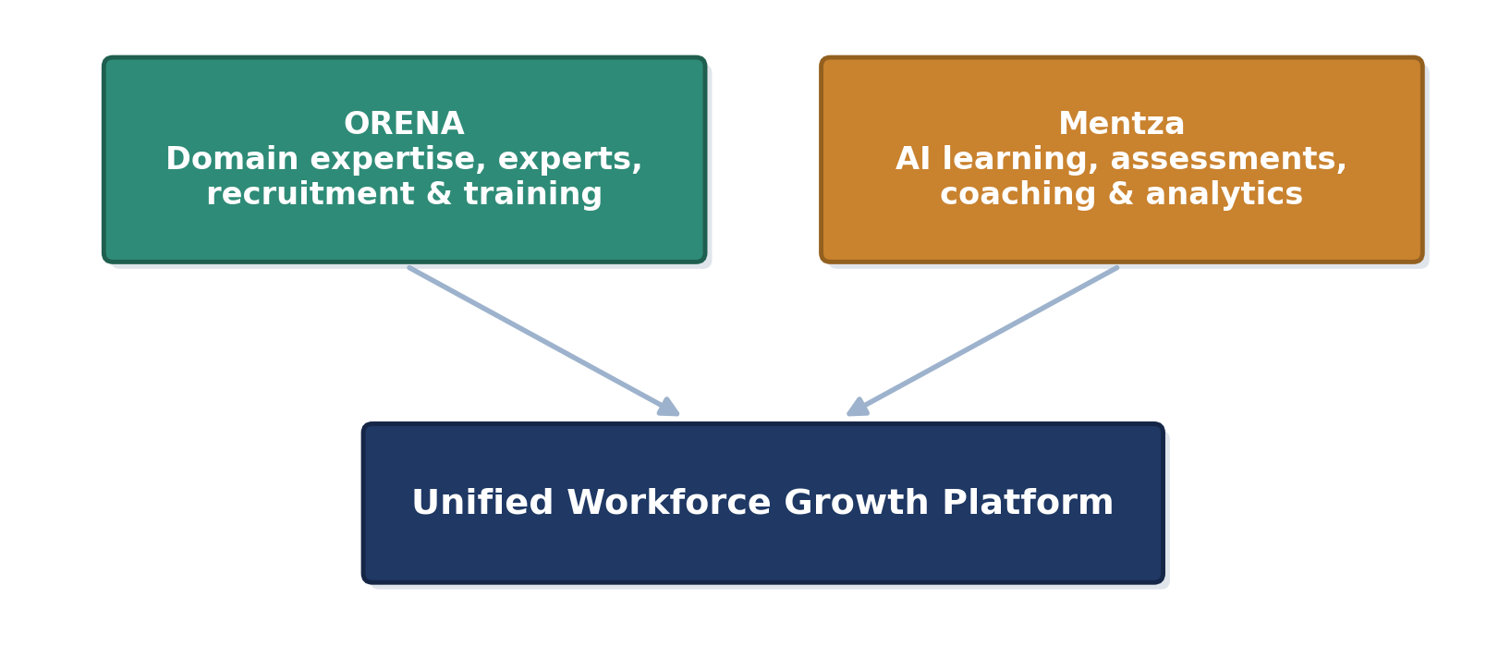

2. Guiding Principle
The customer should experience only one platform: ORENA.
- Mentza is treated as a technology provider — an intelligence layer that powers selected capabilities behind the scenes
- Branding, navigation, dashboards and workflows stay completely consistent with the ORENA experience
- No screen, label or workflow should expose “Mentza” as a separate product to the end customer

3. Where Mentza Fits
Across five business areas, ORENA owns the workflow and relationship while Mentza contributes the AI-powered capability behind it.
Business Area | ORENA Responsibility | Mentza Contribution
Hiring | Experts, recruitment workflow, client management | AI screening, assessments, interview intelligence
Training | Learning programs, workshops, experts | AI coaching, simulations, assessments
Culture | Transformation consulting, workshops | Culture analytics, story collection, AI insights
Analytics | Business reporting | Learning & assessment data
AI Assistant | Unified user interface | Conversation intelligence where applicable

4. Hiring Integration
The hiring lifecycle begins inside ORENA. Companies create hiring requirements, recruiters manage positions and experts perform final evaluations. Mentza is invoked only where automation creates value — final hiring decisions remain with ORENA and the client.
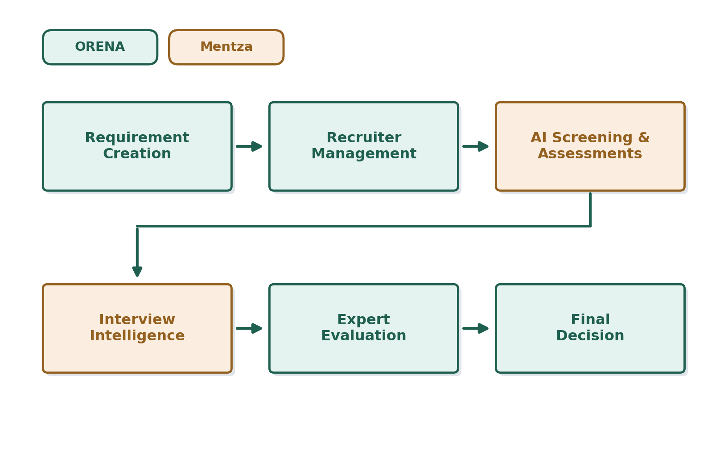

5. Learning Integration
ORENA manages learning journeys, experts, workshops and curriculum. Mentza powers interactive coaching, role-play simulations, multilingual learning, assessments and learner reports.
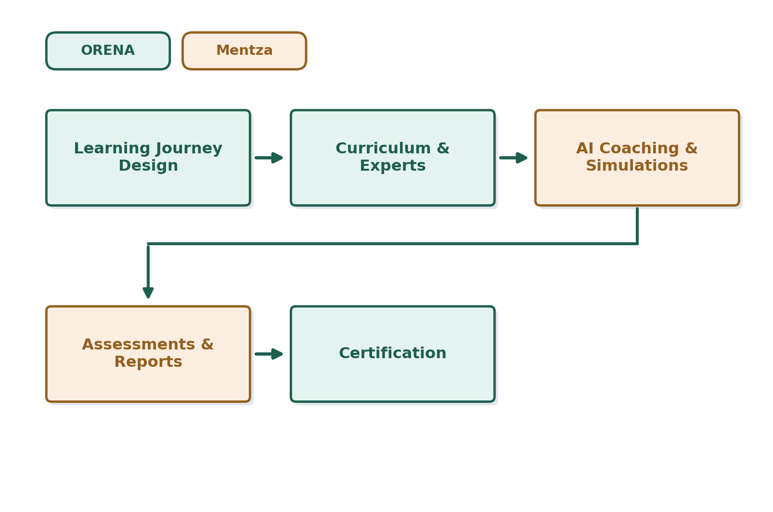
- The frontend stays provider-agnostic
- Another LMS can replace or complement Mentza without changing the overall user experience

6. Culture Transformation
Culture transformation remains an expert-led engagement. Mentza assists by collecting employee stories, analysing behavioural themes, generating dashboards and identifying trends. ORENA consultants interpret these insights, conduct workshops, align leadership and execute organizational change initiatives.
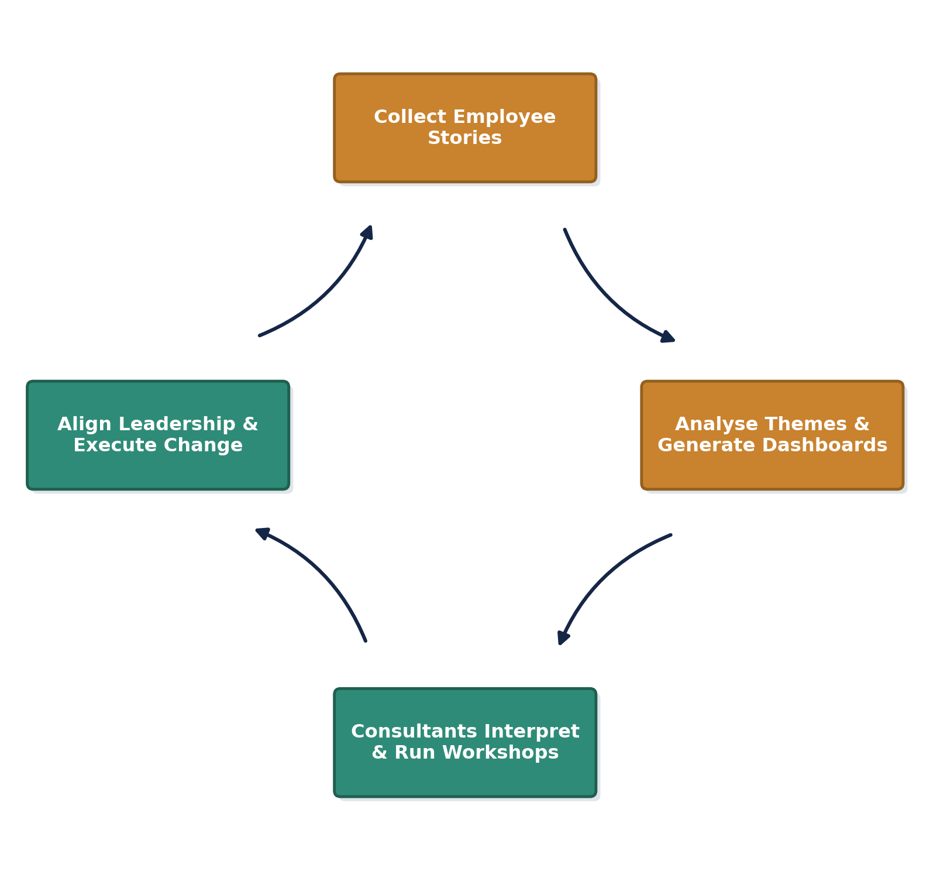

7. Platform Architecture
A single ORENA frontend connects to modular backend services. Hiring, Learning, Culture, Analytics and AI Assistant communicate with integrations — Mentza, LMS providers, WhatsApp and future enterprise systems — through well-defined APIs.
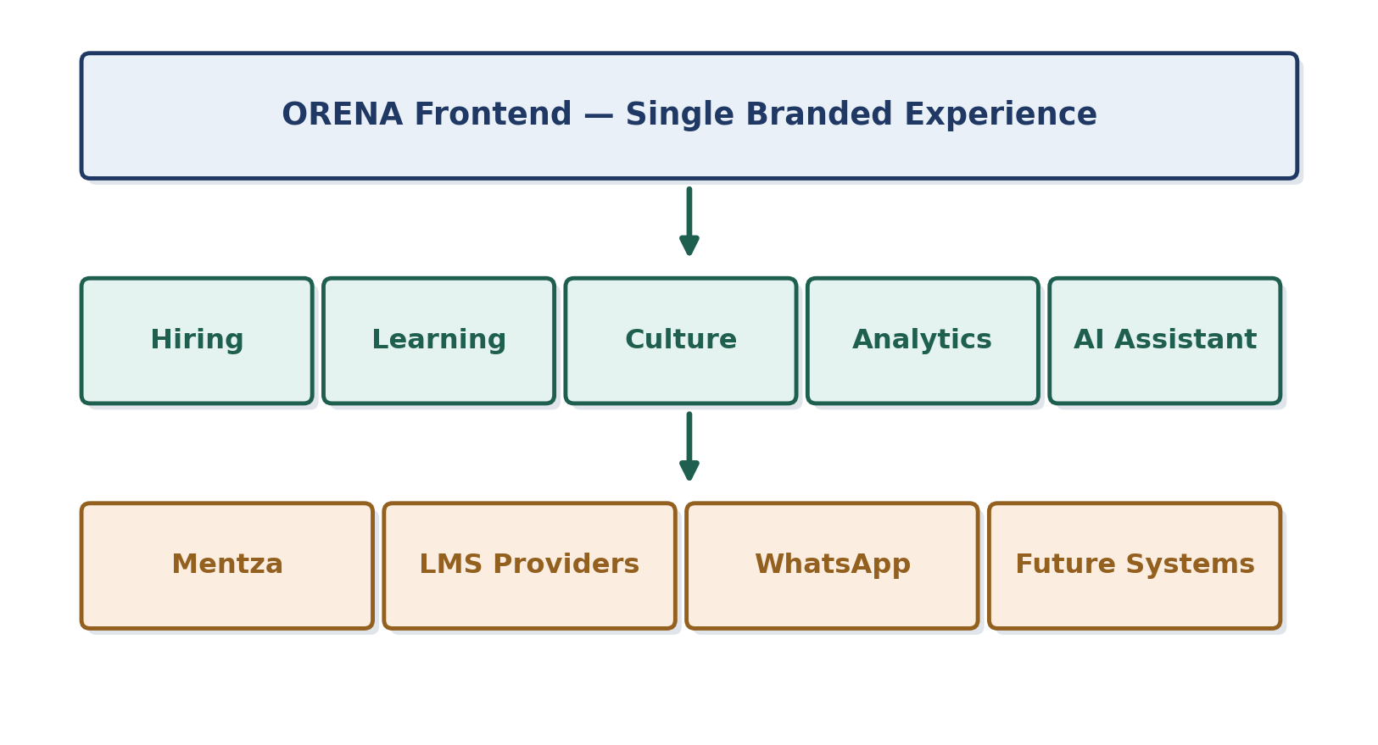
- This abstraction prevents vendor lock-in
- Keeps the platform scalable as new integrations are added

8. Benefits
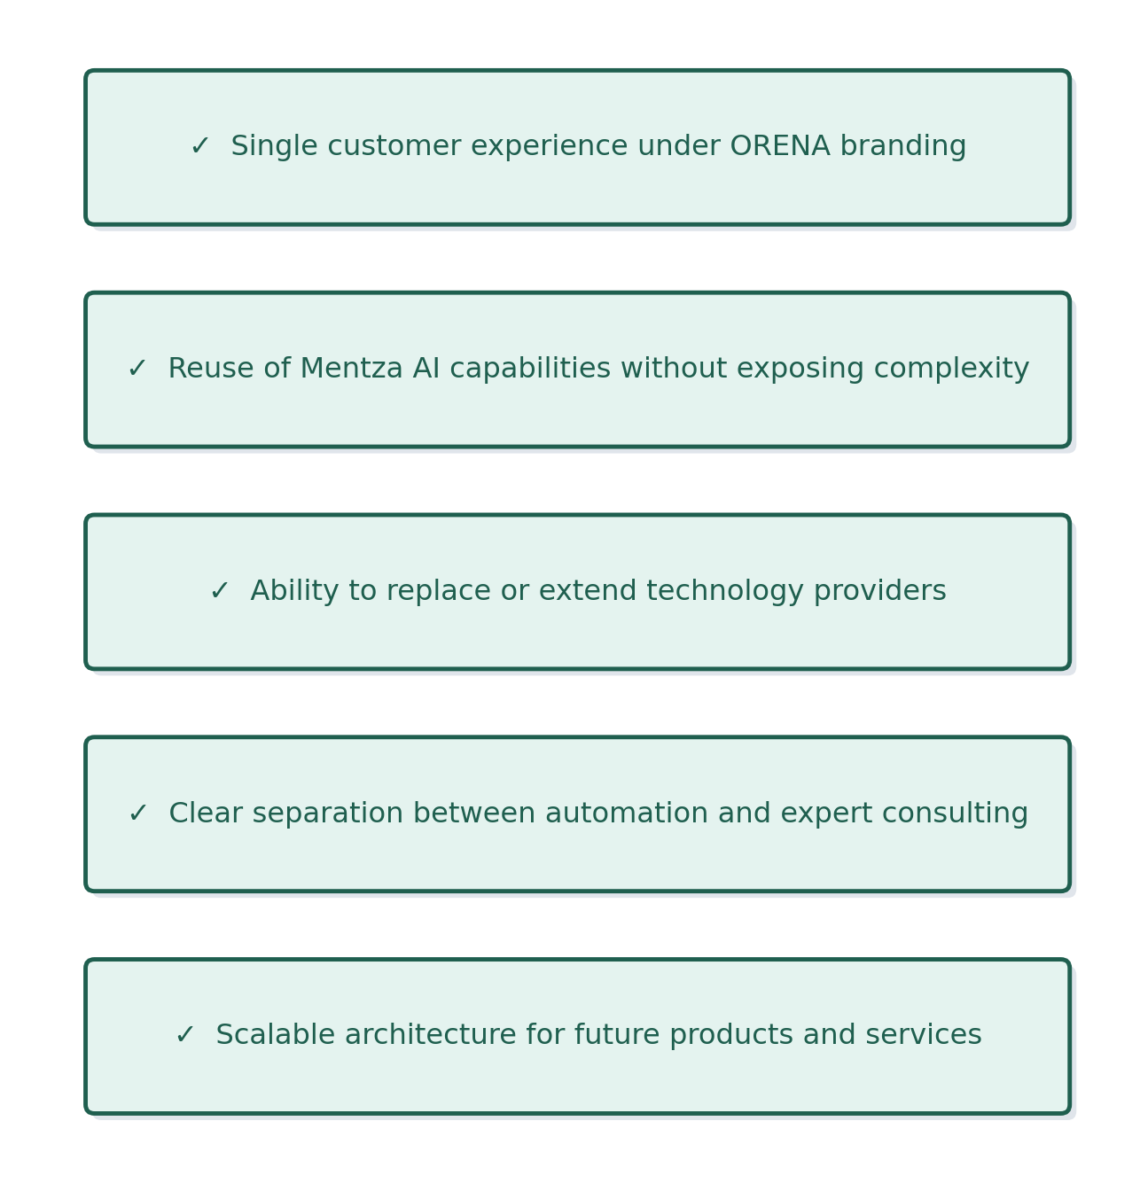

9. Recommendation
Mentza should never be positioned as a competing platform inside the application. Instead it should become the intelligence engine that enhances ORENA's products.
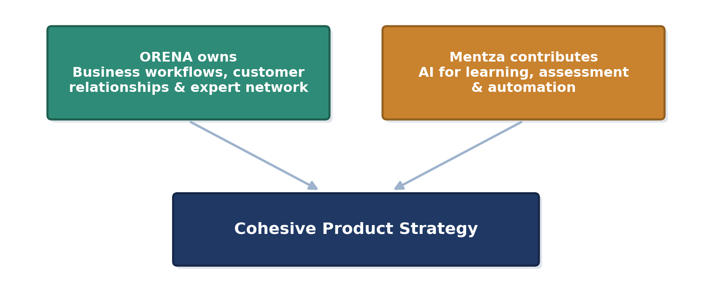
This approach provides a cohesive product strategy and allows the platform to evolve independently of any individual technology partner.

