ORENA Workforce Growth Platform
Product Vision & Module Proposal
Internal discussion document — Leadership & Product Team

Purpose
This document proposes a vision for transforming ORENA from a consulting-driven organization into a unified digital platform. It is intended as an internal discussion document for leadership and the product team, ahead of UI/UX design and technical implementation. It defines what the platform should achieve, which capabilities become software modules, and which services stay expert-driven.
Product definition framework (applies to every module below): business objective · user roles · workflows · data ownership · integrations · success metrics · future extensibility.

1. Executive Summary
ORENA has grown through hiring services, research-based training, industry collaboration and organizational transformation. The next stage is not another website — it is a Workforce Growth Platform that unifies hiring, learning, culture transformation, experts, analytics and AI in one operating environment. Software orchestrates people, workflows and data; experts continue delivering the high-value, judgment-driven work.
What changes
- From services delivered ad hoc → to services delivered through one connected platform
- From fragmented tracking (email / spreadsheets / WhatsApp) → to a single system of record
- From consultant-dependent visibility → to client self-serve dashboards and analytics
- Technology stays abstracted behind the platform, so integrations can change without reworking the UI or information architecture

2. Current Business Challenges
Current engagements involve multiple stakeholders and manual coordination across disconnected tools. This fragments visibility across hiring, learning and transformation programs, and makes outcomes hard to measure from a single place.
Current state — fragmented flow
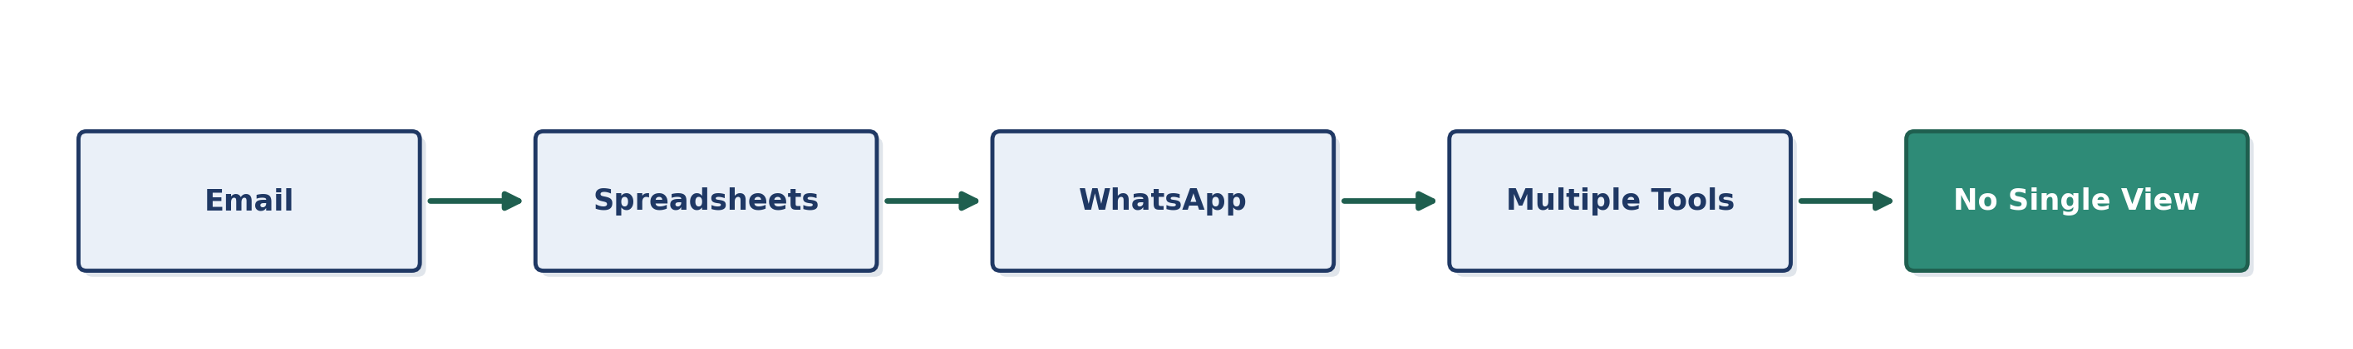
Core pain points
- Manual coordination across stakeholders with no shared system of record
- Progress and outcomes are not measurable from a single place
- Client visibility depends on consultant follow-up, not self-serve data
- No structured way to consolidate hiring, learning and transformation history per client

3. Platform Vision
The platform is a modular ecosystem, not three isolated services. Hiring begins the employee lifecycle, training develops capability, and culture transformation sustains long-term growth. Every module shares common platform services.
Employee lifecycle across modules
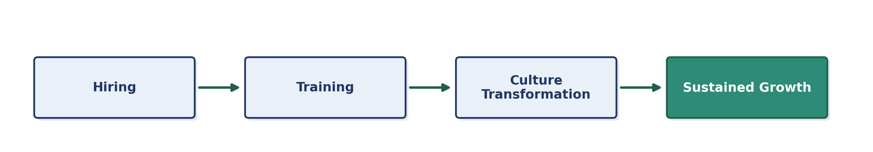
Shared platform services (used by every module)
- Authentication & role-based access
- Analytics & reporting
- Document management
- Notifications
- AI assistant
Platform architecture (layered view)
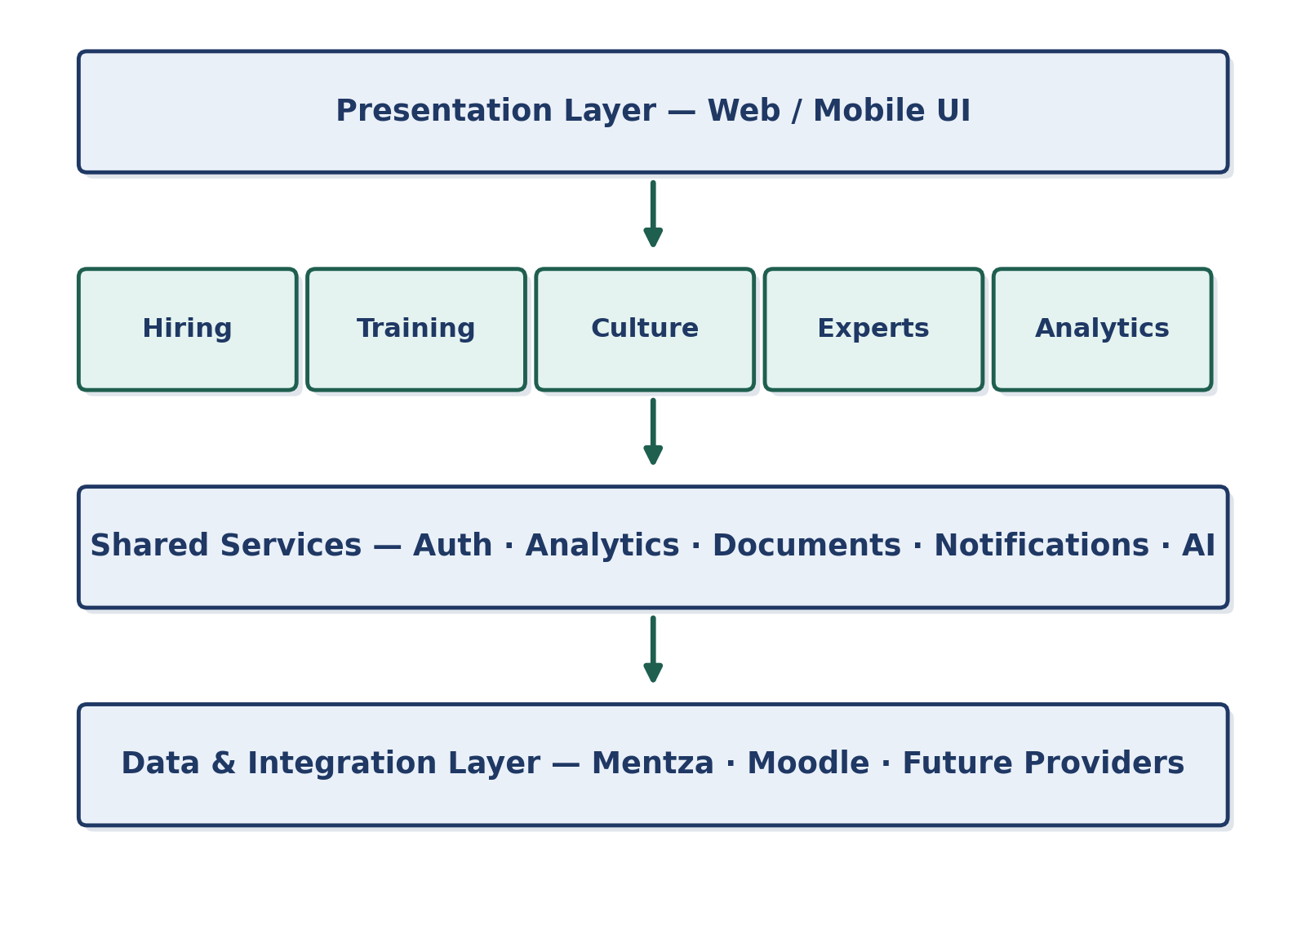

4. Hiring Management
The Hiring module digitizes the complete recruitment lifecycle. Mentza — or any future hiring provider — functions as an integration rather than defining the user experience.
Recruitment lifecycle
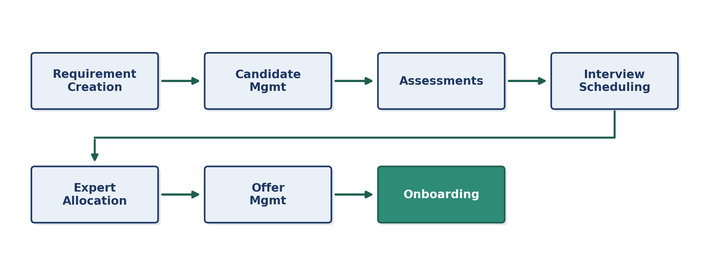
Supported hiring types
- Lateral hiring
- Fresher hiring
- Contractual staffing
- All configurable as workflows within one unified interface for recruiters and clients

5. Learning & Development
The Learning module supports two parallel journeys. The frontend stays independent of the underlying LMS provider, so Moodle, Mentza or another system can be connected later without redesigning the experience.
Two learning journeys
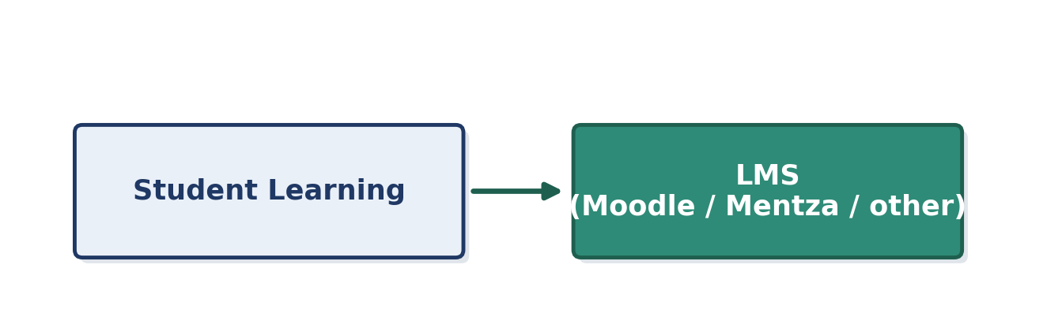
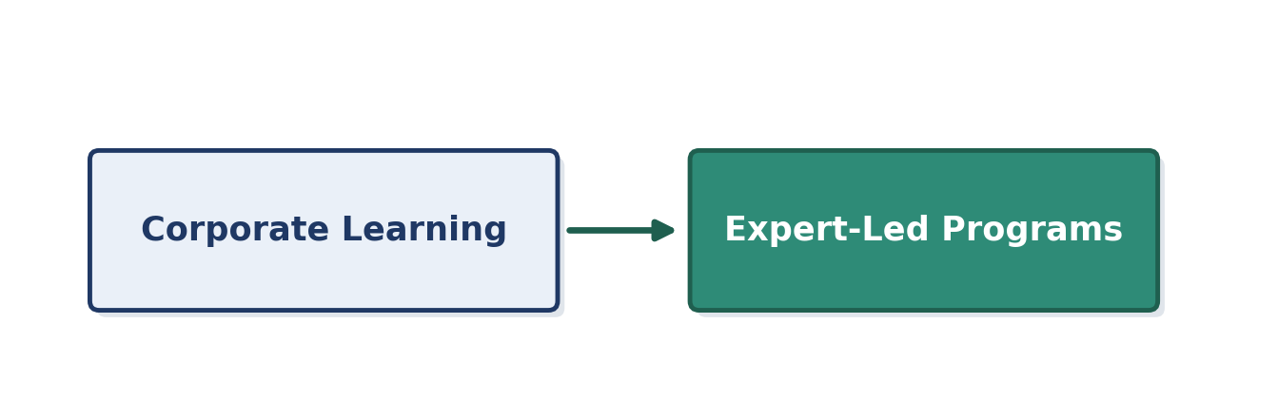
Journey components
- Assessments and assignments
- Workshops
- AI coaching
- Certifications
- Measurable progress dashboards for every learner

6. Culture Transformation
Culture transformation is not reduced to surveys. The platform structures the process; ORENA experts continue facilitating the human parts.
Transformation cycle
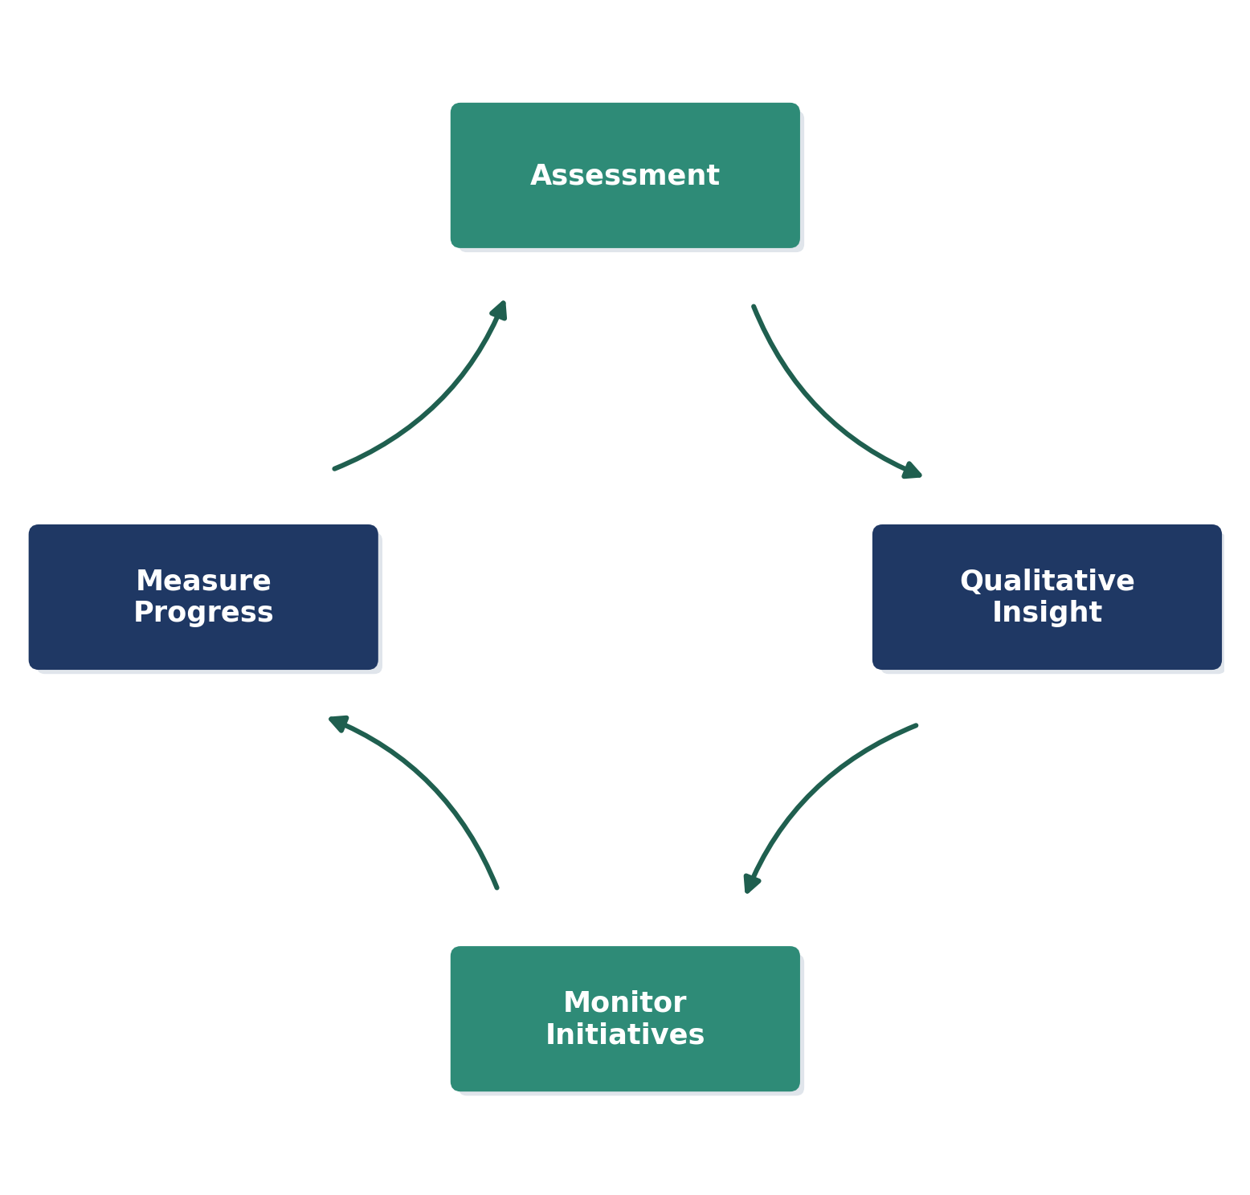
Split of responsibility
Handled by AI / platform | Handled by ORENA experts
Analytics and reporting | Workshop facilitation
Progress tracking over time | Leadership coaching
Data collection at scale | Execution and change management

7. Platform Modules
The initial platform includes nine core modules, each reusable, role-based and connected through a common navigation system. Future capabilities can be added without redesigning the core architecture.
Module | Role
Companies | Client account & organization management
Hiring | End-to-end recruitment lifecycle
Training | Student & corporate learning journeys
Culture | Assessment, insight and transformation tracking
Experts | Expert allocation and delivery management
Analytics | Cross-module reporting and KPIs
AI Assistant | In-context AI support across modules
Documents | Shared document management
Settings | Roles, permissions and configuration
Module ecosystem — everything connects through the platform core
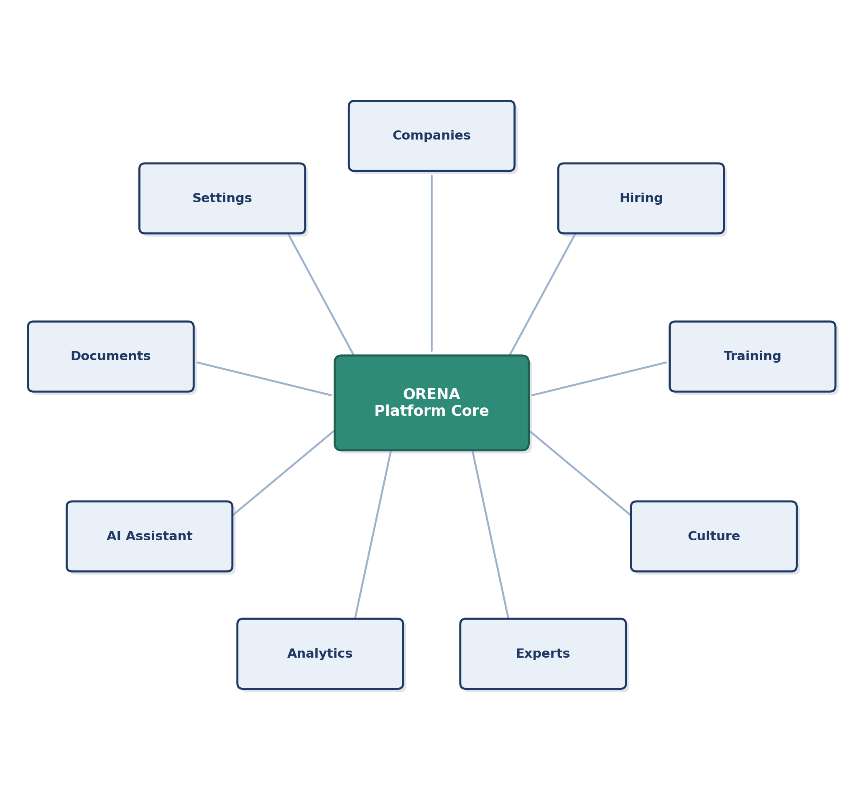
Planned future additions
- CRM
- Automation
- Partner portals
- University portals

8. User Roles & Dashboard
The dashboard is the operational workspace for every user. Each role gets contextual information based on permissions — KPIs, active workflows, pending tasks, AI insights and notifications, not static reports.
Role hierarchy
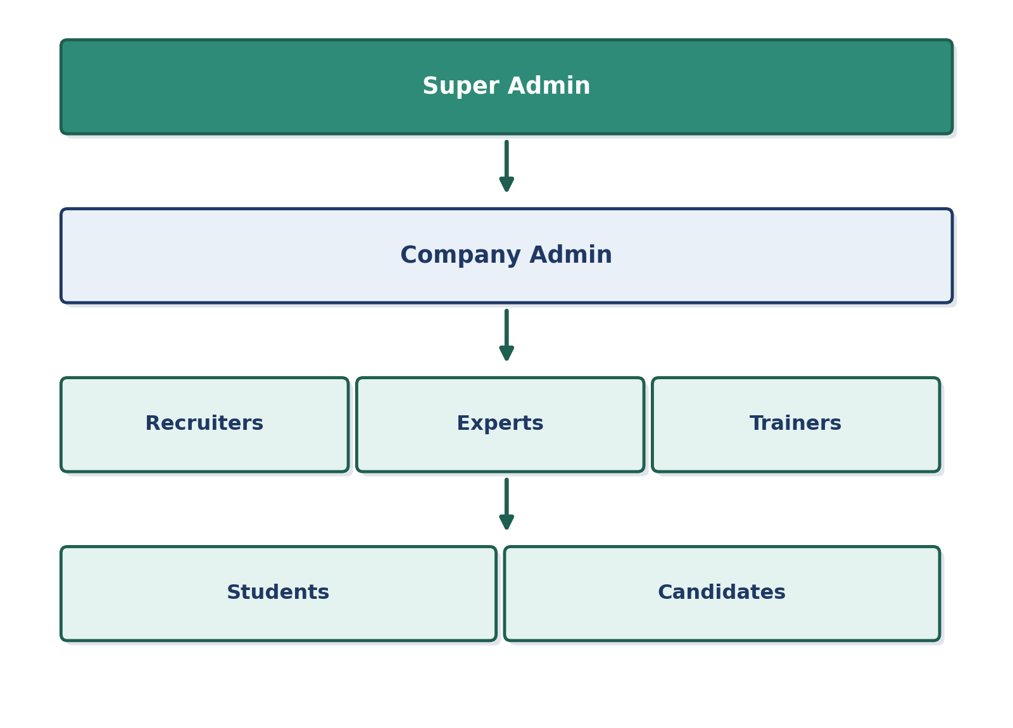
Role → dashboard mapping
Role | Primary dashboard focus
Super Admin | Platform-wide KPIs, configuration, oversight
Company Admin | Org-level hiring, learning and culture progress
Recruiters | Open requirements, candidate pipelines, interviews
Experts | Assigned engagements, delivery schedule
Trainers | Cohorts, assessments, session schedules
Students | Learning path, assignments, certifications
Candidates | Application status, assessments, interviews

9. Roadmap
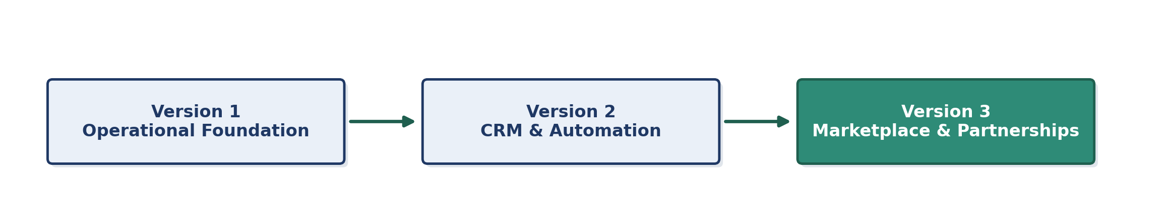
Phase | Scope
Version 1 | Authentication, Companies, Hiring, Learning, Experts, Analytics, Document management — the operational foundation
Version 2 | CRM, WhatsApp automation, culture intelligence, advanced reporting
Version 3 | Marketplaces, research collaboration, university partnerships, broader ecosystem capabilities

10. Recommendations
- Keep the frontend architecture technology-agnostic so backend providers can change without affecting the user experience
- Digitize repeatable operational workflows through the platform
- Keep strategic consulting, executive coaching, business transformation and specialist advisory in the hands of ORENA experts
- This balance preserves ORENA's competitive advantage while building a scalable software platform

