Shakti · Finance Automation
Transaction Tracker
Every bank alert. One picture of your money.
The problem
A business owner with four bank accounts gets about forty alert emails a week — and reads almost none of them. The information is already sitting in the inbox; it just isn't usable there. Net banking shows one bank at a time and forgets anything older than the statement period. A spreadsheet means someone has to type every line in by hand. Accounting software is built for the accountant, not the owner, and its reports arrive weeks late. The one question that actually matters — where did the money go this week, and what's left — has never had a cheap, quick answer.
The idea
Transaction Tracker reads the bank's own alert emails automatically, the same way a person would, and lays them out on one screen — per business, per bank, per account. There is nothing to type in, no bank login to hand over, and no waiting on a monthly statement. It works out which of two accounts at the same bank an alert belongs to, tells a genuine transaction apart from a bounced cheque, and quietly flags anything unusually large so it doesn't get lost among the day's small purchases. It checks for new mail every five minutes, or on demand from a button, and speaks English, Hindi or Gujarati. The owner opens one web address, on a phone or a laptop, and the whole picture is already there.
Bank alert → auto-read → sorted → one live dashboard
What it does
- Every transaction, date, bank, account, debit or credit, amount, counterparty and balance after — filterable by date, bank, account or payment mode, and exportable to CSV.
- A balance per account, the latest known figure for each one, plus a combined total across every account and bank.
- Multiple accounts at one bank told apart, using the last four digits read out of the alert, so each gets its own name and balance.
- Cheque returns kept separate, since no money actually moved — cheque number, amount and the bank's own reason, from 17 known return types.
- Payment mode read automatically, UPI, NEFT, RTGS, IMPS, cheque, card, ATM, net banking, auto-debit or cash — left blank rather than guessed when the alert doesn't say.
- High-value alerts flagged, anything above a threshold the client sets is separated out, so a large payment is never lost among small ones.
Who it's for Anyone accountable for money moving through accounts they don't personally watch all day — today, a sports club with several accounts across banks; the same shape fits a family, a housing society, or a small trust next.
The system design
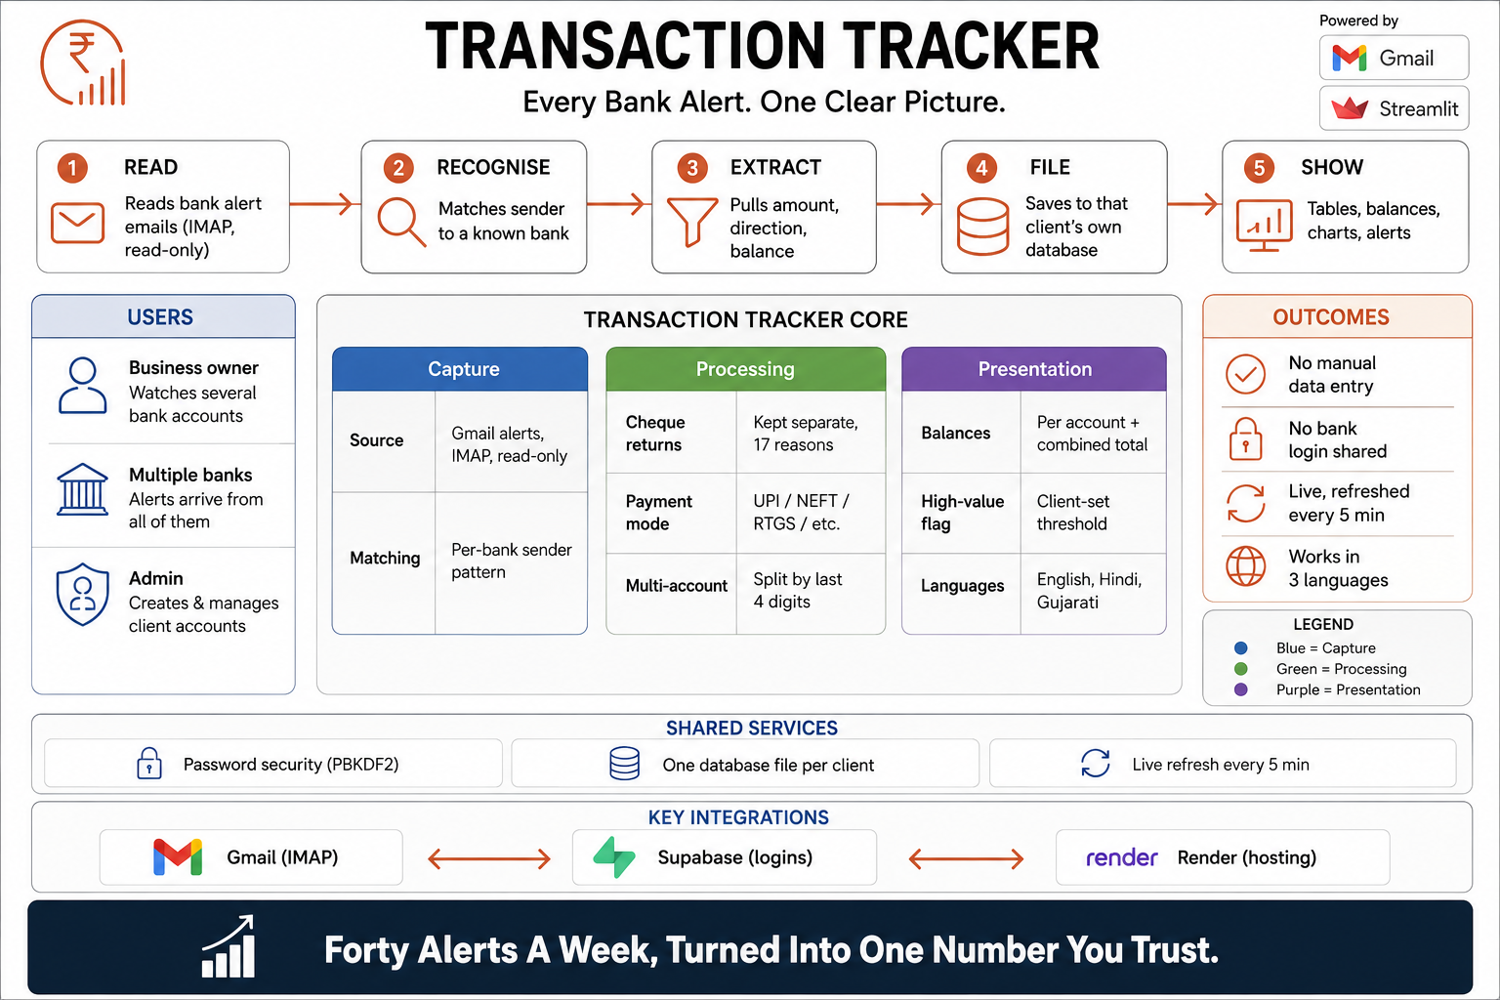
Read left to right: the engine reads bank alerts by IMAP, works out which bank sent each one, pulls the amount and balance out of it, files it under the right client, and shows the result on a dashboard. The centre panel breaks that into three layers — what gets captured, how it's processed (cheque returns, payment mode, splitting accounts at the same bank), and what the client actually sees (balances, high-value flags, three languages) — while the strip underneath names the three outside services the whole thing depends on: Gmail for the alerts, Supabase for logins, Render to host it.
See the dashboard
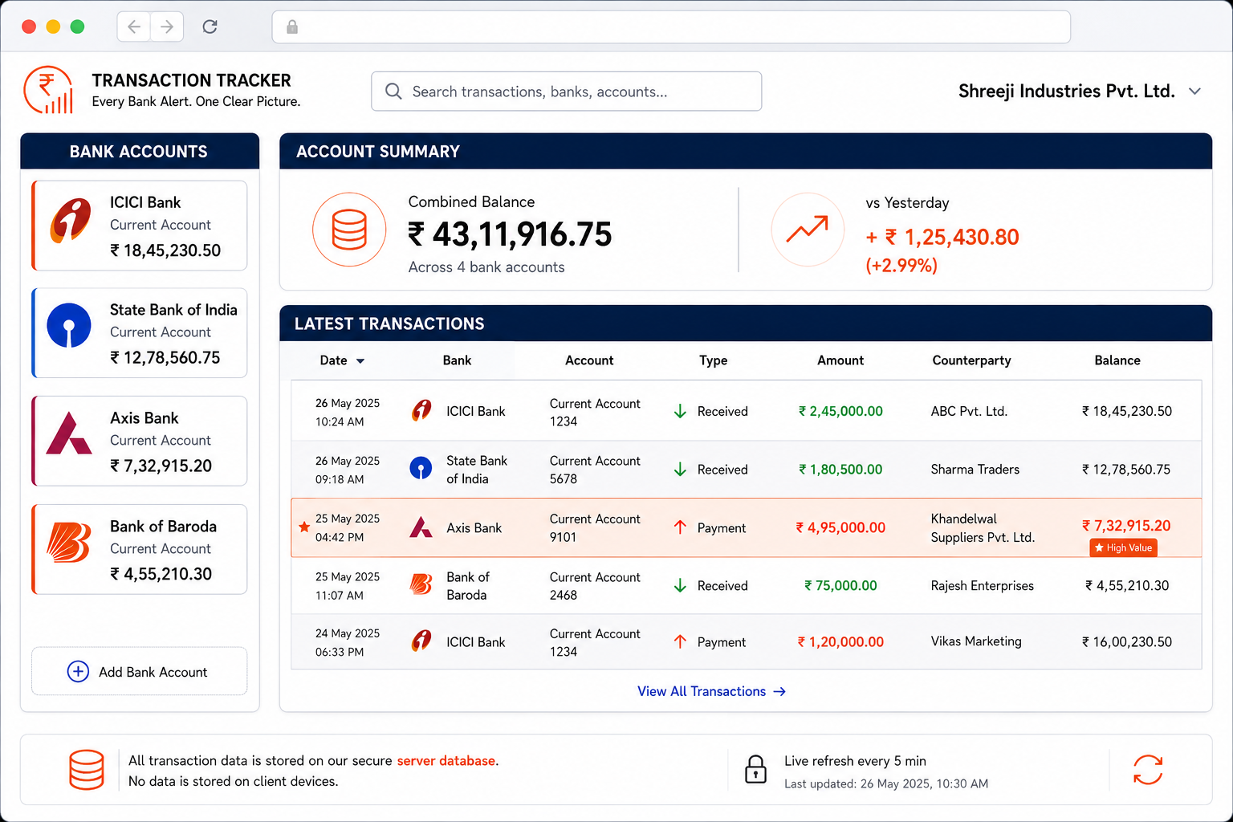
This is what a client actually logs into. On the left, Shreeji Industries' four accounts with their live balances — ICICI, State Bank of India, Axis, Bank of Baroda. Across the top, all four rolled into one combined balance, ₹43,11,916.75, up 2.99% on yesterday. Below that, the five most recent transactions, each showing which account it hit, whether money came in or went out, who it was with, and the balance left afterward — including a ₹4,95,000 payment flagged “High Value” in orange, exactly the transaction a busy owner would otherwise miss buried in an inbox.
Tell the story — before and after
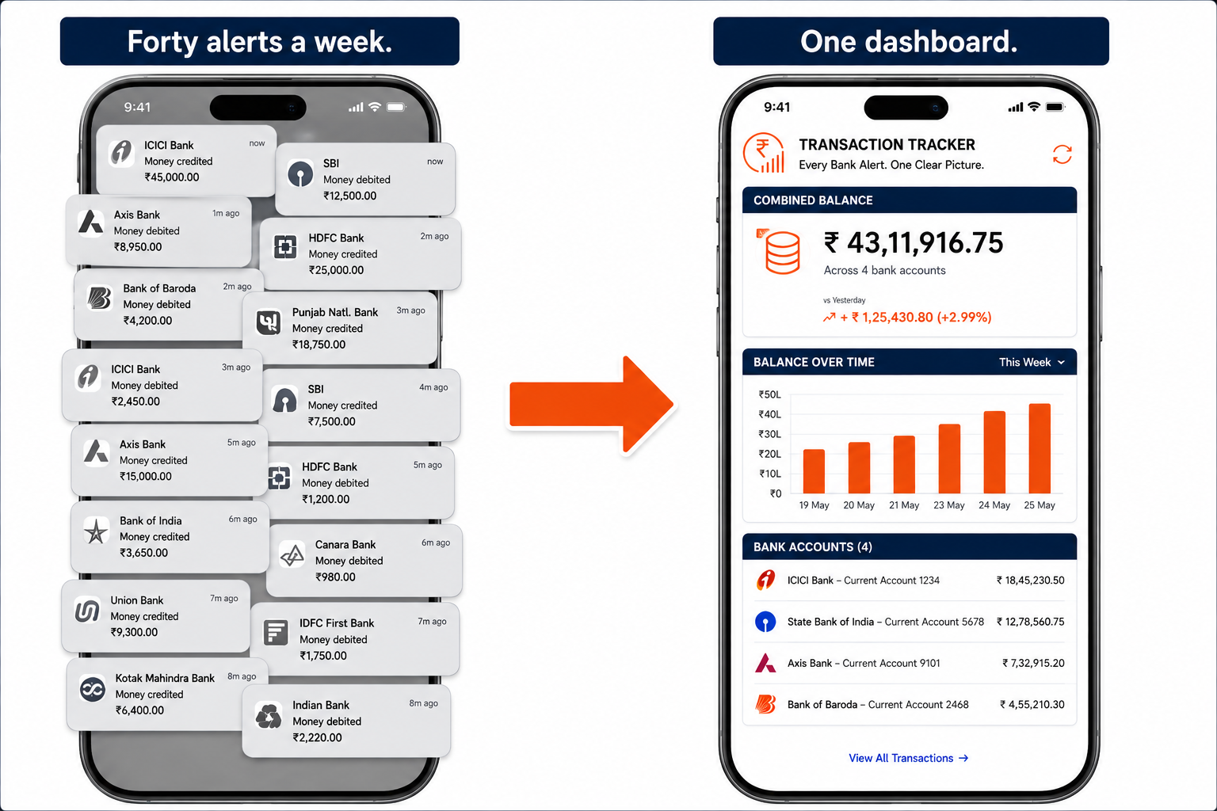
The whole pitch in one picture. On the left, a phone buried under a week's worth of bank notifications — over a dozen visible at once, credits and debits stacked on top of each other, no way to read them at a glance. On the right, the same phone running Transaction Tracker instead: one balance, one week's trend as a simple bar chart, and all four accounts listed underneath with their current balances — the forty emails turned into something an owner can actually glance at.

