SHAKTI · FINANCE AUTOMATION
Transaction Tracker
Automated bank-alert tracking for multi-account businesses

Overview
Transaction Tracker reads a business's bank alert emails automatically and turns them into one live dashboard — one balance, one list of transactions, per business, per bank, per account. There's nothing to type in, and no bank login to hand over.

The Problem
A business owner with four bank accounts gets about forty alert emails a week, and reads almost none of them. Net banking shows one account at a time. A spreadsheet means typing every line in by hand. Accounting software is built for the accountant, and its reports arrive weeks late. The one question that matters — where did the money go this week, and what's left — has never had a quick, cheap answer.

How It Works
- Read — reads bank alert emails by IMAP, read-only.
- Recognise — matches the sender to a known bank.
- Extract — pulls out the amount, direction and balance.
- File — saves it to that client's own database.
- Show — tables, balances, charts and alerts, on one dashboard.
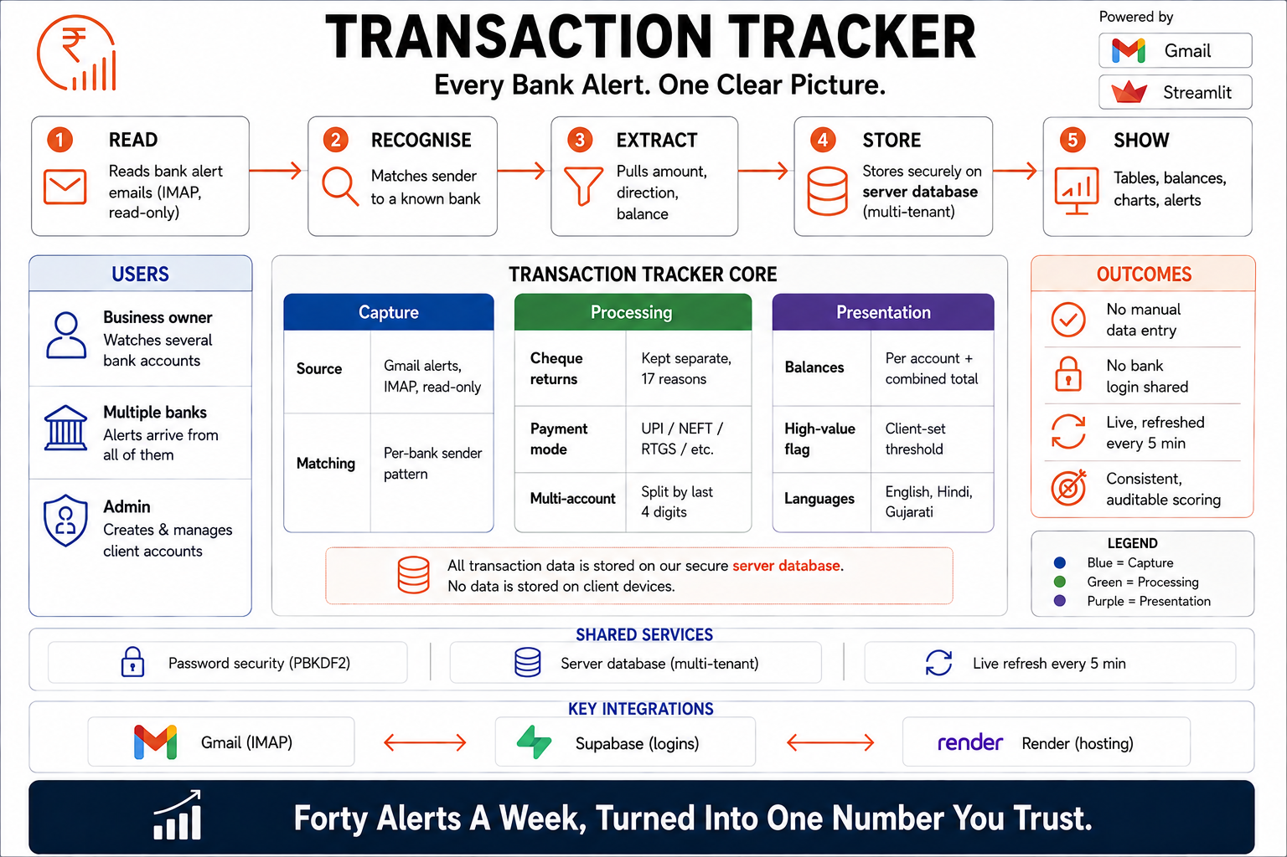
Figure 1. System architecture — capture, processing and presentation, on Gmail, Supabase and Render.

Key Features
- Every transaction — date, bank, account, type, amount, counterparty and balance after. Filterable, and exportable to CSV.
- Balances — per account, plus one combined total across every account and bank.
- Multi-account detection — accounts at the same bank told apart by the last four digits in the alert.
- Cheque returns — kept separate from real transactions, with reason, from 17 known return types.
- Payment mode — UPI, NEFT, RTGS, IMPS, cheque, card, ATM, net banking, auto-debit or cash, read automatically.
- High-value alerts — anything above a client-set threshold is flagged, so a large payment is never lost among small ones.
- Live refresh — checks for new mail every five minutes, or on demand.

Who It's For
Anyone accountable for money moving through accounts they don't watch all day. Today: a sports club with several accounts across banks. Next: a family, a housing society, or a small trust.

The Dashboard
Four accounts on the left, each with a live balance. One combined total at the top — ₹43,11,916.75, up 2.99% on yesterday. The five latest transactions below, each showing bank, direction, counterparty and balance after. A ₹4,95,000 payment is flagged “High Value” in orange — exactly the transaction a busy owner would otherwise miss.
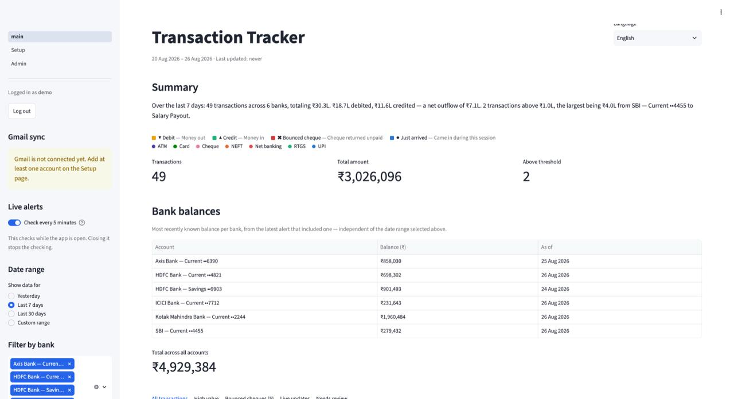
Figure 2. Client dashboard — Shreeji Industries Pvt. Ltd.

